United Nations Development Programme
Birlashgan Millatlar Tashkiloti Taraqqiyot Dasturi

Amendment No. 1

TO REQUEST FOR QUOTATION FOR LOW-VALUE GOODS

Date: September 13, 2019
Regarding: RFQ/048/19 – Supply of magnetic water treatment equipment

This Amendment is submitted to RFQ/048/19 announced on August 30, 2019, for the "Supply of magnetic water treatment equipment"
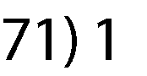
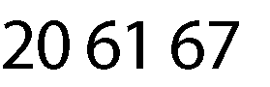
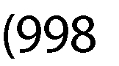
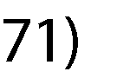
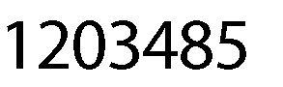
Changes are as follows:

- “Technical specification” regarding the productivity and connection type is revised and to be read as stipulated in Annex No.1 below, which is an integral part of this Amendment No. 1.
All Amendments to the RFQ/048/19 are an integral part of it, and all participants must comply with the requirements stipulated by such additions. Any deviation from the claims made by amendments to this RFQ may result in consideration of the proposal as not meeting the requirements and withdrawing from further evaluation.
All other terms and conditions of the RFQ/048/19 remain unchanged.
Annex No.1
Item # | Item Description |  | Unit of Measure | Q-ty | Price in USD or UZS (exclusive of VAT)
 | REQUIRED | PROPOSED |  |  | Unit Price | Total Price
1 | Magnetic water treatment equipment with a diameter of 10 inches (250 mm)  Technical specification:  Productivity: 130-700 m³/hour  Connection type: internal threaded or flange-mounted, 10 inches |  | pieces | 2

