A. Mathavuvalthakulam Cascade in Vavuniya
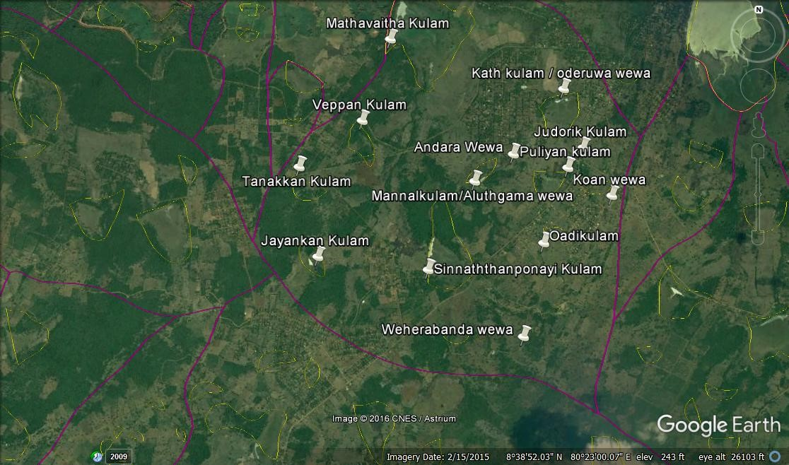
# | Name of Main Tank & small tanks and diversions | GPS Coordinate/reading
 |  | N- | E-
1 | Tanakkan Kulam | 08.39.196 | 080.22.370
2 | Jengan Kulam | 08.38.640 | 080.22.510
3 | Sinnaththanponayi Kulam | 08.38.583 | 080.23.205
4 | Veppankulam | 08.39.501 | 080.22.757
5 | Mannalkulam / Aluthgama wewa | 08.39.144 | 080.23.480
6 | Andara Wewa | 08.39.322 | 080.23.719
7 | Pulliyankulam | 08.39.249 | 080.24.065
8 | Koan wewa
9 | Judarikkulam | 08.39.378 | 080.24.158
10 | Kathkulam / Uderuwa | 08.39.744 | 80.24.026
11 | Mathavuvaltha kulam | 08.40.023 | 80.22.917
12 | Oadikulam | 08.38.774 | 08.23.925
13 | Weherabanda wewa | 08.38.191 | 080.23.813

B. Bandarakumbukwewa Cascade in Horowpothana
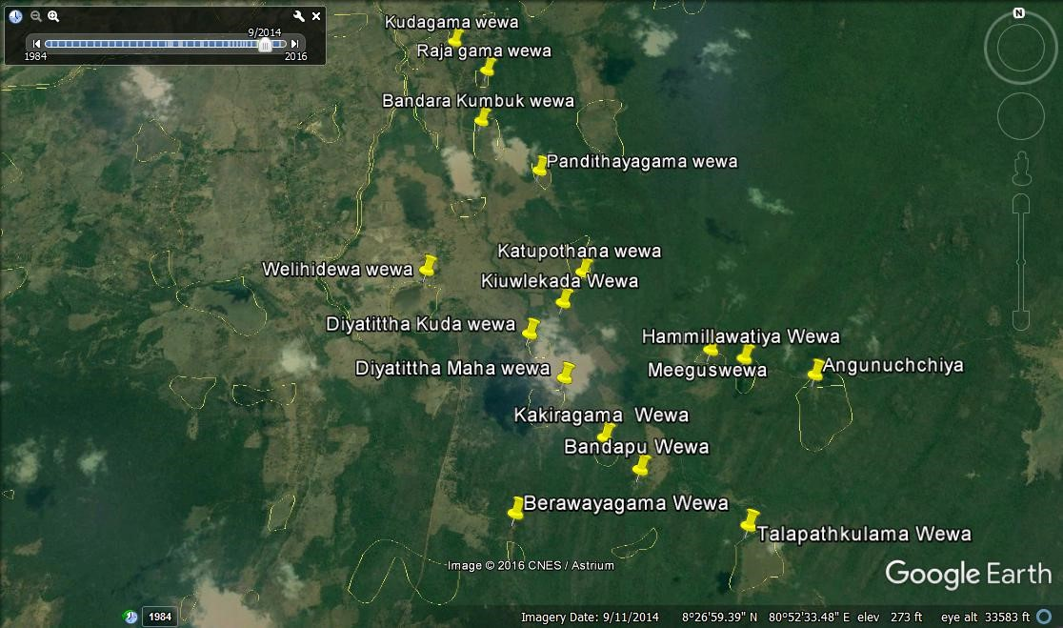
# | Name of Main Tank & small tanks and diversions | GPS Coordinate/reading
 |  | N- | E-
1 | Thalapathkulama wewa  (Tank is located in the forest area) | 08.25.544 | 080.53.713
2 | Bandapu wewa (Tank is located in the forest area) | 08.25.904 | 080.53.114
3 | Berawayagama wewa | 08.25.697 | 080.52.359
4 | Kakiragama wewa (Tank is located in the forest area) | 08.26.106 | 080.52.921
5 | Diyatitthewa Maha wewa | 08.26.485 | 080.52.705
6 | Diyatitthewa Kuda wewa | 08.26.780 | 080.52.509
7 | Katupotana wewa | 08.27.162 | 080.52.873
7 | Kiuvlekada wewa | 08.26.969 | 080.52.733
8 | Walahiddewa wewa | 08.27.238 | 080.51.879
9 | Pandithayagama wewa | 08.27.887 | 080.52.643
10 | Bandarakumbuk wewa | 08.28.279 | 080.52.276
11 | Rajagama wewa
12 | Kudagama wewa

C. Sivalakulam cascade in Galenbindunuwewa
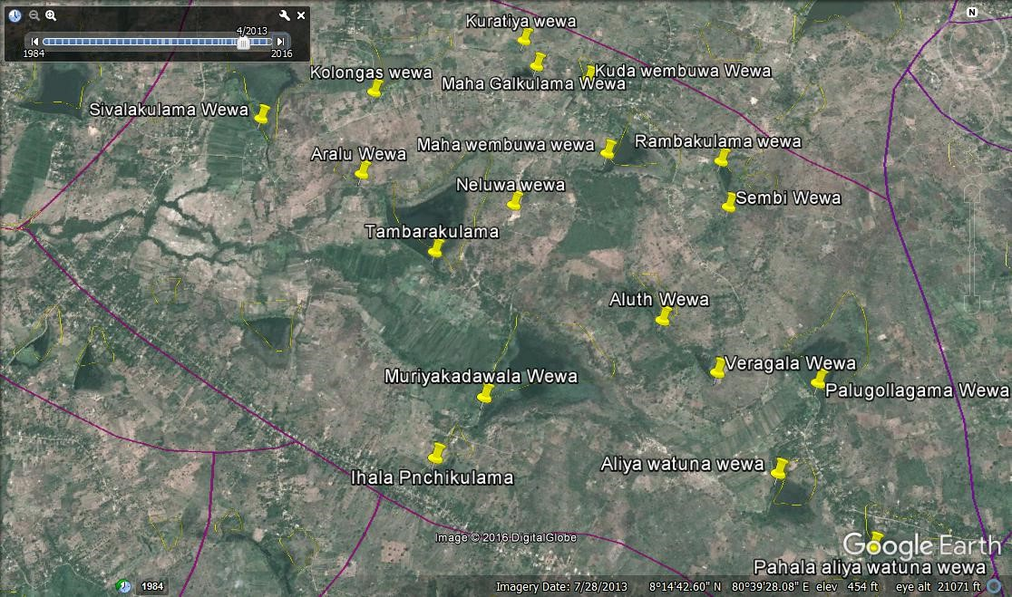
# | Name of Main Tank & small tanks and diversions | GPS Coordinate/reading
 |  | N- | E-
1 | Sivalakulama | 08.15.430 | 080.38.425
2 | Kolongas Wewa | 08.15.548 | 080.38.896
3 | Kuratiya Wewa (privet)
4 | Aralu Wewa | 08.15.184 | 080.38.857
5 | Thabarakulama Wewa | 08.14.852 | 080.39.166
6 | Neluwa wewa | 08.15.050 | 080.39.485
7 | Maha galkulama wewa | 08.15.665 | 080.39.584
8 | Kuda wembukulama wewa | 08.15.603 | 080.39.802
9 | Maha Wembu wewa | 08.15.272 | 080.39.874
10 | Ramba kulama wewa | 08.15.237 | 080.40.344
11 | Sembige wewa | 08.15.040 | 080.40.364
12 | Aluth wewa
13 | Veragala wewa
14 | Muriyakadawala wewa
15 | Ihala punchikulama wewa
16 | Palugolle wewa | 08.14.324 | 080.40.672
17 | Ihala Aliya watunu wewa | 08.13.981 | 080.40.491
18 | Pahala Aliya watunu wewa | 08.13.712 | 080.40.828
19 | Batala wewa
20 | Thimbiri Wewa

C. Palugaswewa cascade in Palugaswewa ( Anuradapura)
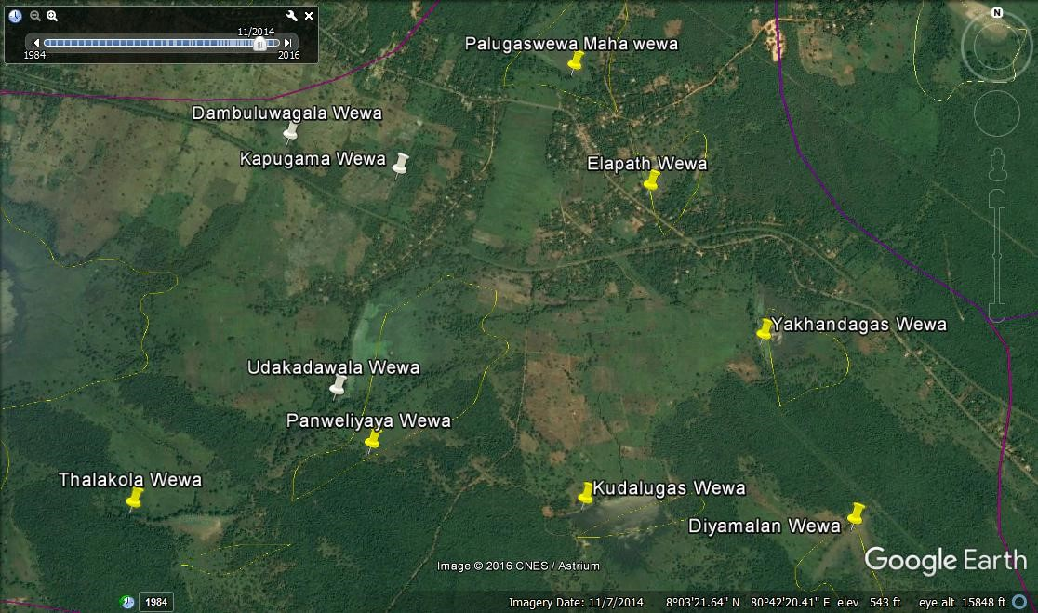
# | Name of Main Tank & small tanks and diversions | GPS Coordinate/reading
 |  | N- | E-
1 | Kudalugas wewa | 08.02.798 | 080.42.516
2 | Yakandagas wewa | 08.03.251 | 080.43.023
3 | Elapath wewa | 08.03.679 | 080.42.708
4 | Palugaswewa | 08.04.038 | 080.42.490
5 | Thalakola wewa | 08.02.781 | 080.41.266
6 | Udakadawala Wewa | 08.02.918 | 80.41.659
7 | Panweliyaya Wewa | 08.02.945 | 80.41.922
8 | Kapugama Wewa
9 | Dumbuluwagama Wewa

