Annex 1

Technical Specifications
Supply of Solar kits
S/N | Description | Compliance  Y/N | Deviations
1 | Electrician Kit  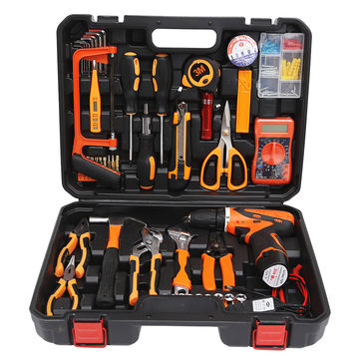  - 2-piece screwdriver  - 1-piece Ratchet Handle  - 1- piece multiple functional digital meter  - 1-piece of Elec. Screwdriver  - 1-piece Utility Knife  - 1 piece of Insulated Tape  - 1-piece Box Knife  - 1-piece Scissors  - 1-piece Fasteners  - 1 piece measuring Tape: 3m  - 1-piece LED flashlight  - 8-piece socket head: 1.5 2, 2.5, 3, 4, 5, 5.5 6  - 9-piece 1/sleeves:  - 4/5/6/7/8/9/10/11/12/13  - 9-piece extended group head  - 1-piece connectors  - 1-piece claw hammer  - 1-piece adjustable wrench  - 1-piece water pump pliers  - 1-piece hardware box
2 | PPE (Helmet, Gloves, Visibility Clothing)  High visibility clothing  Fluorescent green safety vest with retroreflective strip. Taping over shoulders.  ISO 20471  - Different sizes (M, L, XL, XXL)  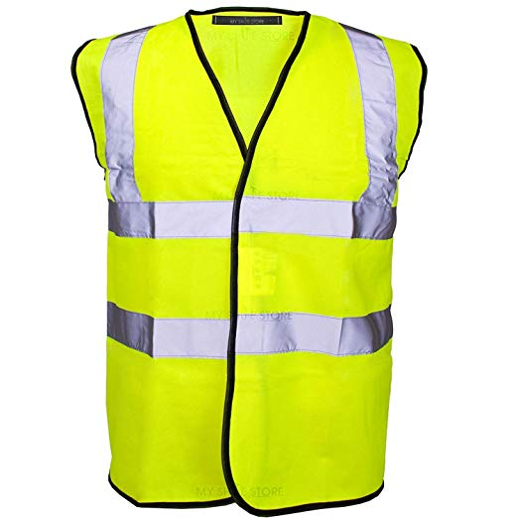  Helmet  - Made from high-density polypropylene the four-point harness includes a foam backed polyester sweatband for wearer comfort.  - Lateral deformation  - Soft foam sweat band included  - Bright compact and lightweight  Gloves  - 14" Cow split leather electrician gauntlet with a one piece back and full cotton lining for comfort. One size.  - 14-inch cow split leather gauntlet  - Maximum EN407 burn behaviour resistance  - Full cotton lining  - EN and ANSI cut level 3  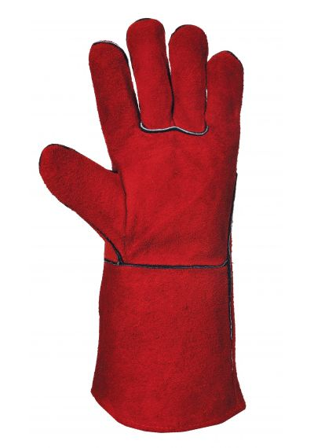

Annex 2

FORM FOR SUBMITTING SUPPLIER’S QUOTATION
(This Form must be submitted only using the Supplier’s Official Letterhead/Stationery)

We, the undersigned, hereby accept in full the UNDP General Terms and Conditions, and hereby offer to provide goods listed below in conformity with the description of goods and requirements of UNDP as per RFQ Reference No: UNDP/SOM/RFQ/2019/010/JPYES/SOLAR-KITS

TABLE 1: Offer to Supply Solar Kits Compliant with Description of Requirements

No. | Description/Specification of Service | Qty | Unit Price  USD | Total Price  USD
1 | Electrician kit | 100
 | Insurance
 | Packaging
 | Freight (DAP Mogadishu)

2 | PPE
2.1 | High visibility vest  M – 23, L – 63, XL – 12, XXL - 2 | 100
 | Insurance
 | Packaging
 | Freight (DAP Mogadishu)

2.2 | Helmets  M - 100 | 100
 | Insurance
 | Packaging
 | Freight (DAP Mogadishu)

2.3 | Gloves  M – 62, L - 38 | 100
 | Insurance
 | Packaging
 | Freight (DAP Mogadishu)

Sub-total for all items
Insurance for all items
Packaging for all items
Freight costs Mogadishu DAP (Inco-terms 2010) for all items
GRAND TOTAL
TABLE 2: Offer to Comply with Other Conditions and Related Requirements

Other Information pertaining to our Quotation are as follows: | Your Responses
 | Yes, we will comply | No, we cannot comply | If you cannot comply, pls. indicate counter proposal
Delivery Lead Time (preferred 30 days)
Warranty on Parts and Labour for minimum period of 1 year
Validity of Quotation (90 days)
All Provisions of the UNDP General Terms and Conditions
All other information that we have not provided automatically implies our full compliance with the requirements, terms and conditions of the RFQ.

[Name and Signature of the Supplier’s Authorized Person]
[Designation]
[Date]

