PUBLIC CALL FOR OPEN COMPETITION
for the permanent contemporary art installation
as part of the MIKRO020 project

Open competition announced by: United Nations Development Program (UNDP)
Open competition organized by: United Nations Development Program (UNDP) in cooperation with The Ministry of Culture and in cooperation with Association of Visual Artists of Montenegro, through the project "Creative Montenegro - Economic Valorization and Creative Industries"
Contact e-mail: nadja.ponomarev@undp.org;

- Introductory Guidelines:

The aim of the cultural policy of Montenegro is to develop and promote cultural and artistic creativity, cultural activities and cultural life in general, valorize cultural heritage, contribute to intercultural dialogue and preserve the specificities of different cultural identities, in order to assist in the affirmation of Montenegro's identity as a state, and promote cultural ties with the other countries.

By strengthening the National Identity of Montenegro, purpose is to strategically highlight and promote local products, creators and the arts and to establish a permanent presence of these categories at the international level.

The aim of implementation of the project activities related to stimulation of creative industries and contemporary creativity, including ideas and infrastructure, within the project Creative Montenegro - Economic Valorization and Creative Industries, implemented by the UNDP Office in cooperation with the Ministry of Culture of Montenegro, is to promote the culture more efficiently with an emphasis on innovation in cultural and artistic creation.

The Ministry of Culture, Capital City Podgorica, Association of Architects of Montenegro, Association of Visual Artists of Montenegro and United Nations Development Program ("UNDP") signed the statement of intent to participate in the implementation of the MIKRO 020 project.
The project "Micro 020" implies the arrangement of neglected micro-locations in Podgorica and aims to create "urban pockets" in all parts of the city enriching them with additional contents.

- Objective of the Open Competition

The aim of this competition is an affirmation of fine arts in open public spaces, stimulation of the creativity of independent artists and providing contemporary Montenegrin creators with visibility through the permanent presentation of their expression in the form of contemporary art installation on the selected location in Podgorica.

Subject location of this public call for open competition is a square in Princess Ksenija Street in Zabjelo, Podgorica.

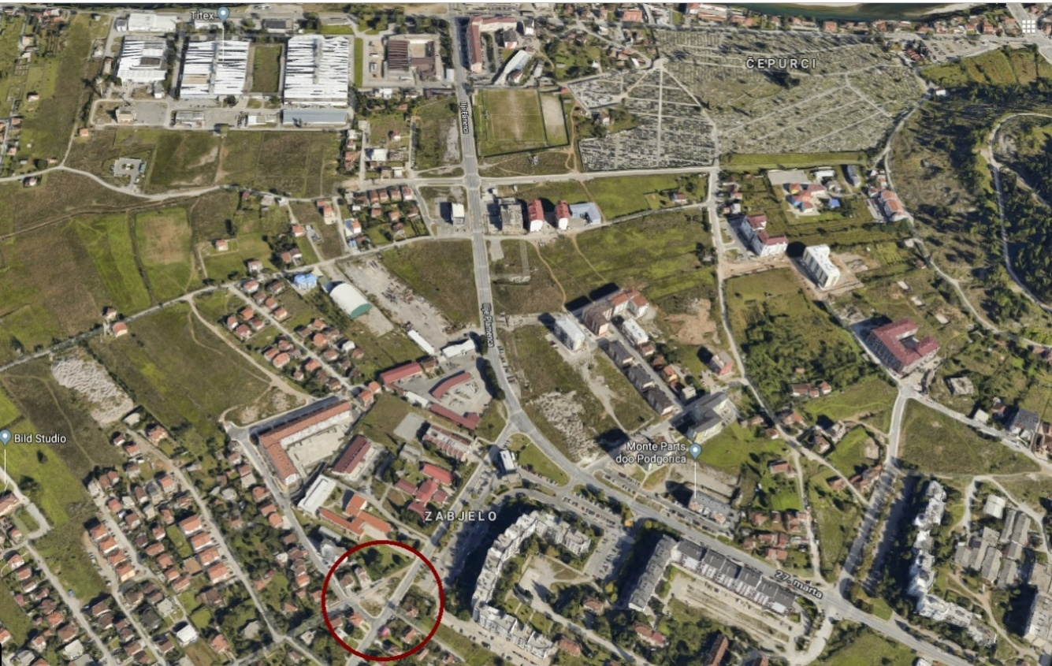

Photo 1. The location in question -extract from google maps

Our intention is to give Montenegrin creators and artists the opportunity to show their qualities and talents to the public on a specific location.

Within the special thematic web site called “Living Culture”, also several segments will be created that will give Montenegrin artists an opportunity to present their work.

The list of monuments that have been realized on the territory of the capital city over the last 20 years speaks in favor of the fact that there are insufficient number of projects implemented through public invitation and that Montenegrin authors are not sufficiently represented in their realization, and also that large number of monuments represent gifts or legacies other countries.

List of made art monuments in capital city in the previous period:
- Monument to Franco Prešeren, author Rok Žnidaršič - 2018.
- Tito Monument - author Antun Augustinčić (1948) - 2018.
- Monument to Duke Mirko Petrovic, author Dimitrije Popovic - 2017.
- Monument "Montenegrin oro", author Mitar Živković - 2016.
- Monument to Hussein Jawid, gift of Azerbaijan - 2013.
- Monument to St. Peter Cetinjski, author Nenad Šoškić - 2006.
- Monument to King Nikola, author Risto Radmilovic - 2006.
- Monument to Vladimir Visotsky - Gift of Russia, 2004.
- Monument to Vasos Mavrovuniotis, gift from Greece - 2003.
- Monument to Valtazar Bogisic, author Pavle Pejovic - 2002.
- The Pushkin Monument - Gift of Russia, 2002
- Monument to Mark Miljanov author Oto Logo - 2001.

- Subject Matter of the Open Competition

Permanent contemporary art installation will be placed on a square in Princess Ksenija Street in Zabjelo, Podgorica, at the place shown on the pictures below. The specified location has already been arranged through the Micro 020 project.

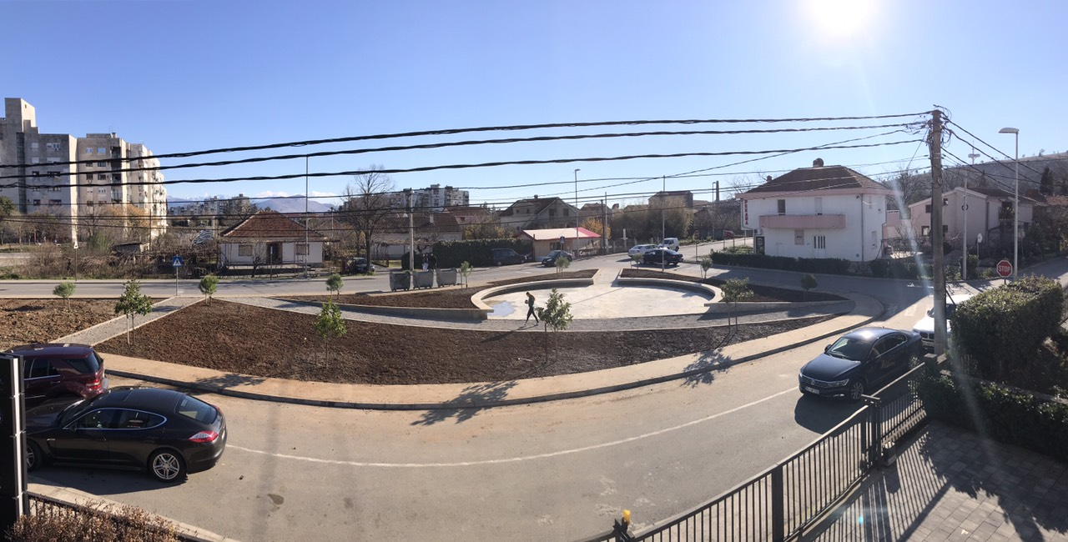

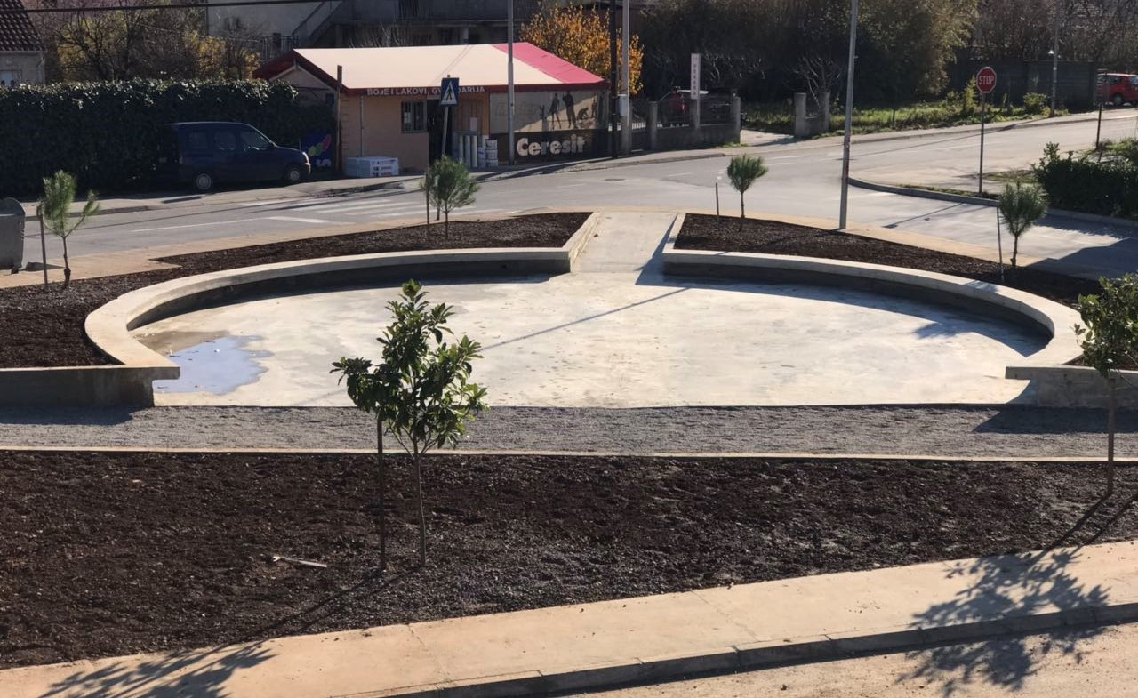
Photo 2 and 3. The location in question -square Princess Ksenija

Making a contemporary art installation will involve two segments:

- Copyright design - conceptual design of art installation, presented through drawings in the form of credible illustrative material (presented through photo documentation or 3d animation or 3d rendering)
- Implementation of the selected solution at the location in question.

The author is expected to submit a conceptual design which must include the following:

- The subject theme for an art the installation is Princess Ksenija, so the related motives / reference features of this historical figure must be implemented in the structure of the art installation presented through the illustrative proposal;

- Take into account the incorporation of the art installation in the ambiance;

- The art installation must be treated as a contemporary artistic piece and as such must convey the contemporary perception of Montenegrin art;

- The art installation must be presented in a comprehensive way;

- In conceptual design, the artist must specify the materials that will be used to create the installation as well as a cost-effective fit to the planned budget which is 10,000 USD. Note that the installation must be made of durable material, so it can be preserved for many years.

- Technical specifications for the art installation

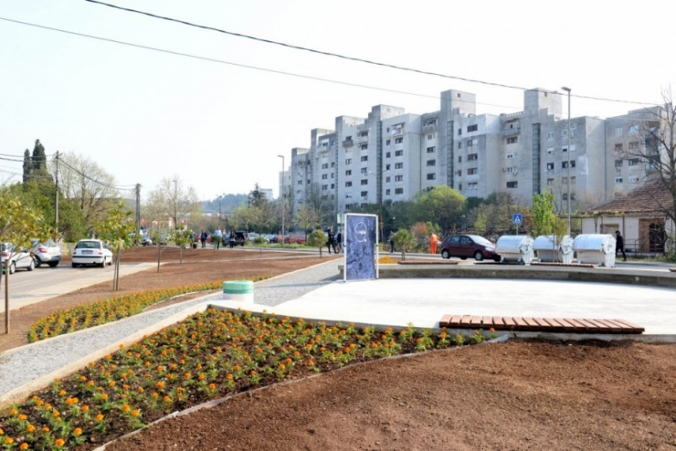
Photo 4. The location in question -square Princess Ksenija
Description of the site: The location of the square is at the corner of Princess Ksenija and JozoVukcevic streets in Podgorica.
Dimensions of the art installation to be made– In terms of dimensions, the art installation must be adapted to the public space and its basic purpose.

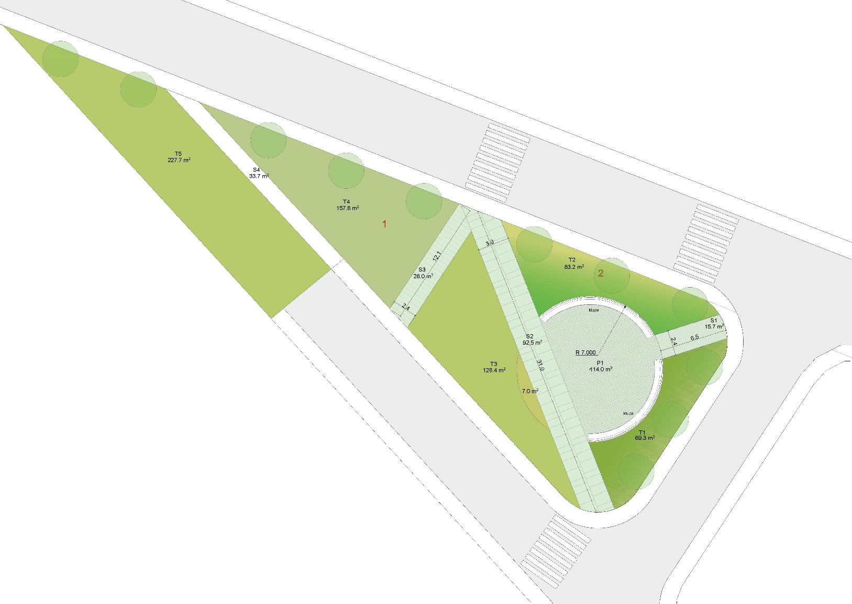

Photo 5. Layout of the square Princess Ksenija

- Competition Terms and Conditions and Deadlines:
The author must submit the conceptual design electronically in the form of a representative elaborate and in analog form which should include the following:
- visual presentation-3d render (model in smaller scale could be filming and presented through photo documentation or 3d animation);
- illustrations or drawings, on which the required thematic framework can be accurately identified;
- narrative explanation about the concept;
- clearly defined content and the technique needed for implementation;
- a cost estimation for the associated performance, that is in line with the planned budget, and consisting of the following items:
- Material necessary for art installation;
- Other associated equipment for the implementation;
- Other associated costs such as work, transport, accommodation or other justified costs proposed by the author.
Guidelines for analog formats:
- Narrative and graphic attachments are made in a free form, scale, and in the technique that participants consider to be the most appropriate.
- The narrative and graphic attachments should be submitted on a soft, uncovered, A3 book format, 6-12 sheets including the cover with a blank back, with the code of author’s work in the upper right corner of each sheet.
- The competition proposal for the concept and content of the set-up must be clear, concise, transparent and communicative.
- The concept and content of the setting must include a complete proposal of materialization with an indicative cost estimate
- All attachments should also be adapted for the jury purposes in a 5-copy book (A4 format).
- In a separate sealed envelope should be provided the author's name and other relevant data.
- The code of the author's work should be marked on the back of the envelope, and on every page of graphic and textual attachments.
Guidelines for digital formats:
- In addition to the analog format, the participants are obliged to submit a CD or USB with a book of conceptual design in PDF format, as well as all graphic attachments in DWG, PDF, JPEG, TIFF, and text files in DOC or PDF format.
- CD should be marked only with the code of author’s work.
Above mentioned material for competiton, should be submitted before December 3rd 2019, until 14:00 h, to the adress:
United Nations Development Programme
UN Eco House
Bulevar Stanka Dragojevica bb
81000 Podgorica, Montenegro
With a note: KONKURS LOK1 MIKRO 020

Attachment to this public call:
Square Princess Ksenija design, prepered by the architects, with suggested (but not mandatory) position for art installation.

Deadlines:
- The deadline for submission of competition entries December 3^{rd,}2019, until 14:00 h.

- The deadline for the beginning of preparation of the art installation is December 19th, 2019.

- The deadline for the completion of art installation is January 31st, 2020.

Competition works that do not meet the foregoing requirements shall not be considered.

Right to Participation

Individuals are eligible to participate in the competition: artists, creators and professionals from Montenegro, who are active in the field of fine art and contemporary creativity.
Each participant has the right to participate in this competition with only one work.

- General conditions

Criteria for evaluation of works:
- Originality of competition solution for art installation........................................0 to 40 points
- Visual identity and fulfillment of thematic requirements .................................. 0 to 30 points
- Rationality and cost-effectiveness of the solution ...............................................0 to 20 points
- Quality and communicativeness of the delivered presentation..........................0 to 10 points

Awards

- The award for the best solution will be the realization of the art installation conceptual solution at the given location, up to the budget amount of 10.000 USD (including all the cost of making the art installation, and other associated costs such as work, transport, accommodation or other justified costs proposed by the author), in accordance with the conditions of the Competition.

Note: All participants who meet the requirements of the competition will be eligible to compete for the main award. The relevant contract for the art installation will be concluded with the selected winner of the award. The money for the realization of the art installation will be paid in gross amount.

All received works that meet the requirements of the competition will be exhibited in a public exhibition together with the awarded works of the competition participants.

Proprietary rights
The proprietary rights of the awarded work shall be transferred to the Capital City, after the payment of the amount for making awarded artistic installation. The authors give their consent to the aforementioned conditions by participating in the competition, while the author retains the copyright of the design of the art installation.

Selection Committee Composition
Members:
- Igor Rakčević, President of the Association of Visual Artists of Montenegro
- Andrijana Pavićević, Arch, Capital City Podgorica
- Bojan Djonović, Arch, Association of Architects of Montenegro
- Petar Kovačević, Graduate Painter, representative of the Ministry of Culture
- Sladjana Lazarević, MSc. Arch, representative of UNDP Program Manager

Secretary of the Selection Committee:
- Nadja Ponomarev, Arch, UNDP Project coordinator

The results of the competition will be announced on the UNDP website on December 16th, 2019 the latest.

