Lot-1. Rotary Mounted Mowers.
Quantity – 8 pcs.
Item # | item description |  |  | unit of measurement | quantity | Price in ____ (please specify currency)
 | Requested |  | offered |  |  | Unit Price | Total Price
1 | Rotary Mounted Mower  Technical specification:  - Productivity not less than 2,5 ha/hr;  - Grip width not less than 2 m;  - Tractor PTO rotation frequency from 540 rpm;  - Cutting hight 40-80 mm;  - Rotor speed not less than 1900 rpm;  - Number of rotors not less than 4 pcs.;  - Working speed up to 15 km/hr;  - Dimensions not more than: 3550х2090х1380 mm (L/W/H);  - Weight not more than 600 kg;  - Aggregability: tractors with not less than 55 horse powers; |  |  | pieces | 8
 |  | Total price of goods for 8 pcs.
 |  | Transportation costs for 8 pcs. (CIP Nukus)
 |  | Packing, insurance and other costs for 8 pcs.
 |  | Total all-inclusive price for 8 pcs. Including all the other costs as per Lot - 1
Lot-2. Mounted 3-trunk ploughs.
Quantity - 10 pcs.
Item # | item description |  |  | unit of measurement | quantity | Price in ____ (please specify currency)
 | Requested |  | offered |  |  | Unit Price | Total Price
1 | Mounted 3-trunk ploughs  Technical specification:  - Aggregation method - mounted  - Productivity for 1 hour – up to 0,995 hr/hour;  - Working speed – up to 9 km/hour;  - Grip width - 1,05 m;  - Weight - 454±3% kg;  - Digging depth up to 30 cm;  Dimensions (in working condition), mm:  - Length, 2730±100;  - Widht, 1370±30;  - Hight, 1200±30;  - Distance between the main supporting plane to the lower part of the frame is not less than 620 mm;  - Number of operating parts, 3 pcs.;  - Digging depth of the skimmer up to 12 cm;  - Aggregation - 80-100 horse powers;  Visual image:  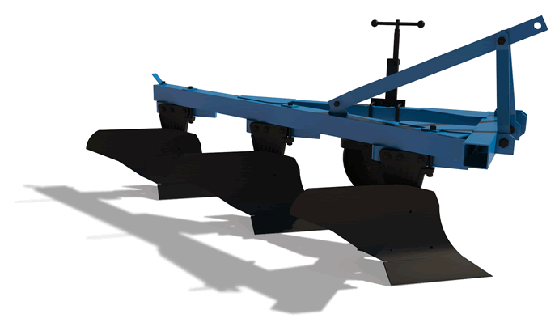 |  |  | pieces | 10
 |  | Total price of goods for 10 pcs.
 |  | Transportation costs for 10 pcs. (CIP Nukus)
 |  | Packing, insurance and other costs for 10 pcs.
 |  | Total all-inclusive price for 10 pcs. including all the other costs as per Lot - 2
 |  | Total price for Lot -1 and Lot - 2
Notes:
- The bidders must quote genuine, branded products. UNDP may conduct post-delivery inspection at its sole discretions.
- Sample of all items to be submitted with the bid response (as applicable).
- Price to include delivery, installation/ testing/ commissioning (as applicable)
- Site survey will be arranged on request (as applicable)
- Brochures and Technical details of the model offered MUST be submitted with the bid offer (as applicable)

The UNDP General Terms and Conditions are an integral part of this RFQ and should be reviewed by all bidders.
http://www.undp.org/content/undp/en/home/procurement/business/how-we-buy.html.
In submitting a quotation, bidders expressly accept to be bound by these General Terms and Conditions.
Any Purchase Order resulting from this process shall incorporate them in full.
Please submit your quotation by completing the right column of the form below:
UNDP Requirements | Bidder’s Response
Validity of Offer:  ☐ 60 days  ☐ 90 days  ☐ 120 days | ☐ Yes  ☐ No  ☐ Please explain in case of “No”: _____________________
Warranty Period Offered:  Minimum 12 months starting from the date of acceptance of the Goods by UNDP | ☐ Yes  ☐ No  ☐ Please explain in case of “No”: _____________________
Description of Warranty Coverage:  Spare parts, repair, technical support and labor | ☐ Yes  ☐ No  ☐ Please explain in case of “No”: _____________________
Description of After Sales Service:  ☐ Warranty on Parts and Labor for minimum period of 12 months starting from the date of acceptance of the Goods by UNDP  ☐ Technical Support via e-mail/phone/fax/internet  ☐ Provision of Service Unit when pulled out for maintenance/ repair  ☐ Others | ☐ Yes  ☐ No  ☐ Please explain in case of “No”: _____________________
Delivery Terms (linked to INCOTERMS 2010):  ☐ FCA  ☐ CPT  ☐ CIP Nukus, Karakalpakstan, Uzbekistan  ☐ DAP  ☐ On-site installation, commissioning and training are required.  Customs clearance, if needed, shall be done by UNDP for Foreign Suppliers (Company registered outside Uzbekistan) | ☐ Yes  ☐ No  ☐ Please explain in case of “No”: _____________________
Payment Terms:  To Local Supplier (Company registered in Uzbekistan):  ☒ 15% advance payment and 85% final payment will be paid in Uzbek Sums (UZS) by bank transfer to the Supplier’s account after delivery and acceptance of goods by UNDP;  To Foreign Suppliers (Company registered outside Uzbekistan):  ☒ 100% payment will be by bank transfer to the Supplier’s account after delivery and acceptance of goods by UNDP | ☐ Yes  ☐ No  ☐ Please explain in case of “No”: _____________________
Delivery terms:  Latest Delivery Date is mot more than 60 calendar days from day of signing contract by both parties. | ☐ Yes  ☐ No  ☐ Please explain in case of “No”: _____________________
All documentations, including catalogs, instructions and operating manuals, shall be in:  ☐ English and/or Russian  ☐ French  ☐ Spanish ☐ Others | ☐ Yes  ☐ No  ☐ Please explain in case of “No”: _____________________
Liquidated Damages:  ☐ Will not be imposed  ☐ Will be imposed under the following conditions:  Percentage of contract price per day of delay: 0.1%  Max. no. of days of delay: 30 calendar days  After which UNDP may terminate the contract. | ☐ Accept  ☐ Does not accept  ☐ Please explain in case of “Does not accept”:
Please confirm that your company is not included in the UN Security Council 1267/1989 list, UN Procurement Division List or other UN Ineligibility List; | ☐ Not listed  ☐ Listed  ☐ Please explain in case of “Listed”:
Please confirm that you accept the UN Supplier Code of Conduct, available at https://www.un.org/Depts/ptd/about-us/un-supplier-code-conduct | ☐ Accept  ☐ Does not accept  ☐ Please explain in case of “Does not accept”:

Must be linked to INCO Terms chosen

