SCOPE OF WORK AND TECHNICAL SPECIFICATIONS
SCOPE OF WORK (LOT 2)
The location of this project is Government Technical College, Bama, Bama LGA, Borno State. The scope of work consists of rehabilitation of Staff Quarters consisting of:
- Three (3) Nos 3-bedroom apartment with inbuilt garage and
- Three (3) Nos 2-bedroom boys’ quarters
The referred structures are labelled SSQ6, SSQ7, & SSQ8 in the attached satellite image. Details of works to be carried out are as specified in the BOQ, Technical Specifications and design drawings provided.
Note: In the event of the detailed description in the Bills of Quantities conflicting with the technical specification clauses contained below, the Bill of Quantities shall take precedence
PROJECT DURATION: 2months

TECHNICAL SPECIFICATIONS
- All excavations, demolition works, removal & arranged construction materials must be clearly encircled with safety caution tapes during works
- Filling around foundations etc. is to be of selected earth obtained from the excavation and is to be filled in 150mm layers, each layer well rammed and consolidated
- All formation level must be compacted before concrete blinding
- Hardcore is to be selected broken brick, concrete, sandcrete blocks or other clean hard and dry material.
- Laterite shall be approved rock laterite or other suitable materials are to be free from dust or other foreign matter and broken to pass a 75mm ring and to be retained on a 50mm ring and deposited in layers not exceeding 150mm thick, each layer being well consolidated by rolling or ramming and well watered.
- Ordinary Portland cement shall be used for all masonry and concrete works and must be lump free
- Fine aggregates shall be sieved and free of organic matter and other impurities
- Well-graded crushed granite shall be used as coarse aggregate (20-25mm for reinforced concrete; 35-40mm for mass concrete)
- Water-Cement ratio by weight shall not exceed 0.55. The quantity of water used in the mixing of the concrete must be adequate to ensure proper hydration of the cement and to bring the mass to a proper consistency and to a workable mix.
- Batching of concrete shall be by volume and Tilting Mixer shall be employed for mixing of fresh concrete
- Concrete shall be placed gently and not tipped or dropped from a height, it shall then be thoroughly rammed into positions to fill the forms and surround the reinforcement without displacing it and without the formation of voids or cavities.
- Compaction of fresh concrete shall be done with a poker vibrator for adequate compaction.
- Curing of concrete shall be in accordance with the recommendation set out in the B.S. Code of Practice and all surfaces shall be kept continually wet after concreting and protected from the sun and drying winds by covering with wet sacking, etc. for not less than one week.
- 28-day compressive strength shall be 15N/mm² (1:3:6 mix ratio) for mass concrete and 21N/mm² (1:2:4 mix ratio) for reinforced concrete
- Hollow sandcrete blocks (225mm X 225mm X 450mm) shall be machine-molded and not hand molded
- Minimum crushing strength of sandcrete blockwork shall not be less than 2.5N/mm² (cement-sand ratio of 1:6 by volume; no of blocks must not exceed 25 per 50kg bag of cement during fabrication).
- Formwork shall be removed without damage to the concrete.
- A schedule of suggested minimum striking times is given below:
Walls, sides of R.C beams sides of columns- 2 days after concreting
Soffits of slabs and soffits of casting to steel beams- 7 days after concreting
Soffits to R.C beam- 14 days after concreting
- All blockwork at substructure level shall be filled solid with concrete mix 1:3:6 while the use of broken blocks, laterite or mortar as a substitute shall not be accepted.
- The mortar used shall be composed of cement and sand and approved to give a strength equal to the strength of the blocks
- All reinforcement shall comply with BS 4449 and associated codes with regards to bending, lapping, binding and cranking
- Reinforcement shall be kept free of oil, mud, rust prior to use
- Concrete cover of 25mm shall be provided to reinforcement in beams and columns; and 50mm cover for foundation
- High yield steel (tensile strength of 410N/mm²) of specified size shall be used for both main reinforcements and links/stirrups.
- The use of BRC wire-mesh for ground floor slab is mandatory in new construction works and photographs are to be shared with supervising engineer as evidence of same
- The sand for plastering/rendering shall comply with B.S 1199.
- The internal and external renderings shall be composed of one-part Portland Cement and four parts and trowelled hard and smooth with a wood float in one coat not less than 12mm thick. All concrete surfaces which are to be rendered are to be carefully and thoroughly hacked with a suitable tool to provide an adequate and suitable keyed surface. All block walling which is to be rendered shall have the joints raked out to provide an adequate and suitable keyed surface.
- Plaster work and paintings which does not thoroughly adhere to any surface shall be removed and re-executed in a proper manner. Such hollowness, cracks, blisters and any other defects will be considered a defect under the Defects Liability Clause of the Contract
- Electrical wiring shall be full conduit, and a main distribution board and changeover switch provided at designated location.
- All lamps must be energy-saver type of approved quality not exceeding 20W rating.
- All sockets outlets for General A.C supplies shall be 13AMP 3-pin type and shall comply fully with B.S.S 1362 and 1363 and supplements as applicable.
- All electrical installations must be earthed, and fittings must be tested and commissioned using a power generator prior to handover of project.
- All PVC ceiling to be used must be presented and approved by the supervising engineer before installation.
- PVC ceiling branding spacing must not exceed 500mm; Line branding up level/horizontal
- Screw your PVC Ceiling panel onto the brandering. Panels should be in the same direction as the main trusses/purlin and all corners must be properly closed with cornice
- Ceiling fan hooks must be properly anchored on roof noggins and provided appropriately
- All Paint materials shall be the best quality of their respective kinds and in accordance with their latest British Standards and obtained from an approved manufacturer. No dilution of painting materials will be allowed, except strictly in accordance with the manufacturer’s directions, or as described in their literature.
- Painting on exterior work shall not be done in wet weather or upon any surface which are not thoroughly dry and free from rust or dust.
- All door and window furniture, ironmongery, flush covers and the like shall be covered or removed before the preparatory processes are commenced and shall be re-fixed on completion of painting.
- The internal wall and external wall painting shall be emulsion paint (colours specified in the BOQ or chosen colour must be carried out upon approval by the supervising engineer)
- Gloss paint shall be on woodwork or metal work after necessary preparations.
- All roofing sheets must be lapped with 2 corrugation at both ends
- Evidence of compliance with specified roof gauge must be provided
- Defective or poorly seasoned timber shall not be used for roof carcass or fascia
- All roof timber structure members including fascia shall be treated with approved chemicals
- Concrete coping of 50mm minimum thickness must be provided for all gable roofs
- Door-post labelling and designation shall be made with plastic plague as directed by the supervising Engineer
CONDITIONS AND SCHEDULE OF PAYMENT

Payment is spread across four (4) milestones as detailed:
Milestone  No. | Milestone’s Description and Required Activities & Documentations | Payment Amount (%) | Completion Date
Milestone No. 1 | NOTE: Achievement of a milestone is considered complete ONLY when the under listed sub-activities are COMPLETED and Verified.  - Signing and Submission of Contract  - Submission of Performance Bond or and other document(s) required by Procurement Unit  - Submission of Invoice to Procurement Unit for milestone % payment  - Attend Entrance meeting in UNDP Sub-Office, Maiduguri with (signed contract, proposed workplan and list of staffs submitted)  - Handing over of site/Taking over of site | 20% | (By end of Contract Week 2)
Milestone No. 2 | - Mobilization of equipment and staff to site  - Carefully removals, alteration and demolition work including removal/repair of all roofing sheets and damaged/defective roofing carcasses and ceiling boards from all the structures.  - Carefully remove all doors and windows, entrance gates and scrape off defective walls, floors etc.  - Delivery of more than 50% of construction materials to site  - Complete more than 50% of renovation works including carpentry & Joinery; plastering/mending of cracks, concrete works, metal & electricals etc.  - Construction and Installation of “ongoing construction/Men at work” visibilities board and caution tapes and safety equipment on site  - Submit progress reports (for week 1-2; week 3-4 and week 4-6) including a summary of activity progress with photographs showing works completed.  - Submit list of workers (not less than 70 with 10-15% being women) and Invoice (hardcopy)  - Site walk along with UNDP Engineer to inspect and certify completed milestone item of works | 40% | (By end of Contract Week 6)
Milestone No. 3 | - Install new ceilings (PVC)  - Replace damaged doors and windows to specifications with burglar proofs  - Painting all required interior and exterior surfaces using required paint to approved quality and color- using emulsion for interior and texcote for exterior surfaces.  - Installation and testing of all electrical fittings, plumbing works  - Treat all structures for termite infestation as required, ensure standard protective measures are taken to prevent future occurrences.  - Complete 100% of all items of work including clearing of construction site and cleaning  - Construction and Installations of all visibilities board and UNDP signages as prescribed and approved by the supervising Engineer  - Contractor submits progress reports (weeks 4-7) including a summary of activity progress. The report will include site photographs and report(s) from bi-weekly project coordination meetings.  - Carry out Project site walk with UNDP supervising Engineering team.  - Submit list of workers (not less than 70 with 10-15% being women) and Invoice (hardcopy)  - Submit project completion report | 35% | (By end of Contract Week 9)
Milestone No. 4 | - Post-completion inspection and certification report by UNDP Engineer that defects which occurred within 6months of practical completion have been satisfactorily repaired | 5% | (24weeks after practical completion of Contract

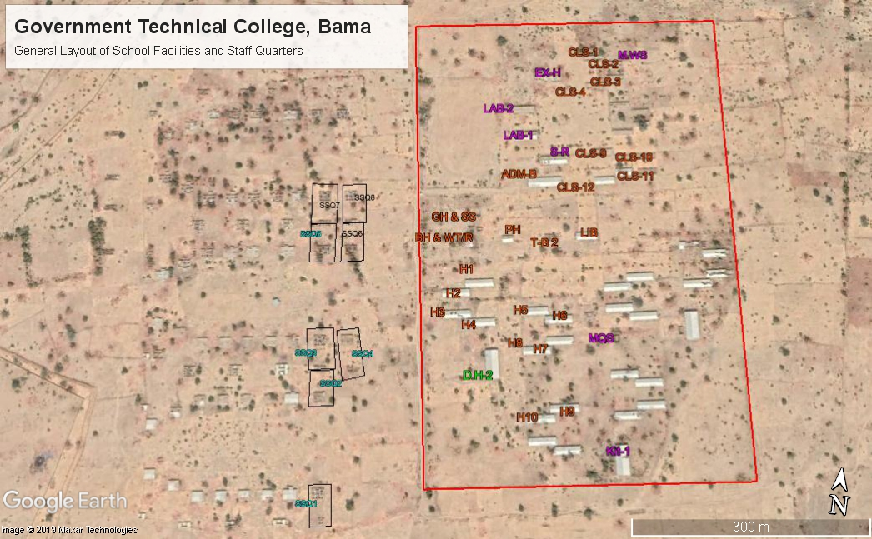
Figure 1: Google Image Showing GTC, Bama with LOT 2 label “SSQ6 – SSQ8” (LHS)

