**Notice of Invitation**

United Nations Volunteers, which is administered by United Nations Development Programme (UNDP) hereinafter referred to as “UNV” hereby invites you to submit a Proposal to this Request for Proposal for **0084041_Asia and the Pacific Regional Coordinator Consultant**

The purpose of the present bidding is to conclude a Consultant Contract for the above.

This procurement process is conducted through UNDP eTendering online system (interested applicants must register in the system in order to access the additional documents).Detailed instruction on how to register in the online system can be found in the attached link provided below:

If you have already registered in the system before, log in using your username and password. If you do not remember your password, use “Forgot Password” link or contact UNDP for support. Do not register as a new bidder. Once you have completed registration and are signed in, search for event ID 0084041 .

For first time registrants, use the following details to login and create access:

i.    URL:                 <https://etendering.partneragencies.org>

Username:**event.guest**

Password:**why2change (DO NOT change this password)**

ii. **Click on “Register as Sourcing Bidder” – see screenshot below:**

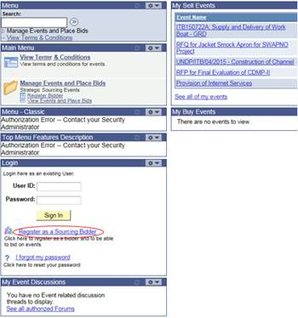

***Please note:***

1. ***It is strongly recommended that you create your username with two parts, i.e. your first name and last name separated by ‘.’ (e.g. john.smith).***
2. ***The registration page enables you to create a user ID. The system will generate a temporary password that will be sent to the email address provided by you during registration process. Ensure that the email address you provide is correct as your login password will be sent there. If you do not receive an email within an hour, please check your junk mail.***
3. ***You will be prompted to create your own password. After this process, you will see and be able to bid on both public events and events to which you have been invited.***

Please ensure that the email address you provide is correct as your login password will be sent there. If you do not receive an email within an hour, please check your junk mail.

Applicants are encouraged to view section 7.1. Bidder Registration in the [**eTendering Bidder Training Guide**](http://www.undp.org/content/dam/undp/img/corporate/procurement/infoforbidders/eTendering%20Instructions%20Manual%20for%20Bidders_June%202016.pdf) which explains the steps that bidders must follow in order to register in the eTendering.

#### We would also encourage you to go through [Information for bidders](http://www.undp.org/content/undp/en/home/operations/procurement/business/procurement-notices/resources/) to watch the video guides *on registering as bidder in eTendering*

Deadline of submission is indicated in the online system. Any extensions or other amendments to the solicitation documents will be posted in the eTendering system. Bidders **must** click on “Accept invitation” button in order to receive automatic notifications if such amendments occur, and to be logged as having posted a bid.

UNV looks forward to receiving your Proposal and thanks you in advance for your interest in UNV procurement opportunities.

Yours sincerely

Julie Spiller

Chief, Administration Unit