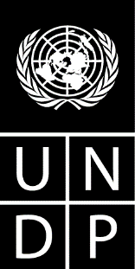

**UNDP Country Office in Mauritius**

has launched a procurement exercise as follows:

***GEF funded UNDP Joint Management Area (JMA) Demonstration Project between Mauritius and Seychelles***

**Communication Consultant to support the JMA Communication activities (Mauritian Nationals only)**

Qualifications:

Minimum Bachelor’s degree in communication, media studies, or any related fields.

For more information, interested candidates are invited to visit the UNDP’s website at: <http://procurement-notices-admin.undp.org/view_notice.cfm?notice_id=55468> (Ref No: 55468).

**Closing Date: 23 May 2019**

**PROCUREMENT NOTICE**

**United Nations Development Programme**