Annex-1

Technical Specifications

No | Item Description and Detail Specification | Quantity | Supplier’s Compliance to the Required Technical specifications
1 | - Model: Vertex Laser VL5  - Brand: Haglof  - Height resolution: 0.1 m  - Distance resolution: 0.01m  - Angle:-40” to +90”  - Accessories:  + Charging cable  +360-degree Adapter  + Transponder  + monopod  Reference Picture:  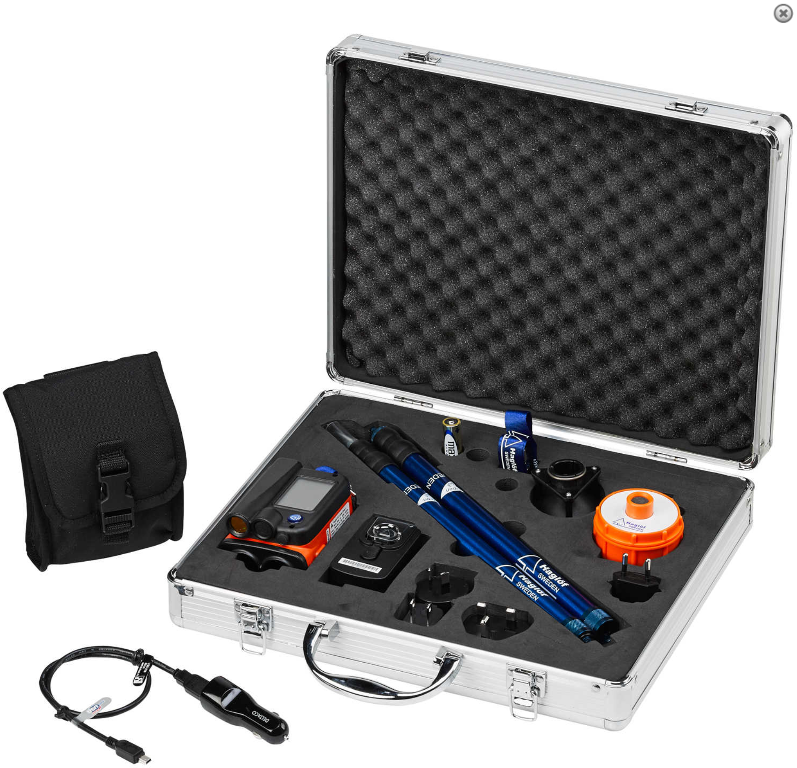 | 2 units

Annex 2

FORM FOR SUBMITTING SUPPLIER’S QUOTATION
(This Form must be submitted only using the Supplier’s Official Letterhead/Stationery)

We, the undersigned, hereby accept in full the UNDP General Terms and Conditions, and hereby offer to Supply and Delivery of Motorbikes listed below in conformity with the technical specifications, requirements, and conditions of UNDP as per RFQ Reference PROCESS ID 35-55855:

Specifications | Quantity | Unit Price  (USD)  DAP-PP | Total Price  (USD)  DAP-PP
Hypsometer | 2 units
Total Price DAP-PP

We, the undersigned, offer to supply the items listed above in conformity with specifications, terms and conditions of the RFQ.

Dated this . . . . .day of . . . . .[year].

. . . . . . . . . . . . . . . . . . . . . . . . . . . . . . . . . . . . . . . . . . . . . . .
Name & Signature [in the capacity of]

Duly authorized to sign the Bid for and on behalf of . . . . . . . . . . . . . . . . . . . . . . . . . . …….

