PERFORMANCE SPECIFICATIONS FOR AUTOMATIC SPRINKLER SYSTEM

MSL LUSAKA PHARMACEUTICAL FACILITY

SITE ADDRESS
Plot 6446, Mukwa Road
Off Lumumba Road
Lusaka
Zambia

I N D E X

ITEM DESCRIPTION PAGE #

Preamble 3

Consultants Design 4

Scope 4

Standards / Codes 4

- Drawings 4

- Approvals 4

- Additional Works to Facilitate the Circulation and Housing of Fire Protection Equipment to be included within the Tenderers Offer 6

8. Price Basis 6

- Programme for the Works 6

Appendix A – Bill of Quantities 7

1 PREAMBLE

MSL are utilising the existing warehouse for the storage and distribution of medical products into the Zambian supply chain supporting the MSL Hub system which further supports hospitals and clinics throughout Zambia. The existing warehouse is an ongoing operation and tenderers must take into consideration the continuation of work during the installation of the sprinkler system.

The new high bay warehouse is adjacent to the existing warehouse but will be unoccupied and is a new construction. The in-rack sprinkler system can only be installed once the racks have been erected and aligned. We refer you to the programme for indicative timelines.
.

An existing water tank and pump does exist and is shown on the schematic diagram below. These pumps and tanks support the new dispatch warehouse and offices which are fully operational and do not form part of this tender document.

The tenderers are to offer a detailed design, manufacture, supply and commissioning for the fire protection system specified in this document.

It is essential that tenderers visit site prior to submission of their offers to make themselves familiar with site conditions and the performance specifications stated above.

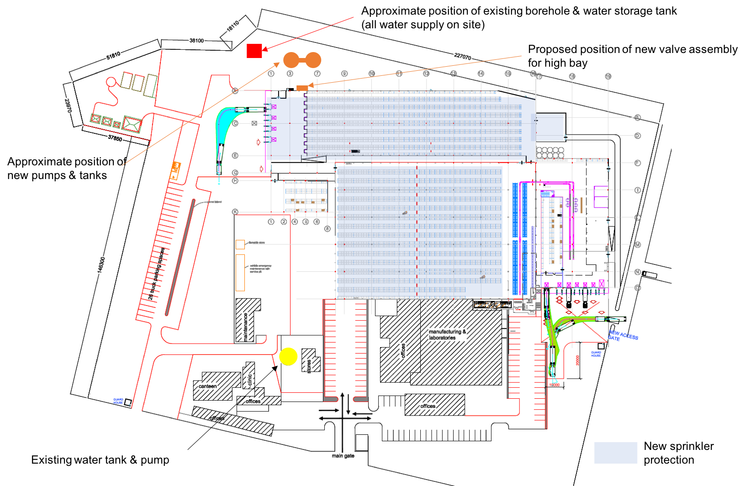

2. CONSULTANTS DESIGN

Tenderers to allow for the following consultants fees:
- design
- drawings
- details issue
- compliance certificate issue

- SCOPE

The scope of work encompasses the detailed design, manufacture, delivery, installation, commissioning and hand over for the following:
- Sprinkler protection of new warehouse at roof level as well as in-rack sprinklers.

Within the description below it does include for the fast response sprinklers in the new warehouse, water tanks, pumps, valves and associated pipe work. These items remain for descriptive purposes only and are shaded yellow in the bill of quantities.

4. CODES / STANDARDS

It is essential that the work complies with a current internationally recognised standard. This specification and associated drawings have been compiled to comply with the 12th Edition of the Rules for Automatic Sprinkler Installations of The Automatic Sprinkler Inspection Bureau of South Africa ("ASIB"). ASIB Rules are based on the LPC code (UK) that in turn incorporates BS EN 12845.

5. DRAWINGS
- MSL 011 Rev A - Existing Warehouse Roof
- MSL 012 Rev B - New Warehouse and battery charging
- MSL 013 Rev B - New Warehouse rack sprinklers
- AutoCad of all above - Rev B

6. APPROVALS

Equipment and materials must be suitable for sprinkler system use and must be approved/listed by one or more of the authorities as indicated below. Details of all equipment and materials must be submitted to the Engineer for approval prior to installation. Acceptance by the Engineer does not absolve the contractor from ensuring that all equipment and materials are suitable for their intended use and carry appropriate approvals.

Sprinkler equipment, including sprinkler heads, alarm valves, hydraulic alarms, etc.:
- LPCB.
- FM Global.
- Underwriters Laboratories.
Fire pumps:
- ASIB.
- LPCB.
- FM Global.
  - Pump performance"
    - "Pmax" 8000ℓ/min @ 900kPa
    - "Qmax" 9600ℓ/min
- Sizes of principal pumphouse pipework items:
  - Suction : 350mm nominal diameter.
  - Delivery : 200mm nominal diameter.
  - Pump test return : 200mm nominal diameter.
- Direct reading flow meter required.

Suction tanks:
- Suction tanks must be cylindrical and of bolted steel construction.
- Corrosion protection:
  - Hot dipped galvanising.
  - "Zincalume" or similar coating.
- Where a liner is required, the liner may be either partial or full.
- Required combined effective capacity of 2 tanks is 580m³.

ALL PIPEWORK, VALVES AND FITTINGS MUST BE SUITABLE FOR A MAXIMUM CONTAINED PRESSURE OF 1200kPa.

Steel piping ≤ 150mm nominal diameter:
- SANS 62 medium class (threaded, roll grooved and/or welded joints) or equivalent.

Steel piping > 150mm diameter:
- SANS 719 Grade B, 4,5mm wall thickness or equivalent.

Jointing:
- Threaded joints for piping ≤ 50mm nominal diameter.
- Piping > 50mm nominal diameter may be joined by threading, welding, flanging and/or mechanical couplings.
- Weld-on sockets can be used where range pipes are connected to mains.
- Sprinklers may be screwed into half sockets welded to range pipes > 25mm nominal diameter.

Underground Piping:
- uPVC Class 16.

Valves generally:
- Stop valves > 50mm:
  - Wafer or grooved butterfly with geared handwheel. Lever operated valves are unacceptable. FM approved or to other standard (eg, EN) acceptable to the Engineer.
  - Flanged or grooved gate valves. FM approved or SABS approved.
- Stop valves ≤ 50mm:
  - Good quality threaded valves - brass or stainless steel.
  - Alarm valve trim valves to be as supplied by the alarm valve manufacturer.
- Non return valves:
  - Wafer type with spring loaded double door. FM approved or to other standard (eg, EN) acceptable to the Engineer.

Corrosion protection:
- Normally "wet" piping:
  - To receive 1 x shop coat of red oxide primer and 1 x shop coat of signal red gloss enamel.
  - 1 x site coat of signal red gloss enamel.
- Piping that is alternately wet and dry (eg, drains):
  - Galvanised.

7. ADDITIONAL WORKS TO FACILITATE THE CIRCULATION AND HOUSING OF FIRE PROTECTION EQUIPMENT TO BE INCLUDED WITHIN THE TENDERES OFFER.

The successful sprinkler contractor will be required to provide adequate drawings and information to enable these works to be carried out.

- Excavation and backfilling of trenches.
- Cutting and making good of paved surfaces.
- Construction of pumphouse.
- Electrical supply to pumphouse and associated distribution board.
- Construction of suction tank bases.
- Valve rooms/chambers.
- Cutting and making good penetrations through building elements.
- Water and electricity for construction and commissioning.

8. PRICE BASIS

The price is to be fixed in US$,

The applicable exchange rate variations will be identified at the tender awards but the Tenderer must clearly identify the sum of the offer, which is subject to exchange rate fluctuation. Price to exclude VAT. A detailed cost breakdown will be required.
There will be no customs duties or surcharges liable for this project.

APPENDIX A

BILL OF QUANTITIES

The following items and quantities are deemed as required for the fire protection system in both new and existing warehouses at MSL Lusaka. Tenderers are requested to make use of the last column in the BOQ to reflect any possible deviations between required and offered items.

All items shaded yellow are for information purposes and are subject to a separate tender, and will not form part of this contract..

Description | Unit | Qty | Rate | Amount
Water Supply
Cylindrical bolted steel suction tank 290m³ effective capacity | ea | 2
Diesel driven fire pump as specified including all peripherals, panels, etc. | ea | 1
Electric motor driven fire pump as specified including all peripherals, panels, etc. | ea | 1
Jockey pump | ea | 1
Pumphouse pipework and valves from suction tank connections to delivery connection point outside pumphouse, including direct reading flow meter, tank filling valves and pumphouse sprinklers. |  | item
200mm uPVC trunk main from pumphouse to sprinkler valve chamber(s) | m | 25
100mm uPVC connection from water supply point to suction tanks | m | 25
Water supply subtotal carried to summary
Installation Controlling Valves and Foam Equipment
100mm wet valve complete with all trim and flow switch | ea | 2
150mm wet valve complete with all trim and flow switch | ea | 2
200mm wet valve complete with all trim and flow switch | ea | 2
Installation controlling valves and foam equipment carried to summary
Sprinkler Protection of Existing Warehouse
200mm connecting main from valve chamber to roof sprinkler arrays. | m | 305
K32 (metric) ESFR sprinkler system at roof including distribution mains. | ea | 1100
150mm connecting main to cold store | m | 232
Dry pendent sprinklers in cold store including distribution mains | ea | 95
100mm connecting main to low level offices, ablutions, etc | m | 30
Ceiling sprinklers in low level offices & ablutions including white sprinklers, rosettes, swivel drops and distribution mains. | ea | 24
Existing warehouse sprinkler system subtotal carried to summary
Sprinkler Protection of New High Bay Warehouse
150mm connecting main from valve chamber to roof sprinkler arrays. | m | 15
7,5mm/min sprinkler system at roof including distribution mains. | ea | 1057
100mm connecting mains from valve chamber to in-rack sprinkler arrays. | m | 98
In-rack sprinkler system including droppers and distribution mains. | ea | 4930
New high bay warehouse sprinkler system subtotal carried to summary.
Sundry Items
Access equipment for installation at roof level. |  | item
O&M manuals (3 copies). |  | item
As built drawings - hard copy and soft copy on CD |  | item
Site establishment |  | item
P&Gs |  | item
Transport of materials and equipment to site |  | item
Third party inspection. |  | item
Sundry items subtotal carried to summary
Additional Works to Facilitate the Circulation and Housing of Fire Protection Equipment to be Included within the Tenderers Offer
Clear Site & remove top soil up to 150mm thick - disposed |  | 375
Soil Poison |  | 375
Excavate for reinforced cement concrete | m³ | 66
30mpa Reinforced cement concrete slab | m³ | 66
Steel Reinforcement to reinforced concrete slab (Rebar allowance 160Kg/m3) | tonne | 11
200mm thick block wall to pump house | m² | 65
200mm wide DPC | m | 20
200mm wide Brickforce | m | 100
Wire ties | No | 150
250 micron Cement Plastic Gunplas USB green waterproof sheeting | m² | 375
Roof trusses & sheeting | m² | 20
Plaster to external & internal walls | m² | 130
Paint to external & internal walls | m² | 130
Transformer from Dow MV1525 2 1235mm including louvre | WO | 1
Excavate & Back Filling to surface trench | m | 25
50 x 50 x 2.5 weld mesh x 3.00 high fencing | m² | 36
Sliding Gate | No | 1
Break through 200mm brick wall for water pipe & make good | No | 14
Additional Works to Facilitate the Circulation and Housing of Fire Protection Equipment to be Included within the Tenderers Offer subtotal carried to summary
SUMMARY
Water Supply
Installation Controlling Valves and Foam Equipment
Sprinkler Protection of Existing Warehouse
Sprinkler Protection of New High Bay Warehouse
Sundry Items
Additional Works to Facilitate the Circulation and Housing of Fire Protection Equipment to be Included within the Tenderers Offer
TOTAL

