UNDP’s Responses to Supplier Questions
ITB Ref: BB-57974
Supply of Goods and Materials for the Repair/Reconstruction of Two School Buildings in Salisbury Dominica
Bid Submission Deadline: 29 January 2019

No. | Section | Question | UNDP Response
1 | Lot 1 - Roofing | - What type of roofing profile are we bidding for?  - What thickness sheets?  - What color? | See below and attached sheet
2 | Lot 1 - Roofing | With regards to Nos. 3a and 3b in lot 1  17’ lengths (net coverage with 9” lap and;  13’ lengths (net coverage with 9” lap)  Kindly send us a picture of the item so that we can quote for the right product. | See below and attached sheet

The sheeting is for a retrofit of an existing building and will be attached to steel purlins spaced 2’ feet on center. See attached drawing and specifications below.
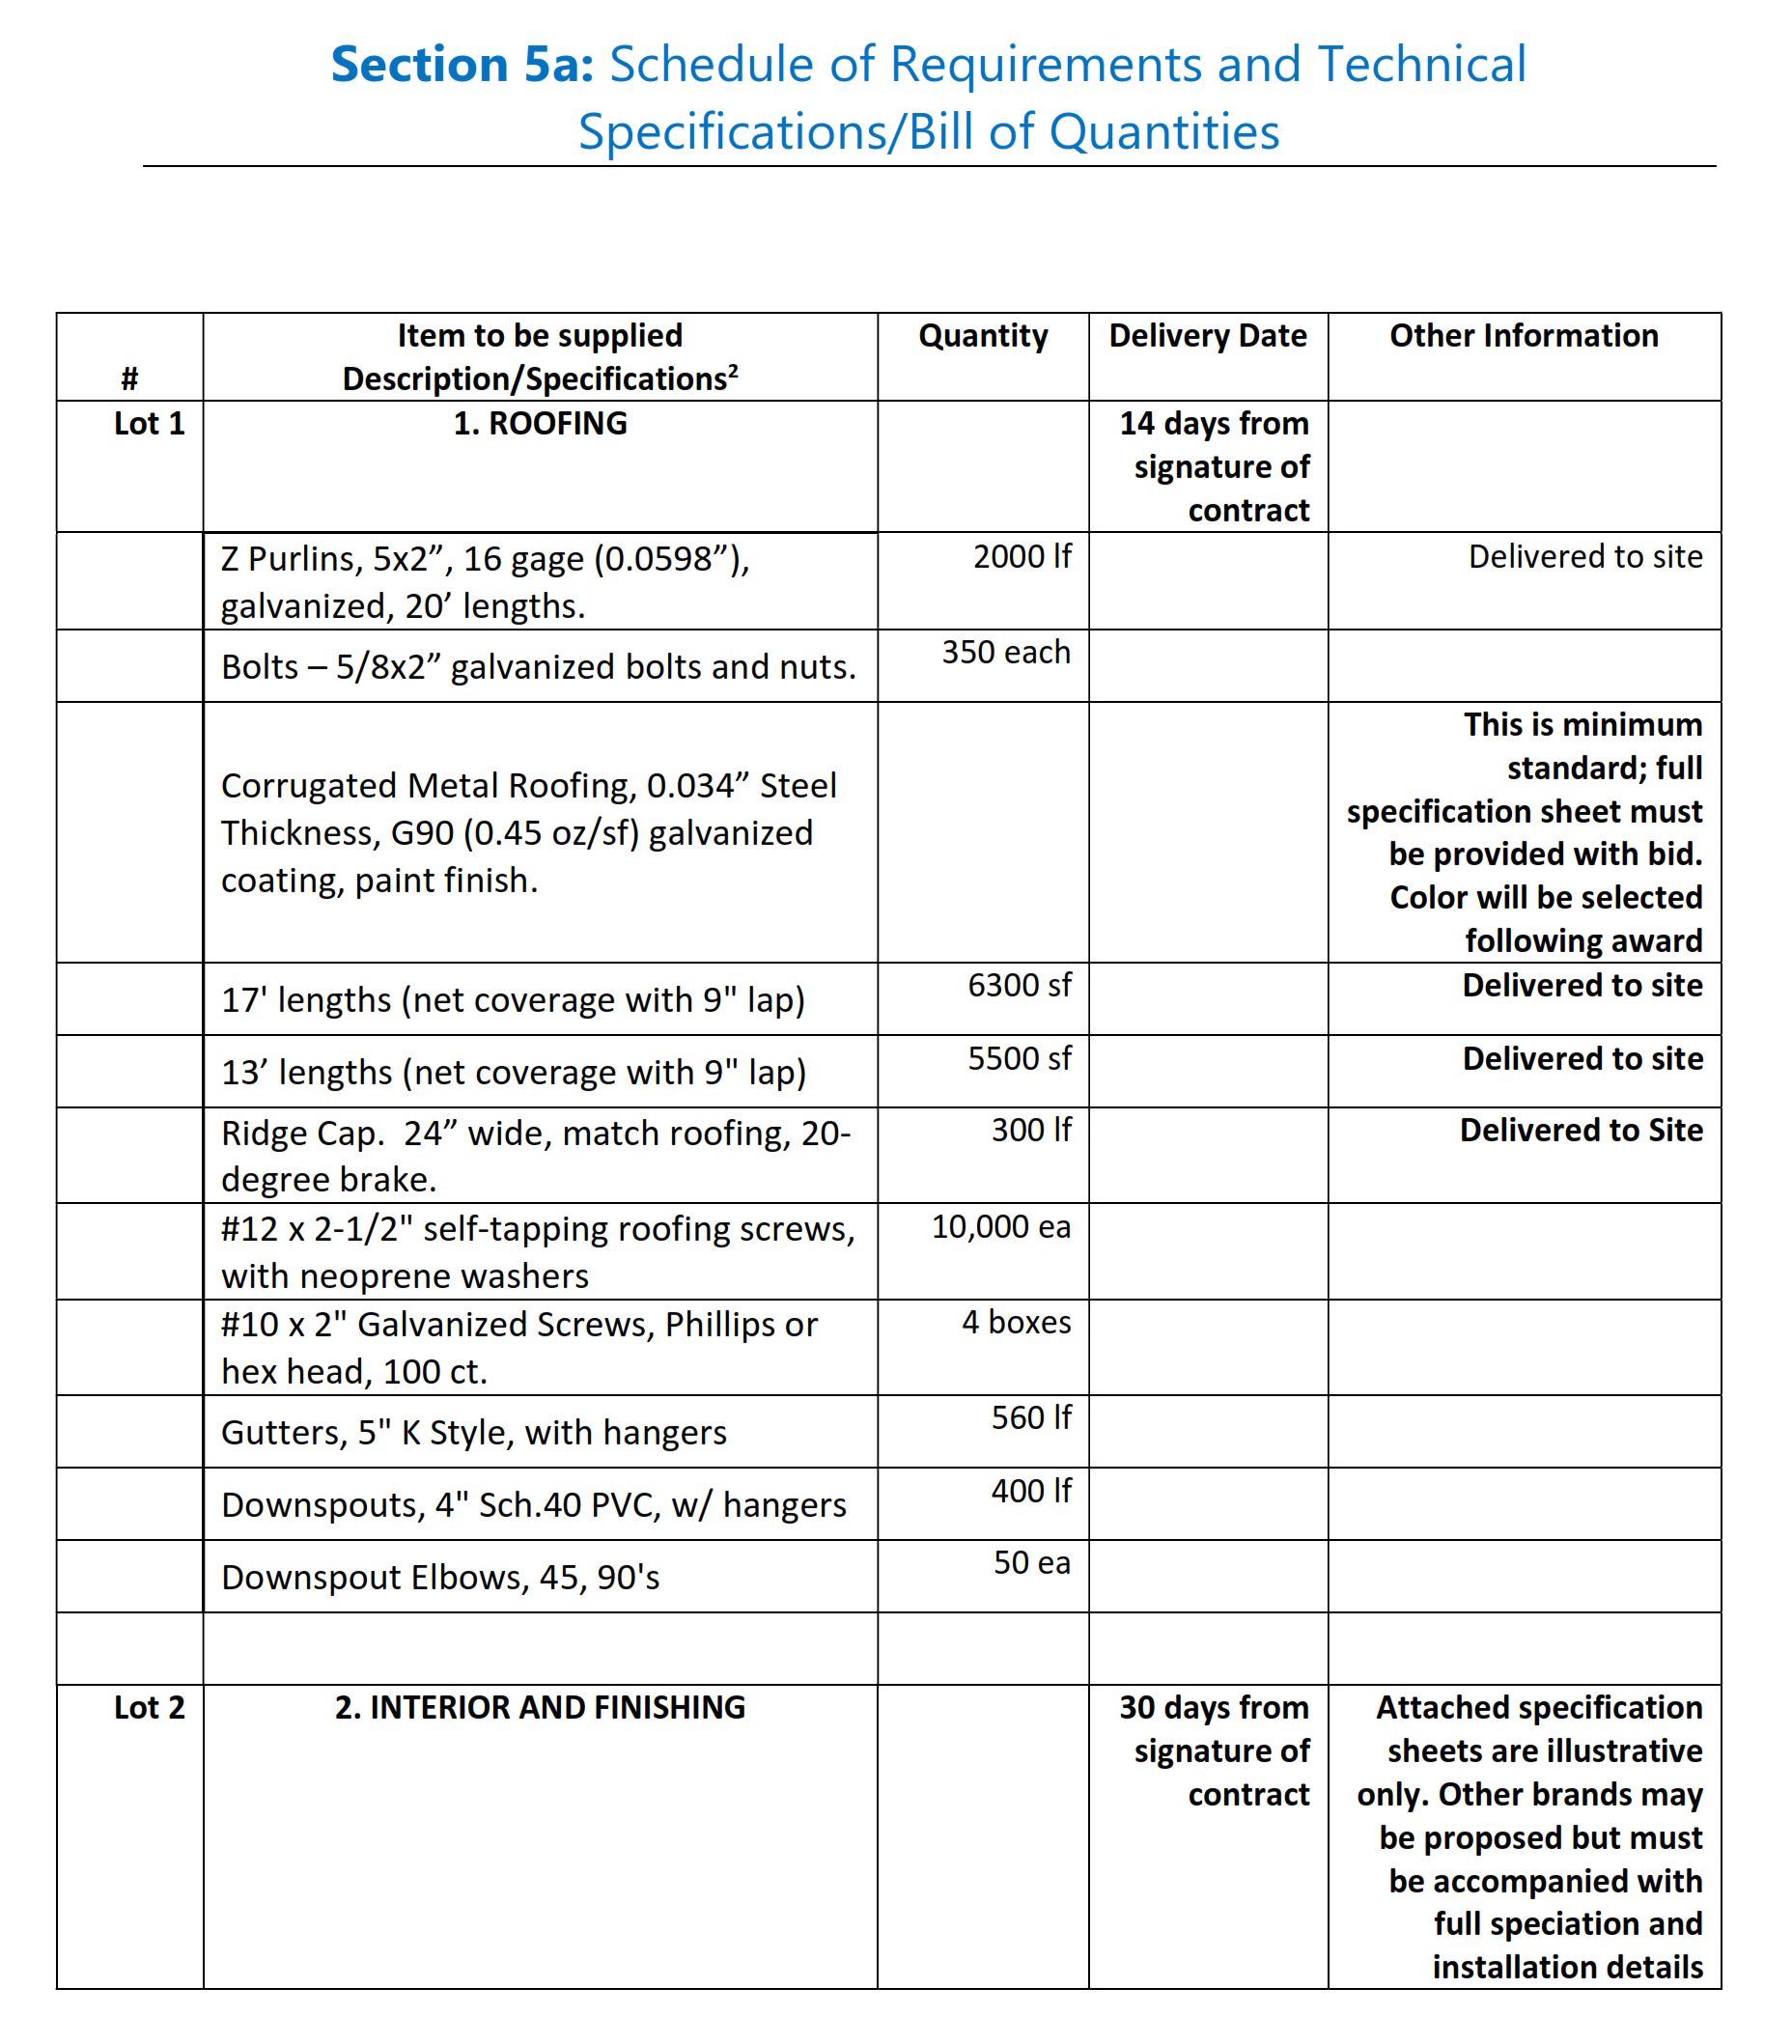

Specifications for Galvanized Roof Sheets

Attribute Minimum Value
Minimum Thickness (Before coating is applied) .034inches or .86 mm or 22 Gauge (uncoated)
Minimum Thickness (After coating is applied-usual) .038 inches or .97 mm or 22 Gauge (coated)
Galvanized Zinc Coating Hot Dipped with 120 g/m^2 each side
Or .002 inch or .05 mm each side
Galvalume Zinc and Aluminum Alloy Coating 120 g/m^2 each side
Depth of Corrugation 11/16 inch or 18 mm (Tolerance +/- 1/16 inch
Or +/- 1.5 mm)
Pitch of Corrugation 3 inches or 76.2 mm (Tolerance +/- 1/16-inch Or

