SCOPE OF WORK
The UNDP, Nigeria invites Bids for installation of solar inverter system to the underlisted Schools in Borno State. The schools are:
Gur Primary School, Gur, Biu LGA (2 Blocks of Classrooms)
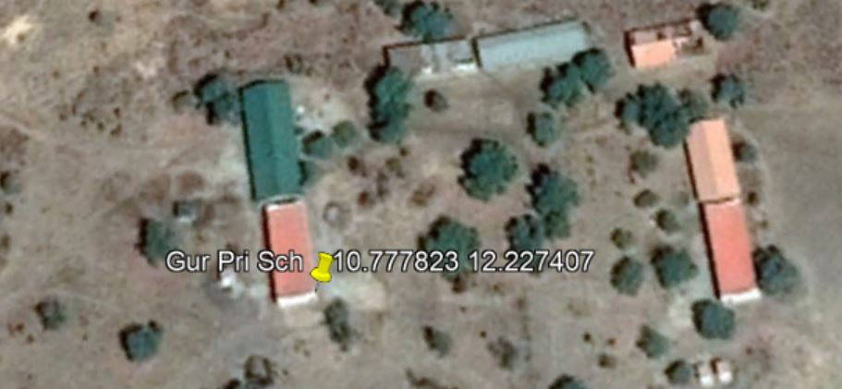
(Lat: 10.777823; Long: 12.227407)

The works consist of:

<Preliminary Works>
- Conduct testing of materials
- Pay police regulations and other charges
- Conduct site clearing, setting our and keep progress record and pictures
- Provide access road, site store, temporary fence and sheds, name boards (UNDP Signage) and power source
- Ensure safety and health facilities/regulations
- Provision of ventilation for installation room, storage for rubbish and other requisite facilities
- Ensure security of both human, equipment and material on site.

Installation of Solar Inverter System>

- Supply and install 5KVA/48V sine-wave inverter system
- Provide and install 200AH/12V deep cycle battery
- Provide and install 200W/24V Polycrystalline solar panels
- Provide and install 60A/48V charge controller
- Provide cabling for all components according to technical specification
- Provide for interconnection of ALL UNDP Blocks within the school Premise
- Provide for testing, commissioning and other civil works

<Terms of Payment>
UNDP will pay the contractor/vendor 20% upon signing of contract and submission of required documents (performance bold, warranty, insurance etc), and 80% upon completion of project.

<Warranty Requirement>
UNDP requires the contractor to give a written warranty of 6months on all supplied and installed solar and inverter materials

