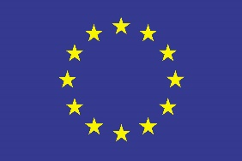 | EUROPEAN UNION  EUROPEAN UNION OFFICE IN KOSOVO /  EUROPEAN UNION SPECIAL REPRESENTATIVE
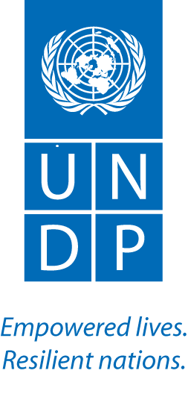

Inter-community Dialogue through Inclusive Cultural Heritage Preservation

Call for Proposals for low value Grants

The UNDP implemented project “Inter-community Dialogue through Inclusive Cultural Heritage Preservation”, financed by the European Union’s Instrument contributing to Stability and Peace (IcSP), is soliciting a call for proposal for the selection of NGOs/CSO’s to implement practical skills development training for women and young people in Kosovo.

Q1: If NGO/CSO applied in previous call for proposal at UNDP can they apply on other calls?

A1: please note that all NGO’s/CSOs are eligible to apply to UNDP Call for Proposals no matter if they have applied to pervious calls/advertisement.

