Item No | Deception of requirement | Please insert (Comply/Not Comply
1 | Compactor 750 kg/m2:  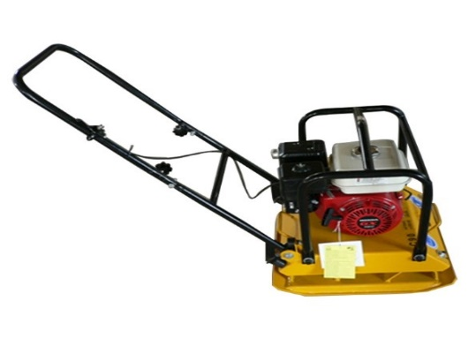
2 | Paint roller brush, minimum roller length (5cm) and minimum arm length (40cm)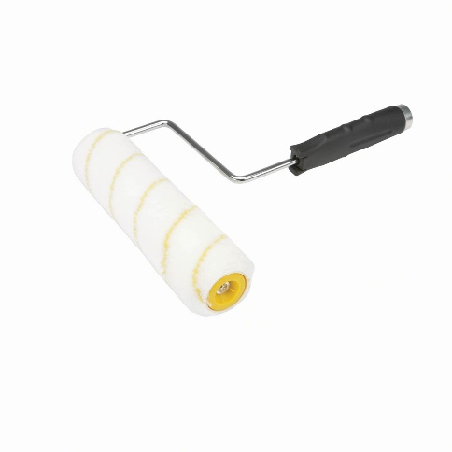
3 | Steel brush, minimum height of wires (4cm) and minimum arm length (20cm) with extension pole.  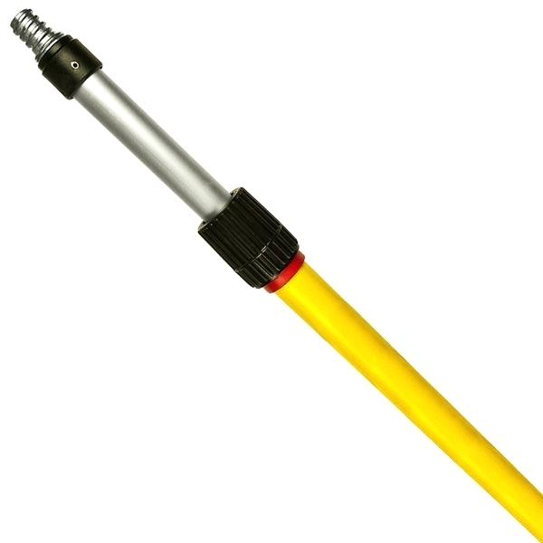  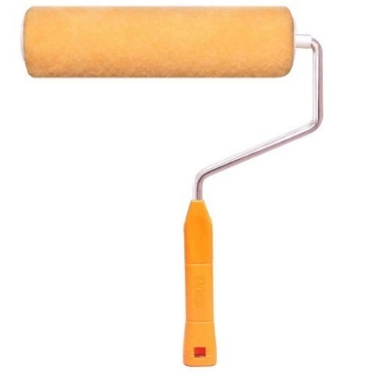
4 | Stainless steel Scraper blade (putty scraper): Material: Wood, Stainless Steel, Total Size: 22 x 10 x 1.6cm (L*W*T), Blade Width: 10cm  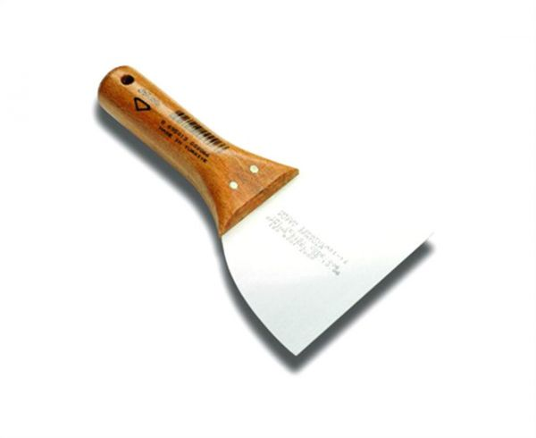
5 | Dodonaea Trees  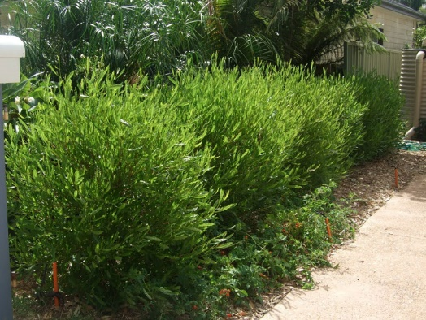
6 | Cupressus Trees:  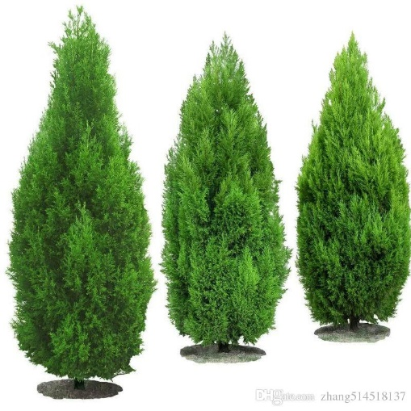
7 | Steel brush, minimum height of wires (4cm) and minimum arm length (20cm)  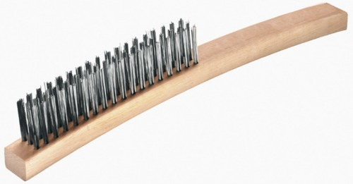
8 | Shovel:  