Annex 2
POLISH CHALLENGE FUND
Engaging Polish Companies and Research Institutes in Development Cooperation

Application Form
Ref Nr: UNDPIRH-202003-CFP03-POLISH CHALLENGE FUND

The Application should be sent to procurement.irh@undp.org by Thursday 16 April, 2020, Central European Time (CET), 4:00 pm.
An Application will be accepted only if it:
- is submitted on the correct form, completed in full and dated;
- is signed by the person authorized to enter into legally binding commitments on behalf of the applicant organization;
- presents a budget in conformity with the call for proposal;
- meets the submission arrangements set out in the call for proposal;
- is submitted by the deadline.

PROJECT
Project Title:
Date of Implementation: May/2020 – december/2020 [No More Than 7,5 Months, not later than December 2020]

Please Select Country of Implementation:
☐ UKRAINE
☐ Republic of BELARUS

Requested Funding From UNDP: [Between US $20,000 And US $40,000]

applicant – CONTACT DETAILS
Applicant´s Name:
Legal Registration Number, Country and Year of Registration:
Type of Entity:
Postal Address:
Telephone:
Websites:

Name of Contact Person:
E-mail:
Telephone:

The Applicant is kindly asked to inform the ‘Polish Challenge Fund – Engaging Polish Companies and Research Institutes in Development Cooperation’ about any contact details change during the implementation of the Project via procurement.irh@undp.org.

EXECUTIVE SUMMARY OF THE PROJECT
Please summarize a Project intervention, proposed innovative solution and the its expected results in targeted county.

Context, Problem analysis and beneficiaries
Please briefly elaborate on the current situation and local demands for a proposed solution; identify the project beneficiaries – the target group(s); describe the proposed innovative solution and its relevance for the local conditions.

What is a degree of innovation and/or level of novelty of the proposed solution? Is the proposed solution new to the global industry and/or to the local market? Does the proposed solution bring a new idea, approach, product or service to the sector and/or target group? Please state a potential for scale-up and replication.

Please mark SDGs relevant to the proposed solution:

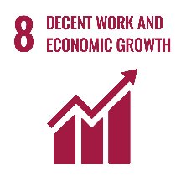
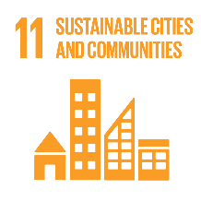
☐ 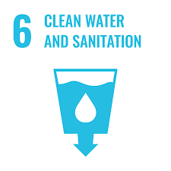 ☐ 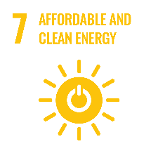 ☐ ☐
☐ ☐ ☐
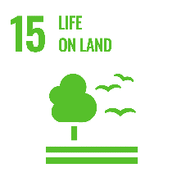

ESTIMATED Results
Please describe the estimated overall development impact and intervention logic of the proposed innovative solution including potential intervention scale-up and replication.

Activities
Please describe in detail the planned activities and timeline of proposed solution.

Budget
Applications must include a detailed estimated Budget Breakdown in balance using the EXCEL SHEET (Annex 3 to the ToR), in which the estimated costs are identified. These costs shall be given in USD. The estimated budget shall also be summarized below:

Requested funding from UNDP:
Co-funding from Applicant´s Side:
Total Project cost:
[LIST DELIVERABLES/MILESTONES] | [INDICATE DELIVERY DATES]

The Applicants provide co-funding of at least 20% of the total cost of the Project. Co-funding can be in-kind. Co-funding above the minimum threshold is preferred and will be taken into account during evaluation.
Please describe value for money and cost effectiveness (the extent to which the proposed solution is expected to achieve its results at lower cost compared with alternatives).

Sustainability
Please provide information on the sustainability of the proposed actions. The following aspects of sustainability should be considered:

- Financial Sustainability (How will the activities be financed after the end of the Project?);
- Environmental Sustainability (Will the proposed solution contribute to the quality of environment on a long-term basis?);
- Social Sustainability (How the proposed solution promotes well-being of people and understanding of their needs?).

local partner(s)
Local partner´s NAME:
Legal registration number, country and year of registration:
Type of Entity:
Postal Address:
Telephone:
Websites:
Name of Contact Person:
E-mail:
Telephone:

Project management
The Applicant should describe how the project will be managed, including the role of partners. The Applicant should provide a description of its relevant competences and previous experience as well as those of the key staff who will be involved in the project implementation. Please, do not forget to attach the CVs of the key staff as a proof of the capacity to implement Project effectively.

PREVIOUS EXPERIENCE OF SIMILAR PROJECTS
Please present previous experience within the area of expertise.

RISK MANAGEMENT
Please list the potential risks and your mitigation strategy.

Attachments to the application:
- CVs of Experts and Background of the Entity
- Budget in the Breakdown Form (Excel Sheet)
- Extract from Public Registry, i.e. Commercial Register [Rejestr handlowy] or other declaration of the legal entity like the charter of the university etc.
- The declaration of the partnership with local partner from Ukraine and Republic of Belarus in the form of the Letter or Contract
- Any other relevant documents supporting the Application like patent registration or additional contracts with partners from the Republic of Poland etc.

Acceptance of terms and conditions
By signing this form, the Applicant accepts the following terms and conditions:
The Applicant declares that he/she is bounded by the process and rules of the competition that have been highlighted in the Guidelines and shall accept the outcome of the process without any deviation or reservation.
The Applicant shall bear all costs related to the preparation and submission of the proposal regardless of whether his/her proposal is selected or not. He/she accepts that the CFCS nor the UNDP will in no case be held responsible or liable for those costs regardless of the outcome of the process.
The Applicant accepts that CFCS determines the level of responsiveness to a challenge fund window exclusively on the contents of the written Application forms.
The Applicant accepts that information relating to the examination, evaluation, and comparison of Applications, and recommendation of contract award shall not be disclosed to you or any other person not officially concerned with such processes.

Signature: …………………………………………………
Name: …………………………………………………
Date: …………………………………………………

Please indicate the milestones of the Project.

