Questions and answers
within the frame of RFQ/065/2022 - Supply and installation of a fruit jam production line and a fruit/vegetable drying line.

Lot 1 Fruit Jam Production line:
Question: What fruits the end user will process please list&?
- Apple, cherry, plum, apricot, quince, pear, persimmon (hurmo in Uzbek)

Question: Pulper only one size sieve requested 0,6 mm?
- Yes, 0.6mm

Question: Capping machine for exactly what type of twist-off caps?
- Metal caps

Question: We need photos and used size of caps by the end user as well as bottle s photo
See attached photos: 1) cap and bottle; 2) bottle
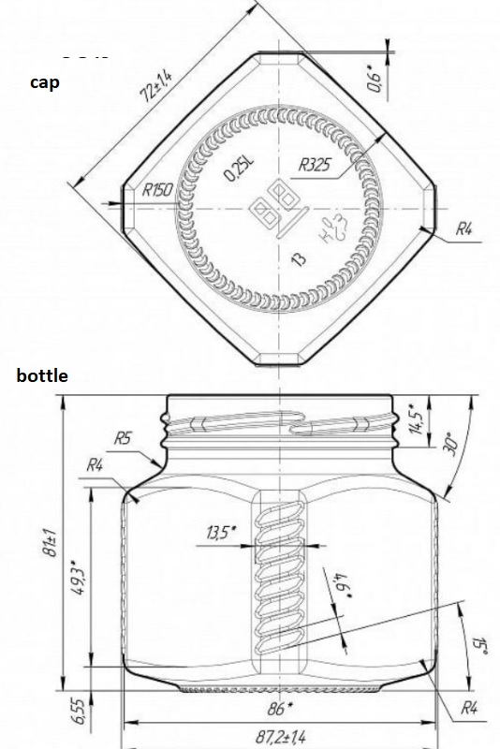
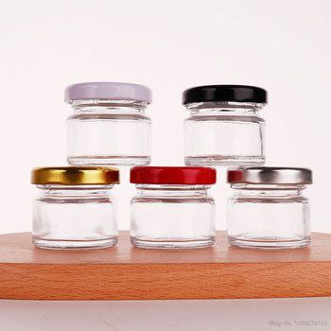

Lot 2. Fruit and Vegetable Drying Production Line

Question: - Item 1 Inspection table there is no mention of any power etc just table need?
- Stainless steel table

Question: Please list the dried products. We assume that it’s raisins, dried apricots.:
- Not only, apricot, raisin, black plum, apple, plum, pear, quince, peach and others
Question: The end user purpose is to wash, remove water from the surface of the product and pack already dried fruits ?:
- Yes

Question: Packing machine with scale if need air source, the end user supply air compressor or bidder?
- By bidder

Question: Packing range weight range please specify?
- From 100grams to 2000grams

Question: Please specify the Height of the carton for the metal detector.
- 18sm

