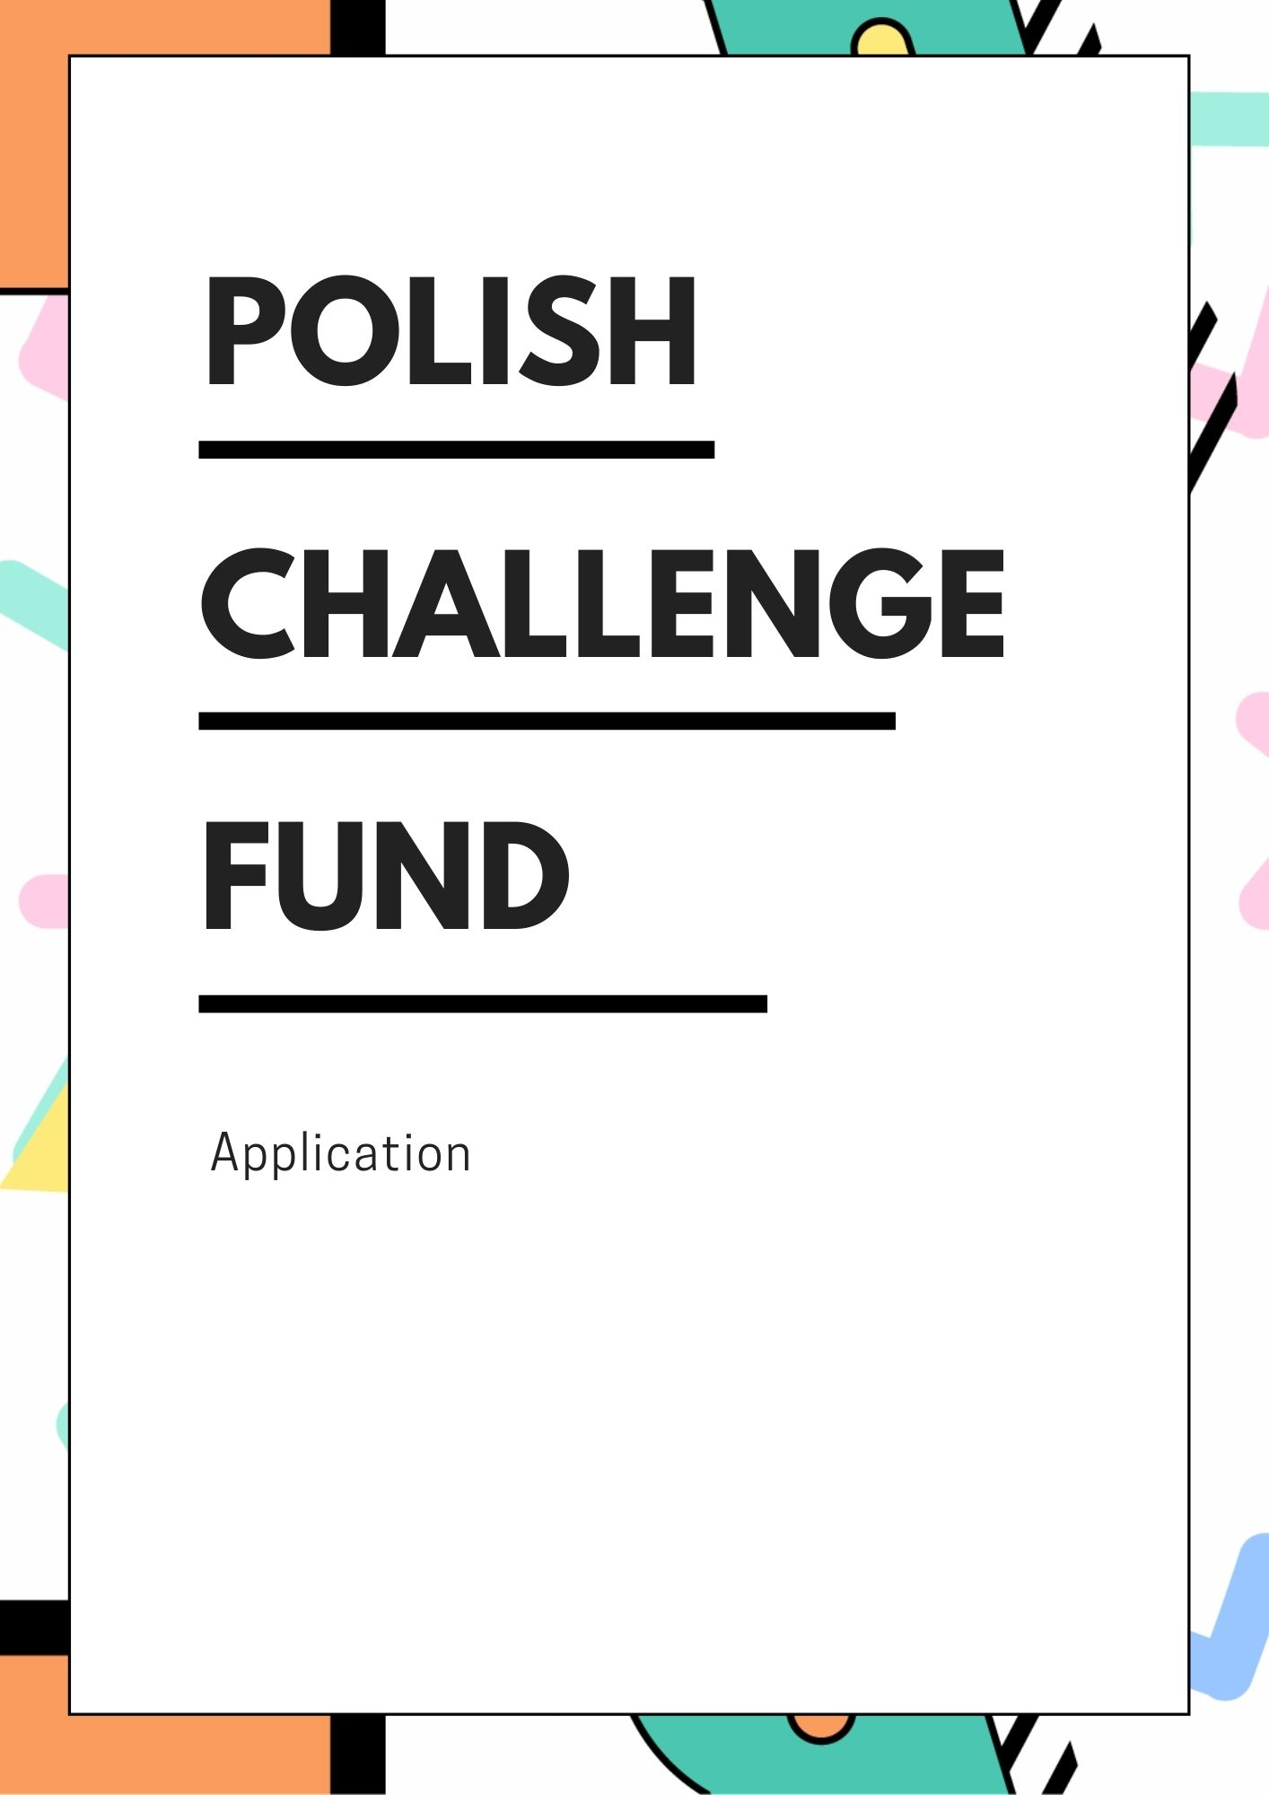

APPLICANT and local partner(s)

Applicant´s Name:
Postal Address:
Telephone:
Website(s):

Legal Registration Number, COUNTRY, and Year of Registration:
Type of Entity (e.g. private sector company, research institute, university):

Name of Contact Person:
E-mail:
Telephone:

Local partner´s NAME:
Postal Address:
Telephone:
Website(s):

Legal registration number, country, and year of registration:
Type of Entity (e.g. private sector company, research institute, university):

Name of Contact Person:
E-mail:
Telephone:

- Extract from the Public Registry, i.e. Commercial Register [Krajowy Rejestr Sądowy].

- Declaration of the partnership with local partner in Georgia, Republic of Moldova and Ukraine in form of Letter of Intent, Bilateral Contract or Memorandum of Understanding.

GENERAL INFORMATION

PROJECT TITLE:

Date of Implementation: month/year – month/year

Please Select Country of Implementation:
☐ GEORGIA
☐ Republic of Moldova
☐ UKRAINE

SUMMARY OF THE PROJECT:
Please state the problem/challenge your Application aims to address. Describe the solution and the expected outcome in the targeted county. Explain the benefits and advantages of the intervention.
(100 – 300 words)

project BUDGET

AWARD (US$): |  | (80%)
Co-FINANCING (US$): |  | (20%)
Total BUDGET (US$): |  | (100%)

Please provide detailed Budget Breakdown in a separate Excel Sheet in Annex 3.

value for money and cost effectiveness:
Please briefly describe the extent to which the proposed solution is expected to achieve its results at lower cost compared with alternatives.
(80 – 120 words)

innovativeness & scalability

Please Select degree of innovation:

☐ Proof of Concept¹
☐ TRANSITION TO SCALE²

1 – When the intellectual concept behind an innovation is field-tested to gain an early, ‘real-world’ assessment of its potential.
2 – When innovations that have demonstrated small-scale success develop their model and attract partners to help fill gaps in their capacity to scale.

innovativeness
What is new about your idea? What substitutes do people resort to because they do not exist in the targeted country or sector yet? Who are your competitors and how different are you? We want to understand what is new about your concept.
(100 – 150 words)

SCALE-UP & REPLICATION
What is the potential of the idea for growth and expansion (in terms of people served, revenues generated, or other targets)? What is the potential of the idea for transition (to a different location, or sector)? We want to understand the potential for scale-up and replication of your concept.
(80 – 120 words)

impact & scope of the project

Please Select development sector:
☐ Sustainable Management of Natural Resources
☐ Economic Transformation and Development
☐ Good Governance and Rule of Law, incl. SMART CITIES
☐ Agriculture and Rural Development
☐ Social and Health Sector
☐ WATER AND SANITATION (WASH)

Please Select development CHALLENGE:
☐ GREEN TECHNOLOGIES & SMART SOLUTIONS
Introducing or improving the current state of green technologies and other smart solutions, which have positive impact on local communities and industries, in the field of energy efficiency, waste management, water management, smart water solutions, air pollution or sustainable agriculture.
☐ INFORMATION AND COMMUNICATION TECHNOLOGIES (ict)
Introducing or improving the current state of Information and Communication Technologies (ICT) and/or open data use for public services or local governance.
☐ ANTI COVID-19 SOLUTIONS
Introducing or improving the current state of digital and emerging solutions/technologies to address development issues resulting from the global health crisis caused by the COVID-19 pandemic, for public services or local governance.
☐ SMART CITIES
Introducing or improving the current state of smart cities and urban intelligence to address growing urbanization challenges for public services or local governance.

Please Select the Sustainable Development Goals relevant to your idea:³

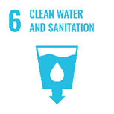  ☐ | 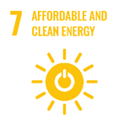  ☐ | 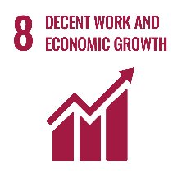  ☐ | 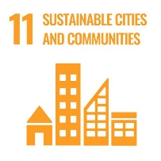  ☐

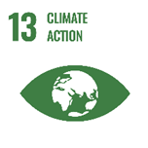  ☐ | 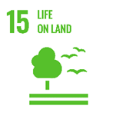  ☐ | 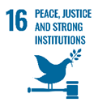  ☐

3 – When aligning to the Sustainable Development Goals, please make sure to understand their underlying targets. To learn more about the SDGs, you can visit the website: 17 Sustainable Development Goals (SDGs).

context and Problem analysis:
What specific problem are you trying to solve? How do you know if people need what you are proposing? Please provide evidence of the size and addressness of the problem, e.g. quotes and data from research, policy papers and strategies, etc.
(80 – 120 words)

stakeholders & BENEFICIARIES:
Who is the most affected by the problem? Who will benefit directly – and who indirectly from your solution? Please include facts and figures – and provide sex-disaggregated and gender-sensitive data.
(40 – 80 words)

impact & results:
What will the Project change and to what extent? We want to understand the effect that your intervention and its results will have on people, practices, and systems.
(40 – 80 words)

activities & timeline:
Please describe in detail planned activities and timeline. Please include numbers and brief specification (e.g. number of participants, frequency of tasks and steps, used tools and resources etc.).
(100 – 350 words)
Name of Activity | Description of activity | date of delivery (DAY/month/year)
1.
2.
3.
4.

visibility:
How do you plan to highlight the Project results with concrete and visible achievements that emphasize the impact in the beneficiaries' life?
(40 – 120 words)

sustainability and risk assesment

Financial, Environmental & Social Sustainability:
How will the activities be financed after the end of the project? Will the proposed solution contribute to the quality of environment on a long-term basis? How the proposed solution promotes well-being of people and understanding of their needs? How is your Project gender sensitive?
(100 – 180 words)

RISK ASSESMENT:
What are possible external risks that can affect Project implementation and its impact? Identify high-level external risks and strategies to mitigate them.
(30 – 80 words)
RISK | Mitigation Strategy
1.
2.
3.

project management
PORTFOLIO:
What is unique about your institution? Have you won any awards or certifications? Explain, why your institution is uniquely qualified to solve the problem.
(50 – 120 words)

roles and responsibilities:
How the Project will be managed and coordinated? What are the relevant competences and roles of the team members?
(50 – 120 words)

experience of team members:
Please describe the experience and background of individual team members, incl. Applicant and local partner(s).
(80 – 380 words)

Expert 1
- Education
- Working Experience
- Languages
- Other Skills

Expert 2
- Education
- Working Experience
- Languages
- Other Skills

Expert 3
- Education
- Working Experience
- Languages
- Other Skills

Expert 4
- Education
- Working Experience
- Languages
- Other Skills

Expert 5
- Education
- Working Experience
- Languages
- Other Skills

Maximum of experts per team is 5 people in total, their background is diverse and brings disruptive ideas and experience, e.g., experience in working with different technologies, familiarity with the key issues confronting a certain region, etc.
Only salaries and fees of experts identified in the application form are eligible for financing. Change of experts can be done only on exceptional basis, i.e. pregnancy/maternity leave, serious illness, etc.
Attachment of CVs is not allowed.

ADDITIONAL information

What is the gender/Sex of the project lead?
Applicant | Local Partner

What is the category of your enterprise
micro enterprise  <10 employees | ☐
small enterprise  10-49 employees | ☐
medium-sized enterprise  50-249 employees | ☐
Large enterprise  >250 employees | ☐

How did you hear about the POLISH challenge fund?
☐ E-mail
☐ Polish Aid website
☐ Social media
☐ Word of mouth
☐ Other ………………………

did YOUR ORGANIZATION APPLy TO THE POLISH challenge fund previously?
☐ Yes
☐ No

did YOUR ORGANIZATION APPLy TO other calls or tenders?
Ministry of Foreign Affairs of Poland (Polish Aid) | ☐ Yes ☐ No
UNDP or other UN Agencies (UNICEF, WHO, etc.) | ☐ Yes ☐ No
European Union (EU) | ☐ Yes ☐ No
Other ……………………… | ☐ Yes ☐ No

Attachments to the application
☐ Extract from Public Registry, i.e. Commercial Register [Krajowy Rejestr Sądowy];
☐ Declaration of the partnership with local partner in Georgia, Republic of Moldova and Ukraine; in the form of the Letter of Intent, Bilateral Contract, or Memorandum of Understanding;
☐ Budget Breakdown Form (Excel Sheet in Annex 3).

Acceptance of terms and conditions
By signing this form, the Applicant accepts the following terms and conditions:
The Applicant declares that he/she is bounded by the process and rules of the competition that were specified in the Guidelines of the Polish Challenge Fund and shall accept the outcome of the process without any deviation or reservation.
The Applicant shall bear all costs related to the preparation and submission of the proposal regardless of whether his/her proposal is selected or not. He/she accepts that the UNDP will in no case be held responsible or liable for those costs regardless of the outcome of the process.
The Applicant accepts that the UNDP determines the level of responsiveness to the Call for Proposals of the Polish Challenge Fund exclusively on the contents of the written, submitted, and signed Application Forms.
The Applicant accepts that information relating to the examination and evaluation of the Applications, and selection of Awardees and signature of Award Agreement shall not be disclosed to any person not officially concerned with such processes.
The Applicant agrees to be bound by his/her proposals for 180 business days after the deadline for submission or until he/she has been notified of non-award.

Signature: …………………………………………………
Name: …………………………………………………
Date: …………………………………………………

