ANNEX 1: SCHEDULE OF REQUIREMENTS/ SCOPE OF WORK
Rehabilitation of Ubari primary school

- PROJECT BACKGROUND

  - Project description

[the project consists on construction of new toilet, sunshade area, paving of the school yard for students its located Ubari city]

- LOCATION

[the Ubari school is located on the way before Ubari about 15 km, the GPS coordinate of school is 26 ° 35´ 42 " N, 12 ° 46´ 47 " E]

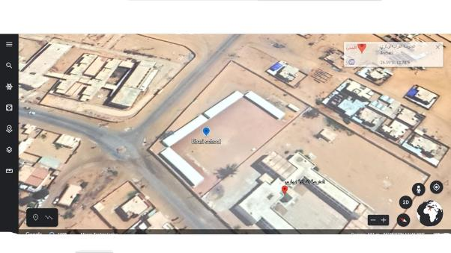

- BUILDING/CONSTRUCTION DESCRIPTION

[the facility is prefabricated classrooms consist of 20 classrooms, the total area of the school is 9,548 m2 almost is free we construction of paving of the school yard, sunshade area, new toilet]

- WORKS ON BRIEF
Site works and Earth works
Concrete works
Block works
Plastering
Finishing works
Tiling and Marble
Doors and windows
Plumbing and Sanitary works
Electrical works
Student Lining-Up Area Works
Soccer Field Works

- DURATION OF THE PROJECT

90 Calendar days.

