REQUEST FOR QUOTATION (RFQ)

RFQ Reference: RFQ-052-PHL-2021: Supply and Delivery of Agrifarm Implements | Date: 02 June 2021

SECTION 1: REQUEST FOR QUOTATION (RFQ)

UNDP kindly requests your quotation for the provision of goods, works and/or services as detailed in Annex 1 of this RFQ.
This Request for Quotation comprises the following documents:
Section 1: This request letter
Section 2: RFQ Instructions and Data
Annex 1: Schedule of Requirements
Annex 2: Quotation Submission Form
Annex 3: Technical and Financial Offer

When preparing your quotation, please be guided by the RFQ Instructions and Data. Please note that quotations must be submitted using Annex 2: Quotation Submission Form and Annex 3 Technical and Financial Offer, by the method and by the date and time indicated in Section 2. It is your responsibility to ensure that your quotation is submitted on or before the deadline. Quotations received after the submission deadline, for whatever reason, will not be considered for evaluation.
Thank you and we look forward to receiving your quotations.
Issued by:

Signature:
Name: ALKA ANEJA
Title: Team Leader, Procurement Team
Date: June 14, 2021

SECTION 2: RFQ INSTRUCTIONS AND DATA
Introduction | Bidders shall adhere to all the requirements of this RFQ, including any amendments made in writing by UNDP. This RFQ is conducted in accordance with the UNDP Programme and Operations Policies and Procedures (POPP) on Contracts and Procurement  Any Bid submitted will be regarded as an offer by the Bidder and does not constitute or imply the acceptance of the Bid by UNDP. UNDP is under no obligation to award a contract to any Bidder as a result of this RFQ.  UNDP reserves the right to cancel the procurement process at any stage without any liability of any kind for UNDP, upon notice to the bidders or publication of cancellation notice on UNDP website.
Deadline for the Submission of Quotation | June 28, 2021, 5:00 PM, Timezone: Manila, Philippines  If any doubt exists as to the time zone in which the quotation should be submitted, refer to http://www.timeanddate.com/worldclock/.  For eTendering submission - as indicated in eTendering system. Note that system time zone is in EST/EDT (New York) time zone.
Method of Submission | Quotations must be submitted as follows:  ☒ Dedicated Email Address  Bid submission address: bids.ph@undp.org  - File Format: PDF  - File names must be maximum 60 characters long and must not contain any letter or special character other than from Latin alphabet/keyboard.  - All files must be free of viruses and not corrupted.  - Max. File Size per transmission: 10MB  - Mandatory subject of email: RFQ-052-PHL-2021: Supply and Delivery of Agri farm Implements  - It is recommended that the entire Quotation be consolidated into as few attachments as possible.  - The bidder should receive an email acknowledging email receipt.
Cost of preparation of quotation | UNDP shall not be responsible for any costs associated with a Supplier’s preparation and submission of a quotation, regardless of the outcome or the manner of conducting the selection process.
Supplier Code of Conduct, Fraud, Corruption, | All prospective suppliers must read the United Nations Supplier Code of Conduct and acknowledge that it provides the minimum standards expected of suppliers to the UN. The Code of Conduct, which includes principles on labour, human rights, environment and ethical conduct may be found at: https://www.un.org/Depts/ptd/about-us/un-supplier-code-conduct  Moreover, UNDP strictly enforces a policy of zero tolerance on proscribed practices, including fraud, corruption, collusion, unethical or unprofessional practices, and obstruction of UNDP vendors and requires all bidders/vendors to observe the highest standard of ethics during the procurement process and contract implementation. UNDP’s Anti-Fraud Policy can be found at http://www.undp.org/content/undp/en/home/operations/accountability/audit/office_of_audit_andinvestigation.html#anti
Gifts and Hospitality | Bidders/vendors shall not offer gifts or hospitality of any kind to UNDP staff members including recreational trips to sporting or cultural events, theme parks or offers of holidays, transportation, or invitations to extravagant lunches, dinners or similar. In pursuance of this policy, UNDP: (a) Shall reject a bid if it determines that the selected bidder has engaged in any corrupt or fraudulent practices in competing for the contract in question; (b) Shall declare a vendor ineligible, either indefinitely or for a stated period, to be awarded a contract if at any time it determines that the vendor has engaged in any corrupt or fraudulent practices in competing for, or in executing a UNDP contract.
Conflict of Interest | UNDP requires every prospective Supplier to avoid and prevent conflicts of interest, by disclosing to UNDP if you, or any of your affiliates or personnel, were involved in the preparation of the requirements, design, specifications, cost estimates, and other information used in this RFQ. Bidders shall strictly avoid conflicts with other assignments or their own interests, and act without consideration for future work. Bidders found to have a conflict of interest shall be disqualified.  Bidders must disclose in their Bid their knowledge of the following: a) If the owners, part-owners, officers, directors, controlling shareholders, of the bidding entity or key personnel who are family members of UNDP staff involved in the procurement functions and/or the Government of the country or any Implementing Partner receiving goods and/or services under this RFQ.  The eligibility of Bidders that are wholly or partly owned by the Government shall be subject to UNDP’s further evaluation and review of various factors such as being registered, operated and managed as an independent business entity, the extent of Government ownership/share, receipt of subsidies, mandate and access to information in relation to this RFQ, among others. Conditions that may lead to undue advantage against other Bidders may result in the eventual rejection of the Bid.
General Conditions of Contract | Any Purchase Order or contract that will be issued as a result of this RFQ shall be subject to the General Conditions of Contract  Select the applicable GTC:  ☒ General Terms and Conditions / Special Conditions for Contract.
Special Conditions of Contract | ☒ Cancellation of PO/Contract if the delivery/completion is delayed by [7 working Days] any adjustment in the delivery completion, the winning vendor shall submit a letter justification citing the reason/s for such adjustment/s.
Eligibility | A vendor who will be engaged by UNDP may not be suspended, debarred, or otherwise identified as ineligible by any UN Organization or the World Bank Group or any other international Organization. Vendors are therefore required to disclose to UNDP whether they are subject to any sanction or temporary suspension imposed by these organizations. Failure to do so may result in termination of any contract or PO subsequently issued to the vendor by UNDP.  It is the Bidder’s responsibility to ensure that its employees, joint venture members, sub-contractors, service providers, suppliers and/or their employees meet the eligibility requirements as established by UNDP.  Bidders must have the legal capacity to enter a binding contract with UNDP and to deliver in the country, or through an authorized representative
Currency of Quotation | Quotations shall be quoted in Philippine Peso (PHP)
Joint Venture, Consortium or Association | If the Bidder is a group of legal entities that will form or have formed a Joint Venture (JV), Consortium or Association for the Bid, they shall confirm in their Bid that : (i) they have designated one party to act as a lead entity, duly vested with authority to legally bind the members of the JV, Consortium or Association jointly and severally, which shall be evidenced by a duly notarized Agreement among the legal entities, and submitted with the Bid; and (ii) if they are awarded the contract, the contract shall be entered into, by and between UNDP and the designated lead entity, who shall be acting for and on behalf of all the member entities comprising the joint venture, Consortium or Association.  Refer to Clauses 19 – 24 under Solicitation policy for details on the applicable provisions on Joint Ventures, Consortium or Association.
Only one Bid | The Bidder (including the Lead Entity on behalf of the individual members of any Joint Venture, Consortium or Association) shall submit only one Bid, either in its own name or, if a joint venture, Consortium or Association, as the lead entity of such Joint Venture, Consortium or Association.  Bids submitted by two (2) or more Bidders shall all be rejected if they are found to have any of the following:  a) they have at least one controlling partner, director or shareholder in common; or b) any one of them receive or have received any direct or indirect subsidy from the other/s; or  b) they have the same legal representative for purposes of this RFQ; or  c) they have a relationship with each other, directly or through common third parties, that puts them in a position to have access to information about, or influence on the Bid of, another Bidder regarding this RFQ process;  d) they are subcontractors to each other’s Bid, or a subcontractor to one Bid also submits another Bid under its name as lead Bidder; or  e) some key personnel proposed to be in the team of one Bidder participates in more than one Bid received for this RFQ process. This condition relating to the personnel, does not apply to subcontractors being included in more than one Bid.
Duties and taxes | Article II, Section 7, of the Convention on the Privileges and Immunities provides, inter alia, that the United Nations, including UNDP as a subsidiary organ of the General Assembly of the United Nations, is exempt from all direct taxes, except charges for public utility services, and is exempt from customs restrictions, duties, and charges of a similar nature in respect of articles imported or exported for its official use. All quotations shall be submitted net of any direct taxes and any other taxes and duties, unless otherwise specified below:  All prices must:  ☒ be exclusive of VAT and other applicable indirect taxes
Language of quotation | International English  Including documentation including catalogues, instructions and operating manuals.
Documents to be submitted | Bidders shall include the following documents in their quotation:  ☒ Annex 2: Quotation Submission Form duly completed and signed  ☒ Annex 3: Technical and Financial Offer duly completed and signed and in  accordance with the Schedule of Requirements in Annex 1
Quotation validity period | Quotations shall remain valid for Ninety (90) days from the deadline for the Submission of Quotation.
Price variation | No price variation due to escalation, inflation, fluctuation in exchange rates, or any other market factors shall be accepted at any time during the validity of the quotation after the quotation has been received.
Partial Quotes | ☒ Permitted
Alternative Quotes | ☒ Not permitted
Payment Terms | ☒ 100% within 30 days after receipt of goods, works and/or services and submission of payment documentation.
Conditions for Release of  Payment | ☒ Written Acceptance of Goods, Services and Works, based on full compliance with RFQ requirements
Contact Person for correspondence, notifications and clarifications | E-mail address: procurement.ph@undp.org  Attention: Quotations shall not be submitted to this address but to the address for quotation submission above. Otherwise, offer shall be disqualified.  Any delay in UNDP’s response shall be not used as a reason for extending the deadline for submission, unless UNDP determines that such an extension is necessary and communicates a new deadline to the Proposers.
Clarifications | Requests for clarification from bidders will not be accepted any later than Three (3) days before the submission deadline. Responses to request for clarification will be communicated through procurement.ph@undp.org.
Evaluation method | ☒The Contract or Purchase Order will be awarded to the lowest price substantially compliant offer  ☒ Other: Evaluation and award will be on a per LOT basis
Evaluation criteria | ☒Full compliance with all requirements as specified in Annex 1  ☒Full acceptance of the General Conditions of Contract
Right not to accept any quotation | UNDP is not bound to accept any quotation, nor award a contract or Purchase Order
Right to vary requirement at time of award | At the time of award of Contract or Purchase Order, UNDP reserves the right to vary (increase or decrease) the quantity of services and/or goods, by up to a maximum twenty-five per cent (25% ) of the total offer, without any change in the unit price or other terms and conditions.
Type of Contract to be awarded | ☒ Purchase Order
Expected date for contract award. | 09 July 2021
Publication of Contract Award | UNDP will publish the contract awards valued at USD 100,000 and more on the websites of the CO and the corporate UNDP Web site.
Policies and procedures | This RFQ is conducted in accordance with UNDP Programme and Operations Policies and Procedures
UNGM registration | Any Contract resulting from this RFQ exercise will be subject to the supplier being registered at the appropriate level on the United Nations Global Marketplace (UNGM) website at www.ungm.org.  The Bidder may still submit a quotation even if not registered with the UNGM, however, if the Bidder is selected for Contract award, the Bidder must register on the UNGM prior to contract signature.

ANNEX 1: SCHEDULE OF REQUIREMENTS
Technical Specifications for Goods:
LOT 1 – Various Agriculture Machineries
Item No | Minimum technical requirements | Unit | Quantity
1 | CASSAVA GRATERS  Specifications:  220V 800kg/hr Potato Grinding Machine Cassava Grinder  This machine is suitable for processing sweet potato, cassava, potato, banana lotus root, taro and other root crops in the grinding operation, processed into powder. apply to mountain, food processing plants and Mid ordinary users. Can be equipped with the 220V 0.5KW motors can also be equipped with a diesel engine driven.  Place of Delivery: Brgy. Buguindan, Tipo-tipo, Basilan  TECHNICAL SPECIFICATIONS:  Specifications Power 0.5KW  Voltage 220V/50Hz  Efficiency ≥800kg/h  Speed 2800r/min Roller  Length 26cmRoller  Diameter 14cm  Dimension 40 X 38 X 78 cm  Sweet potato starch production process: - Cleaning: Clean sweet potato. - Grinding: Add into potato grinder, crushed the sweet potato into residue, improve starchy potato. - Rinse: With a big tub filled with water, to wash the residue until color into white, filtered sweet potato residue - Precipitate: Let containing potato starch water precipitation for a period of time, generally more than 12 hours - Drying: Sweet potato starch will settle down, gently pour water, take into the sun to dry. - Collect: Collect dried sweet potato starch  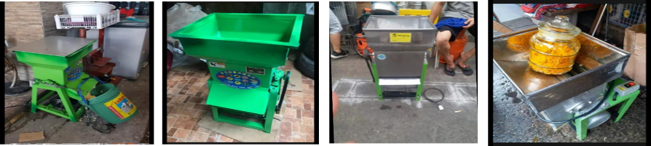 | Unit | 4
2 | 0.5 Ton Mini Trailer for Cultivator  Specifications:  Overall dimension (mm) : 2700*1050*1000  Carriage dimension (mm) : 1200*800*300  Seat dimension (mm) : 400*240*50  Matched tire : 4.00-12 or 4.50-12  Net weight (kg) : 105kg  Load capacity (kg) : 500kg  Max. load capacity (kg) : 1000kg  Brake type : Mechanical type  Angle of Inclination : > 45°  Height of loading surface : 490mm  Quantity/40HQ : 165sets  Description:  7C-0.5T trailer used for the small tiller or some other type machines as the transportation tools for the short distance.  The trailer can match with all kinds of 4-12HP tiller. It's fit for mountain areas, marsh. It mainly used for light-duty transportation. The main characteristic is: Simple and reasonable structure, it can Operates nimbly, dump with manual assistance.  The form of damping: Leaf spring  The form of traction: Tripod traction  Surface treatment: Derusting with large shot blast machine, to change welding stress.  Surface spray coating: Antirusting paint, finishing paint, stoving varnish.  The process of welding: Carbon dioxide jig welding.  The form of transportation: Parts and components, flexible packing with the box plate.  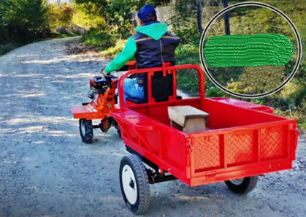 | Unit | 2
3 | Gasoline Powered Water Pump  Place of Delivery: Brgy. Muslim Area, Maluso, Basilan  Specifications:  Model DP40  Suction, discharge port diameter mm(in) 100 (4“)  HP 9  Cont.head(m) 31  Self-priming time (s/4m) 180  Cont.capacity(m3/hr) 96  Engine model 186F  Speed(rpm) 3000 / 3600  Type Single-cylinder, vertical,4-stroke air-cooled diesel engine  Displacement(cc) 406  Bore X stroke (mm) 86×70  Starting system Recoil or Electric  Fuel tank capacity(L) 5.5  Connecter of infall, Connecter of outfall yes  Filter yes  Seal ring yes  Hoop yes  fuel tank 13.5 Liters  Electric Start optional  Dimension(L×W×H) (mm) 645×475×605  Dry weight(kg) 69  Feature 1. Green and Environmental Protection.  2. It's an efficiently economy energy pump.  3. Portable and endurable.  4. Low malfunction and reliable &stable performance.  5. Easily maintained.  6. pre-sale, in-sale and after-sale service. after-sales service staff will reply your E-mail within 12 hours.  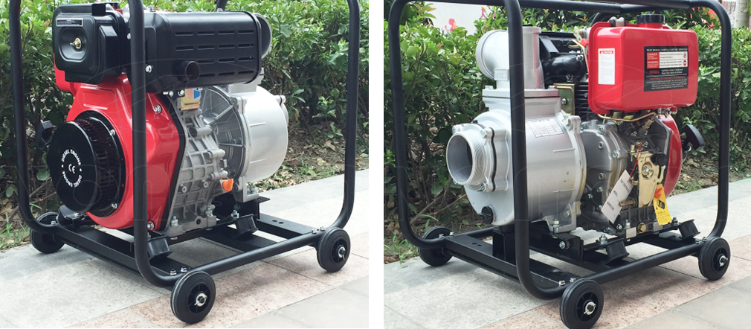 | Unit | 1
4 | 13 hp Horizontal Commercial boat Engine  Specifications:  Engine Type Air-cooled 4-stroke OHV  Bore x Stroke 88 X 64 mm  Displacement 389 cm3  Net Power Output* 11.7 HP (8.7 kW) @ 3,600 rpm  Net Torque 19.5 lb-ft (26.4 Nm) @ 2,500 rpm  PTO Shaft Rotation Counterclockwise (from PTO shaft side)  Compression Ratio 8.2:1  Lamp/Charge coil options 25W, 50W / 1A, 3A, 10A, 18A  Carburettor Butterfly Float Type  Ignition System Digital CDI with variable timing  Starting System Recoil/electric  Lubrication System Splash  Governor System Centrifugal Mass Type  Air cleaner Dual element  Oil Capacity 1.16 US qt (1.1 L)  Fuel Tank Capacity 6.4 U.S. qts (6.1 liters)  Fuel Unleaded 86 octane or higher  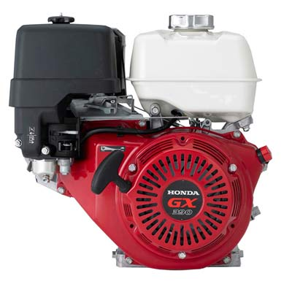 | Units | 10

LOT 2 – Various Gardening Tools and Consumables
Item No | Minimum technical requirements | Unit | Quantity
1 | Garden Shovel  Specification  Size: 32*9 cm  Converse : 1 inch = 2.54cm or 1cm = 0.393”  Material: Steel and Rubberize in handle | Pc | 24
2 | Grab-Hoe  Specification:  Overall Length: 14”  Head size: 60 x 130mm  Wooden handle | Pc | 24
3 | Garden Rake  Specification:  Handle Material: Plastic Handle  Head Material: Steel  Application: Farming Rake  Dimensions: Length 1300mm; +/- 2kg. | Pc | 24
4 | 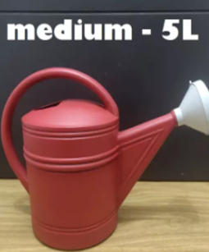  Watering Can Sprinkler  Specification:  Material: Durable Plastic  Capacity: Five (5) Liters | Pc | 24
5 | Knapsack Sprayer  Specifications:  Stainless Steel  16 Liters Capacity  Semi Auto Knapsack Sprayer  Agricultural Machinery Testing and Evaluation Center (AMTEC) Certified | Set | 6
6 | Packs of Vegetable Seeds  Description:  Preferred Brand: East-West  Ambassador F1 (cucumber) 200 seeds pack – x20  Mayumi F1 (Upo) 100g seeds can – x10  Suprema F1 (Squash) 120 seeds pack – x20  Diamante F1 (Tomato) 200 seeds pack – x20  Fortuner F1 (Eggplant) 300 seeds pack – x20  Red Hot F1 (chili) 150 seeds pack – x20  Primera F1 (Ampalaya) 45 seeds pack – x30  Mutya F1 (Patola) 45 seeds pack – x30  Sultan F1 (Bell Pepper) 130 seeds pack – x20  Smooth Green (Okra) 1000 seeds can – x10  Pavito (Pechay) 5000 seeds pack – x10  Curly Green (Lettuce) 25 grams can – x10 | Pack | 220

LOT 3 - Water Tank and Hose
Item No | Minimum technical requirements | Unit | Quantity
1 | 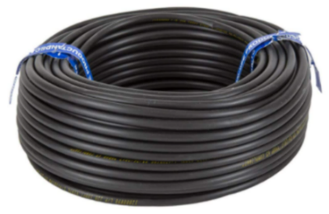  Water Hose  Specifications  Material: PVC Vinyl Tubing  Tube Size: 2”  Length: 100 meters | Roll | 1
2 | 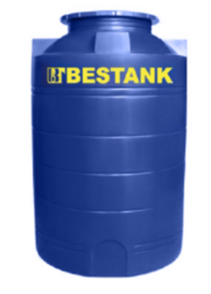  Water Storage Tank  Specifications  Material: Durable Plastic  Capacity: 264 Gallons / 1000 liters  Dimension: -+98cm Diameter * +-162cm Height | Pc | 1
3 | 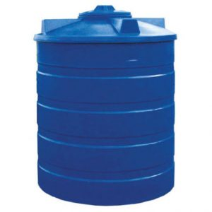  Water Storage Tank  Specification:  Material: Durable Plastic  Capacity 2,000 liters | Pc | 4

LOT 4 – Various miscellaneous agriculture items and consumables
Item No | Minimum technical requirements | Unit | Quantity
1 | 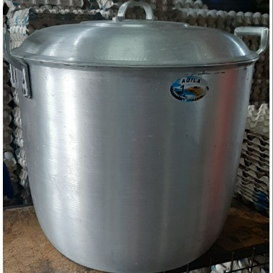  Cauldron (Kaldero)  Specifications:  Material: Casted Iron  Capacity: 20 Liters | Set | 2
2 | 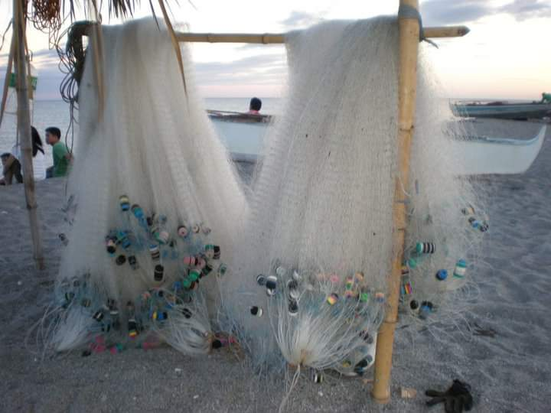  Nylon Fish nets  Description:  Length: 6 feet  Width: 100 meters | Set | 10
3 | Assorted Nylon Strings  Description:  Length: 100 meter  Color: Green with spot  3# - Diameter 0.285mm – Tension 7.9kg / 17.4lbs  4# - Diameter 0.320mm – Tension 10.0kg /22.0lbs  5# - Diameter 0.368mm – Tension 14.5kg / 32.0lbs  6# - Diameter 0.400mm – Tension 15.5kg / 34.2lbs  7# - Diameter 0.450mm – Tension 16.4kg / 36.2lbs  8# - Diameter 0.500mm – Tension 18.4kg / 40.6lbs  Package Includes: 1 roll fishing line  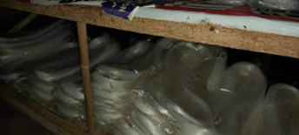 | Set | 1
4 | Dried Native Pandan Leaves  Description:  At least 2Kg per bundle  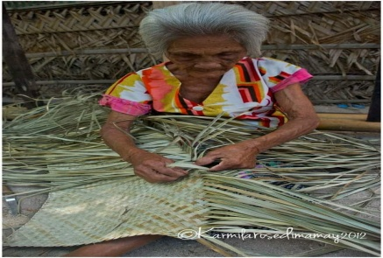 | Bundle | 24
5 | Round haddock hooks eyed tinned  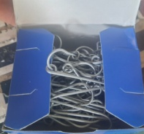  Description:  Point Brand # 16  100 pcs per box  Must be branded &  genuine | Box | 120
6 | 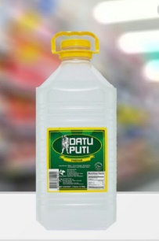  White Vinegar  Description:  1 gallon  Must be branded and Genuine | Gallon | 12
7 | 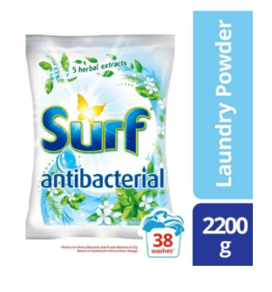  Detergent Powder Soap  Description  Weight Must be 2.2Kg per pack  Must be branded and Genuine | Pack | 12

Delivery Requirements
Delivery Requirements
Delivery date and time | Bidder shall deliver the goods in Thirty (30) calendar days after Contract signature.
Delivery Terms (INCOTERMS 2020) | DPU – Delivery at Place includes Unloading
Customs clearance  (must be linked to INCOTERM | ☒ Supplier/bidder
Exact Address(es) of Delivery Location(s) | LOT # Description Delivery Address  LOT 1 4 units Cassava Graters Armed Force of the Philippines- Western Mindanao Command (AFP-WestMinCom) Zamboanga City  2 units 0.5 Ton Mini Trailer for Cultivator  1 unit Gasoline Powered Water Pump  10 units 13 hp Horizontal Commercial boat Engine  Lot 2 24 pcs Garden Shovel Armed Force of the Philippines- Western Mindanao Command (AFP-WestMinCom) Zamboanga City  24 pcs Grab-Hoe  24 pcs Garden Rake  24 pcs Watering Sprinkler  6 set Knapsack Sprayer  220 pack of Vegetable Seeds  Lot 3 1 roll Water Hose Armed Force of the Philippines- Western Mindanao Command (AFP-WestMinCom) Zamboanga City  1 unit 1000L Water Tank  4 unit 2000L Water Tank  Lot 4 2 pcs Cauldron, 20L Armed Force of the Philippines- Western Mindanao Command (AFP-WestMinCom) Zamboanga City  10 set Nylon Fishnet  1 set Assorted Nylon String  24 bundle Dried Pandan leaves, 2kg per bundle  120 box Round haddock hook eyed tinned  12 gallon White Vinegar  12 pack Detergent powder, 2.2Kg per pack
Distribution of shipping documents  (if using freight forwarder) | ☒ Supplier/bidder
Packing Requirements | Must provide sturdy packaging for each set to avoid damages during transport to final destinations.  A wooden freight box with Styrofoam is recommended for LOT 1 Items
Training on Operations and Maintenance | NA
Warranty Period | Twelve (12) months or above for LOT 1 items
After-sales service and local service support requirements | FOR LOT 1 Items - Yes, within Philippines especially in southern Mindanao area
Preferred Mode of Transport | Air / Sea / Land (Whichever is applicable)

ANNEX 2: QUOTATION SUBMISSION FORM
Bidders are requested to complete this form, including the Company Profile and Bidder’s Declaration, sign it and return it as part of their quotation along with Annex 3: Technical and Financial Offer. The Bidder shall fill in this form in accordance with the instructions indicated. No alterations to its format shall be permitted and no substitutions shall be accepted.
Name of Bidder: | Click or tap here to enter text.
RFQ reference: | Click or tap here to enter text. | Date: Click or tap to enter a date.

Company Profile
Item Description |  | Detail
Legal name of bidder or Lead entity for JVs
Legal Address, City, Country
Website
Year of Registration
Legal structure
Are you a UNGM registered vendor? |  | ☐ Yes ☐ No If yes, insert UNGM Vendor Number
Quality Assurance Certification (e.g. ISO 9000 or Equivalent) (If yes, provide a Copy of the valid Certificate): |  | ☐ Yes ☐ No
Does your Company hold any accreditation such as ISO 14001 or ISO 14064 or equivalent related to the environment? (If yes, provide a Copy of the valid Certificate): |  | ☐ Yes ☐ No
Does your Company have a written Statement of its Environmental Policy? (If yes, provide a Copy) |  | ☐ Yes ☐ No
Does your organization demonstrate significant commitment to sustainability through some other means, for example internal company policy documents on women empowerment, renewable energies or membership of trade institutions promoting such issues (If yes, provide a Copy) |  | ☐ Yes ☐ No
Is your company a member of the UN Global Compact |  | ☐ Yes ☐ No
Bank Information |  | Bank Name:  Bank Address:  IBAN:  SWIFT/BIC:  Account Currency:  Bank Account Number:
Previous relevant experience: 3 contracts
Name of previous contracts | Client & Reference Contact Details including e-mail |  | Contract Value | Period of activity | Types of activities undertaken

Bidder’s Declaration
Yes | No
☒ | ☐ | Requirements and Terms and Conditions: I/We have read and fully understand the RFQ, including the RFQ Information and Data, Schedule of Requirements, the General Conditions of Contract, and any Special Conditions of Contract. I/we confirm that the Bidder agrees to be bound by them.
☐ | ☐ | I/We confirm that the Bidder has the necessary capacity, capability, and necessary licenses to fully meet or exceed the Requirements and will be available to deliver throughout the relevant Contract period.
☐ | ☐ | Ethics: In submitting this Quote I/we warrant that the bidder: has not entered into any improper, illegal, collusive or anti-competitive arrangements with any Competitor; has not directly or indirectly approached any representative of the Buyer (other than the Point of Contact) to lobby or solicit information in relation to the RFQ ;has not attempted to influence, or provide any form of personal inducement, reward or benefit to any representative of the Buyer.
☐ | ☐ | I/We confirm to undertake not to engage in proscribed practices, , or any other unethical practice, with the UN or any other party, and to conduct business in a manner that averts any financial, operational, reputational or other undue risk to the UN and we have read the United Nations Supplier Code of Conduct :https://www.un.org/Depts/ptd/about-us/un-supplier-code-conduct and acknowledge that it provides the minimum standards expected of suppliers to the UN.
☐ | ☐ | Conflict of interest: I/We warrant that the bidder has no actual, potential, or perceived Conflict of Interest in submitting this Quote or entering a Contract to deliver the Requirements. Where a Conflict of Interest arises during the RFQ process the bidder will report it immediately to the Procuring Organisation’s Point of Contact.
☐ | ☐ | Prohibitions, Sanctions: l/We hereby declare that our firm, its affiliates or subsidiaries or employees, including any JV/Consortium members or subcontractors or suppliers for any part of the contract is not under procurement prohibition by the United Nations, including but not limited to prohibitions derived from the Compendium of United Nations Security Council Sanctions Lists and have not been suspended, debarred, sanctioned or otherwise identified as ineligible by any UN Organization or the World Bank Group or any other international Organization.
☐ | ☐ | Bankruptcy: l/We have not declared bankruptcy, are not involved in bankruptcy or receivership proceedings, and there is no judgment or pending legal action against them that could impair their operations in the foreseeable future.
☐ | ☐ | Offer Validity Period: I/We confirm that this Quote, including the price, remains open for acceptance for the Offer Validity.
☐ | ☐ | I/We understand and recognize that you are not bound to accept any Quotation you receive, and we certify that the goods offered in our Quotation are new and unused.
☐ | ☐ | By signing this declaration, the signatory below represents, warrants and agrees that he/she has been authorised by the Organization/s to make this declaration on its/their behalf.

Signature:
Name: Click or tap here to enter text.
Title: Click or tap here to enter text.
Date: Click or tap to enter a date.

ANNEX 3: TECHNICAL AND FINANCIAL OFFER - GOODS
Bidders are requested to complete this form, sign it and return it as part of their bid along with Annex 2: Quotation Submission Form. The Bidder shall fill in this form in accordance with the instructions indicated. No alterations to its format shall be permitted and no substitutions shall be accepted.
Note: Evaluation and award will be on a per LOT basis.
LOT 1 – Various Agriculture Machineries

Name of Bidder:
RFQ reference: |  | Date:

Currency of the Quotation:
INCOTERMS:
Description | UOM | Qty | Unit price | Total price
CASSAVA Graters, 220V 800kg/hr Potato Grinding Machine Cassava Grinder | Unit | 4
0.5 Ton Mini Trailer for Cultivator, 7C-0.5T trailer used for the small tiller or some other type machines as the transportation tools for the short distance. | Unit | 2
Gasoline Powered Water Pump, DP40-186F | Unit | 1
13 hp Horizontal Commercial boat Engine, Air-cooled 4-stroke OHV, Digital CDI with variable timing | Unit | 10
Total Price
Transportation Price
Packaging Price
Insurance Price
Other Charges (specify)
Total Final and All-inclusive Price
Compliance with Requirements
 | You Responses
 | Yes, we will comply | No, we cannot comply | If you cannot comply, pls. indicate counter - offer
Minimum Technical Specifications | ☒ | ☐
Delivery Term (INCOTERMS) | ☐ | ☐
Delivery Lead Time | ☐ | ☐
Warranty and After-Sales Requirements | ☐ | ☐
Validity of Quotation | ☐ | ☐
Payment terms | ☐ | ☐
Other requirements [pls. specify] | ☐ | ☐

Other Information:
Estimated weight/volume/dimension of the Consignment:
Country/ies of Origin:
(if export licence required this must be submitted if awarded the contract)

I, the undersigned, certify that I am duly authorized to sign this quotation and bind the company below in event that the quotation is accepted.
Exact name and address of company  Company Name  Address:  Phone No.:  Email Address: | Authorized Signature:  Date:  Name:  Functional Title of Authorised  Signatory:  Email Address:

LOT 2 – Various Gardening Tools and Consumables

Name of Bidder:
RFQ reference: |  | Date:

Currency of the Quotation:
INCOTERMS:
Description | UOM | Qty | Unit price | Total price
Garden Shovel, Steel material with rubberize handle, 32 X 9 cm | Pc | 24
Grab – Hoe, overall length: 14inches, Head size: 60 x 113mm | Pc | 24
Garden Rake, Handle Material: Plastic Handle, Head Material: Steel, Application: Farming Rake, Dimensions: Length 1300mm; +/- 2kg. | Pc | 24
Watering Can Sprinkler, Material: Durable Plastic Capacity: Five (5) Liters | Pc | 24
Knapsack Sprayer, Stainless Steel, 16 Liters Capacity, Semi Auto Knapsack Sprayer, Agricultural Machinery Testing and Evaluation Center (AMTEC) Certified | Set | 6
Packs of Vegetable Seeds,  Preferred Brand: East-West  Ambassador F1 (cucumber) 200 seeds pack – x20  Mayumi F1 (Upo) 100g seeds can – x10  Suprema F1 (Squash) 120 seeds pack – x20  Diamante F1 (Tomato) 200 seeds pack – x20  Fortuner F1 (Eggplant) 300 seeds pack – x20  Red Hot F1 (chili) 150 seeds pack – x20  Primera F1 (Ampalaya) 45 seeds pack – x30  Mutya F1 (Patola) 45 seeds pack – x30  Sultan F1 (Bell Pepper) 130 seeds pack – x20  Smooth Green (Okra) 1000 seeds can – x10  Pavito (Pechay) 5000 seeds pack – x10  Curly Green (Lettuce) 25 grams can – x10 | Pack | 220
Total Price
Transportation Price
Packaging Price
Insurance Price
Other Charges (specify)
Total Final and All-inclusive Price
Compliance with Requirements
 | You Responses
 | Yes, we will comply | No, we cannot comply | If you cannot comply, pls. indicate counter - offer
Minimum Technical Specifications | ☒ | ☐
Delivery Term (INCOTERMS) | ☐ | ☐
Delivery Lead Time | ☐ | ☐
Warranty and After-Sales Requirements | ☐ | ☐
Validity of Quotation | ☐ | ☐
Payment terms | ☐ | ☐
Other requirements [pls. specify] | ☐ | ☐

Other Information:
Estimated weight/volume/dimension of the Consignment:
Country/ies of Origin:
(if export licence required this must be submitted if awarded the contract)

I, the undersigned, certify that I am duly authorized to sign this quotation and bind the company below in event that the quotation is accepted.
Exact name and address of company  Company Name  Address:  Phone No.:  Email Address: | Authorized Signature:  Date:  Name:  Functional Title of Authorised  Signatory:  Email Address:

LOT 3 - Water Tank and Hose
Name of Bidder:
RFQ reference: |  | Date:

Currency of the Quotation:
INCOTERMS:
Description | UOM | Qty | Unit price | Total price
Water Hose, 2”tube size, 100 meter Length, PVC Vinyl tubing | Roll | 1
Water Storage Tank, Durable pastic, 1000 liters | Unit | 1
Water Storage Tank, Material: Durable Plastic, Capacity 2,000 liters | Pc | 4
Total Price
Transportation Price
Packaging Price
Insurance Price
Other Charges (specify)
Total Final and All-inclusive Price
Compliance with Requirements
 | You Responses
 | Yes, we will comply | No, we cannot comply | If you cannot comply, pls. indicate counter - offer
Minimum Technical Specifications | ☒ | ☐
Delivery Term (INCOTERMS) | ☐ | ☐
Delivery Lead Time | ☐ | ☐
Warranty and After-Sales Requirements | ☐ | ☐
Validity of Quotation | ☐ | ☐
Payment terms | ☐ | ☐
Other requirements [pls. specify] | ☐ | ☐
Other Information:
Estimated weight/volume/dimension of the Consignment:
Country/ies of Origin:
(if export licence required this must be submitted if awarded the contract)

I, the undersigned, certify that I am duly authorized to sign this quotation and bind the company below in event that the quotation is accepted.
Exact name and address of company  Company Name  Address:  Phone No.:  Email Address: | Authorized Signature:  Date:  Name:  Functional Title of Authorised  Signatory:  Email Address:

LOT 4 – Various miscellaneous agriculture items and consumables
Name of Bidder:
RFQ reference: |  | Date:

Currency of the Quotation:
INCOTERMS:
Description | UOM | Qty | Unit price | Total price
Cauldron (Kaldero), Material: Casted Iron, Capacity: 20 Liters | Pc | 2
Nylon Fish nets, Length: 6 feet, Width: 100 meters | Set | 10
Assorted Nylon Strings  Length: 100 meter  Color: Green with spot  3# - Diameter 0.285mm – Tension 7.9kg / 17.4lbs  4# - Diameter 0.320mm – Tension 10.0kg /22.0lbs  5# - Diameter 0.368mm – Tension 14.5kg / 32.0lbs  6# - Diameter 0.400mm – Tension 15.5kg / 34.2lbs  7# - Diameter 0.450mm – Tension 16.4kg / 36.2lbs  8# - Diameter 0.500mm – Tension 18.4kg / 40.6lbs  Package Includes: 1 roll fishing line | Set | 1
Dried Native Pandan Leaves, At least 2Kg per bundle | Bundle | 24
Round haddock hooks eyed tinned, Point Brand # 16, 100 pcs per box, Must be branded & genuine | Box | 120
White Vinegar, 1 gallon, Must be branded and Genuine | Gallon | 12
Detergent Powder Soap, weight Must be 2.2Kg per pack  Must be branded and Genuine | Pack | 12
Total Price
Transportation Price
Packaging Price
Insurance Price
Other Charges (specify)
Total Final and All-inclusive Price
Compliance with Requirements
 | You Responses
 | Yes, we will comply | No, we cannot comply | If you cannot comply, pls. indicate counter - offer
Minimum Technical Specifications | ☒ | ☐
Delivery Term (INCOTERMS) | ☐ | ☐
Delivery Lead Time | ☐ | ☐
Warranty and After-Sales Requirements | ☐ | ☐
Validity of Quotation | ☐ | ☐
Payment terms | ☐ | ☐
Other requirements [pls. specify] | ☐ | ☐
Other Information:
Estimated weight/volume/dimension of the Consignment:
Country/ies of Origin:
(if export licence required this must be submitted if awarded the contract)

I, the undersigned, certify that I am duly authorized to sign this quotation and bind the company below in event that the quotation is accepted.
Exact name and address of company  Company Name  Address:  Phone No.:  Email Address: | Authorized Signature:  Date:  Name:  Functional Title of Authorised  Signatory:  Email Address:

