REQUEST FOR QUOTATION (RFQ)

RFQ Reference: RFQ/2022/16 | Date: 08 August 2022

SECTION 1: REQUEST FOR QUOTATION (RFQ)

UNDP kindly requests your quotation for the provision of “Construction of walls at Kura compost plant” as detailed in Annex 1 of this RFQ.
This Request for Quotation comprises the following documents:
Section 1: This request letter
Section 2: RFQ Instructions and Data
Annex 1: Schedule of Requirements (including technical specifications).
Annex 2: Quotation Submission Form
Annex 3: Technical and Financial Offer
When preparing your quotation, please be guided by the RFQ Instructions and Data. Please note that quotations must be submitted using Annex 2: Quotation Submission Form and Annex 3 Technical and Financial Offer, by the method and by the date and time indicated in Section 2. It is your responsibility to ensure that your quotation is submitted on or before the deadline. Quotations received after the submission deadline, for whatever reason, will not be considered for evaluation.
Thank you and we look forward to receiving your quotations.
Issued by:

Signature:
Name: Nahla Soussou
Title: Procurement and ICT Analyst
Date: 08 August 2022

SECTION 2: RFQ INSTRUCTIONS AND DATA
Introduction | Bidders shall adhere to all the requirements of this RFQ, including any amendments made in writing by UNDP. This RFQ is conducted in accordance with the UNDP Programme and Operations Policies and Procedures (POPP) on Contracts and Procurement  Any Bid submitted will be regarded as an offer by the Bidder and does not constitute or imply the acceptance of the Bid by UNDP. UNDP is under no obligation to award a contract to any Bidder as a result of this RFQ.  UNDP reserves the right to cancel the procurement process at any stage without any liability of any kind for UNDP, upon notice to the bidders or publication of cancellation notice on UNDP website.
Deadline for the Submission of Quotation | 15th August 2022 at 12:00 noon Amman time (GMT+3)  If any doubt exists as to the time zone in which the quotation should be submitted, refer to http://www.timeanddate.com/worldclock/.  For eTendering submission - as indicated in eTendering system. Note that system time zone is in EST/EDT (New York) time zone.
Method of Submission | Quotations must be submitted as follows:  ☐ E-tendering  ☒ Dedicated Email Address  ☐ Courier / Hand delivery  ☐ Other Click or tap here to enter text.  Bid submission address: offers.jo@undp.org  - File Format: PDF  - File names must be maximum 60 characters long and must not contain any letter or special character other than from Latin alphabet/keyboard.  - All files must be free of viruses and not corrupted.  - Max. File Size per transmission: 5 Mb – no more than 3 transmissions  - Mandatory subject of email: RFQ: Construction of walls at Kura compost plant  - Multiple emails must be clearly identified by indicating in the subject line “email no. X of Y”, and the final “email no. Y of Y.  - It is recommended that the entire Quotation be consolidated into as few attachments as possible.  - The bidder should receive an email acknowledging email receipt.  [For eTendering method, click the link https://etendering.partneragencies.org and insert Event ID information]  - Insert BU Code and Event ID number  Detailed instructions on how to submit, modify or cancel a bid in the eTendering system are provided in the eTendering system Bidder User Guide and Instructional videos available on this link: http://www.undp.org/content/undp/en/home/operations/procurement/business/procurement-notices/resources/
Cost of preparation of quotation | UNDP shall not be responsible for any costs associated with a Supplier’s preparation and submission of a quotation, regardless of the outcome or the manner of conducting the selection process.
Supplier Code of Conduct, Fraud, Corruption, | All prospective suppliers must read the United Nations Supplier Code of Conduct and acknowledge that it provides the minimum standards expected of suppliers to the UN. The Code of Conduct, which includes principles on labour, human rights, environment and ethical conduct may be found at: https://www.un.org/Depts/ptd/about-us/un-supplier-code-conduct  Moreover, UNDP strictly enforces a policy of zero tolerance on proscribed practices, including fraud, corruption, collusion, unethical or unprofessional practices, and obstruction of UNDP vendors and requires all bidders/vendors to observe the highest standard of ethics during the procurement process and contract implementation. UNDP’s Anti-Fraud Policy can be found at http://www.undp.org/content/undp/en/home/operations/accountability/audit/office_of_audit_andinvestigation.html#anti
Gifts and Hospitality | Bidders/vendors shall not offer gifts or hospitality of any kind to UNDP staff members including recreational trips to sporting or cultural events, theme parks or offers of holidays, transportation, or invitations to extravagant lunches, dinners or similar. In pursuance of this policy, UNDP: (a) Shall reject a bid if it determines that the selected bidder has engaged in any corrupt or fraudulent practices in competing for the contract in question; (b) Shall declare a vendor ineligible, either indefinitely or for a stated period, to be awarded a contract if at any time it determines that the vendor has engaged in any corrupt or fraudulent practices in competing for, or in executing a UNDP contract.
Conflict of Interest | UNDP requires every prospective Supplier to avoid and prevent conflicts of interest, by disclosing to UNDP if you, or any of your affiliates or personnel, were involved in the preparation of the requirements, design, specifications, cost estimates, and other information used in this RFQ. Bidders shall strictly avoid conflicts with other assignments or their own interests, and act without consideration for future work. Bidders found to have a conflict of interest shall be disqualified.  Bidders must disclose in their Bid their knowledge of the following: a) If the owners, part-owners, officers, directors, controlling shareholders, of the bidding entity or key personnel who are family members of UNDP staff involved in the procurement functions and/or the Government of the country or any Implementing Partner receiving goods and/or services under this RFQ.  The eligibility of Bidders that are wholly or partly owned by the Government shall be subject to UNDP’s further evaluation and review of various factors such as being registered, operated and managed as an independent business entity, the extent of Government ownership/share, receipt of subsidies, mandate and access to information in relation to this RFQ, among others. Conditions that may lead to undue advantage against other Bidders may result in the eventual rejection of the Bid.
General Conditions of Contract | Any Purchase Order or contract that will be issued as a result of this RFQ shall be subject to the General Conditions of Contract  Select the applicable GTC:  ☐ General Terms and Conditions / Special Conditions for Contract.  ☐ General Terms and Conditions for de minimis contracts (services only, less than $50,000)  ☒ General Terms and Conditions for Works  Applicable Terms and Conditions and other provisions are available at UNDP/How-we-buy
Special Conditions of Contract | ☒ Cancellation of PO/Contract if the delivery/completion is delayed by 30 days  ☒ Others Liquidated damages of 0.5% of contract total value per each calendar day of delay, up to cumulative 15% of contract value.
Eligibility | A vendor who will be engaged by UNDP may not be suspended, debarred, or otherwise identified as ineligible by any UN Organization or the World Bank Group or any other international Organization. Vendors are therefore required to disclose to UNDP whether they are subject to any sanction or temporary suspension imposed by these organizations. Failure to do so may result in termination of any contract or PO subsequently issued to the vendor by UNDP.  It is the Bidder’s responsibility to ensure that its employees, joint venture members, sub-contractors, service providers, suppliers and/or their employees meet the eligibility requirements as established by UNDP.  Bidders must have the legal capacity to enter a binding contract with UNDP and to deliver in the country, or through an authorized representative.  The bidder should have a valid business registration certificate in Jordan certificate of grading as a class “D” contractor from Jordan Construction Contractors Association in roads construction or buildings construction , and have at least a 30,000.00 USD annual turnover proven through proper third-party documentation for the past year, in addition to at least 2 similar project in value and nature (includes construction of walls) in the past 3 years. The bidder organization should be established in the year 2020 or before. If any of these requirements is not fulfilled, the bidder might be disqualified.
Currency of Quotation | Quotations shall be quoted in United States Dollars (USD) - USD Exchange rate is fixed at 0.708 JOD
Joint Venture, Consortium or Association | If the Bidder is a group of legal entities that will form or have formed a Joint Venture (JV), Consortium or Association for the Bid, they shall confirm in their Bid that : (i) they have designated one party to act as a lead entity, duly vested with authority to legally bind the members of the JV, Consortium or Association jointly and severally, which shall be evidenced by a duly notarized Agreement among the legal entities, and submitted with the Bid; and (ii) if they are awarded the contract, the contract shall be entered into, by and between UNDP and the designated lead entity, who shall be acting for and on behalf of all the member entities comprising the joint venture, Consortium or Association.  Refer to Clauses 19 – 24 under Solicitation policy for details on the applicable provisions on Joint Ventures, Consortium or Association.
Only one Bid | The Bidder (including the Lead Entity on behalf of the individual members of any Joint Venture, Consortium or Association) shall submit only one Bid, either in its own name or, if a joint venture, Consortium or Association, as the lead entity of such Joint Venture, Consortium or Association.  Bids submitted by two (2) or more Bidders shall all be rejected if they are found to have any of the following:  a) they have at least one controlling partner, director or shareholder in common; or b) any one of them receive or have received any direct or indirect subsidy from the other/s; or  b) they have the same legal representative for purposes of this RFQ; or  c) they have a relationship with each other, directly or through common third parties, that puts them in a position to have access to information about, or influence on the Bid of, another Bidder regarding this RFQ process;  d) they are subcontractors to each other’s Bid, or a subcontractor to one Bid also submits another Bid under its name as lead Bidder; or  e) some key personnel proposed to be in the team of one Bidder participates in more than one Bid received for this RFQ process. This condition relating to the personnel, does not apply to subcontractors being included in more than one Bid.
Duties and taxes | Article II, Section 7, of the Convention on the Privileges and Immunities provides, inter alia, that the United Nations, including UNDP as a subsidiary organ of the General Assembly of the United Nations, is exempt from all direct taxes, except charges for public utility services, and is exempt from customs restrictions, duties, and charges of a similar nature in respect of articles imported or exported for its official use. All quotations shall be submitted net of any direct taxes and any other taxes and duties, unless otherwise specified below:  All prices must:  ☐ be inclusive of VAT and other applicable indirect taxes  ☒ be exclusive of VAT and other applicable indirect taxes  For Sales TAX: The Benefiting entity is responsible to pay Sales TAX.  For Customs: The equipment shall be shipped in the name of the contractor/the name of the Ministry/UNDP. The Contractor should provide a bank guarantees or a certified cheque to the customs department to release any material. The Benefiting entity is responsible to pay custom fees.
Language of quotation | English (catalogues, official documents by government legal entities, and company profile are allowed to be in Arabic)  Including documentation including catalogues, instructions and operating manuals.
Documents to be submitted | Bidders shall include the following documents in their quotation:  ☒ Annex 2: Quotation Submission Form duly completed and signed  ☒ Annex 3: Technical and Financial Offer duly completed and signed and in  accordance with the Schedule of Requirements in Annex 1  ☒ Company Profile reflecting experience in the relevant fields.  ☒ Registration certificate, and financial standing documentation for the past year  ☒ List and value of projects performed for the last five (3) years plus client’s contact details who may be contacted for further information on those contracts.  ☒ Statement of satisfactory Performance (Certificates) from the top one (1) client in terms of Contract value in similar field.  ☒ Completed and signed CVs for the key Personnel (project manager);  ☐ Other Click or tap here to enter text.
Quotation validity period | Quotations shall remain valid for Ninety (90) days from the deadline for the Submission of Quotation.
Price variation | No price variation due to escalation, inflation, fluctuation in exchange rates, or any other market factors shall be accepted at any time during the validity of the quotation after the quotation has been received.
Partial Quotes | ☒ Not permitted  ☐ Permitted Insert conditions for partial quotes and ensure that the requirements are properly listed in lots to allow partial quotes
Alternative Quotes | ☒ Not permitted  ☐ Permitted  If permitted, an alternative quote may be submitted only if a conforming quote to the RFQ requirements is submitted. Where the conditions for its acceptance are met, or justifications are clearly established, Click or tap here to enter text. reserves the right to award a contract based on an alternative quote. If multiple/alternative quotes are being submitted, they must be clearly marked as “Main Quote” and “Alternative Quote”
Payment Terms | ☐ 100% within 30 days after receipt of goods, works and/or services and submission of payment documentation  ☒Other: within 30 days after receipt of goods, works and/or services and submission of payment documentation  - 90% of contract value paid interim payment bases based on percentage of works progress with the 10% retention  - 5% upon issuance of substantial completion certificate and  - 5% After issuance of final completion certificate at the end of defects liability period or at the submission of defects liability guarantee covering a period of six months from the substantial completion date.
Conditions for Release of  Payment | ☒ Passing Inspection [works measurements, material specifications and characteristics, correct method of material application]  ☒ Passing all Testing [As Per Jordan Ministry of Public Works and Housing issues general specifications required tests (and lab tests) for each item]  ☐ Completion of Training on Operation and Maintenance [specify no. of trainees, and location of training, if possible  ☒ Written Acceptance of Goods, Services and Works, based on full compliance with RFQ requirements  ☒ Others [pls. specify]: Valid 10% performance guarantee for payments before the substantial completion certificate issuance
Contact Person for correspondence, notifications and clarifications | E-mail address: nahla.soussou@undp.org  Attention: Quotations shall not be submitted to this address but to the address for quotation submission above. Otherwise, offer shall be disqualified.  Any delay in UNDP’s response shall be not used as a reason for extending the deadline for submission, unless UNDP determines that such an extension is necessary and communicates a new deadline to the Proposers.
Clarifications | Requests for clarification from bidders will not be accepted any later than six (6) days before the submission deadline. Responses to request for clarification will be communicated through email and on the procurement website by 11 August 2022
Evaluation method | ☒The Contract or Purchase Order will be awarded to the lowest price substantially compliant offer  ☐ Other Click or tap here to enter text.
Evaluation criteria | ☒Full compliance with all requirements as specified in Annex 1, and passing the eligibility criteria  ☒Full acceptance of the General Conditions of Contract  ☐Comprehensiveness of after-sales services  ☐Earliest Delivery /shortest lead time  ☐Others Click or tap here to enter text.
Right not to accept any quotation | UNDP is not bound to accept any quotation, nor award a contract or Purchase Order
Right to vary requirement at time of award | At the time of award of Contract or Purchase Order, The UNDP reserves the right to vary (increase or decrease) the quantity of services and/or goods, by up to a maximum twenty-five per cent (25% ) of the total offer, without any change in the unit price or other terms and conditions.
Type of Contract to be awarded | ☒ Purchase Order  ☐ Contract Face Sheet (Goods and-or Services) (this template is also utilised for Long-Term Agreement) and if an LTA will be signed, specify the document that will trigger the call-off. E.g., PO, etc.)  ☒ Contract for Works  ☐ Other Type/s of Contract [pls. specify]
Expected date for contract award. | 04 September 2022
Publication of Contract Award | UNDP will publish the contract awards valued at USD 100,000 and more on the websites of the CO and the corporate UNDP Web site.
Policies and procedures | This RFQ is conducted in accordance with UNDP Programme and Operations Policies and Procedures
UNGM registration | Any Contract resulting from this RFQ exercise will be subject to the supplier being registered at the appropriate level on the United Nations Global Marketplace (UNGM) website at www.ungm.org.  The Bidder may still submit a quotation even if not registered with the UNGM, however, if the Bidder is selected for Contract award, the Bidder must register on the UNGM prior to contract signature.
ANNEX 1: SCHEDULE OF REQUIREMENTS
Terms of Reference

Background
The “Enhancing Women Participation in the Solid Waste Management Sector in Jordan” project initiated by the UNDP in 2020 will contribute to improving women’s quality of life in North of Jordan through enhancing their livelihoods and wellbeing. The project targets women in Kura district, in Irbid Governorate, near Dair Abi Said, at the existing municipal solid waste transfer station. A hangar was constructed at the MSW transfer station area, near the old waste dumping site area, in addition to major earthworks at the for-plant yards leveling. Due to the leveling works of the site, gabion walls work will be required to stabilize the exiting soil, and in addition, a block wall will be constructed around the plant yard in accordance with the relevant instructions to complete the licensing process for production of the compost.
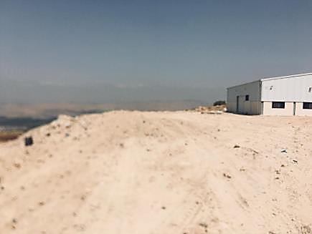
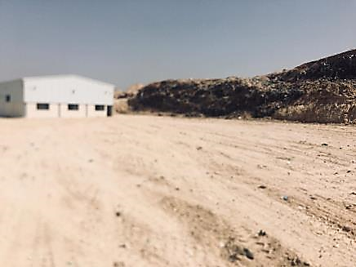
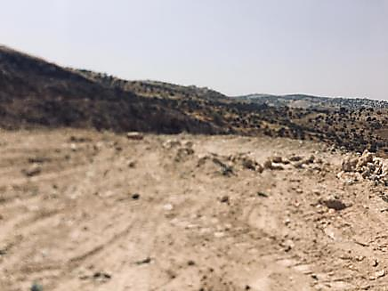
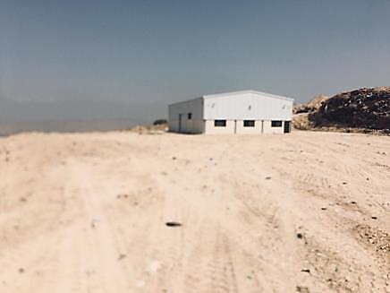
Figure 1 Kura Compost Plant Yards and Hangar

Project Area
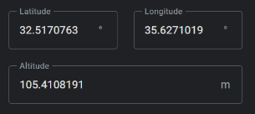
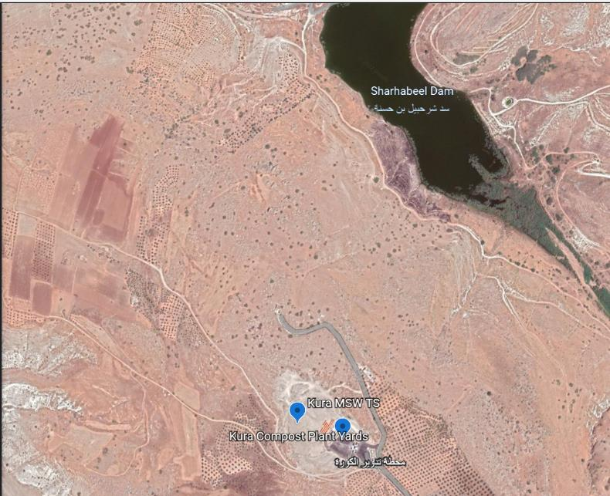
The project is located in Irbid, at Kura MSW Transfer Station. Below is the location on google earth. Also, a land survey of the project location is attached.

Figure 2 Kura MSW Transfer Station location
OBJECTIVES AND ENVISGED OUTCOMES
This contract will serve to the construction of retaining and boundary walls for the following reasons:
- Soil stabilization and site safety
- Environmental compliance with the national instruction related to the compost plants licensing

GENERAL SPECIFICTIONS AND REQUIREMENTS
The Ministry of Public Works and Housing (MPWH) issued general specifications (Volume I, II, III and IV) for buildings, roads, electrical and mechanical works will apply to this contract.
The Contractor will implement the following (but not limited to) tasks:
- Examine all drawings and ensure that the designs are in line with national codes before start of any works (design review) and provide updated designs (if needed) signed and stamped by an engineering office registered at Jordan Engineers Association (JEA). The design review phase shall not exceed one week, including the estimated quantities resulting from any change in the design.
- Develop a land survey report for the plant area (around 8000 m2 area) with topography before the start of work for shop drawings development and quantities survey for later payments.
- Ensure they have site offices for their staff for the duration of the assignment.
- Provide all material, skilled and non-skilled workers, equipment, machinery, and tools to complete all the works required in this TOR.
- Take samples and make the required testing in the general specifications through a licenced lab by MPWH.
- Provide weekly progress report, and report on any obstacles as soon as they are identified.
- Attend on site bi-weekly meetings, including any budget variation forecast.
- Submit shop drawings, work plans, method statement, HS&E plan, material data sheet (if applicable), mix designs and any other documentation to ensure the quality of works (UNDP will review within 3 working days).
- Submit requests for inspections for the works (UNDP will review within 2 working days) for all elements in the BoQ, ensuring that no works are covered or concealed before inspection, and that no new works are carried out if its predecessor is not inspected and approved.
- Ensure the site is clean from all waste always resulting from this contract.
- Provide electricity and water needed for the works.
- Provide all necessary tools for the UNDP to measure and access all works during the inspections.
- Ensure that there are qualified engineering staff of the Contractor present on each working day on site, (project manager – BSc. Civil engineering with at least 3 years of experience, and site foreman with 7 years of experience in construction works.
- The irrigation of trees should start immediately after planting, for 8 weeks (this item is allowed to be carried on during the defects liability period, with retention of its value till its completion).
- The approximate length of the block walls is around 150-meter length, and height between 1.2 to 1.8 m above NGL, and constructed at one to four parts maximum. The strengthening columns should be installed each 5 meters of the block wall.

Bill of Quantities (to be filled and stamped by bidder in number and words)
The rates shall be used for the price analyses and evaluation purposes or any other requirements, shall be fixed and firm for the duration of the contract and shall be inclusive of all facilities, office running cost, communication, transportation, company overheads …. etc.
For any type of work, material, equipment, tool, fitting … etc. required for the scope of work, the contractor must follow the engineer's instructions with getting his approval in advance. The contractor's failure to achieve that shall cause rejecting the work, material, equipment, tool, fitting … etc. All works should be in accordance to MPWH general specifications and national codes.
# | Item | Unit of Measurement | Quantity | Unit Price | Item Price
1 | Levelling and structural excavation below gabion walls to ensure zero slope under the wall (only area below the gabion wall dimensions will be measured) | Lump. Sum (L.S.) | 1
2 | Excavation for the block wall footings in all types of soil and rocks (workspace is not measured), including re-use of material for backfill above footings, and spreading and levelling the excess material inside the old dumpsite, but out of the compost plant yards | m³ | 57
3 | Supply and cast in place ready mix plain concrete below footings of 10 cm thickness and 15 N/mm2 strength after 28 days, inclusive of water spry of the excavated area before cast, and water spry for the first 3 days after cast (twice per day) for curing, inclusive of all formworks, material tools and workmanship | m² | 70
4 | Supply and cast in place ready mix concrete for the footings as shown in the section for of 25 N/mm2 strength after 28 days inclusive of water spry of the excavated area before cast, and water spry for the first 5 days after cast (twice per day) for curing, inclusive of all formworks, material tools and workmanship | m³ | 26
5 | Supply and install steel reinforcement (yield stress (4200 kg/cm² - grade 60) of all lengths and shapes for the footings, inclusive of ties, spacers and temporary fixing tools (only lengths of steel required in the drawings will be measured regardless of any overlaps or waste), inclusive of all material tools and workmanship | Ton | 4
6 | Supply and install hollow cement block of 20 cm width ((400 (L) x 200 (H) x 200 (T) mm) to the hight instructed by the UNDP, inclusive of mortar and any required material for installation, tools and workmanship, and water spraying for 3 days after installation for curing, with 4-inch UPVC pipe installed each 2-meter length of the wall at FFL of the yard for rainwater drainage, inclusive of all material and workmanship. | m² | 220
7 | Supply and install block wall strengthening reinforced concrete (25 n/mm2 after 28 days) column of height between 1.5 to 2 m, width and length of 20 cm each with 4 vertical bars of diameter 12 steel at corners (grade 60) inclusive its overlap with the footing, and one stirrup per 20 cm of height of 10 mm diameter bar (grade 60), inclusive of all material, formwork, curing for 5 days, and equipment, tools and workmanship. | number | 38
8 | Supply and install plastering of two layers ((رشة مسمار وفردة كف in accordance to the general specifications requirements for the first two layers of plaster mix design, on top and both sides of the block walls inclusive of all , metal angles and wire mesh at corners and intersection of concrete columns, all materials, tools, and workmanship | m² | 500
9 | Supply and install rock walls (gabion) using metal cages of 1x1x1 m, filled with rocks suitable for these works as approved by the UNDP, where the openings in the metal cage wires should be more than 60x80 mm, and the wire should be made of galvanized metal wires of not less than 3 mm diameter, with the tie wires made of the same material and diameter. The works include the supply and filling of the cages by solid high strength rocks, and degradable (rock or stone) with dimensions larger than the metal cage openings with maximum dimension of 200 mm, interlocking with each other. This include all material, equipment and tools, and workmanship to the approval of the UNDP. (Height of wall between 1 to 5 meters) | m³ | 480
10 | supply and install Paulownia tree where are instructed at the borders of the yards. The price include transportation, digging, backfilling and fertilizing (2 kg of compost per tree of quality like the compost produced at Al Hussainiyat landfill by JSC-Mafraq/MoMA - الهوائي). Taking into account the diameter of the seeding is not less than 100 cm and the height of tree supplied not less than 1.5 m. The price includes replacement of all defective dead trees during first month of installation approval and shall include a wooden support of 1.5m height (0.3m below ground) of around 1.5 cm diameter with appropriate ties. inclusive materials, equipment, workmanship, accessories & all requirements. All works must be as per the supervisor engineer instructions and assigned locations and after getting approval duly, inclusive of water irrigation for roots during planting process before backfilling. | number | 15
11 | supply and install Eucalyptus tree where are instructed at the borders of the yards. The price include transportation, digging, backfilling and fertilizing (2 kg of compost per tree of quality like the compost produced at Al Hussainiyat landfill by JSC-Mafraq/MoMA - الهوائي). Taking into account the diameter of the seeding is not less than 100 cm and the height of tree supplied not less than 2 m. The price includes replacement of all defective dead trees during first month of installation approval and shall include a wooden support of 1.5m height (0.3m below ground) of around 1.5 cm diameter with appropriate ties. inclusive materials, equipment, workmanship, accessories & all requirements. All works must be as per the supervisor engineer instructions and assigned locations and after getting approval duly, inclusive of water irrigation for roots during planting process before backfilling. | number | 40
12 | Irrigation of trees of minimum 40 lt/tree each time, once a week for the 55 trees through tankers (water suitable for irrigation as per Jordanian codes). | weeks | 8
13 | Supply and install agriculture soil (organic soil), the quality dark brown fertile, loam texture (Sand, Silt, Clay 40-40-20%), freely draining soil holding 25–35% water by volume, and 15–25% air by volume with PH between 6.8 and 7.2. (As per national grading for rich agriculture soil by Ministry of Agriculture). inclusive materials, equipment, workmanship, accessories & all requirements. All works must be as per the supervisor engineer instructions and assigned locations and after getting approval duly to be spread for all of the 55 trees. | m³ | 5.5
Total (currency: ______)

Figure 3: Proposed location for block walls (inside the orange cloud),and gabion walls (inside the green cloud).

Figure 4: typical section in block wall
Contractor Proposed Timetable (to be submitted with the offer)
# | Activity / Description | Dates |  | Duration in Weeks from Contract Award
 |  | Start | Finish | 1 | 2 | 3 | 4 | 5 | 6 | 7 | 8 | 9 | 10
Authorized Signature: [In full and initials]

Date: [Day/Month/Year]
Company
Stamp

Delivery Requirements
Delivery Requirements
Delivery date and time | Bidder shall deliver the goods 60 calendar days after Contract signature.
Delivery Terms (INCOTERMS 2020) | Delivery At Place/Site in Kura Transfer Station in Irbid
Customs clearance  (must be linked to INCOTERM | ☐ Not applicable  Shall be done by:  ☐ Name of organisation (where applicable)  ☒ Supplier/bidder  ☐ Freight Forwarder
Exact Address(es) of Delivery Location(s) | Jordan, Al Kura MSW Transfer Station - Irbid
Distribution of shipping documents (if using freight forwarder) | N.A.
Packing Requirements | Prevent damage to material, and prenvent damage to environment
Training on Operations and Maintenance | Required to provide a detailed O&M manuals in Arabic and English both in soft and hard copies.
Warranty Period | 180 days for all works with a defect liability guarantee.
After-sales service and local service support requirements | N.A.
Preferred Mode of Transport | Land

ANNEX 2: QUOTATION SUBMISSION FORM
Bidders are requested to complete this form, including the Company Profile and Bidder’s Declaration, sign it and return it as part of their quotation along with Annex 3: Technical and Financial Offer. The Bidder shall fill in this form in accordance with the instructions indicated. No alterations to its format shall be permitted and no substitutions shall be accepted.
Name of Bidder: | Click or tap here to enter text.
RFQ reference: | Click or tap here to enter text. | Date: Click or tap to enter a date.

Company Profile
Item Description |  | Detail
Legal name of bidder or Lead entity for JVs |  | Click or tap here to enter text.
Legal Address, City, Country |  | Click or tap here to enter text.
Website |  | Click or tap here to enter text.
Year of Registration |  | Click or tap here to enter text.
Legal structure |  | Choose an item.
Are you a UNGM registered vendor? |  | ☐ Yes ☐ No If yes, insert UNGM Vendor Number
Quality Assurance Certification (e.g. ISO 9000 or Equivalent) (If yes, provide a Copy of the valid Certificate): |  | ☐ Yes ☐ No
Does your Company hold any accreditation such as ISO 14001 or ISO 14064 or equivalent related to the environment? (If yes, provide a Copy of the valid Certificate): |  | ☐ Yes ☐ No
Does your Company have a written Statement of its Environmental Policy? (If yes, provide a Copy) |  | ☐ Yes ☐ No
Does your organization demonstrate significant commitment to sustainability through some other means, for example internal company policy documents on women empowerment, renewable energies or membership of trade institutions promoting such issues (If yes, provide a Copy) |  | ☐ Yes ☐ No
Is your company a member of the UN Global Compact |  | ☐ Yes ☐ No
Bank Information |  | Bank Name: Click or tap here to enter text.  Bank Address: Click or tap here to enter text.  IBAN: Click or tap here to enter text.  SWIFT/BIC: Click or tap here to enter text.  Account Currency: Click or tap here to enter text.  Bank Account Number: Click or tap here to enter text.
Previous relevant experience: 3 contracts
Name of previous contracts | Client & Reference Contact Details including e-mail |  | Contract Value | Period of activity | Types of activities undertaken

Bidder’s Declaration
Yes | No
☐ | ☐ | Requirements and Terms and Conditions: I/We have read and fully understand the RFQ, including the RFQ Information and Data, Schedule of Requirements, the General Conditions of Contract, and any Special Conditions of Contract. I/we confirm that the Bidder agrees to be bound by them.
☐ | ☐ | I/We confirm that the Bidder has the necessary capacity, capability, and necessary licenses to fully meet or exceed the Requirements and will be available to deliver throughout the relevant Contract period.
☐ | ☐ | Ethics: In submitting this Quote I/we warrant that the bidder: has not entered into any improper, illegal, collusive or anti-competitive arrangements with any Competitor; has not directly or indirectly approached any representative of the Buyer (other than the Point of Contact) to lobby or solicit information in relation to the RFQ ;has not attempted to influence, or provide any form of personal inducement, reward or benefit to any representative of the Buyer.
☐ | ☐ | I/We confirm to undertake not to engage in proscribed practices, , or any other unethical practice, with the UN or any other party, and to conduct business in a manner that averts any financial, operational, reputational or other undue risk to the UN and we have read the United Nations Supplier Code of Conduct :https://www.un.org/Depts/ptd/about-us/un-supplier-code-conduct and acknowledge that it provides the minimum standards expected of suppliers to the UN.
☐ | ☐ | Conflict of interest: I/We warrant that the bidder has no actual, potential, or perceived Conflict of Interest in submitting this Quote or entering a Contract to deliver the Requirements. Where a Conflict of Interest arises during the RFQ process the bidder will report it immediately to the Procuring Organisation’s Point of Contact.
☐ | ☐ | Prohibitions, Sanctions: l/We hereby declare that our firm, its affiliates or subsidiaries or employees, including any JV/Consortium members or subcontractors or suppliers for any part of the contract is not under procurement prohibition by the United Nations, including but not limited to prohibitions derived from the Compendium of United Nations Security Council Sanctions Lists and have not been suspended, debarred, sanctioned or otherwise identified as ineligible by any UN Organization or the World Bank Group or any other international Organization.
☐ | ☐ | Bankruptcy: l/We have not declared bankruptcy, are not involved in bankruptcy or receivership proceedings, and there is no judgment or pending legal action against them that could impair their operations in the foreseeable future.
☐ | ☐ | Offer Validity Period: I/We confirm that this Quote, including the price, remains open for acceptance for the Offer Validity.
☐ | ☐ | I/We understand and recognize that you are not bound to accept any Quotation you receive, and we certify that the goods offered in our Quotation are new and unused.
☐ | ☐ | By signing this declaration, the signatory below represents, warrants and agrees that he/she has been authorised by the Organization/s to make this declaration on its/their behalf.

Signature:
Name: Click or tap here to enter text.
Title: Click or tap here to enter text.
Date: Click or tap to enter a date.

ANNEX 3: TECHNICAL AND FINANCIAL OFFER – GOODS
Bidders are requested to complete this form, sign it and return it as part of their bid along with Annex 2: Quotation Submission Form. The Bidder shall fill in this form in accordance with the instructions indicated. No alterations to its format shall be permitted and no substitutions shall be accepted.
Name of Bidder: | Click or tap here to enter text.
RFQ reference: | Click or tap here to enter text. | Date: Click or tap to enter a date.

Description (totals for each section of the BoQ) | UOM | Qty | Unit Price | Total Price
Excavation and earth work | N.A. | N.A. | N.A.
Reinforced concrete works | N.A. | N.A. | N.A.
Gabion walls works | N.A. | N.A. | N.A.
Block walls works and plastering | N.A. | N.A. | N.A.
Total in numbers and words (Currency:_____)
The detailed bills of quantities (BoQ) should be filled, sign and stamped, as they will be the basis for contract final value upon measurement of actual approved implemented works and their offered unit price and method of measurement.
Compliance with Requirements
 | You Responses
 | Yes, we will comply | No, we cannot comply | If you cannot comply, pls. indicate counter - offer
Delivery Lead Time | ☐ | ☐ | Click or tap here to enter text.
Validity of Quotation | ☐ | ☐ | Click or tap here to enter text.
Payment terms | ☐ | ☐ | Click or tap here to enter text.
Other requirements: general specification issued by Jordan MPWH, and ability to perform all works as described in annex 1 | ☐ | ☐ | Click or tap here to enter text.

I, the undersigned, certify that I am duly authorized to sign this quotation and bind the company below in event that the quotation is accepted.
Exact name and address of company  Company NameClick or tap here to enter text.  Address: Click or tap here to enter text.  Click or tap here to enter text.  Phone No.: Click or tap here to enter text.  Email Address: Click or tap here to enter text. | Authorized Signature:  Date: Click or tap here to enter text.  Name: Click or tap here to enter text.  Functional Title of Authorised  Signatory: Click or tap here to enter text.  Email Address: Click or tap here to enter text.

تعليمات تنظيم تخزين ونقل ومعالجة السماد العضوي والإتجار به لسنة 2009
Price breakdown could be requested during offers evaluation phase.

