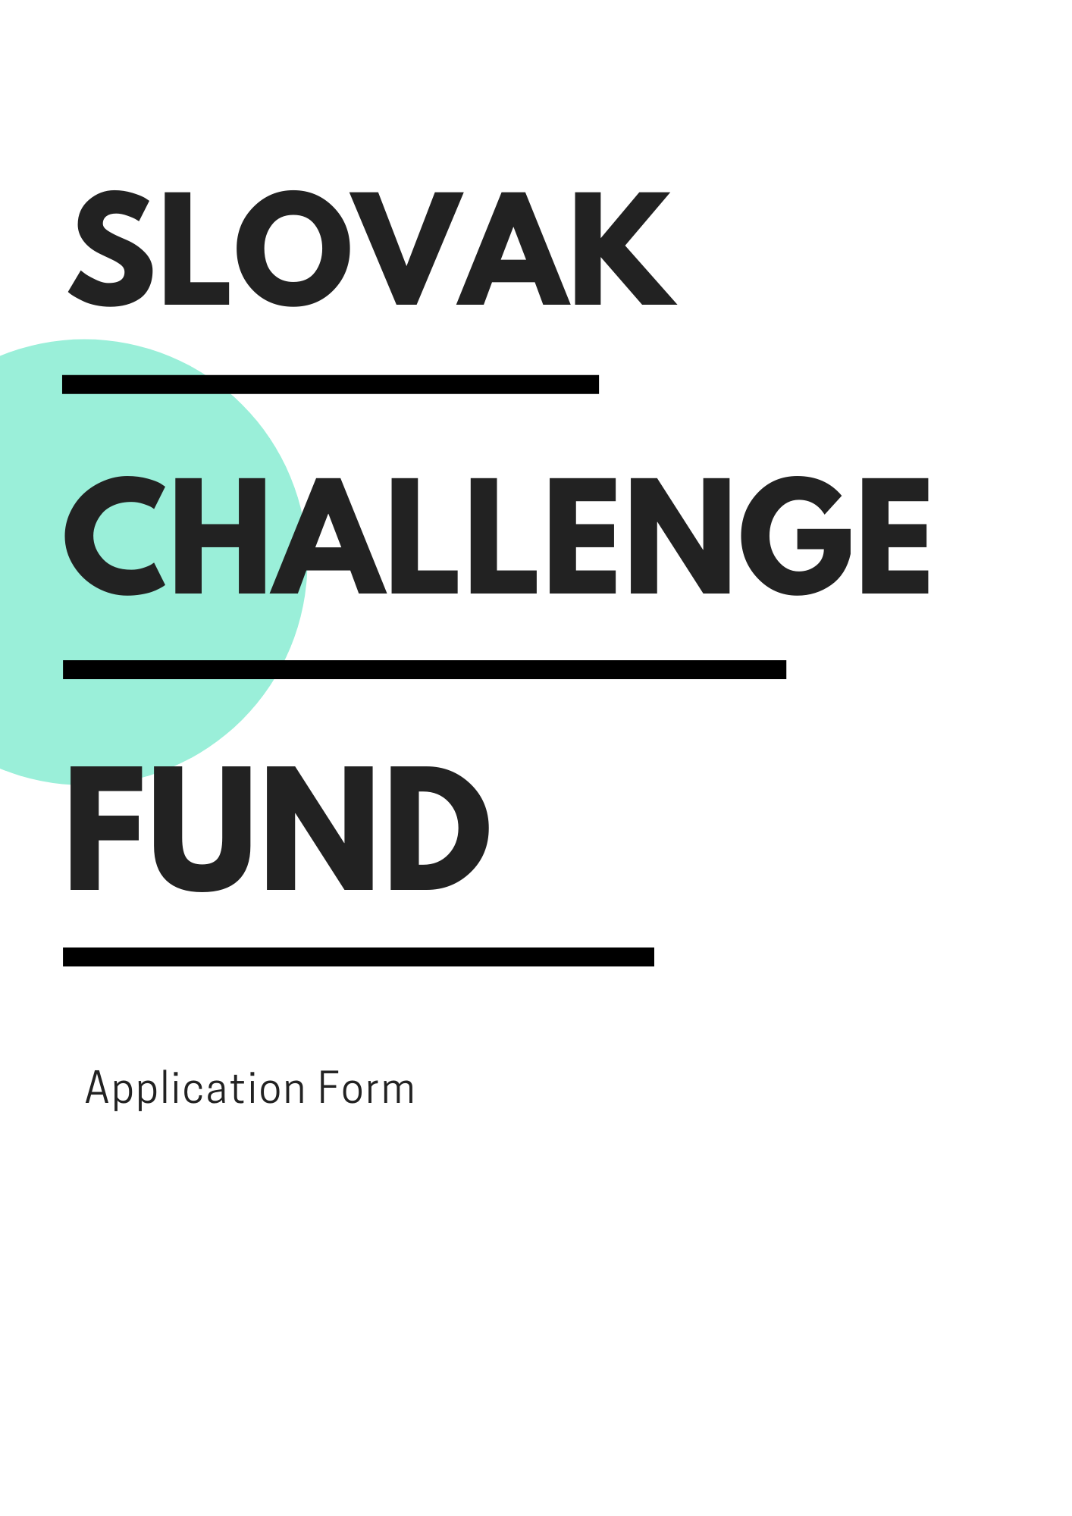

APPLICANT and local partner(s)

Applicant´s Name:
Postal Address:
Telephone:
Websites:

Legal Registration Number, COUNTRY, and Year of Registration:
Type of Entity:

Name of Contact Person:
E-mail:
Telephone:

Local partner´s NAME:
Postal Address:
Telephone:
Websites:

Legal registration number, country, and year of registration:
Type of Entity:

Name of Contact Person:
E-mail:
Telephone:

- Extract from Public Registry, i.e. Commercial Register [Obchodný register]

- The declaration of the partnership with local partner in Moldova and North Macedonia in form of the Letter of Intent, Bilateral Contract, or Memorandum of Understanding

GENERAL INFORMATION

Date of Implementation: month/year – month/year

Please Select Country of Implementation:
☐ North Macedonia
☐ Republic of Moldova

SUMMARY OF THE PROJECT:
Please state the problem or challenge your application aims to address. Describe the solution and expected outcome in targeted county. Explain the benefits and advantages of the intervention.
(100 – 300 words)

budget of the project

AWARD (USD): |  | (80%)
Co-FINANCING (usd): |  | (20%)
Total BUDGET (USD): |  | (100%)

Detailed breakdown of the project´s budget is provided in a separated Excel sheet.
value for money and cost effectiveness:
Please briefly state the extent to which the proposed solution is expected to achieve its results at lower cost compared with alternatives.
(80 – 120 words)

innovativeness & scalability

Please Select the degree of innovation:

☐ Proof of Concept¹
☐ TRANSITION TO SCALE²

1 – When the intellectual concept behind an innovation is field-tested to gain an early, ‘real-world’ assessment of its potential.
2 – When innovations that have demonstrated small-scale success develop their model and attract partners to help fill gaps in their capacity to scale.

innovativeness
What is new about your idea? What substitutes do people resort to because it does not exist in the targeted country or sector yet? Who are your competitors and how different are you? We want to understand what is new about your concept.
(100 – 150 words)

SCALE-UP & REPLICATION
What is the potential of the idea for growth and expansion (in terms of people served, revenues generated, or other targets)? What is the potential of the idea for transition (to a different location, or sector)? We want to understand the potential for scale-up and replication of your concept.
(80 – 120 words)

impact & scope of the project

Please Select the development sector:

☐ Sustainable Management of Natural Resources
☐ Economic Transformation and Development
☐ Good Governance and Rule of Law
☐ Agriculture and Rural Development
☐ Social and Health Sector

Please Select the development CHALLENGE:

☐ Natural Resources
Sustainable use of natural resources through improved water or waste management – and/or increased energy efficiency and clean energy utilization.
☐ AGRICULTURE
Increased productivity, partnerships, access to markets and competitiveness of organic agriculture actors like farmers and producers.
☐ GOOD GOVERNANCE
Introducing and/or improving e-governance and open data use in public sector management and delivery.
☐ COVID-19
Supporting resilience during the COVID-19 pandemic and mitigating the negative effects of the ongoing crisis on the communities.

Please Select the Sustainable Development Goals relevant to your idea:³

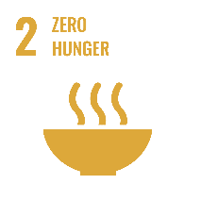  ☐ | 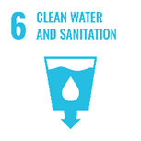  ☐ | 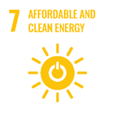  ☐ | 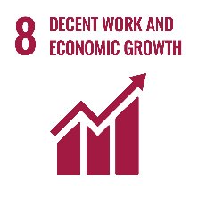  ☐

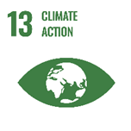  ☐ | 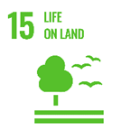  ☐ | ☐

3 – When aligning to the Sustainable Development Goals, make sure to understand their underlying targets. To learn more about the SDGs, you can visit the website: 17 Sustainable Development Goals (SDGs).

context and Problem analysis:
What specific problem are you trying to solve? How do you know, people need what you are making? Please, provide evidence of the size and addressness of the problem, e.g. quotes and data from research, policy papers and strategies, etc.
(80 – 120 words)

stakeholders & BENEFICIARIES:
Who is the most affected by the problem? Who will benefit directly – and who indirectly from your solution? Please, include facts and figures – and provide sex-disaggregated and gender-sensitive data.
(40 – 80 words)

impact & results:
What the project will change and to what extent? We want to understand the effect that the intervention carried out and its results have on people, practices, and systems.
(40 – 80 words)

activities & timeline:
Please describe in detail the planned activities and timeline. Please, include numbers and brief specification, e.g. number of participants, frequency of tasks and steps, used tools and resources, etc.
(100 – 350 words)

Name of Activity | Description of activity | date of delivery (DAY/month/year)
1.
2.
3.
4.

visibility:
How do you plan to highlight the project results with concrete and visible achievements that emphasize the impact in the beneficiaries' life?
(40 – 120 words)

sustainability and risk assesment

Financial, Environmental & Social Sustainability:
How will the activities be financed after the end of the project? Will the proposed solution contribute to the quality of environment on a long-term basis? How the proposed solution promotes well-being of people and understanding of their needs? How is the gender sensitivity implemented?
(100 – 180 words)

RISK ASSESMENT:
What are the possible external risks that can affect the project implementation and its impact? Identify the high-level external risks and the strategies to mitigate them.
(30 – 80 words)

RISK | Mitigation Strategy
1.
2.
3.

project management

roles and responsibilities:
How the project will be managed and coordinated? What are the relevant competences and previous experience of the team members? Explain, why your team is uniquely qualified to solve the problem.
(80 – 180 words)

Attached CVs contain details about the experience and competencies of team members, incl. applicant and local partner(s).

MORE details for our curiosity

What is the gender/Sex of the project lead?

Applicant | Local Partner

What is the category of your enterprise?

micro enterprise  with fewer than 10 employees | ☐
small enterprise  with 10 to 49 employees | ☐
medium-sized enterprise  with 50 to 249 employees | ☐
Large enterprise  with 250 or more employees | ☐

How did you hear about the slovak challenge fund?
☐ Social Media
☐ E-mail
☐ Word of Mouth
☐ Other ………………………

HAS YOUR ORGANIZATION APPLIED TO THE slovak challenge fund previously?
☐ Yes
☐ No

HAS YOUR ORGANIZATION APPLIED TO other calls or tenders?

Slovak Agency for International Development Cooperation (SAIDC) | ☐ Yes ☐ No
UNDP or other UN Agencies (UNICEF, WHO, etc.) | ☐ Yes ☐ No
European Union (EU) | ☐ Yes ☐ No
Other ……………………… | ☐ Yes ☐ No

Attachments to the application
- Extract from Public Registry, i.e. Commercial Register [Obchodný register]
- Budget in the Breakdown Form (Excel Sheet)
- CVs of team members, incl. applicant and local partner(s)
- The declaration of the partnership with local partner Moldova and North Macedonia in the form of the Letter of Intent, Bilateral Contract, or Memorandum of Understanding
- Any other relevant documents supporting the application like patent registration, information about awards and prizes, etc.

Acceptance of terms and conditions

By signing this form, the Applicant accepts the following terms and conditions:
The Applicant declares that he/she is bounded by the process and rules of the competition that have been highlighted in the Guidelines of the Slovak Challenge Fund and shall accept the outcome of the process without any deviation or reservation.
The Applicant shall bear all costs related to the preparation and submission of the proposal regardless of whether his/her proposal is selected or not. He/she accepts that the UNDP will in no case be held responsible or liable for those costs regardless of the outcome of the process.
The Applicant accepts that the UNDP determines the level of responsiveness to the Call for Proposals of the Slovak Challenge Fund exclusively on the contents of the written, submitted, and signed application forms.
The Applicant accepts that information relating to the examination and evaluation of applications, and selection of awardees and signature of agreement shall not be disclosed to any person not officially concerned with such processes.

Signature: …………………………………………………
Name: …………………………………………………
Date: …………………………………………………

