REQUEST FOR QUOTATION (RFQ 80/2020)
(works)

RFQ 80/2020 for Supervision of Construction Works on Riverbed cleanup in urban part of Crn Drim River in Struga in length of 765 meters, and cleaning of area of Ohrid Lake discharge point in Crn Drim River in Struga | DATE: August 13, 2020
 | 00096220 Improving the Management of Protected Areas

Dear Sir / Madam:

We kindly request you to submit your quotation under RFQ 80-2020 for Supervision of Construction Works on Riverbed cleanup in urban part of Crn Drim River in Struga in length of 765 meters, and cleaning of area of Ohrid Lake discharge point in Crn Drim River in Struga, as detailed in Annex 1 of this RFQ. When preparing your quotation, please be guided by the form attached hereto as Annex 3.

Quotations may be submitted on or before 20 August 2020 by 11:00am via dedicated email: offers.mk@undp.org

Subject: MKDRFQ80 - 2020 for Supervision of cleaning of Crn Drim River in Struga_CompanyName

It shall remain your responsibility to ensure that your quotation will reach the address above on or before the deadline. Quotations that are received by UNDP after the deadline indicated above, for whatever reason, shall not be considered for evaluation.

Please take note of the following requirements and conditions pertaining to the supply of the abovementioned works

Delivery Terms  [INCOTERMS 2010]  (Pls. link this to price schedule) | ☐FCA  ☐CPT  ☐CIP  ☐DAP  ☐Other  n/a
Customs clearance, if needed, shall be done by: | ☐UNDP  ☐Supplier/Offeror  ☐Freight Forwarder  n/a
Exact Address/es of Delivery Location/s (identify all, if multiple) | Crn Drim River, Struga
UNDP Preferred Freight Forwarder, if any | n/a
Distribution of shipping documents (if using freight forwarder) | n/a
Latest Expected Delivery Date and Time (if delivery time exceeds this, quote may be rejected by UNDP) | ☒ 2 weeks upon signing of contract  ☒ As per Delivery Schedule attached [if delivery will be staggered]  Time:  Time Zone of Reference:
Delivery Schedule | ☒Required, Defined in the SoW (estimated at 90 days)  ☐Not Required
Packing Requirements | n/a
Mode of Transport | ☐ AIR | ☐LAND
 | ☐SEA | ☐OTHER n/a
Preferred  Currency of Quotation | ☐United States Dollars for foreign bidders  ☐Euro  ☒Local Currency: MKD for domestic bidders
Value Added Tax on Price Quotation | ☐ Must be inclusive of VAT and other applicable indirect taxes  ☒ Must be exclusive of VAT
After-sales services required | ☐Warranty on Parts and Labor for minimum period of Click to type  ☐Technical Support  ☐Provision of Service Unit when pulled out for maintenance/ repair  ☒ n/a
Deadline for the Submission of Quotation | Thursday, August 20, 2020 and 11:00am
All documentations, including catalogs, instructions and operating manuals, shall be in this language | ☒ English (except copies of original documents shall be submitted in Macedonian, no translation required)  ☐ French  ☐ Spanish  ☒ Copies of originals and BoQ in Macedonian
Documents to be submitted | Following Documents Establishing Offeror’s Eligibility & Qualifications must be submitted and include the following:  Required documents:  ☒ Duly Accomplished Form as provided in Annex 2, and in accordance with the list of requirements in the RFQ. Financial offer expressed in MKD, VAT expressed separately  ☒ Latest Business Registration Certificate (a copy);  ☒ Company Profile (brief of your company and experience) and Quality Certificate (e.g., ISO 9001, ISO 14001 and other, etc.) and/or other similar certificates, accreditations, awards and citations received, if any  ☒ Notarized Copy of a valid License B for supervision of construction works of 2nd category buildings issued by the Ministry of Transport and Communication (according to the Law on Construction, Official Gazette 130/2009, 124/10, 18/11, 36/11, 54/11, 13/12, 144/12, 25/13, 79/13, 137/13, 163/13, 27/14, 28/14, 42/14, 115/14, 149/14, 187/14, and 44/2015).  ☒ List of minimum 2 relevant projects of comparable value: supervision of cleanups of riverbeds and canals, supervision of construction of irrigation and drainage systems, river regulations, or other hydraulic/river structures (e.g., dams, check-dams), or supervision of any other construction projects that involve work in the presence of water.  ☒ CV of the Supervising Engineer/Site Manager  ☒ Authorization B for supervision of construction works in the field of civil engineering issued by the Chamber of Authorized Architects and Authorized Engineers (notarized copy in Macedonian to be submitted);  List of clients for reference check (contact details and e-mail addresses to be provided for reference check.  Provide the information regarding relevant projects in the table provided below:  Name of project Client Contract Value Period of activity Types of activities undertaken Status or Date Completed References Contact Details (Name, Phone, Email)  ☒Reference letter for satisfactory Performance from at least 3 clients, if available (or pls provide e-mail addresses of your clients for reference check on your performance by UNDP)  ☒ Key personnel  Supervising Engineer/Site Manager:  - Authorization B for supervision of works in the field of civil engineering issued by the Chamber of Authorized Architects and Engineers.  - At least 8 years of relevant professional experience in constructions projects  - Record of at least 2 projects of comparable nature and degree of complexity in the capacity of Supervision Engineer such as supervision of Cleanups of riverbeds and canals, supervisión of construction of irrigation and drainage systems, river regulations, or other hydraulic/river structures (e.g., dams, check-dams), or supervision of any other construction projects that involve work in the presence of water.  The CVs of engineer shall evidence the required qualifications, relevant experience, copies of the relevant licenses and certificates.  In addition to the CV, the bidder shall submit the following table:  No. Position Relevant projects are (please check the requirements in TOR for relevance of projects) License B (indicate validity) Total experience/ experience in relevant projects (years)  1. Supervising Engineer/Site Manager 1. 2.  ☒ Vendor form to be filled in with company data  ☒ ☒ The financial offer (in MKD) should be VAT exempt
Way of submission of documents by Email: | Documents to be submitted by email to dedicated email: offers.mk@undp.org  Subject: MKDRFQ80 - 2020 for Supervision of cleaning of Crn Drim River in Struga_CompanyName  Format: PDF files  All files must be in PDF and free of viruses and not corrupted.  Technical and Financial OFFER must be separately uploaded.  Max. size of uploaded files (per document) must not exceed: 30 MB  All submitted files should be in the following format:  Companyname_nameofthefile.pdf (or .docx)  ONLY FINANCIAL offer will be submitted as PDF “password protected file”, DIGITALLY signed and or signed and scanned in the .pdf format.  Password for Financial OFFER SHALL be provided to UNDP ONLY after the DEADLINE latest 13 p.m.  (Password protection of a PDF document can be done using Adobe Reader. Open the PDF and choose Tools > Protect > Encrypt > Encrypt with Password)
Period of Validity of Quotes starting the Submission Date | ☐ 60 days  ☐ 90 days  ☒ 120 days  In exceptional circumstances, UNDP may request the Vendor to extend the validity of the Quotation beyond what has been initially indicated in this RFQ. The Proposal shall then confirm the extension in writing, without any modification whatsoever on the Quotation.
Partial Quotes | ☒ Not permitted  ☐ Permitted [pls. provide conditions for partial quotes, and ensure that requirements are properly listed to allow partial quotes (e.g., in lots, etc.)]
Payment Terms | ☒ 100% upon complete delivery of works  ☐ Others: Based upon Invoices submitted by the Contractor and Interim Payment Certificates issued by the Supervising Engineer, UNDP shall make progress payments. submitted by the Contractor in accordance with the tender documents.  ☒ Invoices reflecting final payment certificates shall be paid within max 30 (thirty) days of the date of their receipt and acceptance by UNDP.
Liquidated Damages | ☐ Will not be imposed  ☒ Will be imposed under the following conditions:  Percentage of contract price per week of delay: 5% percent of the delivered price of the delayed works for each week of delay until actual delivery, up to a maximum deduction of 10 percent of the delayed works’ contract price.  Max. no. of days of delay: 2 weeks  Next course of action: Termination of contract
Evaluation Criteria  [check as many as applicable] | ☒ Technical responsiveness/Full compliance to requirements and lowest price  Comprehensiveness of after-sales services  ☒ Full acceptance of the Contract General Terms and Conditions  ☐ Earliest Delivery / Shortest Lead Time  ☐ Others [pls. specify]
UNDP will award to: | ☒ One and only one supplier  ☐ One or more Supplier, depending on the following factors: [Clarify fully how and why will this be achieved. Please do not choose this option without indicating the parameters for awarding to multiple Suppliers]
Type of Contract to be Signed | ☒ Contract for works  ☐ Long-Term Agreement (if LTA will be signed, specify the document that will trigger the call-off. E.g., PO, etc.)  ☐ Other Type/s of Contract [pls. specify]
Contract General Terms and Conditions | Applicable Terms and Conditions are available at  http://www.undp.org/content/undp/en/home/procurement/business/how-we-buy.html
Special conditions of Contract | ☒ n/a  ☐ Others [pls. specify]
Conditions for Release of Payment | Passing Inspection verification of works by the Supervisor  Complete Installation  ☐ Passing all Testing [specify standard, if possible]  ☐ Completion of Training on Operation and Maintenance [specify no. of trainees, and location of training, if possible  ☒ Written Acceptance of works based on full compliance with RFQ requirements  ☒ per submitted invoice and satisfactory report of the works certified by the Supervisor
Annexes to this RFQ | ☒ Scope of Works(Annex 1)  ☒ Evaluation Criteria (Annex 2)  ☒ Form for Submission of Quotation (Annex 3)  ☒ Bill of Quantities (Annex 4)  Non-acceptance of the terms of the General Terms and Conditions (GTC) shall be grounds for disqualification from this procurement process.
Contact Person for Inquiries  (Written inquiries only) | Procurement Official  Procurement.mk@undp.org  Written inquiries only  Any delay in UNDP’s response shall be not used as a reason for extending the deadline for submission, unless UNDP determines that such an extension is necessary and communicates a new deadline to the Proposers.

Goods offered shall be reviewed based on completeness and compliance of the quotation with the minimum specifications described above and any other annexes providing details of UNDP requirements.

The quotation that complies with all of the specifications, requirements and offers the lowest price, as well as all other evaluation criteria indicated, shall be selected. Any offer that does not meet the requirements shall be rejected.

Any discrepancy between the unit price and the total price (obtained by multiplying the unit price and quantity) shall be re-computed by UNDP. The unit price shall prevail and the total price shall be corrected. If the supplier does not accept the final price based on UNDP’s re-computation and correction of errors, its quotation will be rejected.

After UNDP has identified the lowest price offer, UNDP reserves the right to award the contract based only on the prices of the goods in the event that the transportation cost (freight and insurance) is found to be higher than UNDP’s own estimated cost if sourced from its own freight forwarder and insurance provider.

At any time during the validity of the quotation, no price variation due to escalation, inflation, fluctuation in exchange rates, or any other market factors shall be accepted by UNDP after it has received the quotation. At the time of award of Contract or Purchase Order, UNDP reserves the right to vary (increase or decrease) the quantity of services and/or goods, by up to a maximum twenty five per cent (25%) of the total offer, without any change in the unit price or other terms and conditions.

Any Purchase Order that will be issued as a result of this RFQ shall be subject to the General Terms and Conditions attached hereto. The mere act of submission of a quotation implies that the vendor accepts without question the General Terms and Conditions of UNDP herein attached as Annex 3.

UNDP is not bound to accept any quotation, nor award a contract/Purchase Order, nor be responsible for any costs associated with a Supplier’s preparation and submission of a quotation, regardless of the outcome or the manner of conducting the selection process.

Please be advised that UNDP’s vendor protest procedure is intended to afford an opportunity to appeal for persons or firms not awarded a purchase order or contract in a competitive procurement process. In the event that you believe you have not been fairly treated, you can find detailed information about vendor protest procedures in the following link:
http://www.undp.org/content/undp/en/home/operations/procurement/protestandsanctions/

UNDP encourages every prospective Vendor to avoid and prevent conflicts of interest, by disclosing to UNDP if you, or any of your affiliates or personnel, were involved in the preparation of the requirements, design, specifications, cost estimates, and other information used in this RFQ.

UNDP implements a zero tolerance on fraud and other proscribed practices, and is committed to identifying and addressing all such acts and practices against UNDP, as well as third parties involved in UNDP activities. UNDP expects its suppliers to adhere to the UN Supplier Code of Conduct found in this link : http://www.un.org/depts/ptd/pdf/conduct_english.pdf

Thank you and we look forward to receiving your quotation.

Annex 1

Terms of Reference
Supervision for Construction Works on Riverbed cleanup in urban part of Crn Drim River in Struga in length of 765 meters, and cleaning of area of Ohrid Lake discharge point in Crn Drim River in Struga

Background
The project “Improving management of protected areas” which is funded by EU and implemented by UNDP in close collaboration with the Ministry of Environment and Physical Planning aims to improve nature protection and to promote sustainable use of natural resources while increasing the capacity of management authorities of protected areas, local self-governments and CSOs to manage and promote protected areas in a professional and sustainable fashion.
The central feature of the project is a grant scheme that is established to support the achievement of the following three main goals: 1) to address priority needs in improving the management of protected areas, where possible including those recently proposed as pilot Natura 2000 sites; 2) to promote more sustainable use of natural resources; and 3) to demonstrate through practical examples that nature protection and the economic development of communities can go hand in hand.
Ohrid Lake designated as third category of protected area (Monument of Nature) according to nature protection legislation is in the beneficiary group of large protected areas upon supporting the project initiative of Municipalities of Ohrid, Struga and Debarca for improving the water quality management of Ohrid Lake tributaries. The main objective of this initiatives involves diversification of Sateska River in its natural riverbed and improvement of Crn Drim riverbed capacity in order to minimize the flood risk.
Based on the previously made geodetic analyzes and hydraulic modeling, it is necessary to clean the accumulated material in the urban bed of the Crn Drim River and the narrower locality before the outlet of Lake Ohrid in Crn Drim in order to increase the hydraulic and throughput capacity of Crn Drim and reduce the risk of rising groundwater levels and the risk of flooding.
UNDP is seeking an experienced Engineering Supervising Companies for supervision of the construction works for riverbed cleanup in urban part of Crn Drim River in Struga in length of 765 meters and cleaning of area of Ohrid Lake discharge point in Crn Drim River in Struga.

Objectives
The objective of the consultancy supervising services is to ensure that high quality construction works are achieved and to ensure that all work is carried out in full compliance with the architectural and engineering designs, technical specifications and other contract documents, as well as in line with the applicable national laws and regulations.
Scope of Work (Supervision on Construction Works)
The Company shall administer the construction work contract and supervise the construction works construction of the wastewater treatment plant on behalf of UNDP. To fulfill such requirements, the Company shall establish organizational procedures during the construction supervision services in accordance with all requirements for quality control, control of quantities, supervision on the work progress, analysis of expenses, full implementation of wastewater treatment plant construction and environmental criteria as well as dealing with administrative issues during the construction period.
The Company will work under direct supervision of the UNDP Project Manager and will closely collaborate with UNDP Project Specialist/Monitoring Officer.

Duties and Responsibilities
The Supervision Engineer shall provide full project supervision services throughout the duration of the project. The specific duties and responsibilities of the Engineer will be as follows:

- Pre – Construction Activities
- Establish procedures for proper works supervision;
- Outline procedures and forms for inspection, verification, reporting and approval of works related activities, site communication, variation orders and other, according to the requirements of these ToR;
- Procedures and forms for quality assurance and quality control;
- Establish transparent and reliable filing system of electronic and printed documentation, and document distribution;
- Check the validity period of Works Contractor’s insurance policies, guarantees, certificates, and other relevant documents provided by the Works Contractor and ensuring timely renewal of the said documents by the Works Contractor;
- Verification of Work Contractors detailed time and activity schedules including reporting and documents preparation;
- Assess the adequacy and sufficiency of available technical documentation and initiate measures to address suspected cases of inadequacy/insufficiency, excessiveness and technical norms and standards;
- Establish formal contact with UNDP, Works Contractor, Municipality of Struga, ELEM representatives to ensure proper co-ordination during project implementation.

- Construction Period
- Supervision of the timely and in good quality completion of all stages of the project, from the commencement date up to commissioning, tests on and after completion, taking over procedures, presentation of hand-over documentation, implementation of health and safety, standards and environmental protection standards;
- Administration and coordination of Works Contract, providing proper implementation of work plans, achievement of the required quality, and all related parameters as defined in the Work Contract documents;
- Preparation and coordination of site weekly progress meetings, with provision of minutes of these meetings in Macedonian language. The meetings shall be chaired by the Supervising Engineer or UNDP Representative;
- Maintaining of a continuous liaison with the UNDP Project Manager/Project Specialist regarding the relevant information on matters related to works implementation, including ad hoc communication daily;
- To ensure the control of validity period of construction permission, technical documentation and other related documents and to inform the UNDP Project Manager Project Specialist in case of extension;
- Signing / counter-signing of Contractor’s log books with filing of copies. Daily logbooks shall contain references regular site inspections, tests, controls and approvals;
- Approving tests on items such as construction materials, plants, landscape materials and other products according to the instruction of the technical specifications. The Engineer shall: Check manufacturer’s tests for the equipment, landscaping plants, materials and parts delivered by the Contractors; Verify the tests on installed materials, landscaping plants, materials and equipment in situ if needed;
- Providing regular site inspection with attention to quality of construction and landscaping works, as well as health, safety and environmental measures taken by the Works Contractor;
- Providing instructions to the Contractor on modifications in technical and landscaping specifications, parts of the design, work programme in prior consultation and approval by the UNDP Project Manager;
- Administration and verification of Contractor’s interim payments, through establishing the value of works. Interim payment certificates shall be verified by the Engineer within 1 work days after receiving the Work Contractor’s request, and submitted to the UNDP Project Manager for further processing;
- Advising UNDP on the potential for the reduction of the project costs, works execution time, or improvements of the quality of works;
- Approving as-build documentation supported with Work Contractor’s construction record, securing delivery to UNDP Project Manager jointly with certificates, reports, records properly ordered and presented by the Works Contractor;
- Approving and witnessing of Works Contractor’s tests on substantial completion;
- Performing of due taking-over inspection jointly with the representatives of the UNDP, drafting of taking-over certificates, snag lists, and other documentation stipulated in the Contract;
- To ensure Inspection of the machinery and equipment used by the Works Contractor on the construction, for all temporary or permanent works with respect to the normative technical and landscaping standards, safety and environmental requirements;
- To timely inform the UNDP Project Manager if the implementation of Works Contract does not meet the technical requirements and to suspend the construction works of the wastewater treatment plant if the project solution is changed or not in accordance with the technical procedures or standards;
- To collect relevant documents for issuing necessary and additional permits if needed, related to construction works (e.g. traffic, electricity, water, sewerage, environment etc.);
- To supervise, control and approve unforeseen activities related to the implementation of construction works;
- Where the Works Contractor has ceased to perform works as required by the terms of the Construction agreement, the Supervisor must advise UNDP and make relevant recommendations (including termination).
- To check and approve the draft of Works Final Acceptance Certificate prepared by the Works Contractor;
- To check and approve the Advance, Interim and Final Payments Certificates prepared by the Works Contractor together with the supporting documents and submit to the UNDP Project Manager for approval;
- To check the accuracy and validity of Bill of Quantities, guaranties, payments, landscaping plant certificates, ownership of the machinery and other, which shall be provided by the Works Contractor according to the Works Contract;
- Compile and deliver to UNDP, ‘as built drawings’ operational and maintenance manuals and records incorporating information prepared by suppliers as are reasonably necessary to enable the Beneficiary to operate and maintain the wastewater treatment facilities. These must be submitted no later than one month prior to the end of Substantial Completion of Works.
- To check and approve after completion of the works the Final Report prepared by the Works Contractor with the results from all landscaping, insulation tests, surveys, concrete tests, mechanical and electrical installation tests etc.

Deliverables
The main deliverables of the assignment are:
- Weekly Supervision Reports
Brief Note to the file will be prepared weekly with description of the activities on site, potential issues and recommendations. The report will be in a form of an e-mail supported with photographs.
- Minutes of the site technical meetings
The Supervisor will prepare a comprehensive Final Completion Report
Qualification Requirements
Company
The Company shall have extensive experience in site supervision of similar works including: supervision of cleanups of riverbeds and canals, supervision of construction of irrigation and drainage systems, river regulations, or other hydraulic/river structures (e.g., dams, check-dams), or supervision of any other construction projects that involve work in the presence of water.
It will have previous experience from at least 2 projects of comparable nature and degree of complexity (e.g., supervision of cleanups of riverbeds and canals, supervision of construction of irrigation and drainage systems, river regulations, or other hydraulic/river structures (e.g., dams, check-dams), or supervision of any other construction projects that involve work in the presence of water. List of projects to be submitted along with contact details for reference checking purposes (please indicate the e-mail addresses or fax numbers of contact persons).
The Company must be a holder of a valid License B for supervision of construction works of 2nd category buildings issued by the Ministry of Transport and Communication

Supervision Engineer/Site Manager

The mandatory evaluation criteria for each team member are summarized in the following table:

 | Team members  and/or  areas of expertise | Qualification requirements
1. | Supervising Engineer/Site Manager | - Minimum bachelor’s degree in civil engineering  - Minimum 8 years in supervision of construction projects  - License B for supervision of works in the field of civil engineering issued by the Chamber of Authorized Architects and Engineers  - Experience as Supervising Engineer on at least 2 relevant projects Cleanups of riverbeds and canals, supervision of construction of irrigation and drainage systems, river regulations, or other hydraulic/river structures (e.g., dams, check-dams), or supervision of any other construction projects that involve work in the presence of water.

NOTE:
Failure to provide adequate supervision expertise for any of the areas is considered grounds for disqualification.

Terms and Conditions
- Language
The language of the required deliverables/outputs as indicted in the Main Outputs section above is Macedonian.

- Legal and other requirements
The content of the requested documents shall conform to the pertaining relevant legislation in the country for construction projects.

- Review and quality assurance
Review of all Supervision Reports issued by the Supervising Engineer will be carried out by the UNDP Project Manager. Relevant comments and suggestions will have to be integrated in the final versions of the reports.

- Duration of the assignment
The estimated duration of Contractor’s assignment equals to the duration of the works contract which is set at 2 weeks.

- Additional costs
The company should calculate the possible costs for successful finalization of all tasks. UNDP shall not accept any additional expenses which aren’t included in the company’s financial offer.

- Reporting requirements
The Supervising Engineer(s) will report to UNDP through the Project Manager/Monitoring Officer by e-mail the following reports, described under deliverables:
  - Site Visit Reports
  - Final Completion Report

- Payment schedule
The payment will be processed based on invoice upon successful completion of the construction works.

Evaluation criteria

Contract will be awarded to the Bidder that meets the criteria based on pass/fail method and offers the lowest offer.

Annex 1 Photo of the area subject to cleaning

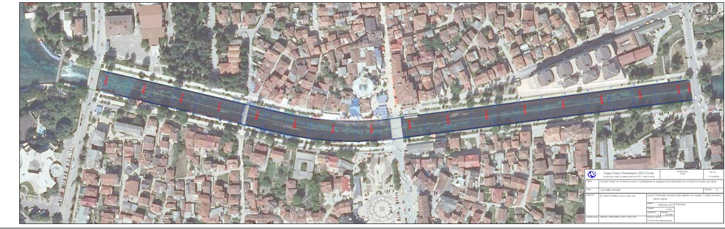

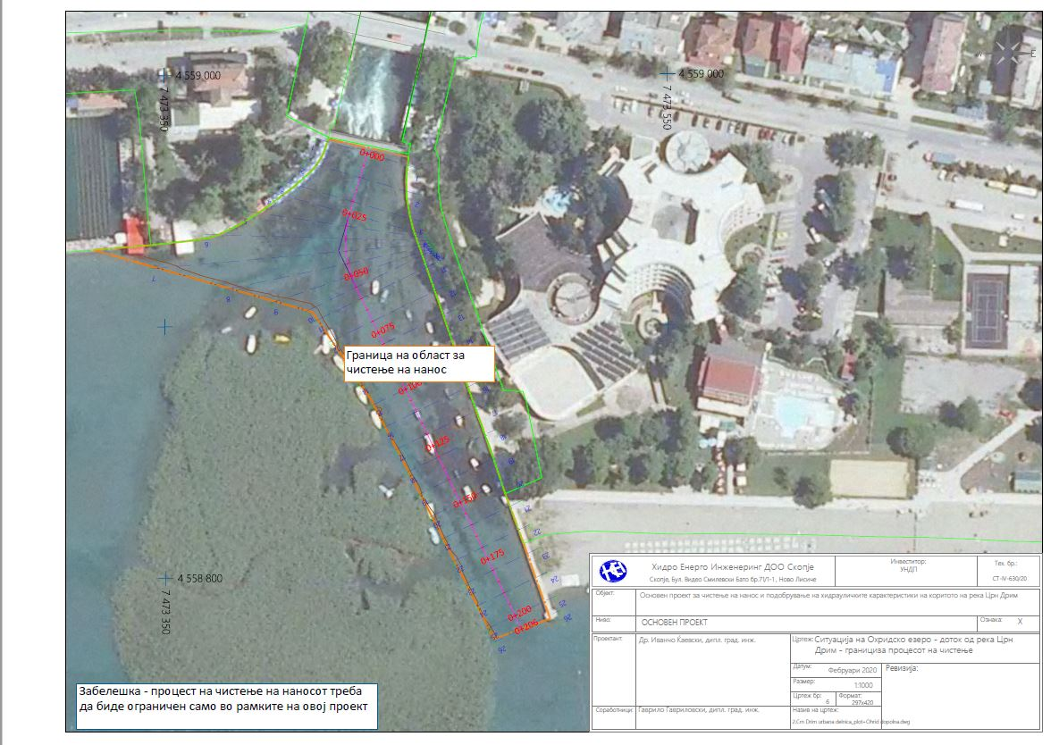

Annex 2

FORM FOR SUBMITTING SUPPLIER’S QUOTATION
(This Form must be submitted only using the Supplier’s Official Letterhead/Stationery)

We, the undersigned, hereby accept in full the UNDP General Terms and Conditions, and hereby offer to deliver supervisory services in conformity with RFQ XX/2020 for Supervision of Construction Works on Riverbed cleanup in urban part of CrnDrim River in Struga in length of 765 meters and cleaning of area of Ohrid Lake discharge point in Crn Drim River in Struga.

Item No. | Description of services | Price in MKD, VAT excluded
1 | Supervision of Construction Works on Riverbed cleanup in urban part of CrnDrim River in Struga in length of 765 meters and cleaning of area of Ohrid Lake discharge point in Crn Drim River in Struga.
TOTAL

*This shall be the basis of the payment tranches

All other information that we have not provided automatically implies our full compliance with the requirements, terms and conditions of the RFQ.

[Name and Signature of the Supplier’s Authorized Person]
[Designation]
[Date]

CVs in English with clear and relevant information about engineer’s involvement in stated projects.
This serves as a guide to the Supplier in preparing the quotation and price schedule.
Official Letterhead/Stationery must indicate contact details – addresses, email, phone and fax numbers – for verification purposes

