REQUEST FOR QUOTATION (RFQ)
(Goods)

NAME & ADDRESS OF FIRM | DATE: November 5, 2019
 | REFERENCE: RFQ/MACHINES PROD PAPER/UNDP

Dear Sir / Madam:

We kindly request you to submit your quotation for “Machines for the production of biodegradable paper” , as detailed in Annex 1 of this RFQ. When preparing your quotation, please be guided by the form attached hereto as Annex 2.

Quotations may be submitted on or before November 11, 2019and via ☒e-mail, to the address below: procurement.bi@undp.org

United Nations Development Programme

Bujumbura - Burundi

Quartier INSS, Avenue des Patriotes, N°10

Quotations submitted by email must be limited to a maximum of 5 MB, virus-free and no more than [indicate number]email transmissions. They must be free from any form of virus or corrupted contents, or the quotations shall be rejected.

It shall remain your responsibility to ensure that your quotation will reach the address above on or before the deadline. Quotations that are received by UNDP after the deadline indicated above, for whatever reason, shall not be considered for evaluation. If you are submitting your quotation by email, kindly ensure that they are signed and in the .pdf format, and free from any virus or corrupted files.

Please take note of the following requirements and conditions pertaining to the supply of the abovementioned good/s:

Delivery Terms  [INCOTERMS 2010]  (Pls. link this to price schedule) | ☒DAP
Customs clearance, if needed, shall be done by: | ☒UNDP
Exact Address/es of Delivery Location/s (identify all, if multiple) | United Nations Development Programme  Bujumbura - Burundi  Quartier INSS, Avenue des Patriotes, N°10 – Compound ONU II
UNDP Preferred Freight Forwarder, if any | N/A
Latest Expected Delivery Date and Time (if delivery time exceeds this, quote may be rejected by UNDP) | ☒ 15 days from the issuance of the Purchase Order (PO)
Delivery Schedule | ☒Required
 | ☒SEA | ☒ AIR
Preferred  Currency of Quotation | ☒United States Dollars  ☒Euro  ☒Local Currency : BIF for Local Suppliers
Value Added Tax on Price Quotation | ☒ Must be exclusive of VAT and other applicable indirect taxes
After-sales services required | ☒Warranty on Parts and Labor for minimum period of 12 months
Deadline for the Submission of Quotation | COB, Monday, November 11, 2019
All documentations, including catalogs, instructions and operating manuals, shall be in this language | ☒ English  ☒ French
Documents to be submitted | ☒ Duly Accomplished Form as provided in Annex 2, and in accordance with the list of requirements in Annex 1;  ☒ Latest Business Registration Certificate ;  ☒ Latest Internal Revenue Certificate / Tax Clearance;  ☒ Company’s profile  ☒ References of minimum three previous executed contracts
Period of Validity of Quotes starting the Submission Date | ☒ 90 days  In exceptional circumstances, UNDP may request the Vendor to extend the validity of the Quotation beyond what has been initially indicated in this RFQ. The Proposal shall then confirm the extension in writing, without any modification whatsoever on the Quotation.
Partial Quotes | ☒ Not permitted
Payment Terms | ☒ 100% upon complete delivery of goods
Evaluation Criteria  [check as many as applicable] | ☒ Technical responsiveness/Full compliance to requirements and lowest price  Comprehensiveness of after-sales services  ☒ Full acceptance of the PO/Contract General Terms and Conditions [this is a mandatory criteria and cannot be deleted regardless of the nature of services required]  ☒ Earliest Delivery / Shortest Lead Time
UNDP will award to: | ☒ One and only one supplier
Type of Contract to be Signed | ☒ Purchase Order
Contract General Terms and Conditions | ☒ General Terms and Conditions for contracts (goods and/or services)  Applicable Terms and Conditions are available at  http://www.undp.org/content/undp/en/home/procurement/business/how-we-buy.html
Special conditions of Contract | ☒ Cancellation of PO/Contract if the delivery/completion is delayed
Conditions for Release of Payment | ☒ Passing all Testing  ☒ Written Acceptance of Goods based on full compliance with RFQ requirements
Annexes to this RFQ | ☒ Specifications of the Goods Required (Annex 1)  ☒ Form for Submission of Quotation (Annex 2)  ☒ General Terms and Conditions / Special Conditions: http://www.undp.org/content/undp/en/home/procurement/business/how-we-buy.html  Non-acceptance of the terms of the General Terms and Conditions (GTC) shall be grounds for disqualification from this procurement process.
Contact Person for Inquiries  (Written inquiries only) | Derrick Mpundu  Procurment Analyst  derrick.mpundu@undp.org  Any delay in UNDP’s response shall be not used as a reason for extending the deadline for submission, unless UNDP determines that such an extension is necessary and communicates a new deadline to the Proposers.

Goods offered shall be reviewed based on completeness and compliance of the quotation with the minimum specifications described above and any other annexes providing details of UNDP requirements.

The quotation that complies with all of the specifications, requirements and offers the lowest price, as well as all other evaluation criteria indicated, shall be selected. Any offer that does not meet the requirements shall be rejected.

Any discrepancy between the unit price and the total price (obtained by multiplying the unit price and quantity) shall be re-computed by UNDP. The unit price shall prevail and the total price shall be corrected. If the supplier does not accept the final price based on UNDP’s re-computation and correction of errors, its quotation will be rejected.

After UNDP has identified the lowest price offer, UNDP reserves the right to award the contract based only on the prices of the goods in the event that the transportation cost (freight and insurance) is found to be higher than UNDP’s own estimated cost if sourced from its own freight forwarder and insurance provider.

At any time during the validity of the quotation, no price variation due to escalation, inflation, fluctuation in exchange rates, or any other market factors shall be accepted by UNDP after it has received the quotation. At the time of award of Contract or Purchase Order, UNDP reserves the right to vary (increase or decrease) the quantity of services and/or goods, by up to a maximum twenty-five per cent (25%) of the total offer, without any change in the unit price or other terms and conditions.

Any Purchase Order that will be issued as a result of this RFQ shall be subject to the General Terms and Conditions attached hereto. The mere act of submission of a quotation implies that the vendor accepts without question the General Terms and Conditions of UNDP indicated above - http://www.undp.org/content/undp/en/home/procurement/business/how-we-buy.html .

UNDP is not bound to accept any quotation, nor award a contract/Purchase Order, nor be responsible for any costs associated with a Supplier’s preparation and submission of a quotation, regardless of the outcome or the manner of conducting the selection process.

Please be advised that UNDP’s vendor protest procedure is intended to afford an opportunity to appeal for persons or firms not awarded a purchase order or contract in a competitive procurement process. In the event that you believe you have not been fairly treated, you can find detailed information about vendor protest procedures in the following link:
http://www.undp.org/content/undp/en/home/operations/procurement/protestandsanctions/

UNDP encourages every prospective Vendor to avoid and prevent conflicts of interest, by disclosing to UNDP if you, or any of your affiliates or personnel, were involved in the preparation of the requirements, design, specifications, cost estimates, and other information used in this RFQ.

UNDP implements a zero tolerance on fraud and other proscribed practices, and is committed to identifying and addressing all such acts and practices against UNDP, as well as third parties involved in UNDP activities. UNDP expects its suppliers to adhere to the UN Supplier Code of Conduct found in this link : http://www.un.org/depts/ptd/pdf/conduct_english.pdf

Thank you and we look forward to receiving your quotation.
Sincerely yours,

Annex 1

Technical Specifications

Items to be Supplied* | Quantity | Description / Specifications of Goods | Latest Delivery Date
- Machine type sharp botton paper bag making machine ( V botton ) : Dimensions = 3200 x 1800 x 1900 mm; Poids = 2000 kg; Power Voltage = 380 V/220 V,50/60 hz; Power = 10 kw;  “Or equivalent” | 2 | 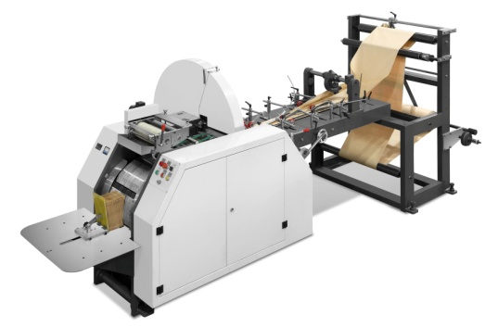 | 15 days
- Machine de RECYCLAGE ZT-F 1000 egg Tray Production line: Total Power 34 kw; Voltage 380 V 50 HZ; Capacity 800 - 1000 pcs/h  “Or equivalent” | 1 | 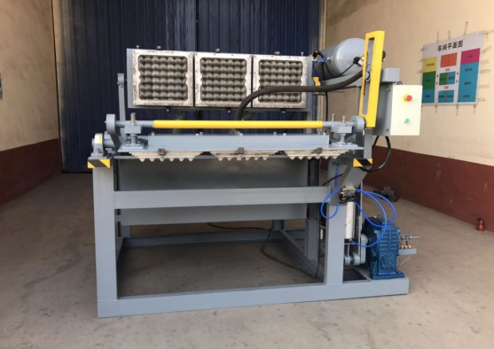 | 15 days
- PP.Woven bag Printing on Bag  Productio capacity = 20 sets/ month  Printing speed =1500-3500 /h  Machine dimension (2.9x1.4x1.2) LxWxH  Poids =1.3 tonne  Motor Power = 2.2 kw  Machine Voltage = 3P,380v  “Or equivalent” | 2 | 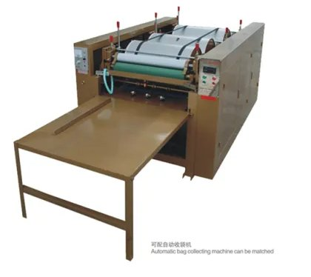 | 15 days

*Pls. attach delivery schedule, if relevant, and cluster by lot, if partial bids will be allowed. Specify delivery locations if goods multiple destinations.

[Enter name of authorized staff]
[Designation] [Click here to enter a date]
Annex 2

FORM FOR SUBMITTING SUPPLIER’S QUOTATION
(This Form must be submitted only using the Supplier’s Official Letterhead/Stationery)

We, the undersigned, hereby accept in full the UNDP General Terms and Conditions, and hereby offer to supply the items listed below in conformity with the specification and requirements of UNDP as per RFQ Reference No. RFQ/MACHINES PROD PAPER/UNDP:

TABLE 1 : Offer to Supply Goods Compliant with Technical Specifications and Requirements

Item No. | Description/Specification of Goods | Quantity | Latest Delivery Date | Unit Price | Total Price per Item
 | Total Prices of Goods
 | Add : Cost of Transportation
 | Add : Cost of Insurance
 | Add : Other Charges (pls. specify)
 | Total Final and All-Inclusive Price Quotation

TABLE 2 : Offer to Comply with Other Conditions and Related Requirements

Other Information pertaining to our Quotation are as follows : | Your Responses
 | Yes, we will comply | No, we cannot comply | If you cannot comply, pls. indicate counter proposal
Delivery Lead Time
Estimated weight/volume/dimension of the Consignment:
Country/ies Of Origin:
Warranty and After-Sales Requirements
- Minimum one (1) year warranty on parts
Validity of Quotation
All Provisions of the UNDP General Terms and Conditions

All other information that we have not provided automatically implies our full compliance with the requirements, terms and conditions of the RFQ.

[Name and Signature of the Supplier’s Authorized Person]
[Designation]
[Date]

Must be linked to INCO Terms chosen.
Depends on INCO Terms. The suggestion to use a UNDP preferred courier is only for purposes of familiarity with procedures and documentary requirements applicable to the UNDP when clearing with customs.
Local vendors must comply with any applicable laws regarding doing business in other currencies. Conversion of currency into the UNDP preferred currency, if the offer is quoted differently from what is required, shall be based only on UN Operational Exchange Rate prevailing at the time of UNDP’s issuance of Purchase Order.
This must be reconciled with the INCO Terms required by the RFQ. Furthermore, VAT exemption status varies from one country to another. Pls. tick whatever is applicable to the UNDP CO/BU requiring the goods.
First 2 items in this list are mandatory for the supply of imported goods
UNDP preference is not to pay advanced amount upon signing of contract. If vendor strictly requires advanced payment, it will be limited only up to 20% of the total price quoted. For any higher percentage, or advanced payment of $30,000 or higher, UNDP shall require the vendor to submit a bank guarantee or bank checque payable to UNDP, in the same amount as the advanced payment made by UNDP to the vendor.
UNDP reserves the right not to award the contract to the lowest priced offer, if the second lowest price among the responsive offer is found to be significantly more superior, and the price is higher than the lowest priced compliant offer by not more than 10%, and the budget can sufficiently cover the price difference. The term “more superior” as used in this provision shall refer to offers that have exceeded the pre-determined requirements established in the specifications.
This shall be used for time-critical and/or exigent requirements (e.g., post-crisis emergencies, elections, etc.).
Where the information is available in the web, a URL for the information may simply be provided.
This contact person and address is officially designated by UNDP. If inquiries are sent to other person/s or address/es, even if they are UNDP staff, UNDP shall have no obligation to respond nor can UNDP confirm that the query was received.
This serves as a guide to the Supplier in preparing the quotation and price schedule.
Official Letterhead/Stationery must indicate contact details – addresses, email, phone and fax numbers – for verification purposes
Pricing of goods should be consistent with the INCO Terms indicated in the RFQ
If the country of origin requires Export License for the goods being procured, or other relevant documents that the country of destination may require, the supplier must submit them to UNDP if awarded the PO/contract.

