REQUEST FOR QUOTATION (RFQ 100/2020)

RFQ 100/2020 Identifying possible transmission paths of six-valent chrome through the underground waters in Zeden Massif and their impact on Rashce spring | DATE: September 11, 2020
Requesting project:
Resilient Skopje: Scaling-up for Sustainability, Innovation and
Climate Change

Dear Sir / Madam:

We kindly invite you to submit your quotation in MKD, Vat exempt under RFQ 100/2020 for Identifying possible transmission paths of six-valent chrome through the underground waters in Zeden Massif and their impact on Rashce spring, as detailed in Annex 1 of this RFQ. When preparing your quotation, please be guided by the form attached hereto as Annex 3.

Quotations shall be submitted on or before September 28, 2020 by 11:00am via dedicated email: offers.mk@undp.org

Subject: RFQ 100/2020 for six-valent chrome-Company’s name

It shall remain your responsibility to ensure that your quotation will reach UNDP before the deadline. Quotations that are received by UNDP after the deadline indicated above, for whatever reason, shall not be considered for evaluation.

Please take note of the following requirements and conditions pertaining to the supply of the abovementioned works

Delivery Terms  [INCOTERMS 2010]  (Pls. link this to price schedule) | ☐FCA  ☐CPT  ☐CIP  ☐DAP  ☒ n/a
Customs clearance, if needed, shall be done by: | ☐UNDP  ☐Supplier/Offeror  ☐Freight Forwarder  n/a
Exact Address/es of Delivery Location/s (identify all, if multiple) | UNDP,Project Manager
UNDP Preferred Freight Forwarder, if any | ^{n/a}
Distribution of shipping documents (if using freight forwarder) | n/a
Latest Expected Delivery Date and Time (if delivery time exceeds this, quote may be rejected by UNDP) | ☒ 8 months  ☐ As per Delivery Schedule attached  Time:  Time Zone of Reference:
Delivery Schedule | ☒Required  ☐ Not Required
Packing Requirements | n/a
Mode of Transport | ☐ AIR | ☐LAND
 | ☐SEA | ☒ n/a
Preferred  Currency of Quotation | ☐United States Dollars  ☐Euro  ☒Local Currency : MKD
Value Added Tax on Price Quotation | ☐ Must be inclusive of VAT and other applicable indirect taxes  ☒ Must be exclusive of VAT
After-sales services required | ☐Warranty on Parts and Labor for minimum period of Click to type  ☐Technical Support  ☐Provision of Service Unit when pulled out for maintenance/ repair  n/a
Deadline for the Submission of Quotation | Monday, September 28, 2020 by 11:00am
All documentations requested, (including catalogs, instructions and operating manuals), shall be in this language | ☒ English (except copies of original documents shall be submitted in Macedonian, no translation required)  ☐ French  ☐ Spanish  ☒ Macedonian (copies of original documents)
Documents to be submitted | Following Documents Establishing Offeror’s Eligibility & Qualifications must be submitted and include the following:  Required documents :  FOR THE COMPANY  ☒ Company Profile reflecting the relevant experience (brief of the company, experience, Quality Certificate (e.g., ISO, etc.)  ☒ Certificate of Registration of the business (Tekovna sostojba)  ☒ Copy of the Authorization for preparation of geological documentation, construction and supervision of geological research issued by the Ministry of Economy  ☒ List of relevant projects only (as required in the TOR)  (fill in the table 1 under Annex 1.1)  List of relevant projects needs to be submitted along with contact details for reference checking purposes (please indicate the e-mail addresses or fax numbers of contact persons).  ☒ Please provide a list of ongoing projects and time for completion.  ☒ Self-Declaration that the company is not in the UN Security Council 1267/1989 List, UN Procurement Division List or Other UN Ineligibility List  FOR THE EXPERTS  ☒ CVs of all Experts/Team Members reflecting their experience. Also please fill in the table 2 under Annex 1.1  ☒ Sattement of availability / Written confirmation from each personnel that they are available for the entire duration of the contract.  ☒ Financial Offer (BoQ) expressed in MKD, VAT presented separately
Way of submission of documents by Email: | Documents to be submitted by email to dedicated email: offers.mk@undp.org  Subject: RFQ100/2020 six-valent chrome- Bidder’s name  Format: PDF files  All files must be in PDF and free of viruses and not corrupted.  Technical and Financial OFFER must be separately uploaded as TWO separate documents.  Max. size of uploaded files (per document) must not exceed: 30 MB  All submitted files should be in the following format:  Companyname_nameofthefile.pdf (or .docx)  FINANCIAL offer (BoQ) will be submitted as Excel file and as PDF separate file, DIGITALLY signed and or signed and scanned in the .pdf format.
Period of Validity of Quotes starting the Submission Date | ☐ 60 days  ☐ 90 days  ☒ 120 days  In exceptional circumstances, UNDP may request the Vendor to extend the validity of the Quotation beyond what has been initially indicated in this RFQ. The Proposal shall then confirm the extension in writing, without any modification whatsoever on the Quotation.
Partial Quotes | ☒ Not permitted  ☐ Permitted [pls. provide conditions for partial quotes, and ensure that requirements are properly listed to allow partial quotes (e.g., in lots, etc.)]
Payment Terms | ☒ in installments upon successful completion of deliverables  - 1st installment -upon the realization of hydrogeological mapping– not later than 10 November 2020  - 2nd installment -upon realization of the geophysical research–not later than 15 December 2020  - 3rd installment - upon installment of the 2 piezometers – not later than 30 March 2021  - 4th installment - upon approval of the Final Report – not later than 30 May 2021  ☐ Based upon Invoices submitted.  ☐ Invoices reflecting final payment certificates shall be paid within 30 (thirty) days of the date of their receipt and acceptance by UNDP.
Liquidated Damages | n/a
Evaluation Criteria  [check as many as applicable] | ☒ Technical responsiveness/Full compliance to requirements and lowest price  Comprehensiveness of after-sales services  ☒ Full acceptance of the Contract General Terms and Conditions  ☐ Earliest Delivery / Shortest Lead Time  ☐ Others [pls. specify]
UNDP will award to: | ☒ One and only one supplier  ☐ One or more Suppliers
Type of Contract to be Signed | ☒ minime Contract for services  ☐ Long-Term Agreement (if LTA will be signed, specify the document that will trigger the call-off. E.g., PO, etc.)  ☐ Other Type/s of Contract [pls. specify]
General Terms and Conditions | http://www.undp.org/content/undp/en/home/procurement/business/how-we-buy.html  Non-acceptance of the terms of the General Terms and Conditions (GTC) shall be grounds for disqualification from this procurement process.
Special conditions of Contract | ☐ n/a  ☐ Others
Conditions for Release of Payment | The payment will be processed in the following tentative installments:  ☒ Passing all Testing All the phases of the installation and the piezometers must be approved by representative/s from the City of Skopje and the PE Vodovod I Kanalizacija.  ☐ Completion of Training on Operation and Maintenance  ☒ Installments: Flexible, linked to the Construction Contractor’s payment certificates (invoice amount shall be equal to the percentage of works completed)  ☒ Payments will be done upon submitted invoice
Annexes to this RFQ | ☒ Terms of reference (TOR) (Annex 1)  ☒ Table to fill in for relevant experience/projects (Annex 1.1)  ☒ Form for Submission of Quotation (Annex 2)  ☒ Evaluation Criteria (Annex 3)
Contact Person for Inquiries  (Written inquiries only) | Procurement Official  Procurement.mk@undp.orgProcurement.mk@undp.org  Written inquiries only Written inquiries only  Any delay in UNDP’s response shall be not used as a reason for extending the deadline for submission, unless UNDP determines that such an extension is necessary and communicates a new deadline to the Proposers.

Goods offered shall be reviewed based on completeness and compliance of the quotation with the minimum specifications described above and any other annexes providing details of UNDP requirements.

The quotation that complies with all of the specifications, requirements and offers the lowest price, as well as all other evaluation criteria indicated, shall be selected. Any offer that does not meet the requirements shall be rejected.

Any discrepancy between the unit price and the total price (obtained by multiplying the unit price and quantity) shall be re-computed by UNDP. The unit price shall prevail and the total price shall be corrected. If the supplier does not accept the final price based on UNDP’s re-computation and correction of errors, its quotation will be rejected.

After UNDP has identified the lowest price offer, UNDP reserves the right to award the contract based only on the prices of the goods in the event that the transportation cost (freight and insurance) is found to be higher than UNDP’s own estimated cost if sourced from its own freight forwarder and insurance provider.

At any time during the validity of the quotation, no price variation due to escalation, inflation, fluctuation in exchange rates, or any other market factors shall be accepted by UNDP after it has received the quotation. At the time of award of Contract or Purchase Order, UNDP reserves the right to vary (increase or decrease) the quantity of services and/or goods, by up to a maximum twenty five per cent (25%) of the total offer, without any change in the unit price or other terms and conditions.

Any Purchase Order that will be issued as a result of this RFQ shall be subject to the General Terms and Conditions attached hereto. The mere act of submission of a quotation implies that the vendor accepts without question the General Terms and Conditions of UNDP herein attached as Annex 3.

UNDP is not bound to accept any quotation, nor award a contract/Purchase Order, nor be responsible for any costs associated with a Supplier’s preparation and submission of a quotation, regardless of the outcome or the manner of conducting the selection process.

Please be advised that UNDP’s vendor protest procedure is intended to afford an opportunity to appeal for persons or firms not awarded a purchase order or contract in a competitive procurement process. In the event that you believe you have not been fairly treated, you can find detailed information about vendor protest procedures in the following link:
http://www.undp.org/content/undp/en/home/operations/procurement/protestandsanctions/

UNDP encourages every prospective Vendor to avoid and prevent conflicts of interest, by disclosing to UNDP if you, or any of your affiliates or personnel, were involved in the preparation of the requirements, design, specifications, cost estimates, and other information used in this RFQ.

UNDP implements a zero tolerance on fraud and other proscribed practices, and is committed to identifying and addressing all such acts and practices against UNDP, as well as third parties involved in UNDP activities. UNDP expects its suppliers to adhere to the UN Supplier Code of Conduct found in this link : http://www.un.org/depts/ptd/pdf/conduct_english.pdf

Thank you and we look forward to receiving your quotation.

Annex 1
Terms of Reference
(works and services)
Identifying possible transmission paths of six-valent chrome through the underground waters in Zeden Massif and their impact on Rashce spring

Project: Resilient Skopje: Scaling-up for Sustainability, Innovation and Climate Change
Location Skopje, North Macedonia
Expected Duration of Assignment: 8 months (October 2020- May 2021)

Background

Since July 2018, UNDP and the City of Skopje are implementing the project:” Resilient Skopje: Scaling-up for Sustainability, Innovation and Climate Change”. The main project objective is to assist the City of Skopje to become more resilient to climate change and other environmental challenges. One of main outputs of the project comprises a set of interlinked activities aiming at improving the scientific information and data in the field of environment that will enhance the evidence-based decision making in the City of Skopje and determine future actions that will advance the local environmental agenda.

As part of this project output, the possible transmission paths of six-valent chrome (Cr⁶⁺⁾ through the underground waters in Zeden Massif will be identified and their impact on Rashce spring. Some rapid assessments done in the past years indicate that six-valent chrome (Cr⁶⁺) from the Chemical Metallurgical Capacity - Jugohrom Ferroalloys DOO might get to the Rashce spring through the Zeden Massif underground waters system.

The Rashce spring is a basic source for water supply of drinking water for the City of Skopje, and thus it is extremely important to ensure that the quality of the water is up to standard, and that no polluting and/or harmful substances are endangering the spring. Numerous studies have been produced related to the origin of the water, its reserves, as well as the risks of pollution and preservation of water quality.

This spring is located on the margin of the cracked karst aquifer formed in the carbonate Zeden Massif, in the locality of the village Rashce, at an altitude of about 300 meters and at a distance of 17 km west of the city of Skopje. The average capacity of the spring is 5m³/sec and a total annual capacity of about 155 million m³.

Due to the presence of potential sources of pollution in the Polog Valley from one side and the Zeden Massif aquifer potentially endangered by them on the other side, the matter of safety of water quality from the Rashce spring must be studied. Above all, the closeness of the location of the industrial landfill from the former Chemical Metallurgical Capacity - Jugohrom Ferroalloys DOO from Jegunovce is important, which is in the locality of the Zeden Massif.

The potential pollution from six-valent chrome (Cr⁶⁺) and its migration through the Zeden massif has been the subject of several studies but there is not enough reliable information about the possibilities, transmission path and time required for movement of six-valent chrome (Cr⁶⁺) from the potential pollution zone of the landfill Jugohrom through the Zeden massif to the Rasche spring.

For that purpose, a large number of exploratory boreholes have been drilled, a good part of which are formed as piezometric boreholes where the groundwater level and quality can be monitored. All the performed exploratory piezometric boreholes are located along the edges of the Zeden massif. There is currently no piezometer inside the massif. Several exploratory boreholes were drilled in the 1960s but were not designed to be piezometric boreholes so they cannot serve as monitoring points in the future and they have lost their original function. With the drilling of the new deep hydrogeological structural boreholes inside the Zeden Massif, there would be a better insight into the interaction of the water bodies and the potential contamination of the Rasche spring with six-valent chrome (Cr⁶⁺), as well as the possible transmission paths. The need to perform hydrogeological exploratory boreholes inside the massif is to study karstification, groundwater regime, and by forming them as piezometric boreholes to serve as monitoring points for groundwater level observation and for testing the quality of the water.

Therefore, the project will support exploratory works for identifying possible transmission paths of the six-valent chrome through the Zeden Massif and to determine if this harmful substance is endangering the Rasche spring.

Scope of Work
The aim of the activity is to perform exploratory works for defining the transmission paths of the six-valent chrome of the groundwater through the Zeden Massif that feed the Rasche spring, and to determine if this harmful substance is endangering the Rasche spring. For that purpose, exploratory works and installation of two piezometric boreholes in the Zeden Massif are envisaged, in order to explore the possibilities, transmission path and time of movement of six-valent chrome (Cr⁶⁺) from the potential pollution zone of the landfill Jugohrom to the Rashce spring . The two deep structural boreholes should be constructed in the inner core of the Zeden Massif with depth of 30-50 m below the groundwater level along the profile line from the landfill Jugohrom to the Rasche spring. The proposed locations of the piezometers can be seen in Figure 1. The selection and micro locating of exact locations for the new piezometers, will be performed after the hydrogeological analysis and mapping of the area and after the geophysical seismic investigations of the area are performed.
The piezometric holes will provide information on the geological structure of the Zeden Massif, the type, degree and depth of karstification, by mapping of the core of the piezometric borehole along its entire length. After the piezometers are installed in the drilled piezometric boreholes it will help define the possible transmission paths of the Cr⁶⁺ and perform chemical analyzes of the water so the presence of six-valent chrome (Cr⁶⁺) will be examined. The results of the performed research and examinations will be presented in a report on the performed works.
Since the construction works will be performed in the First Protection Zone of the Rasche spring, it is necessary to apply the strictest measures of environmental protection.

Duties and Responsibilities
Under the supervision of the Project Manager and in close cooperation with the representatives of City of Skopje and PE Vodovod I kanalizacija - Skopje, the Contractor shall be responsible for carrying out the following tasks:

- Hydrogeological analysis and mapping of the terrain area:
- Hydrogeological mapping of the entire carbonate Zeden Massif with an area of 133 km², together with the close surrounding contact zones and the abysses in the village of Rotince, with a total area of 150 km². Attention should be put to the analysis and study of the karstification of the massifs surface, as well on the contact zones of the river Vardar with the Zeden Massif and detection of possible zones of infiltration of surface water in the massif;
- The hydrogeological mapping of the terrain will also take into consideration the locations of abysses in the village of Raotince, as well as the contact zone of the Zeden massif with the Polog valley.

- Field activities for selection of micro-locations and geophysical seismic investigations
- The micro locations should be selected along the profile line from the Jugohrom landfill through the Zeden massif to the Rashce spring. The profile line should represent a possible, shortest and most anticipated path for movement of six-valent chrome (Cr⁶⁺) from the potential pollution zone of the landfill Jugohrom to the Rashce spring;
- Geophysical seismic investigations are needed in order to define the karst zones in the envisaged zones for drilling of exploratory boreholes;
- According to the morphological conditions of the area, two locations have been pre-selected where two exploratory piezometric boreholes can be drilled and piezometric pipes can be installed in them;
- Geophysical seismic investigations should be performed in the two pre-selected locations (SP-1 and SP-2, see Figure 1) in order to select the micro- locations for the investigation boreholes in terms of defining the karst zones and their drilling. The investigation should be performed at location SP-1 on profile line in length of 250m and in-depth grip 250m and at location SP-2 on profile line in length of 750m and in-depth grip 500m. Access to both pre-selected locations can be difficult, because there is no road infrastructure in the area.

- Installation of piezometers
- Installation of two structural exploratory boreholes with machine core drilling;
- Estimated depth of the exploration boreholes is 220m and 425m. The exact depth will be determined on site, depending on the final selection of the micro-locations based on the results of geophysical research, current monitoring and analysis of the geological profile, karstification and groundwater level. The drilling the boreholes must be with depth of 30-50 m below the groundwater level;
- Mapping and photographing of the core of the installed boreholes along its entire length with special attention to karstification;
Installing of piezometric constructions (pipes) in the piezometric boreholes. The piezometric constructions should be made of hot-dip galvanized steel with diameter 2” (50 mm) and wall thickness of 3.5 mm. In the aquifer zone, under the groundwater level a perforated pipe with circular openings 3 mm and a percentage of perforation min of 8% should be installed. A schematic presentation of the piezometric constructions of a deep piezometer is given in Figure 5;
- The interspace must be filled with river filter filling with a fraction of 4-8 mm;
- Rinsing and purifying of the piezometers with clean water with quantity of min 60 l/min, for a period of 3-5 hours per piezometer. In order to protect the piezometers, a concrete pillar with a metal cover and padlock should be made for each of them.

- Water sample analysis and final report
- In the period after the installation of each piezometer is completed and at least 14 days after the rinsing and purifying of the piezometers with clean water , water samples should be taken from the piezometers for water quality analysis and preparation of complete physical-chemical analysis of the water and six valent chrome (Cr⁺⁶) content. The analyses should be made in certified laboratory;
- For the completed works a final report should be prepared, which should contain all the data for the installed piezometers and all the data from the completed research works and analyzes should be explained, analyzed and presented in the textual, tabular and graphic form. The following elements should be addressed and analyzed as part of the final report:
- hydrogeological conditions and mapping of the environment;
- geophysical seismic investigations of the environment;
- data on the installed piezometers;
- transmission paths of the six valent chrome (Cr⁺⁶);
- results from the water physical-chemical analyzes.

Main Outputs/Deliverables

The main deliverables of the assignment are:

- 1st installment -upon the realization of hydrogeological mapping– not later than 10 November 2020
- 2nd installment -upon realization of the geophysical research–not later than 15 December 2020
- 3rd installment - upon installment of the 2 piezometers – not later than 30 March 2021
- 4th installment - upon approval of the Final Report – not later than 30 May 2021

QUALIFICATION REQUIREMENTS
The company shall have minimum 5 years of experience in developing and managing complex projects in construction of piezometric boreholes /hydrological explorations /groundwater explorations /construction (drilling) of wells for groundwater exploitation / geology / hydrogeology and similar.
The company must have a track record of a minimum 5 relevant projects of comparable degree of complexity. The successfully completed projects shall include technical works in construction of piezometric boreholes/hydrological explorations/groundwater explorations or similar.
A list of these projects must be submitted with the offer, timeframe (start-end date) for completed works/projects, including contact details for reference checking purposes (e-mail addresses for contact persons).
The company must hold Authorization for preparation of geological documentation, construction and supervision of geological research issued by the Ministry of Economy.
The scope of work requires a multidisciplinary team of skilled professionals with previous experience in similar groundwater /hydrogeological /hydrological and geology projects. Team members shall possess excellent relevant technical skills in order to successfully implement the assignment.

The team of experts shall be able to respond to the requirements of the following mandatory areas of expertise
 | Team members  and/or  areas of expertise | Qualification requirements of Lead experts
1. | Team Leader / Hydrogeology | Advanced university degree (minimum M.Sc.) in relevant area (geology / hydrology / hydrogeology / or similar). PhD in the relevant area shall be considered an asset.  Minimum 7 years of professional experience in similar assignments (construction of piezometric boreholes / hydrological explorations / groundwater explorations / construction of piezometric boreholes / construction of wells for groundwater exploitation/geology/ hydrogeology/ hydrogeological construction works or similar)  Track record of minimum 5 relevant projects of comparable degree of complexity (construction of piezometric boreholes / hydrological explorations/groundwater explorations/construction of piezometric boreholes/construction of wells for groundwater exploitation/ geology/hydrogeology/hydrogeological construction works or similar)
2. | Geology expert | University degree in civil engineering/geology/geotechnics or similar. Advanced degree will be considered an asset.  At least 3 years of experience in the field of drilling works for groundwater exploration/ piezometric boreholes or similar.  Track record of minimum 4 relevant projects of comparable complexity (drilling works for groundwater exploration/ geophysical exploration/piezometric boreholes/ geophysical seismic investigation or similar)
3. | Drilling labor | Minimum 3 years of experience in drilling or any related area of work  Any other relevant qualification (license or certificate, permit, etc.) for the related type of works.

NOTES:
- One of Team of Experts must serve as a Team Leader.
- Failure to provide adequate expertise (or failure to meet any of the min. requirements) for each of the areas is considered grounds for disqualification.

Terms and conditions for provision of services
Reporting requirements
The Contractor will report about the progress of the works monthly to the UNDP Project Manager through the Team Leader.Each stage of the construction works of must be photo documented and proved for each step (for example, depth of borehole confirmation, etc.)
Language
The final report shall be submitted in Macedonian and English language. It is Contractor’s responsibility to ensure high quality proofreading of the produced report. The quality of the report is subject to UNDP for approval.
Sources of data
The Contractor has the general responsibility for collecting the required data, evaluating its quality, and incorporating it into the work. The Contractor should own all the necessary documents (permits, elaborates or similar) for starting up of the construction works.
Specification of works
The specification of works (Figure6) should be completed as part of the bidders offer.
Ownership and submission of data, reports and other material produced
The final report shall be made available to UNDP and City of Skopje in 3 (three) hard copy and 2(two) electronic copies. All data acquired during the assignment will be in the ownership of the City of Skopje and cannot be used by the Contractor.
The constructed piezometers are subject of approval and in the ownership of the beneficiary (The City of Skopje and PE Vodovod I Kanalizacija).

Quality assurance
All the phases of the installation and the piezometers must be approved by representative/s from the City of Skopje and the PE Vodovod I Kanalizacija.
Assignment Workstation
The construction of the piezometers will be done in the Zeden Massif area, in the locality from the landfill Jugohrom to the Rasche spring.

Timeframe
The assignment must be completed in a period of maximum 8 months after the signing of the contract. The completion of the assignment is expected not later than May 2021.
Payments, travel and other associated costs
The whole assignment will be consisted of home based and field work. The Contractor shall ensure that all the necessary staff and additional technical resources (e.g. organizing field work, transportation, laboratory analyses, technical equipment, permits, translation services and other) required for efficient finalization of the assignment must be provided by the contractor and shall be calculated within the financial offer. UNDP shall not accept any additional expenses which aren't included in the company's financial offer.
The payment will be processed after the completion of the deliverables in three instalments:
- 1st installment upon the realization of hydrogeological mapping– not later than 10 November 2020
- 2nd installment upon realization of the geophysical research–not later than 15 December 2020
- 3rd installment upon installment of the 2 piezometers – not later than 30 March 2021
- 4th installment - upon approval of the Final Report – not later than 30 May 2021

Annex 1A
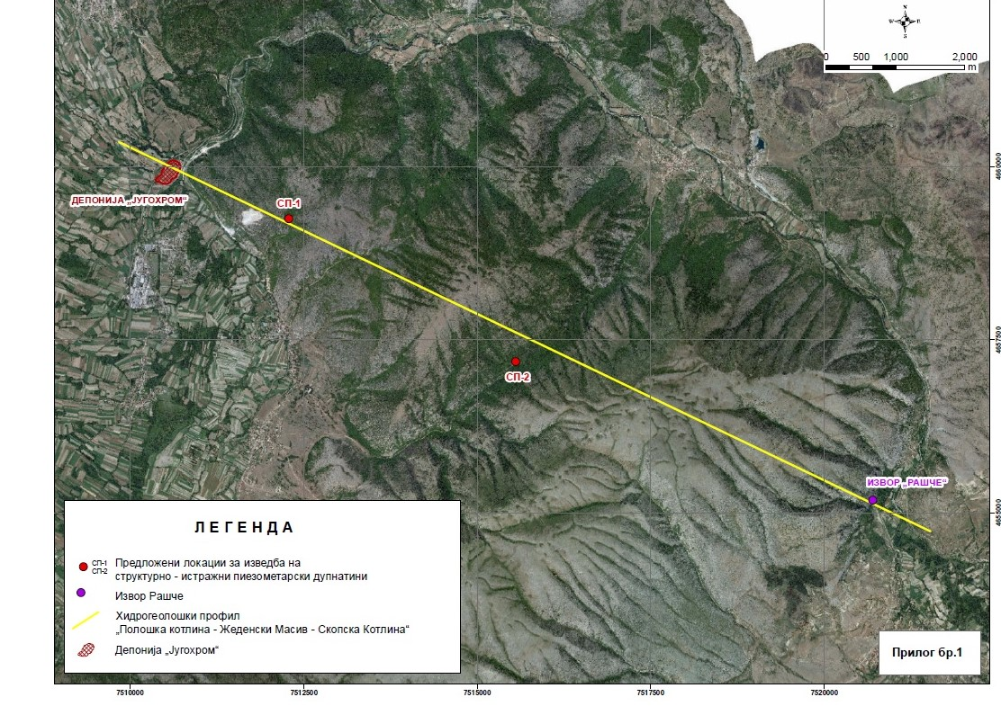
Figure 1-The map with the proposed locations of the piezometers, from the landfill Jugohrom to the spring Rasche

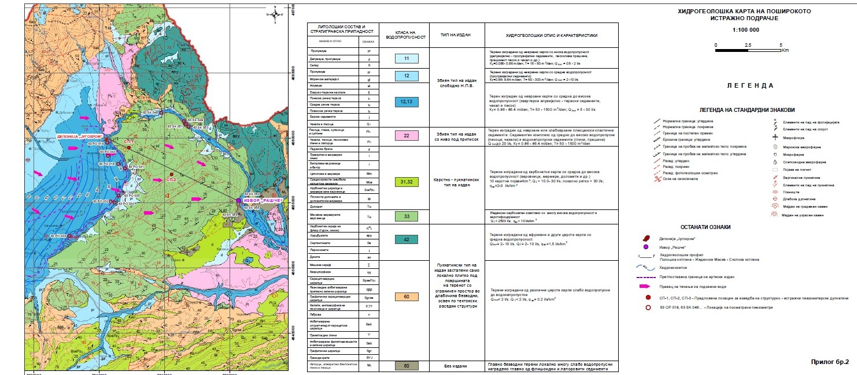
Figure 2-Hydrogeological map with locations of the exploration area-piezometers

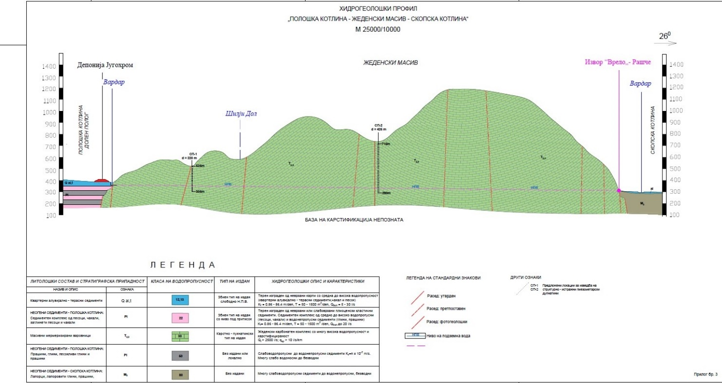
Figure 3- Hydrogeological profile of the area

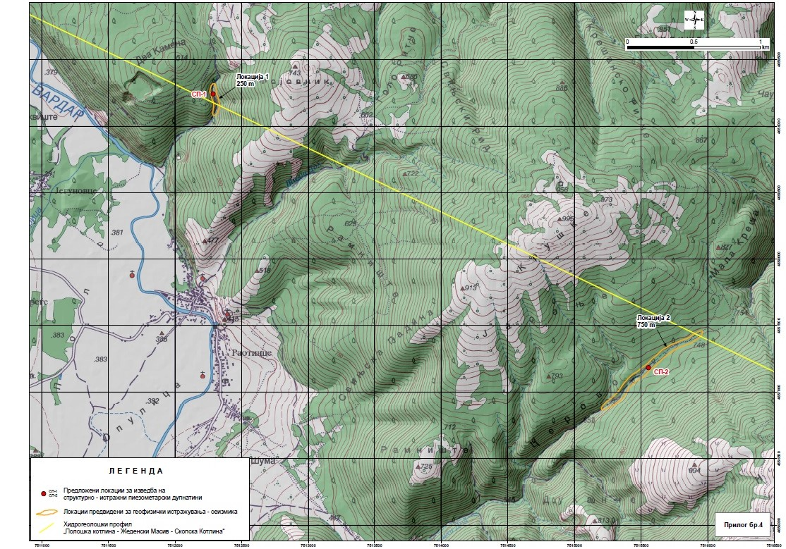
Figure 4 -Topographic map with locations of the exploratory piezometers (SP-1 and SP-2)

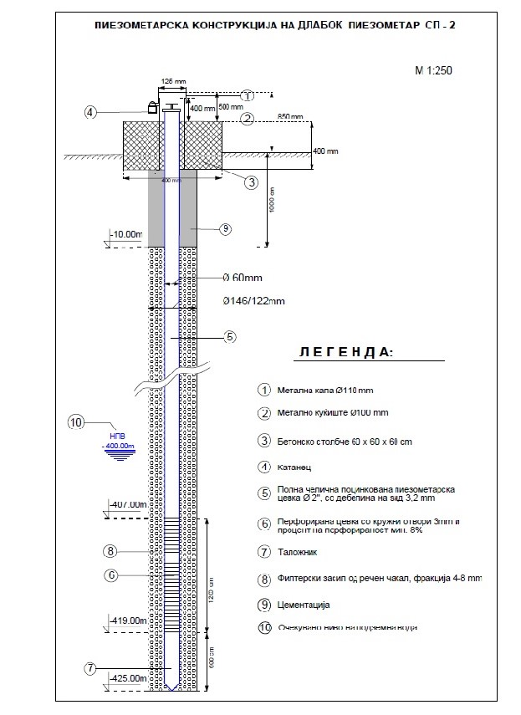
Figure 5-A schematic presentation of the piezometric constructions of a deep piezometer

Table 1. For the Company/Service provider

Please fill in the table below to summarize the relevant projects
The full reference list of projects shall also be provided separately, but it shall not exceed 15.
Titles of TOP 5 relevant projects | Timeframe (start-end date) | References Contact Details (Name /Email) | Briefly elaborate the title/relevance of the project
1.
2.
3.
4.
5.

2. For the Key Personnel
Please fill in the table below as per the requirements of the ToR, for each of the proposed Key Personnel.
No. | Position | TOP 5 relevant projects (as per requirements in TOR ) | Total experience/  experience in relevant projects (years)
1. | Team Leader / Hydrogeology | 1.  2.  3.  4.  5.
2. | Geology expert | 1.  2.  3.  4.
3. | Drilling labor

3. Availability confirmation form (to be filled by all proposed experts)

I _______________________ (name, last name), agree that the entity _____________ (name of the applicant entity) will use my CV for the tender application under this RFP

I declare that the information provided in my CV is accurate, and I am able to provide relevant evidence (reference letters, job contracts, etc.) upon request.
If the entity _____________ (name of the applicant entity), is selected for contract, I agree to be available under the conditions given in the ToR.

Name and last name: _______________________
(as in your ID document)

Signature: _________________

Date: __________________

Annex 2

FORM FOR SUBMITTING SUPPLIER’S QUOTATION
(This Form must be submitted only using the Supplier’s Official Letterhead/Stationery

Skopje
Date: ___________
To: UNDP

Dear Sir/Madam:

We, the undersigned, hereby accept in full the UNDP General Terms and Conditions, and hereby offer to supply the services listed below in conformity with the specification and requirements of UNDP as per RFQ 100/2020 for Identifying possible transmission paths of six-valent chrome in Zeden Massif in the total amount of ____________________________________MKD, VAT excluded, as per detailed BoQ.

The specification of works-Bill of quantities (BoQ)

Реден број | Опис на работите | Единица мерка | Количина | Единечна цена (МКД) | Вкупна цена (МКД)
Installment 1

1.1 | Хидрогеолошко картирање на теренот во М 1:25 000, со посебен осврт на карстифицираност на теренот и контакт р.Вардар со Жеден | km² | 150
1.2 | Припремни работи, транспортни трошоци, прочистување на пристапни патишта и зарамнување на терен на локации за дупчење, ископ на базени | Локации | 2
Installment 2
1.3 | Геофизички,сеизмички истражувања за дефинирање на карстифицирани и раздробени зони. ИБ-1 на профил од 250м и длабински зафат 250м, ИБ-2 на профил 750м и длабински зафат 500м | m | 1000
Installment 3
1.4 | Изведба на хидрогеолошко структруно истражно дупчење на 1 (еден) пиезометар до длабина од 425 метра, услов 30-40 метра под НПВ. Завршен пречник на дупчење Ø 96 mm | m | 220
1.5 | Изведба на хидрогеолошко структруно истражно дупчење на 1 (еден) пиезометар до длабина од 425 метра, услов 30-40 метра под НПВ. Завршен пречник на дупчење Ø 96 mm | m | 425
1.6 | Обезбедување на техничка вода за хидрогеолошко истражно дупчење | m | 645
1.7 | Картирање и фотографирање на јадро од изведените истражни дупнатини | m | 645
1.8 | Набавка, подготовка и вградување на челични поцинкувани пиезометарски конструкции 2" дебелина на ѕид 3,2 mm, полни и филтерски цевки со кружна перфорација со ширина на отвори 3mm мин перфорација 8%. | m | 645
1.9 | Испирање на пиезометрите со чиста вода 3-5h по пиезометар, со втискување на чиста вода во количина од мин 60лит/мин | h | 8
1.10 | Изработка на бетонско заштитно столбче на пиезометри и метален поклопец со клуч, со цел нивна заштита и осигурување | парче | 2
Installment 4
1.11 | Земање на примероци од вода за изработка на комплетни физичко-хемиски анализи и содржина на Cr⁶+; Од двата пиезометри, од река Вардар и од други карактеристични места | анализа | 6
1.12 | Анализа и обработка на податоците од изведените истражувања и изработка на извештај со препорака за следна фаза | паушал | 1
Вкупно без ДДВ

All other information that we have not provided automatically implies our full compliance with the requirements, terms and conditions of the RfQ.

We hereby declare that:

- All the information and statements made in this Bid are true and we accept that any misrepresentation contained in it may lead to our disqualification;
- We are currently not on the removed or suspended vendor list of the UN or other such lists of other UN agencies, nor are we associated with, any company or individual appearing on the 1267/1989 list of the UN Security Council;
- We have no outstanding bankruptcy or pending litigation or any legal action that could impair our operation as a going concern; and
- We do not employ, nor anticipate employing, any person who is or was recently employed by the UN or UNDP.

We confirm that we have read, understood and hereby fully accept the Schedule of Requirements and Technical Specifications describing the duties and responsibilities required of us in this RfQ, and the General Terms and Conditions of UNDP’s Standard Contract for this RfQ.

We agree to abide by this Bid for 60 days.

We undertake, if our Bid is accepted, to commence the Works and provision of related services not later than the date indicated in the Data Sheet.

We fully understand and recognize that UNDP is not bound to accept this Bid, that we shall bear all costs associated with its preparation and submission, and that UNDP will in no case be responsible or liable for those costs, regardless of the conduct or outcome of the evaluation.

We remain,

Yours sincerely,

Authorized Signature [In full and initials]:
Name and Title of Signatory:
Name of Firm:
Contact Details:

[please mark this letter with your corporate seal, if available]

Annex 3
Evaluation criteria

Evaluation criteria
Contract will be awarded to the Bidder that meets the criteria based on pass/fail method and offers the lowest offer.

Minimum Requirements |  | Status
For the Company: |  | YES/NO
 | - Authorization for preparation of geological documentation, construction and supervision of geological research issued by the Ministry of Economy | YES/NO
 | - The company shall have minimum 5 years of experience in developing and managing complex projects in construction of piezometric boreholes /hydrological explorations /groundwater explorations /construction (drilling) of wells for groundwater exploitation / geology / hydrogeology and similar. | YES/NO
 | - The company must have a track record of a minimum 5 relevant projects of comparable degree of complexity. The successfully completed projects shall include technical works in construction of piezometric boreholes/hydrological explorations/groundwater explorations or similar. | YES/NO
Team Leader / Hydrogeology
 | - Advanced university degree (minimum M.Sc.) in relevant area (geology / hydrology / hydrogeology / or similar). PhD in the relevant area shall be considered an asset.
 | - Minimum 7 years of professional experience in similar assignments (construction of piezometric boreholes / hydrological explorations / groundwater explorations / construction of piezometric boreholes / construction of wells for groundwater exploitation/geology/ hydrogeology/ hydrogeological construction works or similar). | YES/NO
 | Track record of minimum 5 relevant projects of comparable degree of complexity (construction of piezometric boreholes / hydrological explorations/groundwater explorations/construction of piezometric boreholes/construction of wells for groundwater exploitation/ geology/hydrogeology/hydrogeological construction works or similar) | YES/NO
Geology expert
 | - University degree in civil engineering/geology/geotechnics or similar. Advanced degree will be considered an asset. | YES/NO
 | - At least 3 years of experience in the field of drilling works for groundwater exploration/ piezometric boreholes or similar | YES/NO
 | - Track record of minimum 4 relevant projects of comparable complexity (drilling works for groundwater exploration/ geophysical exploration/piezometric boreholes/ geophysical seismic investigation or similar) | YES/NO
Drilling labor
 | - Minimum 3 years of experience in drilling or any related area of work | YES/NO
 | - Any other relevant qualification (license or certificate, permit, etc.) for the related type of works. | YES/NO

CVs in English with clear and relevant information about reviewer’s involvement in stated projects.

