Scope of Work Annex 1
Rehabilitation of Alhadayek Clinic, Benghazi City, Libya

1. Introduction/Background:
The Alhadayek Clinic is one of the main Public Clinics in the city of Benghazi which serves all of Benghazi city citizens especially the nearby neighborhoods. which provides medical services in different departments from vaccination to motherhood, childcare, dentist, nursery and OPD
The Alhadayek Clinic is located in the heart of Benghazi (30.096982, 20.104154) in a residential area of Alhadayek. Due to the lengthy period passed on the clinic without any rehabilitation works and also using the clinic during the armed conflict period as a shelter for refugees, the clinic is in a poor condition and need to be rehabilitated the soonest
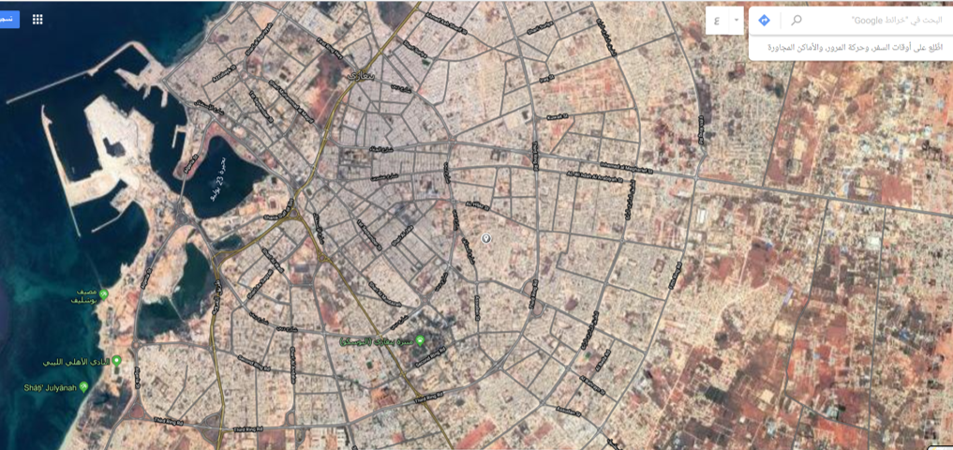
The clinic consists of two story precast buildings and it has been in operation since early 1990s

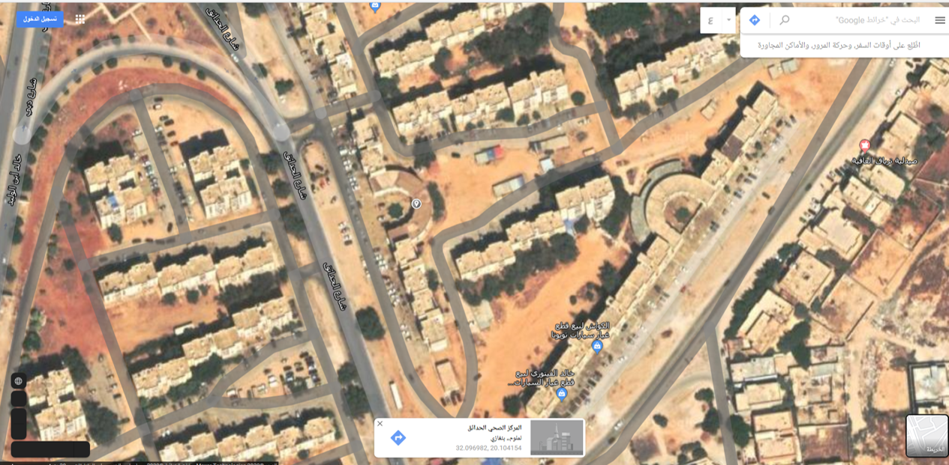

2. Required works:
The Alhadayek Clinic requires rehabilitation works detailed below as these have been somehow modified during the conflict. The whole clinic need to be painted internally, demolished protection bars, windows and doors need to be either repaired or replaced.
A new protection bars and metal doors need to be installed at the front side of the clinic in order to isolate it from the road. Some new block walls need to be built, plastered and painted.
The estimated project period is four months
Below are the important and summary of the required rehabilitation works, for more detail refer to BOQ, the work shall include but not limited to the following: -
A – Demolishing, dismantling and preparation Works
B- Structural works repairs
C- Masonry and plastering Works
D- Painting Works (External and External)
E- Replacement of Doors, windows and metal Works for windows
F- Plumbing and Sanitary Works
G- Electrical Works

