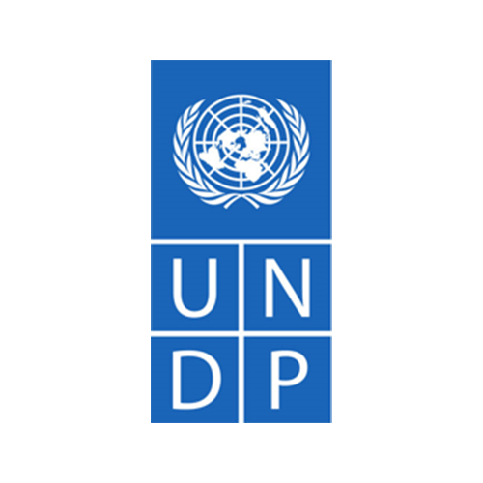

Terms of References
Country: Jordan
Post Title: | Gender Equality Advisor to support the implementation of the Gender Equality Seal for Public Institutions in Jordan
Starting Date: | 16 June, 2022
Location: | Amman (Greater Amman Municipality), Jordan
Duration: | 30 working days over 1 year.
Project | Gender Seal for Public Institution

- Background
The Global Agenda of the Sustainable Development Goals (SDGs) provides a great opportunity to achieve, in the next 15 years, reversing gender gaps and removing existing obstacles in the different spheres of human development. But in these efforts governments face some challenges. It is not easy to translate the SDGs into national development agendas. Likewise, the follow-up of the SDGs requires developing effective mechanisms to promote equality, on-discrimination, and the empowerment of women within the framework of harmonized agendas.
It is imperative to consolidate mechanisms that allow the achievement of essential objectives for the State to include equality as a central axis of its public policies. The first step is the institutionalization of gender equality in the daily actions of the state operations to ensure that commitment is internalized and reflected in the mandates, regulations, processes and budgets of public institutions. A second step is the mainstreaming of gender issues so that the State positions itself as a central actor in the achievement of substantive equality.
This double process of institutionalization and mainstreaming will seek to develop clear and accessible tools and concepts to consolidate architectures and capacities for coordination, spaces for participation, development of programs and public policies within the framework of the SDG Agenda and indicators for monitoring and impact of public policies.
One of the greatest concerns to achieve an inclusive State concerns the processes and mechanisms to achieve better coordination between the different sectors, policies and programs. There are various international experiences that seek to install integrative structures, government institutions and other forms of articulation within the State to avoid the fragmentation of policies. In the area of gender equality, Jordan has experiences of integration of perspective in public policy in different departments of the State institutions.
The Gender Equality Seal for Public Institutions is the culmination of the efforts made in the implementation of Public Management Systems for Institutionalization and Gender Mainstreaming. The seal recognizes the efforts made by institutions at three levels. First, in the degree of political commitment to gender issues inside and outside the institution. Second, in the management of the public policy cycle in all its phases, from planning, execution, monitoring and evaluation. And third, in its own organizational and institutional management, enabling the integration of the gender perspective in all its areas and levels.

- Objective
The objective of this assignment is to provide technical assistance to the Ministry of Environment (MoEnv) for the process of rolling out the Gender Equality Seal for Public Institutions.

- Main Scope of Work
The assignment holder’s main scope of work is to coordinate with the UNDP, together with the Ministry of Environment, to roll out the Gender Equality Seal in Public Institutions as a tool to support and recognize the efforts made by public institutions towards the achievement of substantive equality between men and women.

- Detailed Tasks and Responsibilities
The consultant, in coordination with the gender specialist of the UNDP Office in Jordan and implementing public institution, must conduct the following activities to fulfill the objectives of the consultancy:
- Support the ministry of environment in the development of the Gender Seal process throughout all its steps:
1) Online self-diagnosis of the institution
2) Development, implementation, and monitoring of the Action Plan for Improvement
3) Preparation for the external evaluation.
- Accompany the implementation of staff surveys and the collection of quantitative and qualitative data.
- Conduct at least 3 awareness and/or training sessions on gender equality to the MoEnv staff in Arabic.
- Provide technical assistance in the collection of information to feed the online self-diagnosis and in the elaboration of the action plan.
- Accompany the development and implementation of the gender equality policy and action plan.
- Support the MoEnv in the evaluation process to obtain the Gender Equality Seal, working on the requirements of evidence and necessary documentation of the institution.
- Support the country office with interpretation of some training materials and assessment materials from English to Arabic.

- Expected Outputs & Deliverables Timeframe
Deliverable |  | Documents | Duration/Deadline
5.1 | Interpretation of training materials and report of the training sessions  Content and reports of at least 3 gender equality awareness sessions for the MoEnv staff. | Gender Seal for public institutions guidance note and training materials | Throughout the year as agreed by the workplan
5.2 | Documentation of the online self-diagnosis for the MoEnv | Gender seal for public institution online portal | July 2022
5.3 | Report detailing the information derived from the online staff survey, as per the Gender Seal for Public Institutions program outcome for MoEnv | Assessment report | July 2022
5.4 | Gender Seal Action plan for MoEnv designed | Gender seal for public institutions template | August 2022
5.5 | PowerPoint presentation detailing the process, and level achieved by the PI determined from of the findings of the survey in Arabic and English | PowerPoint presentation | December 2022
5.6 | Provide a set of thematic trainings for the MoEnv gender committee |  | As per the assessment

- Required Qualifications and Skills

6.1 Education and Experience

- Degree in gender, human rights, law, or related fields.
- Specific and substantive training on gender equality and women’s empowerment relate fields.
- At least five years of experience working on gender equality, particularly in the development of gender analysis, gender research and assessments. Experience in gender equality certification systems would be an asset.
- At least 5 years’ experience in designing and facilitating capacity building activities on gender equality
- At least 3 years’ experience working in public administration/governance related areas or institutions. Experience on gender mainstreaming in public administration would be an asset.

6.2 Skills and Competencies
- Excellent technical and analytical writing skills.
- Excellent research and reporting skills.
- Proficient computer-based skills, including Microsoft office.
- Excellent inter-personal, communication, networking and negotiating skills.
- Ability to use information technology as a tool and resource.

- Compensation and Special Conditions
The individual contractor will be compensated according to the following schedule (all payments are subject to deliverable approval by UNDP):
- The 1st payment (20 % of total) after delivery and approval of deliverable 5.1.
- The 2nd payment (30% of total) after delivery and approval of deliverable 5.2.
- The 3rd payment (30% of total) after delivery and approval of deliverable 5.3
- The 4th payment (20% of total) after delivery and approval of deliverables 5.4, 5.5, 5.6

- Proposal Submission Requirements
Interested individual consultant must submit the following documents in order to be considered for the assignment:

- Technical Proposal
  - Explaining why he\she and the members are the most suitable for the work (1-page max.).
  - Providing a brief methodology on how they will approach and conduct the work (2-3 pages).

- Financial proposal
- Indicating the daily rate inclusive of accommodation, transportation, and DSA of all members, or
- Indicating the total lump sum for the assignment

- Personal CV including experience in similar projects and at least 3 references.

UNDP Signature | IC Signature

