United Nations Development Programme

REQUEST FOR PROPOSAL
Study on a business model and roadmap for operational establishment of the Government Data Centre in Kragujevac

RFP No.: 634
Project: Serbia at Your Fingertips – Digital Transformation for Development
Country: Serbia

Issued on: 17 March 2020

Contents
Section 1. Letter of Invitation 4
Section 2. Instruction to Bidders 5
A. GENERAL PROVISIONS 5
1. Introduction 5
2. Fraud & Corruption, Gifts and Hospitality 5
3. Eligibility 5
4. Conflict of Interests 6
B. PREPARATION OF PROPOSALS 6
5. General Considerations 6
6. Cost of Preparation of Proposal 6
7. Language 7
8. Documents Comprising the Proposal 7
9. Documents Establishing the Eligibility and Qualifications of the Bidder 7
10. Technical Proposal Format and Content 7
11. Financial Proposals 7
12. Proposal Security 7
13. Currencies 8
14. Joint Venture, Consortium or Association 8
15. Only One Proposal 9
16. Proposal Validity Period 9
17. Extension of Proposal Validity Period 9
18. Clarification of Proposal 9
19. Amendment of Proposals 10
20. Alternative Proposals 10
21. Pre-Bid Conference 10
C. SUBMISSION AND OPENING OF PROPOSALS 10
22. Submission 10
23. Deadline for Submission of Proposals and Late Proposals 12
24. Withdrawal, Substitution, and Modification of Proposals 12
25. Proposal Opening 12
D. EVALUATION OF PROPOSALS 12
26. Confidentiality 12
27. Evaluation of Proposals 13
28. Preliminary Examination 13
29. Evaluation of Eligibility and Qualification 13
30. Evaluation of Technical and Financial Proposals 13
31. Due Diligence 14
32. Clarification of Proposals 14
33. Responsiveness of Proposal 15
34. Nonconformities, Reparable Errors and Omissions 15
E. AWARD OF CONTRACT 15
35. Right to Accept, Reject, Any or All Proposals 15
36. Award Criteria 15
37. Debriefing 16
38. Right to Vary Requirements at the Time of Award 16
39. Contract Signature 16
40. Contract Type and General Terms and Conditions 16
41. Performance Security 16
42. Bank Guarantee for Advanced Payment 16
43. Liquidated Damages 16
44. Payment Provisions 16
45. Vendor Protest 16
46. Other Provisions 17
Section 3. Bid Data Sheet 18
Section 4. Evaluation Criteria 23
Section 5. Terms of Reference 32
Section 6: Returnable Bidding Forms / Checklist 47
form a: technical proposal submission form 48
form b: bidder information form 49
form c: joint venture/consortium/association information form 50
form d: qualification form 52
form e: format of technical proposal 55
form f: financial proposal submission form 59
form g: financial proposal form 60
form h: form of proposal security 62

Section 1. Letter of Invitation

The United Nations Development Programme (UNDP) hereby invites you to submit a Proposal to this Request for Proposal (RFP) for the above-referenced subject.
This RFP includes the following documents and the General Terms and Conditions of Contract which is inserted in the Bid Data Sheet (BDS):
Section 1: This Letter of Invitation
Section 2: Instruction to Bidders
Section 3: Bid Data Sheet (BDS)
Section 4: Evaluation Criteria
Section 5: Terms of Reference
Section 6: Returnable Bidding Forms
- Form A: Technical Proposal Submission Form
- Form B: Bidder Information Form
- Form C: Joint Venture/Consortium/Association Information Form
- Form D: Qualification Form
- Form E: Format of Technical Proposal
- Form F: Financial Proposal Submission Form
- Form G: Financial Proposal Form
- Form H: Form of Proposal Security
If you are interested in submitting a Proposal in response to this RFP, please prepare your Proposal in accordance with the requirements and procedure as set out in this RFP and submit it by the Deadline for Submission of Proposals set out in Bid Data Sheet.
Please acknowledge receipt of this RFP by sending an email to procurement.rs@undp.org, indicating whether you intend to submit a Proposal or otherwise. You may also utilize the “Accept Invitation” function in e-Tendering system. Should you require further clarifications, kindly communicate with the contact person/s identified in the attached Bid Data Sheet as the focal point for queries on this RFP.
UNDP looks forward to receiving your Proposal and thank you in advance for your interest in UNDP procurement opportunities.
UNDP Serbia

Section 2. Instruction to Bidders

GENERAL PROVISIONS
Introduction | - Bidders shall adhere to all the requirements of this RFP, including any amendments in writing by UNDP. This RFP is conducted in accordance with the UNDP Programme and Operations Policies and Procedures (POPP) on Contracts and Procurement which can be accessed at https://popp.undp.org/SitePages/POPPBSUnit.aspx?TermID=254a9f96-b883-476a-8ef8-e81f93a2b38d  - Any Proposal submitted will be regarded as an offer by the Bidder and does not constitute or imply the acceptance of the Proposal by UNDP. UNDP is under no obligation to award a contract to any Bidder as a result of this RFP.  - As part of the bid, it is desired that the Bidder registers at the United Nations Global Marketplace (UNGM) website (www.ungm.org). The Bidder may still submit a bid even if not registered with the UNGM. However, if the Bidder is selected for contract award, the Bidder must register on the UNGM prior to contract signature.
Fraud & Corruption,  Gifts and Hospitality | - UNDP strictly enforces a policy of zero tolerance on proscribed practices, including fraud, corruption, collusion, unethical or unprofessional practices, and obstruction of UNDP vendors and requires all bidders/vendors observe the highest standard of ethics during the procurement process and contract implementation. UNDP’s Anti-Fraud Policy can be found at http://www.undp.org/content/undp/en/home/operations/accountability/audit/office_of_audit_andinvestigation.html#anti  - Bidders/vendors shall not offer gifts or hospitality of any kind to UNDP staff members including recreational trips to sporting or cultural events, theme parks or offers of holidays, transportation, or invitations to extravagant lunches or dinners.  - In pursuance of this policy, UNDP  (a) Shall reject a proposal if it determines that the selected bidder has engaged in any corrupt or fraudulent practices in competing for the contract in question;  (b) Shall declare a vendor ineligible, either indefinitely or for a stated period of time, to be awarded a contract if at any time it determines that the vendor has engaged in any corrupt or fraudulent practices in competing for, or in executing a UNDP contract.  - All Bidders must adhere to the UN Supplier Code of Conduct, which may be found at http://www.un.org/depts/ptd/pdf/conduct_english.pdf
Eligibility | - A vendor should not be suspended, debarred, or otherwise identified as ineligible by any UN Organization or the World Bank Group or any other international Organization. Vendors are therefore required to disclose to UNDP whether they are subject to any sanction or temporary suspension imposed by these organizations.  - It is the Bidder’s responsibility to ensure that its employees, joint venture members, sub-contractors, service providers, suppliers and/or their employees meet the eligibility requirements as established by UNDP.
Conflict of Interests | - Bidders must strictly avoid conflicts with other assignments or their own interests, and act without consideration for future work. Bidders found to have a conflict of interest shall be disqualified. Without limitation on the generality of the above, Bidders, and any of their affiliates, shall be considered to have a conflict of interest with one or more parties in this solicitation process, if they:  - Are or have been associated in the past, with a firm or any of its affiliates which have been engaged by UNDP to provide services for the preparation of the design, specifications, Terms of Reference, cost analysis/estimation, and other documents to be used for the procurement of the goods and services in this selection process;  - Were involved in the preparation and/or design of the programme/project related to the services requested under this RFP; or  - Are found to be in conflict for any other reason, as may be established by, or at the discretion of UNDP.  - In the event of any uncertainty in the interpretation of a potential conflict of interest, Bidders must disclose to UNDP, and seek UNDP’s confirmation on whether or not such a conflict exists.  - Similarly, the Bidders must disclose in their proposal their knowledge of the following:  - If the owners, part-owners, officers, directors, controlling shareholders, of the bidding entity or key personnel are family members of UNDP staff involved in the procurement functions and/or the Government of the country or any Implementing Partner receiving services under this RFP; and  - All other circumstances that could potentially lead to actual or perceived conflict of interest, collusion or unfair competition practices.  Failure to disclose such an information may result in the rejection of the proposal or proposals affected by the non-disclosure.  - The eligibility of Bidders that are wholly or partly owned by the Government shall be subject to UNDP’s further evaluation and review of various factors such as being registered, operated and managed as an independent business entity, the extent of Government ownership/share, receipt of subsidies, mandate and access to information in relation to this RFP, among others. Conditions that may lead to undue advantage against other Bidders may result in the eventual rejection of the Proposal.

PREPARATION OF PROPOSALS
General Considerations | - In preparing the Proposal, the Bidder is expected to examine the RFP in detail. Material deficiencies in providing the information requested in the RFP may result in rejection of the Proposal.  - The Bidder will not be permitted to take advantage of any errors or omissions in the RFP. Should such errors or omissions be discovered, the Bidder must notify the UNDP
Cost of Preparation of Proposal | - The Bidder shall bear any and all costs related to the preparation and/or submission of the Proposal, regardless of whether its Proposal was selected or not. UNDP shall not be responsible or liable for those costs, regardless of the conduct or outcome of the procurement process.
Language | - The Proposal, as well as any and all related correspondence exchanged by the Bidder and UNDP, shall be written in the language (s) specified in the BDS.
Documents Comprising the Proposal | - The Proposal shall comprise of the following documents:  - Documents Establishing the Eligibility and Qualifications of the Bidder;  - Technical Proposal;  - Financial Proposal;  - Proposal Security, if required by BDS;  - Any attachments and/or appendices to the Proposal.
Documents Establishing the Eligibility and Qualifications of the Bidder | - The Bidder shall furnish documentary evidence of its status as an eligible and qualified vendor, using the Forms provided under Section 6 and providing documents required in those forms. In order to award a contract to a Bidder, its qualifications must be documented to UNDP’s satisfaction.
Technical Proposal Format and Content | - The Bidder is required to submit a Technical Proposal using the Standard Forms and templates provided in Section 6 of the RFP.  - The Technical Proposal shall not include any price or financial information. A Technical Proposal containing material financial information may be declared non-responsive.  - Samples of items, when required as per Section 5, shall be provided within the time specified and unless otherwise specified by UNDP, and at no expense to UNDP  - When applicable and required as per Section 5, the Bidder shall describe the necessary training programme available for the maintenance and operation of the services and/or equipment offered as well as the cost to the UNDP. Unless otherwise specified, such training as well as training materials shall be provided in the language of the Bid as specified in the BDS.
Financial Proposals | - The Financial Proposal shall be prepared using the Standard Form provided in Section 6 of the RFP. It shall list all major cost components associated with the services, and the detailed breakdown of such costs.  - Any output and activities described in the Technical Proposal but not priced in the Financial Proposal, shall be assumed to be included in the prices of other activities or items, as well as in the final total price.  - Prices and other financial information must not be disclosed in any other place except in the financial proposal.
Proposal Security | - A Proposal Security, if required by BDS, shall be provided in the amount and form indicated in the BDS. The Proposal Security shall be valid up to thirty (30) days after the final date of validity of the Proposal.  - The Proposal Security shall be included along with the Technical Proposal. If Proposal Security is required by the RFP but is not found along with the Technical Proposal, the Proposal shall be rejected.  - If the Proposal Security amount or its validity period is found to be less than what is required by UNDP, UNDP shall reject the Proposal.  - In the event an electronic submission is allowed in the BDS, Bidders shall include a copy of the Bid Security in their proposal and the original of the Proposal Security must be sent via courier or hand delivery as per the instructions in BDS.  - The Proposal Security may be forfeited by UNDP, and the Proposal rejected, in the event of any one or combination, of the following conditions:  - If the Bidder withdraws its offer during the period of the Proposal Validity specified in the BDS, or;  - In the event that the successful Bidder fails:  - to sign the Contract after UNDP has issued an award; or  - to furnish the Performance Security, insurances, or other documents that UNDP may require as a condition precedent to the effectivity of the contract that may be awarded to the Bidder.
Currencies | - All prices shall be quoted in the currency or currencies indicated in the BDS. Where Proposals are quoted in different currencies, for the purposes of comparison of all Proposals:  - UNDP will convert the currency quoted in the Proposal into the UNDP preferred currency, in accordance with the prevailing UN operational rate of exchange on the last day of submission of Proposals; and  - In the event that UNDP selects a proposal for award that is quoted in a currency different from the preferred currency in the BDS, UNDP shall reserve the right to award the contract in the currency of UNDP’s preference, using the conversion method specified above.
Joint Venture, Consortium or Association | - If the Bidder is a group of legal entities that will form or have formed a Joint Venture (JV), Consortium or Association for the Proposal, they shall confirm in their Proposal that : (i) they have designated one party to act as a lead entity, duly vested with authority to legally bind the members of the JV, Consortium or Association jointly and severally, which shall be evidenced by a duly notarized Agreement among the legal entities, and submitted with the Proposal; and (ii) if they are awarded the contract, the contract shall be entered into, by and between UNDP and the designated lead entity, who shall be acting for and on behalf of all the member entities comprising the joint venture.  - After the Deadline for Submission of Proposal, the lead entity identified to represent the JV, Consortium or Association shall not be altered without the prior written consent of UNDP.  - The lead entity and the member entities of the JV, Consortium or Association shall abide by the provisions of Clause 9 herein in respect of submitting only one proposal.  - The description of the organization of the JV, Consortium or Association must clearly define the expected role of each of the entity in the joint venture in delivering the requirements of the RFP, both in the Proposal and the JV, Consortium or Association Agreement. All entities that comprise the JV, Consortium or Association shall be subject to the eligibility and qualification assessment by UNDP.  - A JV, Consortium or Association in presenting its track record and experience should clearly differentiate between:  - Those that were undertaken together by the JV, Consortium or Association; and  - Those that were undertaken by the individual entities of the JV, Consortium or Association.  - Previous contracts completed by individual experts working privately but who are permanently or were temporarily associated with any of the member firms cannot be claimed as the experience of the JV, Consortium or Association or those of its members, but should only be claimed by the individual experts themselves in their presentation of their individual credentials.  - JV, Consortium or Associations are encouraged for high value, multi-sectoral requirements when the spectrum of expertise and resources required may not be available within one firm.
Only One Proposal | - The Bidder (including the individual members of any Joint Venture) shall submit only one Proposal, either in its own name or as part of a Joint Venture.  - Proposals submitted by two (2) or more Bidders shall all be rejected if they are found to have any of the following:  - they have at least one controlling partner, director or shareholder in common; or  - any one of them receive or have received any direct or indirect subsidy from the other/s; or  - they have the same legal representative for purposes of this RFP; or  - they have a relationship with each other, directly or through common third parties, that puts them in a position to have access to information about, or influence on the Proposal of, another Bidder regarding this RFP process;  - they are subcontractors to each other’s Proposal, or a subcontractor to one Proposal also submits another Proposal under its name as lead Bidder; or  - some key personnel proposed to be in the team of one Bidder participates in more than one Proposal received for this RFP process. This condition relating to the personnel, does not apply to subcontractors being included in more than one Proposal.
Proposal Validity Period | - Proposals shall remain valid for the period specified in the BDS, commencing on the Deadline for Submission of Proposals. A Proposal valid for a shorter period may be rejected by UNDP and rendered non-responsive.  - During the Proposal validity period, the Bidder shall maintain its original Proposal without any change, including the availability of the Key Personnel, the proposed rates and the total price.
Extension of Proposal Validity Period | - In exceptional circumstances, prior to the expiration of the proposal validity period, UNDP may request Bidders to extend the period of validity of their Proposals. The request and the responses shall be made in writing and shall be considered integral to the Proposal.  - If the Bidder agrees to extend the validity of its Proposal, it shall be done without any change in the original Proposal.  - The Bidder has the right to refuse to extend the validity of its Proposal, and in which case, such Proposal will not be further evaluated.
Clarification of Proposal | - Bidders may request clarifications on any of the RFP documents no later than the date indicated in the BDS. Any request for clarification must be sent in writing in the manner indicated in the BDS. If inquiries are sent other than specified channel, even if they are sent to a UNDP staff member, UNDP shall have no obligation to respond or confirm that the query was officially received.  - UNDP will provide the responses to clarifications through the method specified in the BDS.  - UNDP shall endeavor to provide responses to clarifications in an expeditious manner, but any delay in such response shall not cause an obligation on the part of UNDP to extend the submission date of the Proposals, unless UNDP deems that such an extension is justified and necessary.
Amendment of Proposals | - At any time prior to the deadline of Proposal submission, UNDP may for any reason, such as in response to a clarification requested by a Bidder, modify the RFP in the form of an amendment to the RFP. Amendments will be made available to all prospective bidders.  - If the amendment is substantial, UNDP may extend the Deadline for submission of proposal to give the Bidders reasonable time to incorporate the amendment into their Proposals.
Alternative Proposals | - Unless otherwise specified in the BDS, alternative proposals shall not be considered. If submission of alternative proposal is allowed by BDS, a Bidder may submit an alternative proposal, but only if it also submits a proposal conforming to the RFP requirements. UNDP shall only consider the alternative proposal offered by the Bidder whose conforming proposal ranked the highest as per the specified evaluation method. Where the conditions for its acceptance are met, or justifications are clearly established, UNDP reserves the right to award a contract based on an alternative proposal.  - If multiple/alternative proposals are being submitted, they must be clearly marked as “Main Proposal” and “Alternative Proposal”
Pre-Bid Conference | - When appropriate, a Bidder’s conference will be conducted at the date, time and location specified in the BDS. All Bidders are encouraged to attend. Non-attendance, however, shall not result in disqualification of an interested Bidder. Minutes of the Bidder’s conference will be disseminated on the procurement website and shared by email or on the e-Tendering platform as specified in the BDS. No verbal statement made during the conference shall modify the terms and conditions of the RFP, unless specifically incorporated in the Minutes of the Bidder’s Conference or issued/posted as an amendment to RFP.

SUBMISSION AND OPENING OF PROPOSALS
Submission | - The Bidder shall submit a duly signed and complete Proposal comprising the documents and forms in accordance with the requirements in the BDS. The submission shall be in the manner specified in the BDS.  - The Proposal shall be signed by the Bidder or person(s) duly authorized to commit the Bidder. The authorization shall be communicated through a document evidencing such authorization issued by the legal representative of the bidding entity, or a Power of Attorney, accompanying the Proposal.  - Bidders must be aware that the mere act of submission of a Proposal, in and of itself, implies that the Bidder fully accepts the UNDP General Contract Terms and Conditions.
Hard copy (manual) submission  Email Submission  eTendering submission | - Hard copy (manual) submission by courier or hand delivery allowed or specified in the BDS shall be governed as follows:  - The signed Proposal shall be marked “Original”, and its copies marked “Copy” as appropriate. The number of copies is indicated in the BDS. All copies shall be made from the signed original only. If there are discrepancies between the original and the copies, the original shall prevail.  - The Technical Proposal and the Financial Proposal envelopes MUST BE COMPLETELY SEPARATE and each of them must be submitted sealed individually and clearly marked on the outside as either “TECHNICAL PROPOSAL” or “FINANCIAL PROPOSAL”, as appropriate. Each envelope SHALL clearly indicate the name of the Bidder. The outer envelopes shall:  i. Bear the name and address of the bidder;  ii. Be addressed to UNDP as specified in the BDS  iii Bear a warning that states “Not to be opened before the time and date for proposal opening” as specified in the BDS.  If the envelopes and packages with the Proposal are not sealed and marked as required, UNDP shall assume no responsibility for the misplacement, loss, or premature opening of the Proposal.  - Email submission, if allowed or specified in the BDS, shall be governed as follows:  - Electronic files that form part of the proposal must be in accordance with the format and requirements indicated in BDS;  - The Technical Proposal and the Financial Proposal files MUST BE COMPLETELY SEPARATE. The financial proposal shall be encrypted with different passwords and clearly labelled. The files must be sent to the dedicated email address specified in the BDS.  - The password for opening the Financial Proposal should be provided only upon request of UNDP. UNDP will request password only from bidders whose Technical Proposal has been found to be technically responsive. Failure to provide correct password may result in the proposal being rejected.  - Electronic submission through eTendering, if allowed or specified in the BDS, shall be governed as follows:  - Electronic files that form part of the proposal must be in accordance with the format and requirements indicated in BDS;  - The Technical Proposal and the Financial Proposal files MUST BE COMPLETELY SEPARATE and each of them must be uploaded individually and clearly labeled.  - The Financial Proposal file must be encrypted with a password so that it cannot be opened nor viewed until the password is provided. The password for opening the Financial Proposal should be provided only upon request of UNDP. UNDP will request password only from bidders whose technical proposal has been found to be technically responsive. Failure to provide the correct password may result in the proposal being rejected.  - Documents which are required to be in original form (e.g. Bid Security, etc.) must be sent via courier or hand delivery as per the instructions in BDS.  - Detailed instructions on how to submit, modify or cancel a bid in the eTendering system are provided in the eTendering system Bidder User Guide and Instructional videos available on this link: http://www.undp.org/content/undp/en/home/operations/procurement/business/procurement-notices/resources/
Deadline for Submission of Proposals and Late Proposals | - Complete Proposals must be received by UNDP in the manner, and no later than the date and time, specified in the BDS. UNDP shall only recognize the date and time that the bid was received by UNDP  - UNDP shall not consider any Proposal that is submitted after the deadline for the submission of Proposals.
Withdrawal, Substitution, and Modification of Proposals | - A Bidder may withdraw, substitute or modify its Proposal after it has been submitted at any time prior to the deadline for submission.  - Manual and Email submissions: A bidder may withdraw, substitute or modify its Proposal by sending a written notice to UNDP, duly signed by an authorized representative, and shall include a copy of the authorization (or a Power of Attorney). The corresponding substitution or modification of the Proposal, if any, must accompany the respective written notice. All notices must be submitted in the same manner as specified for submission of proposals, by clearly marking them as “WITHDRAWAL” “SUBSTITUTION,” or “MODIFICATION”  - eTendering: A Bidder may withdraw, substitute or modify its Proposal by Canceling, Editing, and re-submitting the proposal directly in the system. It is the responsibility of the Bidder to properly follow the system instructions, duly edit and submit a substitution or modification of the Proposal as needed. Detailed instructions on how to cancel or modify a Proposal directly in the system are provided in Bidder User Guide and Instructional videos.  - Proposals requested to be withdrawn shall be returned unopened to the Bidders (only for manual submissions), except if the bid is withdrawn after the bid has been opened
Proposal Opening | - There is no public bid opening for RFPs. UNDP shall open the Proposals in the presence of an ad-hoc committee formed by UNDP, consisting of at least two (2) members. In the case of e-Tendering submission, bidders will receive an automatic notification once their proposal is opened.

EVALUATION OF PROPOSALS
Confidentiality | - Information relating to the examination, evaluation, and comparison of Proposals, and the recommendation of contract award, shall not be disclosed to Bidders or any other persons not officially concerned with such process, even after publication of the contract award.  - Any effort by a Bidder or anyone on behalf of the Bidder to influence UNDP in the examination, evaluation and comparison of the Proposals or contract award decisions may, at UNDP’s decision, result in the rejection of its Proposal and may be subject to the application of prevailing UNDP’s vendor sanctions procedures.
Evaluation of Proposals | - The Bidder is not permitted to alter or modify its Proposal in any way after the proposal submission deadline except as permitted under Clause 24 of this RFP. UNDP will conduct the evaluation solely on the basis of the submitted Technical and Financial Proposals.  - Evaluation of proposals is made of the following steps:  - Preliminary Examination  - Minimum Eligibility and Qualification (if pre-qualification is not done)  - Evaluation of Technical Proposals  - Evaluation of Financial Proposals
Preliminary Examination | - UNDP shall examine the Proposals to determine whether they are complete with respect to minimum documentary requirements, whether the documents have been properly signed, and whether the Proposals are generally in order, among other indicators that may be used at this stage. UNDP reserves the right to reject any Proposal at this stage.
Evaluation of Eligibility and Qualification | - Eligibility and Qualification of the Bidder will be evaluated against the Minimum Eligibility/Qualification requirements specified in the Section 4 (Evaluation Criteria).  - In general terms, vendors that meet the following criteria may be considered qualified:  a)They are not included in the UN Security Council 1267/1989 Committee's list of terrorists and terrorist financiers, and in UNDP’s ineligible vendors’ list;  - They have a good financial standing and have access to adequate financial resources to perform the contract and all existing commercial commitments,  - They have the necessary similar experience, technical expertise, production capacity where applicable, quality certifications, quality assurance procedures and other resources applicable to the provision of the services required;  - They are able to comply fully with UNDP General Terms and Conditions of Contract;  - They do not have a consistent history of court/arbitral award decisions against the Bidder; and  - They have a record of timely and satisfactory performance with their clients.
Evaluation of Technical and Financial Proposals | - The evaluation team shall review and evaluate the Technical Proposals on the basis of their responsiveness to the Terms of Reference and other RFP documents, applying the evaluation criteria, sub-criteria, and point system specified in the Section 4 (Evaluation Criteria). A Proposal shall be rendered non-responsive at the technical evaluation stage if it fails to achieve the minimum technical score indicated in the BDS. When necessary and if stated in the BDS, UNDP may invite technically responsive bidders for a presentation related to their technical proposals. The conditions for the presentation shall be provided in the bid document where required.  - In the second stage, only the Financial Proposals of those Bidders who achieve the minimum technical score will be opened for evaluation. The Financial Proposals corresponding to Technical Proposals that were rendered non-responsive shall remain unopened, and, in the case of manual submission, be returned to the Bidder unopened. For emailed Proposals and e-tendering submissions, UNDP will not request for the password of the Financial Proposals of bidders whose Technical Proposal were found not responsive.  - The evaluation method that applies for this RFP shall be as indicated in the BDS, which may be either of two (2) possible methods, as follows: (a) the lowest priced method which selects the lowest evaluated financial proposal of the technically responsive Bidders; or (b) the combined scoring method which will be based on a combination of the technical and financial score.  - When the BDS specifies a combined scoring method, the formula for the rating of the Proposals will be as follows:  Rating the Technical Proposal (TP):  TP Rating = (Total Score Obtained by the Offer / Max. Obtainable Score for TP) x 100  Rating the Financial Proposal (FP):  FP Rating = (Lowest Priced Offer / Price of the Offer Being Reviewed) x 100  Total Combined Score:  Combined Score = (TP Rating) x (Weight of TP, e.g. 70%) + (FP Rating) x (Weight of FP, e.g., 30%)
Due Diligence | - UNDP reserves the right to undertake a due diligence exercise, also called post qualification, aimed at determining to its satisfaction, the validity of the information provided by the Bidder. Such exercise shall be fully documented and may include, but need not be limited to, all or any combination of the following:  - Verification of accuracy, correctness and authenticity of information provided by the Bidder;  - Validation of extent of compliance to the RFP requirements and evaluation criteria based on what has so far been found by the evaluation team;  - Inquiry and reference checking with Government entities with jurisdiction on the Bidder, or with previous clients, or any other entity that may have done business with the Bidder;  - Inquiry and reference checking with previous clients on the performance on on-going or contracts completed, including physical inspections of previous works, as necessary;  - Physical inspection of the Bidder’s offices, branches or other places where business transpires, with or without notice to the Bidder;  - Other means that UNDP may deem appropriate, at any stage within the selection process, prior to awarding the contract.
Clarification of Proposals | - To assist in the examination, evaluation and comparison of Proposals, UNDP may, at its discretion, ask any Bidder for a clarification of its Proposal.  - UNDP’s request for clarification and the response shall be in writing and no change in the prices or substance of the Proposal shall be sought, offered, or permitted, except to provide clarification, and confirm the correction of any arithmetic errors discovered by UNDP in the evaluation of the Proposals, in accordance with RFP.  - Any unsolicited clarification submitted by a Bidder in respect to its Proposal, which is not a response to a request by UNDP, shall not be considered during the review and evaluation of the Proposals.
Responsiveness of Proposal | - UNDP’s determination of a Proposal’s responsiveness will be based on the contents of the Proposal itself. A substantially responsive Proposal is one that conforms to all the terms, conditions, TOR and other requirements of the RFP without material deviation, reservation, or omission.  - If a Proposal is not substantially responsive, it shall be rejected by UNDP and may not subsequently be made responsive by the Bidder by correction of the material deviation, reservation, or omission.
Nonconformities, Reparable Errors and Omissions | - Provided that a Proposal is substantially responsive, UNDP may waive any non-conformities or omissions in the Proposal that, in the opinion of UNDP, do not constitute a material deviation.  - UNDP may request the Bidder to submit the necessary information or documentation, within a reasonable period of time, to rectify nonmaterial nonconformities or omissions in the Proposal related to documentation requirements. Such omission shall not be related to any aspect of the price of the Proposal. Failure of the Bidder to comply with the request may result in the rejection of its Proposal.  - For Financial Proposal that has been opened, UNDP shall check and correct arithmetical errors as follows:  - if there is a discrepancy between the unit price and the line item total that is obtained by multiplying the unit price by the quantity, the unit price shall prevail and the line item total shall be corrected, unless in the opinion of UNDP there is an obvious misplacement of the decimal point in the unit price; in which case the line item total as quoted shall govern and the unit price shall be corrected;  - if there is an error in a total corresponding to the addition or subtraction of subtotals, the subtotals shall prevail and the total shall be corrected; and  - if there is a discrepancy between words and figures, the amount in words shall prevail, unless the amount expressed in words is related to an arithmetic error, in which case the amount in figures shall prevail.  - If the Bidder does not accept the correction of errors made by UNDP, its Proposal shall be rejected.

AWARD OF CONTRACT
Right to Accept, Reject, Any or All Proposals | - UNDP reserves the right to accept or reject any Proposal, to render any or all of the Proposals as non-responsive, and to reject all Proposals at any time prior to award of contract, without incurring any liability, or obligation to inform the affected Bidder(s) of the grounds for UNDP’s action. UNDP shall not be obliged to award the contract to the lowest priced offer.
Award Criteria | - Prior to expiration of the proposal validity, UNDP shall award the contract to the qualified Bidder based on the award criteria indicated in the BDS.
Debriefing | - In the event that a Bidder is unsuccessful, the Bidder may request a debriefing from UNDP. The purpose of the debriefing is to discuss the strengths and weaknesses of the Bidder’s submission, in order to assist the Bidder in improving its future proposals for UNDP procurement opportunities. The content of other proposals and how they compare to the Bidder’s submission shall not be discussed.
Right to Vary Requirements at the Time of Award | - At the time of award of Contract, UNDP reserves the right to vary the quantity of services and/or goods, by up to a maximum twenty-five per cent (25%) of the total offer, without any change in the unit price or other terms and conditions.
Contract Signature | - Within fifteen (15) days from the date of receipt of the Contract, the successful Bidder shall sign and date the Contract and return it to UNDP. Failure to do so may constitute sufficient grounds for the annulment of the award, and forfeiture of the Proposal Security, if any, and on which event, UNDP may award the Contract to the Second Ranked Bidder or call for new Proposals.
Contract Type and General Terms and Conditions | - The types of Contract to be signed and the applicable UNDP Contract General Terms and Conditions, as specified in BDS, can be accessed at http://www.undp.org/content/undp/en/home/procurement/business/how-we-buy.html
Performance Security | - 40.1 A performance security, if required in BDS, shall be provided in the amount specified in BDS and form available at  https://popp.undp.org/_layouts/15/WopiFrame.aspx?sourcedoc=/UNDP_POPP_DOCUMENT_LIBRARY/Public/PSU_Solicitation_Performance%20Guarantee%20Form.docx&action=default within fifteen (15) days of the contract signature by both parties. Where a performance security is required, the receipt of the performance security by UNDP shall be a condition for rendering the contract effective.
Bank Guarantee for Advanced Payment | - Except when the interests of UNDP so require, it is UNDP’s preference to make no advance payment(s) (i.e., payments without having received any outputs). If an advance payment is allowed as per BDS, and exceeds 20% of the total contract price, or USD 30,000, whichever is less, the Bidder shall submit a Bank Guarantee in the full amount of the advance payment in the form available at https://popp.undp.org/_layouts/15/WopiFrame.aspx?sourcedoc=/UNDP_POPP_DOCUMENT_LIBRARY/Public/PSU_Contract%20Management%20Payment%20and%20Taxes_Advanced%20Payment%20Guarantee%20Form.docx&action=default
Liquidated Damages | - If specified in BDS, UNDP shall apply Liquidated Damages resulting from the Contractor’s delays or breach of its obligations as per the Contract.
Payment Provisions | - Payment will be made only upon UNDP's acceptance of the work performed. The terms of payment shall be within thirty (30) days, after receipt of invoice and certification of acceptance of work issued by the proper authority in UNDP with direct supervision of the Contractor. Payment will be effected by bank transfer in the currency of contract.
Vendor Protest | - UNDP’s vendor protest procedure provides an opportunity for appeal to those persons or firms not awarded a contract through a competitive procurement process. In the event that a Bidder believes that it was not treated fairly, the following link provides further details regarding UNDP vendor protest procedures: http://www.undp.org/content/undp/en/home/operations/procurement/business/protest-and-sanctions.html
Other Provisions | - In the event that the Bidder offers a lower price to the host Government (e.g. General Services Administration (GSA) of the federal government of the United States of America) for similar services, UNDP shall be entitled to same lower price. The UNDP General Terms and Conditions shall have precedence.  - UNDP is entitled to receive the same pricing offered by the same Contractor in contracts with the United Nations and/or its Agencies. The UNDP General Terms and Conditions shall have precedence.  - The United Nations has established restrictions on employment of (former) UN staff who have been involved in the procurement process as per bulletin ST/SGB/2006/15 http://www.un.org/en/ga/search/view_doc.asp?symbol=ST/SGB/2006/15&referer

Section 3. Bid Data Sheet
The following data for the services to be procured shall complement, supplement, or amend the provisions in the Request for Proposals. In the case of a conflict between the Instructions to Bidders, the Data Sheet, and other annexes or references attached to the Data Sheet, the provisions in the Data Sheet shall prevail.

BDS No. | Ref. to Section.2 | Data | Specific Instructions / Requirements
1 | 7 | Language of the Proposal | English
2 |  | Submitting Proposals for Parts or sub-parts of the TOR (partial bids) | Not Allowed
3 | 20 | Alternative Proposals | Shall not be considered
4 | 21 | Pre-proposal conference | Will not be conducted
5 | 10 | Proposal Validity Period | 90 days
6 | 14 | Bid Security | Required in the amount of USD 6,000.00 for foreign or RSD 600,000.00 for Serbian bidders  (one/any of the options marked below will be accepted by UNDP):  Acceptable Form of Bid Security:  ☒ Bank Guarantee (See Form H for template to be used), or  ☒ Any Bank-issued Check/Cashier’s Check/Certified Check (menica sa punovažnom meničnom izjavom i potvrdom o deponovanom potpisu)  ☐ Other negotiable instrument  ☐ Cash (exceptionally, if none of the other forms are feasible)  ☐ Others [pls. specify]  Important Remarks:  - The Bid Security shall be valid until 30 days after the final date of validity of bids.  - The Original Copy of Bid Security must be physically received by UNDP prior to the deadline for submission of offers indicated in the eTendering module. The address for submitting Bid Security is as follows:  UNDP  Bulevar Zorana Djindjica 64  11070 Novi Beograd, Serbia  REFERENCE: RFP 634 (Bid Security Original Copy Only)
7 | 41 | Advanced Payment upon signing of contract | Not Allowed
8 | 42 | Liquidated Damages | Will be imposed as follows:  Percentage of contract price per day of delay: 1%  Max. no. of days of delay: 10  After which UNDP may terminate the contract.
9 | 40 | Performance Security | Not Required
10 | 18 | Currency of Proposal | United States Dollar
11 | 31 | Deadline for submitting requests for clarifications/questions | 7 days before the submission deadline
12 | 31 | Contact Details for submitting clarifications/questions | Focal Person in UNDP:  e-mail address: procurement.rs@undp.org
13 | 18, 19 and 21 | Manner of Disseminating Supplemental Information to the RFP and responses/clarifications to queries | Posted directly to eTendering
14 | 23 | Deadline for Submission | As indicated in the eTendering Event for this tender.  Offers submitted to UNDP after the above-mentioned date and time will not be accepted by the eTendering Portal.
14 | 22 | Allowable Manner of Submitting Proposals | Submission by:  ☒ eTendering ONLY  eTendering Portal link:  https://etendering.partneragencies.org  BU Code and Event ID number  SRB10, Event # 0000005624  Format: .PDF and/or .DOC and/or .ZIP documents/ files  File names must be maximum 60 characters long (Ref. No. of tender and Bidder’s name and Technical or Financial Proposal reference to be indicated) and must not contain any letter or special character other than from English Latin alphabet/keyboard.  All files must be free of viruses and not corrupted.  Technical and Financial Proposals must be separately uploaded.  Financial Proposal file must be password protected. Password for Financial Proposal must not be provided to UNDP until requested by UNDP, in case bidder’s Technical Proposal is found technically responsive.  Max. size of uploads (per document/file) must not exceed: 35 MB  Documents which are required in original (e.g. Bid Security) if any requested by this RFP document must be sent to the below address by mail or courier and received by UNDP before the deadline for submission of proposals indicated in the eTendering Event indicated above, with a PDF copy also submitted through eTendering as part of the electronic submission within the Technical Proposal file:  Address: UNDP, Bulevar Zorana Djindjica 64, 11070 Belgrade, Serbia (please indicate tender reference No on the envelope).
15 | 22 | Proposal Submission Address | N/A
16 | 22 | Electronic submission (eTendering) requirements | 1 duly signed/stamped electronic copy of technical proposal, and  1 duly signed/stamped electronic copy of financial proposal (Password Protected),  in separate files.  Uploaded files/ documents must be titled as “Technical Proposal” and “Financial Proposal”, with indicated “REFERENCE” number of tender (please see the 1st page above) and name of the bidder.  Remark: Technical and Financial Proposals shall be submitted/ uploaded in the separate files/documents. Technical Proposal must be submitted preferably in one file as .pdf or .doc document or as zipped file.  The price in the eTendring Portal’s “Price” field for RFP processes must be populated as “1”and quantity must be populated as “1” as per the sample in the printscreen below – THE ONLY PLACE WHERE THE OFFERED PRICE (AND THE ASSOCIATED BREAKDOWN, IF REQUESTED) IS TO BE ACTUALLY INDICATED BY THE BIDDER IS IN THE FINANCIAL PROPOSAL FILE/DOCUMEN5 that is uploaded as a part of the bid. Financial Proposal document/ file must be password protected.  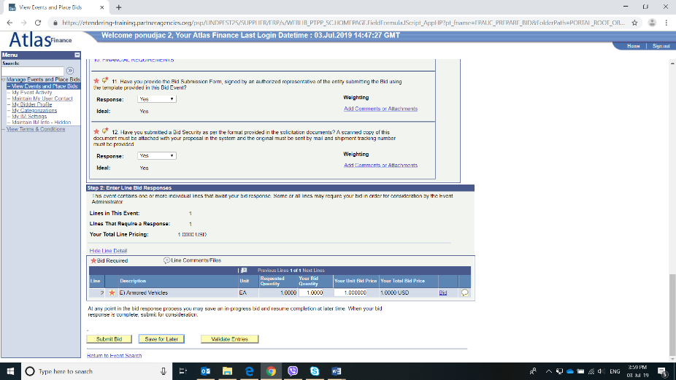
17 | 27  36 | Evaluation Method for the Award of Contract | Combined Scoring Method, using the 70%-30% distribution for technical and financial proposals respectively  The minimum technical score required to pass is 70%.
18 |  | Expected date for commencement of Contract | May, 2020
19 |  | Maximum expected duration of contract | 90 days from the date of Contract signing, but Contract end date shall not be later than 31 July 2020
20 | 35 | UNDP will award the contract to: | One Proposer Only
21 | 39 | Type of Contract | Purchase Order and Contract for Goods and Services for UNDP  http://www.undp.org/content/undp/en/home/procurement/business/how-we-buy.html
22 | 39 | UNDP Contract Terms and Conditions that will apply | UNDP General Terms and Conditions for contracts (goods and/or Services)  http://www.undp.org/content/undp/en/home/procurement/business/how-we-buy.html
23 |  | Other Information Related to the RFP | IMPORTANT REMARK ON (online) eTENDERING SUBMISSIONS:  On the following link: https://www.undp.org/content/undp/en/home/operations/procurement/business/procurement-notices/resources/  you may find step-by-step instructions in all UN languages on:  - How to register in the eTendering Module as a bidder,  - How to find the tender you wish to submit your offer for,  - How to submit your offer,  - All other information related to the eTendering Module (bidder’s support).

Section 4. Evaluation Criteria
Preliminary Examination Criteria
Proposals will be examined to determine whether they are complete and submitted in accordance with RFP requirements as per below criteria on a Yes/No basis:
- Appropriate signatures
- Power of Attorney
- Minimum documents provided
- Technical and Financial Proposals submitted separately
- Bid Validity
- Bid Security submitted as per the RFP requirements with compliant validity period

Minimum Eligibility and Qualification Criteria
Eligibility and Qualification will be evaluated on Pass/Fail basis.
If the Proposal is submitted as a Joint Venture/Consortium/Association, each member should meet minimum criteria, unless otherwise specified in the criterion.

Subject | Criteria | Document Submission requirement
ELIGIBILITY
Legal Status | Vendor is a legally registered entity.  Vendor must be registered in the country of origin in the required line of business for a minimum of 10 years.  (In case of a consortium/joint venture, this requirement must be met by the Lead Partner in the consortium/joint venture) | Form B: Bidder Information Form
Eligibility | Vendor is not suspended, nor debarred, nor otherwise identified as ineligible by any UN Organization or the World Bank Group or any other international Organization in accordance with ITB clause 3. | Form A: Technical Proposal Submission Form
Conflict of Interest | No conflicts of interest in accordance with ITB clause 4. | Form A: Technical Proposal Submission Form
Bankruptcy | Not declared bankruptcy, not involved in bankruptcy or receivership proceedings, and there is no judgment or pending legal action against the vendor that could impair its operations in the foreseeable future. | Form A: Technical Proposal Submission Form
QUALIFICATION
History of Non-Performing Contracts | Non-performance of a contract did not occur as a result of contractor default for the last 3 years. | Form D: Qualification Form
Litigation History | No consistent history of court/arbitral award decisions against the Bidder for the last 3 years. | Form D: Qualification Form
Previous Experience | Proven relevant experience related to governments, enterprises or investors on at least 2 Data Center strategy or Due Diligence projects, of the similar complexity, with energy needs of more than 2MW, completed in the last 7 years. The Bidder shall submit the respective Statements of Satisfactory Performance from the previous clients. All submitted materials will be treated confidentially and used only for this tender purposes. The details of the relevant references must be submitted in the format provided under the Form D: Qualification Form below.  (In case of JV/Consortium/Association, all Parties shall cumulatively meet these requirements) | Form D: Qualification Form
Financial Standing | Minimum annual turnover of USD 700,000 for each of the following 3 years (2016, 2017, 2018).  (In case of JV/Consortium/Association, all Parties shall cumulatively meet this requirement). | Form D: Qualification Form
 | Bidder must demonstrate the current soundness of its financial standing and indicate its prospective long-term profitability.  (In case of JV/Consortium/Association, all Parties shall cumulatively meet this requirement). | Form D: Qualification Form
Key staff | The Bidder shall ensure that appropriately qualified expertise is identified and provided as required for each of the different tasks outlined above. Given the complexity of the work to be performed, the team shall have a multi-disciplinary character and shall include a range of professional experts to address the issues at stake from a multi-disciplinary point of view and ensure a deep knowledge of data center operation.  The team of the following 3 key experts shall be engaged by the Bidder for the entire duration of the potential assignment:  Team Leader/Project Manager  - Graduate degree in economy, finance, business administration or similar. MBA would be an asset;  - At least 15 years’ experience on project management positions;  - Experience in at least 2 Data Center Strategy Projects;  - Experience as a Team Leader/Project Manager in at least 2 projects for establishment of Strategy in ICT sector;  - Relevant experience in large-scale ICT project delivery;  - Fluency in English, both written and spoken.  Business Consultant  - Graduate degree in economy, finance, business administration or similar fields;  - At least 10 years of experience on project management or business analyst positions in large-scale projects;  - Relevant experience in large-scale ICT project delivery;  - Experience in conducting market analysis and business modelling;  - Fluency in English, both written and spoken.  DC Product and Operations Specialist  - Graduate degree in IT, ICT or similar fields;  - At least 5 years’ experience in managing data center operations and services;  - Knowledge of standards related to equipping and operation of data centers;  - Experience in developing data center products and services;  - Fluency in English, both written and spoken.  Education for all the above required team members must be proven by submitting copies of their diplomas. | Form E: Format of Technical Proposal

Technical Evaluation Criteria
Summary of Technical Proposal Evaluation Forms |  | Points Obtainable
1. | Bidder’s qualification, capacity and experience | 320
2. | Proposed Methodology, Approach and Implementation Plan | 340
3. | Management Structure and Key Personnel | 340
 | Total | 1000

Section 1. Bidder’s qualification, capacity and experience |  | Points obtainable
1.1 | Reputation of Organization and Staff Credibility/Reliability/Industry Standing  Means of evidence Sub-Score  Affirmed statements by previous clients 30  Opinion polls and market surveys 5  Certifications and awards 5  Articles in the press or in specialized publications 10 | 50
1.2 | General Organizational Capability which is likely to affect implementation  Means of evidence Sub-Score  Possess the required financial capacity, meaning that in the following three years (2016, 2017 and 2018) - the selected bidder must have annual turnover of at least 700,000.00 USD per each specified year. The proposals meeting the minimum requirement of an annual turnover as indicated above will receive 20 points, with additional 2 points awarded for each 10% above the minimally required annual turnover, up to max 30 points. 30  Age of the firm, as per registration document bidders registered for 10 years will receive 7 points, with additional 1 point for each additional year of age, up to max 10 points. 10  Size of the firm, as per financial reports: 11 points awarded for 20 full time staff, 1 point for each 2 staff in addition, up to max 15 points 15  Sole bidder/ Consortium size: - One company (sole bidder) or two members of consortium with the previous experience of working together, automatically will receive full 15 points - Two members of consortium without previous experience of working together OR three or more members of consortium, 11 points 15 | 70
1.3 | Relevance of specialized knowledge and experience on similar engagements  Means of evidence Sub-Score  Key references: Proven relevant experience related to governments, enterprises or investors on at least 2 Data Center strategy or Due Dilligence projects, of the similar complexity, with energy needs of more than 2MW, completed in the last 7 years. The Bidder shall submit the Statements of Satisfactory Performance from the previous client/s. All submitted materials will be treated confidentially and used only for the tender. For previous experience above if fulfilled bidder will obtain 140 points. For each additional complete above-mentioned reference bidder will receive an additional 30 points up to max 200 points in total 200 | 200
Total Section 1 |  | 320

Section 2. Proposed Methodology, Approach and Implementation Plan |  | Points obtainable
2.1 | Understanding of the requirement: Have the important aspects of the task been addressed in sufficient detail? Are the different components of the project adequately weighted relative to one another? Does the bidder understand goals of the intervention? Is it demonstrated in the proposal? | 100
2.2 | Description of the Offeror’s approach and methodology for meeting or exceeding the requirements of the Terms of Reference. Structure of the methodology, is it developed in detail? Are all activities of the assignment developed in a clear and logical manner? Clarity of the proposed procedures, their relevance and connection with the expected outcomes? | 100
2.3 | Details on how the different service elements shall be organized, controlled and delivered. Are there sufficient details on coordination with other stakeholders and bidder’s role in the process? | 100
2.4 | Assessment of the implementation plan proposed including whether the activities are properly sequenced and if these are logical and realistic? | 40
Total Section 2 |  | 340

Section 3. Management Structure and Key Personnel |  |  | Points obtainable
3 | Qualifications of key personnel proposed
3.1 | Team leader/Project Manager
 | - Graduate degree in economy, finance, business administration or similar fields, 7 points. For MBA degree, 3 additional points;  - At least 15 years of relevant experience on project management positions:  - 15 years’ experience, 50 points;  - Each additional year, 4 additional points up to max 80 points. | 80 | 140
 | - Relevant experience in large-scale ICT project delivery;  - Fluency in English, both written and spoken;  - Experience in at least 2 Data Center Strategy Projects  - Experience as Team Leader/Project Manager in at least 2 projects for establishment of a Strategy in ICT sector;  - 2 data centre project, 45 points;  - Each additional relevant project, 5 additional points up to 60 points. | 60
3.2 | Business Consultant
 | - Graduate degree in economy, finance, business administration or similar fields, 10 points;  - Relevant experience in large-scale ICT project delivery;  - Fluency in English, both written and spoken;  - Experience in conducting market analysis, business modelling;  - At least 10 years’ experience on project management or business analyst positions in ICT:  - 10 years’ experience, 70 points;  - Each additional year, 4 additional points up to max 100 points. | 100 | 100
3.3 | DC Product and Operations Specialist
 | - Graduate degree in IT, ICT or similar fields, 10 points;  - At least 5 years’ experience in managing data centre operations and services:  - 5 years’ experience, 28 points;  - Each additional year, 4 additional points up to max 50 points. | 50 | 100
 | - Knowledge of standards related to design, construction, equipping and operation of data centres, 20 points;  - Fluency in English, both written and spoken;  - Experience in developing data center products and services, 30 points. | 50
Total Section 3 |  |  | 340

Section 5. Terms of Reference

Title: Study on a business model and roadmap for operational establishment of the Government Data Centre in Kragujevac, Serbia
Project: Serbia at Your Fingertips – Digital Transformation for Development
Reporting to: Portfolio Manager
Duration: May 2020- 31 July 2020

a. Purpose
To conduct a study aimed at developing a business strategy and operating model of the new Government Data Centre facility in Kragujevac.

b. Objective
To support development of the common government ICT infrastructures and platforms, necessary for rapid provision of cost-effective, secure and citizen-focused e services.

c. Background Information
Digital transformation of the national economy and public administration are among the key priorities of Serbian Government. In addition to providing high-level political support and institutional sponsorship, the Government introduced new institutional framework to manage this process and initiate internal changes. A new cabinet-level body – Office for IT and e Government (ITE) – was created to consolidate government's ICT resources, develop shared infrastructures and support transition from institution-centric to citizen-centric model of designing and providing e services. In addition, the Government formed Coordination Council for e-Government, ministerial Council for IT and Innovative Entrepreneurship and Prime Minister’s Council for Creative Industries – tasked with coordinating government’s policies and joint implementation of multiple initiatives in their area of expertise.

UNDP provided support to this broad digitalization agenda of the Serbian Government since its inception through "Serbia at your Fingertips – Digital Transformation for Development" project. This Project comprises five segments. The first three relate to development of the e-government system, the fourth includes support for implementation of activities from the councils' agendas, while the fifth includes support for implementation of big infrastructural projects in e-government.

One of the project segments is dedicated to supporting the ITE in establishing and managing the digital government stack – a set of common government ICT infrastructures for provision of e services. This digital government stack, operated by ITE, comprises physical infrastructure (including Government Network and data centers), virtual infrastructure (Government Cloud, with IaaS, PaaS and SaaS services), key registries and databases (including the interoperability standards and Government Service Bus for data exchange between institutions), portals and integrated services (including the central government e-services portal, sector portals and standalone apps), as well as various other IT services provided by ITE to other government entities (e.g. Internet access for government institutions, email for civil servants, hosting of government web sites etc.).

ITE currently provides some kind of IT/infrastructure service to 87 state institutions and all (174) municipalities in Serbia. With digitalization high on government’s agenda, this number is expected to grow significantly in the coming years. ITE will, therefore, need to adapt its business processes related to ICT infrastructure management, to provide for the anticipated growth, while maintaining the expected levels of service quality and security.

In early 2018, the ITE decided to implement a central cloud platform to support fundamental and most urgently needed digital infrastructure and services. The cloud platform is intended to provide software services, platform services and infrastructure services to governmental institutions, public enterprises, municipalities and potentially other entities. Initial consultations between the key government stakeholders gathered in the Coordination Council for e-Government (35 institutions) indicated that the currently available data center facilities will be insufficient or unqualified to provide for the required long-term computing, communication and security infrastructure needs. In response to this, the ITE has decided to establish primary government data center location in Belgrade (hosted in one of Telecom Serbia’s data centers). In addition, the Government of Serbia decided to commission construction of a new data center/disaster recovery facility in Kragujevac, as the facility of strategic national importance.

In the summer of 2018, ITE formed project management team and requested assistance of UNDP in producing technical documentation for the facility. UNDP selected an international consulting company with exceptional track record and relevant experience on similar projects, to provide ITE with specialized advisory services related to needs assessment and development of a roadmap for the facility. During fall and winter 2018, the consultants have collected and analyzed data on the current and future use of ICTs by government institutions, performed needs assessment and produced a detailed roadmap for the facility. The roadmap included four different scenarios for development of the facility, in line with government needs. At the beginning of 2019, ITE selected one of the proposed scenarios for further development and production of technical documentation for the building permit. The consultants continued working with the architectural bureau on producing technical documentation for the building permit. With initial civil works underway, focus of ITE is shifting to other activities related to operational establishment of the facility.

UNDP is currently conducting a selection process to engage another reputable consulting company to provide UNDP with Study on legal model and business projection for Data Center.

Bidder engaged to undertake Study on a business model and roadmap for operational establishment of the Government Data Centre in Kragujevac will need to work closely with the Bidder engaged to develop the Study on legal model and business projection for Data Center.

d. Scope of Work
UNDP is looking for a specialized legal entity with excellent track record in providing management consulting to enterprise and government clients (hereinafter referred to as the Selected Bidder), that will provide integrated consultancy services related to development of a business strategy and operating model of the new Government Data Centre (DC) facility in Kragujevac. All deliverables must be developed in accordance with the phasing plan for the DC development which will be provided to the Selected Bidder by UNDP at the time of contract signing. (The phasing plan reflects the capacity of DC which will be fully operational trough out the different phases which must be reflected in OPEX and CAPEX investment and revenue projections)

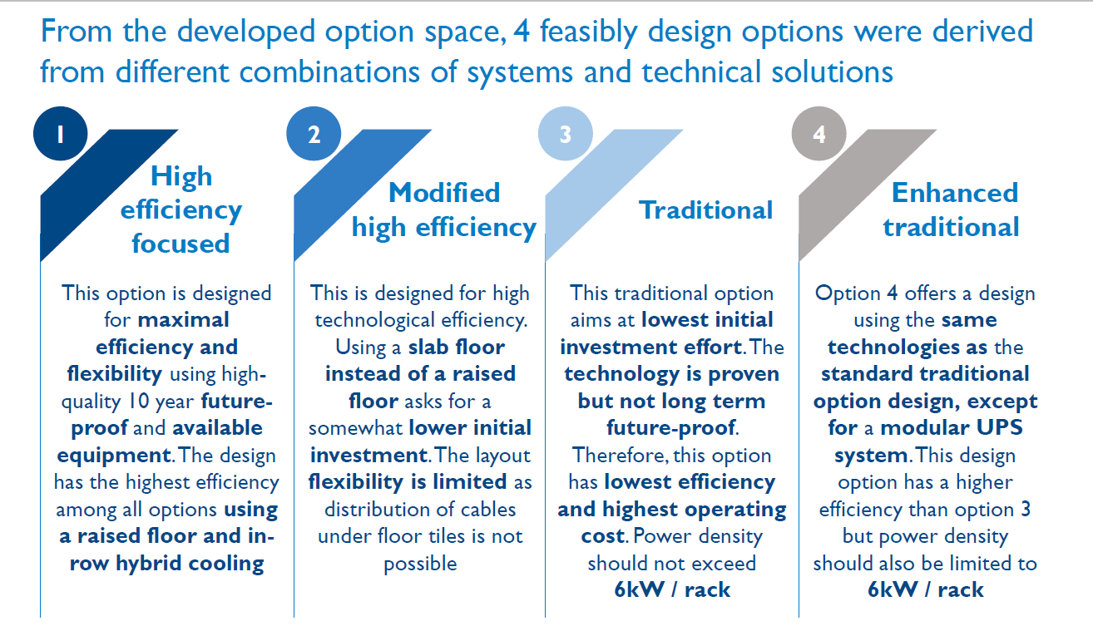

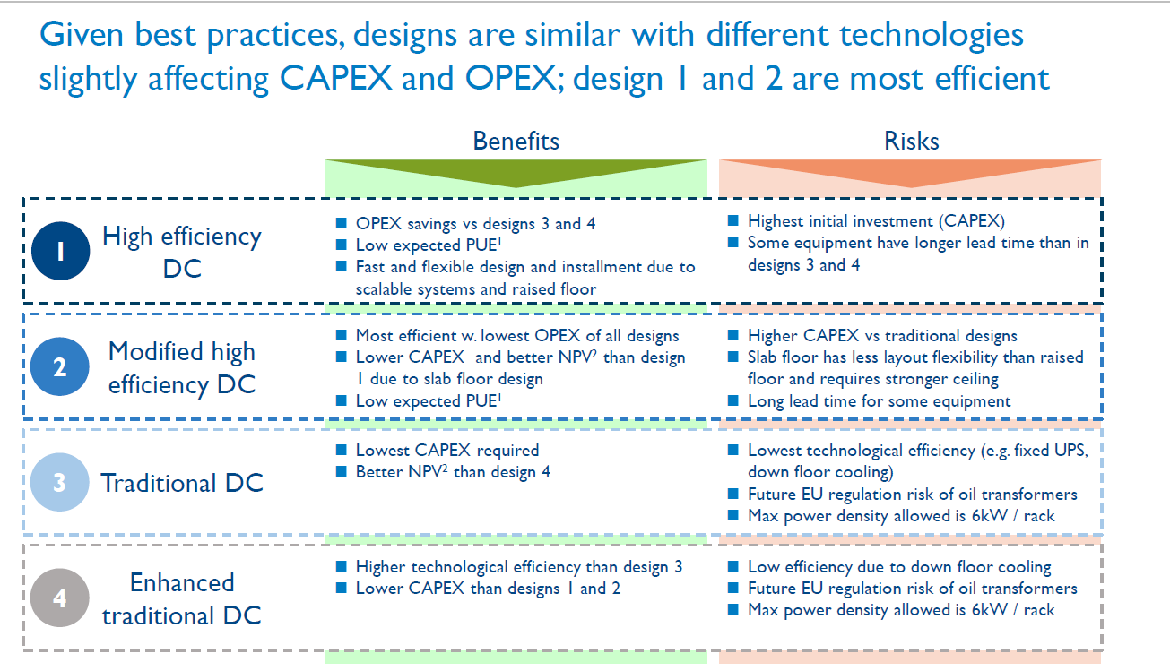

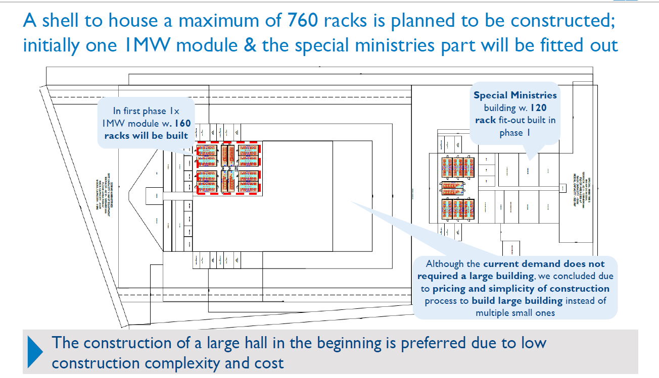

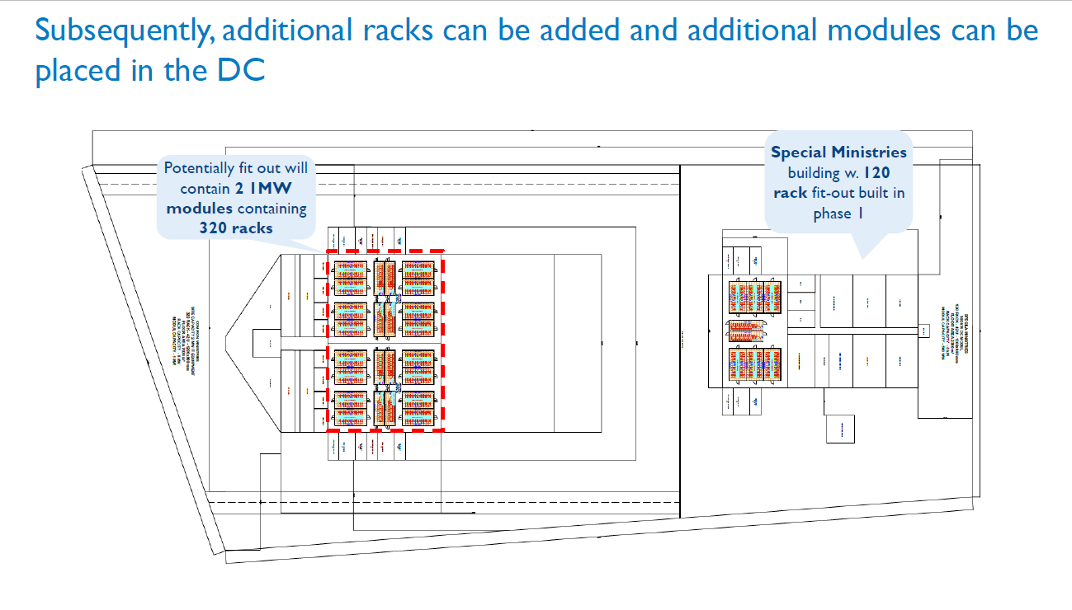

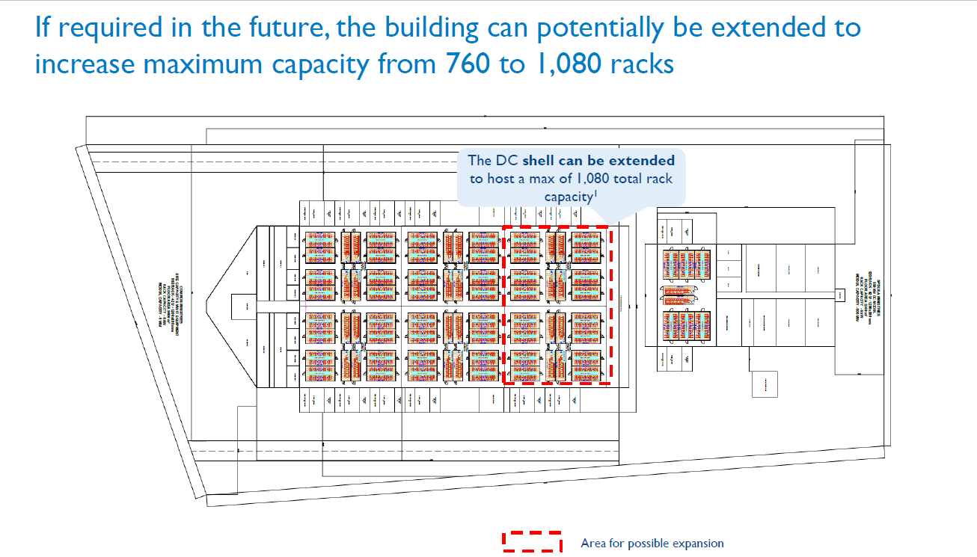

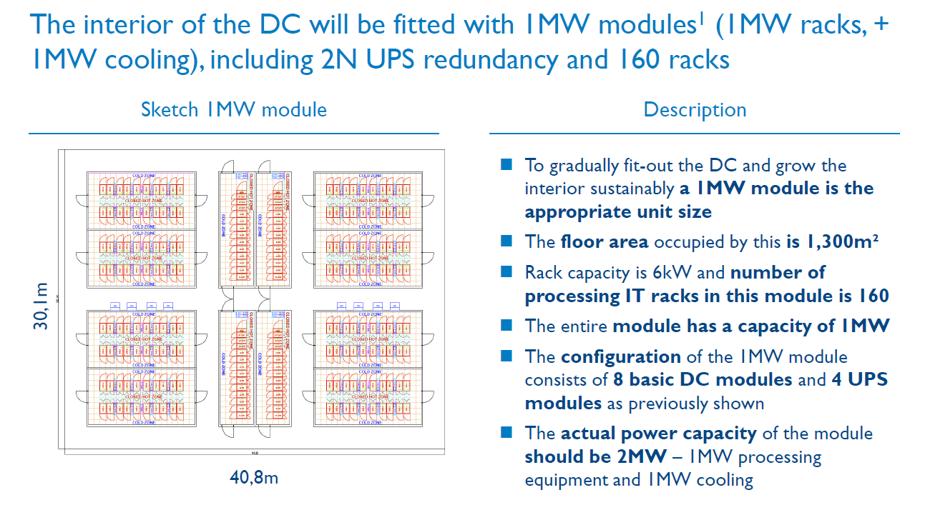

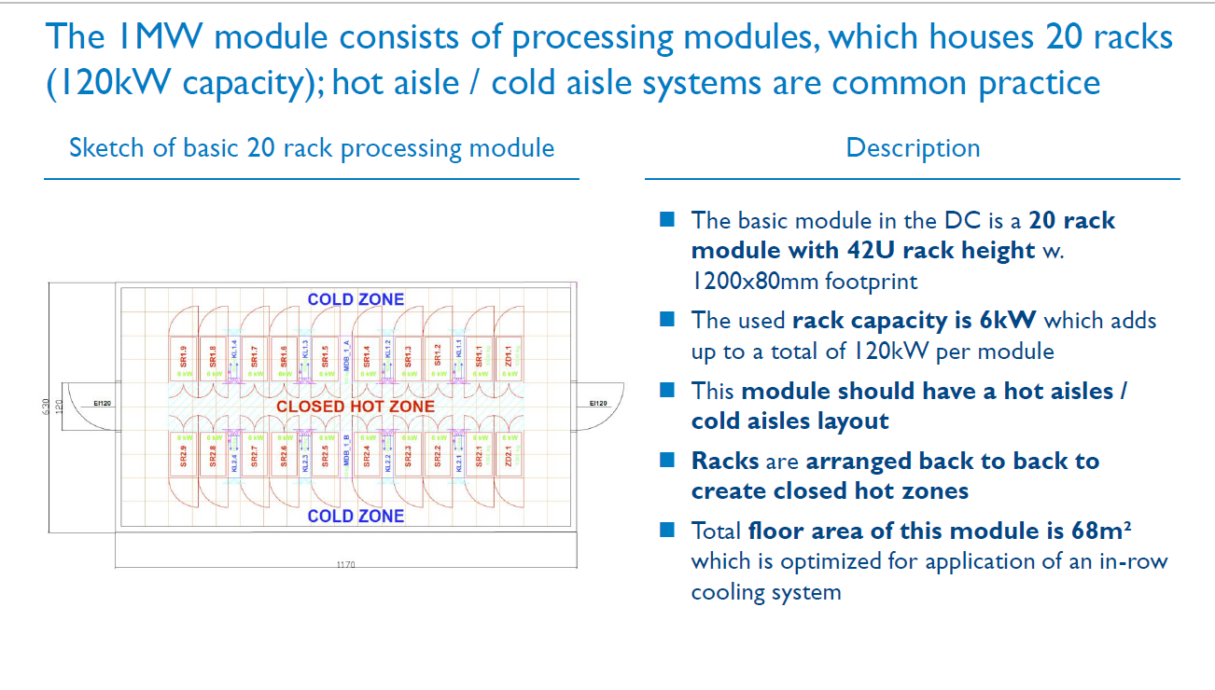

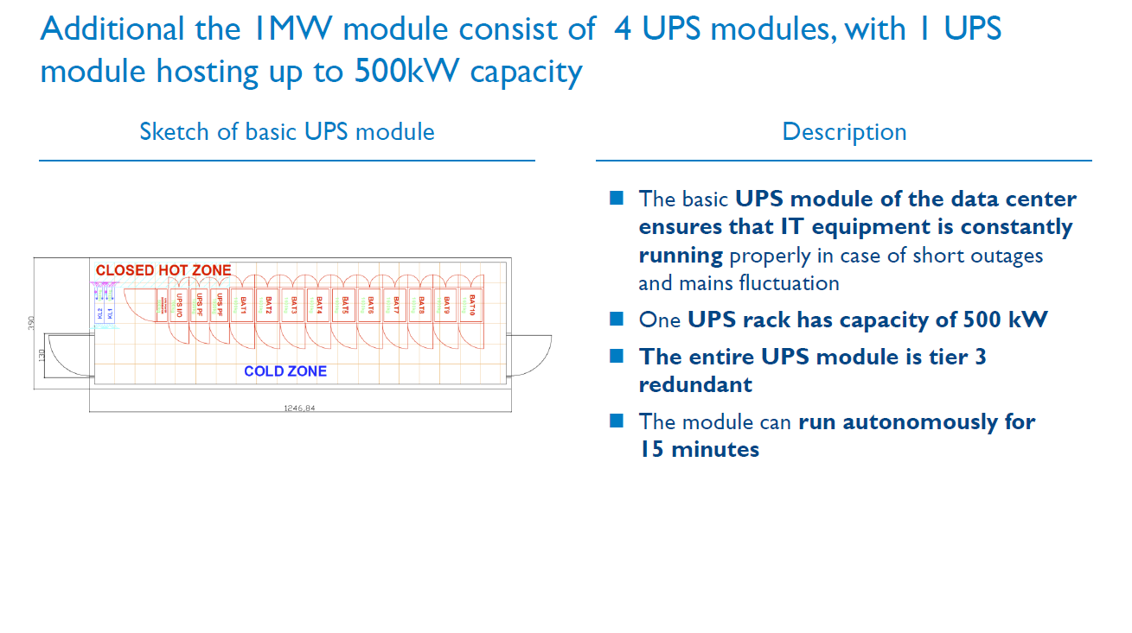

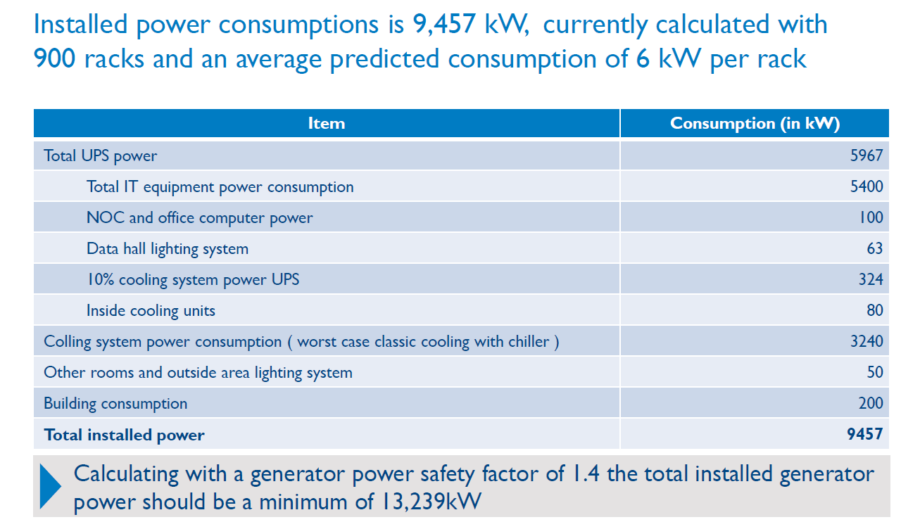

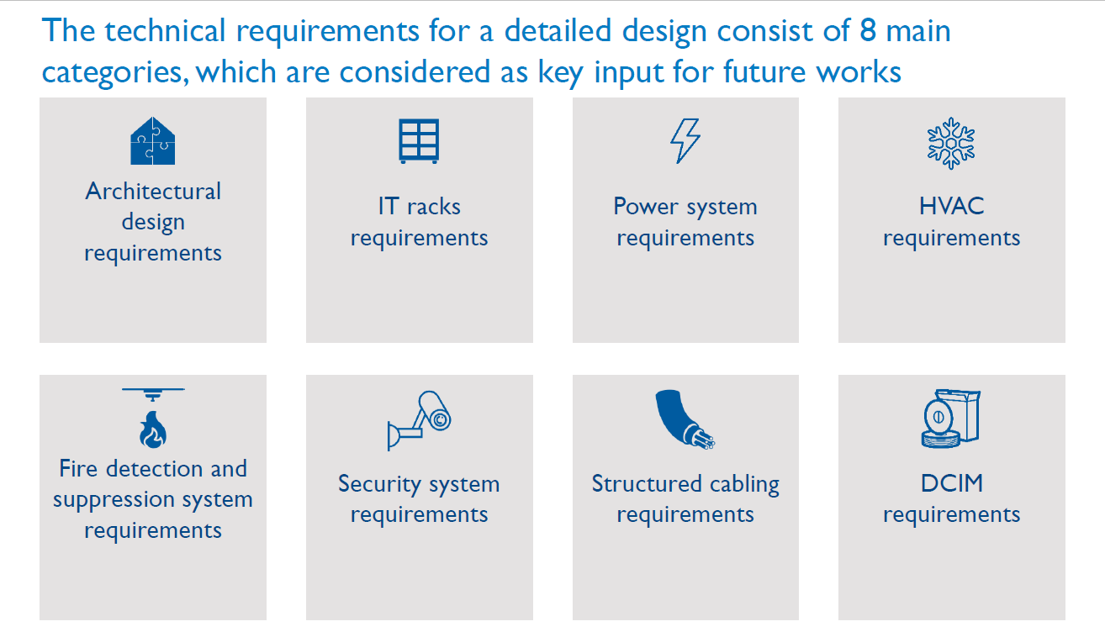

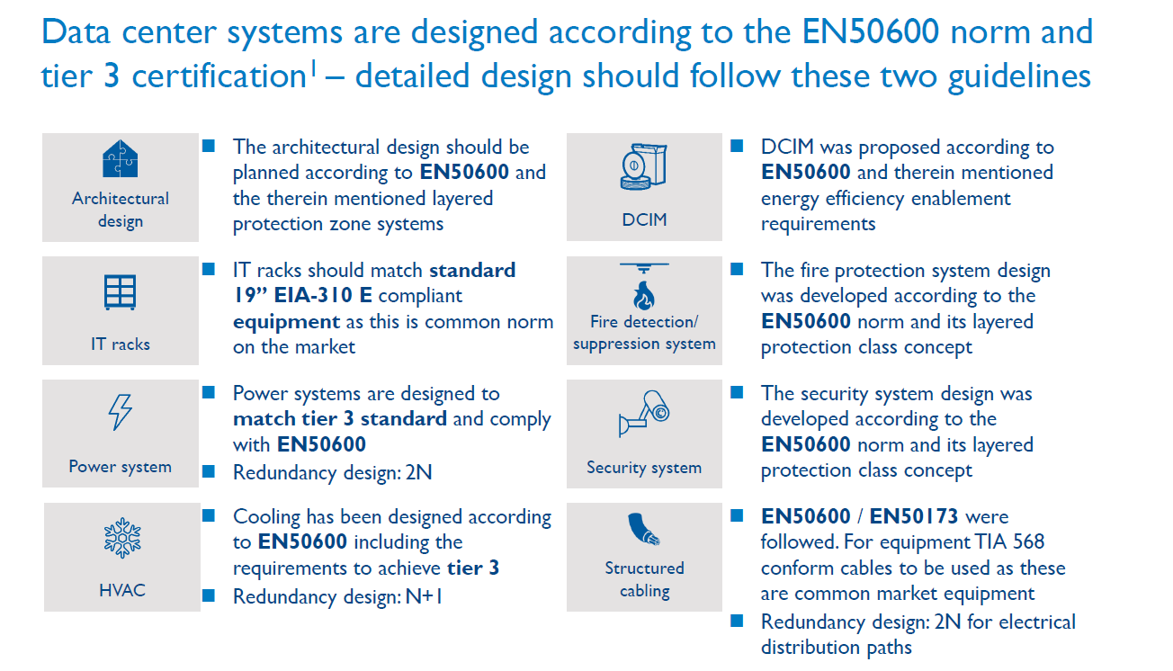

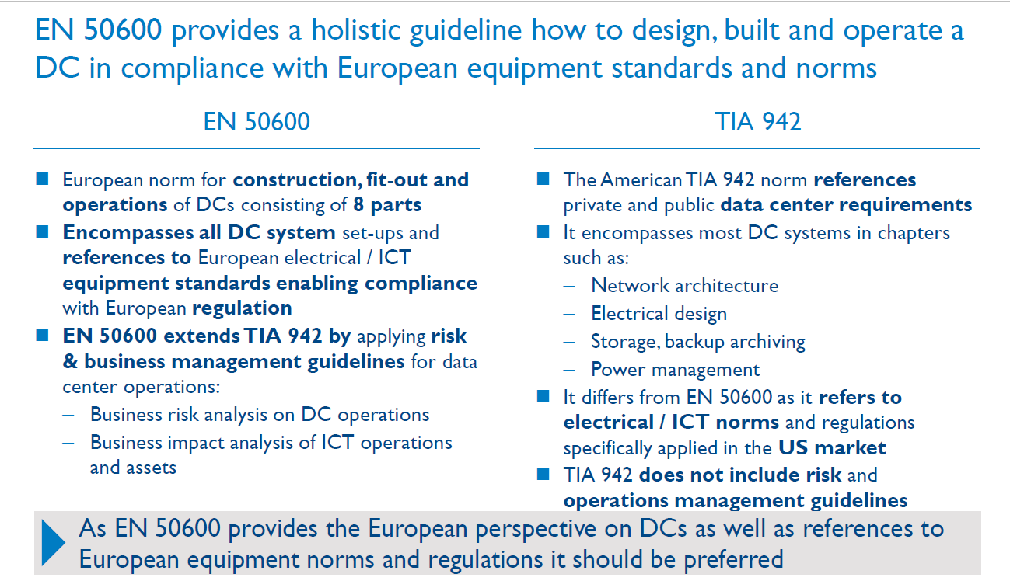

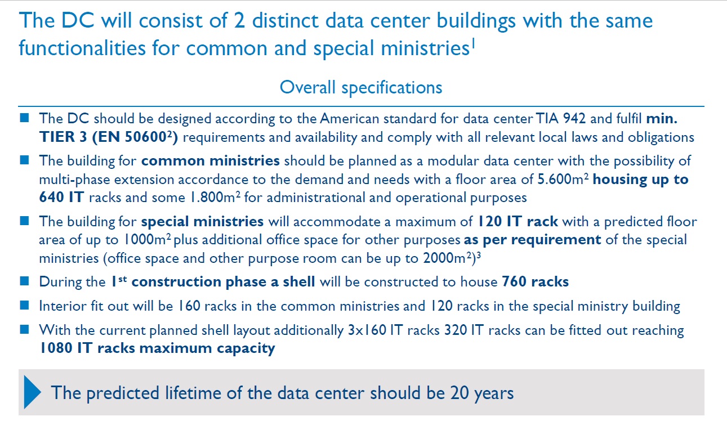

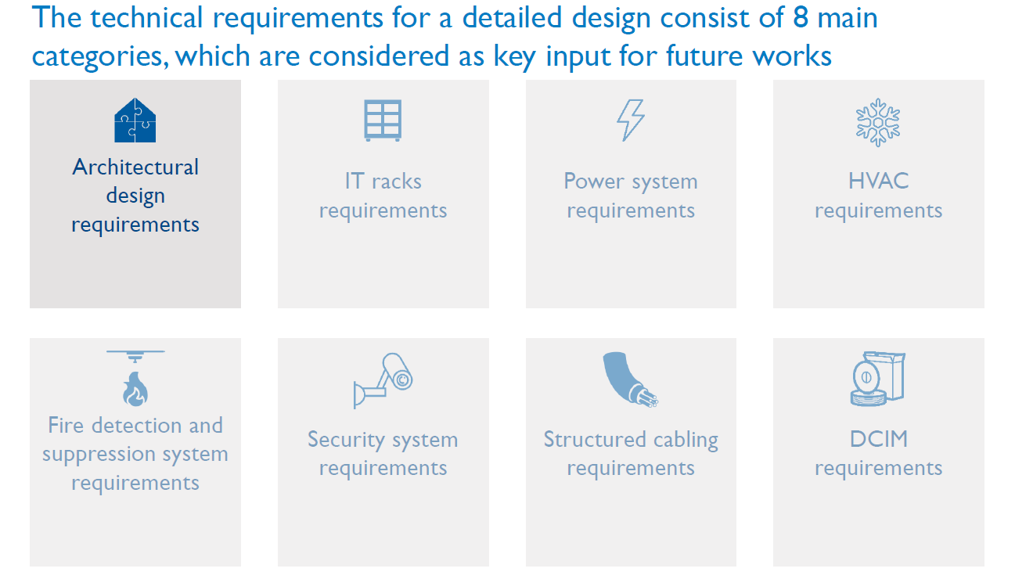

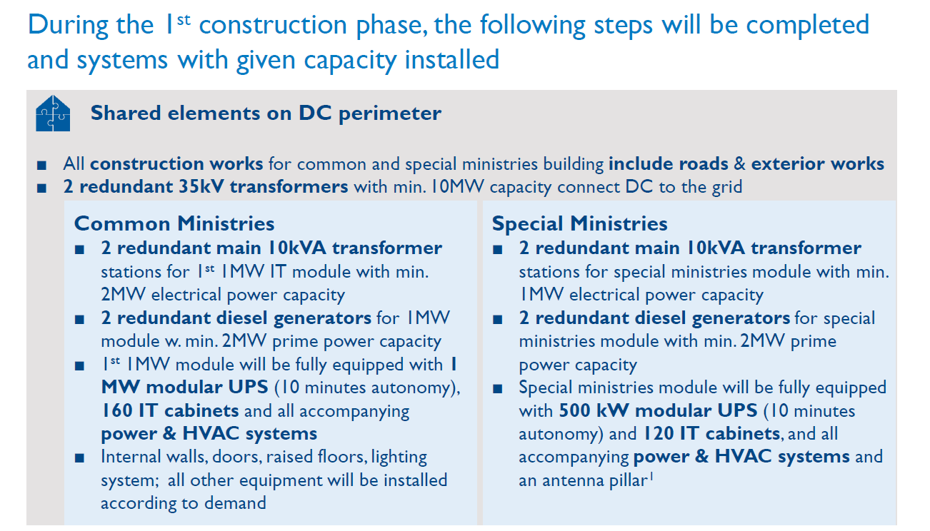

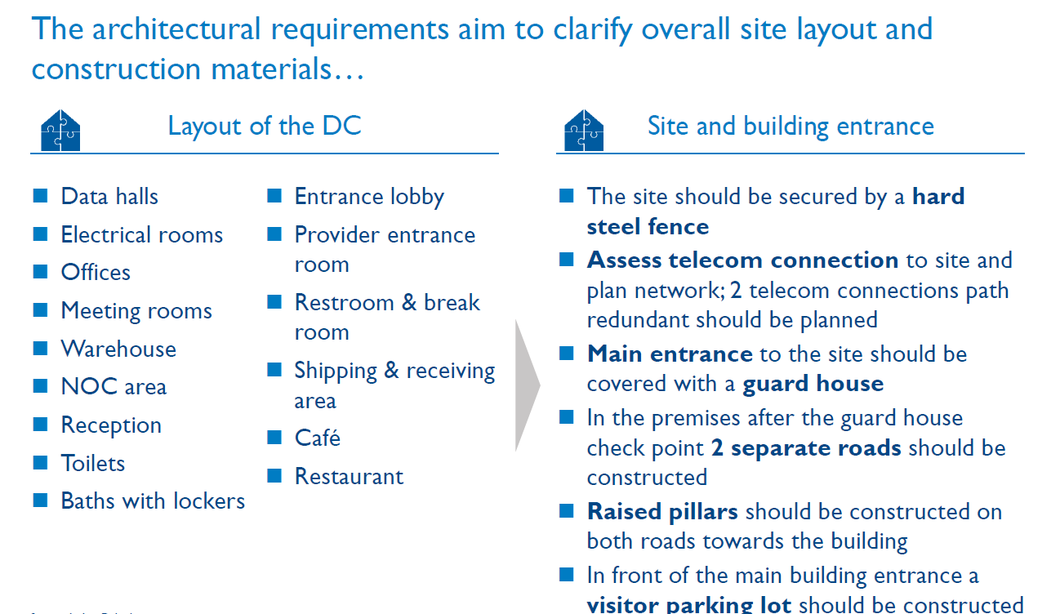

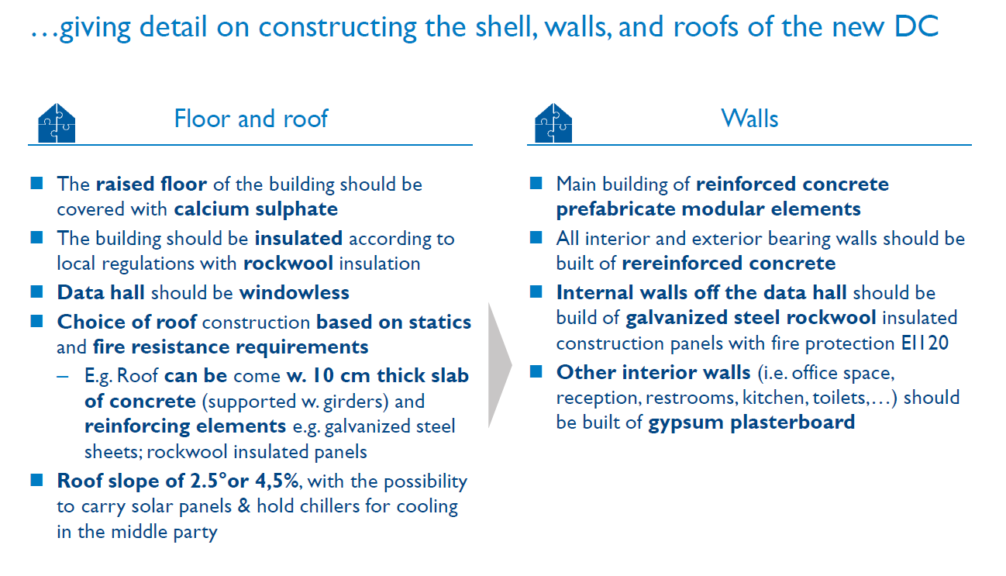

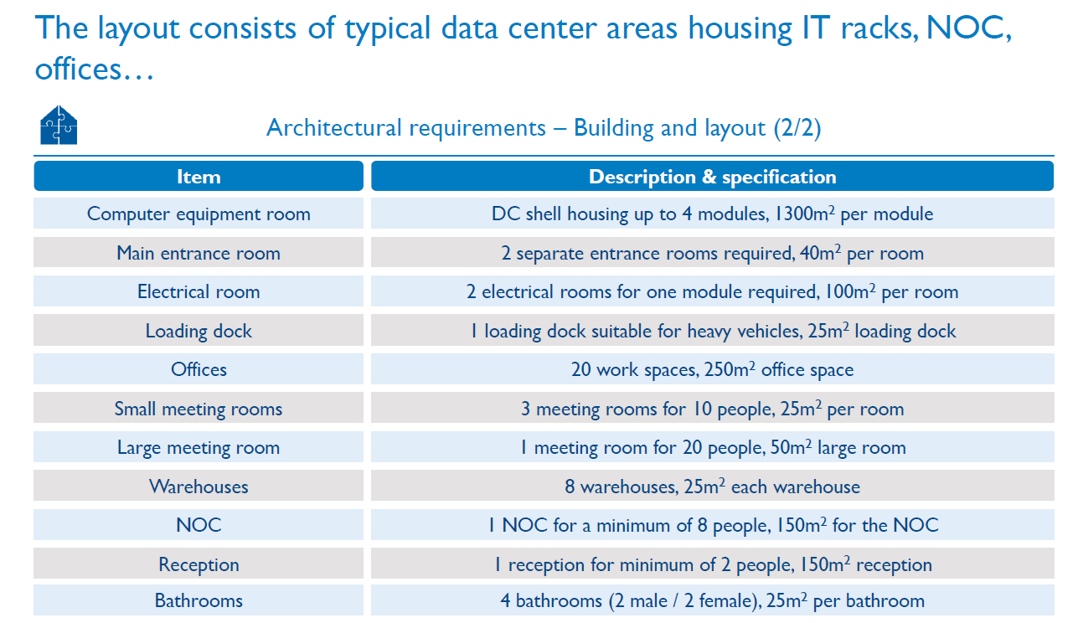

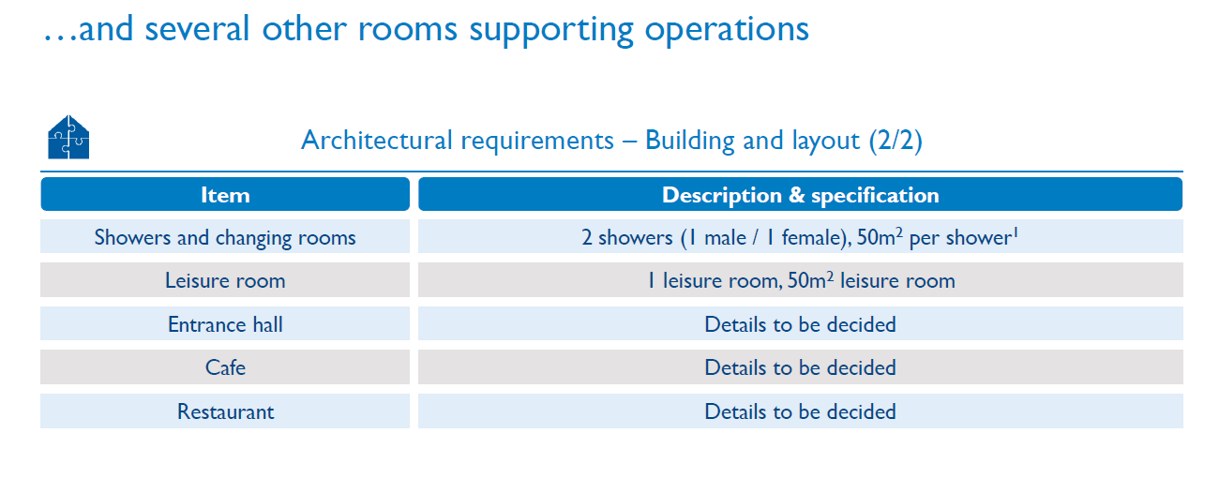

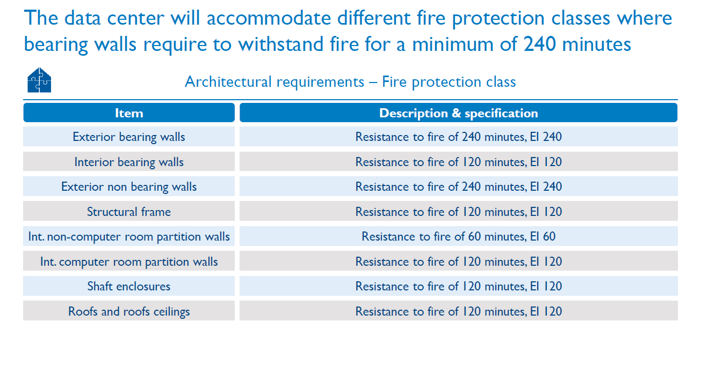
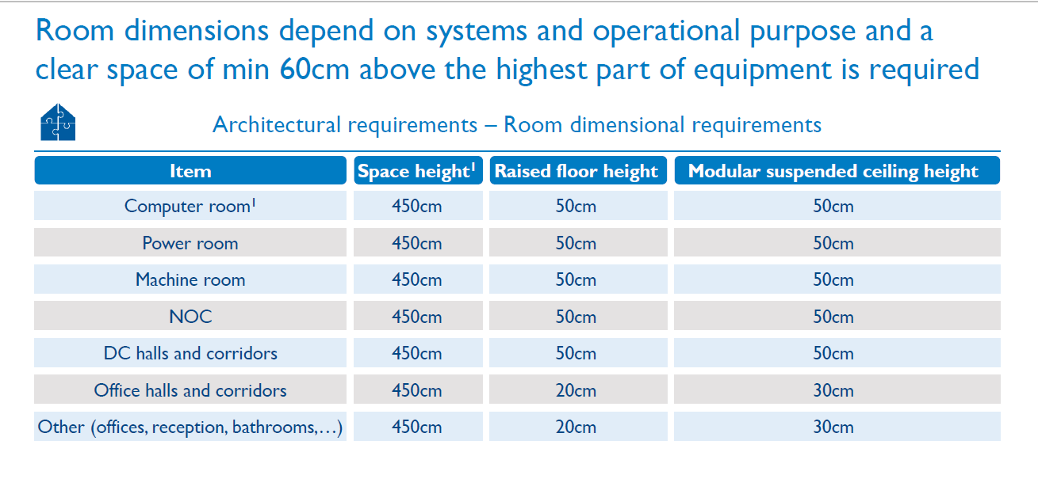
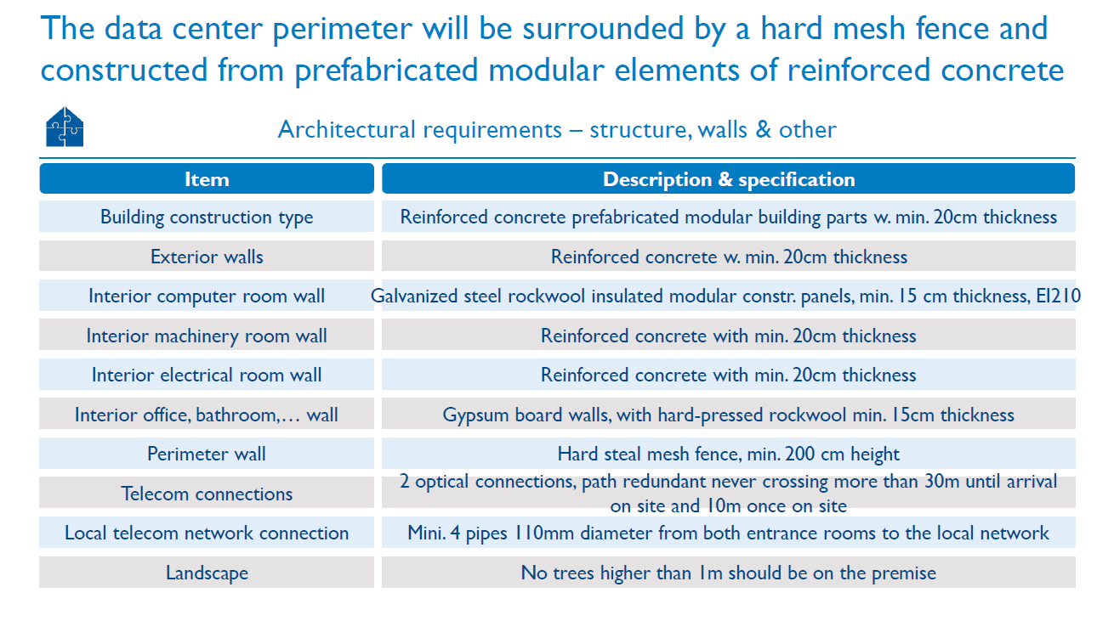
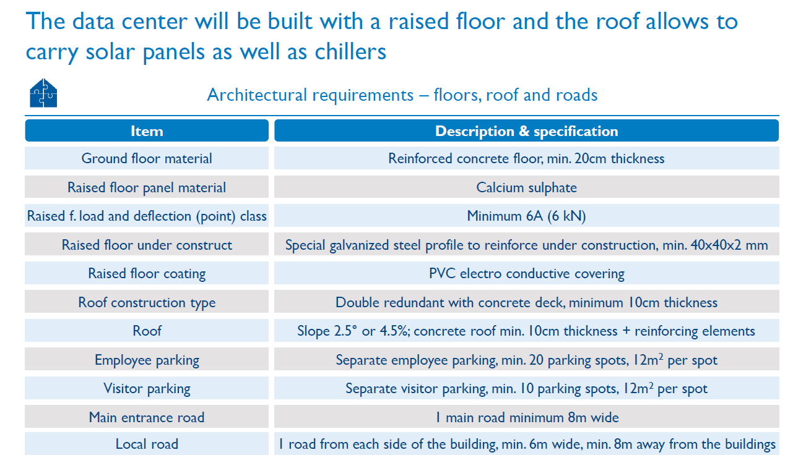
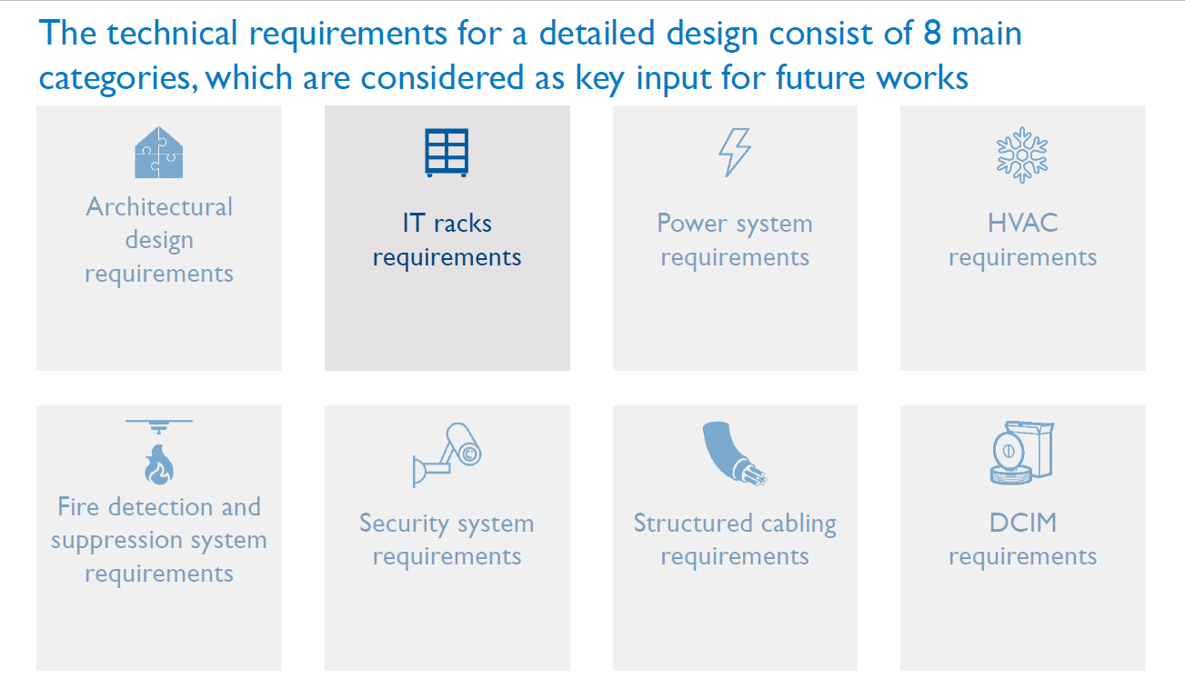

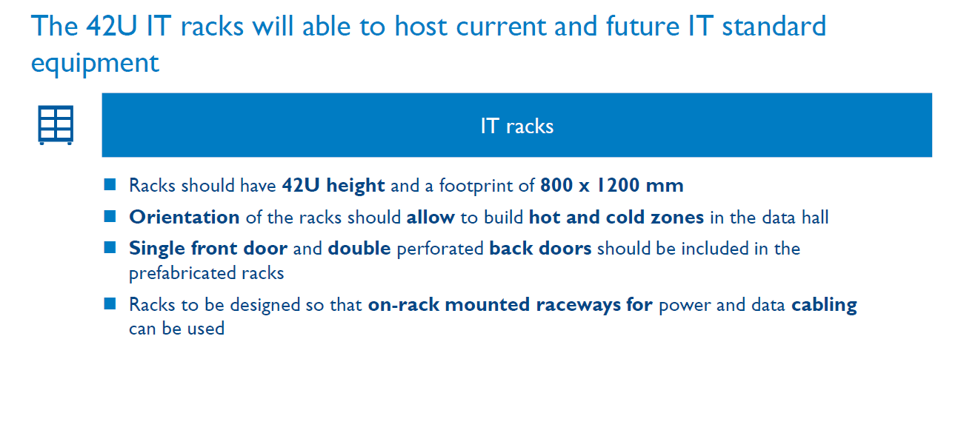
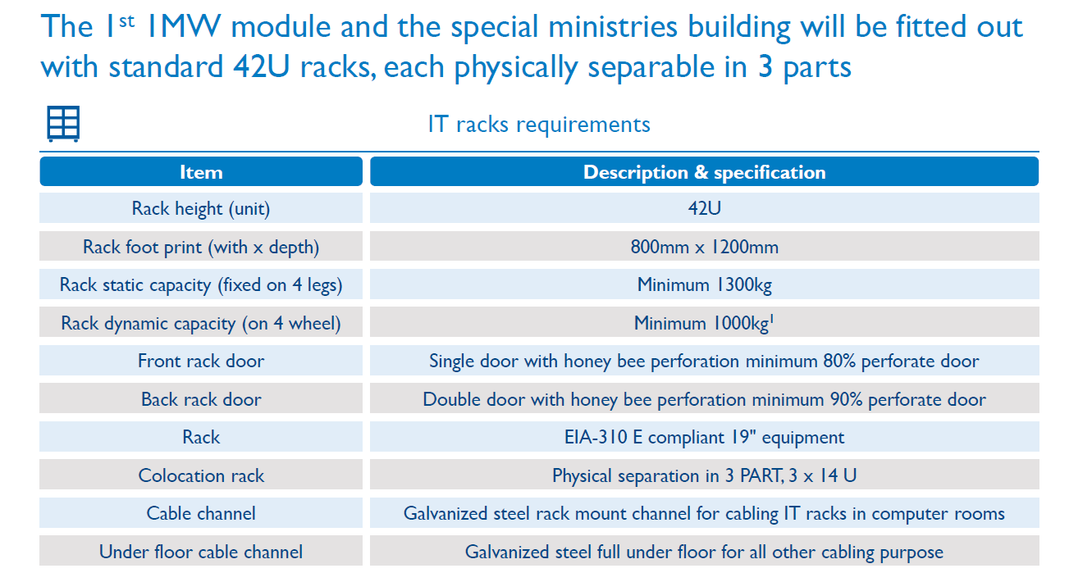

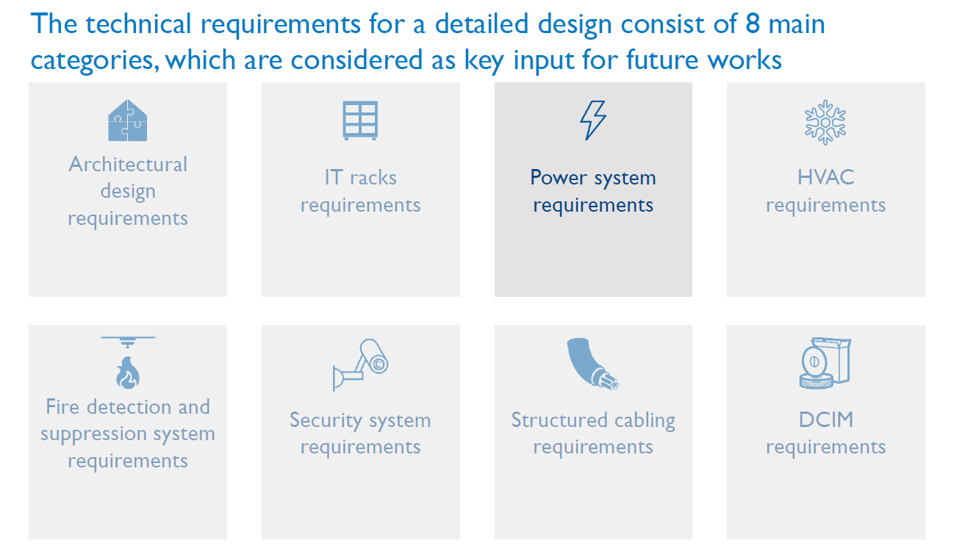

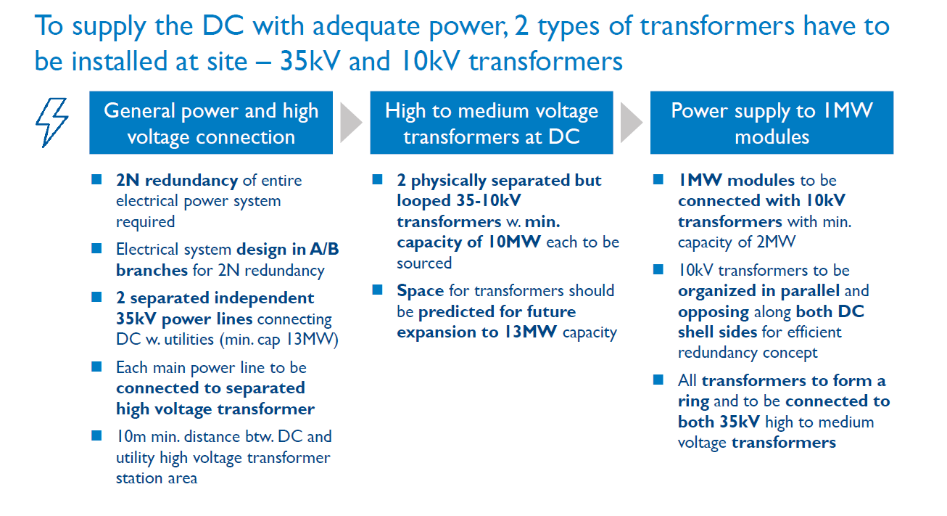

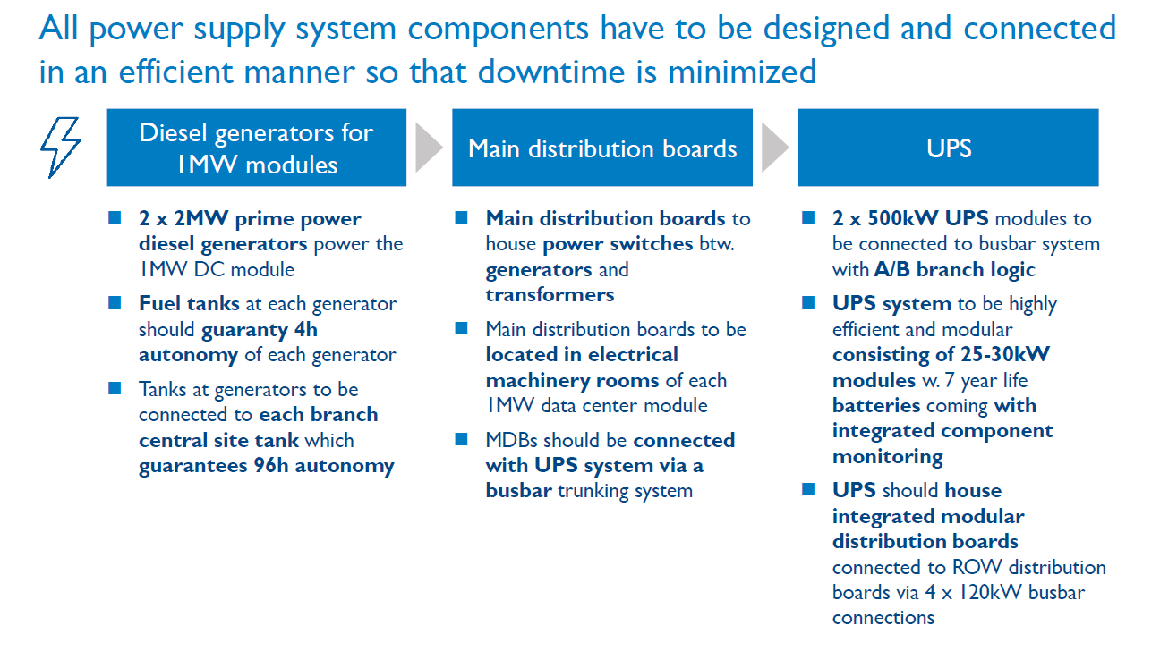

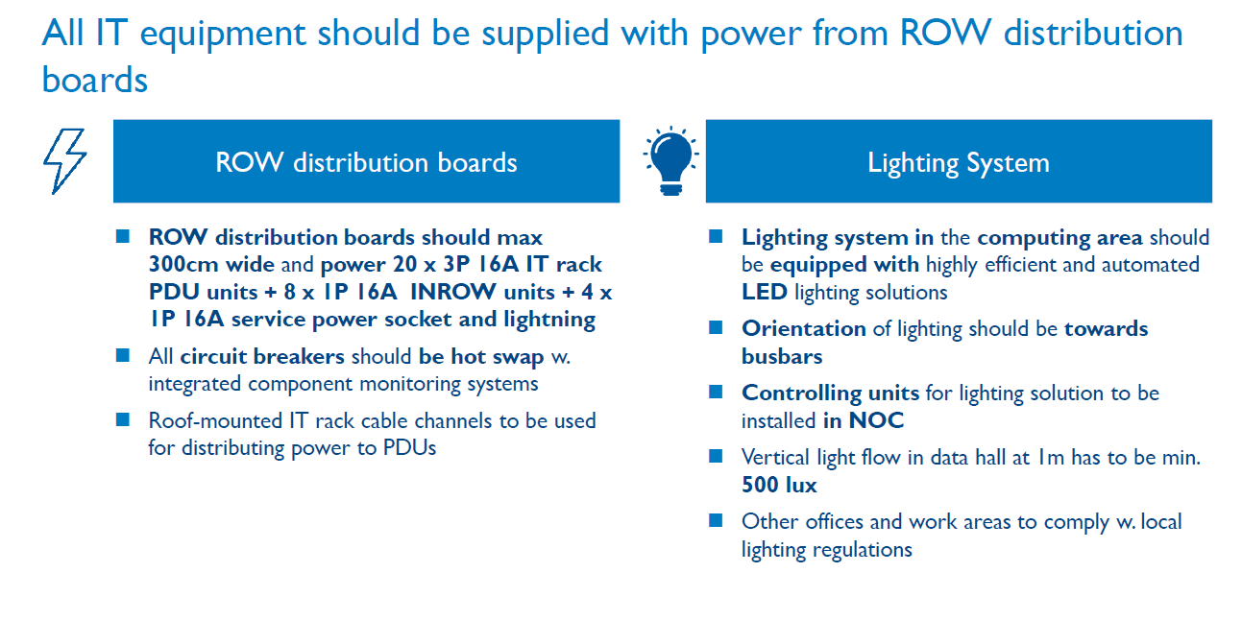

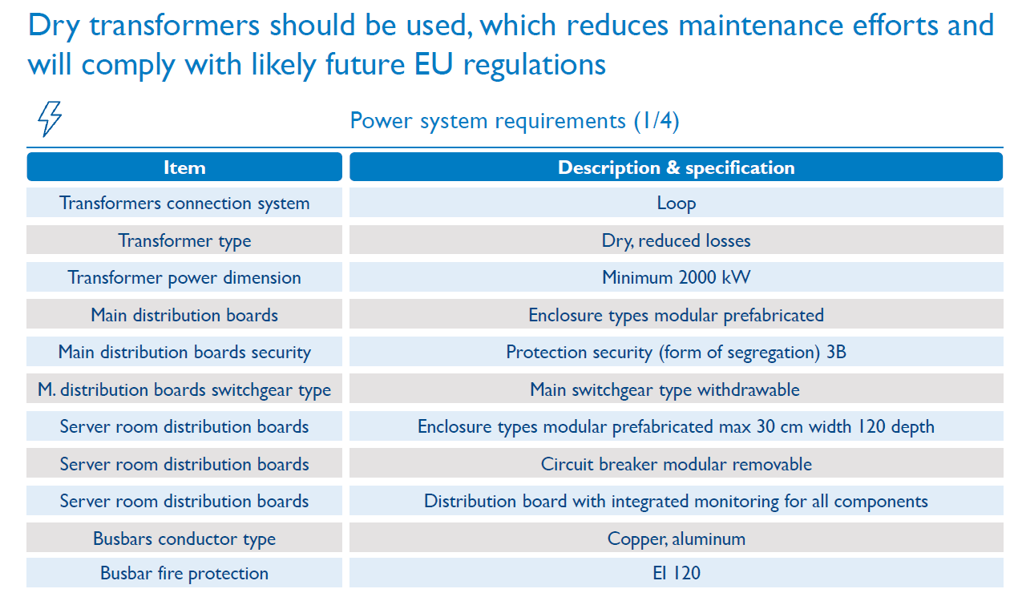

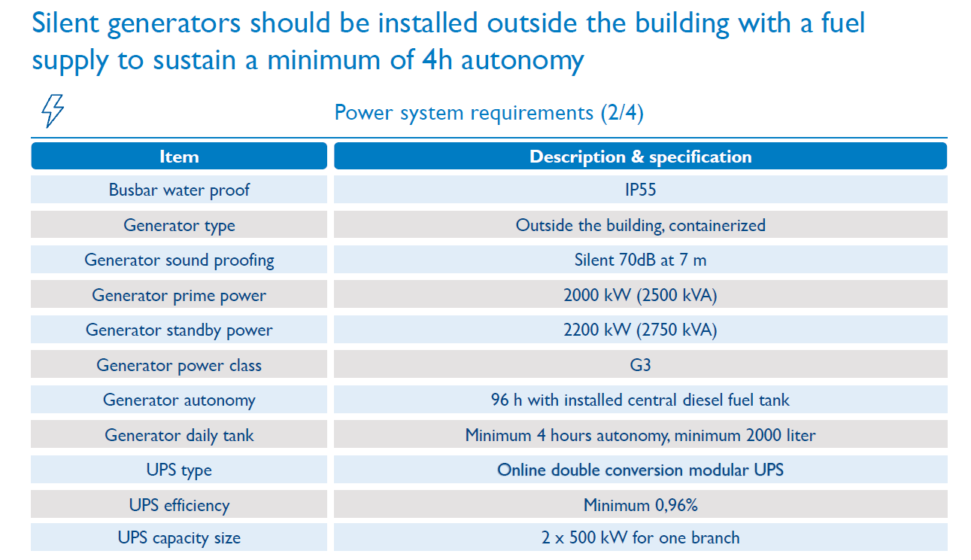

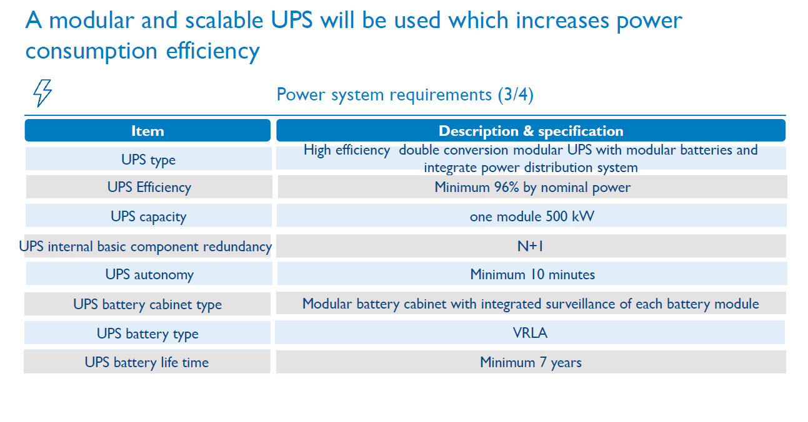

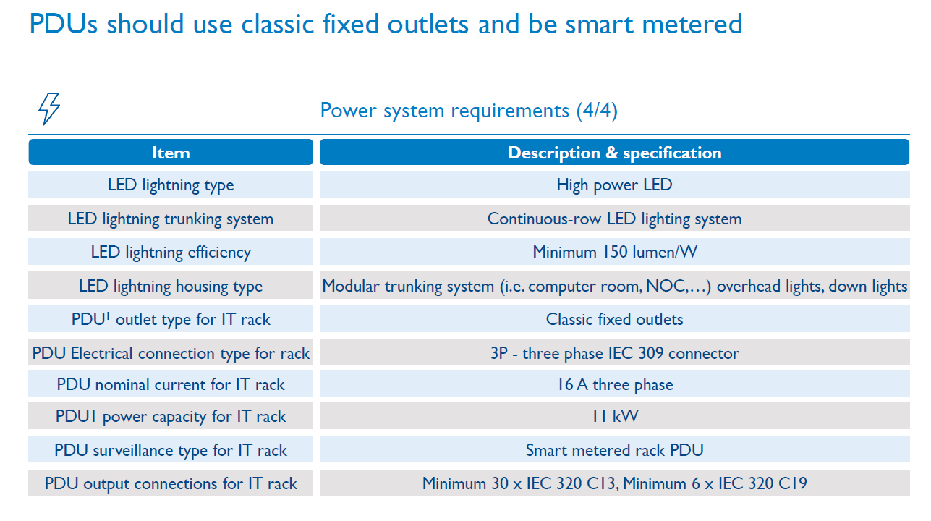

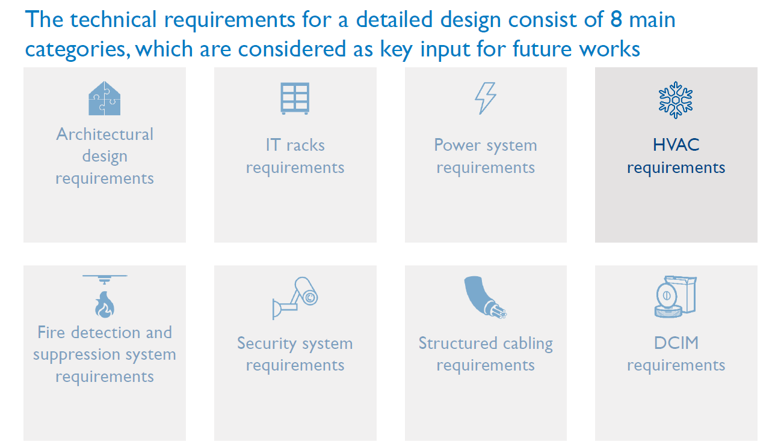

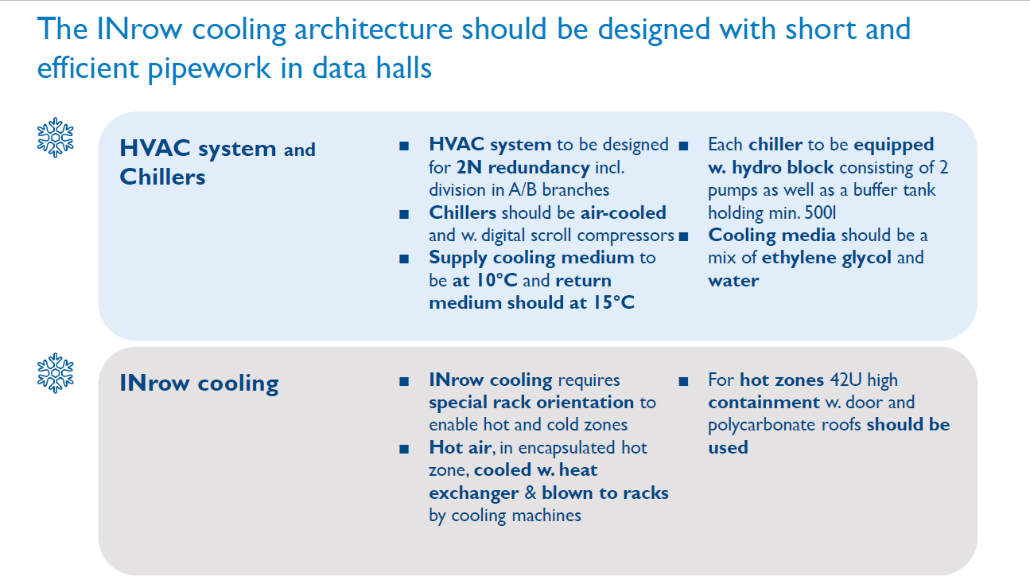

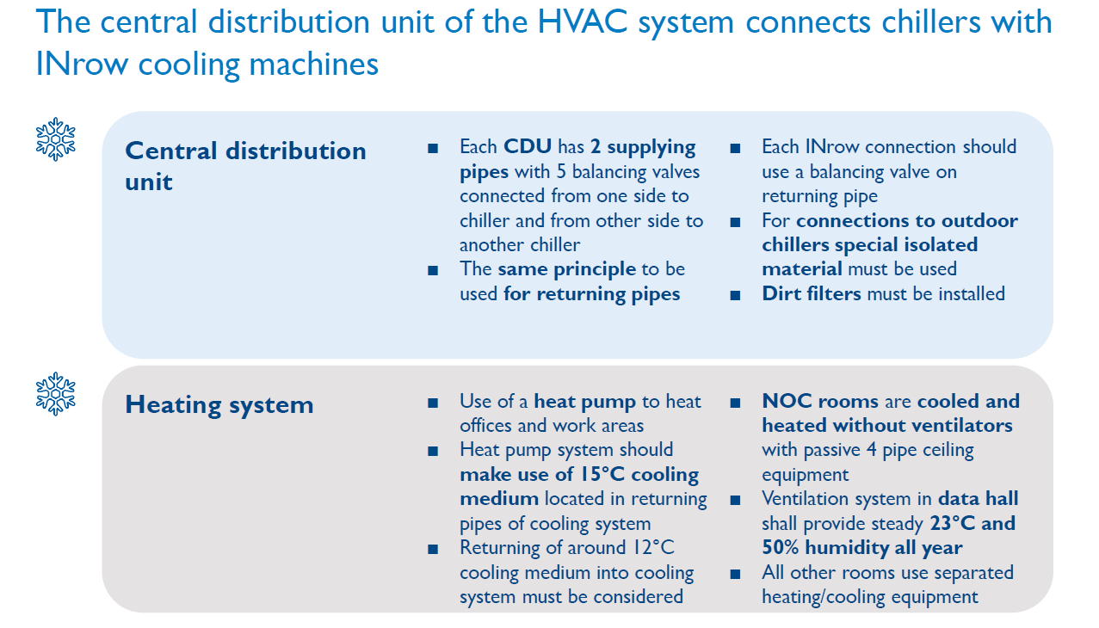

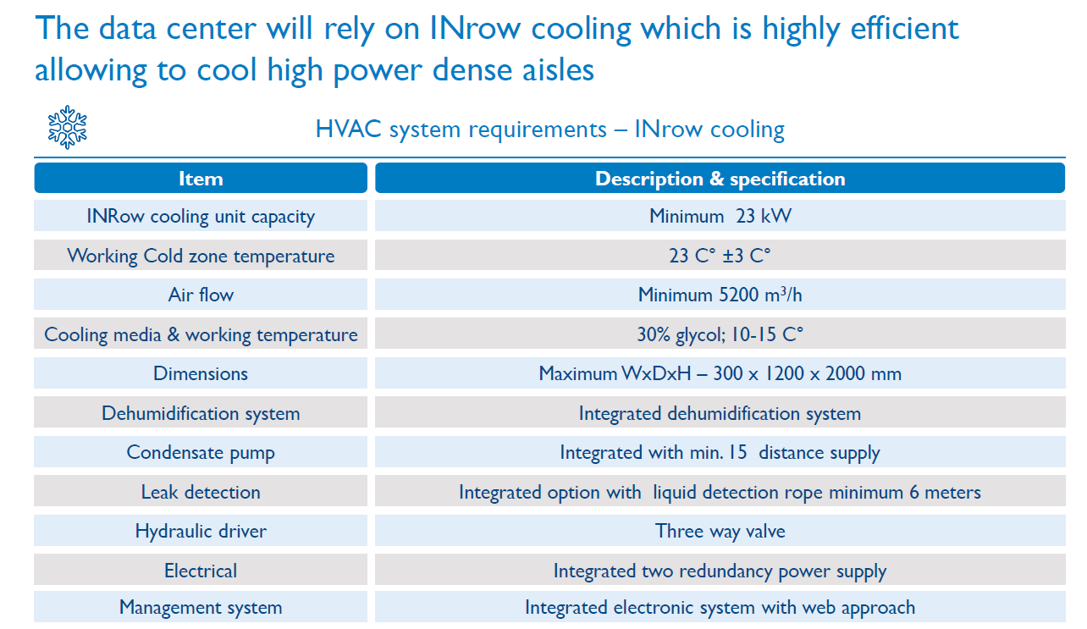

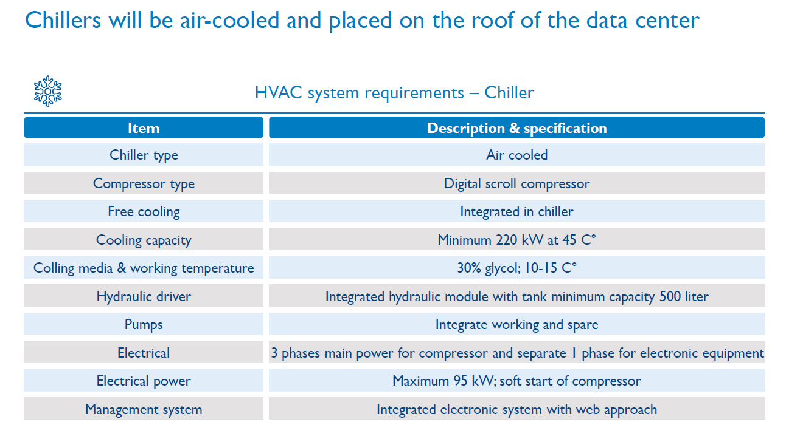

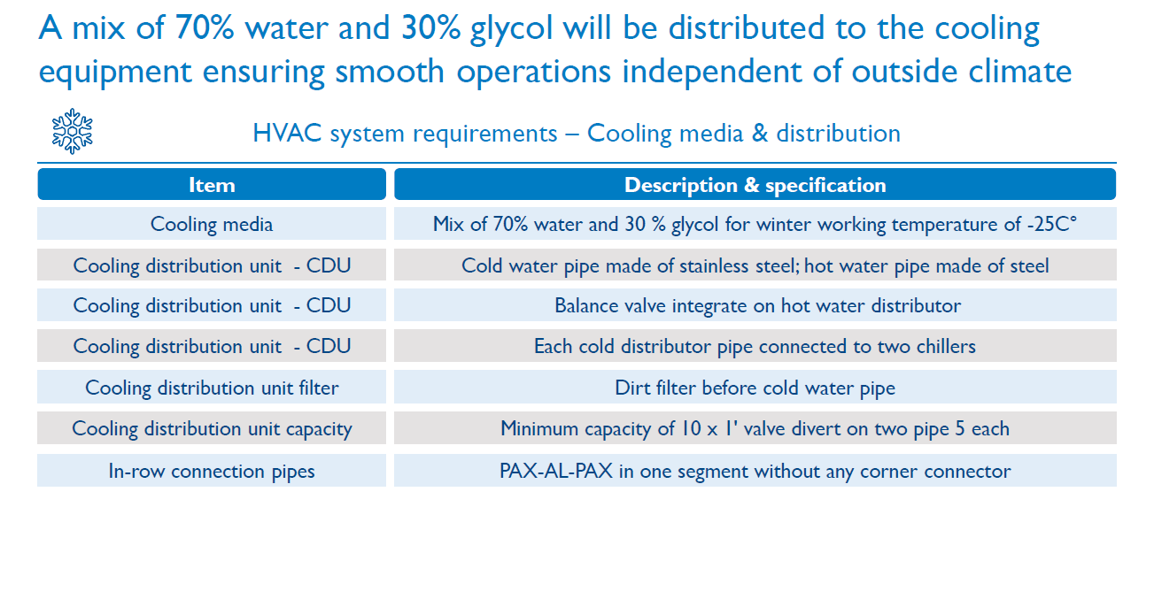

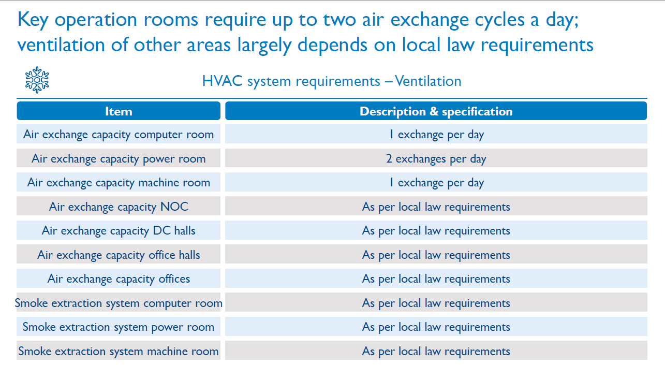

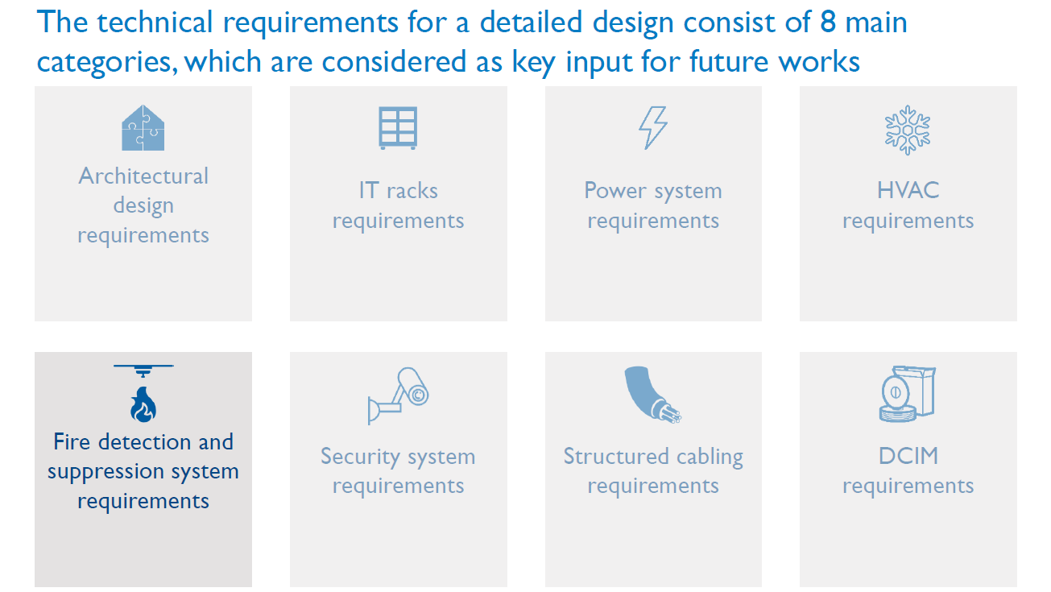

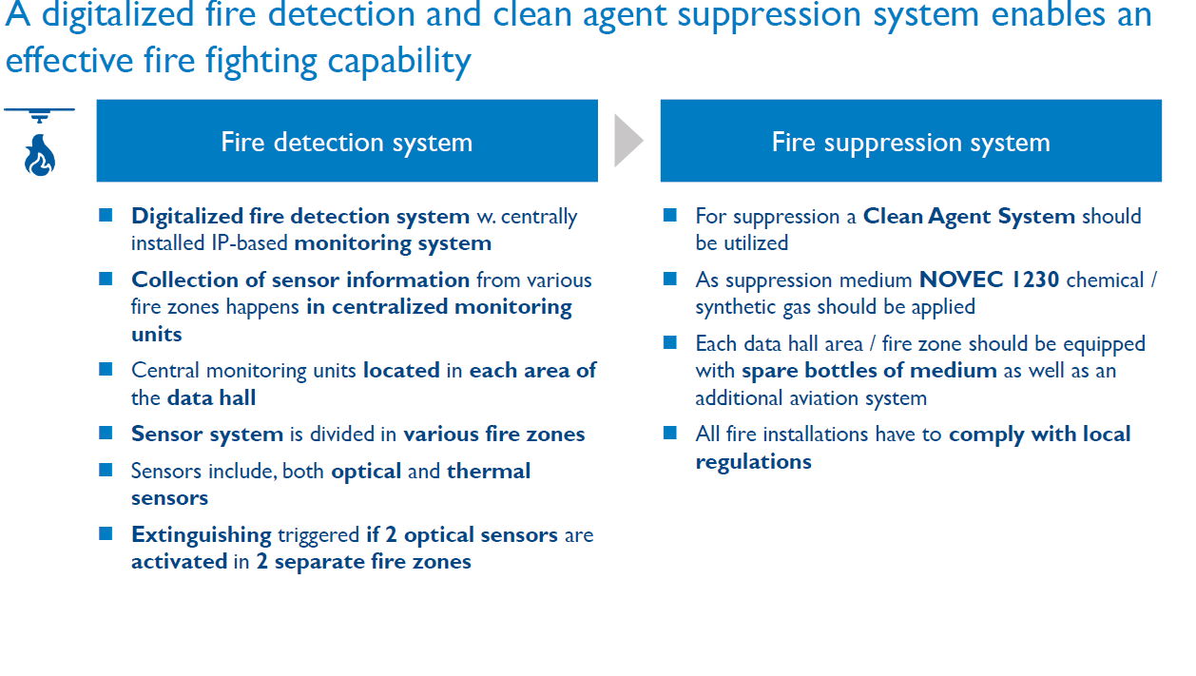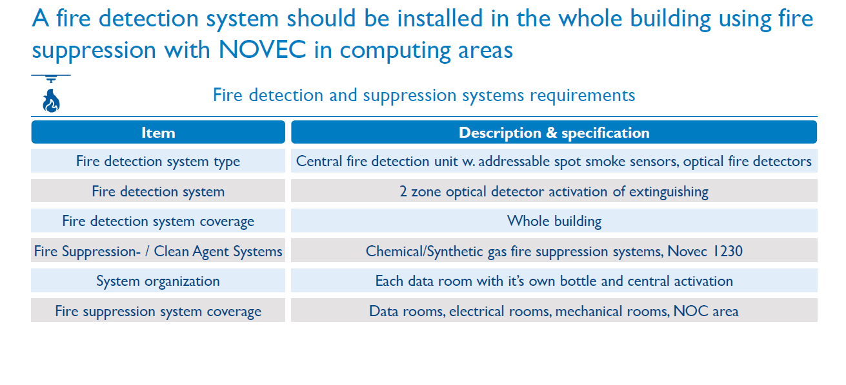

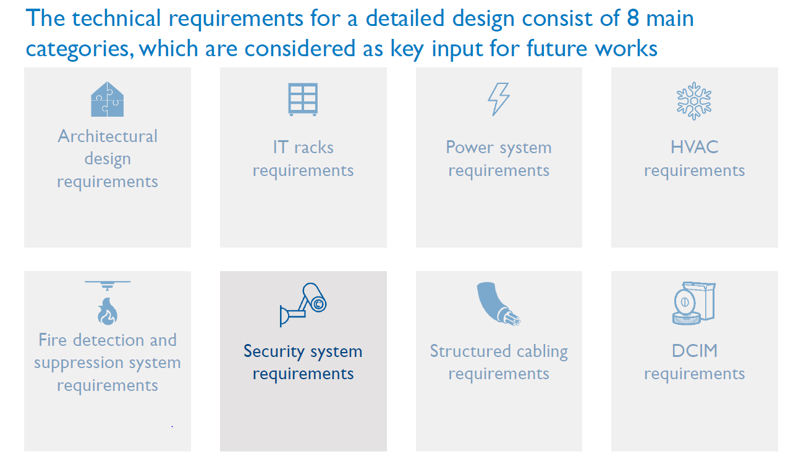

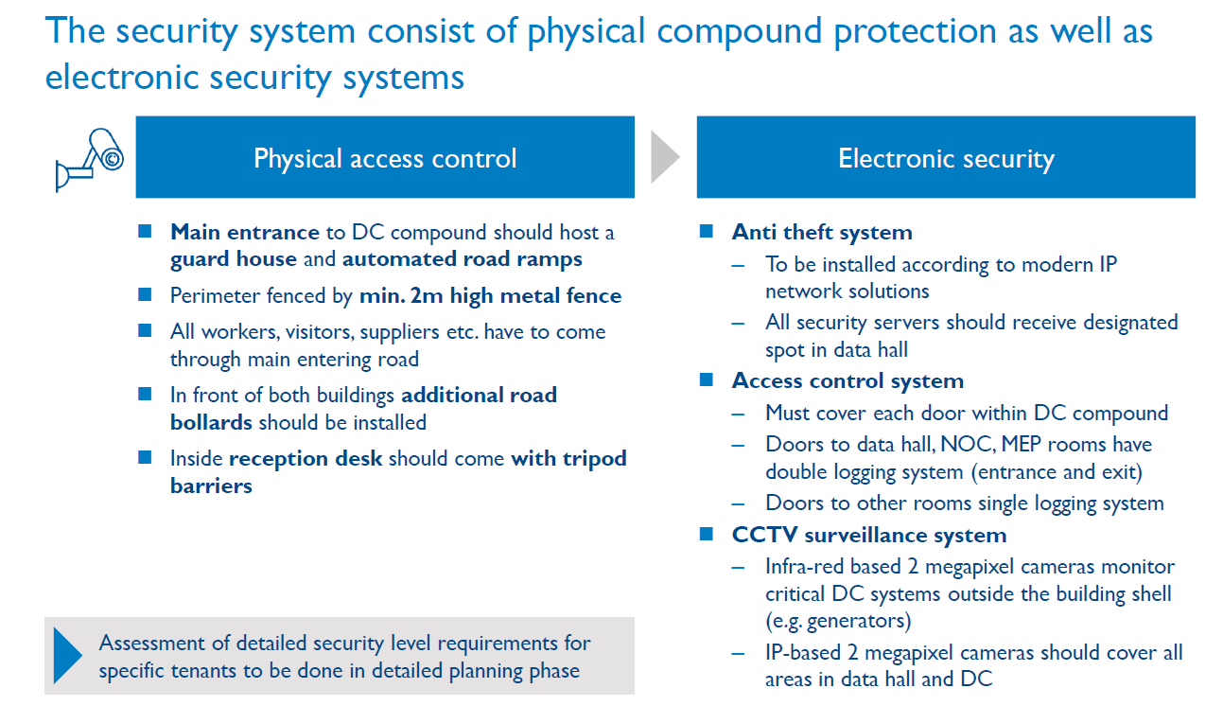

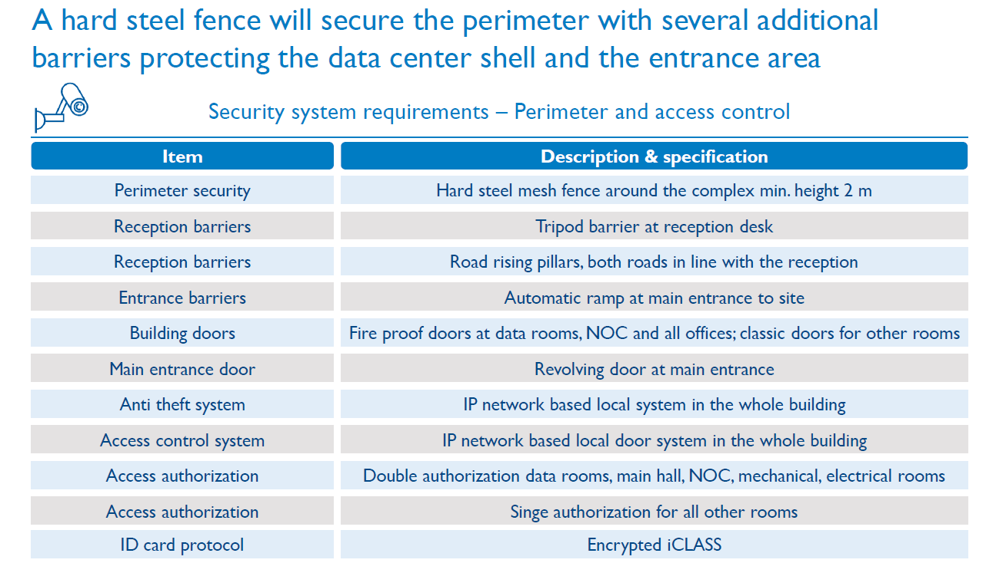

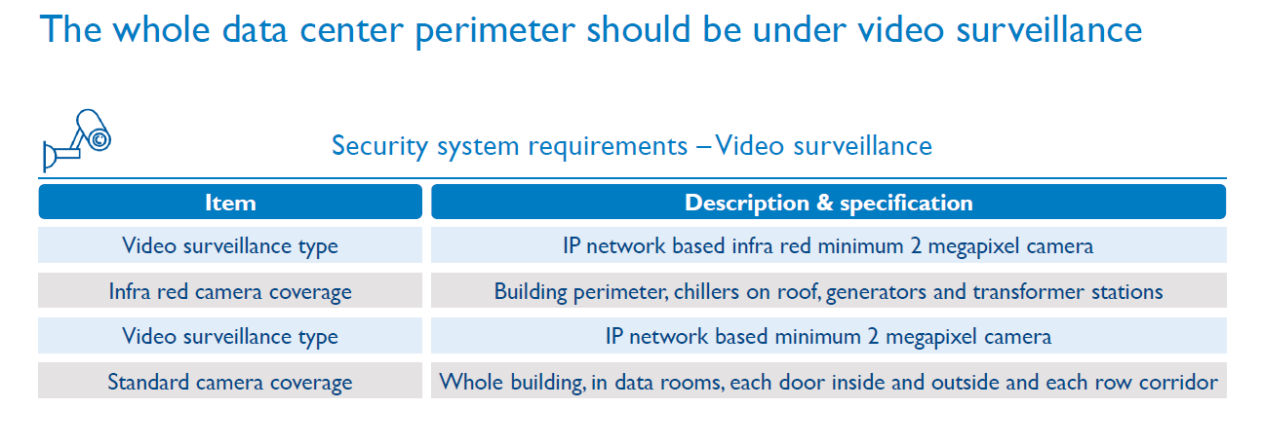

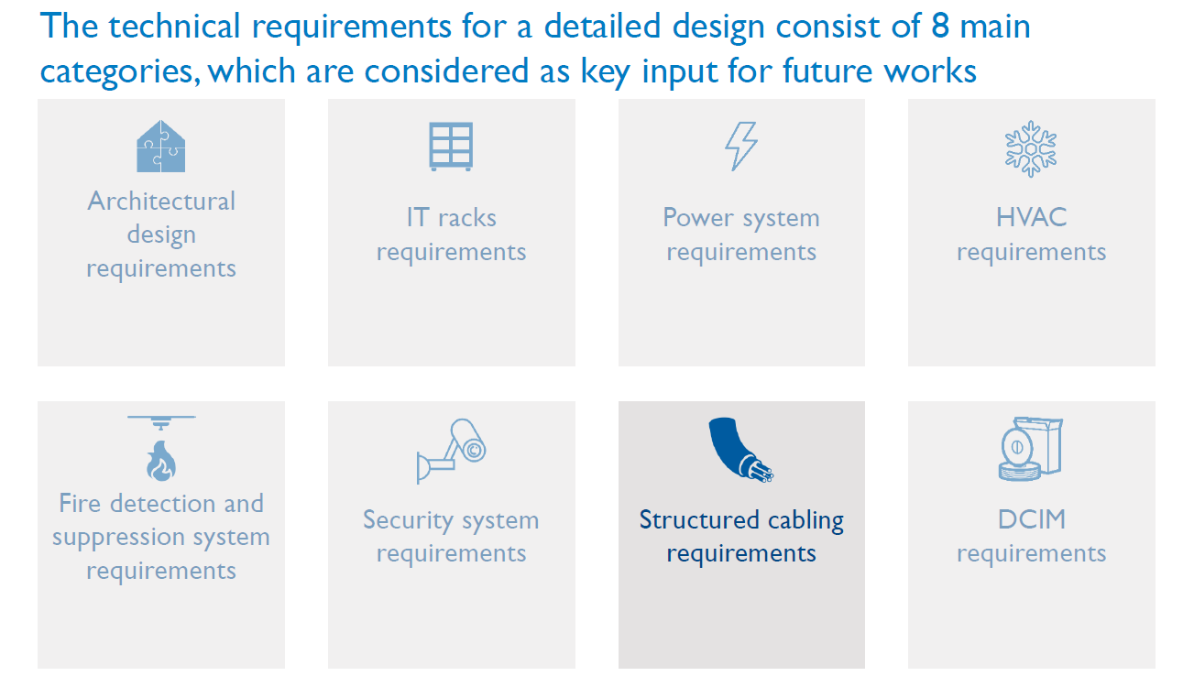

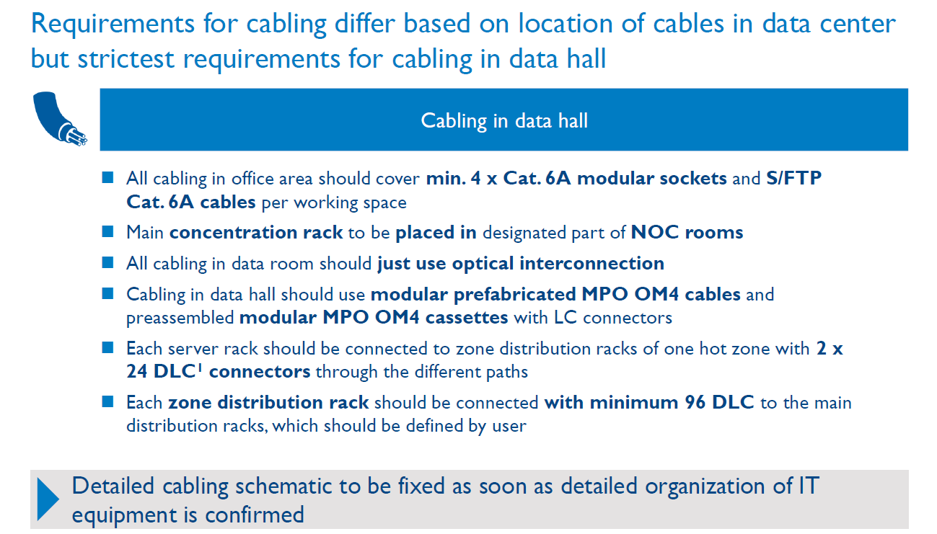

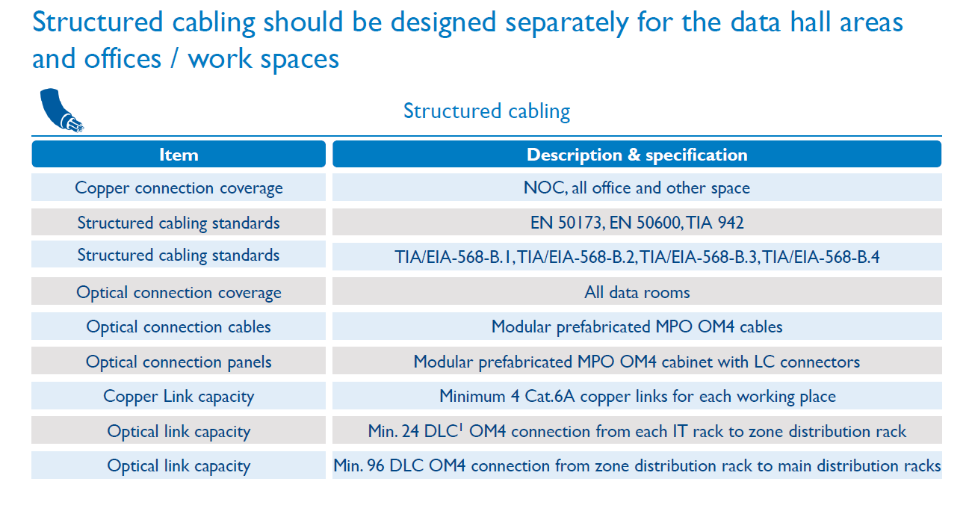

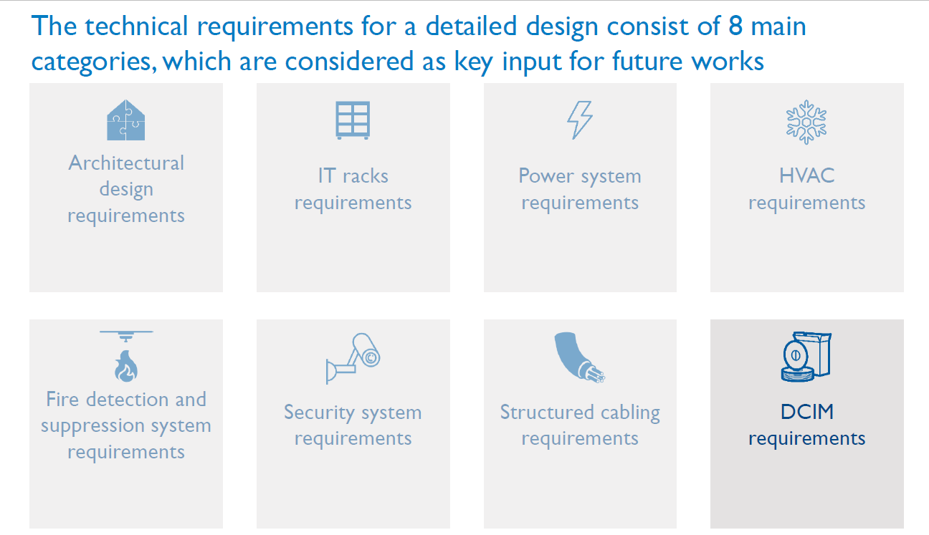

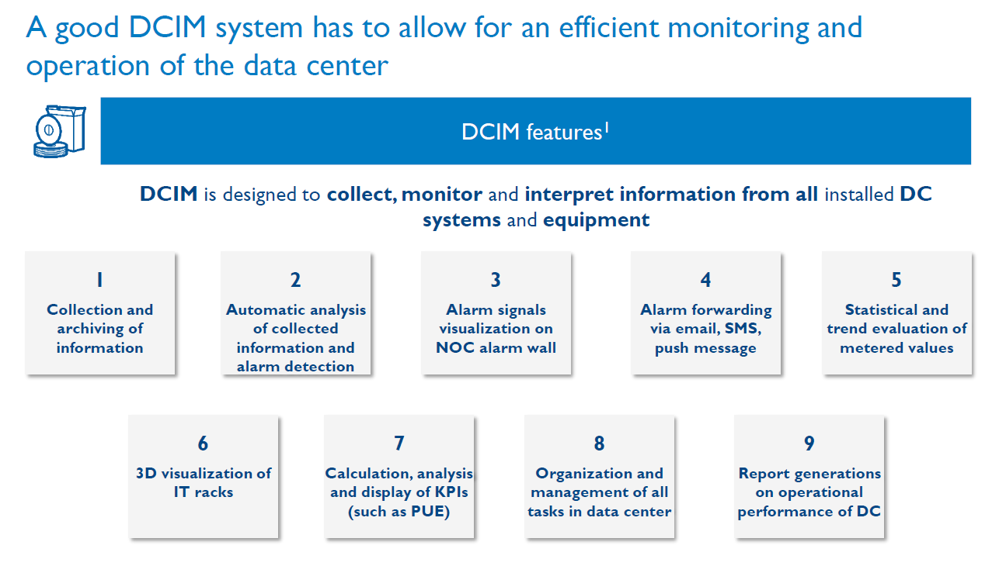

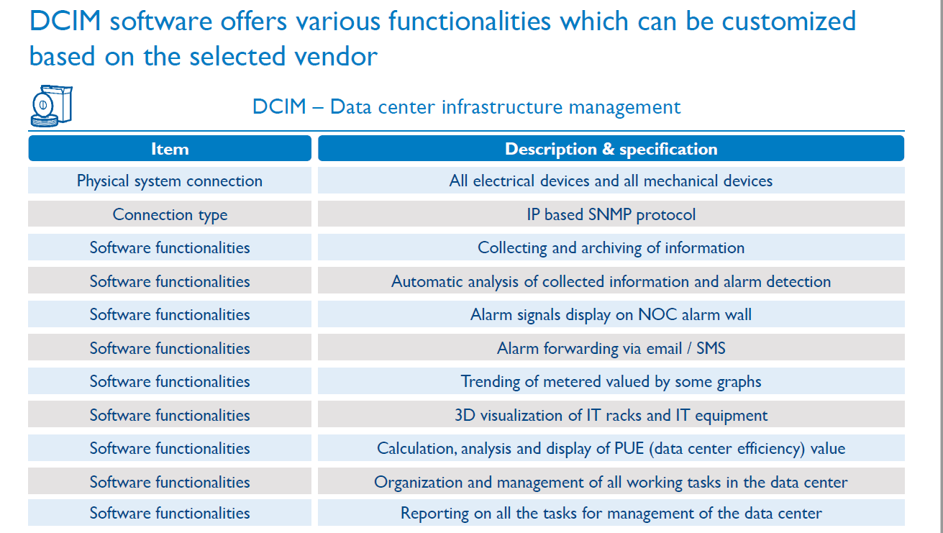

In particular, the Selected Bidder is expected to deliver the following Study of the business strategy and operating model for DCOE, which must include:

Task 1.
a. IT strategy for ITE’s DC services and development of deployment/migration framework for government tenants;
b. Commercial strategy of the DC and definition of the product/services portfolio which will be provided from DC;
c. Estimate of the required capabilities for DC services and operations;

Task 2.
Based on the inputs from the Study on DCOE Legal model which will be provided by UNDP to the Selected Bidder
d. Definition of the operating model for DCOE (target operating model);
e. Staffing plan with organizational structure, description of responsibilities, required qualifications and number of employees for each position, as well as employment dynamics in the first five years of data center operation;

Task 3.
f. Identification of prospective data center tenant/customer segments;
g. Projection of operating revenues and pricing policy for each customer segment;
h. Projection of capital expenditures (CAPEX), with structure and dynamic of investments related to IT infrastructure;
i. Projection of operational expenditures (OPEX) related to IT systems maintenance.

In developing the above listed deliverables, the Selected Bidder must consider the relevant international standards (EN 50600) and best international practice for similar facilities.

The scope of work related to this assignment is subject to non-disclosure policy.

UNDP with the support of ITE will provide the Selected Bidder with the following non-classified documentation at the time of contract signing:
- Final Design for Construction Permit of the facility (“Projekat za građevinsku dozvolu“), including cost estimates.

The Selected Bidder is expected to describe, as part of its proposal, overall approach and methodology for conducting the studies and projections listed above. The Selected Bidder shall adjust, if need be the methodology in line with comments from UNDP with a support of ITE at a later stage/s.

Language of communication with UNDP is English. If there is a need for translation services in communication with government institutions during the potential Contract’s implementation, providing translation services shall be responsibility of the Selected Bidder.

e. Deliverables and Deadlines
The Selected Bidder shall produce the following deliverables:
No. | Deliverable | Deadline
1 | Submitted Inception report | 15 days from the date of Contract signing
2 | Submitted draft version of the Study, covering Tasks 1, 2 and 3 above | 60 days from the date of Contract signing
3 | Submitted final version of the Study, with integrated comments from UNDP supported by ITE | 90 days from the date of Contract signing, but not later than 31 .July 2020

All documents and reports produced by the Selected Bidder must be in both, English and Serbian language of the highest quality and provided to UNDP in electronic format (open editable formats).
All deliverables will be quality reviewed and accepted by the UNDP Portfolio Manager, in consultation with the ITE.
All deliverables developed under the future contract belong to UNDP and UNDP has the right to transfer the ownership to ITE. None of the materials produced as part of the obligations under the future contract, will be used, released, and/or disseminated without prior written approval issued by UNDP.

f. Qualifications
Corporate Requirements
Bidders eligible to participate in this procurement process shall fulfil the following mandatory minimum eligibility criteria:
- to be registered in the country of origin in the required line of business for a minimum of 10 years. In case of a consortium/joint venture, this requirement must be met by the Lead Partner in the consortium/joint venture;
- Minimum annual turnover of at least 700,000 USD per year for the following three years (2016, 2017 and 2018). In case of a consortium/joint venture, this requirement must be met jointly by the consortium/joint venture members;
- Proven relevant experience related to governments, enterprises or investors on at least 2 Data Center strategy or Due Diligence projects, of the similar complexity, with energy needs of more than 2MW, completed in the last 7 years. The Bidder shall submit the respective Statements of Satisfactory Performance from the previous clients. All submitted materials will be treated confidentially and used only for this tender purposes. The details of the relevant references must be submitted in the format provided under the RFP’s Form D: Qualification Form below.
Personnel requirements
The Bidder shall ensure that appropriately qualified expertise is identified and provided as required for each of the different tasks outlined above. Given the complexity of the work to be performed, the team shall have a multi-disciplinary character and shall include a range of professional experts to address the issues at stake from a multi-disciplinary point of view and ensure a deep knowledge of data center operation.

The team of the following 3 key experts shall be engaged by the Selected Bidder for the entire duration of the potential assignment:

Team Leader/Project Manager
- Graduate degree in economy, finance, business administration or similar. MBA would be an asset;
- At least 15 years’ experience on project management positions;
- Experience in at least 2 Data Center Strategy Projects;
- Experience as a Team Leader/Project Manager in at least 2 projects for establishment of Strategy in ICT sector;
- Relevant experience in large-scale ICT project delivery
- Fluency in English, both written and spoken.

Business Consultant
- Graduate degree in economy, finance, business administration or similar fields;
- At least 10 years of experience on project management or business analyst positions in large-scale projects;
- Relevant experience in large-scale ICT project delivery;
- Experience in conducting market analysis and business modelling;
- Fluency in English, both written and spoken.

DC Product and Operations Specialist
- Graduate degree in IT, ICT or similar fields;
- At least 5 years’ experience in managing data center operations and services;
- Knowledge of standards related to equipping and operation of data centers;
- Experience in developing data center products and services;
- Fluency in English, both written and spoken.

Education for all the above required team members must be proven by submitting copies of their diplomas.
CVs for all the above listed team members shall be submitted in a format provided in the RFP’s Form E: Format of Technical Proposal below.
The Selected Bidder must provide the team structure chart with clearly specified roles of the proposed team members (Team Leader, etc.) as a part of the technical proposal.
Bidder may propose more team members than requested above, but only the positions indicated above shall be considered in the technical and financial evaluation.

Section 6: Returnable Bidding Forms / Checklist

This form serves as a checklist for preparation of your Proposal. Please complete the Returnable Bidding Forms in accordance with the instructions in the forms and return them as part of your Proposal submission. No alteration to format of forms shall be permitted and no substitution shall be accepted.
Before submitting your Proposal, please ensure compliance with the Proposal Submission instructions of the BDS 22.

Technical Proposal Envelope:
Have you duly completed all the Returnable Bidding Forms?
- Form A: Technical Proposal Submission Form | ☐
- Form B: Bidder Information Form | ☐
- Form C: Joint Venture/Consortium/Association Information Form | ☐
- Form D: Qualification Form | ☐
- Form E: Format of Technical Proposal | ☐
- Form H: Proposal Security Form | ☐
Have you provided the required documents to establish compliance with the evaluation criteria in Section 4? | ☐
Have you provided Bid Security, following the instructions of this RFP document? | ☐

Financial Proposal Envelope
(Must be password protected and submitted/uploaded as the separate document from the Technical Proposal File/Document)
- Form F: Financial Proposal Submission Form | ☐
- Form G: Financial Proposal Form | ☐

Form A: Technical Proposal Submission Form
Name of Bidder: | [Insert Name of Bidder] | Date: | Select date
RFP reference: | [Insert RFP Reference Number]
We, the undersigned, offer to provide the services for [Insert Title of services] in accordance with your Request for Proposal No. [Insert RFP Reference Number] and our Proposal. We are hereby submitting our Proposal, which includes this Technical Proposal and our Financial Proposal sealed under a separate envelope.
We hereby declare that our firm, its affiliates or subsidiaries or employees, including any JV/Consortium /Association members or subcontractors or suppliers for any part of the contract:
- is not under procurement prohibition by the United Nations, including but not limited to prohibitions derived from the Compendium of United Nations Security Council Sanctions Lists;
- have not been suspended, debarred, sanctioned or otherwise identified as ineligible by any UN Organization or the World Bank Group or any other international Organization;
- have no conflict of interest in accordance with Instruction to Bidders Clause 4;
- do not employ, or anticipate employing, any person(s) who is, or has been a UN staff member within the last year, if said UN staff member has or had prior professional dealings with our firm in his/her capacity as UN staff member within the last three years of service with the UN (in accordance with UN post-employment restrictions published in ST/SGB/2006/15);
- have not declared bankruptcy, are not involved in bankruptcy or receivership proceedings, and there is no judgment or pending legal action against them that could impair their operations in the foreseeable future;
- undertake not to engage in proscribed practices, including but not limited to corruption, fraud, coercion, collusion, obstruction, or any other unethical practice, with the UN or any other party, and to conduct business in a manner that averts any financial, operational, reputational or other undue risk to the UN and we embrace the principles of the United Nations Supplier Code of Conduct and adhere to the principles of the United Nations Global Compact.
We declare that all the information and statements made in this Proposal are true and we accept that any misinterpretation or misrepresentation contained in this Proposal may lead to our disqualification and/or sanctioning by the UNDP.
We offer to provide services in conformity with the Bidding documents, including the UNDP General Conditions of Contract and in accordance with the Terms of Reference
Our Proposal shall be valid and remain binding upon us for the period of time specified in the Bid Data Sheet.
We understand and recognize that you are not bound to accept any Proposal you receive.
I, the undersigned, certify that I am duly authorized by [Insert Name of Bidder] to sign this Proposal and bind it should UNDP accept this Proposal.
Name: _____________________________________________________________
Title: _____________________________________________________________
Date: _____________________________________________________________
Signature: _____________________________________________________________
[Stamp with official stamp of the Bidder]

Form B: Bidder Information Form
Legal name of Bidder | [Complete]
Legal address | [Complete]
Year of registration | [Complete]
Bidder’s Authorized Representative Information | Name and Title: [Complete]  Telephone numbers: [Complete]  e-mail: [Complete]
Are you a UNGM registered vendor? | ☐ Yes ☐ No If yes, [insert UGNM vendor number]
Are you a UNDP vendor? | ☐ Yes ☐ No If yes, [insert UNDP vendor number]
Countries of operation | [Complete]
No. of full-time employees | [Complete]
Quality Assurance Certification (e.g. ISO 9000 or Equivalent) (If yes, provide a Copy of the valid Certificate): | [Complete]
Does your Company hold any accreditation such as ISO 14001 related to the environment? (If yes, provide a Copy of the valid Certificate): | [Complete]
Does your Company have a written Statement of its Environmental Policy? (If yes, provide a Copy) | [Complete]
Contact person UNDP may contact for requests for clarification during Proposal evaluation | Name and Title: [Complete]  Telephone numbers: [Complete]  Email: [Complete]
Please attach the following documents: | - Company Profile, which should not exceed 10 pages, including printed brochures and product catalogues relevant to the goods/services being procured;  - Certificate of Incorporation/Business Registration (in case of consortium for each member of consortium);  - Tax Registration/Payment Certificate issued by the Internal Revenue Authority evidencing that the Bidder is updated with its tax payment obligations, or Certificate of Tax exemption, if any such privilege is enjoyed by the Bidder. Alternatively, bidders may submit signed self-declaration confirming they have requested issuance of the above-mentioned Certificate from the Tax Office and UNDP reserves the right to request submission of this Certificate during the bids evaluation phase as well as the right to disqualify the offer if such Certificate is not swiftly submitted upon the mentioned request;  - Official Letter of Appointment as local representative, if Bidder is submitting a Bid in behalf of an entity located outside the country;  - Power of Attorney, if needed.

If JV/Consortium/Association, to be completed by each partner and all documents requested herein must be submitted for each partner.

Form C: Joint Venture/Consortium/Association Information Form
Name of Bidder: | [Insert Name of Bidder] | Date: | Select date
RFP reference: | [Insert RFP Reference Number]

To be completed and returned within your Technical Proposal if the Proposal is submitted as a Joint Venture/Consortium/Association.

No | Name of Partner and contact information (address, telephone numbers, fax numbers, e-mail address) |  | Proposed proportion of responsibilities (in %) and type of services to be performed
1 | [Complete] |  | [Complete]
2 | [Complete] |  | [Complete]
3 | [Complete] |  | [Complete]
Name of leading partner  (with authority to bind the JV, Consortium, Association during the RFP process and, in the event a Contract is awarded, during contract execution) |  | [Complete]

We have attached a copy of the below document signed by every partner, which details the likely legal structure of and the confirmation of joint and severable liability of the members of the said joint venture:
☐ JV/Consortium/Association agreement

We hereby confirm that if the contract is awarded, all parties of the Joint Venture/Consortium/Association shall be jointly and severally liable to UNDP for the fulfillment of the provisions of the Contract.
Name of partner: ___________________________________ | Name of partner: ___________________________________
Signature: ______________________________ | Signature: _______________________________
Date: ___________________________________ | Date: ___________________________________
Name of partner: ___________________________________ | Name of partner: ___________________________________
Signature: ______________________________ | Signature: _______________________________
Date: ___________________________________ | Date: ___________________________________

Form D: Qualification Form
Name of Bidder: | [Insert Name of Bidder] | Date: | Select date
RFP reference: | [Insert RFP Reference Number]

If JV/Consortium/Association, to be completed by each partner.

Historical Contract Non-Performance
☐ Contract non-performance did not occur for the last 3 years
☐ Contract(s) not performed for the last 3 years
Year | Non- performed portion of contract | Contract Identification | Total Contract Amount (current value in US$)
Name of Client:
Address of Client:
Reason(s) for non-performance:

Litigation History (including pending litigation)
☐ No litigation history for the last 3 years
☐ Litigation History as indicated below
Year of dispute | Amount in dispute (in US$) | Contract Identification | Total Contract Amount (current value in US$)
Name of Client:
Address of Client:
Matter in dispute:
Party who initiated the dispute:
Status of dispute:
Party awarded if resolved:

Previous Relevant Experience
Please list only previous assignments which are similar in the complexity, scope and value to this assignment and that have been successfully completed.
List only those assignments for which the Bidder was legally contracted or sub-contracted by the Client as a company or was one of the Consortium/JV partners. Assignments completed by the Bidder’s individual experts working privately or through other firms cannot be claimed as the relevant experience of the Bidder, or that of the Bidder’s partners or sub-consultants, but can be claimed by the Experts themselves in their CVs.
In addition to the list, Bidders shall provide the Statement of Satisfactory Performance from previous clients for the completed assignments they specify in the list. These Statements must be signed and stamped by the previous client/s and shall contain information that relates to the requirements listed under criterium Previous Experience above (Section 4). Only those assignments for which the Statement of Satisfactory Performance is submitted shall be considered for evaluation during the technical evaluation.
The Bidder shall be prepared to substantiate the claimed experience by presenting copies of relevant documents, such as copies of contracts, part of contracts and TORs, if so requested by UNDP at later stages.
Project name & Country of Assignment | Client & Responsible Person’s Name, Position, his/her e-mail address and phone number | Contract Value | Period of activity and status (From-To Month/Year) | Types of activities undertaken
Bidders may also attach their own Project Data Sheets with more details for assignments above, HOWEVER THE ABOVE TABLE MUST BE DULY FILLED AND SUBMITTED AS PART OF THE TECHNICAL PROPOSAL.

☐ Attached are the Statements of Satisfactory Performance from the previous client/s, if required as defined in BDS and the TOR (Section 4 and 5 of this RFP).

Financial Standing
Bidders shall provide copies of the audited financial statements (balance sheets, including all related notes, and income statements) for the required years.

Annual Turnover for the last 3 years | Year 2016 USD  Year 2017 USD  Year 2018 USD
Latest Credit Rating (if any), indicate the source

Financial information  (in US$ equivalent) | Historic information for the following 3 years
 | Year 2016 | Year 2017 | Year 2018
 | Information from Balance Sheet
Total Assets (TA)
Total Liabilities (TL)
Current Assets (CA)
Current Liabilities (CL)
 | Information from Income Statement
Total / Gross Revenue (TR)
Profits Before Taxes (PBT)
Net Profit
Current Ratio

☐ Attached are copies of the audited financial statements (balance sheets, including all related notes, and income statements) for the years required above complying with the following condition:
  - Must reflect the financial situation of the Bidder or party to a JV, and not sister or parent companies;
  - Historic financial statements must be audited by a certified public accountant;
  - Historic financial statements must correspond to accounting periods already completed and audited. No statements for partial periods shall be accepted.

Key Staff
Please fill the table below, which refers to key staff for this RFP. In addition, bidders shall attach CVs of below listed key staff.

Key Staff | Name
Team Leader/Project Manager
Business Consultant
DC Product and Operations Specialist

☐ Attached are the CVs of proposed Key Staff in the form specified below (Form E – Format of technical proposal);

☐ Attached are copies of proof of completed education, e.g. University degrees obtained in relevant fields of each proposed Key Staff, if requested by this RFP document.

List of on-going projects
Please fill the table below, which refers to Bidder(s) on-going project(s).

Project Name and key staff engaged on the project | Value | Contact details of Investor | Current percentage completion
*Please insert more rows if applicable

Form E: Format of Technical Proposal
Name of Bidder: | [Insert Name of Bidder] | Date: | Select date
RFP reference: | [Insert RFP Reference Number]

The Bidder’s proposal should be organized to follow this format of Technical Proposal. Where the bidder is presented with a requirement or asked to use a specific approach, the bidder must not only state its acceptance, but also describe how it intends to comply with the requirements. Where a descriptive response is requested, failure to provide the same will be viewed as non-responsive.
SECTION 1: Bidder’s qualification, capacity and expertise
  - Brief description of the organization, including the year and country of incorporation, and types of activities undertaken.
  - General organizational capability which is likely to affect implementation: management structure, personnel capacity, financial stability and project financing capacity, project management controls, extent to which any work would be subcontracted (if so, provide details).
  - Relevance of specialized knowledge and experience on similar engagements done in the previous period.
  - Quality assurance procedures and risk mitigation measures.
  - Organization’s commitment to sustainability.
SECTION 2: Proposed Methodology, Approach and Implementation Plan
This section should demonstrate the bidder’s responsiveness to the TOR by identifying the specific components proposed, addressing the requirements, providing a detailed description of the essential performance characteristics proposed and demonstrating how the proposed approach and methodology meets or exceeds the requirements. All important aspects should be addressed in sufficient detail and different components of the project should be adequately weighted relative to one another.
  - A detailed description of the approach and methodology for how the Bidder will achieve the Terms of Reference of the project, keeping in mind the appropriateness to local conditions and project environment. Details how the different service elements shall be organized, controlled, synchronized and delivered.
  - The methodology shall also include details of the Bidder’s internal technical and quality assurance review mechanisms.
  - Explain whether any work would be subcontracted, to whom, how much percentage of the work, the rationale for such, and the roles of the proposed sub-contractors and how everyone will function as a team. Proportion/percentage of subcontracted work should not be significant.
  - Description of available performance monitoring and evaluation mechanisms and tools; how they shall be adopted and used for a specific requirement.
  - Implementation plan including a Gantt Chart or Project Schedule indicating the detailed sequence of activities that will be undertaken and their corresponding timing.
  - Demonstrate how you plan to integrate sustainability measures in the execution of the contract.
  - Any other comments or information regarding the project approach and methodology that will be adopted.

IMPORTANT REMARK: Failure to provide the Proposed Methodology, Approach and Implementation plan as described above, shall result in the rejection of the proposal as it will be considered technically non-responsive.

SECTION 2A: Bidder’s Comments and Suggestions on the Terms of Reference
Provide comments and suggestions on the Terms of Reference, or additional services that will be rendered beyond the requirements of the TOR, if any.

SECTION 3: Management Structure and Key Personnel
  - Describe the overall management approach toward planning and implementing the project. Include an organization chart for the management of the project describing the relationship of key positions and designations. Provide a spreadsheet to show the activities of each personnel and the time allocated for his/her involvement. Proposed Team’s Structure Chart to be submitted with clearly indicated roles of all proposed Key Staff (i.e. Team Leader, etc.);
  - Provide copies of educational diplomas, if requested by this RFP, as well as CVs for key personnel that will be provided to support the implementation of this project using the format below. CVs should demonstrate qualifications in areas relevant to the Scope of Services.

Format for CV of Proposed Key Personnel
Name of Personnel | [Insert]
Position for this assignment | [Insert]
Nationality | [Insert]
Language proficiency | [Insert]
Education/ Qualifications | [Summarize college/university and other specialized education of personnel member, giving names of schools, dates attended, and degrees/qualifications obtained.]
 | [Insert]
Professional certifications | [Provide details of professional certifications relevant to the scope of services]
- Name of institution: [Insert]
- Date of certification: [Insert]
Employment Record/ Experience | [List all positions held by personnel (starting with present position, list in reverse order), giving dates, names of employing organization, title of position held and location of employment. For experience in last five years, detail the type of activities performed, degree of responsibilities, location of assignments and any other information or professional experience considered pertinent for this assignment.]  Important remarks: Only experience, that is in line with requirements defined above in this RFP document, shall be evaluated as relevant.
 | [Insert]
References | [Provide names, addresses, phone and email contact information for two (2) references]
Reference 1:
[Insert]

Reference 2:
[Insert]

I, the undersigned, certify that to the best of my knowledge and belief, these data correctly describe my qualifications, my experiences, and other relevant information about myself.

________________________________________ ___________________
Signature of Personnel Date (Day/Month/Year)

Form F: Financial Proposal Submission Form

Name of Bidder: | [Insert Name of Bidder] | Date: | Select date
RFP reference: | [Insert RFP Reference Number]

We, the undersigned, offer to provide the services for [Insert Title of services] in accordance with your Request for Proposal No. [Insert RFP Reference Number] and our Proposal. We are hereby submitting our Proposal, which includes this Technical Proposal and our Financial Proposal sealed under a separate envelope.
Our attached Financial Proposal is for the sum of [Insert amount in words and figures].
Our Proposal shall be valid and remain binding upon us for the period of time specified in the Bid Data Sheet.
We understand you are not bound to accept any Proposal you receive.

Name: _____________________________________________________________
Title: _____________________________________________________________
Date: _____________________________________________________________
Signature: _____________________________________________________________
[Stamp with official stamp of the Bidder]

Form G: Financial Proposal Form

Name of Bidder: | [Insert Name of Bidder] | Date: | Select date
RFP reference: | [Insert RFP Reference Number]

The Bidder is required to prepare the Financial Proposal following the below format and submit it in an envelope or file separate from the Technical Proposal as indicated in the Instruction to Bidders. Any Financial information provided in the Technical Proposal shall lead to Bidder’s disqualification.
The Financial Proposal should align with the requirements in the Terms of Reference and the Bidder’s Technical Proposal.
This contract is deliverable-based (fixed price) and Table 1b) may be used for payment matters. Breakdown of professional fees and costs is required to assess the Bidders reasonable understanding of the assignment and for the event that additional services are required.
The following templates of the Financial Proposal must not be altered in any way.
Prices/amounts, No. of days, Quantity figures (and description/s under the box Other Costs in Table 3, if needed) are allowed to be added in the respective fields of all tables only.

Table 1: Summary of Overall Prices
1a) Financial proposal, per type of cost | Amount(s)
Professional Fees (honorarium for team members, from Table 2) | USD
Other Costs (from Table 3) | USD
Total final and all-inclusive price quotation (VAT 0%) * | USD
* Total final and all-inclusive price quotation (VAT 0%) amount in USD must equal to sum of subtotals of Table 2 and Table 3 below.

1b) Financial proposal, per deliverable |  | Amount(s)
1 | Submitted Inception report | USD
2 | Submitted draft version of the Study, covering TOR Tasks 1, 2 and 3 | USD
3 | Submitted final version of the Study, with integrated comments from UNDP supported by ITE | USD
Total final and all-inclusive price quotation (VAT 0%) ** |  | USD
** The Total final financial proposal per type of cost amount (Table 1a) must be equal with the total financial proposal per deliverable amount (Table 1b).

Table 2: Breakdown of Professional Fees
Name | Position | Daily Fee Rate | No. of days | Total Amount
 |  | A | B | C=A*B
 | Team Leader/Project Manager | USD |  | USD
 | Business Consultant | USD |  | USD
 | DC Product and Operations Specialist | USD |  | USD
Subtotal Professional Fees: |  |  |  | USD

Table 3: Breakdown of Other Costs
Description | UOM | Quantity | Unit Price | Total Amount
Miscellaneous travel expenses | Trip |  | USD | USD
Local transportation costs | Lump Sum |  | USD | USD
Out-of-Pocket Expenses | Lump Sum |  | USD | USD
Other Costs: (please specify, e.g. administrative/office costs, communications etc.) |  |  | USD | USD
Subtotal Other Costs: |  |  |  | USD

Form H: Form of Proposal Security

Proposal Security must be issued using the official letterhead of the Issuing Bank.
Except for indicated fields, no changes may be made on this template.

To: UNDP
[Insert contact information as provided in Data Sheet]
WHEREAS [Name and address of Bidder] (hereinafter called “the Bidder”) has submitted a Proposal to UNDP dated Click here to enter a date. to execute Services [Insert Title of Services] (hereinafter called “the Proposal”):
AND WHEREAS it has been stipulated by you that the Bidder shall furnish you with a Bank Guarantee by a recognized bank for the sum specified therein as security in the event that the Bidder:
- Fails to sign the Contract after UNDP has awarded it;
- Withdraws its Proposal after the date of the opening of the Proposals;
- Fails to comply with UNDP’s variation of requirement, as per RFP instructions; or
- Fails to furnish Performance Security, insurances, or other documents that UNDP may require as a condition to rendering the contract effective.
AND WHEREAS we have agreed to give the Bidder such this Bank Guarantee:
NOW THEREFORE we hereby affirm that we are the Guarantor and responsible to you, on behalf of the Bidder, up to a total of [amount of guarantee] [in words and numbers], such sum being payable in the types and proportions of currencies in which the Price Proposal is payable, and we undertake to pay you, upon your first written demand and without cavil or argument, any sum or sums within the limits of [amount of guarantee as aforesaid] without your needing to prove or to show grounds or reasons for your demand for the sum specified therein.
This guarantee shall be valid up to 30 days after the final date of validity of bids.

SIGNATURE AND SEAL OF THE GUARANTOR BANK
Signature: _____________________________________________________________
Name: _____________________________________________________________
Title: _____________________________________________________________
Date: _____________________________________________________________
Name of Bank __________________________________________________________
Address ________________________________________________________________
[Stamp with official stamp of the Bank]

Non-performance, as decided by UNDP, shall include all contracts where (a) non-performance was not challenged by the contractor, including through referral to the dispute resolution mechanism under the respective contract, and (b) contracts that were so challenged but fully settled against the contractor. Non-performance shall not include contracts where Employers decision was overruled by the dispute resolution mechanism. Non-performance must be based on all information on fully settled disputes or litigation, i.e. dispute or litigation that has been resolved in accordance with the dispute resolution mechanism under the respective contract and where all appeal instances available to the Bidder have been exhausted.

