United Nations Development Programme | 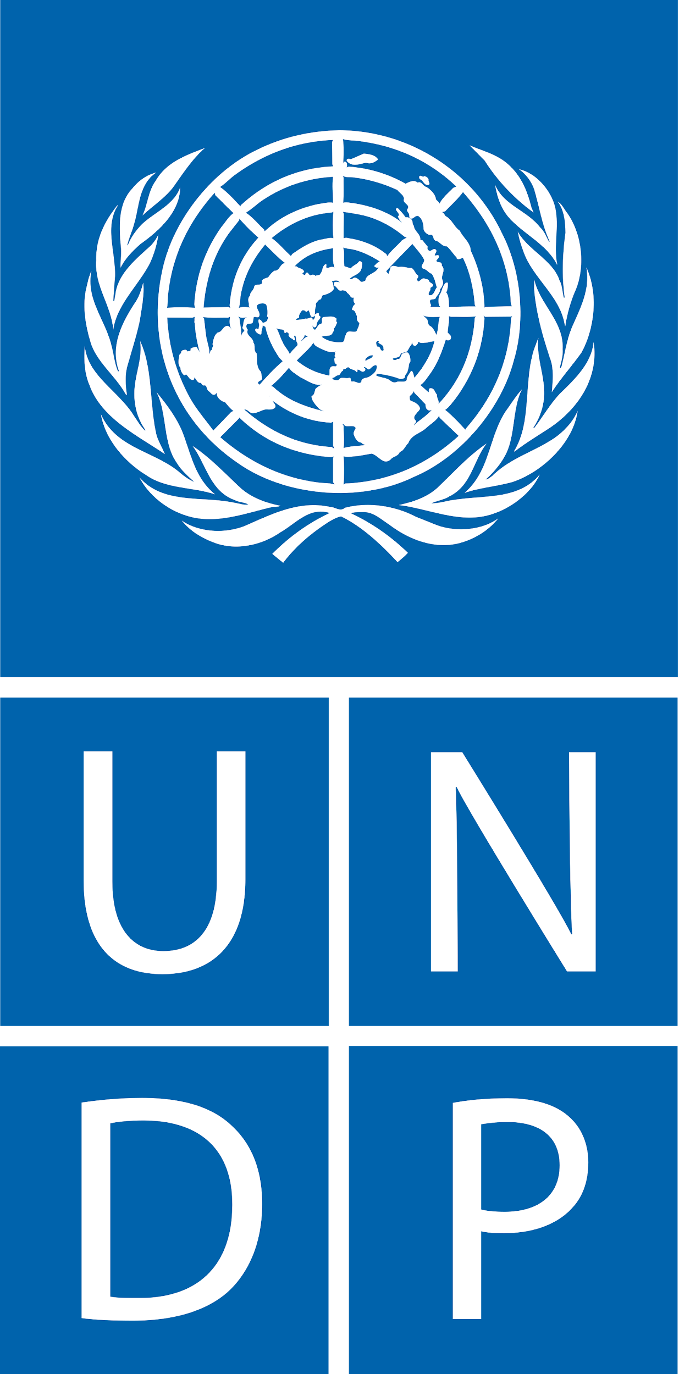
ADDENDUM 3
Procurement Notice Ref: B-220404
Subject: National / International firms / institutions/organizations to develop an Action Plan to adopt the Sustainable Finance Framework in the banking sector for Vietnam
Issued Date: 27 April 2022
Original deadline for submission of bids/offers 11 May 2022
1st Extended deadline for submission of bids/offers 31 May 2022

The submission deadline is now extended to: 17.00 hrs., 10 June 2022 (Hanoi time)

This correspondence pertaining to the above-mentioned requirement should be considered as an integral part of the tender documents.
The complete bidding documents and addendums/amendments concerning this call for bids can be examined and obtained free of charge from the following website:
https://procurement-notices.undp.org/view_notice.cfm?notice_id=90599

