New Atlas Login Step-by-Step

New Atlas Login Step-by-Step
From 4 October 2020, the Atlas login page is being modernized to improve the overall user experience while allowing modern security functionality in the future. To enable this, you will be prompted to register in Atlas through the new login page using your existing login/password credentials to sign-in to Atlas. This is a one-off exercise.
The following step-by-step guide outlines the Atlas registration process.

Steps:
Step 1. The Atlas login page will be changed to look something similar to the below image. Please use your existing login/password credentials to sign-in to Atlas.

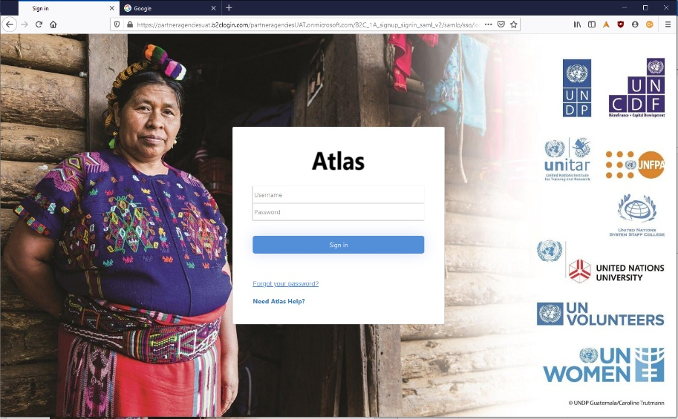

Step 2. Follow the prompts on the screen to register on the new authentication system. Enter your corporate email address and then click the Send Verification Code button.

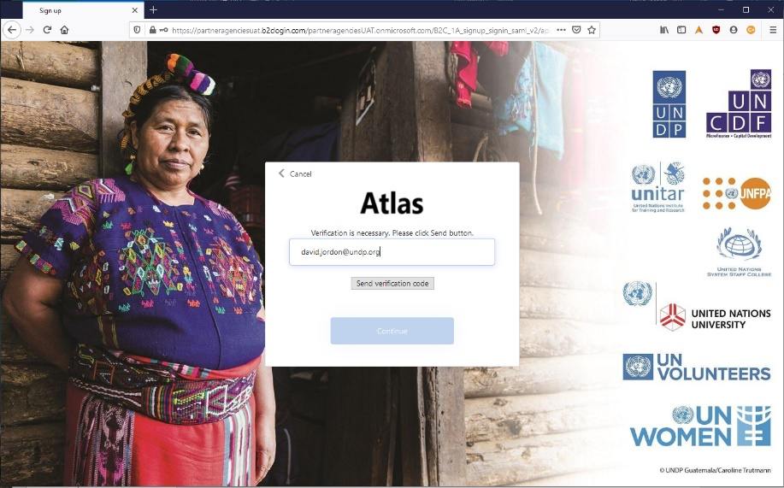

You will then receive a message similar to the one below.
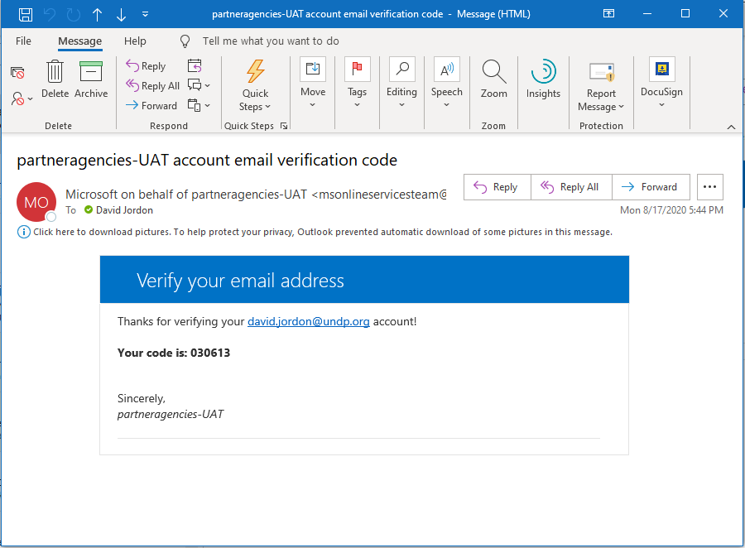

Step 3. Enter the code from the email message to the Verification Code box. The select the Verify Code button.
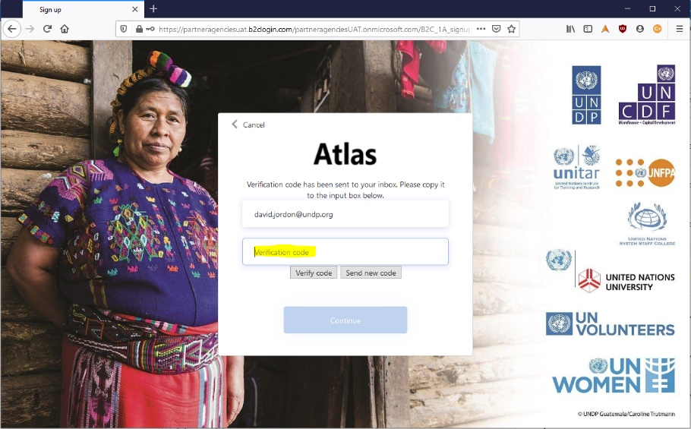

Step 4. Click Continue
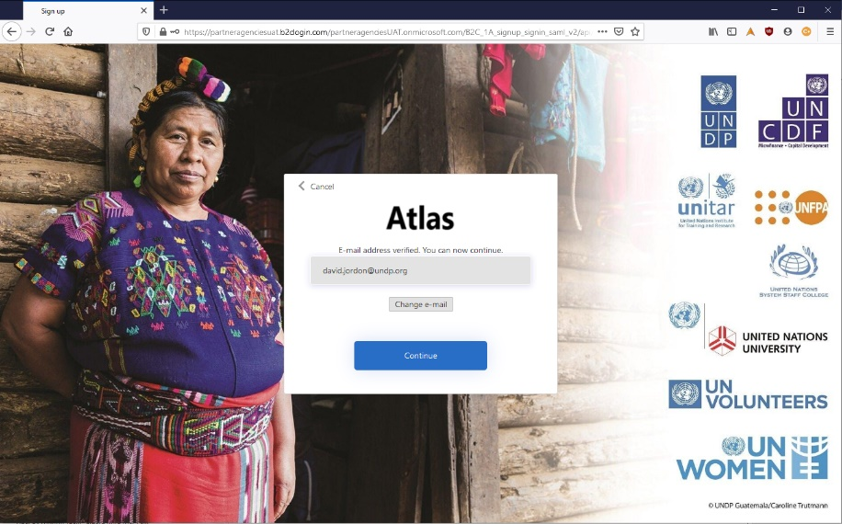

Step 5. Enter a NEW password and select Continue
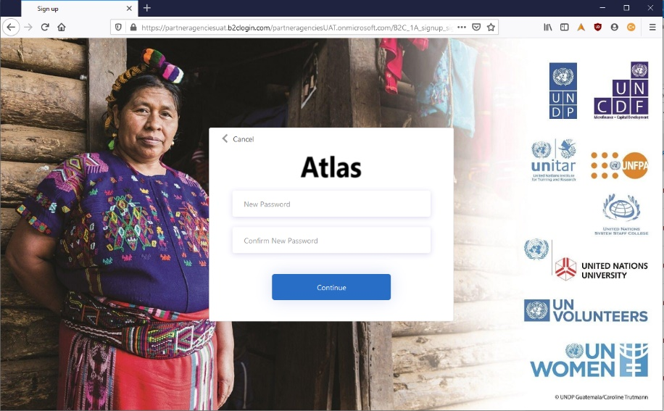

Use Atlas as normal

*If you experience any issues with accessing Atlas or have Atlas related questions, please submit a “Create Incident” request in UNall service management portal for follow-up by the technical team.

