REQUEST FOR QUOTATION (RFQ 023/22)
RFQ Reference:  Civil Works for the installation of the hydrological and meteorological stations for Institute for Hydrometeorology and Seismology of Montenegro/Građevinski radovi za postavljanje hidroloških i meteoroloških stanica za Zavod za hidrometeorologiju i seizmologiju (ZHMS)  Project Name:  Integrated climate-resilient transboundary flood risk management in the Drin River basin in the Western Balkans Project (Drin FRM Project) | Date: 09 June 2022

SECTION 1: REQUEST FOR QUOTATION (RFQ)

UNDP kindly requests your quotation for the provision of services as detailed in Annex 1 of this RFQ.
This Request for Quotation comprises the following documents:
Section 1: This request letter
Section 2: RFQ Instructions and Data
Annex 1: Schedule of Requirements
Annex 2: Quotation Submission Form
Annex 3: Technical and Financial Offer
When preparing your quotation, please be guided by the RFQ Instructions and Data. Please note that quotations must be submitted using Annex 2: Quotation Submission Form and Annex 3 Technical and Financial Offer, by the method and by the date and time indicated in Section 2. It is your responsibility to ensure that your quotation is submitted on or before the deadline. Quotations received after the submission deadline, for whatever reason, will not be considered for evaluation.
Thank you and we look forward to receiving your quotations.
Issued by:
Name: Snezana Doljanica
Title: Operations Manager

Date: 09 June 2022

SECTION 2: RFQ INSTRUCTIONS AND DATA
Introduction | Bidders shall adhere to all the requirements of this RFQ, including any amendments made in writing by UNDP. This RFQ is conducted in accordance with the UNDP Programme and Operations Policies and Procedures (POPP) on Contracts and Procurement  Any Bid submitted will be regarded as an offer by the Bidder and does not constitute or imply the acceptance of the Bid by UNDP. UNDP is under no obligation to award a contract to any Bidder as a result of this RFQ.  UNDP reserves the right to cancel the procurement process at any stage without any liability of any kind for UNDP, upon notice to the bidders or publication of cancellation notice on UNDP website.  We strongly encourage local companies, especially from Pljevlja region, to apply!
Deadline for the Submission of Quotation | 27 June 2022, 16:00h CET
Method of Submission | Quotations must be submitted as follows:  ☐ E-tendering  ☒ Dedicated Email Address  ☐ Courier / Hand delivery  ☐ Other Click or tap here to enter text.  Bid submission address: procurement.me@undp.org  - File Format: pdf  - File names must be maximum 60 characters long and must not contain any letter or special character other than from Latin alphabet/keyboard.  - All files must be free of viruses and not corrupted.  - Max. File Size per transmission: 30 MB  - Mandatory subject of email: RFQ 023-22 - Civil Works for the installation of the hydrological and meteorological stations for Institute for Hydrometeorology and Seismology of Montenegro/Građevinski radovi za postavljanje hidroloških i meteoroloških stanica za Zavod za hidrometeorologiju i seizmologiju (ZHMS) - Bidder’s name  - Multiple emails must be clearly identified by indicating in the subject line “email no. X of Y”, and the final “email no. Y of Y.  - It is recommended that the entire Quotation be consolidated into as few attachments as possible.  [For e-Tendering method, click the link https://etendering.partneragencies.org and insert Event ID information] -N/A  - Insert BU Code and Event ID number - N/A  Detailed instructions on how to submit, modify or cancel a bid in the eTendering system are provided in the eTendering system Bidder User Guide and Instructional videos available on this link: http://www.undp.org/content/undp/en/home/operations/procurement/business/procurement-notices/resources/- N/A
Cost of preparation of quotation | UNDP shall not be responsible for any costs associated with a Supplier’s preparation and submission of a quotation, regardless of the outcome or the manner of conducting the selection process.
Supplier Code of Conduct, Fraud, Corruption | All prospective suppliers must read the United Nations Supplier Code of Conduct and acknowledge that it provides the minimum standards expected of suppliers to the UN. The Code of Conduct, which includes principles on labour, human rights, environment and ethical conduct may be found at: https://www.un.org/Depts/ptd/about-us/un-supplier-code-conduct  Moreover, UNDP strictly enforces a policy of zero tolerance on proscribed practices, including fraud, corruption, collusion, unethical or unprofessional practices, and obstruction of UNDP vendors and requires all bidders/vendors to observe the highest standard of ethics during the procurement process and contract implementation. UNDP’s Anti-Fraud Policy can be found at http://www.undp.org/content/undp/en/home/operations/accountability/audit/office_of_audit_andinvestigation.html#anti
Gifts and Hospitality | Bidders/vendors shall not offer gifts or hospitality of any kind to UNDP staff members including recreational trips to sporting or cultural events, theme parks or offers of holidays, transportation, or invitations to extravagant lunches, dinners or similar. In pursuance of this policy, UNDP: (a) Shall reject a bid if it determines that the selected bidder has engaged in any corrupt or fraudulent practices in competing for the contract in question; (b) Shall declare a vendor ineligible, either indefinitely or for a stated period, to be awarded a contract if at any time it determines that the vendor has engaged in any corrupt or fraudulent practices in competing for, or in executing a UNDP contract.
Conflict of Interest | UNDP requires every prospective Supplier to avoid and prevent conflicts of interest, by disclosing to UNDP if you, or any of your affiliates or personnel, were involved in the preparation of the requirements, design, specifications, cost estimates, and other information used in this RFQ. Bidders shall strictly avoid conflicts with other assignments or their own interests, and act without consideration for future work. Bidders found to have a conflict of interest shall be disqualified.  Bidders must disclose in their Bid their knowledge of the following: a) If the owners, part-owners, officers, directors, controlling shareholders, of the bidding entity or key personnel who are family members of UNDP staff involved in the procurement functions and/or the Government of the country or any Implementing Partner receiving goods and/or services under this RFQ.  The eligibility of Bidders that are wholly or partly owned by the Government shall be subject to UNDP’s further evaluation and review of various factors such as being registered, operated and managed as an independent business entity, the extent of Government ownership/share, receipt of subsidies, mandate and access to information in relation to this RFQ, among others. Conditions that may lead to undue advantage against other Bidders may result in the eventual rejection of the Bid.
General Conditions of Contract | Any Purchase Order or contract that will be issued as a result of this RFQ shall be subject to the General Conditions of Contract  Select the applicable GTC:  ☐ General Terms and Conditions / Special Conditions for Contract.  ☒ General Terms and Conditions for de minimis contracts (services only, less than $50,000)  ☐ General Terms and Conditions for Works  Applicable Terms and Conditions and other provisions are available at UNDP/How-we-buy
Special Conditions of Contract | ☒ Cancellation of PO/Contract if the delivery/completion is delayed by 10 days  ☐ Others [pls. specify]
Eligibility | A vendor who will be engaged by UNDP may not be suspended, debarred, or otherwise identified as ineligible by any UN Organization or the World Bank Group or any other international Organization. Vendors are therefore required to disclose to UNDP whether they are subject to any sanction or temporary suspension imposed by these organizations. Failure to do so may result in termination of any contract or PO subsequently issued to the vendor by UNDP.  It is the Bidder’s responsibility to ensure that its employees, joint venture members, sub-contractors, service providers, suppliers and/or their employees meet the eligibility requirements as established by UNDP.  Bidders must have the legal capacity to enter a binding contract with UNDP and to deliver in the country, or through an authorized representative.
Currency of Quotation | Quotations shall be quoted in EURO
Joint Venture, Consortium or Association | If the Bidder is a group of legal entities that will form or have formed a Joint Venture (JV), Consortium or Association for the Bid, they shall confirm in their Bid that : (i) they have designated one party to act as a lead entity, duly vested with authority to legally bind the members of the JV, Consortium or Association jointly and severally, which shall be evidenced by a duly notarized Agreement among the legal entities, and submitted with the Bid; and (ii) if they are awarded the contract, the contract shall be entered into, by and between UNDP and the designated lead entity, who shall be acting for and on behalf of all the member entities comprising the joint venture, Consortium or Association.  Refer to Clauses 19 – 24 under Solicitation policy for details on the applicable provisions on Joint Ventures, Consortium or Association.
Only one Bid | The Bidder (including the Lead Entity on behalf of the individual members of any Joint Venture, Consortium or Association) shall submit only one Bid, either in its own name or, if a joint venture, Consortium or Association, as the lead entity of such Joint Venture, Consortium or Association.  Bids submitted by two (2) or more Bidders shall all be rejected if they are found to have any of the following:  a) they have at least one controlling partner, director or shareholder in common; or b) any one of them receive or have received any direct or indirect subsidy from the other/s; or  b) they have the same legal representative for purposes of this RFQ; or  c) they have a relationship with each other, directly or through common third parties, that puts them in a position to have access to information about, or influence on the Bid of, another Bidder regarding this RFQ process;  d) they are subcontractors to each other’s Bid, or a subcontractor to one Bid also submits another Bid under its name as lead Bidder; or  e) some key personnel proposed to be in the team of one Bidder participates in more than one Bid received for this RFQ process. This condition relating to the personnel, does not apply to subcontractors being included in more than one Bid.
Duties and taxes | Article II, Section 7, of the Convention on the Privileges and Immunities provides, inter alia, that the United Nations, including UNDP as a subsidiary organ of the General Assembly of the United Nations, is exempt from all direct taxes, except charges for public utility services, and is exempt from customs restrictions, duties, and charges of a similar nature in respect of articles imported or exported for its official use. All quotations shall be submitted net of any direct taxes and any other taxes and duties, unless otherwise specified below:  All prices must:  ☐ be inclusive of VAT and other applicable indirect taxes  ☒ be exclusive of VAT and other applicable indirect taxes (VAT stated separately)
Language of quotation | English or Montenegrin  Including documentation including catalogues, instructions and operating manuals.
Documents to be submitted | Bidders shall include the following documents in their quotation:  ☒ Annex 2: Quotation Submission Form duly completed and signed  ☒ Annex 3: Technical and Financial Offer duly completed and signed and in  accordance with the Schedule of Requirements in Annex 1  ☒ Company Profile.  ☒ Registration certificate.  ☒ List of 3 projects of similar value and complexity to the subject of this procurement, performed for the last five years plus client’s contact details who may be contacted for further information on those contracts;  ☒ Written Readiness and Availability Statement to execute the assignment immediately upon contract signing  ☒ Completed and signed CVs for the proposed key Personnel, including the Statement on availability and exclusivity during the entire contracted period, signed by each team member
Quotation validity period | Quotations shall remain valid for 120 days from the deadline for the Submission of Quotation.
Price variation | No price variation due to escalation, inflation, fluctuation in exchange rates, or any other market factors shall be accepted at any time during the validity of the quotation after the quotation has been received.
Partial Quotes | ☒ Not permitted  ☐ Permitted Insert conditions for partial quotes and ensure that the requirements are properly listed in lots to allow partial quotes
Alternative Quotes | ☒ Not permitted  ☐ Permitted  If permitted, an alternative quote may be submitted only if a conforming quote to the RFQ requirements is submitted. Where the conditions for its acceptance are met, or justifications are clearly established, Click or tap here to enter text. reserves the right to award a contract based on an alternative quote. If multiple/alternative quotes are being submitted, they must be clearly marked as “Main Quote” and “Alternative Quote”
Payment Terms | ☒ 100% within 15 days after receipt of goods, works and/or services and submission of payment documentation.
Conditions for Release of  Payment | ☐ Passing Inspection [specify method, if possible] Complete Installation  ☐ Passing all Testing [specify standard, if possible]  ☐ Completion of Training on Operation and Maintenance [specify no. of trainees, and location of training, if possible  ☒ Written Acceptance of Services, based on full compliance with RFQ requirements (by UNDP Project Manager, based on the confirmation of Supervisory authority – expert/engineer engaged by UNDP)  ☐ Others [pls. specify]
Contact Person for correspondence, notifications and clarifications | E-mail address for clarifications only: procurement.me@undp.org  Any delay in UNDP’s response shall be not used as a reason for extending the deadline for submission, unless UNDP determines that such an extension is necessary and communicates a new deadline to the Proposers.
Clarifications | Requests for clarification from bidders will not be accepted any later than 2 days before the submission deadline.
Evaluation method | ☒The Contract or Purchase Order will be awarded to the lowest price substantially compliant offer  ☒ Technical responsiveness/Full compliance to requirements and lowest priced offer
Evaluation criteria/  Evaluacioni  kriterijumi | ☒ Full compliance with all requirements as specified in Annex 1  ☒ Full acceptance of the General Conditions of Contract  ☒ Company Profile  ☒ Registration certificate  ☒ Written Readiness and Availability Statement to execute the assignment immediately upon contract signing  Pisana potvrda o spremnosti za izvršenje posla odmah po potpisivanju ugovora  ☒ List of 3 projects of similar value and complexity to the subject of this procurement, performed for the last 5 years  Lista od 3 projekta slične vrijednosti i složenosti, kao što je predmet ovog tendera, a koji su izvedeni u prethodnih 5 godina  ☒ License:  The bidder has to have valid license for project designing and construction (Law on Spatial Planning and Construction of Structures – Official Gazette of Montenegro, No. 064/17 from 06.10.2017, 044/18 from 06.07.2018, 063/18 from 28.09.2018, 011/19 from 19.02.2019, 082/20 from 06.08.2020)  Posjedovanje licence:  Ponuđač treba da posjeduje licencu za izradu projektne dokumentacije i građenje objekata (Zakon o planiranju prostora i izgradnji objekata - "Službeni list Crne Gore", br. 064/17 od 06.10.2017, 044/18 od 06.07.2018, 063/18 od 28.09.2018, 011/19 od 19.02.2019, 082/20 od 06.08.2020)  ☒ Minimum key personnel proposed for this project:  The Bidder shall have the following professional and personnel capacities necessary for the implementation of the contract, as follows:  - At least one civil engineer, and  - At least one electrical engineer (low and high voltage)  Note: A certified engineer who will manage the construction of the facility as a whole, may also be a certified engineer for individual construction works on the facility.  All engineers must have a license of a certified engineer for the preparation of technical documents and construction of facilities issued by the competent ministry in accordance with the Law on Spatial Development and Construction of Structures and submit proof of membership in the Chamber of Engineers of Montenegro.  Minimalni zahtjevi za ključno osoblje za ovaj projekat:  Ponuđač je dužan da posjeduje sljedeće stručne i kadrovske kapacitete koji su potrebni za izvršenje ugovora i to:  - minimum jednog građevinskog inženjera, i  - minimum jednog inženjera elektrotehnike (niska i visoka struja).  Napomena: Ovlašćeni inženjer koji će rukovoditi građenjem na objektu u cjelini, istovremeno može biti i ovlašćeni inženjer za pojedine radove na građenju na objektu.  Svi inženjeri moraju posjedovati licencu ovlašćenog inženjera za obavljanje djelatnosti izrade tehničke dokumentacije i građenje objekata izdatu od strane nadležnog ministarstva u skladu sa Zakonom o planiranju prostora i izgradnji objekata i dostaviti dokaz o članstvu u Inženjerskoj komori Crne Gore.  ☒ Guarantee: The Contractor guarantees the correctness of the performed works for 2 years, counting from the day of technical acceptance.  Garancija: Izvođač radova se obavezuje na ispravnost izvedenih radova u periodu od 2 godine, od dana tečničkog prijema.
Right not to accept any quotation | UNDP is not bound to accept any quotation, nor award a contract or Purchase Order
Right to vary requirement at time of award | At the time of award of Contract or Purchase Order, UNDP MNE reserves the right to vary (increase or decrease) the quantity of services and/or goods, by up to a maximum twenty-five per cent (25%) of the total offer, without any change in the unit price or other terms and conditions.
Type of Contract to be awarded | ☐ Purchase Order  ☒ Contract Face Sheet (Goods and-or Services) (this template is also utilised for Long-Term Agreement) and if an LTA will be signed, specify the document that will trigger the call-off. E.g., PO, etc.)  ☐ Contract for Works  ☐ Other Type/s of Contract [pls. specify]
Expected date for contract award. | 01 July 2022
Expected date of commencement of activities | 04 July 2022
Publication of Contract Award | UNDP will publish the contract awards valued at USD 100,000 and more on the websites of the CO and the corporate UNDP Web site.
Policies and procedures | This RFQ is conducted in accordance with UNDP Programme and Operations Policies and Procedures

ANNEX 1: SCHEDULE OF REQUIREMENTS
Terms of Reference/Projektni zadatak
Civil Works for the installation of the hydrological and meteorological stations for Institute for Hydrometeorology and Seismology of Montenegro
Građevinski radovi za postavljanje hidroloških i meteoroloških stanica za Zavod za hidrometeorologiju i seizmologiju (ZHMS)

- Brief Description of the Required Service and Scope of work
UNDP Montenegro is seeking for a qualified company/es with the capacity and expertise needed to perform civil works for the installations of hydrological and meteorological stations.

Bill of Quantities for hydrological stations (.xls format):
https://e1.pcloud.link/publink/show?code=XZxz1RZLGXCP93dMrLt807xG8ll2JmjdgeX

Bill of Quantities for meteorological stations (.xls format):
https://e1.pcloud.link/publink/show?code=XZgODRZnmOEJGfuxHFi5onQ9tRSFpflMvhk

Bill of Quantities for all stations – electrotechnical works (.xls format):
https://e1.pcloud.link/publink/show?code=XZaV3RZJELoDfsPOuYLB4pbuBlhObOe9hvk

- Kratak opis zahtijevanih usluga i opis posla
UNDP Crna Gora traži kvalifikovanu firmu/e sa kapacitetim i ekspertizom potrebnom za izvođenje građevinskih radova na postavljanju hidroloških i meteoroloških stanica za Zavod za hidrometeorlogiju i seizmologiju.

Predmjer za hidrološke stanice (.xls format):
https://e1.pcloud.link/publink/show?code=XZxz1RZLGXCP93dMrLt807xG8ll2JmjdgeX

Predmjer za meteorološke stanice (.xls format):
https://e1.pcloud.link/publink/show?code=XZgODRZnmOEJGfuxHFi5onQ9tRSFpflMvhk

Predmjer za sve stanice – elektrotehnički radovi (.xls format):
https://e1.pcloud.link/publink/show?code=XZaV3RZJELoDfsPOuYLB4pbuBlhObOe9hvk

1. GENERAL INFORMATION ABOUT THE FACILITY/ OPŠTE INFORMACIJE O OBJEKTU

The standard project was made on the basis of the submitted project task by the Investor (UNDP), and all the requirements set by the project task were met.

Standardni projekat urađen je na osnovu projektnog zadatka koji je dostavio Investitor (UNDP) i ispunjeni su svi zahtjevi utvrđeni projektnim zadatkom.

2. LOCATIONS/LOKACIJE

The following paragraphs illustrate the number of the new monitoring stations that shall be installed by the selected contractor. For every single station / site it is reported: ID / Code, location / sub-basin, geographical coordinates, and notes.
The stations were subdivided into two categories, precipitation (meteorological) monitoring stations, and hydrological monitoring stations.

METEOROLOGICAL MONITORING STATIONS
N° | ID Code | Name | Location /  Sub-basin | Latitude | Longitude | Notes
1 |  | Manastir Morača |  | 42°46’00,00’’ | 19°24’00,00’’
2 |  | Kučka Korita |  | 42°29’04,95’’ | 19°31’46,63’’
3 |  | Vrbanje |  | 42°33’29,05’’ | 18°30’29,53’’
4 |  | Ivanova Korita |  | 42°22’47,59’’ | 18°50’06,38’’

HYDROLOGICAL MONITORING STATIONS
N° | ID Code | Name | Location /  Sub-basin | Latitude | Longitude | Notes
1 |  | Virpazar | Orahovštica | 42°14’55,20’’ | 19°05’08,82’’
2 |  | Ulcinj – Mareo | Adriatic Sea | 41°52’25,19’’ | 19°19’46,57’’
3 |  | Međurečje | Morača | 42°43’10,73’’ | 19°22’11,54’’

PREVOD
Stavovi u nastavku ilustruju broj novih stanica za praćenje koje će instalirati izabrani izvođač. Za svaku pojedinačnu stanicu/lokaciju se prijavljuje: Identifikacioni broj/šifra, lokacija/podsliv, geografske koordinate i napomene.
Stanice su podijeljene u dvije kategorije, stanice za praćenje padavina (meteorološke) i hidrološke stanice.

METEOROLOŠKE STANICE
Br° | Identifikaciona oznaka | Naziv | Lokacija /  podsliv | Geografska širina | Geografska dužina | Napomene
1 |  | Manastir Morača |  | 42°46’00,00’’ | 19°24’00,00’’
2 |  | Kučka Korita |  | 42°29’04,95’’ | 19°31’46,63’’
3 |  | Vrbanje |  | 42°33’29,05’’ | 18°30’29,53’’
4 |  | Ivanova Korita |  | 42°22’47,59’’ | 18°50’06,38’’

HIDROLOŠKE STANICE
N° | ID Code | Naziv | Lokacija /  Podsliv | Geografska širina | Geografska dužina | Napomene
1 |  | Virpazar | Orahovštica | 42°14’55,20’’ | 19°05’08,82’’
2 |  | Ulcinj – Mareo | Jadransko more | 41°52’25,19’’ | 19°19’46,57’’
3 |  | Međurečje | Morača | 42°43’10,73’’ | 19°22’11,54’’

3. FUNCTION, CONSTRUCTION AND MATERIALIZATION/FUNKCIJA I IZGRADNJA
Hydrological Stations:
Construction of hydrologic stations with the hoppers for the installation of the measuring equipment (metal structure and the sandwich panels). Construction of a reinforced concrete foundation to set up cell.
The construction consists of metal poles (10x10) and sandwich panels (4cm).
Reinforced concrete slab (150x150x40).
The roof is single-pitched, sloping, with a slope of 15o, also made of sandwich panels d = 4cm.

Precipitation Stations:
Procurement and installation of a protective fence, climatological circle (9 x 6 m) with all accompanying works (excavation of fence foots and their concreting, painting of the fence). Metal fence (30.00 x 1.50 m) with a gate (1.00 x 1.50 m) and a lock (padlock). Excavation and concreting of the foundation rate of the pillar of the support of the house, sensor and solar panel (100 x 100 x 150 cm). Excavation and concreting of the foundation foot of the rain gauge support pillar (100 x 100 x 150 cm). Excavation and backfilling of the channel trench between the rain gauge pillar and the protection box support pillar (5.00 x 0.60 x 0.80). Procurement and installation of high density polyethylene pipes (PEHD Ø 50 x 5 m) between the rain gauge pillar and the protection box support column. Digging a ground channel (25.00 x 0.80 m). Procurement and installation of grounding strip (30.00 m).
Metallic Mast & Accessories:
Metallic mast (H min = 3.0 m, diameter min 4“hot galvanized steel) to which an equipment cabinet and a solar panel are attached. The mast is designed to be self-supporting and stable, so that it can withstand the dead and living forces of the wind.

PREVOD
Hidrološke stanice:
Izgradnja hidroloških stanica sa rezervoarima za ugradnju mjerne opreme (metalna konstrukcija i sendvič paneli). Izgradnja armirano-betonske osnove za postavljanje ćelije.
Konstrukciju čine metalni stubovi (10x10) i sendvič paneli (4cm).
Armirano betonska ploča (150x150x40).
Krov je jednovodni, kosi, nagiba 15º, takođe od sendvič panela d=4cm.

Padavinske/meteorološke stanice:
Nabavka i postavljanje zaštitne ograde, klimatološki krug (9 h 6 m) sa svim pratećim radovima (iskop temeljnih stopa ograde i njihovo betoniranje, farbanje ograde). Metalna ograda (30,00 x 1,50 m) sa kapijom (1,00 x 1,50 m) i bravom (katanac). Iskop i betoniranje temeljne stope stuba oslonca objekta, senzora i solarnog panela (100 x 100 x 150 cm). Iskop i betoniranje temeljne stope potpornog stuba kišomjera (100 x 100 x 150 cm). Iskop i zatrpavanje kanalskog rova između stuba kišomjera i stuba nosača zaštitne kutije (5,00 x 0,60 x 0,80). Nabavka i ugradnja cijevi od polietilena visoke gustine (PEHD Ø 50 k 5 m) između stuba kišomjera i stuba nosača zaštitne kutije. Kopanje zemljanog kanala (25,00 x 0,80 m). Nabavka i montaža uzemljivača (30,00 m).
Metalni jarbol i dodaci:
Metalni jarbol (H min = 3,0 m, prečnik min 4“ vruće pocinkovani čelik) na koji su pričvršćeni ormar za opremu i solarni panel. Jarbol je projektovan da bude samonosiv i stabilan, tako da može da izdrži „mrtve“ i „žive“ sile vjetra.

4. TECHNICAL CONDITIONS FOR PROJECT IMPLEMENTATION/ TEHNIČKI USLOVI ZA IMPLEMENTACIJU PROJEKTA

The project in question must be reported in the spirit of applicable regulations and standards, according to which this project was made.

The Contractor is obliged to check this documentation before the start of construction, and if certain necessary changes or deviations are necessary, both in terms of materials and technical solution, the Contractor must consult the Supervisory authority engaged by UNDP, and in case of major changes, obtain written instructions from them and consent to the proposed changes.

All works and materials listed in the descriptions of each individual bill of quantities item must be included in the offered price of the contractor and include all costs for labour, materials, transport, protective fences, warning signs, etc., as well as other costs required for completion.
Execution of each position according to the bill of quantities implies execution of works fully according to technical regulations and standards, in an unconditionally professional and precise manner.
For all construction works, it is required to use high-quality materials according to the existing technical regulations, standards and descriptions of the works item concerned in the bill of quantities.
The Contractor shall remove all debris and excess material from the facility after the completion of all works and restore the terrain around the facility to its original condition. Disposal of excess material and rubble, as well as restoration to the original condition shall not be charged separately, and the Contractor shall include labour for these positions in the unit price of installed material and completed works.
Work force
For the execution of construction works, and construction and finishing works, the Contractor shall use the workforce with relevant professional qualifications, as regulated under construction industry standards for particular items of works.

Installation and assembly of individual elements of these facilities must be performed according to the technical description and bill of quantities of this project, as well as according to the Main project of the complete installation and the attached drawings.
Link with relevant drawings: https://e1.pcloud.link/publink/show?code=XZkR1RZsTeuGPi9CtkKg63iU0rPjbWxTl1V

PREVOD:
Predmetni projekat mora biti prijavljen u skladu sa važećim propisima i standardima po kojima je ovaj projekat urađen.

Izvođač je dužan da prije početka izgradnje provjeri ovu dokumentaciju, a ukoliko su neophodne određene izmjene ili odstupanja, kako u pogledu materijala tako i u pogledu tehničkog rješenja, Izvođač mora da konsultuje Nadzornog organa kojeg je angažovao UNDP, a u slučaju većih promjena, od njega mora da pribavi pismena uputstva i saglasnost na predložene izmjene.

Svi radovi i materijali navedeni u opisima pojedinih pozicija predmjera moraju biti obuhvaćeni ponuđenom cijenom izvođača i obuhvatiti sve izdatke za rad, materijal, transport, zaštitne ograde, oznake upozorenja i dr., kao i ostale izdatke potrebne za završetak radova.
Izvođenje svake pozicije prema predmjeru radova podrazumijeva izvođenje radova u svemu prema tehničkim propisima i standardima bezuslovno stručno i precizno.
Kod svih građevinskih uslovljava se upotreba kvalitetnog materijala prema postojećim tehničkim propisima, standardima i opisu odgovarajućih pozicija radova u predmjeru.
Obaveza Izvođača je da po završetku svih radova, sa objekta ukloni sav šut i višak materijala i da teren oko objekta vrati u prvobitno stanje. Odvoz viška materijala i šuta, kao i vraćanje u prvobitno stanje se neće posebno naplaćivati već će Izvođač rad na ovim pozicijama uključiti kroz jediničnu cijenu ugrađenom materijala i izvedenih radova.
Radna snaga
Za izvođenje građevinskih i građevinsko-zanatskih radova Izvođač radova je u obavezi da koristi radnu snage odgovarajućih stručnih kvalifikacija kako je to za pojedine pozicije radova predviđeno normama u građevinarstvu.

Ugradnja i montaža pojedinih elemenata ovih objekata mora se izvršiti prema tehničkom opisu i predmjeru i predračunu radova ovog projekta, kao i prema Glavnom projektu kompletne montaže i priloženim crtežima.
Link sa relevantnim crtežima: https://e1.pcloud.link/publink/show?code=XZkR1RZsTeuGPi9CtkKg63iU0rPjbWxTl1V

5. Dinamika realizacije aktivnosti i pružanja usluga
Deliverables and Schedules/Expected Outputs
Activity (as per TOR) – Aktivnosti u skladu sa projektnim zadatkom | Completion deadline / Rok za završetak
 | 25 Jul/July 2022

6. Governance and Accountability
Contractor will appoint representative who will at all times be responsible for keeping track of plans, activities, progress reports and ongoing issues.
Upravljanje i odgovornost
Ugovorena firma će imenovati predstavnika koja će u svakom trenutku biti odgovorna za praćenje planova, aktivnosti, izveštaja o napretku i tekućih pitanja.

7. Guarantee/Garancija
The Contractor guarantees the correctness of the performed works for at least two years, counting from the day of technical acceptance. All damages that would occur in that period due to the use of bad material or unreliable workpersonship, the contractor is obliged to remove without the right to compensation.

All changes and additions to the works that have an impact on the estimated value of the facility must be approved by the Investor or its representative.

The Investor, i.e. the body or organization to which the ownership of the facility and its maintenance is transferred – Institute for Hydrometeorology and Seismology, are obliged to keep one copy of the technical documentation permanently.

The Investor is obliged to organize constant Supervisory authority during the construction of the facility, through expert - engineer engaged by UNDP, in cooperation with End-user: Institute for Hydrometeorology and Seismology.

The obligation of the Contractor is to coordinate the works from this part of the project with the works for the rest of the installation and the facility itself, in order to enable the works themselves and avoid additional construction costs.

Equipment installed by the Contractor, not manufactured, has a warranty according to the Manufacturer's warranty card.

When performing work on this installation, the Contractor must take care not to damage the surrounding objects, other installations or devices.

These general conditions are an integral part of the tender document and are mandatory for the Contractor.

PREVOD:
Izvođač garantuje za ispravnost izvedenih radova najmanje dvije godine, računajući od dana tehničkog prijema. Sve štete koje mogu nastati u tom periodu kao posljedica korišćenja lošeg materijala ili nepouzdanog rada, izvođač je dužan da otkloni bez prava na naknadu.

Sve izmjene i dopune radova koje imaju uticaja na procijenjenu vrijednost objekta mora da odobri Investitor ili njegov zastupnik.

Investitor, odnosno organ ili organizacija na koju se prenosi vlasništvo nad objektom i njegovo održavanje – Zavod za hidrometeorologiju i seizmologiju, dužni su da trajno čuvaju jedan primjerak tehničke dokumentacije.

Investitor je dužan da organizuje stalni nadzor u toku izgradnje objekta, preko stručnjaka-inženjera kojeg je angažovao UNDP-a, u saradnji sa krajnjim korisnikom: Zavodom za hidrometeorologiju i seizmologiju.

Obaveza Izvođača je da uskladi radove iz ovog dijela projekta sa radovima na ostatku montaže i samog objekta, kako bi se osposobili sami radovi i izbjegli dodatni troškovi izgradnje.

Oprema koju postavlja Izvođač, a nije proizvedena, ima garanciju prema garantnom listu Proizvođača.

Prilikom izvođenja radova na ovoj instalaciji, Izvođač mora voditi računa da ne ošteti okolne objekte, druge instalacije ili uređaje.

Ovi opšti uslovi sastavni su dio konkursne dokumentacije i obavezni su za Izvođača.

8. Informative elaboration on the earthing for electrical devices and equipment video surveillance
The project envisages earthing switches for electrical devices and equipment video surveillance installations. It is planned to install supplied by the Investor in agreement with the Institute for Hydrometeorology and Seismology.
Solar panels to power devices and sensors are not part of the project, as they are supplied by the Investor.
Note to the Bidders: the following specifications can be used to prepare the technical offer. The bidders can include designated brands or equivalent.
Informativna detaljna razrada u vezi uzemljenja električnih uređaja i opreme video nadzora
Projektom su predviđeni uzemljivači za električne uređaje i opremu instalacija video nadzora. Predviđena je ugradnja koju isporučuje Investitor u dogovoru sa Zavodom za hidrometeorologiju i seizmologiju.
Solarni paneli za napajanje uređaja i senzora nijesu deo projekta, jer ih isporučuje Investitor.
Napomena za ponuđače: za pripremu tehničke ponude mogu se koristiti sljedeće specifikacije. Ponuđači mogu uključiti određene ili ekvivalentne brendove.

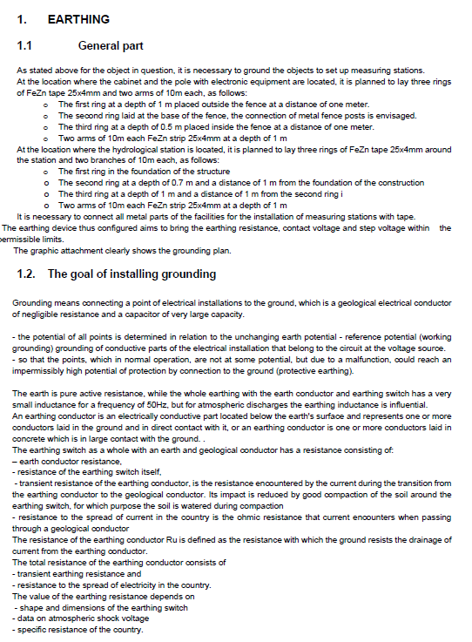
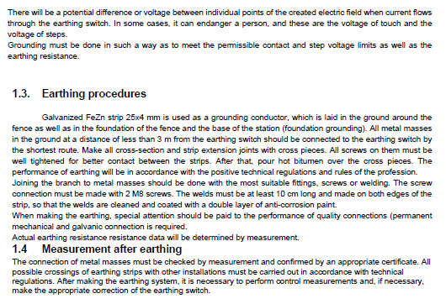
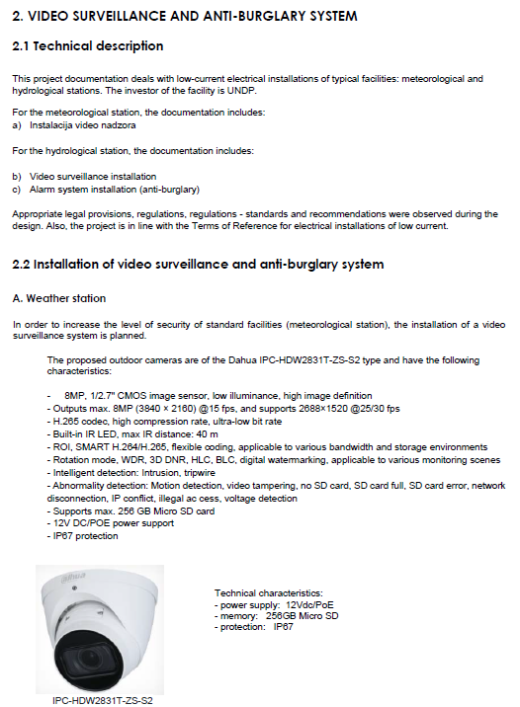
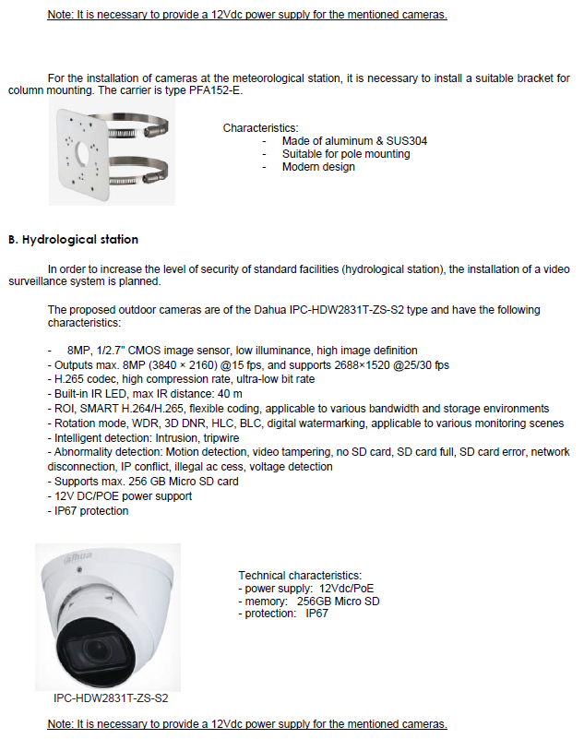

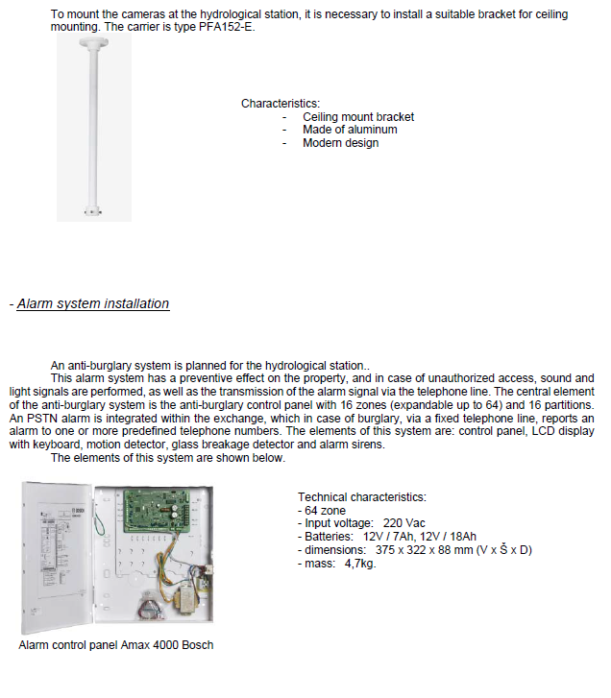

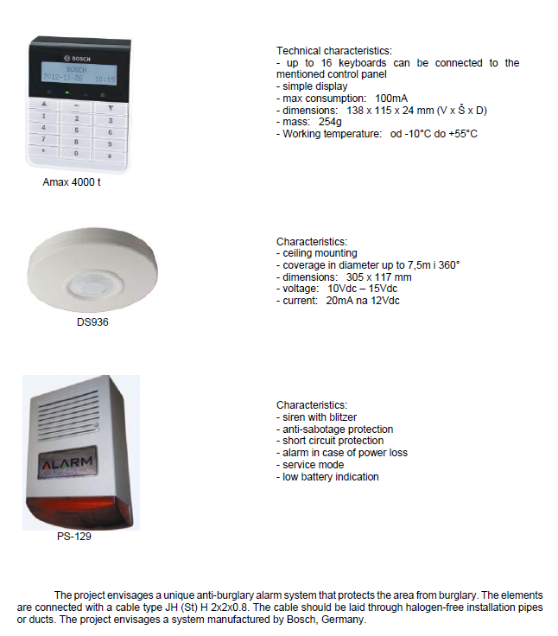

ANNEX 2: QUOTATION SUBMISSION FORM
Bidders are requested to complete this form, including the Company Profile and Bidder’s Declaration, sign it and return it as part of their quotation along with Annex 3: Technical and Financial Offer. The Bidder shall fill in this form in accordance with the instructions indicated. No alterations to its format shall be permitted and no substitutions shall be accepted.
Name of Bidder: | Click or tap here to enter text.
RFQ reference: | Click or tap here to enter text. | Date: Click or tap to enter a date.

Company Profile
Item Description |  | Detail
Legal name of bidder or Lead entity for JVs |  | Click or tap here to enter text.
Legal Address, City, Country |  | Click or tap here to enter text.
Website |  | Click or tap here to enter text.
Year of Registration |  | Click or tap here to enter text.
Legal structure |  | Choose an item.
Are you a UNGM registered vendor? |  | ☐ Yes ☐ No If yes, insert UNGM Vendor Number
Quality Assurance Certification (e.g. ISO 9000 or Equivalent) (If yes, provide a Copy of the valid Certificate): |  | ☐ Yes ☐ No
Does your Company hold any accreditation such as ISO 14001 or ISO 14064 or equivalent related to the environment? (If yes, provide a Copy of the valid Certificate): |  | ☐ Yes ☐ No
Does your Company have a written Statement of its Environmental Policy? (If yes, provide a Copy) |  | ☐ Yes ☐ No
Does your organization demonstrate significant commitment to sustainability through some other means, for example internal company policy documents on women empowerment, renewable energies or membership of trade institutions promoting such issues (If yes, provide a Copy) |  | ☐ Yes ☐ No
Is your company a member of the UN Global Compact |  | ☒ Yes ☐ No
Bank Information |  | Bank Name: Click or tap here to enter text.  Bank Address: Click or tap here to enter text.  IBAN: Click or tap here to enter text.  SWIFT/BIC: Click or tap here to enter text.  Account Currency: Click or tap here to enter text.  Bank Account Number: Click or tap here to enter text.
Previous relevant experience: 3 contracts in last 5 years
Name of previous contracts | Client & Reference Contact Details including e-mail |  | Contract Value | Period of activity | Types of activities undertaken

Bidder’s Declaration
Yes | No
☐ | ☐ | Requirements and Terms and Conditions: I/We have read and fully understand the RFQ, including the RFQ Information and Data, Schedule of Requirements, the General Conditions of Contract, and any Special Conditions of Contract. I/we confirm that the Bidder agrees to be bound by them.
☐ | ☐ | I/We confirm that the Bidder has the necessary capacity, capability, and necessary licenses to fully meet or exceed the Requirements and will be available to deliver throughout the relevant Contract period.
☐ | ☐ | Ethics: In submitting this Quote I/we warrant that the bidder: has not entered into any improper, illegal, collusive or anti-competitive arrangements with any Competitor; has not directly or indirectly approached any representative of the Buyer (other than the Point of Contact) to lobby or solicit information in relation to the RFQ ;has not attempted to influence, or provide any form of personal inducement, reward or benefit to any representative of the Buyer.
☐ | ☐ | I/We confirm to undertake not to engage in proscribed practices, , or any other unethical practice, with the UN or any other party, and to conduct business in a manner that averts any financial, operational, reputational or other undue risk to the UN and we have read the United Nations Supplier Code of Conduct :https://www.un.org/Depts/ptd/about-us/un-supplier-code-conduct and acknowledge that it provides the minimum standards expected of suppliers to the UN.
☐ | ☐ | Conflict of interest: I/We warrant that the bidder has no actual, potential, or perceived Conflict of Interest in submitting this Quote or entering a Contract to deliver the Requirements. Where a Conflict of Interest arises during the RFQ process the bidder will report it immediately to the Procuring Organisation’s Point of Contact.
☐ | ☐ | Prohibitions, Sanctions: l/We hereby declare that our firm, its affiliates or subsidiaries or employees, including any JV/Consortium members or subcontractors or suppliers for any part of the contract is not under procurement prohibition by the United Nations, including but not limited to prohibitions derived from the Compendium of United Nations Security Council Sanctions Lists and have not been suspended, debarred, sanctioned or otherwise identified as ineligible by any UN Organization or the World Bank Group or any other international Organization.
☐ | ☐ | Bankruptcy: l/We have not declared bankruptcy, are not involved in bankruptcy or receivership proceedings, and there is no judgment or pending legal action against them that could impair their operations in the foreseeable future.
☐ | ☐ | Offer Validity Period: I/We confirm that this Quote, including the price, remains open for acceptance for the Offer Validity.
☐ | ☐ | I/We understand and recognize that you are not bound to accept any Quotation you receive, and we certify that the goods offered in our Quotation are new and unused.
☐ | ☐ | By signing this declaration, the signatory below represents, warrants and agrees that he/she has been authorised by the Organization/s to make this declaration on its/their behalf.

Signature:
Name: Click or tap here to enter text.
Title: Click or tap here to enter text.
Date: Click or tap to enter a date.

ANNEX 3: TECHNICAL AND FINANCIAL OFFER

Bidders are requested to complete this form, sign it and return it as part of their quotation along with Annex 2 Quotation Submission Form. The Bidder shall fill in this form in accordance with the instructions indicated. No alterations to its format shall be permitted and no substitutions shall be accepted.
Name of Bidder: | Click or tap here to enter text.
RFQ reference: | Click or tap here to enter text. | Date: Click or tap to enter a date.

Tehnička ponuda
Molimo dostavite sledeće:
- kratak opis kvalifikacija firme, podatke o registraciji, licenci, prethodnom relevantnom iskustvu i opis ljudskih i tehničkih kapaciteta i ekspertize relevantne za ovaj tender, potvrdu o spremnosti za izvođenje radova odmah po potpisivanju ugovora
- sastav tima – spisak osoba koje će biti uključene u realizaciju (imena, kontakt podaci, zanimanje, godine radnog iskustva), zajedno sa kratkim radnim biografijama I licencama
- dinamički plan
Technical Offer
Please provide the following:
- a brief description of your qualification, registration proof, licence copy, previous relevant experience and capacity and expertise that is relevant to the Terms of Reference, written confirmation on the readiness to perform the work immediately upon contract signing
- team composition and CVs of key personnel with licences
- a brief implementation plan;
Finansijska ponuda
Molimo da finansijsku ponudu pripremite koristeci predmjere date na linku: https://e1.pcloud.link/publink/show?code=XZxz1RZLGXCP93dMrLt807xG8ll2JmjdgeX za hidrološke stanice i linku: https://e1.pcloud.link/publink/show?code=XZgODRZnmOEJGfuxHFi5onQ9tRSFpflMvhk za meteorološke stanice.
Za elektrotehničke radove koristiti predmjer za sve stanice sa linka:
https://e1.pcloud.link/publink/show?code=XZaV3RZJELoDfsPOuYLB4pbuBlhObOe9hvk .
Valuta ponude – euro.

Financial Offer
Kindly prepare financial offer using the bills of quantities given on the following link: https://e1.pcloud.link/publink/show?code=XZxz1RZLGXCP93dMrLt807xG8ll2JmjdgeX for hydrological stations and link: https://e1.pcloud.link/publink/show?code=XZgODRZnmOEJGfuxHFi5onQ9tRSFpflMvhk for meteorological stations.
For electrotechnical works kindly use the bills of quantities for all stations given on the following link:
https://e1.pcloud.link/publink/show?code=XZaV3RZJELoDfsPOuYLB4pbuBlhObOe9hvk .

Currency of Quotation: EURO .

Compliance with Requirements
 | You Responses
 | Yes, we will comply | No, we cannot comply | If you cannot comply, pls. indicate counter – offer
Delivery Lead Time | ☐ | ☐ | Click or tap here to enter text.
Validity of Quotation | ☐ | ☐ | Click or tap here to enter text.
Payment terms | ☐ | ☐ | Click or tap here to enter text.
Other requirements [pls. specify] | ☐ | ☐ | Click or tap here to enter text.

I, the undersigned, certify that I am duly authorized to sign this quotation and bind the company below in event that the quotation is accepted.
Exact name and address of company  Company NameClick or tap here to enter text.  Address: Click or tap here to enter text.  Click or tap here to enter text.  Phone No.: Click or tap here to enter text.  Email Address: Click or tap here to enter text. | Authorized Signature:  Date: Click or tap here to enter text.  Name: Click or tap here to enter text.  Functional Title of Authorised  Signatory: Click or tap here to enter text.  Email Address: Click or tap here to enter text.

