REQUEST FOR QUOTATION (RFQ 30/2020)

Project: 00109163 - Resilient Skopje: Scaling-up for Sustainability, Innovation and Climate Change | DATE: May 4, 2020
 | REFERENCE: RFQ 30/2020 for Preparation of Basic Design Project for a Green Parking Lot of the Skopje ZOO

Dear Sir / Madam:

We kindly request you to submit your quotation for Preparation of Basic Design Project for a Green Parking Lot of the Skopje ZOO
, as detailed in Annex 1 of this RFQ. When preparing your quotation, please be guided by the form attached hereto as Annex 2.

Quotations shall be submitted on or before May 21, 2020 by 11:00am via dedicated email: offers.mk@undp.org

Subject: MKDRFQ30-2020 for green parking lot at ZOO

It shall remain your responsibility to ensure that your quotation will reach UNDP before the deadline. Quotations that are received by UNDP after the deadline indicated above, for whatever reason, shall not be considered for evaluation.

Please take note of the following requirements and conditions pertaining to the supply of the abovementioned works
Delivery Terms  [INCOTERMS 2010]  (Pls. link this to price schedule) | ☐FCA  ☐CPT  ☐CIP  ☐DAP  ☒ n/a
Customs clearance, if needed, shall be done by: | ☐UNDP  ☐Supplier/Offeror  ☐Freight Forwarder  n/a
Exact Address/es of Delivery Location/s (identify all, if multiple) | UNDP,Project Manager
UNDP Preferred Freight Forwarder, if any | n/a
Distribution of shipping documents (if using freight forwarder) | n/a
Latest Expected Delivery Date and Time (if delivery time exceeds this, quote may be rejected by UNDP) | ☒ 1,5 months upon contract signing  ☒ As per Delivery Schedule attached  Time:  Time Zone of Reference:
Delivery Schedule | ☐Required  ☐xNot Required
Packing Requirements | n/a
Mode of Transport | ☐ AIR | ☐LAND
 | ☐SEA | ☒ n/a
Preferred  Currency of Quotation | ☐United States Dollars  ☐Euro  ☒Local Currency : MKD
Value Added Tax on Price Quotation | ☐ Must be inclusive of VAT and other applicable indirect taxes  ☒ Must be exclusive of VAT
After-sales services required | ☐Warranty on Parts and Labor for minimum period of Click to type  ☐Technical Support  ☐Provision of Service Unit when pulled out for maintenance/ repair  n/a
Deadline for the Submission of Quotation | Thursday, May 21, 2020 and 11:00am
All documentations requested, (including catalogs, instructions and operating manuals), shall be in this language | ☒ English (except copies of original documents shall be submitted in Macedonian, no translation required)  ☐ French  ☐ Spanish  ☒ Macedonian
Documents to be submitted | Following Documents Establishing Offeror’s Eligibility & Qualifications must be submitted and include the following:  Required documents :  ☒ Company profile and ISO, Quality Certificates if any;  ☒ Latest Business Registration Certificate; (Tekovna Sostojba)  ☒Copy of valid License B of the Company for design of technical documentation  ☒ Written Self-Declaration of not being included in the UN Security Council 1267/1989 list, UN Procurement Division List or other UN Ineligibility List;  ☒ Record of relevant (defined in TOR) completed projects and contact details of the clients for reference check (email addresses)  ☒ List of the experts assigned and their CVs  (as per qualifications requested in the TOR)  FOR THE ENGINEERs  ☒ CV of the Engineers (architect, civil engineer, landscape expert and electrical engineer) and copy of Authorization B for preparation of technical documentation in the field of architecture and civil enginbeering and electrical works issued by the Chamber of Authorized Architects and Authorized Engineers (a copy to be submitted)  ☒ fill in the table in Annex 2 for each expert  ☒ Financial Offer
Way of submission of documents by Email: | Documents to be submitted by email to dedicated email: offers.mk@undp.org  SUBJECT: OFFER MKDRFQ30-2020 for green parking at ZOO  Format: PDF files  All files must be in PDF and free of viruses and not corrupted.  Technical and Financial OFFER must be separately uploaded.  Max. size of uploaded files (per document) must not exceed: 30 MB  All submitted files should be in the following format:  Companyname_nameofthefile.pdf (or .docx)  ONLY FINANCIAL offer will be submitted as PDF “password protected file”, DIGITALLY signed and or signed and scanned in the .pdf format.  Password for Financial OFFER SHALL be provided to UNDP ONLY the NEXT day after the DEADLINE.  (Password protection of a PDF document can be done using Adobe Reader. Open the PDF and choose Tools > Protect > Encrypt > Encrypt with Password)
Period of Validity of Quotes starting the Submission Date | ☒ 60 days  ☐ 90 days  ☐ 120 days  In exceptional circumstances, UNDP may request the Vendor to extend the validity of the Quotation beyond what has been initially indicated in this RFQ. The Proposal shall then confirm the extension in writing, without any modification whatsoever on the Quotation.
Partial Quotes | ☒ Not permitted  ☐ Permitted [pls. provide conditions for partial quotes, and ensure that requirements are properly listed to allow partial quotes (e.g., in lots, etc.)]
Payment Terms | ☒ 100% upon complete delivery of services  ☐ Based upon Invoices submitted by the Contractor and Interim Payment Certificates issued by the Supervising Engineer, UNDP shall make progress payments. The period covered by each Invoice shall be 30 (thirty) days during the Time for completion. Invoices shall indicate the quantity of work performed and percentage of completion of each portion of Works as of the end of the period covered by the Invoice. Each Invoice shall be based on the Programme of Work submitted by the Contractor in accordance with the tender documents.  ☐ Invoices reflecting final payment certificates shall be paid within 30 (thirty) days of the date of their receipt and acceptance by UNDP.
Liquidated Damages | n/a
Evaluation Criteria  [check as many as applicable] | ☒ Technical responsiveness/Full compliance to requirements and lowest price  Comprehensiveness of after-sales services  ☒ Full acceptance of the Contract General Terms and Conditions  ☐ Earliest Delivery / Shortest Lead Time  ☐ Others [pls. specify]
UNDP will award to: | ☒ One and only one supplier  ☐ One or more Suppliers
Type of Contract to be Signed | ☒ minime Contract for services  ☐ Long-Term Agreement (if LTA will be signed, specify the document that will trigger the call-off. E.g., PO, etc.)  ☐ Other Type/s of Contract [pls. specify]
General Terms and Conditions | http://www.undp.org/content/undp/en/home/procurement/business/how-we-buy.html  Non-acceptance of the terms of the General Terms and Conditions (GTC) shall be grounds for disqualification from this procurement process.
Special conditions of Contract | ☐ n/a  ☐ Others
Conditions for Release of Payment | Passing Inspection by project unit  Complete Installation  ☐ Passing all Testing  ☐ Completion of Training on Operation and Maintenance  ☒ Written/final Acceptance of design by the Reviewer, as pe the national law  ☒ Completion of the design
Annexes to this RFQ | ☒ Terms of reference (TOR) (Annex 1)  ☒ Table to fill in for relevant experience/projects (Annex 2)  ☒ Evaluation Criteria (Annex 3)  ☒ Form for Submission of Quotation (Annex 4)  ☒ Financial offer (Annex 5).  Non-acceptance of the terms of the General Terms and Conditions (GTC) shall be grounds for disqualification from this procurement process.
Contact Person for Inquiries  (Written inquiries only) | Procurement Official  Procurement.mk@undp.orgProcurement.mk@undp.org  Written inquiries only Written inquiries only  Any delay in UNDP’s response shall be not used as a reason for extending the deadline for submission, unless UNDP determines that such an extension is necessary and communicates a new deadline to the Proposers.

Goods offered shall be reviewed based on completeness and compliance of the quotation with the minimum specifications described above and any other annexes providing details of UNDP requirements.

The quotation that complies with all of the specifications, requirements and offers the lowest price, as well as all other evaluation criteria indicated, shall be selected. Any offer that does not meet the requirements shall be rejected.

Any discrepancy between the unit price and the total price (obtained by multiplying the unit price and quantity) shall be re-computed by UNDP. The unit price shall prevail and the total price shall be corrected. If the supplier does not accept the final price based on UNDP’s re-computation and correction of errors, its quotation will be rejected.

After UNDP has identified the lowest price offer, UNDP reserves the right to award the contract based only on the prices of the goods in the event that the transportation cost (freight and insurance) is found to be higher than UNDP’s own estimated cost if sourced from its own freight forwarder and insurance provider.

At any time during the validity of the quotation, no price variation due to escalation, inflation, fluctuation in exchange rates, or any other market factors shall be accepted by UNDP after it has received the quotation. At the time of award of Contract or Purchase Order, UNDP reserves the right to vary (increase or decrease) the quantity of services and/or goods, by up to a maximum twenty five per cent (25%) of the total offer, without any change in the unit price or other terms and conditions.

Any Purchase Order that will be issued as a result of this RFQ shall be subject to the General Terms and Conditions attached hereto. The mere act of submission of a quotation implies that the vendor accepts without question the General Terms and Conditions of UNDP herein attached as Annex 3.

UNDP is not bound to accept any quotation, nor award a contract/Purchase Order, nor be responsible for any costs associated with a Supplier’s preparation and submission of a quotation, regardless of the outcome or the manner of conducting the selection process.

Please be advised that UNDP’s vendor protest procedure is intended to afford an opportunity to appeal for persons or firms not awarded a purchase order or contract in a competitive procurement process. In the event that you believe you have not been fairly treated, you can find detailed information about vendor protest procedures in the following link:
http://www.undp.org/content/undp/en/home/operations/procurement/protestandsanctions/

UNDP encourages every prospective Vendor to avoid and prevent conflicts of interest, by disclosing to UNDP if you, or any of your affiliates or personnel, were involved in the preparation of the requirements, design, specifications, cost estimates, and other information used in this RFQ.

UNDP implements a zero tolerance on fraud and other proscribed practices, and is committed to identifying and addressing all such acts and practices against UNDP, as well as third parties involved in UNDP activities. UNDP expects its suppliers to adhere to the UN Supplier Code of Conduct found in this link : http://www.un.org/depts/ptd/pdf/conduct_english.pdf

Thank you and we look forward to receiving your quotation.

ANNEX 1

Annex 1

Terms of Reference

Preparation of Basic Design Project for a Green Parking Lot of the Skopje ZOO

Project: 00109163: Resilient Skopje: Scaling-up for Sustainability, Innovation and
Climate Change
Duration: 1.5 month
Duty Station: Skopje

BACKGROUND

The City of Skopje, in cooperation with UNDP, is implementing the project Resilient Skopje: Scaling-up for Sustainability, Innovation and Climate Change. The main purpose of the project is to establish models for enhancing urban resilience, resistance to risks and climate change.

City urbanization has brought about several undesirable environmental changes. In the process of urbanization, land cover change and natural surfaces are replaced by the urban fabric which is characterized by higher temperatures than the surrounding green areas in the city. Up to half of the surface area of a typical city can consist of paved surfaces. A large percent of this paved surfaces are unroofed parking lots made mostly of asphalt and other dark materials. The dark pavements absorb almost all of the sun’s energy, the pavement surface heats up, which in turn warms the local air and aggravates urban heat islands. Uncovered parking lots account for a large part of the surface area in the City of Skopje making them a major contributor to increased urban temperature call the “heat island” effect.

In 2018 analysis and action plan for Urban Heat Islands for the City of Skopje was developed. The action plan gave recommendations and measures for certain locations that were identified as urban heat islands. One of the locations that were identified with the thermal mapping for urban heat islands of the city of Skopje, is the parking lot of the Skopje ZOO. The parking area of the ZOO is paved with asphalt, one of the most common paving materials used for parking lots, a dark, a heat-absorbing material. In order to cope with the extreme temperatures identified in the area, the design project needs to rethink the commercial parking area in front of the ZOO and transform it into green parking space.

To this end, UNDP is looking for a company for the preparation of a technical documentation that will propose a design project for greening of the parking lot in front of the Skopje ZOO (pictures in Annex 1A).

SCOPE OF WORK

The main objective of this assignment is to prepare basic design project for Green Parking Lot in front of the ZOO in City of Skopje. The basic design project should propose a creative project design for green parking lot that will decrease the temperatures on the location. The project should take into consideration the urban design, movement of cars and environmental challenges in order to create parking spaces that are environmentally friendly and safe.

The technical documentation / basic project design should be detailed and comprehensive to serve as basis for issuing a tender for selecting a company that will implementing the proposed design.

DUTIES AND RESPONSIBILITIES

Under the supervision of the Project Manager, as well as in close cooperation with the relevant representatives from the City of Skopje, the Contractor shall be responsible for carrying out the following tasks:

TASK 1: FIELD ASSESSMENT

The Conceptual Design and the Basic Design Project should be prepared based on previous field analysis, review of existing technical documentation and the detailed understanding of the scope of the works and the area.
The filed and area analysis should cover the following:
- Urban analysis;
- Traffic analysis;
- Geographical analysis;
- Landscaping analysis;
- Electrotechnical analysis of the location;
- Analysis of the water and sewage infrastructure of the area- Characteristics of the available water infrastructure and possibility to connect the irrigation system if needed.

TASK 2- PREPARATION OF A CONCEPTUAL AND BASIC DESIGN PROJECT AND TECHNICAL REPORT

The Contractor shall develop a creative Conceptual and Basic Design for Green Parking Lot in front of the Skopje ZOO, as per the requirements of the national regulations. The Conceptual and Basic Design Project should include detailed analysis, graphical attachments and bill of quantities.
The activities under this task are as follow:
- Technical report of the Conceptual and Basic Project

The technical report of the Conceptual and the Basic Design should provide information about the project design:
- Project assignment;
- Technical description
- Analysis of the activities required in the phase of implementation;
- Selection of types of greenery (grass/sedum/shrubs/trees) and the quantity;
- Scheme of the parking lots etc.

- Bill of quantities (BoQ)-Priced bill of quantities with summary of calculated costs of the construction works of each section separately;
- Technical specifications for construction with detailed description of the positions, conditions, method of construction and quality control of materials;
- Define the schedule and required timeline for the construction works for each section separately.

- Graphic part of the Conceptual and the Basic Project Design

The technical/graphic documentation of Conceptual and Basic Project Design should be developed as per national regulation and the Law on Construction (Article 53).The Basic Design Project should take into consideration the surrounding and the current traffic regime on the location, and develop a creative design project for green parking of the parking lot with landscaping and urban furniture.
Graphic documentation of Conceptual and Basic Project Design contains the graphic annexes at appropriate scale:
- Layout Plan of the site/location - 1:1000/1:500;
- Layout Plan of the site with the new design project - 1:1000/1:500;
- Fifth façade - 1:200/1:100;
- Layout of the basic design - 1:200/1:100;
- Layout with landscaping;
- Section drawings (longitudinal, elevations and cross)-1:100;
- Views (front, side and back) of the design project;
- Characteristic details and sections -1:50/1:20;
- Construction and static project;
- Water supply and sewage project;
- Electrotechnical project;
- 3D visualization presentation and 3D images;

MAIN OUTPUT/ DELIVERABLES
- Preparation of a Conceptual design for the green parking lot in front of the Skopje ZOO - submitted not later than 1 July 2020;
- Basic design project for green parking lot in front of the Skopje ZOO and Bill of Quantities -submitted not later than 15 July 2020.

QUALIFICATION REQUIREMENTS

The Company shall have minimum of 5 years of experience in architectural design and planning, preparing of technical documentation in public buildings, commercial buildings, parking spaces/buildings and public space planning. The Company must have a minimum valid License B valid for preparation of technical documentation for construction projects, as per national regulations issued by the Ministry of Transport and Communications.
Minimum 5 projects are required with compatible nature and scope (parking spaces/buildings and public space planning, public buildings andcommercial buildings). The list of relevant projects shall include their value, year of execution (from date – till date) and contacts of clients (e-mail addresses) for reference checking purposes. If available, relevant references should also be submitted.
The scope of work requires an interdisciplinary team of skilled professionals with previous experience in similar projects. The team members shall possess excellent relevant creative, analytical, technical and practical skills to successfully implement the assignment.
The team of experts shall be able to respond to the requirements of the following mandatory areas of expertise:
 | Team members  and/or  areas of expertise | Qualification requirements
1. | Architect | - Valid Authorization (minimum B Authorisation) for preparation of technical documentation in the field of architecture issued by the Macedonian Chamber of Authorized Architects and Authorized Engineers;  - Minimum 5 years of relevant professional experience in preparation of projects for public buildings /commercial buildings/ parking spaces and/or buildings / public space planning or similar.  - Record of at least 5 projects in preparing technical documentation of compatible nature and degree of complexity (e.g. parking buildings/ spaces planning/ public buildings/ commercial buildings or similar).
2. | Landscape expert | - Minimum university degree in Agriculture, Forestry, or equivalent;  - Minimum 3 years of professional experience in landscaping projects/ green area management/ design of green urban areas/ green parking lots or equivalent;  - Record in at least 3 relevant projects (i.e. design of green areas /complex landscaping projects / public green spaces/ greening of parking lots/green urban areas that include combination of irrigation and landscaping works of similar nature.
3. | Civil Engineer | - Valid Authorization (minimum B Authorisation) for preparation of technical documentation in the field of civil engineering issued by the Macedonian Chamber of Authorized Architects and Authorized Engineers;  - Minimum 3 years of relevant professional experience in preparation of construction and static projects for public/commercial/ residential buildings or equivalent.  - Record of at least 3 projects in preparing construction and static projects of compatible nature and degree of complexity (e.g. public/commercial/ residential buildings).
4. | Electrical Engineer | - Valid Authorization (minimum B Authorisation) for preparation of technical documentation in the field of electrical engineering issued by the Macedonian Chamber of Authorized Architects and Authorized Engineers;  - Minimum 3 years of relevant professional experience in preparation of electrical projects for public/commercial/ residential buildings or equivalent;  - Record of at least 3 projects in preparing electrical projects of compatible nature and degree of complexity (e.g. public/commercial/ residential buildings).

Notes:
- Failure to provide adequate expertise in all areas of expertise is considered grounds for disqualification/

OTHER STAFF AND RESOURCES
The Contractor will ensure that all other necessary staff and additional technical resources required for efficient finalization of the work within the planned time-framework will be provided.
Terms and Conditions
- Language
The language of the required deliverables/outputs is Macedonian.
- Legal and other requirements
The content of the requested documents shall conform to the pertaining relevant legislation in the country and the international best practices and models.
- Review and quality assurance
Review of the deliverables will be carried out by an authorized review expert as per the requirements of the national regulations.
- Duration of the assignment
Maximum available time for completion of tasks under these terms of reference is 1.5 month upon signing of the contract.
- Additional costs
The Contractor should calculate the possible costs for acquiring various maps, layouts and other relevant documents/information and technical equipment required for successful finalisation of all tasks. Planned field trips and logistical arrangements will not be covered additionally. UNDP shall not accept any additional expenses which are not included in the company’s financial offer.
- Reporting requirements
The expert team will report to UNDP through the Project Manager.
- Submission of data, reports and other material produced
All primary data, reports, designs, and other documentation produced during this assignment shall be made available to UNDP in 2 digital copies on CDs or USB and 2 printed certified copies. The digital copies are submitted so that one copy is in PDF format and the other contains the text in Word, tables in Excel and drawings in DWG. All data acquired and products developed in the course of the assignment will be in the ownership of UNDP and City of Skopje and cannot be used by the Contractor and its team without prior written permission.
- Cooperation requirements
The Contractor is expected to work closely with UNDP team and City of Skopje representatives.
- Payment schedule
The payment will be processed in instalments based on the milestones defined in the contract (subject to agreement with the selected contractor). The payment will be done in instalments:

- 1st instalment -Upon submission of the conceptual design - not later than 1 July 2020;
- 2nd instalment -Upon submission and positive review of the basic design – not later than 15 July 2020.

Annex 1A
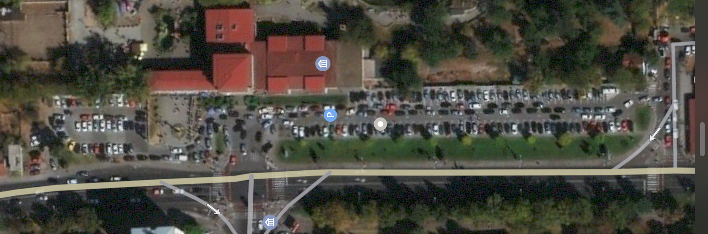
Figure 1-View of the location-parking lot of the Skopje ZOO
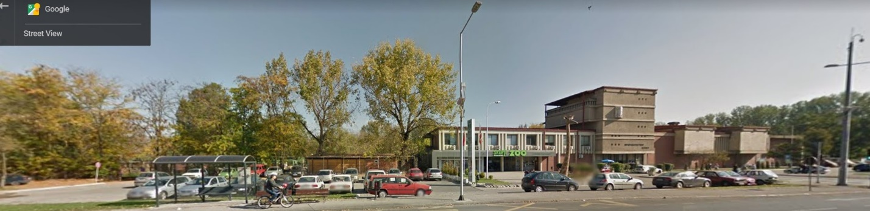
Figure 2-View of the Skopje ZOO 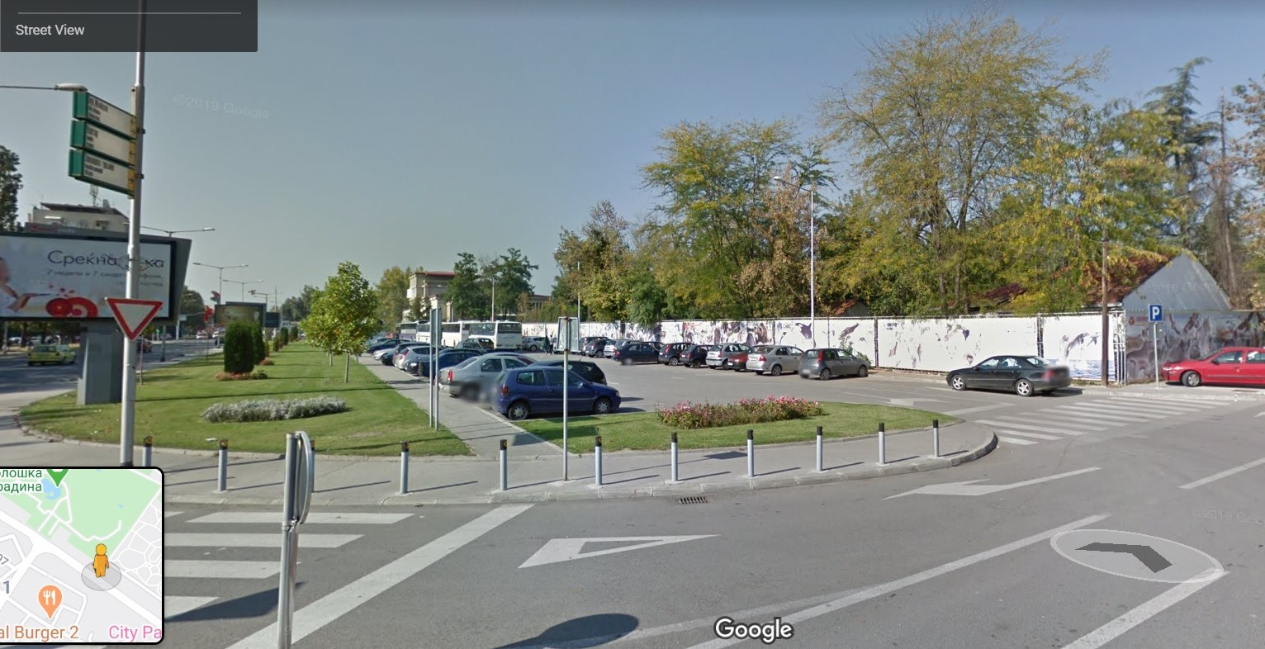
Figure 3-View of the parking lot in front of the Skopje ZOO

Annex 2

Fill in the table below as per the TOR requirements and reflect the years of experience and relevant projects delivered by the Company

Minimum valid License B valid for preparation of technical documentation for construction projects. | Min 5 years of relevant experience  Yes/no | Name of project | Status or Date Completed  (from date – till date) | References Client Contact Details  (Name, Phone, Email)

Fill in the (sample) table for each expert assigned reflecting the experience, relevant projects and licenses if required with validity date

Team members  and/or  areas of expertise | Name of personnel assigned | Licence  B (valid till)  Or n/a | Years of relevant experience | Relevant projects
Architect |  |  |  | Record of at least 5 projects in preparing technical documentation of compatible nature and degree of complexity (e.g. parking buildings/ spaces planning/ public buildings/ commercial buildings or similar).
 |  |  |  | 1.
 |  |  |  | 2.
 |  |  |  | 3.
 |  |  |  | 4.
 |  |  |  | 5.
Landscape expert |  |  |  | Record in at least 3 relevant projects (i.e. design of green areas /complex landscaping projects / public green spaces/ greening of parking lots/green urban areas that include combination of irrigation and landscaping works of similar nature.
 |  |  |  | 1.
 |  |  |  | 2.
 |  |  |  | 3.
Civil Engineer |  |  |  | Record of at least 3 projects in preparing construction and static projects of compatible nature and degree of complexity (e.g. public/commercial/ residential buildings).
 |  |  |  | 1.
 |  |  |  | 2.
 |  |  |  | 3.
Electrical Engineer |  |  |  | Record of at least 3 projects in preparing electrical projects of compatible nature and degree of complexity (e.g. public/commercial/ residential buildings).
 |  |  |  | 1.
 |  |  |  | 2.
 |  |  |  | 3.

Annex 3
Evaluation criteria
Contract will be awarded to the Bidder that meets the criteria based on pass/fail method and offers the lowest offer.
Minimum Requirements |  | Status
For the Company: |  | YES/NO
 | - Legal entity registered for the business activity (тековна состојба на фирмата) | YES/NO
 | - minimum of 5 years of experience in contemporary architectural design and planning | YES/NO
 | - minimum valid License B valid for preparation of technical documentation for construction projects, as per national regulations issued by the Ministry of Transport and Communications | YES/NO
 | - Minimum 5 projects are required with compatible nature and scope (public buildings, commercial buildings, parking spaces/buildings and public space planning). | YES/NO
Architect |  | YES/NO
 | - Valid Authorization (minimum B Authorisation) for preparation of technical documentation in the field of architecture issued by the Macedonian Chamber of Authorized Architects and Authorized Engineers; | YES/NO
 | - Minimum 5 years of relevant professional experience in preparation of projects for public buildings /commercial buildings/ parking spaces and/or buildings / public space planning or similar. | YES/NO
 | - Record of at least 5 projects in preparing technical documentation of compatible nature and degree of complexity (e.g. parking buildings/ spaces planning/ public buildings/ commercial buildings or similar). | YES/NO
Landscape expert |  | YES/NO
 | - Minimum university degree in Agriculture, Forestry, or equivalent. | YES/NO
 | - Minimum 3 years of professional experience in landscaping projects/ green area management/ design of green urban areas/ green parking lots or equivalent; | YES/NO
 | - Record in at least 3 relevant projects (i.e. design of green areas /complex landscaping projects / public green spaces/ greening of parking lots/green urban areas that include combination of irrigation and landscaping works of similar nature. | YES/NO
Civil Engineer |  | YES/NO
 | - Valid Authorization (minimum B Authorisation) for preparation of technical documentation in the field of civil engineering issued by the Macedonian Chamber of Authorized Architects and Authorized Engineers; | YES/NO
 | - Minimum 3 years of relevant professional experience in preparation of construction and static projects for public/commercial/ residential buildings or equivalent. | YES/NO
 | - Record of at least 3 projects in preparing construction and static projects of compatible nature and degree of complexity (e.g. public/commercial/ residential buildings). | YES/NO
Electrical Engineer |  | YES/NO
 | - Valid Authorization (minimum B Authorisation) for preparation of technical documentation in the field of electrical engineering issued by the Macedonian Chamber of Authorized Architects and Authorized Engineers; | YES/NO
 | - Minimum 3 years of relevant professional experience in preparation of electrical projects for public/commercial/ residential buildings or equivalent; | YES/NO
 | - Record of at least 3 projects in preparing electrical projects of compatible nature and degree of complexity (e.g. public/commercial/ residential buildings). | YES/NO

Annex 4

FORM FOR SUBMITTING SUPPLIER’S QUOTATION
(This Form must be submitted only using the Supplier’s Official Letterhead/Stationery

Skopje
Date: ___________
To: UNDP

Dear Sir/Madam:

We, the undersigned, hereby accept in full the UNDP General Terms and Conditions, and hereby offer to supply the works listed below in conformity with the specification and requirements of UNDP as per RFQ 30/2020 for Preparation of Basic Design Project for Green Parking Lot of the Skopje ZOO

____________________________________MKD, VAT excluded.

All other information that we have not provided automatically implies our full compliance with the requirements, terms and conditions of the RfQ.

We hereby declare that:

- All the information and statements made in this Bid are true and we accept that any misrepresentation contained in it may lead to our disqualification;
- We are currently not on the removed or suspended vendor list of the UN or other such lists of other UN agencies, nor are we associated with, any company or individual appearing on the 1267/1989 list of the UN Security Council;
- We have no outstanding bankruptcy or pending litigation or any legal action that could impair our operation as a going concern; and
- We do not employ, nor anticipate employing, any person who is or was recently employed by the UN or UNDP.

We confirm that we have read, understood and hereby fully accept the Schedule of Requirements and Technical Specifications describing the duties and responsibilities required of us in this RfQ, and the General Terms and Conditions of UNDP’s Standard Contract for this RfQ.

We agree to abide by this Bid for 60 days.

We undertake, if our Bid is accepted, to commence the Works and provision of related services not later than the date indicated in the Data Sheet.

We fully understand and recognize that UNDP is not bound to accept this Bid, that we shall bear all costs associated with its preparation and submission, and that UNDP will in no case be responsible or liable for those costs, regardless of the conduct or outcome of the evaluation.

We remain,

Yours sincerely,

Authorized Signature [In full and initials]:
Name and Title of Signatory:
Name of Firm:
Contact Details:

[please mark this letter with your corporate seal, if available]
Annex 5

FORM FOR SUBMITTING SUPPLIER’S QUOTATION
(This Form must be submitted only using the Supplier’s Official Letterhead/Stationery

We, the undersigned, hereby accept in full the UNDP General Terms and Conditions, and hereby offer to deliver services in conformity with TOR under RFQ 30/2020 for Preparation of Basic Design Project for Green Parking Lot of the Skopje ZOO

TABLE 1: Offer to Supply services compliant with TOR

Item No. | Description of milestones* | Total Price in MKD, VAT excluded | Completion date
1 | Conceptual design for green parking lot- not later than 1 July 2020
2 | Basic design for green parking lot - not later than 15 July 2020
 | TOTAL in MKD, VAT excluded

All other information that we have not provided automatically implies our full compliance with the requirements, terms and conditions of the RFQ.

[Name and Signature of the Supplier’s Authorized Person]
[Designation]
date

