PREPARATORY CHECKLIST: PROVINCIAL SITE ASSESSMENTS (DRAFT)
(for inclusion in RFP Scope of Services for each site)
Prepared by: PMU Palu Date: 26-July 2019.
PROVINCE | Central Sulawesi |  |  | KABUPATEN | Kota Palu |  | KECAMATAN |  | Tatanga
SCHOOL FACILITY? |  | Yes |  | GoI Facility name |  | SD Negeri 21 Palu
HEALTH FACILITY |  |  |  | GoI Facility name
Street Address |  | Jl. Delima No.3, Kel. Boyaoge |  |  |  |  |  | Postcode |  | 94223
SITE DATA ASSESSMENT
ITEM# | ATTRIBUTE | VERIFIABLE EVIDENCE | YES | NO
1 | Geographical positioning | GPS Coordinates | Yes
 |  | Cadastral Map | Yes
 |  | Technical description: boundary alignments; adjoining lots. | Yes
 |  | Survey boundary monuments located & clear of debris/ vegetation. |  | No
2 | Ownership | Certificate of Title copy attached |  | No
 |  | Clear and Clean title guaranteed by Provincial Government (#5) | Yes
 |  | Acquisition of new site if high risk is apparent on existing site? |  | No
 |  | Enlargement or realignment of site boundaries required? |  | No
3 | Agency Commitment | Proposed works are Included in RENAKSI? (#1) | Yes
 |  | Buildings certified as government owned with major damage (#2) | Yes
 |  | Funds are not duplicating other budget sources (#3) | Yes
 |  | There is a safe & secure location (#4) Subject to Geological Survey
 |  | Willingness for removal of asset to be reconstructed (#6) | Yes
 |  | Local authority willing to receive & maintain rebuilt buildings (#7) | Yes
 |  | Development approval and permit costs by local authority (#8) | Yes
4 | Site Assessment
 | DPU Assets Inspection | Serviceability & forensic assessment certification? | Yes
 | Geophysical Assessment | Report on fissures, faults/ fault lines, landslip, liquefaction risks?
5 | Site/ structures plans | Original as built site layout plan available in digital form? |  | No
 |  | Current as built site layout plan available in digital form? |  | No
 |  | Original as built structures plans available in digital form? |  | No
 |  | Updated as built structures plans available in digital form? |  | No
 |  | Each structure has digital general arrangement & detail drawings? |  | No
 |  | Each structure type can be identified by drawing no. and/ or code? |  | No
6 | Electrical Mains | Inspected and rendered functional & safe by power authority? | Yes
7 | Potable water | Reticulated water with ample flow & operational service points? |  | No
 |  | Rainwater storage collection and storage? |  | No
8 | Sewerage & Septic Tanks | Adequately functional with no health hazard? |  | No
 | Telephone land lines | Connections are in working order and cables well secured? | Yes
9 | Road access | External access road is trafficable and in fair to good condition? | Yes
10 | Demolition & Clean up | Most site areas have not been cleaned up/ are not trafficable |  | No
11 | ESM Framework | Draft document circulated to Pemda /local agencies for comment? |  | No
12 | Disabled Users | Building users have cited special needs for handicapped persons? |  | No
13 | Cultural Identifiers | Stakeholders request cultural character in building design? |  | No
14 | Site Greening | Stakeholders request guidance on shade trees &food gardens? |  | No
15 | Alternative Energy | Stakeholders OK with solar panels & battery storage? | Yes
GUIDANCE
- The above checklist and the attached graphics has the purpose of ensuring that (a) we in PETRA have been thorough and diligent in producing a “360⁰“assessment of each site (a) National, Provincial and community stakeholders have provided initial consensus input to the design process, which will be augmented by the DCS consultants’ working engagement, and (c) consultant responses to the RFP shall be well informed
- We need to have site plans in a common format, with a common numbering convention and reference to parent agency drawing numbers or type designation. Numbering shall go anticlockwise from the bottom LH corner
- All site plans shall be presented in the same format as SD Negeri 21 PALU
- Please delete this “GUIDANCE” to add brief clarifying remarks on the above responses, particularly any “NO” responses which are not self-evident. Please also where appropriate state what further actions will be taken by you.

RENAKSI DATA _ from Intervention Matrix UNDP
GPS COORDINATE | 0° 54’ 28.793” S 119° 51’ 16.074” E
Damage Severity | HEAVY | X | MODERATE |  | LIGHT
BUDGET NEEDED IN RENAKSI (IDR) | N/A
Summarized description – main tasks : MUST ACCURATELY REFLECT TASK BREAKDOWN IN BILL OF QUANTITIES
Design of the buildings at SD Negeri 21 Palu should be in accordance with regulations and standards from Ministry of Public Works and Ministry of Education.

SITE PLAN – Please make sure every site for both Education, Health & Environment contexts are uniformly presented
Please see Annex 4.4

PHOTOGRAPHS OF DAMAGE TO BE ADDRESSED THROUGH RFP DCS CONSULTANTS & LATER ITB WORKS
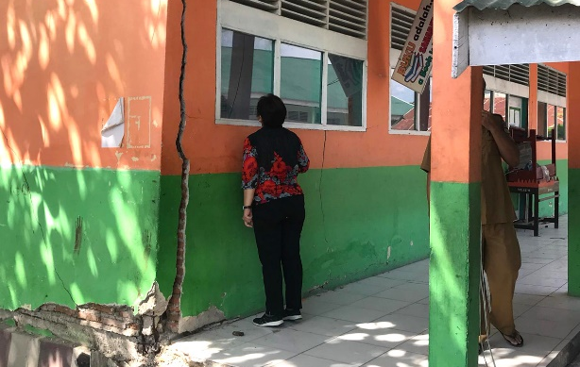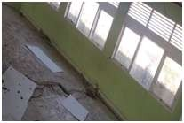

PREPARATORY CHECKLIST: PROVINCIAL SITE ASSESSMENTS (DRAFT)
(for inclusion in RFP Scope of Services for each site)
Prepared by: PMU Palu Date: 26-July 2019.
PROVINCE | Central Sulawesi |  |  | KABUPATEN | Kota Palu |  | KECAMATAN |  | Tatanga
SCHOOL FACILITY? |  | Yes |  | GoI Facility name |  | SD Negeri Pengawu
HEALTH FACILITY |  |  |  | GoI Facility name
Street Address |  | Jl. Malontara no. 10, Kel. Pengawu |  |  |  |  |  | Postcode |  | 94239
SITE DATA ASSESSMENT
ITEM# | ATTRIBUTE | VERIFIABLE EVIDENCE | YES | NO
1 | Geographical positioning | GPS Coordinates | Yes
 |  | Cadastral Map | Yes
 |  | Technical description: boundary alignments; adjoining lots. | Yes
 |  | Survey boundary monuments located & clear of debris/ vegetation. |  | No
2 | Ownership | Certificate of Title copy attached |  | No
 |  | Clear and Clean title guaranteed by Provincial Government (#5) | Yes
 |  | Acquisition of new site if high risk is apparent on existing site? |  | No
 |  | Enlargement or realignment of site boundaries required? |  | No
3 | Agency Commitment | Proposed works are Included in RENAKSI? (#1) | Yes
 |  | Buildings certified as government owned with major damage (#2) | Yes
 |  | Funds are not duplicating other budget sources (#3) | Yes
 |  | There is a safe & secure location (#4) Subject to Geological Survey
 |  | Willingness for removal of asset to be reconstructed (#6) | Yes
 |  | Local authority willing to receive & maintain rebuilt buildings (#7) | Yes
 |  | Development approval and permit costs by local authority (#8) | Yes
4 | Site Assessment
 | DPU Assets Inspection | Serviceability & forensic assessment certification? | Yes
 | Geophysical Assessment | Report on fissures, faults/ fault lines, landslip, liquefaction risks?
5 | Site/ structures plans | Original as built site layout plan available in digital form? |  | No
 |  | Current as built site layout plan available in digital form? |  | No
 |  | Original as built structures plans available in digital form? |  | No
 |  | Updated as built structures plans available in digital form? |  | No
 |  | Each structure has digital general arrangement & detail drawings? |  | No
 |  | Each structure type can be identified by drawing no. and/ or code? |  | No
6 | Electrical Mains | Inspected and rendered functional & safe by power authority? | Yes
7 | Potable water | Reticulated water with ample flow & operational service points? |  | No
 |  | Rainwater storage collection and storage? |  | No
8 | Sewerage & Septic Tanks | Adequately functional with no health hazard? |  | No
 | Telephone land lines | Connections are in working order and cables well secured? | Yes
9 | Road access | External access road is trafficable and in fair to good condition? | Yes
10 | Demolition & Clean up | Most site areas have not been cleaned up/ are not trafficable |  | No
11 | ESM Framework | Draft document circulated to Pemda /local agencies for comment? |  | No
12 | Disabled Users | Building users have cited special needs for handicapped persons? |  | No
13 | Cultural Identifiers | Stakeholders request cultural character in building design? |  | No
14 | Site Greening | Stakeholders request guidance on shade trees &food gardens? |  | No
15 | Alternative Energy | Stakeholders OK with solar panels & battery storage? | Yes
GUIDANCE
- The above checklist and the attached graphics has the purpose of ensuring that (a) we in PETRA have been thorough and diligent in producing a “360⁰“assessment of each site (a) National, Provincial and community stakeholders have provided initial consensus input to the design process, which will be augmented by the DCS consultants’ working engagement, and (c) consultant responses to the RFP shall be well informed
- We need to have site plans in a common format, with a common numbering convention and reference to parent agency drawing numbers or type designation. Numbering shall go anticlockwise from the bottom LH corner
- All site plans shall be presented in the same format as SD Negeri PENGAWU
- Please delete this “GUIDANCE” to add brief clarifying remarks on the above responses, particularly any “NO” responses which are not self-evident. Please also where appropriate state what further actions will be taken by you.

RENAKSI DATA _ from Intervention Matrix UNDP
GPS COORDINATE | 0° 55’ 22.519” S 119° 50’ 49.924” E
Damage Severity | HEAVY | X | MODERATE |  | LIGHT
BUDGET NEEDED IN RENAKSI (IDR) | 3,220,310,000
Summarized description – main tasks : MUST ACCURATELY REFLECT TASK BREAKDOWN IN BILL OF QUANTITIES
Design of the buildings at SD Negeri Pengawu should be in accordance with regulations and standards from Ministry of Public Works and Ministry of Education.

SITE PLAN – Please make sure every site for both Education, Health & Environment contexts are uniformly presented
Please see Annex 4.4

PHOTOGRAPHS OF DAMAGE TO BE ADDRESSED THROUGH RFP DCS CONSULTANTS & LATER ITB WORKS
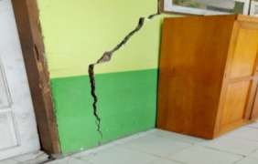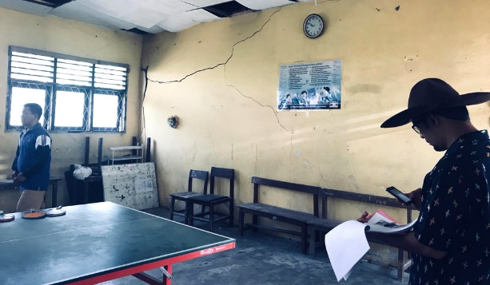

PREPARATORY CHECKLIST: PROVINCIAL SITE ASSESSMENTS (DRAFT)
(for inclusion in RFP Scope of Services for each site)
Prepared by: PMU Palu Date: 26-July 2019.
PROVINCE | Central Sulawesi |  |  | KABUPATEN | Kota Palu |  | KECAMATAN |  | Palu Timur
SCHOOL FACILITY? |  | Yes |  | GoI Facility name |  | SMP Negeri 14 Palu
HEALTH FACILITY |  |  |  | GoI Facility name
Street Address |  | Jl. Letjen Suprapto no. 67 |  |  |  |  |  | Postcode |  | 94111
SITE DATA ASSESSMENT
ITEM# | ATTRIBUTE | VERIFIABLE EVIDENCE | YES | NO
1 | Geographical positioning | GPS Coordinates | Yes
 |  | Cadastral Map | Yes
 |  | Technical description: boundary alignments; adjoining lots. | Yes
 |  | Survey boundary monuments located & clear of debris/ vegetation. | Yes
2 | Ownership | Certificate of Title copy attached |  | No
 |  | Clear and Clean title guaranteed by Provincial Government (#5) | Yes
 |  | Acquisition of new site if high risk is apparent on existing site? |  | No
 |  | Enlargement or realignment of site boundaries required? |  | No
3 | Agency Commitment | Proposed works are Included in RENAKSI? (#1) | Yes
 |  | Buildings certified as government owned with major damage (#2) | Yes
 |  | Funds are not duplicating other budget sources (#3) | Yes
 |  | There is a safe & secure location (#4) Subject to Geological Survey
 |  | Willingness for removal of asset to be reconstructed (#6) | Yes
 |  | Local authority willing to receive & maintain rebuilt buildings (#7) | Yes
 |  | Development approval and permit costs by local authority (#8) | Yes
4 | Site Assessment
 | DPU Assets Inspection | Serviceability & forensic assessment certification? | Yes
 | Geophysical Assessment | Report on fissures, faults/ fault lines, landslip, liquefaction risks?
5 | Site/ structures plans | Original as built site layout plan available in digital form? |  | No
 |  | Current as built site layout plan available in digital form? |  | No
 |  | Original as built structures plans available in digital form? |  | No
 |  | Updated as built structures plans available in digital form? |  | No
 |  | Each structure has digital general arrangement & detail drawings? |  | No
 |  | Each structure type can be identified by drawing no. and/ or code? |  | No
6 | Electrical Mains | Inspected and rendered functional & safe by power authority? | Yes
7 | Potable water | Reticulated water with ample flow & operational service points? |  | No
 |  | Rainwater storage collection and storage? |  | No
8 | Sewerage & Septic Tanks | Adequately functional with no health hazard? |  | No
 | Telephone land lines | Connections are in working order and cables well secured? | Yes
9 | Road access | External access road is trafficable and in fair to good condition? | Yes
10 | Demolition & Clean up | Most site areas have not been cleaned up/ are not trafficable |  | No
11 | ESM Framework | Draft document circulated to Pemda /local agencies for comment? |  | No
12 | Disabled Users | Building users have cited special needs for handicapped persons? |  | No
13 | Cultural Identifiers | Stakeholders request cultural character in building design? |  | No
14 | Site Greening | Stakeholders request guidance on shade trees &food gardens? |  | No
15 | Alternative Energy | Stakeholders OK with solar panels & battery storage? | Yes
GUIDANCE
- The above checklist and the attached graphics has the purpose of ensuring that (a) we in PETRA have been thorough and diligent in producing a “360⁰“assessment of each site (a) National, Provincial and community stakeholders have provided initial consensus input to the design process, which will be augmented by the DCS consultants’ working engagement, and (c) consultant responses to the RFP shall be well informed
- We need to have site plans in a common format, with a common numbering convention and reference to parent agency drawing numbers or type designation. Numbering shall go anticlockwise from the bottom LH corner
- All site plans shall be presented in the same format as SMP Negeri 14 PALU
- Please delete this “GUIDANCE” to add brief clarifying remarks on the above responses, particularly any “NO” responses which are not self-evident. Please also where appropriate state what further actions will be taken by you.

RENAKSI DATA _ from Intervention Matrix UNDP
GPS COORDINATE | 0° 53’ 21.826” S 119° 52’ 31.127” E
Damage Severity | HEAVY | X | MODERATE |  | LIGHT
BUDGET NEEDED IN RENAKSI (IDR) | 4,070,256,000
Summarized description – main tasks : MUST ACCURATELY REFLECT TASK BREAKDOWN IN BILL OF QUANTITIES
Design of the buildings at SMP Negeri 14 Palu should be in accordance with regulations and standards from Ministry of Public Works and Ministry of Education.

SITE PLAN – Please make sure every site for both Education, Health & Environment contexts are uniformly presented
Please see Annex 4.4

PHOTOGRAPHS OF DAMAGE TO BE ADDRESSED THROUGH RFP DCS CONSULTANTS & LATER ITB WORKS
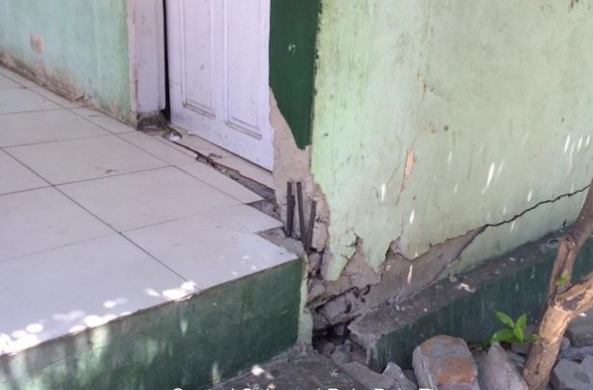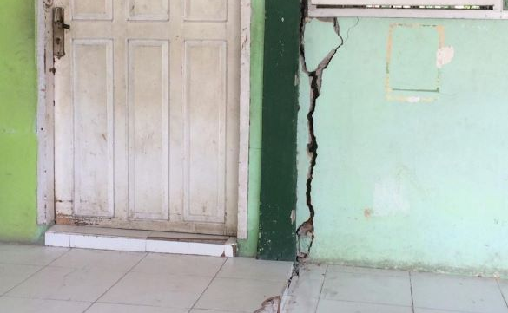

PREPARATORY CHECKLIST: PROVINCIAL SITE ASSESSMENTS (DRAFT)
(for inclusion in RFP Scope of Services for each site)
Prepared by: PMU Palu Date: 26-July 2019.
PROVINCE | Central Sulawesi |  |  | KABUPATEN | Kota Palu |  | KECAMATAN |  | Mantikulore
SCHOOL FACILITY? |  | Yes |  | GoI Facility name |  | SMK Negeri 8 Palu
HEALTH FACILITY |  |  |  | GoI Facility name
Street Address |  | Jl. Ragigau no.3 Palu |  |  |  |  |  | Postcode |  | 94228
SITE DATA ASSESSMENT
ITEM# | ATTRIBUTE | VERIFIABLE EVIDENCE | YES | NO
1 | Geographical positioning | GPS Coordinates | Yes
 |  | Cadastral Map | Yes
 |  | Technical description: boundary alignments; adjoining lots. | Yes
 |  | Survey boundary monuments located & clear of debris/ vegetation. | Yes
2 | Ownership | Certificate of Title copy attached |  | No
 |  | Clear and Clean title guaranteed by Provincial Government (#5) | Yes
 |  | Acquisition of new site if high risk is apparent on existing site? | Yes
 |  | Enlargement or realignment of site boundaries required? | Yes
3 | Agency Commitment | Proposed works are Included in RENAKSI? (#1) | Yes
 |  | Buildings certified as government owned with major damage (#2) | Yes
 |  | Funds are not duplicating other budget sources (#3) | Yes
 |  | There is a safe & secure location (#4) Subject to Geological Survey
 |  | Willingness for removal of asset to be reconstructed (#6) | Yes
 |  | Local authority willing to receive & maintain rebuilt buildings (#7) | Yes
 |  | Development approval and permit costs by local authority (#8) | Yes
4 | Site Assessment
 | DPU Assets Inspection | Serviceability & forensic assessment certification? | Yes
 | Geophysical Assessment | Report on fissures, faults/ fault lines, landslip, liquefaction risks?
5 | Site/ structures plans | Original as built site layout plan available in digital form? |  | No
 |  | Current as built site layout plan available in digital form? |  | No
 |  | Original as built structures plans available in digital form? |  | No
 |  | Updated as built structures plans available in digital form? |  | No
 |  | Each structure has digital general arrangement & detail drawings? |  | No
 |  | Each structure type can be identified by drawing no. and/ or code? |  | No
6 | Electrical Mains | Inspected and rendered functional & safe by power authority? | Yes
7 | Potable water | Reticulated water with ample flow & operational service points? |  | No
 |  | Rainwater storage collection and storage? |  | No
8 | Sewerage & Septic Tanks | Adequately functional with no health hazard? |  | No
 | Telephone land lines | Connections are in working order and cables well secured? | Yes
9 | Road access | External access road is trafficable and in fair to good condition? | Yes
10 | Demolition & Clean up | Most site areas have not been cleaned up/ are not trafficable |  | No
11 | ESM Framework | Draft document circulated to Pemda /local agencies for comment? |  | No
12 | Disabled Users | Building users have cited special needs for handicapped persons? |  | No
13 | Cultural Identifiers | Stakeholders request cultural character in building design? |  | No
14 | Site Greening | Stakeholders request guidance on shade trees &food gardens? |  | No
15 | Alternative Energy | Stakeholders OK with solar panels & battery storage? | Yes
GUIDANCE
- The above checklist and the attached graphics has the purpose of ensuring that (a) we in PETRA have been thorough and diligent in producing a “360⁰“assessment of each site (a) National, Provincial and community stakeholders have provided initial consensus input to the design process, which will be augmented by the DCS consultants’ working engagement, and (c) consultant responses to the RFP shall be well informed
- We need to have site plans in a common format, with a common numbering convention and reference to parent agency drawing numbers or type designation. Numbering shall go anticlockwise from the bottom LH corner
- All site plans shall be presented in the same format as SMK Negeri 8 PALU
- Please delete this “GUIDANCE” to add brief clarifying remarks on the above responses, particularly any “NO” responses which are not self-evident. Please also where appropriate state what further actions will be taken by you.

RENAKSI DATA _ from Intervention Matrix UNDP
GPS COORDINATE | 0° 52’ 16.561” S 119° 53’ 25.271” E
Damage Severity | HEAVY | X | MODERATE |  | LIGHT
BUDGET IN RENAKSI (IDR) | 5,506,560,000
Summarized description – main tasks : MUST ACCURATELY REFLECT TASK BREAKDOWN IN BILL OF QUANTITIES
Design of the buildings at SMK Negeri 8 Palu should be in accordance with regulations and standards from Ministry of Public Works and Ministry of Education.

SITE PLAN – Please make sure every site for both Education, Health & Environment contexts are uniformly presented
Please see Annex 4.4

PHOTOGRAPHS OF DAMAGE TO BE ADDRESSED THROUGH RFP DCS CONSULTANTS & LATER ITB WORKS
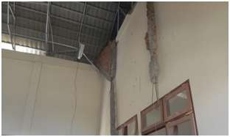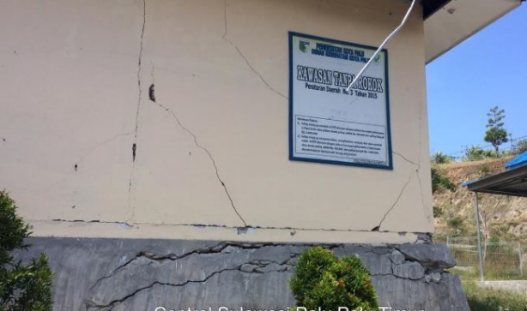

PREPARATORY CHECKLIST: PROVINCIAL SITE ASSESSMENTS (DRAFT)
(for inclusion in RFP Scope of Services for each site)
Prepared by: PMU Palu Date: 26-July 2019.
PROVINCE | Central Sulawesi |  |  | KABUPATEN | Sigi |  | KECAMATAN |  | Sigi Biromaru
SCHOOL FACILITY? |  | Yes |  | GoI Facility name |  | SD Inpres Jono Oge
HEALTH FACILITY |  |  |  | GoI Facility name
Street Address |  | Jl. Lasoso, Desa Jono Oge |  |  |  |  |  | Postcode |  | 94364
SITE DATA ASSESSMENT
ITEM# | ATTRIBUTE | VERIFIABLE EVIDENCE | YES | NO
1 | Geographical positioning | GPS Coordinates | Yes
 |  | Cadastral Map | Yes
 |  | Technical description: boundary alignments; adjoining lots. | Yes
 |  | Survey boundary monuments located & clear of debris/ vegetation. | Yes
2 | Ownership | Certificate of Title copy attached |  | No
 |  | Clear and Clean title guaranteed by Provincial Government (#5) | Yes
 |  | Acquisition of new site if high risk is apparent on existing site? |  | No
 |  | Enlargement or realignment of site boundaries required? |  | No
3 | Agency Commitment | Proposed works are Included in RENAKSI? (#1) | Yes
 |  | Buildings certified as government owned with major damage (#2) | Yes
 |  | Funds are not duplicating other budget sources (#3) | Yes
 |  | There is a safe & secure location (#4) Subject to Geological Survey
 |  | Willingness for removal of asset to be reconstructed (#6) | Yes
 |  | Local authority willing to receive & maintain rebuilt buildings (#7) | Yes
 |  | Development approval and permit costs by local authority (#8) | Yes
4 | Site Assessment
 | DPU Assets Inspection | Serviceability & forensic assessment certification? | Yes
 | Geophysical Assessment | Report on fissures, faults/ fault lines, landslip, liquefaction risks?
5 | Site/ structures plans | Original as built site layout plan available in digital form? |  | No
 |  | Current as built site layout plan available in digital form? |  | No
 |  | Original as built structures plans available in digital form? |  | No
 |  | Updated as built structures plans available in digital form? |  | No
 |  | Each structure has digital general arrangement & detail drawings? |  | No
 |  | Each structure type can be identified by drawing no. and/ or code? |  | No
6 | Electrical Mains | Inspected and rendered functional & safe by power authority? | Yes
7 | Potable water | Reticulated water with ample flow & operational service points? |  | No
 |  | Rainwater storage collection and storage? |  | No
8 | Sewerage & Septic Tanks | Adequately functional with no health hazard? |  | No
 | Telephone land lines | Connections are in working order and cables well secured? | Yes
9 | Road access | External access road is trafficable and in fair to good condition? | Yes
10 | Demolition & Clean up | Most site areas have not been cleaned up/ are not trafficable |  | No
11 | ESM Framework | Draft document circulated to Pemda /local agencies for comment? |  | No
12 | Disabled Users | Building users have cited special needs for handicapped persons? |  | No
13 | Cultural Identifiers | Stakeholders request cultural character in building design? |  | No
14 | Site Greening | Stakeholders request guidance on shade trees &food gardens? |  | No
15 | Alternative Energy | Stakeholders OK with solar panels & battery storage? | Yes
GUIDANCE
- The above checklist and the attached graphics has the purpose of ensuring that (a) we in PETRA have been thorough and diligent in producing a “360⁰“assessment of each site (a) National, Provincial and community stakeholders have provided initial consensus input to the design process, which will be augmented by the DCS consultants’ working engagement, and (c) consultant responses to the RFP shall be well informed
- We need to have site plans in a common format, with a common numbering convention and reference to parent agency drawing numbers or type designation. Numbering shall go anticlockwise from the bottom LH corner
- All site plans shall be presented in the same format as SD Inpres JONO OGE
- Please delete this “GUIDANCE” to add brief clarifying remarks on the above responses, particularly any “NO” responses which are not self-evident. Please also where appropriate state what further actions will be taken by you.

RENAKSI DATA _ from Intervention Matrix UNDP
GPS COORDINATE | 0° 58’ 53.162” S 119° 54’ 58.158” E
Damage Severity | HEAVY | X | MODERATE |  | LIGHT
BUDGET NEEDED IN RENAKSI (IDR) | 1,226,384,000
Summarized description – main tasks : MUST ACCURATELY REFLECT TASK BREAKDOWN IN BILL OF QUANTITIES
Design of the buildings at SD Inpres Jono Oge should be in accordance with regulations and standards from Ministry of Public Works and Ministry of Education.

SITE PLAN – Please make sure every site for both Education, Health & Environment contexts are uniformly presented
Please see Annex 4.4

PHOTOGRAPHS OF DAMAGE TO BE ADDRESSED THROUGH RFP DCS CONSULTANTS & LATER ITB WORKS
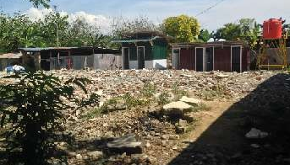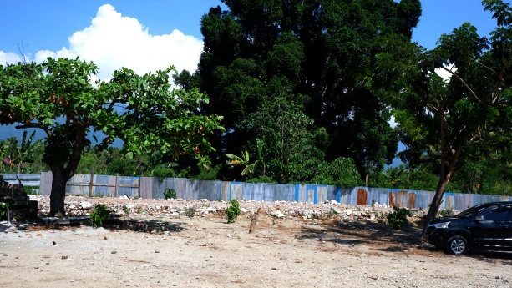

PREPARATORY CHECKLIST: PROVINCIAL SITE ASSESSMENTS (DRAFT)
(for inclusion in RFP Scope of Services for each site)
Prepared by: PMU Palu Date: 26-July 2019.
PROVINCE | Central Sulawesi |  |  | KABUPATEN | Sigi |  | KECAMATAN |  | Sigi Biromaru
SCHOOL FACILITY? |  | Yes |  | GoI Facility name |  | SMK Negeri 1 Sigi
HEALTH FACILITY |  |  |  | GoI Facility name
Street Address |  | Jl. Raya Palu – Palolo KM. 14 Sidera |  |  |  |  |  | Postcode |  | 94364
SITE DATA ASSESSMENT
ITEM# | ATTRIBUTE | VERIFIABLE EVIDENCE | YES | NO
1 | Geographical positioning | GPS Coordinates | Yes
 |  | Cadastral Map | Yes
 |  | Technical description: boundary alignments; adjoining lots. | Yes
 |  | Survey boundary monuments located & clear of debris/ vegetation. | Yes
2 | Ownership | Certificate of Title copy attached |  | No
 |  | Clear and Clean title guaranteed by Provincial Government (#5) | Yes
 |  | Acquisition of new site if high risk is apparent on existing site? |  | No
 |  | Enlargement or realignment of site boundaries required? |  | No
3 | Agency Commitment | Proposed works are Included in RENAKSI? (#1) | Yes
 |  | Buildings certified as government owned with major damage (#2) | Yes
 |  | Funds are not duplicating other budget sources (#3) | Yes
 |  | There is a safe & secure location (#4) Subject to Geological Survey
 |  | Willingness for removal of asset to be reconstructed (#6) | Yes
 |  | Local authority willing to receive & maintain rebuilt buildings (#7) | Yes
 |  | Development approval and permit costs by local authority (#8) | Yes
4 | Site Assessment
 | DPU Assets Inspection | Serviceability & forensic assessment certification? | Yes
 | Geophysical Assessment | Report on fissures, faults/ fault lines, landslip, liquefaction risks?
5 | Site/ structures plans | Original as built site layout plan available in digital form? |  | No
 |  | Current as built site layout plan available in digital form? |  | No
 |  | Original as built structures plans available in digital form? |  | No
 |  | Updated as built structures plans available in digital form? |  | No
 |  | Each structure has digital general arrangement & detail drawings? |  | No
 |  | Each structure type can be identified by drawing no. and/ or code? |  | No
6 | Electrical Mains | Inspected and rendered functional & safe by power authority? | Yes
7 | Potable water | Reticulated water with ample flow & operational service points? |  | No
 |  | Rainwater storage collection and storage? |  | No
8 | Sewerage & Septic Tanks | Adequately functional with no health hazard? |  | No
 | Telephone land lines | Connections are in working order and cables well secured? | Yes
9 | Road access | External access road is trafficable and in fair to good condition? | Yes
10 | Demolition & Clean up | Most site areas have not been cleaned up/ are not trafficable |  | No
11 | ESM Framework | Draft document circulated to Pemda /local agencies for comment? |  | No
12 | Disabled Users | Building users have cited special needs for handicapped persons? |  | No
13 | Cultural Identifiers | Stakeholders request cultural character in building design? |  | No
14 | Site Greening | Stakeholders request guidance on shade trees &food gardens? |  | No
15 | Alternative Energy | Stakeholders OK with solar panels & battery storage? | Yes
GUIDANCE
- The above checklist and the attached graphics has the purpose of ensuring that (a) we in PETRA have been thorough and diligent in producing a “360⁰“assessment of each site (a) National, Provincial and community stakeholders have provided initial consensus input to the design process, which will be augmented by the DCS consultants’ working engagement, and (c) consultant responses to the RFP shall be well informed
- We need to have site plans in a common format, with a common numbering convention and reference to parent agency drawing numbers or type designation. Numbering shall go anticlockwise from the bottom LH corner
- All site plans shall be presented in the same format as SMK Negeri 1 SIGI
- Please delete this “GUIDANCE” to add brief clarifying remarks on the above responses, particularly any “NO” responses which are not self-evident. Please also where appropriate state what further actions will be taken by you.

RENAKSI DATA _ from Intervention Matrix UNDP
GPS COORDINATE | 1° 0’ 5.731” S 119° 55’ 33.377” E
Damage Severity | HEAVY | X | MODERATE |  | LIGHT
BUDGET NEEDED IN RENAKSI (IDR) | 24,048,180,000
Summarized description – main tasks : MUST ACCURATELY REFLECT TASK BREAKDOWN IN BILL OF QUANTITIES
Design of the buildings at SMK Negeri 1 Sigi should be in accordance with regulations and standards from Ministry of Public Works and Ministry of Education.

SITE PLAN – Please make sure every site for both Education, Health & Environment contexts are uniformly presented
Please see Annex 4.4

PHOTOGRAPHS OF DAMAGE TO BE ADDRESSED THROUGH RFP DCS CONSULTANTS & LATER ITB WORKS
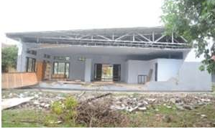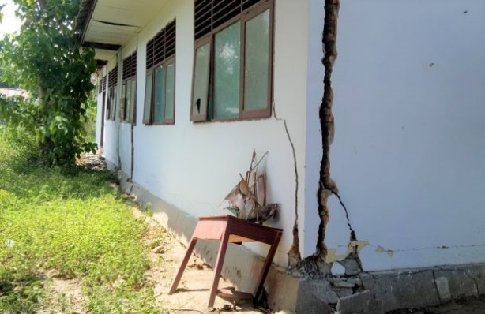

PREPARATORY CHECKLIST: PROVINCIAL SITE ASSESSMENTS (DRAFT)
(for inclusion in RFP Scope of Services for each site)
Prepared by: PMU Palu Date: 26-July 2019.
PROVINCE | Central Sulawesi |  |  | KABUPATEN | Sigi |  | KECAMATAN |  | Sigi Biromaru
SCHOOL FACILITY? |  | Yes |  | GoI Facility name |  | SD Negeri Bulupountu Jaya
HEALTH FACILITY |  |  |  | GoI Facility name
Street Address |  | Jl. Kebun Sari, Desa Sidera |  |  |  |  |  | Postcode |  | 94364
SITE DATA ASSESSMENT
ITEM# | ATTRIBUTE | VERIFIABLE EVIDENCE | YES | NO
1 | Geographical positioning | GPS Coordinates | Yes
 |  | Cadastral Map | Yes
 |  | Technical description: boundary alignments; adjoining lots. | Yes
 |  | Survey boundary monuments located & clear of debris/ vegetation. | Yes
2 | Ownership | Certificate of Title copy attached |  | No
 |  | Clear and Clean title guaranteed by Provincial Government (#5) | Yes
 |  | Acquisition of new site if high risk is apparent on existing site? |  | No
 |  | Enlargement or realignment of site boundaries required? |  | No
3 | Agency Commitment | Proposed works are Included in RENAKSI? (#1) | Yes
 |  | Buildings certified as government owned with major damage (#2) | Yes
 |  | Funds are not duplicating other budget sources (#3) | Yes
 |  | There is a safe & secure location (#4) Subject to Geological Survey
 |  | Willingness for removal of asset to be reconstructed (#6) | Yes
 |  | Local authority willing to receive & maintain rebuilt buildings (#7) | Yes
 |  | Development approval and permit costs by local authority (#8) | Yes
4 | Site Assessment
 | DPU Assets Inspection | Serviceability & forensic assessment certification? | Yes
 | Geophysical Assessment | Report on fissures, faults/ fault lines, landslip, liquefaction risks?
5 | Site/ structures plans | Original as built site layout plan available in digital form? |  | No
 |  | Current as built site layout plan available in digital form? |  | No
 |  | Original as built structures plans available in digital form? |  | No
 |  | Updated as built structures plans available in digital form? |  | No
 |  | Each structure has digital general arrangement & detail drawings? |  | No
 |  | Each structure type can be identified by drawing no. and/ or code? |  | No
6 | Electrical Mains | Inspected and rendered functional & safe by power authority? | Yes
7 | Potable water | Reticulated water with ample flow & operational service points? |  | No
 |  | Rainwater storage collection and storage? |  | No
8 | Sewerage & Septic Tanks | Adequately functional with no health hazard? |  | No
 | Telephone land lines | Connections are in working order and cables well secured? | Yes
9 | Road access | External access road is trafficable and in fair to good condition? | Yes
10 | Demolition & Clean up | Most site areas have not been cleaned up/ are not trafficable |  | No
11 | ESM Framework | Draft document circulated to Pemda /local agencies for comment? |  | No
12 | Disabled Users | Building users have cited special needs for handicapped persons? |  | No
13 | Cultural Identifiers | Stakeholders request cultural character in building design? |  | No
14 | Site Greening | Stakeholders request guidance on shade trees &food gardens? |  | No
15 | Alternative Energy | Stakeholders OK with solar panels & battery storage? | Yes
GUIDANCE
- The above checklist and the attached graphics has the purpose of ensuring that (a) we in PETRA have been thorough and diligent in producing a “360⁰“assessment of each site (a) National, Provincial and community stakeholders have provided initial consensus input to the design process, which will be augmented by the DCS consultants’ working engagement, and (c) consultant responses to the RFP shall be well informed
- We need to have site plans in a common format, with a common numbering convention and reference to parent agency drawing numbers or type designation. Numbering shall go anticlockwise from the bottom LH corner
- All site plans shall be presented in the same format as SD Negeri BULUPOUNTU JAYA
- Please delete this “GUIDANCE” to add brief clarifying remarks on the above responses, particularly any “NO” responses which are not self-evident. Please also where appropriate state what further actions will be taken by you.

RENAKSI DATA _ from Intervention Matrix UNDP
GPS COORDINATE | 1° 0’ 10.649” S 119° 56’ 31.844” E
Damage Severity | HEAVY | X | MODERATE |  | LIGHT
BUDGET NEEDED IN RENAKSI (IDR) | 568,472,000
Summarized description – main tasks : MUST ACCURATELY REFLECT TASK BREAKDOWN IN BILL OF QUANTITIES
Design of the buildings at SD Negeri Bulupountu Jaya should be in accordance with regulations and standards from Ministry of Public Works and Ministry of Education.

SITE PLAN – Please make sure every site for both Education, Health & Environment contexts are uniformly presented
Please see Annex 4.4

PHOTOGRAPHS OF DAMAGE TO BE ADDRESSED THROUGH RFP DCS CONSULTANTS & LATER ITB WORKS
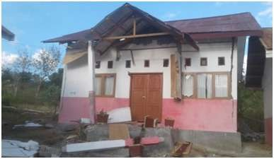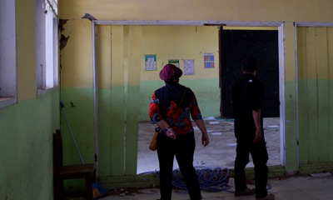

PREPARATORY CHECKLIST: PROVINCIAL SITE ASSESSMENTS (DRAFT)
(for inclusion in RFP Scope of Services for each site)
Prepared by: PMU Palu Date: 26-July 2019.
PROVINCE | Central Sulawesi |  |  | KABUPATEN | Sigi |  | KECAMATAN |  | Sigi Biromaru
SCHOOL FACILITY? |  | Yes |  | GoI Facility name |  | SD Negeri Lompio
HEALTH FACILITY |  |  |  | GoI Facility name
Street Address |  | Jl. Tanggul Gumbasa, Lompio |  |  |  |  |  | Postcode |  | 94364
SITE DATA ASSESSMENT
ITEM# | ATTRIBUTE | VERIFIABLE EVIDENCE | YES | NO
1 | Geographical positioning | GPS Coordinates | Yes
 |  | Cadastral Map | Yes
 |  | Technical description: boundary alignments; adjoining lots. | Yes
 |  | Survey boundary monuments located & clear of debris/ vegetation. | Yes
2 | Ownership | Certificate of Title copy attached |  | No
 |  | Clear and Clean title guaranteed by Provincial Government (#5) | Yes
 |  | Acquisition of new site if high risk is apparent on existing site? |  | No
 |  | Enlargement or realignment of site boundaries required? |  | No
3 | Agency Commitment | Proposed works are Included in RENAKSI? (#1) | Yes
 |  | Buildings certified as government owned with major damage (#2) | Yes
 |  | Funds are not duplicating other budget sources (#3) | Yes
 |  | There is a safe & secure location (#4) Subject to Geological Survey
 |  | Willingness for removal of asset to be reconstructed (#6) | Yes
 |  | Local authority willing to receive & maintain rebuilt buildings (#7) | Yes
 |  | Development approval and permit costs by local authority (#8) | Yes
4 | Site Assessment
 | DPU Assets Inspection | Serviceability & forensic assessment certification? | Yes
 | Geophysical Assessment | Report on fissures, faults/ fault lines, landslip, liquefaction risks?
5 | Site/ structures plans | Original as built site layout plan available in digital form? |  | No
 |  | Current as built site layout plan available in digital form? |  | No
 |  | Original as built structures plans available in digital form? |  | No
 |  | Updated as built structures plans available in digital form? |  | No
 |  | Each structure has digital general arrangement & detail drawings? |  | No
 |  | Each structure type can be identified by drawing no. and/ or code? |  | No
6 | Electrical Mains | Inspected and rendered functional & safe by power authority? | Yes
7 | Potable water | Reticulated water with ample flow & operational service points? |  | No
 |  | Rainwater storage collection and storage? |  | No
8 | Sewerage & Septic Tanks | Adequately functional with no health hazard? |  | No
 | Telephone land lines | Connections are in working order and cables well secured? | Yes
9 | Road access | External access road is trafficable and in fair to good condition? | Yes
10 | Demolition & Clean up | Most site areas have not been cleaned up/ are not trafficable |  | No
11 | ESM Framework | Draft document circulated to Pemda /local agencies for comment? |  | No
12 | Disabled Users | Building users have cited special needs for handicapped persons? |  | No
13 | Cultural Identifiers | Stakeholders request cultural character in building design? |  | No
14 | Site Greening | Stakeholders request guidance on shade trees &food gardens? |  | No
15 | Alternative Energy | Stakeholders OK with solar panels & battery storage? | Yes
GUIDANCE
- The above checklist and the attached graphics has the purpose of ensuring that (a) we in PETRA have been thorough and diligent in producing a “360⁰“assessment of each site (a) National, Provincial and community stakeholders have provided initial consensus input to the design process, which will be augmented by the DCS consultants’ working engagement, and (c) consultant responses to the RFP shall be well informed
- We need to have site plans in a common format, with a common numbering convention and reference to parent agency drawing numbers or type designation. Numbering shall go anticlockwise from the bottom LH corner
- All site plans shall be presented in the same format as SD Negeri LOMPIO
- Please delete this “GUIDANCE” to add brief clarifying remarks on the above responses, particularly any “NO” responses which are not self-evident. Please also where appropriate state what further actions will be taken by you.

RENAKSI DATA _ from Intervention Matrix UNDP
GPS COORDINATE | 1° 4’ 13.310” S 119° 56’ 9.823” E
Damage Severity | HEAVY | X | MODERATE |  | LIGHT
BUDGET NEEDED IN RENAKSI (IDR) | 967,902,400
Summarized description – main tasks : MUST ACCURATELY REFLECT TASK BREAKDOWN IN BILL OF QUANTITIES
Design of the buildings at SD Negeri Lompio should be in accordance with regulations and standards from Ministry of Public Works and Ministry of Education.

SITE PLAN – Please make sure every site for both Education, Health & Environment contexts are uniformly presented
Please see Annex 4.4

PHOTOGRAPHS OF DAMAGE TO BE ADDRESSED THROUGH RFP DCS CONSULTANTS & LATER ITB WORKS
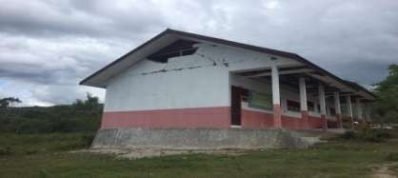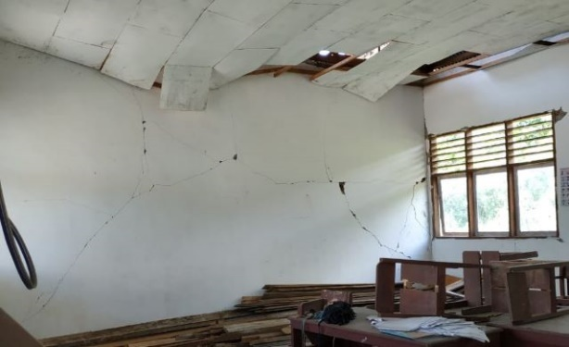

PREPARATORY CHECKLIST: PROVINCIAL SITE ASSESSMENTS (DRAFT)
(for inclusion in RFP Scope of Services for each site)
Prepared by: PMU Palu Date: 26-July 2019.
PROVINCE | Central Sulawesi |  |  | KABUPATEN | Sigi |  | KECAMATAN |  | Kulawi
SCHOOL FACILITY? |  | Yes |  | GoI Facility name |  | SD Negeri No.1 Boladangko
HEALTH FACILITY |  |  |  | GoI Facility name
Street Address |  | Ds. Boladangko |  |  |  |  |  | Postcode |  | 94363
SITE DATA ASSESSMENT
ITEM# | ATTRIBUTE | VERIFIABLE EVIDENCE | YES | NO
1 | Geographical positioning | GPS Coordinates | Yes
 |  | Cadastral Map | Yes
 |  | Technical description: boundary alignments; adjoining lots. | Yes
 |  | Survey boundary monuments located & clear of debris/ vegetation. | Yes
2 | Ownership | Certificate of Title copy attached |  | No
 |  | Clear and Clean title guaranteed by Provincial Government (#5) | Yes
 |  | Acquisition of new site if high risk is apparent on existing site? |  | No
 |  | Enlargement or realignment of site boundaries required? |  | No
3 | Agency Commitment | Proposed works are Included in RENAKSI? (#1) | Yes
 |  | Buildings certified as government owned with major damage (#2) | Yes
 |  | Funds are not duplicating other budget sources (#3) | Yes
 |  | There is a safe & secure location (#4) Subject to Geological Survey
 |  | Willingness for removal of asset to be reconstructed (#6) | Yes
 |  | Local authority willing to receive & maintain rebuilt buildings (#7) | Yes
 |  | Development approval and permit costs by local authority (#8) | Yes
4 | Site Assessment
 | DPU Assets Inspection | Serviceability & forensic assessment certification? | Yes
 | Geophysical Assessment | Report on fissures, faults/ fault lines, landslip, liquefaction risks?
5 | Site/ structures plans | Original as built site layout plan available in digital form? |  | No
 |  | Current as built site layout plan available in digital form? |  | No
 |  | Original as built structures plans available in digital form? |  | No
 |  | Updated as built structures plans available in digital form? |  | No
 |  | Each structure has digital general arrangement & detail drawings? |  | No
 |  | Each structure type can be identified by drawing no. and/ or code? |  | No
6 | Electrical Mains | Inspected and rendered functional & safe by power authority? | Yes
7 | Potable water | Reticulated water with ample flow & operational service points? |  | No
 |  | Rainwater storage collection and storage? |  | No
8 | Sewerage & Septic Tanks | Adequately functional with no health hazard? |  | No
 | Telephone land lines | Connections are in working order and cables well secured? | Yes
9 | Road access | External access road is trafficable and in fair to good condition? | Yes
10 | Demolition & Clean up | Most site areas have not been cleaned up/ are not trafficable |  | No
11 | ESM Framework | Draft document circulated to Pemda /local agencies for comment? |  | No
12 | Disabled Users | Building users have cited special needs for handicapped persons? |  | No
13 | Cultural Identifiers | Stakeholders request cultural character in building design? |  | No
14 | Site Greening | Stakeholders request guidance on shade trees &food gardens? |  | No
15 | Alternative Energy | Stakeholders OK with solar panels & battery storage? | Yes
GUIDANCE
- The above checklist and the attached graphics has the purpose of ensuring that (a) we in PETRA have been thorough and diligent in producing a “360⁰“assessment of each site (a) National, Provincial and community stakeholders have provided initial consensus input to the design process, which will be augmented by the DCS consultants’ working engagement, and (c) consultant responses to the RFP shall be well informed
- We need to have site plans in a common format, with a common numbering convention and reference to parent agency drawing numbers or type designation. Numbering shall go anticlockwise from the bottom LH corner
- All site plans shall be presented in the same format as SD Negeri No.1 Boladangko
- Please delete this “GUIDANCE” to add brief clarifying remarks on the above responses, particularly any “NO” responses which are not self-evident. Please also where appropriate state what further actions will be taken by you.

RENAKSI DATA _ from Intervention Matrix UNDP
GPS COORDINATE | 1° 26’ 57.966” S 119° 58’ 54.473” E
Damage Severity | HEAVY | X | MODERATE |  | LIGHT
BUDGET NEEDED IN RENAKSI (IDR) | 739,830,400
Summarized description – main tasks : MUST ACCURATELY REFLECT TASK BREAKDOWN IN BILL OF QUANTITIES
Design of the buildings at SD Negeri No.1 Boladangko should be in accordance with regulations and standards from Ministry of Public Works and Ministry of Education.

SITE PLAN – Please make sure every site for both Education, Health & Environment contexts are uniformly presented
Please see Annex 4.4

PHOTOGRAPHS OF DAMAGE TO BE ADDRESSED THROUGH RFP DCS CONSULTANTS & LATER ITB WORKS
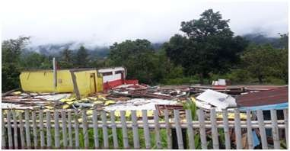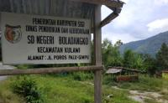

PREPARATORY CHECKLIST: PROVINCIAL SITE ASSESSMENTS (DRAFT)
(for inclusion in RFP Scope of Services for each site)
Prepared by: PMU Palu Date: 26-July 2019.
PROVINCE | Central Sulawesi |  |  | KABUPATEN | Sigi |  | KECAMATAN |  | Kulawi
SCHOOL FACILITY? |  | Yes |  | GoI Facility name |  | SD Negeri 2 Gimpu
HEALTH FACILITY |  |  |  | GoI Facility name
Street Address |  | Ds. Gimpu |  |  |  |  |  | Postcode |  | 94363
SITE DATA ASSESSMENT
ITEM# | ATTRIBUTE | VERIFIABLE EVIDENCE | YES | NO
1 | Geographical positioning | GPS Coordinates | Yes
 |  | Cadastral Map | Yes
 |  | Technical description: boundary alignments; adjoining lots. | Yes
 |  | Survey boundary monuments located & clear of debris/ vegetation. | Yes
2 | Ownership | Certificate of Title copy attached |  | No
 |  | Clear and Clean title guaranteed by Provincial Government (#5) | Yes
 |  | Acquisition of new site if high risk is apparent on existing site? |  | No
 |  | Enlargement or realignment of site boundaries required? |  | No
3 | Agency Commitment | Proposed works are Included in RENAKSI? (#1) | Yes
 |  | Buildings certified as government owned with major damage (#2) | Yes
 |  | Funds are not duplicating other budget sources (#3) | Yes
 |  | There is a safe & secure location (#4) Subject to Geological Survey
 |  | Willingness for removal of asset to be reconstructed (#6) | Yes
 |  | Local authority willing to receive & maintain rebuilt buildings (#7) | Yes
 |  | Development approval and permit costs by local authority (#8) | Yes
4 | Site Assessment
 | DPU Assets Inspection | Serviceability & forensic assessment certification? | Yes
 | Geophysical Assessment | Report on fissures, faults/ fault lines, landslip, liquefaction risks?
5 | Site/ structures plans | Original as built site layout plan available in digital form? |  | No
 |  | Current as built site layout plan available in digital form? |  | No
 |  | Original as built structures plans available in digital form? |  | No
 |  | Updated as built structures plans available in digital form? |  | No
 |  | Each structure has digital general arrangement & detail drawings? |  | No
 |  | Each structure type can be identified by drawing no. and/ or code? |  | No
6 | Electrical Mains | Inspected and rendered functional & safe by power authority? | Yes
7 | Potable water | Reticulated water with ample flow & operational service points? |  | No
 |  | Rainwater storage collection and storage? |  | No
8 | Sewerage & Septic Tanks | Adequately functional with no health hazard? |  | No
 | Telephone land lines | Connections are in working order and cables well secured? | Yes
9 | Road access | External access road is trafficable and in fair to good condition? | Yes
10 | Demolition & Clean up | Most site areas have not been cleaned up/ are not trafficable |  | No
11 | ESM Framework | Draft document circulated to Pemda /local agencies for comment? |  | No
12 | Disabled Users | Building users have cited special needs for handicapped persons? |  | No
13 | Cultural Identifiers | Stakeholders request cultural character in building design? |  | No
14 | Site Greening | Stakeholders request guidance on shade trees &food gardens? |  | No
15 | Alternative Energy | Stakeholders OK with solar panels & battery storage? | Yes
GUIDANCE
- The above checklist and the attached graphics has the purpose of ensuring that (a) we in PETRA have been thorough and diligent in producing a “360⁰“assessment of each site (a) National, Provincial and community stakeholders have provided initial consensus input to the design process, which will be augmented by the DCS consultants’ working engagement, and (c) consultant responses to the RFP shall be well informed
- We need to have site plans in a common format, with a common numbering convention and reference to parent agency drawing numbers or type designation. Numbering shall go anticlockwise from the bottom LH corner
- All site plans shall be presented in the same format as SD Negeri 2 Gimpu
- Please delete this “GUIDANCE” to add brief clarifying remarks on the above responses, particularly any “NO” responses which are not self-evident. Please also where appropriate state what further actions will be taken by you.

RENAKSI DATA _ from Intervention Matrix UNDP
GPS COORDINATE | 1° 41’ 38.958” S 120° 5’ 56.962” E
Damage Severity | HEAVY | X | MODERATE |  | LIGHT
BUDGET NEEDED IN RENAKSI (IDR) | 967,902,400
Summarized description – main tasks : MUST ACCURATELY REFLECT TASK BREAKDOWN IN BILL OF QUANTITIES
Design of the buildings at SD Negeri 2 Gimpu should be in accordance with regulations and standards from Ministry of Public Works and Ministry of Education.

SITE PLAN – Please make sure every site for both Education, Health & Environment contexts are uniformly presented
Please see Annex 4.4

PHOTOGRAPHS OF DAMAGE TO BE ADDRESSED THROUGH RFP DCS CONSULTANTS & LATER ITB WORKS
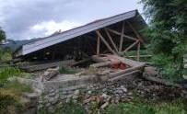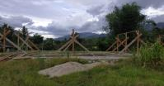

PREPARATORY CHECKLIST: PROVINCIAL SITE ASSESSMENTS (DRAFT)
(for inclusion in RFP Scope of Services for each site)
Prepared by: PMU Palu Date: 26-July 2019.
PROVINCE | Central Sulawesi |  |  | KABUPATEN | Sigi |  | KECAMATAN |  | Kulawi
SCHOOL FACILITY? |  | Yes |  | GoI Facility name |  | SMP Negeri 3 Sigi
HEALTH FACILITY |  |  |  | GoI Facility name
Street Address |  | Ds. Bolapapu |  |  |  |  |  | Postcode |  | 94363
SITE DATA ASSESSMENT
ITEM# | ATTRIBUTE | VERIFIABLE EVIDENCE | YES | NO
1 | Geographical positioning | GPS Coordinates | Yes
 |  | Cadastral Map | Yes
 |  | Technical description: boundary alignments; adjoining lots. | Yes
 |  | Survey boundary monuments located & clear of debris/ vegetation. | Yes
2 | Ownership | Certificate of Title copy attached |  | No
 |  | Clear and Clean title guaranteed by Provincial Government (#5) | Yes
 |  | Acquisition of new site if high risk is apparent on existing site? |  | No
 |  | Enlargement or realignment of site boundaries required? |  | No
3 | Agency Commitment | Proposed works are Included in RENAKSI? (#1) | Yes
 |  | Buildings certified as government owned with major damage (#2) | Yes
 |  | Funds are not duplicating other budget sources (#3) | Yes
 |  | There is a safe & secure location (#4) Subject to Geological Survey
 |  | Willingness for removal of asset to be reconstructed (#6) | Yes
 |  | Local authority willing to receive & maintain rebuilt buildings (#7) | Yes
 |  | Development approval and permit costs by local authority (#8) | Yes
4 | Site Assessment
 | DPU Assets Inspection | Serviceability & forensic assessment certification? | Yes
 | Geophysical Assessment | Report on fissures, faults/ fault lines, landslip, liquefaction risks?
5 | Site/ structures plans | Original as built site layout plan available in digital form? |  | No
 |  | Current as built site layout plan available in digital form? |  | No
 |  | Original as built structures plans available in digital form? |  | No
 |  | Updated as built structures plans available in digital form? |  | No
 |  | Each structure has digital general arrangement & detail drawings? |  | No
 |  | Each structure type can be identified by drawing no. and/ or code? |  | No
6 | Electrical Mains | Inspected and rendered functional & safe by power authority? | Yes
7 | Potable water | Reticulated water with ample flow & operational service points? |  | No
 |  | Rainwater storage collection and storage? |  | No
8 | Sewerage & Septic Tanks | Adequately functional with no health hazard? |  | No
 | Telephone land lines | Connections are in working order and cables well secured? | Yes
9 | Road access | External access road is trafficable and in fair to good condition? | Yes
10 | Demolition & Clean up | Most site areas have not been cleaned up/ are not trafficable |  | No
11 | ESM Framework | Draft document circulated to Pemda /local agencies for comment? |  | No
12 | Disabled Users | Building users have cited special needs for handicapped persons? |  | No
13 | Cultural Identifiers | Stakeholders request cultural character in building design? |  | No
14 | Site Greening | Stakeholders request guidance on shade trees &food gardens? |  | No
15 | Alternative Energy | Stakeholders OK with solar panels & battery storage? | Yes
GUIDANCE
- The above checklist and the attached graphics has the purpose of ensuring that (a) we in PETRA have been thorough and diligent in producing a “360⁰“assessment of each site (a) National, Provincial and community stakeholders have provided initial consensus input to the design process, which will be augmented by the DCS consultants’ working engagement, and (c) consultant responses to the RFP shall be well informed
- We need to have site plans in a common format, with a common numbering convention and reference to parent agency drawing numbers or type designation. Numbering shall go anticlockwise from the bottom LH corner
- All site plans shall be presented in the same format as SMP Negeri 3 SIGI
- Please delete this “GUIDANCE” to add brief clarifying remarks on the above responses, particularly any “NO” responses which are not self-evident. Please also where appropriate state what further actions will be taken by you.

RENAKSI DATA _ from Intervention Matrix UNDP
GPS COORDINATE | 1° 26’ 38.324” S 119° 59’ 4.628” E
Damage Severity | HEAVY | X | MODERATE |  | LIGHT
BUDGET NEEDED IN RENAKSI (IDR) | N/A
Summarized description – main tasks : MUST ACCURATELY REFLECT TASK BREAKDOWN IN BILL OF QUANTITIES
Design of the buildings at SMP Negeri 3 Sigi should be in accordance with regulations and standards from Ministry of Public Works and Ministry of Education.

SITE PLAN – Please make sure every site for both Education, Health & Environment contexts are uniformly presented
Please see Annex 4.4

PHOTOGRAPHS OF DAMAGE TO BE ADDRESSED THROUGH RFP DCS CONSULTANTS & LATER ITB WORKS
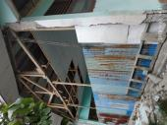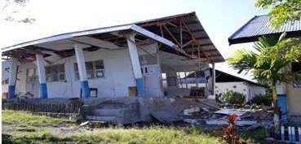

PREPARATORY CHECKLIST: PROVINCIAL SITE ASSESSMENTS (DRAFT)
(for inclusion in RFP Scope of Services for each site)
Prepared by: PMU Palu Date: 26-July 2019.
PROVINCE | Central Sulawesi |  |  | KABUPATEN | Donggala |  | KECAMATAN |  | Sirenja
SCHOOL FACILITY? |  | Yes |  | GoI Facility name |  | SD Negeri 21 Sirenja
HEALTH FACILITY |  |  |  | GoI Facility name
Street Address |  | Dusun III Labuana, Desa Lende Tovea |  |  |  |  |  | Postcode |  | 94354
SITE DATA ASSESSMENT
ITEM# | ATTRIBUTE | VERIFIABLE EVIDENCE | YES | NO
1 | Geographical positioning | GPS Coordinates | Yes
 |  | Cadastral Map | Yes
 |  | Technical description: boundary alignments; adjoining lots. | Yes
 |  | Survey boundary monuments located & clear of debris/ vegetation. | Yes
2 | Ownership | Certificate of Title copy attached |  | No
 |  | Clear and Clean title guaranteed by Provincial Government (#5) | Yes
 |  | Acquisition of new site if high risk is apparent on existing site? |  | No
 |  | Enlargement or realignment of site boundaries required? |  | No
3 | Agency Commitment | Proposed works are Included in RENAKSI? (#1) | Yes
 |  | Buildings certified as government owned with major damage (#2) | Yes
 |  | Funds are not duplicating other budget sources (#3) | Yes
 |  | There is a safe & secure location (#4) Subject to Geological Survey
 |  | Willingness for removal of asset to be reconstructed (#6) | Yes
 |  | Local authority willing to receive & maintain rebuilt buildings (#7) | Yes
 |  | Development approval and permit costs by local authority (#8) | Yes
4 | Site Assessment
 | DPU Assets Inspection | Serviceability & forensic assessment certification? | Yes
 | Geophysical Assessment | Report on fissures, faults/ fault lines, landslip, liquefaction risks?
5 | Site/ structures plans | Original as built site layout plan available in digital form? |  | No
 |  | Current as built site layout plan available in digital form? |  | No
 |  | Original as built structures plans available in digital form? |  | No
 |  | Updated as built structures plans available in digital form? |  | No
 |  | Each structure has digital general arrangement & detail drawings? |  | No
 |  | Each structure type can be identified by drawing no. and/ or code? |  | No
6 | Electrical Mains | Inspected and rendered functional & safe by power authority? | Yes
7 | Potable water | Reticulated water with ample flow & operational service points? |  | No
 |  | Rainwater storage collection and storage? |  | No
8 | Sewerage & Septic Tanks | Adequately functional with no health hazard? |  | No
 | Telephone land lines | Connections are in working order and cables well secured? | Yes
9 | Road access | External access road is trafficable and in fair to good condition? | Yes
10 | Demolition & Clean up | Most site areas have not been cleaned up/ are not trafficable |  | No
11 | ESM Framework | Draft document circulated to Pemda /local agencies for comment? |  | No
12 | Disabled Users | Building users have cited special needs for handicapped persons? |  | No
13 | Cultural Identifiers | Stakeholders request cultural character in building design? |  | No
14 | Site Greening | Stakeholders request guidance on shade trees &food gardens? |  | No
15 | Alternative Energy | Stakeholders OK with solar panels & battery storage? | Yes
GUIDANCE
- The above checklist and the attached graphics has the purpose of ensuring that (a) we in PETRA have been thorough and diligent in producing a “360⁰“assessment of each site (a) National, Provincial and community stakeholders have provided initial consensus input to the design process, which will be augmented by the DCS consultants’ working engagement, and (c) consultant responses to the RFP shall be well informed
- We need to have site plans in a common format, with a common numbering convention and reference to parent agency drawing numbers or type designation. Numbering shall go anticlockwise from the bottom LH corner
- All site plans shall be presented in the same format as SD Negeri 21 SIRENJA
- Please delete this “GUIDANCE” to add brief clarifying remarks on the above responses, particularly any “NO” responses which are not self-evident. Please also where appropriate state what further actions will be taken by you.

RENAKSI DATA _ from Intervention Matrix UNDP
GPS COORDINATE | 0° 8’ 58.873” S 119° 48’ 22.997” E
Damage Severity | HEAVY | X | MODERATE |  | LIGHT
BUDGET NEEDED IN RENAKSI (IDR) | 2,340,000,000
Summarized description – main tasks : MUST ACCURATELY REFLECT TASK BREAKDOWN IN BILL OF QUANTITIES
Design of the buildings at SD Negeri 21 Sirenja should be in accordance with regulations and standards from Ministry of Public Works and Ministry of Education.

SITE PLAN – Please make sure every site for both Education, Health & Environment contexts are uniformly presented
Please see Annex 4.4

PHOTOGRAPHS OF DAMAGE TO BE ADDRESSED THROUGH RFP DCS CONSULTANTS & LATER ITB WORKS
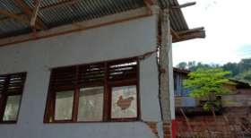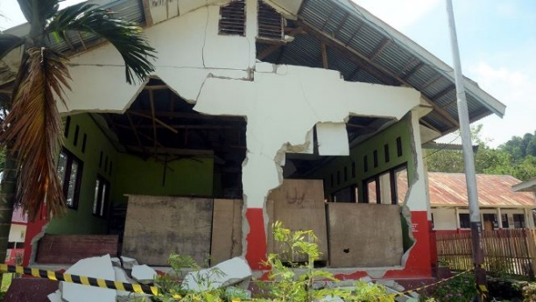

PREPARATORY CHECKLIST: PROVINCIAL SITE ASSESSMENTS (DRAFT)
(for inclusion in RFP Scope of Services for each site)
Prepared by: PMU Palu Date: 26-July 2019.
PROVINCE | Central Sulawesi |  |  | KABUPATEN | Donggala |  | KECAMATAN |  | Labuan
SCHOOL FACILITY? |  | Yes |  | GoI Facility name |  | SMP Negeri 1 Labuan
HEALTH FACILITY |  |  |  | GoI Facility name
Street Address |  | Labuan |  |  |  |  |  | Postcode |  | 94352
SITE DATA ASSESSMENT
ITEM# | ATTRIBUTE | VERIFIABLE EVIDENCE | YES | NO
1 | Geographical positioning | GPS Coordinates | Yes
 |  | Cadastral Map | Yes
 |  | Technical description: boundary alignments; adjoining lots. | Yes
 |  | Survey boundary monuments located & clear of debris/ vegetation. | Yes
2 | Ownership | Certificate of Title copy attached |  | No
 |  | Clear and Clean title guaranteed by Provincial Government (#5) | Yes
 |  | Acquisition of new site if high risk is apparent on existing site? |  | No
 |  | Enlargement or realignment of site boundaries required? |  | No
3 | Agency Commitment | Proposed works are Included in RENAKSI? (#1) | Yes
 |  | Buildings certified as government owned with major damage (#2) | Yes
 |  | Funds are not duplicating other budget sources (#3) | Yes
 |  | There is a safe & secure location (#4) Subject to Geological Survey
 |  | Willingness for removal of asset to be reconstructed (#6) | Yes
 |  | Local authority willing to receive & maintain rebuilt buildings (#7) | Yes
 |  | Development approval and permit costs by local authority (#8) | Yes
4 | Site Assessment
 | DPU Assets Inspection | Serviceability & forensic assessment certification? | Yes
 | Geophysical Assessment | Report on fissures, faults/ fault lines, landslip, liquefaction risks?
5 | Site/ structures plans | Original as built site layout plan available in digital form? |  | No
 |  | Current as built site layout plan available in digital form? |  | No
 |  | Original as built structures plans available in digital form? |  | No
 |  | Updated as built structures plans available in digital form? |  | No
 |  | Each structure has digital general arrangement & detail drawings? |  | No
 |  | Each structure type can be identified by drawing no. and/ or code? |  | No
6 | Electrical Mains | Inspected and rendered functional & safe by power authority? | Yes
7 | Potable water | Reticulated water with ample flow & operational service points? |  | No
 |  | Rainwater storage collection and storage? |  | No
8 | Sewerage & Septic Tanks | Adequately functional with no health hazard? |  | No
 | Telephone land lines | Connections are in working order and cables well secured? | Yes
9 | Road access | External access road is trafficable and in fair to good condition? | Yes
10 | Demolition & Clean up | Most site areas have not been cleaned up/ are not trafficable |  | No
11 | ESM Framework | Draft document circulated to Pemda /local agencies for comment? |  | No
12 | Disabled Users | Building users have cited special needs for handicapped persons? |  | No
13 | Cultural Identifiers | Stakeholders request cultural character in building design? |  | No
14 | Site Greening | Stakeholders request guidance on shade trees &food gardens? |  | No
15 | Alternative Energy | Stakeholders OK with solar panels & battery storage? | Yes
GUIDANCE
- The above checklist and the attached graphics has the purpose of ensuring that (a) we in PETRA have been thorough and diligent in producing a “360⁰“assessment of each site (a) National, Provincial and community stakeholders have provided initial consensus input to the design process, which will be augmented by the DCS consultants’ working engagement, and (c) consultant responses to the RFP shall be well informed
- We need to have site plans in a common format, with a common numbering convention and reference to parent agency drawing numbers or type designation. Numbering shall go anticlockwise from the bottom LH corner
- All site plans shall be presented in the same format as SMP Negeri 1 LABUAN
- Please delete this “GUIDANCE” to add brief clarifying remarks on the above responses, particularly any “NO” responses which are not self-evident. Please also where appropriate state what further actions will be taken by you.

RENAKSI DATA _ from Intervention Matrix UNDP
GPS COORDINATE | 0° 40’ 28.510” S 119° 49’ 57.572” E
Damage Severity | HEAVY | X | MODERATE |  | LIGHT
BUDGET NEEDED IN RENAKSI (IDR) | 2,730,000,000
Summarized description – main tasks : MUST ACCURATELY REFLECT TASK BREAKDOWN IN BILL OF QUANTITIES
Design of the buildings at SMP Negeri 1 Labuan should be in accordance with regulations and standards from Ministry of Public Works and Ministry of Education.

SITE PLAN – Please make sure every site for both Education, Health & Environment contexts are uniformly presented
Please see Annex 4.4

PHOTOGRAPHS OF DAMAGE TO BE ADDRESSED THROUGH RFP DCS CONSULTANTS & LATER ITB WORKS
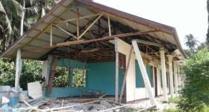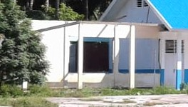

PREPARATORY CHECKLIST: PROVINCIAL SITE ASSESSMENTS (DRAFT)
(for inclusion in RFP Scope of Services for each site)
Prepared by: PMU Palu Date: 26-July 2019.
PROVINCE | Central Sulawesi |  |  | KABUPATEN | Donggala |  | KECAMATAN |  | Sindue Tobata
SCHOOL FACILITY? |  | Yes |  | GoI Facility name |  | SMP Negeri Satap 3 Sindue Tobata
HEALTH FACILITY |  |  |  | GoI Facility name
Street Address |  | Jl. Jumadi no.41, Tamarenja |  |  |  |  |  | Postcode |  | 94353
SITE DATA ASSESSMENT
ITEM# | ATTRIBUTE | VERIFIABLE EVIDENCE | YES | NO
1 | Geographical positioning | GPS Coordinates | Yes
 |  | Cadastral Map | Yes
 |  | Technical description: boundary alignments; adjoining lots. | Yes
 |  | Survey boundary monuments located & clear of debris/ vegetation. | Yes
2 | Ownership | Certificate of Title copy attached |  | No
 |  | Clear and Clean title guaranteed by Provincial Government (#5) | Yes
 |  | Acquisition of new site if high risk is apparent on existing site? |  | No
 |  | Enlargement or realignment of site boundaries required? |  | No
3 | Agency Commitment | Proposed works are Included in RENAKSI? (#1) | Yes
 |  | Buildings certified as government owned with major damage (#2) | Yes
 |  | Funds are not duplicating other budget sources (#3) | Yes
 |  | There is a safe & secure location (#4) Subject to Geological Survey
 |  | Willingness for removal of asset to be reconstructed (#6) | Yes
 |  | Local authority willing to receive & maintain rebuilt buildings (#7) | Yes
 |  | Development approval and permit costs by local authority (#8) | Yes
4 | Site Assessment
 | DPU Assets Inspection | Serviceability & forensic assessment certification? | Yes
 | Geophysical Assessment | Report on fissures, faults/ fault lines, landslip, liquefaction risks?
5 | Site/ structures plans | Original as built site layout plan available in digital form? |  | No
 |  | Current as built site layout plan available in digital form? |  | No
 |  | Original as built structures plans available in digital form? |  | No
 |  | Updated as built structures plans available in digital form? |  | No
 |  | Each structure has digital general arrangement & detail drawings? |  | No
 |  | Each structure type can be identified by drawing no. and/ or code? |  | No
6 | Electrical Mains | Inspected and rendered functional & safe by power authority? | Yes
7 | Potable water | Reticulated water with ample flow & operational service points? |  | No
 |  | Rainwater storage collection and storage? |  | No
8 | Sewerage & Septic Tanks | Adequately functional with no health hazard? |  | No
 | Telephone land lines | Connections are in working order and cables well secured? | Yes
9 | Road access | External access road is trafficable and in fair to good condition? | Yes
10 | Demolition & Clean up | Most site areas have not been cleaned up/ are not trafficable |  | No
11 | ESM Framework | Draft document circulated to Pemda /local agencies for comment? |  | No
12 | Disabled Users | Building users have cited special needs for handicapped persons? |  | No
13 | Cultural Identifiers | Stakeholders request cultural character in building design? |  | No
14 | Site Greening | Stakeholders request guidance on shade trees &food gardens? |  | No
15 | Alternative Energy | Stakeholders OK with solar panels & battery storage? | Yes
GUIDANCE
- The above checklist and the attached graphics has the purpose of ensuring that (a) we in PETRA have been thorough and diligent in producing a “360⁰“assessment of each site (a) National, Provincial and community stakeholders have provided initial consensus input to the design process, which will be augmented by the DCS consultants’ working engagement, and (c) consultant responses to the RFP shall be well informed
- We need to have site plans in a common format, with a common numbering convention and reference to parent agency drawing numbers or type designation. Numbering shall go anticlockwise from the bottom LH corner
- All site plans shall be presented in the same format as SMP Negeri SATAP 3 SINDUE TOBATA
- Please delete this “GUIDANCE” to add brief clarifying remarks on the above responses, particularly any “NO” responses which are not self-evident. Please also where appropriate state what further actions will be taken by you.

RENAKSI DATA _ from Intervention Matrix UNDP
GPS COORDINATE | 0° 24’ 48.1” S 119° 48’ 22.7” E
Damage Severity | HEAVY | X | MODERATE |  | LIGHT
BUDGET NEEDED IN RENAKSI (IDR) | 1,008,000,000
Summarized description – main tasks : MUST ACCURATELY REFLECT TASK BREAKDOWN IN BILL OF QUANTITIES
Design of the buildings at SMP Negeri Satap 3 Sindue Tobata should be in accordance with regulations and standards from Ministry of Public Works and Ministry of Education.

SITE PLAN – Please make sure every site for both Education, Health & Environment contexts are uniformly presented
Please see Annex 4.4

PHOTOGRAPHS OF DAMAGE TO BE ADDRESSED THROUGH RFP DCS CONSULTANTS & LATER ITB WORKS
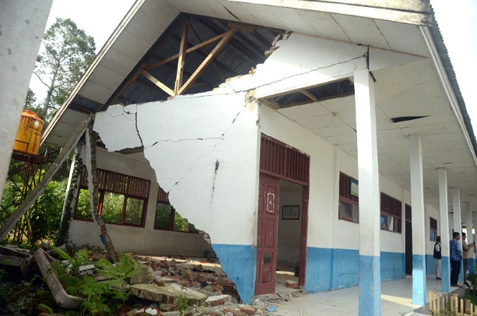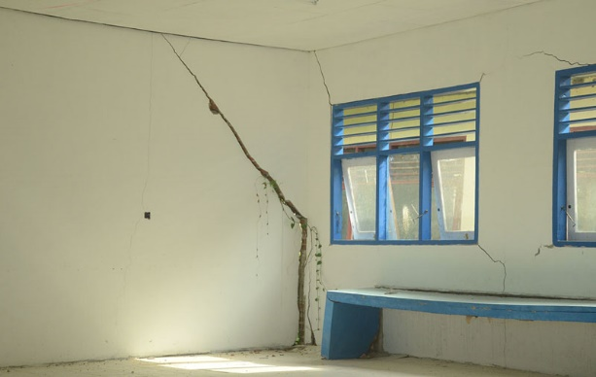

PREPARATORY CHECKLIST: PROVINCIAL SITE ASSESSMENTS (DRAFT)
(for inclusion in RFP Scope of Services for each site)
Prepared by: PMU Palu Date: 26-July 2019.
PROVINCE | Central Sulawesi |  |  | KABUPATEN | Parigi Moutong |  | KECAMATAN |  | Kasimbar
SCHOOL FACILITY? |  | Yes |  | GoI Facility name |  | SD Negeri 3 Kasimbar
HEALTH FACILITY |  |  |  | GoI Facility name
Street Address |  | Dusun Lemo |  |  |  |  |  | Postcode |  | 94462
SITE DATA ASSESSMENT
ITEM# | ATTRIBUTE | VERIFIABLE EVIDENCE | YES | NO
1 | Geographical positioning | GPS Coordinates | Yes
 |  | Cadastral Map | Yes
 |  | Technical description: boundary alignments; adjoining lots. | Yes
 |  | Survey boundary monuments located & clear of debris/ vegetation. | Yes
2 | Ownership | Certificate of Title copy attached |  | No
 |  | Clear and Clean title guaranteed by Provincial Government (#5) | Yes
 |  | Acquisition of new site if high risk is apparent on existing site? |  | No
 |  | Enlargement or realignment of site boundaries required? |  | No
3 | Agency Commitment | Proposed works are Included in RENAKSI? (#1) | Yes
 |  | Buildings certified as government owned with major damage (#2) | Yes
 |  | Funds are not duplicating other budget sources (#3) | Yes
 |  | There is a safe & secure location (#4) Subject to Geological Survey
 |  | Willingness for removal of asset to be reconstructed (#6) | Yes
 |  | Local authority willing to receive & maintain rebuilt buildings (#7) | Yes
 |  | Development approval and permit costs by local authority (#8) | Yes
4 | Site Assessment
 | DPU Assets Inspection | Serviceability & forensic assessment certification? | Yes
 | Geophysical Assessment | Report on fissures, faults/ fault lines, landslip, liquefaction risks?
5 | Site/ structures plans | Original as built site layout plan available in digital form? |  | No
 |  | Current as built site layout plan available in digital form? |  | No
 |  | Original as built structures plans available in digital form? |  | No
 |  | Updated as built structures plans available in digital form? |  | No
 |  | Each structure has digital general arrangement & detail drawings? |  | No
 |  | Each structure type can be identified by drawing no. and/ or code? |  | No
6 | Electrical Mains | Inspected and rendered functional & safe by power authority? | Yes
7 | Potable water | Reticulated water with ample flow & operational service points? |  | No
 |  | Rainwater storage collection and storage? |  | No
8 | Sewerage & Septic Tanks | Adequately functional with no health hazard? |  | No
 | Telephone land lines | Connections are in working order and cables well secured? | Yes
9 | Road access | External access road is trafficable and in fair to good condition? | Yes
10 | Demolition & Clean up | Most site areas have not been cleaned up/ are not trafficable |  | No
11 | ESM Framework | Draft document circulated to Pemda /local agencies for comment? |  | No
12 | Disabled Users | Building users have cited special needs for handicapped persons? |  | No
13 | Cultural Identifiers | Stakeholders request cultural character in building design? |  | No
14 | Site Greening | Stakeholders request guidance on shade trees &food gardens? |  | No
15 | Alternative Energy | Stakeholders OK with solar panels & battery storage? | Yes
GUIDANCE
- The above checklist and the attached graphics has the purpose of ensuring that (a) we in PETRA have been thorough and diligent in producing a “360⁰“assessment of each site (a) National, Provincial and community stakeholders have provided initial consensus input to the design process, which will be augmented by the DCS consultants’ working engagement, and (c) consultant responses to the RFP shall be well informed
- We need to have site plans in a common format, with a common numbering convention and reference to parent agency drawing numbers or type designation. Numbering shall go anticlockwise from the bottom LH corner
- All site plans shall be presented in the same format as SD Negeri 3 KASIMBAR
- Please delete this “GUIDANCE” to add brief clarifying remarks on the above responses, particularly any “NO” responses which are not self-evident. Please also where appropriate state what further actions will be taken by you.

RENAKSI DATA _ from Intervention Matrix UNDP
GPS COORDINATE | 0° 7’ 8.400” S 119° 58’ 41.160” E
Damage Severity | HEAVY | X | MODERATE |  | LIGHT
BUDGET NEEDED IN RENAKSI (IDR) | 908,160,000
Summarized description – main tasks : MUST ACCURATELY REFLECT TASK BREAKDOWN IN BILL OF QUANTITIES
Design of the buildings at SD Negeri 3 Kasimbar should be in accordance with regulations and standards from Ministry of Public Works and Ministry of Education.

SITE PLAN – Please make sure every site for both Education, Health & Environment contexts are uniformly presented
Please see Annex 4.4

PHOTOGRAPHS OF DAMAGE TO BE ADDRESSED THROUGH RFP DCS CONSULTANTS & LATER ITB WORKS
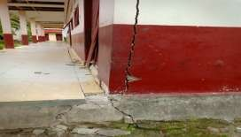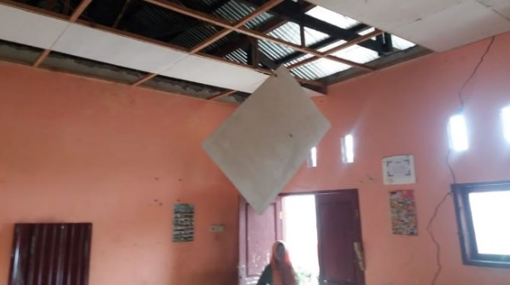

PREPARATORY CHECKLIST: PROVINCIAL SITE ASSESSMENTS (DRAFT)
(for inclusion in RFP Scope of Services for each site)
Prepared by: PMU Palu Date: 26-July 2019.
PROVINCE | Central Sulawesi |  |  | KABUPATEN | Parigi Moutong |  | KECAMATAN |  | Siniu
SCHOOL FACILITY? |  | Yes |  | GoI Facility name |  | SD Inpres Marantale
HEALTH FACILITY |  |  |  | GoI Facility name
Street Address |  | Jl. Trans Sulawesi, Kel. Uevolo |  |  |  |  |  | Postcode |  | 94474
SITE DATA ASSESSMENT
ITEM# | ATTRIBUTE | VERIFIABLE EVIDENCE | YES | NO
1 | Geographical positioning | GPS Coordinates | Yes
 |  | Cadastral Map | Yes
 |  | Technical description: boundary alignments; adjoining lots. | Yes
 |  | Survey boundary monuments located & clear of debris/ vegetation. | Yes
2 | Ownership | Certificate of Title copy attached |  | No
 |  | Clear and Clean title guaranteed by Provincial Government (#5) | Yes
 |  | Acquisition of new site if high risk is apparent on existing site? |  | No
 |  | Enlargement or realignment of site boundaries required? |  | No
3 | Agency Commitment | Proposed works are Included in RENAKSI? (#1) | Yes
 |  | Buildings certified as government owned with major damage (#2) | Yes
 |  | Funds are not duplicating other budget sources (#3) | Yes
 |  | There is a safe & secure location (#4) Subject to Geological Survey
 |  | Willingness for removal of asset to be reconstructed (#6) | Yes
 |  | Local authority willing to receive & maintain rebuilt buildings (#7) | Yes
 |  | Development approval and permit costs by local authority (#8) | Yes
4 | Site Assessment
 | DPU Assets Inspection | Serviceability & forensic assessment certification? | Yes
 | Geophysical Assessment | Report on fissures, faults/ fault lines, landslip, liquefaction risks?
5 | Site/ structures plans | Original as built site layout plan available in digital form? |  | No
 |  | Current as built site layout plan available in digital form? |  | No
 |  | Original as built structures plans available in digital form? |  | No
 |  | Updated as built structures plans available in digital form? |  | No
 |  | Each structure has digital general arrangement & detail drawings? |  | No
 |  | Each structure type can be identified by drawing no. and/ or code? |  | No
6 | Electrical Mains | Inspected and rendered functional & safe by power authority? | Yes
7 | Potable water | Reticulated water with ample flow & operational service points? |  | No
 |  | Rainwater storage collection and storage? |  | No
8 | Sewerage & Septic Tanks | Adequately functional with no health hazard? |  | No
 | Telephone land lines | Connections are in working order and cables well secured? | Yes
9 | Road access | External access road is trafficable and in fair to good condition? | Yes
10 | Demolition & Clean up | Most site areas have not been cleaned up/ are not trafficable |  | No
11 | ESM Framework | Draft document circulated to Pemda /local agencies for comment? |  | No
12 | Disabled Users | Building users have cited special needs for handicapped persons? |  | No
13 | Cultural Identifiers | Stakeholders request cultural character in building design? |  | No
14 | Site Greening | Stakeholders request guidance on shade trees &food gardens? |  | No
15 | Alternative Energy | Stakeholders OK with solar panels & battery storage? | Yes
GUIDANCE
- The above checklist and the attached graphics has the purpose of ensuring that (a) we in PETRA have been thorough and diligent in producing a “360⁰“assessment of each site (a) National, Provincial and community stakeholders have provided initial consensus input to the design process, which will be augmented by the DCS consultants’ working engagement, and (c) consultant responses to the RFP shall be well informed
- We need to have site plans in a common format, with a common numbering convention and reference to parent agency drawing numbers or type designation. Numbering shall go anticlockwise from the bottom LH corner
- All site plans shall be presented in the same format as SD Inpres MARANTALE
- Please delete this “GUIDANCE” to add brief clarifying remarks on the above responses, particularly any “NO” responses which are not self-evident. Please also where appropriate state what further actions will be taken by you.

RENAKSI DATA _ from Intervention Matrix UNDP
GPS COORDINATE | 0° 8’ 35.020” S 120° 0’ 0.220” E
Damage Severity | HEAVY | X | MODERATE |  | LIGHT
BUDGET NEEDED IN RENAKSI (IDR) | 825,600,000
Summarized description – main tasks : MUST ACCURATELY REFLECT TASK BREAKDOWN IN BILL OF QUANTITIES
Design of the buildings at SD Inpres Marantale should be in accordance with regulations and standards from Ministry of Public Works and Ministry of Education.

SITE PLAN – Please make sure every site for both Education, Health & Environment contexts are uniformly presented
Please see Annex 4.4

PHOTOGRAPHS OF DAMAGE TO BE ADDRESSED THROUGH RFP DCS CONSULTANTS & LATER ITB WORKS
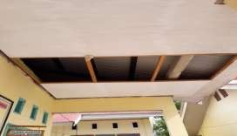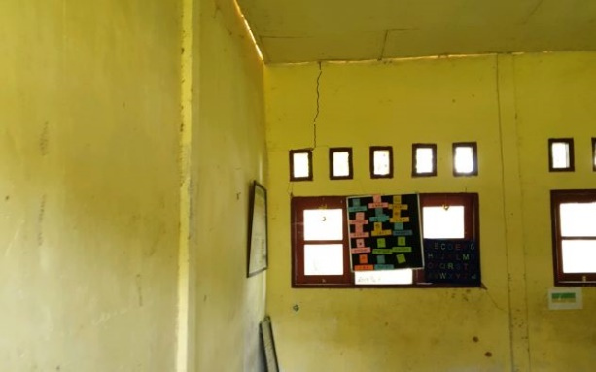

PREPARATORY CHECKLIST: PROVINCIAL SITE ASSESSMENTS (DRAFT)
(for inclusion in RFP Scope of Services for each site)
Prepared by: PMU Palu Date: 26-July 2019.
PROVINCE | Central Sulawesi |  |  | KABUPATEN | Parigi Moutong |  | KECAMATAN |  | Parigi Utara
SCHOOL FACILITY? |  | Yes |  | GoI Facility name |  | SD Negeri Toboli
HEALTH FACILITY |  |  |  | GoI Facility name
Street Address |  | Jl. Trans Sulawesi, Desa Toboli |  |  |  |  |  | Postcode |  | 94471
SITE DATA ASSESSMENT
ITEM# | ATTRIBUTE | VERIFIABLE EVIDENCE | YES | NO
1 | Geographical positioning | GPS Coordinates | Yes
 |  | Cadastral Map | Yes
 |  | Technical description: boundary alignments; adjoining lots. | Yes
 |  | Survey boundary monuments located & clear of debris/ vegetation. | Yes
2 | Ownership | Certificate of Title copy attached |  | No
 |  | Clear and Clean title guaranteed by Provincial Government (#5) | Yes
 |  | Acquisition of new site if high risk is apparent on existing site? |  | No
 |  | Enlargement or realignment of site boundaries required? |  | No
3 | Agency Commitment | Proposed works are Included in RENAKSI? (#1) | Yes
 |  | Buildings certified as government owned with major damage (#2) | Yes
 |  | Funds are not duplicating other budget sources (#3) | Yes
 |  | There is a safe & secure location (#4) Subject to Geological Survey
 |  | Willingness for removal of asset to be reconstructed (#6) | Yes
 |  | Local authority willing to receive & maintain rebuilt buildings (#7) | Yes
 |  | Development approval and permit costs by local authority (#8) | Yes
4 | Site Assessment
 | DPU Assets Inspection | Serviceability & forensic assessment certification? | Yes
 | Geophysical Assessment | Report on fissures, faults/ fault lines, landslip, liquefaction risks?
5 | Site/ structures plans | Original as built site layout plan available in digital form? |  | No
 |  | Current as built site layout plan available in digital form? |  | No
 |  | Original as built structures plans available in digital form? |  | No
 |  | Updated as built structures plans available in digital form? |  | No
 |  | Each structure has digital general arrangement & detail drawings? |  | No
 |  | Each structure type can be identified by drawing no. and/ or code? |  | No
6 | Electrical Mains | Inspected and rendered functional & safe by power authority? | Yes
7 | Potable water | Reticulated water with ample flow & operational service points? |  | No
 |  | Rainwater storage collection and storage? |  | No
8 | Sewerage & Septic Tanks | Adequately functional with no health hazard? |  | No
 | Telephone land lines | Connections are in working order and cables well secured? | Yes
9 | Road access | External access road is trafficable and in fair to good condition? | Yes
10 | Demolition & Clean up | Most site areas have not been cleaned up/ are not trafficable |  | No
11 | ESM Framework | Draft document circulated to Pemda /local agencies for comment? |  | No
12 | Disabled Users | Building users have cited special needs for handicapped persons? |  | No
13 | Cultural Identifiers | Stakeholders request cultural character in building design? |  | No
14 | Site Greening | Stakeholders request guidance on shade trees &food gardens? |  | No
15 | Alternative Energy | Stakeholders OK with solar panels & battery storage? | Yes
GUIDANCE
- The above checklist and the attached graphics has the purpose of ensuring that (a) we in PETRA have been thorough and diligent in producing a “360⁰“assessment of each site (a) National, Provincial and community stakeholders have provided initial consensus input to the design process, which will be augmented by the DCS consultants’ working engagement, and (c) consultant responses to the RFP shall be well informed
- We need to have site plans in a common format, with a common numbering convention and reference to parent agency drawing numbers or type designation. Numbering shall go anticlockwise from the bottom LH corner
- All site plans shall be presented in the same format as SD Negeri TOBOLI
- Please delete this “GUIDANCE” to add brief clarifying remarks on the above responses, particularly any “NO” responses which are not self-evident. Please also where appropriate state what further actions will be taken by you.

RENAKSI DATA _ from Intervention Matrix UNDP
GPS COORDINATE | 0° 42’ 35.924” S 120° 5’ 33.137” E
Damage Severity | HEAVY | X | MODERATE |  | LIGHT
BUDGET NEEDED IN RENAKSI (IDR) | 1,348,480,000
Summarized description – main tasks : MUST ACCURATELY REFLECT TASK BREAKDOWN IN BILL OF QUANTITIES
Design of the buildings at SD Negeri Toboli should be in accordance with regulations and standards from Ministry of Public Works and Ministry of Education.

SITE PLAN – Please make sure every site for both Education, Health & Environment contexts are uniformly presented
Please see Annex 4.4

PHOTOGRAPHS OF DAMAGE TO BE ADDRESSED THROUGH RFP DCS CONSULTANTS & LATER ITB WORKS
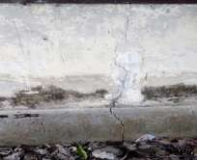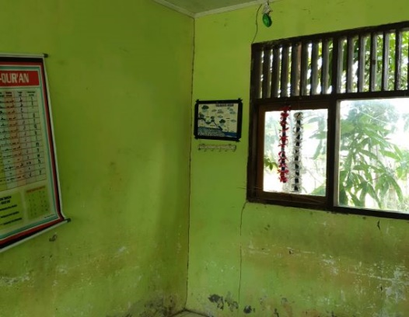

PREPARATORY CHECKLIST: PROVINCIAL SITE ASSESSMENTS (DRAFT)
(for inclusion in RFP Scope of Services for each site)
Prepared by: PMU Palu Date: 26-July 2019.
PROVINCE | Central Sulawesi |  |  | KABUPATEN | Parigi Moutong |  | KECAMATAN |  | Parigi Barat
SCHOOL FACILITY? |  | Yes |  | GoI Facility name |  | SD Negeri Parigimpuu
HEALTH FACILITY |  |  |  | GoI Facility name
Street Address |  | Jl. Magau Janggo, Ds. Parigimpuu |  |  |  |  |  | Postcode |  | 94471
SITE DATA ASSESSMENT
ITEM# | ATTRIBUTE | VERIFIABLE EVIDENCE | YES | NO
1 | Geographical positioning | GPS Coordinates | Yes
 |  | Cadastral Map | Yes
 |  | Technical description: boundary alignments; adjoining lots. | Yes
 |  | Survey boundary monuments located & clear of debris/ vegetation. | Yes
2 | Ownership | Certificate of Title copy attached |  | No
 |  | Clear and Clean title guaranteed by Provincial Government (#5) | Yes
 |  | Acquisition of new site if high risk is apparent on existing site? |  | No
 |  | Enlargement or realignment of site boundaries required? |  | No
3 | Agency Commitment | Proposed works are Included in RENAKSI? (#1) | Yes
 |  | Buildings certified as government owned with major damage (#2) | Yes
 |  | Funds are not duplicating other budget sources (#3) | Yes
 |  | There is a safe & secure location (#4) Subject to Geological Survey
 |  | Willingness for removal of asset to be reconstructed (#6) | Yes
 |  | Local authority willing to receive & maintain rebuilt buildings (#7) | Yes
 |  | Development approval and permit costs by local authority (#8) | Yes
4 | Site Assessment
 | DPU Assets Inspection | Serviceability & forensic assessment certification? | Yes
 | Geophysical Assessment | Report on fissures, faults/ fault lines, landslip, liquefaction risks?
5 | Site/ structures plans | Original as built site layout plan available in digital form? |  | No
 |  | Current as built site layout plan available in digital form? |  | No
 |  | Original as built structures plans available in digital form? |  | No
 |  | Updated as built structures plans available in digital form? |  | No
 |  | Each structure has digital general arrangement & detail drawings? |  | No
 |  | Each structure type can be identified by drawing no. and/ or code? |  | No
6 | Electrical Mains | Inspected and rendered functional & safe by power authority? | Yes
7 | Potable water | Reticulated water with ample flow & operational service points? |  | No
 |  | Rainwater storage collection and storage? |  | No
8 | Sewerage & Septic Tanks | Adequately functional with no health hazard? |  | No
 | Telephone land lines | Connections are in working order and cables well secured? | Yes
9 | Road access | External access road is trafficable and in fair to good condition? | Yes
10 | Demolition & Clean up | Most site areas have not been cleaned up/ are not trafficable |  | No
11 | ESM Framework | Draft document circulated to Pemda /local agencies for comment? |  | No
12 | Disabled Users | Building users have cited special needs for handicapped persons? |  | No
13 | Cultural Identifiers | Stakeholders request cultural character in building design? |  | No
14 | Site Greening | Stakeholders request guidance on shade trees &food gardens? |  | No
15 | Alternative Energy | Stakeholders OK with solar panels & battery storage? | Yes
GUIDANCE
- The above checklist and the attached graphics has the purpose of ensuring that (a) we in PETRA have been thorough and diligent in producing a “360⁰“assessment of each site (a) National, Provincial and community stakeholders have provided initial consensus input to the design process, which will be augmented by the DCS consultants’ working engagement, and (c) consultant responses to the RFP shall be well informed
- We need to have site plans in a common format, with a common numbering convention and reference to parent agency drawing numbers or type designation. Numbering shall go anticlockwise from the bottom LH corner
- All site plans shall be presented in the same format as SD Negeri PARIGIMPUU
- Please delete this “GUIDANCE” to add brief clarifying remarks on the above responses, particularly any “NO” responses which are not self-evident. Please also where appropriate state what further actions will be taken by you.

RENAKSI DATA _ from Intervention Matrix UNDP
GPS COORDINATE | 0° 48’ 50.677” S 120° 8’ 22.790” E
Damage Severity | HEAVY | X | MODERATE |  | LIGHT
BUDGET NEEDED IN RENAKSI (IDR) | 825,600,000
Summarized description – main tasks : MUST ACCURATELY REFLECT TASK BREAKDOWN IN BILL OF QUANTITIES
Design of the buildings at SD Negeri Parigimpuu should be in accordance with regulations and standards from Ministry of Public Works and Ministry of Education.

SITE PLAN – Please make sure every site for both Education, Health & Environment contexts are uniformly presented
Please see Annex 4.4

PHOTOGRAPHS OF DAMAGE TO BE ADDRESSED THROUGH RFP DCS CONSULTANTS & LATER ITB WORKS
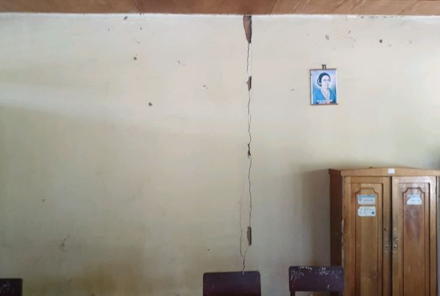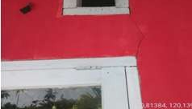

PREPARATORY CHECKLIST: PROVINCIAL SITE ASSESSMENTS (DRAFT)
(for inclusion in RFP Scope of Services for each site)
Prepared by: PMU Palu Date: 26-July 2019.
PROVINCE | Central Sulawesi |  |  | KABUPATEN | Parigi Moutong |  | KECAMATAN |  | Torue
SCHOOL FACILITY? |  | Yes |  | GoI Facility name |  | SD Negeri Purwosari
HEALTH FACILITY |  |  |  | GoI Facility name
Street Address |  | Jl. Trans Sulawesi, Desa Purwosari |  |  |  |  |  | Postcode |  | 94372
SITE DATA ASSESSMENT
ITEM# | ATTRIBUTE | VERIFIABLE EVIDENCE | YES | NO
1 | Geographical positioning | GPS Coordinates | Yes
 |  | Cadastral Map | Yes
 |  | Technical description: boundary alignments; adjoining lots. | Yes
 |  | Survey boundary monuments located & clear of debris/ vegetation. | Yes
2 | Ownership | Certificate of Title copy attached |  | No
 |  | Clear and Clean title guaranteed by Provincial Government (#5) | Yes
 |  | Acquisition of new site if high risk is apparent on existing site? |  | No
 |  | Enlargement or realignment of site boundaries required? |  | No
3 | Agency Commitment | Proposed works are Included in RENAKSI? (#1) | Yes
 |  | Buildings certified as government owned with major damage (#2) | Yes
 |  | Funds are not duplicating other budget sources (#3) | Yes
 |  | There is a safe & secure location (#4) Subject to Geological Survey
 |  | Willingness for removal of asset to be reconstructed (#6) | Yes
 |  | Local authority willing to receive & maintain rebuilt buildings (#7) | Yes
 |  | Development approval and permit costs by local authority (#8) | Yes
4 | Site Assessment
 | DPU Assets Inspection | Serviceability & forensic assessment certification? | Yes
 | Geophysical Assessment | Report on fissures, faults/ fault lines, landslip, liquefaction risks?
5 | Site/ structures plans | Original as built site layout plan available in digital form? |  | No
 |  | Current as built site layout plan available in digital form? |  | No
 |  | Original as built structures plans available in digital form? |  | No
 |  | Updated as built structures plans available in digital form? |  | No
 |  | Each structure has digital general arrangement & detail drawings? |  | No
 |  | Each structure type can be identified by drawing no. and/ or code? |  | No
6 | Electrical Mains | Inspected and rendered functional & safe by power authority? | Yes
7 | Potable water | Reticulated water with ample flow & operational service points? |  | No
 |  | Rainwater storage collection and storage? |  | No
8 | Sewerage & Septic Tanks | Adequately functional with no health hazard? |  | No
 | Telephone land lines | Connections are in working order and cables well secured? | Yes
9 | Road access | External access road is trafficable and in fair to good condition? | Yes
10 | Demolition & Clean up | Most site areas have not been cleaned up/ are not trafficable |  | No
11 | ESM Framework | Draft document circulated to Pemda /local agencies for comment? |  | No
12 | Disabled Users | Building users have cited special needs for handicapped persons? |  | No
13 | Cultural Identifiers | Stakeholders request cultural character in building design? |  | No
14 | Site Greening | Stakeholders request guidance on shade trees &food gardens? |  | No
15 | Alternative Energy | Stakeholders OK with solar panels & battery storage? | Yes
GUIDANCE
- The above checklist and the attached graphics has the purpose of ensuring that (a) we in PETRA have been thorough and diligent in producing a “360⁰“assessment of each site (a) National, Provincial and community stakeholders have provided initial consensus input to the design process, which will be augmented by the DCS consultants’ working engagement, and (c) consultant responses to the RFP shall be well informed
- We need to have site plans in a common format, with a common numbering convention and reference to parent agency drawing numbers or type designation. Numbering shall go anticlockwise from the bottom LH corner
- All site plans shall be presented in the same format as SD Negeri PURWOSARI
- Please delete this “GUIDANCE” to add brief clarifying remarks on the above responses, particularly any “NO” responses which are not self-evident. Please also where appropriate state what further actions will be taken by you.

RENAKSI DATA _ from Intervention Matrix UNDP
GPS COORDINATE | 0° 58’ 36.981” S 120° 19’ 8.269” E
Damage Severity | HEAVY | X | MODERATE |  | LIGHT
BUDGET NEEDED IN RENAKSI (IDR) | 2,421,760,000
Summarized description – main tasks : MUST ACCURATELY REFLECT TASK BREAKDOWN IN BILL OF QUANTITIES
Design of the buildings at SD Negeri Purwosari should be in accordance with regulations and standards from Ministry of Public Works and Ministry of Education.

SITE PLAN – Please make sure every site for both Education, Health & Environment contexts are uniformly presented
Please see Annex 4.4

PHOTOGRAPHS OF DAMAGE TO BE ADDRESSED THROUGH RFP DCS CONSULTANTS & LATER ITB WORKS
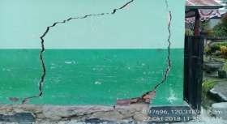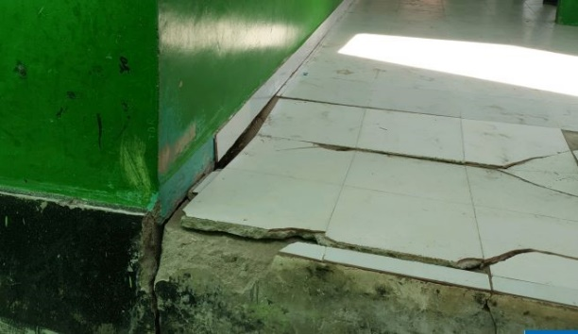

PREPARATORY CHECKLIST: PROVINCIAL SITE ASSESSMENTS (DRAFT)
(for inclusion in RFP Scope of Services for each site)
Prepared by: PMU Palu Date: 26-July 2019.
PROVINCE | Central Sulawesi |  |  | KABUPATEN | Parigi Moutong |  | KECAMATAN |  | Torue
SCHOOL FACILITY? |  | Yes |  | GoI Facility name |  | SMP Negeri 2 Satap Parigi Selatan
HEALTH FACILITY |  |  |  | GoI Facility name
Street Address |  | JL Bonebula Gunung Mulya Desa Sumbersari |  |  |  |  |  | Postcode |  | 94471
SITE DATA ASSESSMENT
ITEM# | ATTRIBUTE | VERIFIABLE EVIDENCE | YES | NO
1 | Geographical positioning | GPS Coordinates | Yes
 |  | Cadastral Map | Yes
 |  | Technical description: boundary alignments; adjoining lots. | Yes
 |  | Survey boundary monuments located & clear of debris/ vegetation. | Yes
2 | Ownership | Certificate of Title copy attached |  | No
 |  | Clear and Clean title guaranteed by Provincial Government (#5) | Yes
 |  | Acquisition of new site if high risk is apparent on existing site? |  | No
 |  | Enlargement or realignment of site boundaries required? |  | No
3 | Agency Commitment | Proposed works are Included in RENAKSI? (#1) | Yes
 |  | Buildings certified as government owned with major damage (#2) | Yes
 |  | Funds are not duplicating other budget sources (#3) | Yes
 |  | There is a safe & secure location (#4) Subject to Geological Survey
 |  | Willingness for removal of asset to be reconstructed (#6) | Yes
 |  | Local authority willing to receive & maintain rebuilt buildings (#7) | Yes
 |  | Development approval and permit costs by local authority (#8) | Yes
4 | Site Assessment
 | DPU Assets Inspection | Serviceability & forensic assessment certification? | Yes
 | Geophysical Assessment | Report on fissures, faults/ fault lines, landslip, liquefaction risks?
5 | Site/ structures plans | Original as built site layout plan available in digital form? |  | No
 |  | Current as built site layout plan available in digital form? |  | No
 |  | Original as built structures plans available in digital form? |  | No
 |  | Updated as built structures plans available in digital form? |  | No
 |  | Each structure has digital general arrangement & detail drawings? |  | No
 |  | Each structure type can be identified by drawing no. and/ or code? |  | No
6 | Electrical Mains | Inspected and rendered functional & safe by power authority? | Yes
7 | Potable water | Reticulated water with ample flow & operational service points? |  | No
 |  | Rainwater storage collection and storage? |  | No
8 | Sewerage & Septic Tanks | Adequately functional with no health hazard? |  | No
 | Telephone land lines | Connections are in working order and cables well secured? | Yes
9 | Road access | External access road is trafficable and in fair to good condition? | Yes
10 | Demolition & Clean up | Most site areas have not been cleaned up/ are not trafficable |  | No
11 | ESM Framework | Draft document circulated to Pemda /local agencies for comment? |  | No
12 | Disabled Users | Building users have cited special needs for handicapped persons? |  | No
13 | Cultural Identifiers | Stakeholders request cultural character in building design? |  | No
14 | Site Greening | Stakeholders request guidance on shade trees &food gardens? |  | No
15 | Alternative Energy | Stakeholders OK with solar panels & battery storage? | Yes
GUIDANCE
- The above checklist and the attached graphics has the purpose of ensuring that (a) we in PETRA have been thorough and diligent in producing a “360⁰“assessment of each site (a) National, Provincial and community stakeholders have provided initial consensus input to the design process, which will be augmented by the DCS consultants’ working engagement, and (c) consultant responses to the RFP shall be well informed
- We need to have site plans in a common format, with a common numbering convention and reference to parent agency drawing numbers or type designation. Numbering shall go anticlockwise from the bottom LH corner
- All site plans shall be presented in the same format as SMP Negeri 2 Satap Parigi Selatan
- Please delete this “GUIDANCE” to add brief clarifying remarks on the above responses, particularly any “NO” responses which are not self-evident. Please also where appropriate state what further actions will be taken by you.

RENAKSI DATA _ from Intervention Matrix UNDP
GPS COORDINATE | 0° 56’ 18.352” S 120° 16’ 46.960” E
Damage Severity | HEAVY | X | MODERATE |  | LIGHT
BUDGET NEEDED IN RENAKSI (IDR) | 970,080,000
Summarized description – main tasks : MUST ACCURATELY REFLECT TASK BREAKDOWN IN BILL OF QUANTITIES
Design of the buildings at SMP Negeri 2 Satap Parigi Selatan should be in accordance with regulations and standards from Ministry of Public Works and Ministry of Education.

SITE PLAN – Please make sure every site for both Education, Health & Environment contexts are uniformly presented
Please see Annex 4.4

PHOTOGRAPHS OF DAMAGE TO BE ADDRESSED THROUGH RFP DCS CONSULTANTS & LATER ITB WORKS
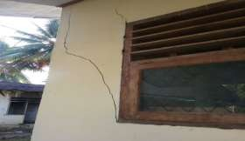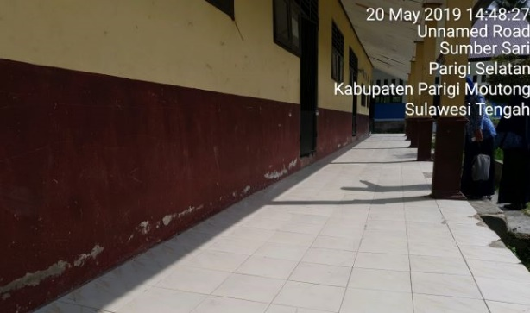

PREPARATORY CHECKLIST: PROVINCIAL SITE ASSESSMENTS (DRAFT)
(for inclusion in RFP Scope of Services for each site)
Prepared by: PMU Palu Date: 26-July 2019.
PROVINCE | Central Sulawesi |  |  | KABUPATEN | Parigi Moutong |  | KECAMATAN |  | Parigi Utara
SCHOOL FACILITY? |  | Yes |  | GoI Facility name |  | SMP Negeri 1 Parigi Utara
HEALTH FACILITY |  |  |  | GoI Facility name
Street Address |  | Jl. Trans Sulawesi no. 266, Desa Toboli |  |  |  |  |  | Postcode |  | 94471
SITE DATA ASSESSMENT
ITEM# | ATTRIBUTE | VERIFIABLE EVIDENCE | YES | NO
1 | Geographical positioning | GPS Coordinates | Yes
 |  | Cadastral Map | Yes
 |  | Technical description: boundary alignments; adjoining lots. | Yes
 |  | Survey boundary monuments located & clear of debris/ vegetation. | Yes
2 | Ownership | Certificate of Title copy attached |  | No
 |  | Clear and Clean title guaranteed by Provincial Government (#5) | Yes
 |  | Acquisition of new site if high risk is apparent on existing site? |  | No
 |  | Enlargement or realignment of site boundaries required? |  | No
3 | Agency Commitment | Proposed works are Included in RENAKSI? (#1) | Yes
 |  | Buildings certified as government owned with major damage (#2) | Yes
 |  | Funds are not duplicating other budget sources (#3) | Yes
 |  | There is a safe & secure location (#4) Subject to Geological Survey
 |  | Willingness for removal of asset to be reconstructed (#6) | Yes
 |  | Local authority willing to receive & maintain rebuilt buildings (#7) | Yes
 |  | Development approval and permit costs by local authority (#8) | Yes
4 | Site Assessment
 | DPU Assets Inspection | Serviceability & forensic assessment certification? | Yes
 | Geophysical Assessment | Report on fissures, faults/ fault lines, landslip, liquefaction risks?
5 | Site/ structures plans | Original as built site layout plan available in digital form? |  | No
 |  | Current as built site layout plan available in digital form? |  | No
 |  | Original as built structures plans available in digital form? |  | No
 |  | Updated as built structures plans available in digital form? |  | No
 |  | Each structure has digital general arrangement & detail drawings? |  | No
 |  | Each structure type can be identified by drawing no. and/ or code? |  | No
6 | Electrical Mains | Inspected and rendered functional & safe by power authority? | Yes
7 | Potable water | Reticulated water with ample flow & operational service points? |  | No
 |  | Rainwater storage collection and storage? |  | No
8 | Sewerage & Septic Tanks | Adequately functional with no health hazard? |  | No
 | Telephone land lines | Connections are in working order and cables well secured? | Yes
9 | Road access | External access road is trafficable and in fair to good condition? | Yes
10 | Demolition & Clean up | Most site areas have not been cleaned up/ are not trafficable |  | No
11 | ESM Framework | Draft document circulated to Pemda /local agencies for comment? |  | No
12 | Disabled Users | Building users have cited special needs for handicapped persons? |  | No
13 | Cultural Identifiers | Stakeholders request cultural character in building design? |  | No
14 | Site Greening | Stakeholders request guidance on shade trees &food gardens? |  | No
15 | Alternative Energy | Stakeholders OK with solar panels & battery storage? | Yes
GUIDANCE
- The above checklist and the attached graphics has the purpose of ensuring that (a) we in PETRA have been thorough and diligent in producing a “360⁰“assessment of each site (a) National, Provincial and community stakeholders have provided initial consensus input to the design process, which will be augmented by the DCS consultants’ working engagement, and (c) consultant responses to the RFP shall be well informed
- We need to have site plans in a common format, with a common numbering convention and reference to parent agency drawing numbers or type designation. Numbering shall go anticlockwise from the bottom LH corner
- All site plans shall be presented in the same format as SMP Negeri 1 Parigi Utara
- Please delete this “GUIDANCE” to add brief clarifying remarks on the above responses, particularly any “NO” responses which are not self-evident. Please also where appropriate state what further actions will be taken by you.

RENAKSI DATA _ from Intervention Matrix UNDP
GPS COORDINATE | 0° 42’ 31.576” S 120° 5’ 42.792” E
Damage Severity | HEAVY | X | MODERATE |  | LIGHT
BUDGET NEEDED IN RENAKSI (IDR) | 1,444,800,000
Summarized description – main tasks : MUST ACCURATELY REFLECT TASK BREAKDOWN IN BILL OF QUANTITIES
Design of the buildings at SMP Negeri 1 Parigi Utara should be in accordance with regulations and standards from Ministry of Public Works and Ministry of Education.

SITE PLAN – Please make sure every site for both Education, Health & Environment contexts are uniformly presented
Please see Annex 4.4

PHOTOGRAPHS OF DAMAGE TO BE ADDRESSED THROUGH RFP DCS CONSULTANTS & LATER ITB WORKS
