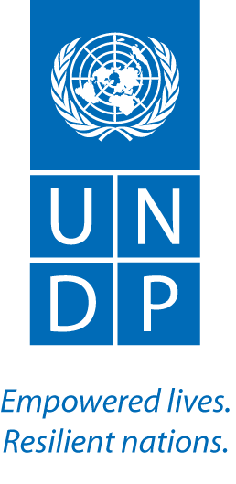

UNITED NATIONS DEVELOPMENT PROGRAMME

Addendum 1

Subject: Communications and Knowledge Management Specialist

Extension of Deadline for Submission:

Deadline for Submission | Friday 22nd November 2019 at 4:pm AST

