REQUEST FOR PROPOSAL (RFP)

NAME & ADDRESS OF FIRM | DATE: 01 May 2020
 | REFERENCE: “EU4Schools” Action

Dear Sir / Madam:

We kindly request you to submit your Proposal for UNDP Albania for the services of “Preparations of the Designs and Supervision for Repair and Retrofitting of the objects of Lot I”, under the “EU4Schools” Action, funded by European Union and implemented by UNDP. Please be guided by the form attached hereto as Annex 2, in preparing your Proposal.

Proposals may be submitted on or before 18th of May 2020; at 14:00 via courier mail or hand delivered to the address below:

United Nations Development Programme

Str. “Skenderbej”, Gurten Center, 2nd floor, Tirana, Albania

UNDP Procurement team

Your Proposal must be expressed in the English language and valid for a minimum period of one hundred twenty days (120).

In the course of preparing your Proposal, it shall remain your responsibility to ensure that it reaches the address above on or before the deadline. Proposals that are received by UNDP after the deadline indicated above, for whatever reason, shall not be considered for evaluation.

Services proposed shall be reviewed and evaluated based on completeness and compliance of the Proposal and responsiveness with the requirements of the RFP and all other annexes providing details of UNDP requirements.

The Proposal that complies with all of the requirements meets all the evaluation criteria and offers the best value for money shall be selected and awarded the contract. Any offer that does not meet the requirements shall be rejected.

Any discrepancy between the unit price and the total price shall be re-computed by UNDP, and the unit price shall prevail, and the total price shall be corrected. If the Service Provider does not accept the final price based on UNDP’s re-computation and correction of errors, its Proposal will be rejected.

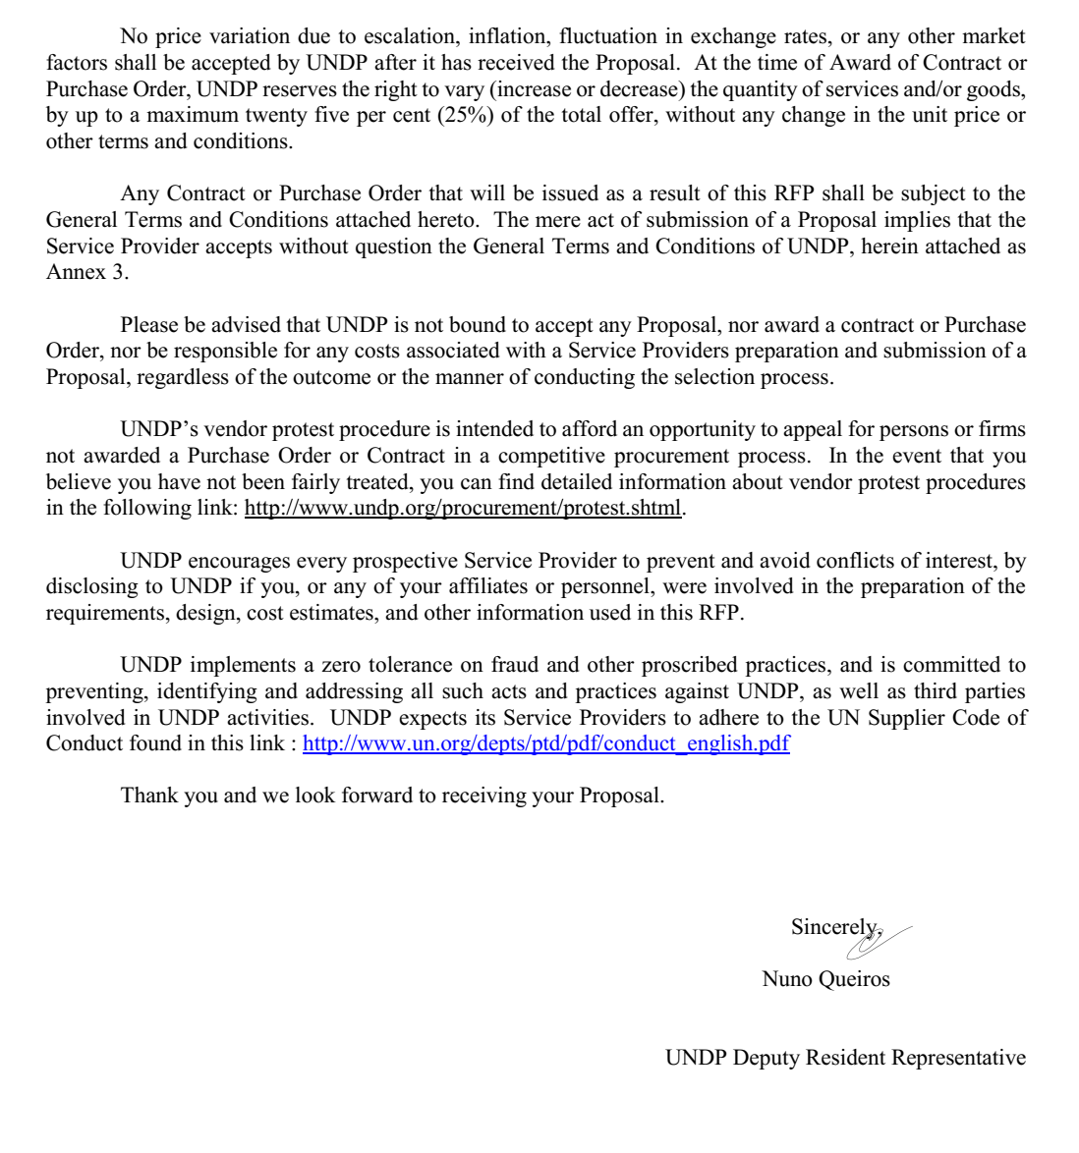

ANNEX 1

DESCRIPTION OF REQUIREMENTS

Context of the Requirement | This requirement is a part of the “EU4Schools” Action, an initiative funded by European Union in response of the earthquake of 26 November 2019 and will be implemented by UNDP. It consists of provision of services on preparation of the: “Designs and Supervision for Repair and Retrofitting of the objects of Lot I”.  Overall objective of the assignment  The overall objective of the assignment is to deliver complete design documentation for repair and retrofitting of the following educational facilities in Durres municipality: 1 Qershori Kindergarten, Dhosi Liperi High school; Hysen Cela Professional Highschool, Ismet Nanushi Joint School, in line with national legislation and regulations in area of construction.  The Supervision of construction works during implementation phase is also an objective of this assignment. Despite the above-mentioned educational facilities, supervision will include also Kindergarten in Kulla village.  The Main design should include:  - Architectural design  - Structural design  - Water and sewage installations design  - Electrical installations design  - Mechanical installations design (heating)  - Survey of energy consumption and thermal insulation of the building  - Survey of fire protection of the building  - Survey of the protection of site work
Notes related Required Services | For more details, please see attached Terms of References/ToRs (Annex 4).
List and Description of Expected Outputs to be Delivered | The expected outputs are as follow:  Design for the repair and retrofitting of the building of: 1 Qershori Kindergarten, Dhosi Liperi Highschool; Hysen Cela Professional Highschool and Ismet Nanushi Joint School in Durres Municipality in line with national legislation and regulations in area of construction. Detailed design must be completed within 30 calendar days after signing the contract from both parties.  Supervision of the Qershori Kindergarten, Dhosi Liperi Highschool; Hysen Cela Professional Highschool and Ismet Nanushi Joint School, Kindergarten in Kulla village in Durres Municipality in line with national legislation and regulations in area of construction.  The purpose of this RFP is to invite proposals from Designing & Supervision Consultancy Companies to:  - Asses the current situation of the objects listed in the ToRs to be repaired and or retrofitted;  - Prepare the preliminary Design for the 4 (four) educational objects listed in the ToRs;  - Prepare the Detailed Technical Design for the implementation of the civil works for the  repair & retrofitting of the 4 (four) listed objects;  - Ensure the Construction Permit in collaboration with Municipality of Durrres for all the  five objects to be repaired (including a Kindergarten in Kulle that will be part of the supervision works also);  - Supervise the civil works during the implementation phase of the object’s repair and  retrofitting;  For more information please refer to Annex 4 (ToRs)
List and Description of Expected Outputs to be Delivered | - Inception report detailing the proposed work methodology and work plan and providing the outline of the capacity building activities and local accessibility action plans;  - The detailed technical design folder including all the documents specified in ToRs (Annex 4);  - Detailed working plan for the supervision of civil works during implementation phase for each of 5(five) objects listed in the ToRs (Annex 4);  - Monthly reports on working progress for each of 4(four) constructions contracts;  - Minutes of the monthly meetings in each of the construction sites, agenda, and list of invitees proposed;  - Final assignment report (in English language) summarizing the work carried out and enclosing all related materials.  For more information please refer to Annex 4 (ToRs)
Person to Supervise the Work/Performance of the Service Provider | Programme staff of the “EU4Schools” Action
Frequency of Reporting | Every month during implementation phase
Progress Reporting Requirements | Narrative and financial reporting as linked to deliverables
Location of work | ☑ Exact Address/es:  ☑At Contractor’s Location in Durres Municipality
Expected duration of work | 8 months, May to December 2020
Target start date | 22nd of May 2020
Latest completion date | December 2020
Travels Expected | In 4 (four) different sites within Municipality of Durres (Ismet Nanushi Joint School and Kindergarten are in the same location).
Personnel to execute the Works/Performance of the Service Provider | The Bidders shall propose a team of 5 key engineers and other staff who shall be included, if selected, in the preparation of the design and supervision. Such engineers shall possess the relevant experience and licenses. The team will be composed by:  - One Team leader/Leading designer -Architect  - One Team leader/Leading supervisor – Civil engineer with specialisation in structural engineer  - One senior expert – Architect  - One senior expert - Civil engineer/hydro-technical engineer  - One senior expert – Civil engineer with specialisation in construction materials  - Other staff (one geological engineer, one electrical engineer, mechanical engineer and cost estimator).  Bidders are given the opportunity to propose more experts (i.e. bigger team), on the basis of their knowledge and experience. However, UNDP shall score only CVs of the Key Experts mentioned above during the technical and financial evaluation of received proposals. Bidders must provide a Structure Chart in their offer with clearly indicated names and functions of each proposed team member (e.g. Architect, Civil Engineer, etc.)
Facilities to be Provided by UNDP (i.e., must be excluded from Price Proposal) | N/A
Implementation Schedule indicating breakdown and timing of activities/sub-activities | Required. Please submit the time schedule table.  - Preparation of Preliminary Project Ideas – 15 days for the contract signature;  - Preparation of Detailed Technical Design – 30 days after approval of the Preliminary Project Idea;  - Supervision of the construction works – during all the time life of the construction contract
Frequency of Reporting | Described in detail in attached ToR (Annex 4)
Progress Reporting Requirements | Described in detail in attached ToR (Annex 4)
Names and curriculum vitae of individuals who will be involved in completing the services | ☑ Required  ☐ Not Required
Currency of Proposal | ☐ United States Dollars  ☐ Euro  ☑ Local Currency (Albanian leke)
Value Added Tax on Price Proposal | ☑must be inclusive of VAT and other applicable indirect taxes  "In case the services provided by your entity will be exempt or out of scope of Albanian VAT, please clearly state the lawinfo@mfa.gov.al provisions your organization makes reference to.  In case of non for-profit organizations, please note that based on Law 92/2014 dated 24.07.2014 and Decision 953, dated 29.12.2014, there are certain conditions to be met in order for the services provided by the latter to be considered as exempt from VAT. In case your entity will opt for such exemption, please provide us proof that your organization meets all the conditions stipulated in article 2 of Decision 953."  ☐ must be exclusive of VAT and other applicable indirect taxes
Validity Period of Proposals (Counting for the last day of submission of quotes) | ☐ 60 days  ☐ 90 days  ☑ 120 days  In exceptional circumstances, UNDP may request the Proposer to extend the validity of the Proposal beyond what has been initially indicated in this RFP. The Proposal shall then confirm the extension in writing, without any modification whatsoever on the Proposal.
Partial Quotes | ☑Not permitted  ☐ Permitted [pls. provide conditions for partial quotes, and ensure that requirements are properly listed to allow partial quotes (e.g., in lots, etc.)]
Payment Terms | Outputs Percentage Timing Condition for Payment Release  Assignment Outputs 15% 40% 45% For the preliminary evaluation report and design Upon completing/ delivering the detail design Upon complete supervision and preparing the full hand over file and as build drawings Within thirty (30) days from the date of meeting the following conditions: - UNDP’s written acceptance (i.e., not mere receipt) of the quality of the outputs; and - Receipt of invoice from the Service Provider.
Person(s) to review/inspect/ approve outputs/completed services and authorize the disbursement of payment | Civil Engineers of the Action
Type of Contract to be Signed | ☐ Purchase Order  ☐ Institutional Contract  ☑ Contract for Professional Services  ☐ Long-Term Agreement (if LTA will be signed, specify the document that will trigger the call-off. E.g., PO, etc.)  ☐ Other Type of Contract [pls. specify]
Criteria for Contract Award | ☐ Lowest Price Quote among technically responsive offers  ☑ Highest Combined Score (based on the 70% technical offer and 30% price weight distribution)  ☑ Full acceptance of the UNDP Contract General Terms and Conditions (GTC). This is a mandatory criterion and cannot be deleted regardless of the nature of services required. Non acceptance of the GTC may be grounds for the rejection of the Proposal.
Criteria for the Assessment of Proposal | The assessment will be performed in following phases:  - Preliminary Examination Criteria  Proposals will be examined to determine whether they are complete and submitted in accordance with RFP requirements as per below criteria on a Yes/No basis:  - Submission within deadline;  - Technical and Financial Proposals submitted in separate closed envelopes;  - Eligibility criteria and fulfilment of minimum qualification requirements  Eligibility criteria and minimum requirement will be evaluated on Pass/Fail basis. If the Proposal is submitted as a Joint Venture/Consortium/Association, each member should meet minimum criteria, unless otherwise specified in the criterion.  Fulfilment of Minimum Qualification Requirements and Eligibility Criteria are explained in detail in Annex 5.  - Technical Proposal Evaluation  The evaluation team shall review and evaluate the Technical Proposals of only those companies that fulfil the minimum qualification requirements and eligibility criteria outlined in Annex 5.  The technical proposals will be evaluated on the basis of their responsiveness to the Terms of Reference and other RFP documents, applying the evaluation criteria, sub-criteria, and point system specified in the Annex 6 (Technical Evaluation Criteria). A Proposal shall be rendered non-responsive at the technical evaluation stage if it fails to achieve the minimum technical score of 70%.  Technical Proposal (70%)  ☒ Bidder’s qualification, capacity and experience 30%  ☒ Proposed Methodology, Its Appropriateness to the Condition and Timeliness of the Implementation Plan 30%  ☒ Management Structure and Key Personnel 40%  See Annex 6 for Technical Evaluation Criteria  - Financial Proposal Evaluation  In this stage, only the Financial Proposals of those Bidders who achieve the minimum technical score will be opened for evaluation. The Financial Proposals corresponding to Technical Proposals that were rendered non-responsive shall remain unopened and will be returned to the Bidder unopened.  Financial Proposal (30%).  To be computed as a ratio of the Proposal’s offer to the lowest price among the proposals received by UNDP.  Rating of the proposals.  The combined scoring method will be based on a combination of the technical and financial score. The formula for the rating of the Proposals will be as follows:  Rating the Technical Proposal (TP):  TP Rating = (Total Score Obtained by the Offer/Max. Obtained Score for TP) x 100  Rating the Financial Proposal (FP):  FP Rating = (Lowest Prices Offer/Price of the Offer Being Reviewed) x 100  Total Combined Score:  Combined Score = (TP Rating) x (Weight of TP, e.g. 70%) + (FP Rating) x (Weight of FP, e.g., 30%)
UNDP will award the contract to: | ☑ One and only one Service Provider  ☐ One or more Service Providers, depending on the following factors: [Clarify fully how and why will this be achieved. Please do not choose this option without indicating the parameters for awarding to multiple Service Providers]
Annexes to this RFP | ☑ Form for Submitting Service Provider’s Proposal (Annex 2)  ☑ General Terms and Conditions for Services (Annex 3)  ☑ Terms of References (Annex 4)  ☑ Minimum Qualification Requirements and Eligibility Criteria (Annex 5)  ☑ Technical Evaluation Criteria (Annex 6)  ☐ Others [pls. specify]
Contact Person for Inquiries  (Written inquiries only) | UNDP Albania Procurement Unit  Procurement.al@undp.org  Any delay in UNDP’s response shall be not used as a reason for extending the deadline for submission, unless UNDP determines that such an extension is necessary and communicates a new deadline to the Proposers.
Other Information:

ANNEX 2

FORM FOR SUBMITTING SERVICE PROVIDER’S PROPOSAL

(This Form must be submitted only using the Service Provider’s Official Letterhead/Stationery)

[insert: Location].
[insert: Date]

To: [insert: Name and Address of UNDP focal point]

Dear Sir/Madam:

We, the undersigned, hereby offer to render the following services to UNDP in conformity with the requirements defined in the RFP dated [specify date], and all of its attachments, as well as the provisions of the UNDP General Contract Terms and Conditions:

- Qualifications of the Service Provider

The Service Provider must describe and explain how and why they are the best entity that can deliver the requirements of UNDP by indicating the following:

- Profile – describing the nature of business, field of expertise, licenses, certifications, accreditations;
- Business Licenses – Registration Papers, Tax Payment Certification, etc.
- Latest Audited Financial Statement – income statement and balance sheet to indicate Its financial stability, liquidity, credit standing, and market reputation, etc. ;
- Track Record – list of clients for similar services as those required by UNDP, indicating description of contract scope, contract duration, contract value, contact references;
- Certificates and Accreditation – including Quality Certificates, Patent Registrations, Environmental Sustainability Certificates, etc.
- Written Self-Declaration that the company is not in the UN Security Council 1267/1989 List, UN Procurement Division List or Other UN Ineligibility List.

- Proposed Methodology for the Completion of Services

The Service Provider must describe how it will address/deliver the demands of the RFP; providing a detailed description of the essential performance characteristics, reporting conditions and quality assurance mechanisms that will be put in place, while demonstrating that the proposed methodology will be appropriate to the local conditions and context of the work.

- Qualifications of Key Personnel

If required by the RFP, the Service Provider must provide:

- Names and qualifications of the key personnel that will perform the services indicating who is Team Leader, who are supporting, etc.;
- CVs demonstrating qualifications must be submitted if required by the RFP; and
- Written confirmation from each personnel that they are available for the entire duration of the contract.

D. Cost Breakdown per Deliverable* (*This shall be the basis of the payment tranches)

 | Deliverables  [list them as referred to in the RFP] | Percentage of Total Price (Weight for payment) | Price  (Lump Sum, All Inclusive)
1 | Deliverable 1
2 | Deliverable 2
3 | ….
 | Total | 100%

E. Cost Breakdown by Cost Component [This is only an Example]:
Description of Activity | Remuneration per Unit of Time | Total Period of Engagement | No. of Personnel | Total Rate
I. Personnel Services
1. Services from Home Office
a. Expertise 1
b. Expertise 2
2. Services from Field Offices
a . Expertise 1
b. Expertise 2
3. Services from Overseas
a. Expertise 1
b. Expertise 2
II. Out of Pocket Expenses
1. Travel Costs
2. Daily Allowance
3. Communications
4. Others
III. Other Related Costs

[Name and Signature of the Service Provider’s Authorized Person]
[Designation]
[Date]

ANNEX 3

GENERAL TERMS AND CONDITIONS FOR SERVICES

1.0 LEGAL STATUS:

The Contractor shall be considered as having the legal status of an independent contractor vis-à-vis the United Nations Development Programme (UNDP). The Contractor’s personnel and sub-contractors shall not be considered in any respect as being the employees or agents of UNDP or the United Nations.

2.0 SOURCE OF INSTRUCTIONS:

The Contractor shall neither seek nor accept instructions from any authority external to UNDP in connection with the performance of its services under this Contract. The Contractor shall refrain from any action that may adversely affect UNDP or the United Nations and shall fulfil its commitments with the fullest regard to the interests of UNDP.

3.0 CONTRACTOR'S RESPONSIBILITY FOR EMPLOYEES:

The Contractor shall be responsible for the professional and technical competence of its employees and will select, for work under this Contract, reliable individuals who will perform effectively in the implementation of this Contract, respect the local customs, and conform to a high standard of moral and ethical conduct.

4.0 ASSIGNMENT:

The Contractor shall not assign, transfer, pledge or make other disposition of this Contract or any part thereof, or any of the Contractor's rights, claims or obligations under this Contract except with the prior written consent of UNDP.

5.0 SUB-CONTRACTING:

In the event the Contractor requires the services of sub-contractors, the Contractor shall obtain the prior written approval and clearance of UNDP for all sub-contractors. The approval of UNDP of a sub-contractor shall not relieve the Contractor of any of its obligations under this Contract. The terms of any sub-contract shall be subject to and conform to the provisions of this Contract.

6.0 OFFICIALS NOT TO BENEFIT:

The Contractor warrants that no official of UNDP or the United Nations has received or will be offered by the Contractor any direct or indirect benefit arising from this Contract or the award thereof. The Contractor agrees that breach of this provision is a breach of an essential term of this Contract.

7.0 INDEMNIFICATION:

The Contractor shall indemnify, hold and save harmless, and defend, at its own expense, UNDP, its officials, agents, servants and employees from and against all suits, claims, demands, and liability of any nature or kind, including their costs and expenses, arising out of acts or omissions of the Contractor, or the Contractor's employees, officers, agents or sub-contractors, in the performance of this Contract. This provision shall extend, inter alia, to claims and liability in the nature of workmen's compensation, products liability and liability arising out of the use of patented inventions or devices, copyrighted material or other intellectual property by the Contractor, its employees, officers, agents, servants or sub-contractors. The obligations under this Article do not lapse upon termination of this Contract.

8.0 INSURANCE AND LIABILITIES TO THIRD PARTIES:

8.1 The Contractor shall provide and thereafter maintain insurance against all risks in respect of its property and any equipment used for the execution of this Contract.

8.2 The Contractor shall provide and thereafter maintain all appropriate workmen's compensation insurance, or the equivalent, with respect to its employees to cover claims for personal injury or death in connection with this Contract.

8.3 The Contractor shall also provide and thereafter maintain liability insurance in an adequate amount to cover third party claims for death or bodily injury, or loss of or damage to property, arising from or in connection with the provision of services under this Contract or the operation of any vehicles, boats, airplanes or other equipment owned or leased by the Contractor or its agents, servants, employees or sub-contractors performing work or services in connection with this Contract.

8.4 Except for the workmen's compensation insurance, the insurance policies under this Article shall:

8.4.1 Name UNDP as additional insured;
8.4.2 Include a waiver of subrogation of the Contractor's rights to the insurance carrier against the UNDP;
8.4.3 Provide that the UNDP shall receive thirty (30) days written notice from the insurers prior to any cancellation or change of coverage.
8.5 The Contractor shall, upon request, provide the UNDP with satisfactory evidence of the insurance required under this Article.

9.0 ENCUMBRANCES/LIENS:

The Contractor shall not cause or permit any lien, attachment or other encumbrance by any person to be placed on file or to remain on file in any public office or on file with the UNDP against any monies due or to become due for any work done or materials furnished under this Contract, or by reason of any other claim or demand against the Contractor.

10.0 TITLE TO EQUIPMENT:

Title to any equipment and supplies that may be furnished by UNDP shall rest with UNDP and any such equipment shall be returned to UNDP at the conclusion of this Contract or when no longer needed by the Contractor. Such equipment, when returned to UNDP, shall be in the same condition as when delivered to the Contractor, subject to normal wear and tear. The Contractor shall be liable to compensate UNDP for equipment determined to be damaged or degraded beyond normal wear and tear.

11.0 COPYRIGHT, PATENTS AND OTHER PROPRIETARY RIGHTS:

11.1 Except as is otherwise expressly provided in writing in the Contract, the UNDP shall be entitled to all intellectual property and other proprietary rights including, but not limited to, patents, copyrights, and trademarks, with regard to products, processes, inventions, ideas, know-how, or documents and other materials which the Contractor has developed for the UNDP under the Contract and which bear a direct relation to or are produced or prepared or collected in consequence of, or during the course of, the performance of the Contract, and the Contractor acknowledges and agrees that such products, documents and other materials constitute works made for hire for the UNDP.

11.2 To the extent that any such intellectual property or other proprietary rights consist of any intellectual property or other proprietary rights of the Contractor: (i) that pre-existed the performance by the Contractor of its obligations under the Contract, or (ii) that the Contractor may develop or acquire, or may have developed or acquired, independently of the performance of its obligations under the Contract, the UNDP does not and shall not claim any ownership interest thereto, and the Contractor grants to the UNDP a perpetual license to use such intellectual property or other proprietary right solely for the purposes of and in accordance with the requirements of the Contract.

11.3 At the request of the UNDP; the Contractor shall take all necessary steps, execute all necessary documents and generally assist in securing such proprietary rights and transferring or licensing them to the UNDP in compliance with the requirements of the applicable law and of the Contract.

11.4 Subject to the foregoing provisions, all maps, drawings, photographs, mosaics, plans, reports, estimates, recommendations, documents, and all other data compiled by or received by the Contractor under the Contract shall be the property of the UNDP, shall be made available for use or inspection by the UNDP at reasonable times and in reasonable places, shall be treated as confidential, and shall be delivered only to UNDP authorized officials on completion of work under the Contract.

12.0 USE OF NAME, EMBLEM OR OFFICIAL SEAL OF UNDP OR THE UNITED NATIONS:

The Contractor shall not advertise or otherwise make public the fact that it is a Contractor with UNDP, nor shall the Contractor, in any manner whatsoever use the name, emblem or official seal of UNDP or THE United Nations, or any abbreviation of the name of UNDP or United Nations in connection with its business or otherwise.

13.0 CONFIDENTIAL NATURE OF DOCUMENTS AND INFORMATION:

Information and data that is considered proprietary by either Party and that is delivered or disclosed by one Party (“Discloser”) to the other Party (“Recipient”) during the course of performance of the Contract, and that is designated as confidential (“Information”), shall be held in confidence by that Party and shall be handled as follows:

13.1 The recipient (“Recipient”) of such information shall:

13.1.1 use the same care and discretion to avoid disclosure, publication or dissemination of the Discloser’s Information as it uses with its own similar information that it does not wish to disclose, publish or disseminate; and,
13.1.2 use the Discloser’s Information solely for the purpose for which it was disclosed.

13.2 Provided that the Recipient has a written agreement with the following persons or entities requiring them to treat the Information confidential in accordance with the Contract and this Article 13, the Recipient may disclose Information to:

13.2.1 any other party with the Discloser’s prior written consent; and,
13.2.2 the Recipient’s employees, officials, representatives and agents who have a need to know such Information for purposes of performing obligations under the Contract, and employees officials, representatives and agents of any legal entity that it controls controls it, or with which it is under common control, who have a need to know such Information for purposes of performing obligations under the Contract, provided that, for these purposes a controlled legal entity means:
13.2.2.1 a corporate entity in which the Party owns or otherwise controls, whether directly or indirectly, over fifty percent (50%) of voting shares thereof; or,
13.2.2.2 any entity over which the Party exercises effective managerial control; or,
13.2.2.3 for the UNDP, an affiliated Fund such as UNCDF, UNIFEM and UNV.

13.3 The Contractor may disclose Information to the extent required by law, provided that, subject to and without any waiver of the privileges and immunities of the United Nations, the Contractor will give the UNDP sufficient prior notice of a request for the disclosure of Information in order to allow the UNDP to have a reasonable opportunity to take protective measures or such other action as may be appropriate before any such disclosure is made.

13.4 The UNDP may disclose Information to the extent as required pursuant to the Charter of the UN, resolutions or regulations of the General Assembly, or rules promulgated by the Secretary-General.

13.5 The Recipient shall not be precluded from disclosing Information that is obtained by the Recipient from a third party without restriction, is disclosed by the Discloser to a third party without any obligation of confidentiality, is previously known by the Recipient, or at any time is developed by the Recipient completely independently of any disclosures hereunder.

13.6 These obligations and restrictions of confidentiality shall be effective during the term of the Contract, including any extension thereof, and, unless otherwise provided in the Contract, shall remain effective following any termination of the Contract.

14.0 FORCE MAJEURE; OTHER CHANGES IN CONDITIONS

14.1 In the event of and as soon as possible after the occurrence of any cause constituting force majeure, the Contractor shall give notice and full particulars in writing to the UNDP, of such occurrence or change if the Contractor is thereby rendered unable, wholly or in part, to perform its obligations and meet its responsibilities under this Contract. The Contractor shall also notify the UNDP of any other changes in conditions or the occurrence of any event that interferes or threatens to interfere with its performance of this Contract. On receipt of the notice required under this Article, the UNDP shall take such action as, in its sole discretion; it considers to be appropriate or necessary in the circumstances, including the granting to the Contractor of a reasonable extension of time in which to perform its obligations under this Contract.

14.2 If the Contractor is rendered permanently unable, wholly, or in part, by reason of force majeure to perform its obligations and meet its responsibilities under this Contract, the UNDP shall have the right to suspend or terminate this Contract on the same terms and conditions as are provided for in Article 15, "Termination", except that the period of notice shall be seven (7) days instead of thirty (30) days.

14.3 Force majeure as used in this Article means acts of God, war (whether declared or not), invasion, revolution, insurrection, or other acts of a similar nature or force.

14.4 The Contractor acknowledges and agrees that, with respect to any obligations under the Contract that the Contractor must perform in or for any areas in which the UNDP is engaged in, preparing to engage in, or disengaging from any peacekeeping, humanitarian or similar operations, any delays or failure to perform such obligations arising from or relating to harsh conditions within such areas or to any incidents of civil unrest occurring in such areas shall not, in and of itself, constitute force majeure under the Contract..

15.0 TERMINATION

15.1 Either party may terminate this Contract for cause, in whole or in part, upon thirty (30) days’ notice, in writing, to the other party. The initiation of arbitral proceedings in accordance with Article 16.2 (“Arbitration”), below, shall not be deemed a termination of this Contract.

15.2 UNDP reserves the right to terminate without cause this Contract at any time upon 15 days prior written notice to the Contractor, in which case UNDP shall reimburse the Contractor for all reasonable costs incurred by the Contractor prior to receipt of the notice of termination.

15.3 In the event of any termination by UNDP under this Article, no payment shall be due from UNDP to the Contractor except for work and services satisfactorily performed in conformity with the express terms of this Contract.

15.4 Should the Contractor be adjudged bankrupt, or be liquidated or become insolvent, or should the Contractor make an assignment for the benefit of its creditors, or should a Receiver be appointed on account of the insolvency of the Contractor, the UNDP may, without prejudice to any other right or remedy it may have under the terms of these conditions, terminate this Contract forthwith. The Contractor shall immediately inform the UNDP of the occurrence of any of the above events.

16.0 SETTLEMENT OF DISPUTES

16.1 Amicable Settlement: The Parties shall use their best efforts to settle amicably any dispute, controversy or claim arising out of this Contract or the breach, termination or invalidity thereof. Where the parties wish to seek such an amicable settlement through conciliation, the conciliation shall take place in accordance with the UNCITRAL Conciliation Rules then obtaining, or according to such other procedure as may be agreed between the parties.

16.2 Arbitration: Any dispute, controversy, or claim between the Parties arising out of the Contract or the breach, termination, or invalidity thereof, unless settled amicably under Article 16.1, above, within sixty (60) days after receipt by one Party of the other Party’s written request for such amicable settlement, shall be referred by either Party to arbitration in accordance with the UNCITRAL Arbitration Rules then obtaining. The decisions of the arbitral tribunal shall be based on general principles of international commercial law. For all evidentiary questions, the arbitral tribunal shall be guided by the Supplementary Rules Governing the Presentation and Reception of Evidence in International Commercial Arbitration of the International Bar Association, 28 May 1983 edition. The arbitral tribunal shall be empowered to order the return or destruction of goods or any property, whether tangible or intangible, or of any confidential information provided under the Contract, order the termination of the Contract, or order that any other protective measures be taken with respect to the goods, services or any other property, whether tangible or intangible, or of any confidential information provided under the Contract, as appropriate, all in accordance with the authority of the arbitral tribunal pursuant to Article 26 (“Interim Measures of Protection”) and Article 32 (“Form and Effect of the Award”) of the UNCITRAL Arbitration Rules. The arbitral tribunal shall have no authority to award punitive damages. In addition, unless otherwise expressly provided in the Contract, the arbitral tribunal shall have no authority to award interest in excess of the London Inter-Bank Offered Rate (“LIBOR”) then prevailing, and any such interest shall be simple interest only. The Parties shall be bound by any arbitration award rendered as a result of such arbitration as the final adjudication of any such dispute, controversy, or claim.

17.0 PRIVILEGES AND IMMUNITIES:

Nothing in or relating to this Contract shall be deemed a waiver, express or implied, of any of the privileges and immunities of the United Nations, including its subsidiary organs.

18.0 TAX EXEMPTION

18.1 Section 7 of the Convention on the Privileges and Immunities of the United Nations provides, inter-alia that the United Nations, including its subsidiary organs, is exempt from all direct taxes, except charges for public utility services, and is exempt from customs duties and charges of a similar nature in respect of articles imported or exported for its official use. In the event any governmental authority refuses to recognize the United Nations exemption from such taxes, duties or charges, the Contractor shall immediately consult with the UNDP to determine a mutually acceptable procedure.

18.2 Accordingly, the Contractor authorizes UNDP to deduct from the Contractor's invoice any amount representing such taxes, duties or charges, unless the Contractor has consulted with the UNDP before the payment thereof and the UNDP has, in each instance, specifically authorized the Contractor to pay such taxes, duties or charges under protest. In that event, the Contractor shall provide the UNDP with written evidence that payment of such taxes, duties or charges has been made and appropriately authorized.

19.0 CHILD LABOUR

19.1 The Contractor represents and warrants that neither it, nor any of its suppliers is engaged in any practice inconsistent with the rights set forth in the Convention on the Rights of the Child, including Article 32 thereof, which, inter alia, requires that a child shall be protected from performing any work that is likely to be hazardous or to interfere with the child's education, or to be harmful to the child's health or physical mental, spiritual, moral or social development.

19.2 Any breach of this representation and warranty shall entitle UNDP to terminate this Contract immediately upon notice to the Contractor, at no cost to UNDP.

20.0 MINES:

20.1 The Contractor represents and warrants that neither it nor any of its suppliers is actively and directly engaged in patent activities, development, assembly, production, trade or manufacture of mines or in such activities in respect of components primarily utilized in the manufacture of Mines. The term "Mines" means those devices defined in Article 2, Paragraphs 1, 4 and 5 of Protocol II annexed to the Convention on Prohibitions and Restrictions on the Use of Certain Conventional Weapons Which May Be Deemed to Be Excessively Injurious or to Have Indiscriminate Effects of 1980.

20.2 Any breach of this representation and warranty shall entitle UNDP to terminate this Contract immediately upon notice to the Contractor, without any liability for termination charges or any other liability of any kind of UNDP.

21.0 OBSERVANCE OF THE LAW:

The Contractor shall comply with all laws, ordinances, rules, and regulations bearing upon the performance of its obligations under the terms of this Contract.

22.0 SEXUAL EXPLOITATION:

22.1 The Contractor shall take all appropriate measures to prevent sexual exploitation or abuse of anyone by it or by any of its employees or any other persons who may be engaged by the Contractor to perform any services under the Contract. For these purposes, sexual activity with any person less than eighteen years of age, regardless of any laws relating to consent, shall constitute the sexual exploitation and abuse of such person. In addition, the Contractor shall refrain from, and shall take all appropriate measures to prohibit its employees or other persons engaged by it from, exchanging any money, goods, services, offers of employment or other things of value, for sexual favours or activities, or from engaging in any sexual activities that are exploitive or degrading to any person. The Contractor acknowledges and agrees that the provisions hereof constitute an essential term of the Contract and that any breach of this representation and warranty shall entitle UNDP to terminate the Contract immediately upon notice to the Contractor, without any liability for termination charges or any other liability of any kind.

22.2 The UNDP shall not apply the foregoing standard relating to age in any case in which the Contractor’s personnel or any other person who may be engaged by the Contractor to perform any services under the Contract is married to the person less than the age of eighteen years with whom sexual activity has occurred and in which such marriage is recognized as valid under the laws of the country of citizenship of such Contractor’s personnel or such other person who may be engaged by the Contractor to perform any services under the Contract.

- AUTHORITY TO MODIFY:
Pursuant to the Financial Regulations and Rules of UNDP, only the UNDP Authorized Official possesses the authority to agree on behalf of UNDP to any modification of or change in this Contract, to a waiver of any of its provisions or to any additional contractual relationship of any kind with the Contractor. Accordingly, no modification or change in this Contract shall be valid and enforceable against UNDP unless provided by an amendment to this Contract signed by the Contractor and jointly by the UNDP Authorized Official.

ANNEX 4

TERMS OF REFERENCES

FOR PREPARATION OF DESIGN AND SUPERVISION FOR REPAIR AND RETROFITTING OF:

KINDERGARTEN 1 QERSHORI (DURRES);
HIGH SCHOOL, DHOSI LIPERI, (SUKTH);
PROFESSIONAL HIGH SCHOOL, HYSEN CELA (DURRES);
JOINT SCHOOL, ISMET NANUSHI (SUKTH);
KINDERGARTEN KULLA VILLAGE (Only supervision)

LOT I

MUNICIPALITY OF DURRES

- BACKGROUND

“EU4Schools” Action is an initiative funded by the European Union in response to the earthquake of 26 November 2019. It aims to contribute in the improvement of education sector in Albania through repair and reconstruction of educational facilities in five municipalities affected by the earthquake. It is part of the financial package committed by European Union to support Albanian citizens during the donor conference organised in Brussels on 17 February 2020. The Action will be implemented by UNDP Albania.

The overall objective of the “EU4Schools” Action is to support national and local governments in reducing further social and economic losses, and to accelerate the recovery process through educational facility repairs and reconstruction. While, the specific objectives are:

- To support repairing and reconstruction, including basic furnishing, of education facilities
in municipalities affected by the earthquake according to international standards;

- To provide increased transparency, accountability and inclusiveness to the recovery process

In response to the needs of those most affected, vulnerable and marginalized, as well as the local communities impacted by the earthquake, the focus will be to support national and local governments in reducing further social and economic losses, and to accelerate the recovery process by building on prior UNDP work with vulnerable communities ensuring that the poorest and most-at-risk population segments can benefit from educational facility repairs and reconstruction. The Action will deliver rapid assistance to help restore education services in local communities in order to ensure students loose minimum school and learning days, and to enable the gradual normalization of life of affected population in those municipalities, with education the foremost priority.

The Action will ensure that the recovery process does not recreate the vulnerability that led to the disaster in the first place and must leave the communities safer by reducing risks and building resilience. Therefore, for the repairing and reconstruction, a Build Back Better (BBB) approach will be taken. The recovery within a BBB framework would give the impacted communities the chance to reduce risk not only from the immediate hazard but provide an opportunity to sustainably reduce the future risk. BBB offers the opportunity to rebuild stronger, safer, more disaster-resilient infrastructure and systems and with higher standards.

The Action will adopt the most-up-to date BBB approaches while institutional and regulatory framework that promote resilient reconstruction will be established, including codification of multi hazard risk reduction aligned with the Eurocodes, improved construction quality control, assurance that settlement designs pursue concepts of liability and infrastructure resilience. In order to ensure sustainability, the reconstruction process will support broader urban development goals, including promotion of transformative urban development that is modern, green, energy efficient, low-carbon and community friendly.

In order to move fast and assist affected communities, the recovery interventions will strengthen resilience, build capacity and social capital and reduce the risk and effects of future disasters. In addition to the “build back better” approach the intervention will apply a “build back together” approach within each locality, working together with local governments, local public institutions and communities to design and implement recovery activities rapidly with a participatory approach and a transparent and accountable system.

Education facilities staff, students and parents will be a valuable source of information to guide the design of the new facilities. The education facilities external environment, entrances, internal circulation, evacuation, other facilities, and classrooms will be given attention when designing for accessibility. The Action will make all efforts to take into consideration the unique requirements of the various groups of persons with disabilities.

Inclusion of communities, including teacher staff, students, parents, local authorities etc..., during all the phases of the action will be considered. It is crucial to ensure that all stakeholders are involved, and their needs will be addressed.

Through this Action support will be provided to the repair and reconstruction of 22 educational facilities, in five municipalities affected by the earthquake of 26 November 2019. (Durrës, Krujë, Kurbin, Kamëz and Kavajë). The direct beneficiaries will be around 7.500 school children and staff of these schools.

The preparation of design and supervision for these education facilities is divided in five Lots.
This ToRs is dedicated to educational facilities included in Lot I, including: (i) Kindergarten 1 Qershori (Durres); (ii) High school, Dhosi Liperi, (Sukth); (iii) Professional high school, Hysen Cela (Durres); (iv) Joint school, Ismet Nanushi (Sukth) and (v) Kindergarten in Kulle village (for the last only supervision is foreseen under this contract).All objects are situated in the territory of Durres Municipality (including Durres city and administrative units). Based on the detailed expertise acts conducted by Institute of Construction and after inspections and field visits, all these facilities are recommended for repair and/or retrofitting.

- GENERAL DATA AND EXISTING CONDITION OF THE FACILITIES

Under this section will be provided information on conditions of five educational facilities to be repaired/retrofitting in Durres municipality. They are situated in Durres city and administrative units of Durres municipality. The information includes description of facilities and physical appraisal.

The Selected Bidder shall examine all available archived documentation and shall conduct all necessary surveys that will result in a database required for the successful completion of the design and supervision. The technical documentation shall contain all elements required for obtaining the location conditions, the necessary permit, public procurement of works, as well as for complete execution of the designed and supervision works.

  - Kindergarten 1 Qershori (Durres);
The kindergarten 1 Qershori, is situated in Tofik Kalaci street in Municipality of Durres. It is a two-floor building, covered by roof. This building is constructed in 1964.

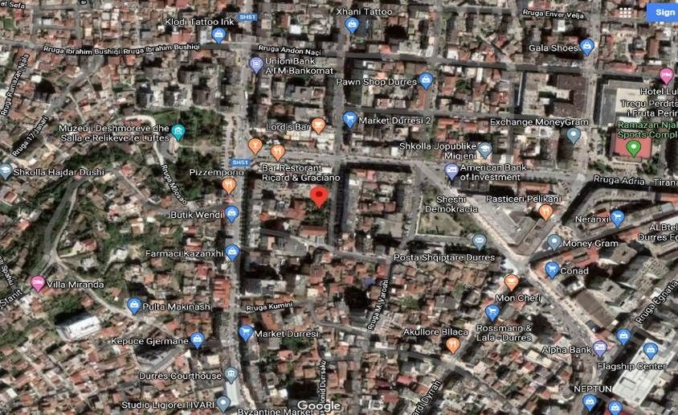

https://goo.gl/maps/AbNHazacUC4teaPi9

Description and Capacity: The building is providing services to 137 children. The constructive system is based in massive unreinforced retaining walls. The kindergarten has a total surface area of 700 m2. It has 4 classrooms and 8 auxiliary facilities. This building has gone through partial rehabilitation in 2010.

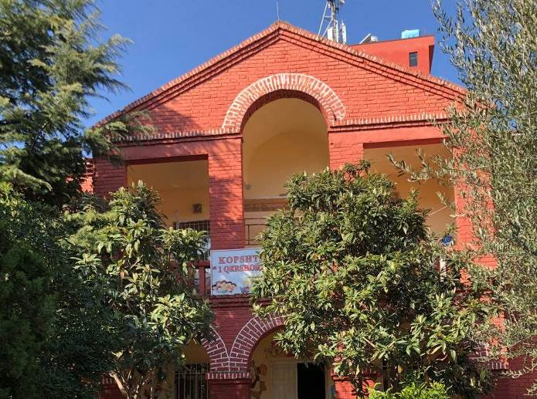

Physical appraisal of the facility: After field verification and based on the Expertise Act performed by the engineering team s of the Construction Institute it results that the building has suffered damages caused by the earthquake mainly in the walls, the roof, the arches, etc. The structural system isn’t damaged so the building can undergo repair and reinforcement works of its the structural system. Various premises need repair work.

  - High school, Dhosi Liperi, (Sukth);

The high school, Dhosi Liperi, is situated in Administrative Unit of Sukth, Municipality of Durres. It is a two-floor building.

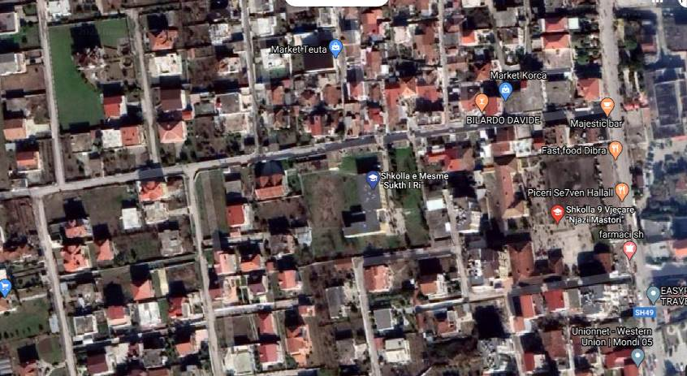

https://goo.gl/maps/fMgedfiURsp6kdHA8

Description and Capacity: The building is hosting and providing services to 295 children. The constructive system is composed of massive retaining walls and anti-seismic columns. The building is built in 1978. The school has a total surface of 1160 m2.

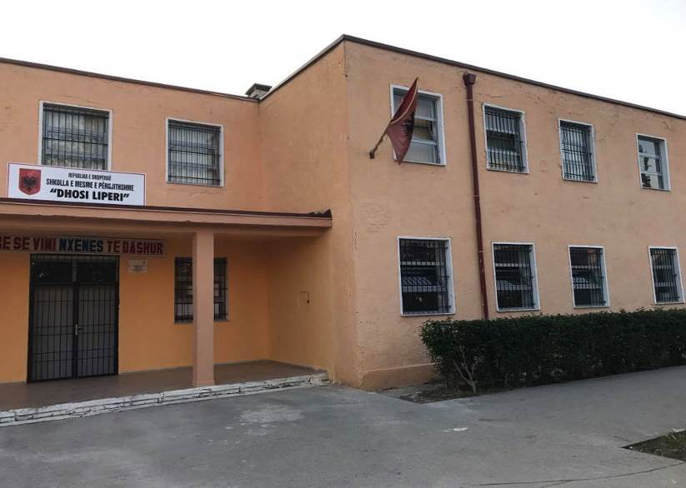

Physical appraisal of the facility: The existing conditions of the building are assessed based on detailed inspection of the building in consideration of modern codes of construction for seismicity such as EC-6 and EC-8. The inspection shows that the building is damaged especially in the ground floor. The building is in the presence of high humidity that might be the cause damages in the plasters of the retaining walls of the ground floor. The building has also damages in the retaining walls and anti-seismic columns.

  - Professional High School Hysen Cela (Durres)

The professional high school Hysen Cela is situated in Mbreti Gent street, Municipality of Durres. It is composed of 3 buildings: the one floor building and two floor building were built in 2012 and the four-floor building is built in 2014.

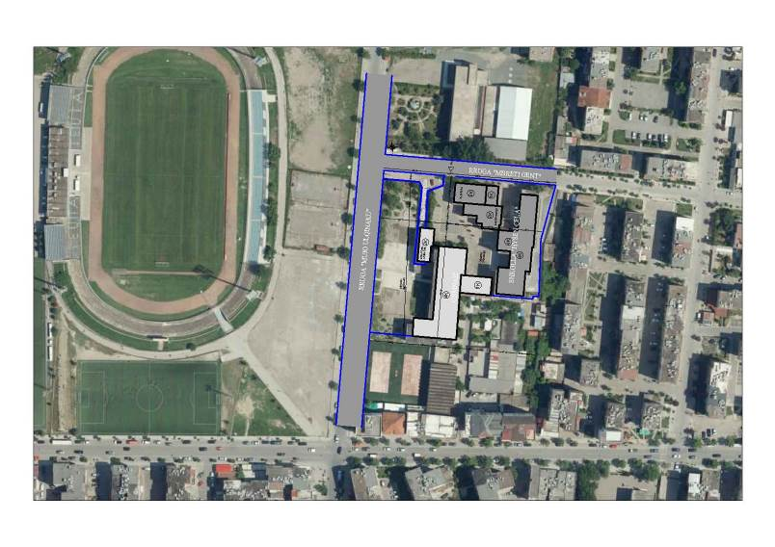
https://goo.gl/maps/BgH6jYu3jGaTLZs67

Description and Capacity: The building is used as education facility serving to 1370 students. The constructive system is a concrete frame structure building. The school has a total surface area of 4325 m2. It accommodates 27 classrooms and 11 auxiliary premises.

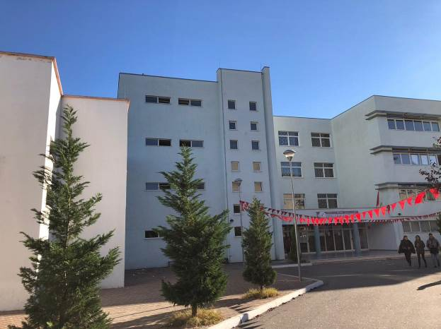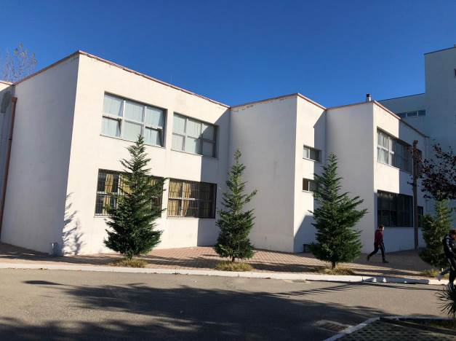

Physical appraisal of the facility: The existing conditions of the building are assessed based in detailed inspection of the building in consideration of the modern codes of construction for the seismicity like EC-6 and EC-8. The inspection shows that the building is damaged mostly in the ground t floor. Verification on the site identified cracks in slab’s beams, separations between walls and beams of the slab.

  - Joint School Ismet Nanushi (Sukth);

The joint school Ismet Nanushi is situated in Kulle-Manez street, Administrative Unit of Sukth in Municipality of Durres. It is a two-floor building.

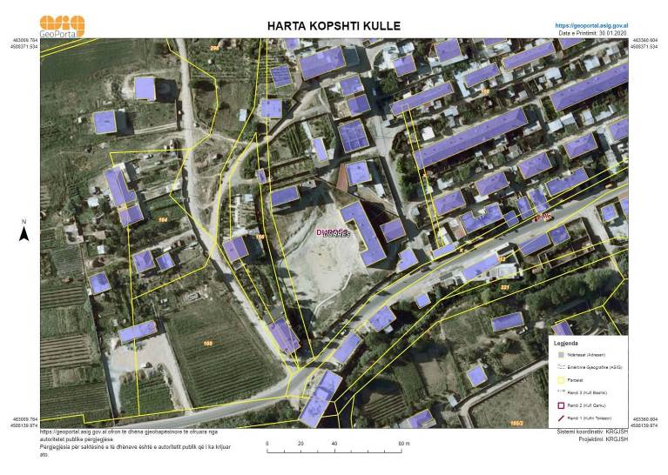
https://goo.gl/maps/B1bBCy2WbDpbE6WL7

Description and Capacity: The building serves to 705 students. The school has a total surface area of 960 m2. It is built in 1979. It has 15 classrooms and 4 auxiliary premises.
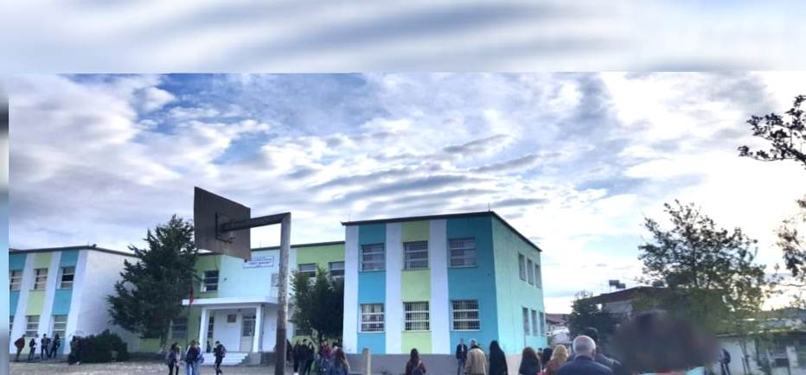

Physical appraisal of the facility: The existing conditions of the building are assessed based in detailed inspection of the building in consideration of modern codes of construction for the seismicity like EC-2, EC-6 and EC-8. After field verification, it’s observed that the object has fissures of retaining walls in the two corners on the right side; it has also a diagonal fissure in the entrance wall of the building, it has a lot of problems with finishes and presence of humidity. The school is recommended for repair and retrofitting.

Close to this school it is located a kindergarten. It has the capacity of giving service to 90 children with a total surface area 140 m2. It was built in 1979. It has 2 classrooms and 4 auxiliary facilities that are insufficient for the number of kids that frequent this kindergarten. After field verification, it’s observed that the roof is very damaged, the walls have fissures, etc. The Kindergarten is recommended for repair and retrofitting.

UNDP has previously prepared the detailed technical design for the Kindergarten repair and extension. This design would be made available to the consultant to allow them to provide an informed technical judgment on the solution to be provided for Ismet Nanushi school and the Kindergarten as a complex since both objects share the same site.

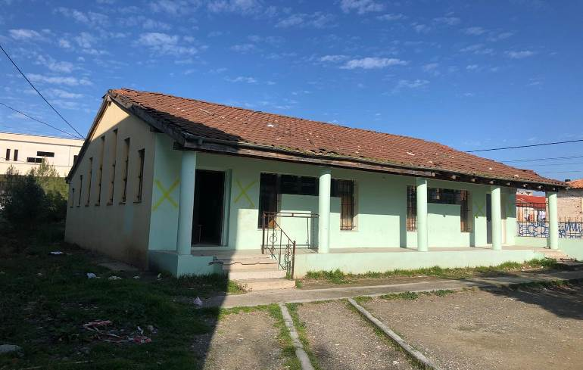

- DESCRIPTION OF REQUIRED SERVICES & DESIGN DOCUMENTS BE:

- General design requirements for the repair and/or retrofitting of the buildings.

The designer must perform all work in accordance with all the design norms and standards provided by the legislation in force, foreseen in the Decision of Council of Ministers no. 319, dated 12.04.2017 “On approval of standards for projection of schools”. The designer should ensure that the standards are respected, even during implementation. It should also recommend the introduction of new standards for approximation with EU norms, especially EC-2, EC-6 and EC-8 as well as international best practices in design and implementation.

The project design should consider all approved norms. The design should provide the necessary infrastructure that is fully accessible for various categories of students with disabilities. The design will take into consideration the particular accessibility requirements of all users: students, teachers and administration staff, parents, and visitors, however the main focus will be on the special needs of students with disabilities. To allow all users to make use of the services available in the education facilities buildings, it will be used the “universal design” approach which will ensure that the education facilities can be accessed and used: i) to the greatest possible extent, ii) in the most independent and natural manner possible, and iii) in the widest range of situations, without the need for adaptation, modification, or specialized solutions.

The Action promotes, and is informed by, the principle of inclusion. Thus, the design may contribute to promoting inclusion through optimizing all students’ access to the school environment and removing unnecessary barriers to participation. While, the infrastructural designs of all targeted educational facilities will have a keen focus on women and girls’ specific needs as users of infrastructure. While, community forums with all stakeholders, will be organized on different phases and the contractor will be invited to participate and contribute.

On the other hand, to ensure BBB, it is crucial to adopt Eurocode 8 as the standard providing a uniform approach for the design of new buildings, and seismic retrofitting of the existing buildings. Hazardous construction materials (e.g. asbestos, POP containing sealants) will be banned and environmentally friendly furnishings and equipment (e.g. LED lights instead of mercury containing fluorescent light bulbs) will be promoted. The BBB principle also includes the application of accessible construction principles, e.g. building ramps for wheelchairs (EU 6° incline), accessible door sills, stairs, doors, hygienic facilities, among others. Hygienic facilities should comply with EU standards, taking hygiene, child protection and gender into account. Chemistry and physics labs should be equipped according to EU safety standards and include e.g. fume hoods in chemistry cabinets/labs, secure and safe storage rooms for chemicals, etc. Building back better will also entail using energy efficient and resistant materials in line with Eurocode 8 standards.

In terms of environmental sustainability, improvements to energy efficiency, through better joinery and green heating systems, will be pursued. The design should aim the achievement of the optimal building energy efficiency within the construction cost restrictions and local parameters.

- The educational facilities will be considered with all its functional components as foreseen in the Decision of Council of Ministers no. 319, dated 12.04.2017 “On approval of standards for projection of schools” and include the following:

• Classrooms, in the design of classrooms the surface should be calculated according to the standard 28 -32 pupils per classroom, with min 1.5 m2 per pupil
• Laboratories, in calculating the space of these laboratory classes it should be taken as the basis that the space for each student should be 2.2 m2 and the auxiliary facilities for equipment and preparations should be calculated.
•Library, library users are both students and teachers, so this should be taken into account when calculating library spaces. For elementary schools, there should be a library space of at least 18 m² or depending on the number of students, a minimum area of 0.1 m² shall be calculated for each student.
• Multipurpose spaces, multipurpose spaces include environments that can be used for several purposes such as student-teacher meeting rooms, teacher-parent meeting rooms, symposiums, display of various film materials, etc. For elementary schools this setting should be calculated based on the number of pupils considering a minimum area of 0.2 m² for each pupil not less than 70 m2.
• Physical Education Room, nine-year schools must have a separate indoor gym for physical education as well as outdoor playgrounds. The dimensions for the gym should be such that basketball and volleyball can be played in this environment.
In addition, the physical education room should have its own auxiliary facilities such are: (i) Two size wardrobes each 16 m², (ii) two bathrooms - showers 16 m², (iii) a warehouse 16 m² for materials, (iv) teacher room with bathroom - shower and wardrobe 10 m²;Outdoor playgrounds are designated according to the curriculum requirements where should be:a volleyball court, a basketball court, gymnastic part etc.

- Requirement for constructive and functional conditioning are as follow:

• Terrace / Roof
The designer should provide all the details for the terrace / roof layers, the installation of the discharge cassette and the vertical-horizontal gutters. In the design of gutters, consideration must be given to avoid being blocked by external factors, a phenomenon that has often occurred in the building. The designer should also indicate the number of gutters and their diameters according to the applicable norms.
Hydrometeorological Institute data will be used for rainfall amounts.

• Walls
In the case of moistered walls, the consultant will indicate how to repair them. If the separate walls are splited as result of seismic vawes, the way to repair them must be presented. The retaining walls will be fully evaluated for the bearing structure, the grade of their damage and the appropriate assessments for their reconstruction.

• Bearing Structure

The structure of the object must be thoroughly verified. Analyzes and verifications of the security of the existing structure should be done and the way of fixing it should be calculated based on European Standards and Codes and world design codes. Also consider the Albanian Design Code KTP 89.

• Plastering

In the damaged areas, plastering of the walls and ceilings will be carried out over the entire surface, preserving the first existing layer, where possible on the walls, meanwhile the ceilings should be cleaned and re-plastered where necessary.

• Painting of Interior and Exterior Walls

The walls and ceilings will be painted with hydromat dye.

• Facades

The facade of the kindergarten should be easy to maintain. The colors of the facade shpold be beautiful, so that the object becomes more attractive to children.

• Tile Layers

Existing tiles in poor condition should be replaced taking into account its restoration with cement mortar, as well as the necessary insulating layers. The floors of the toilets and their walls at a certain height should be insulated and the designer should provide the detail of their insulation. Each layer must be detailed with the relevant specifications.

• Fire Protection System (MNZ)

The designer should also present the fire protection project as well as the technical safety rules for MNZs according to European norms and standards.
• Fire extinguishers;
• Fixed dispensers (with foam or dust) should be installed in the hallways and in the technical environment;
• Smoke sensors should be considered.

• Sanitary Facilities

The consultant should provide appropriate sanitary facilities for the age group of children. Sanitary nodes should be separate with enough sinks for the number of children. Provide continuous and warm water in the sink, so consider the possibility of installing boilers, as well as the realization of the necessary plumbing network. The bathrooms should be ventilated and illuminated. Where there is no direct ventilation special facility for ventilation should be provided. Bathrooms should have open gates on the outside and disconnected from the floor and exclude openings on the inside for emergencies.

• Playground

Outdoor playground terrain is needed to ensure the quality of playgrounds.

Adjustment of the territory and Green Areas

Special attention should be paid to the arrangement of the kindergarten yard as the existing fencing is very close to residential buildings. It should result in transparent enclosures (such as railings) and guarantee all safety standards and normative for construction of this type. Outside spaces are environments that mainly serve for rest and relaxation, so creating a green area with plants or trees is of importance. The designer should give importance to combining the living facilities with the green areas and forestall the exterior lighting of the building, in accordance with the area and the specific requirements for the lighting network provided in this design task. In order to maintain the cleanliness of the kindergarten yard, in the project / preventive should also be provided for waste bins, especially near benches. Also, a special attention should be shown to the regulation and discipline of surface water.

- SPECIAL REQUIREMENTS
In the realization of the repair and retrofitting technical design as well as the proper architectural design, all urban and architectural rules and norms for people with disabilities should be considered and properly implemented. The designer should include in the design also ramps and or elevators for movements of children with disabilities (PWDs), signage for the blind, etc.

Regardless of the results of the examination and decision-making on the typology of the intervention, it should be foreseen the construction of emergency stairs, according to the technical design criteria in force.

- CALCULATIONS, TECHNICAL SPECIFICATIONS AND ESTIMATES
The total cost will be determined by the facility's final cost estimate, which will be prepared based on the implementation project, technical specifications, relevance, as well as considering the specific requirements of UNDP Albania in relation to the accepted standards.

For the cost estimation the reference prices will be according to the legislation in force, based on the Technical Pricing Manual, foreseen by the Decision of Council of Ministers no. 627, dated 15.09.2015. For works items not contained in the manual, the designer should design relevant analyzes, which will be attached to the detailed project implementation, to ensure cost savings and efficiency of use. Bill of Quantities will be presented according to the format / model recommended by UNDP Albania.

- DESIGN IMPLEMENTATION
Design for the repair and retrofitting of the 1 Qershori Kindergarten, Dhosi Liperi Highschool, Hysen Cela Professional Highschool, Ismet Nanushi Joint School will be in line with the standards foreseen be the Decision of Council of Ministers no. 354, dated 11.5.2016 "On the approval of the tariff manual for territorial planning, design, supervision and auditing services". It shall pass through the following phases:

PHASE I: Design task analyses

Analysis of design task / terms of reference and determination of project basis. Finding the conditions for solving the task through planning. It should include an argumentative analysis of the main issues / requirements addressed in the design task. Presentation of the results of object verification, examination and proposal of the typology of intervention.
For each object mentioned in this document the report of the Detailed Analyses and Testing expertise conducted by Institute of Constructed will be made available to the Consultant.

This process should be performed by the Consultant, who inspects the facility and evaluates its condition, the degree of damage, the depreciation condition, and determines whether the facility has structural damage or not. In consideration of the report of the Institute of Construction, if Consultant concludes that the building has structural damages then a detailed analysis and testing should be performed. If the building does not have structural damages, hence needing only repair and retrofitting works, the design process should start.

PHASE II: Design Preliminary Ideas

After having analyzed and assessed the current situation of the facilities, referring to the laws and legislations as well as in Eurocodes, the Consultant will start designing the Preliminary Ideas through:
a. the conceptualization of the interior partitioning depending on their function with the relevant arguments as well as providing the technological and other systems based on the terms of references (two variants)
b. Technical report (on planned interventions)
c. Preliminary BoQ and Cost Estimation.

Materials should be delivered in hard copy and CD/USB format in soft copy formats (Acad, exel, word etc.).

Time for preparation of Phase I + Phase II – 15 (fifteen days).

PHASE III: Preparation of the Detailed Technical Design

Completed folder of the Detailed Technical Design for the project implementation for Repair & Retrofitting of 1 Qershori Kindergarten, Dhosi Liperi High school, Hysen Cela Professional Highschool, Ismet Nanushi Joint School, should contain:

- Technical reports (constructive, architectural, topographic, geological, hydrotechnical, electrical, conditioning, energy efficiency, KUZ, KUSH);
- Topographic survey;
- Architectural design;
- Construction design;
- Geological-engineering study;
- Seismological study;
- Electrical and lightening design;
- Fire Protection and Safety design;
- Hydro-technical design;
- Thermotechnical / air conditioning design;
- Design for the implementation of the rainwater drainage network;
- Design for the implementation of the sewage system;
- Water Supply Network Implementation Design, including details of equipment, manholes and joint fixtures, etc.;
- Technical specifications for the items of works to be performed;
- Cost Estimation based on technical manuals of prices in force;
- Chart of detailed works according to work items;
- Plan for the organization of works and the construction of the shipyard in function of the means, which are part of the realization of the facility, based on the schedule of works;
- Environmental Impact Assessment (EIA) report;
- Design firm license, environmental expert license and trade register extract;
- Declarations of professional responsibility of the staff involved in the implementation of the study design.

The above mentioned materials should be submitted physically and in the appropriate formats: (Acad, word, excel).

PHASE IV: Construction Permit Approval Project: Documents Processing and Submitting for Necessary Legal Procedures.

The designer should also envisage the project for approval of the construction permit, which should be based on Law no. 107/2014 “On Territory Planning and Development”, applying for a construction permit through the Integrated Territory Register portal.

PHASE V: Final Cost Estimation

For the final estimate the designer must rely on Decision of Council of Ministers no. 629, dates. 15.07.2015 "On the approval of the technical manuals of prices of construction works and their technical analysis". For each item of work, which is not included in this manual, the designer must submit the relevant price analysis / quotation. The calculation of the estimate shall be made in accordance with the applicable norms and legal acts, saving and efficiency of using funds. References must be made to prices according the legislation in force. The Bill of Quantities will be compiled according to the standard format / model recommended by UNDP-Albania.

In the preparation of the estimate, reference prices will be in line with the applicable legal acts, and regulations.

Time for preparation of Phase III + Phase IV + Phase V – 30 (thirty) days.

- RECOMMENDATIONS FOR THE DESIGNER
The designer should use and review all existing information regarding the site where the facility is located, the existing water removal system, the drinking water supply system, the distances allowed and the urban criteria of the area concerned.

Standards in Design

The project will be designed in accordance with all design norms and standards provided by applicable legislation. Design should ensure that standards are adhered to, even when implemented. It is the responsibility of the designer to ensure the accuracy and compliance with all relevant standards and norms.The designer should recommend the introduction of new standards for similarity with EU norms as well as international best practices in design and implementation.The project design should take into account the approved norms for people with disabilities, the blind, etc. The project should provide the necessary infrastructure for this category.Technical details of the infrastructure for this category should be provided by the designer on separate Project Sheets.

Standards in the presentation of technical documentation

In designing and presenting project documentation, the designer should use the required computer software as well as promote the use of new, more advanced field software.

- ORGANIZATION, WORK PLAN AND STAFF REQUIRED

The project will be carried out in close cooperation with UNDP Albania. The Selected Bidder shall be required to follow all requirements of the Albanian legislation on the field including those on the requirements for the company and personal licenses for the preparation of the technical documentation and supervision. For detailed information please refer to Annex 5.

The Consultant should submitt certified copy of bidder’s license both for company and key personnel (team leader and team members) for preparation of technical documentation as follow:
- For design: Cat. 2 - b2; Cat. 3-a; Cat. 4 – a, b, f; Cat. 9 – a.
- For Supervision: NP-1; NP-2; NP-3; NS-1; NS-4.
Personnel to execute the Works/Performance of the Service Provider will include:
- One Team leader/Leading designer -Architect
- One Team leader/Leading supervisor – Civil engineer with specialisation in structural engineer
- One senior expert – Architect
- One senior expert - Civil engineer/hydro-technical engineer
- One senior expert – Civil engineer with specialisation in construction materials
- One geological engineer
- One electrical engineer
- One mechanical engineer
- One cost estimator

- PRESENTATION OF DRAWINGS.

Project implementation phase drawings must be in A3 format, readable and contain at least the following sheets:

- Topography of the existing situation in which all the buildings in the actual situation are updated (with or without permission);
- Existing plan of the building on scale 1: 100;
- General layout of the building in scale 1: 200; 1: 500;
- Plan of the existing floors scale 1: 100, 1:50;
- Object layouts after changes 1: 100; 1:50;
- Existing facades scale 1: 100;
- New facades in 2D and 3D scale 1: 100;
- Building sections (in both directions) scale 1: 100;
- Furniture plan scale 1: 100;
- Foundation plan scale 1: 100;
- Foundation sections and details scale 1: 50;
- Structural plan scale 1: 100;
- Sewer network layout at the scale of 1: 100;
- Manholes and other sewer network details scale 1: 10, 1:20;
- Water supply layout in scale 1: 200, 1: 100;
- Water supply axonometric charts, details of sanitary equipment scale1: 100;
- Wells and other details of the water supply network scale 1: 20, 1:10;
- Power supply system plans scale 1: 100;
- Lightening plans and details scale 1: 100;
- LAN and telephon system plans scale 1: 100;
- Outdoor lighting layout and details scale 1: 100; 1:50;
- Layout and details of the fire protection system scale 1: 100;
- Greenery layout and details scale 1: 100; 1:50;
- Surrounding wall layout, type and detail of bench fixing scale 1: 100; 1:50;
- Surface water discipline and discharge plan and related details scale 1: 100; 1:50.

- REPORTING
Reports and documents should be in 5 (five) color copies in English language. Drawings should be readible in dwg format (AutoCad 2007-2012). All materials will also be submitted in soft copy (5 CDs).

- SUPERVISION WORKS
To perform this task the Consultant Company will comprise Inspectors, who will conduct inspections per project at various stages of implementation. The duties of the inspectors are to ensure that all interventions comply with the various requirements elaborated in Detailed Design and disbursement. The cycle will be conducted based on Albanian legal acts in power through (i) verifying that the materials purchased are in accordance with the detailed design and implementation contract in terms of quantities and quality, and at the same time the initial works; (ii) verifying that the completed works are in accordance to the quality standards required including compliance with the agreed upon plans, both in terms of the quality of the labor and with respect to the schedule.

Specifically, the tasks of the Supervisors are as follows:

- Regularly reporting on a project’s progress by providing standard documentation,
- Working with the implementing construction company to identify problems and bring them to the attention of UNDP-Albania
- Collecting and verifying statements of accomplished works/report from the implementing company.
- Reviewing implementing company source documentation consisting of:
a) Verification of periodic expense statements against the expenditures reported in a financial report forms for the particular stage,
b) Determination of allowed and applicable costs supported by source documentation,
c) Determination of implementing company compliance to the regulations on procurement and acquisition of goods and services as described in the contract.
- Participate in the subprojects Hand Over process

Schedule of deliverables/reporting is as follow:
- Progress Report for each building implementation;
- Supervision Reports at various stages of each building implementation;
- Issuing Supervision Approval and Request for Payments to the contractors, according to the Interim and Final Certificates of the performed works, signed by the respective parties: Contractors, Inspector, UNDP-Albania.
- At the end of the Supervision phase a Final Report should be submitted, summarizing all performed works during these Consultant Services.

- Appendix I:List of Albanian legislation regulating design, supervision, civil works, testing and commissioning.

Law No 8402, dated 10.09.1998 “On the supervision of civil works”, amended;
Law No 8408, dated 25.09.1998 “On the Construction Policy”, amended;
Law No 8464, dated 11.03.1999 “On standardization” amended;
Law No 9780, dated 16.07.2007 “About the inspection of civil works”
Law No 9290, dated 07.10.2004 “On construction materials”;
Government Decrees
Decision of Council of Ministers No. 68, dated 15.02.2001 “On the approval of technical conditions for projecting and executing construction procedures”, amended;
Decision of Council of Ministers No. 679, dated 22.10.2004 “On the approval of technical conditions for the use of concrete structures”;
Decision of Council of Ministers No. 514, dated 15.08.2007 “On the informatization of cost calculation and redaction of technical manuals about prices of civil works”;
Decision of Council of Ministers No. 629, dated 15.07.2015 “On the approval of technical manuals about prices of civil works and their technical analysis”;
Decision of Council of Ministers No. 1503, dated 19.11.2018 “On the use of spaces from the persons with disabilities”;
Guidelines
Guideline No. 3, dated 15.09.2001 “On the supervision of civil works”, amended;
Guideline No. 2, dated 08.05.2003 “For the classification and structure of civil works costs”;
Guideline No. 2, dated 13.05.2005 “On the execution of civil works”;
Guideline No. 1, dated 16.06.2011 “About some changes in the Guideline No. 3, date 15.02.2001 of the Council of Ministers “For the supervision and commissioning of civil works” amended.

- Eurocodes:
EC0 – Bases of structures design
EC1 – Loads in structures
EC2 – Design of reinforced concrete structures
EC7 – Geotechnical design
EC8 – Seismic structures design

ANNEX 5

MINIMUM QUALIFICATION REQUIREMENTS AND ELIGIBILITY CRITERIA

Subject | Documents to be provided
Eligibility

- Registration to perform the requested services as a legal entity;  - Profile – describing the nature of business, field of expertise, licenses, certifications, accreditations;  - Financial standing and tax obligations  - Personnel/staff of the company | 1.1 Certified copy of applicant’s registration  1.2 Written Self-Declaration that the company is not in the UN Security Council 1267/1989 List, UN Procurement Division List or Other UN Ineligibility List. Etc;  2.1 Company profile  2.2 License for services of technical documentation preparation, as a legal entity, issued by relevant government authority;  2.3 Certified copy of applicant’s license both for company and key personnel (team leader and team members) for preparation of technical documentation. Following categories of license are required: (i) For design: Category 2, b2; Cat. 3.a; Cat. 4 a,b,f; Cat 9, a. and (ii) For supervision: NP-1; NP-2; NP-3; NS-1; NS-4  2.4 Certificates and Accreditation – including ISO, Quality Certificates, Patent Registrations, Environmental Sustainability Certificates, etc  3.1 Latest Audited Financial Statement (Income Statement and Balance Sheet) as required by the law of the Bidder’s country, proving minimum average annual turnover of 7.000.000 ALL for the last three years;  3.2 Certificate from Tax Office that shows that the Consultant has paid all obligatory taxes for the last year (not older than three months)  4.1 Organigramme of the company (including job titles of personnel/staff)
Qualification
Experiences:  At least 5 (five) years of experience as a legal entity in preparation of technical documentation (technical detailed design, technical specification, reports, cost estimations) for community buildings, educational facilities, high rise buildings and/or civil construction of similar complexity.  At least 3 (three) successfully prepared detailed designs within the last 5 (five) years, of educational facilities, community buildings and/or civil construction structures of similar size and complexity | Reference list indicating successfully implemented projects within the last 5 (five) years on the company memorandum letter;  Recommendation letters indicating the value, complexity and date of project completion, for at least 3 (three) projects implemented within the last 5 (five) years. Letters should include referral’s contact details.  At least three references from the similar works performed by the company, within the last 5 (five) years.
Team composition and competences of the team members:  - One (1) Architect (Team Leader) with professional exam certificate and minimum 10 years of experience in design of public buildings and works of similar complexity;  - One (1) Architect (assistant designer) with minimum 5 years of experience in design of public buildings and works of similar complexity;  - One (1) Civil engineer with professional exam certificate in area of construction with minimum 10 years of experience in structural design of buildings and works of similar size and complexity in design and supervision;  - One (1) Civil engineer with professional exam certificate in area of hydro technics with minimum 5 years of experience in design of hydro installations of similar complexity;  - One (1) Electrical engineer with professional exam certificate in area of energetics with minimum 10 years of experience in electrical design of buildings and works of similar complexity;  - One (1) licensed graduate Mechanical engineer with professional exam certificate with minimum 10 years of experience in heating design and works of similar complexity;  - One (1) licensed graduate Geological engineer with professional exam certificate with minimum 10 years of experience in geological studies and works of similar complexity;  - One (1) licensed graduate environmental engineer/with profession exam certificate with minimum 5 years of experience in design and works of similar complexity;  - One (1) civil engineer experienced in construction materials field;  - One (1) cost estimator  Team Leader and at least two team members must be permanent (full-time) personnel of the Service Provider. For the other required staff a notarized working contract that defines the scope of the contract and part’s obligations should be submitted. | - List of team members (engineers and other personal) to be engaged for the contract (names, education, skills, years of experience);  - Original certificate issued by relevant Tax Administration Office indicating the number of employees registered by the company. This document must issued within the 30 days from the tender launching date;  - CV of each team member with references and letters of recommendation;  - Copies of professional licenses and university diplomas (bachelor and/or master degree) of each team member);  - Statement on availability and exclusivity during the entire contracted period, signed by each team member;  - Contract signed by the Bidder and engaged staff including statement on availability and exclusivity during the entire contracted period  - Contract on the Joint Venture establishment

NOTE: Above minimum qualification requirements are defined. Bidder must demonstrate relevant capacity in terms of the engaged staff through the submission of their CVs.

ANNEX 6

TECHNICAL EVALUATION CRITERIA

Summary of Technical Proposal Evaluation Forms |  | Points Obtainable
1. | Bidder’s qualification, capacity and experience | 300
2. | Proposed Plan Methodology, its appropriateness to the condition and timeliness of the implementation plan | 300
3. | Management Structure and Key Personnel | 400
 | Total | 1000

Section 1. Bidder’s qualification, capacity and experience |  | Points obtainable
1.1 | Reputation of Organization and Staff Credibility / Reliability / Industry Standing | 30
1.2 | Litigation and Arbitration history | 20
1.2 | General Organizational Capability which is likely to affect implementation: management structure, financial stability and project financing capacity, project management controls. | 50
1.3 | Relevance of specialized knowledge and experience on similar engagements in technical design and supervision. | 100
1.4 | Experience in implementation of activities and preparation of tendering dossiers in accordance with the UNDP and/or EU Guidelines for the Procurement of Supplies, Works and Services | 50
1.5 | Quality assurance procedures and risk mitigation measures | 20
1.6 | Organizational Commitment to Sustainability  -Organization is compliant with ISO 9001or ISO 14064 or equivalent  -Organization demonstrates significant commitment to sustainability through some other means such as renewable energies, sustainable environment etc… | 30
Total Section 1 |  | 300

Section 2. Proposed Methodology, Approach and Implementation Plan |  | Points obtainable
2.1 | To what degree does the applicant understands the tasks. | 50
2.2 | Description of the Offeror’s approach and methodology for meeting or exceeding the requirements of the Terms of Reference | 50
2.3 | Are the different components of the project adequately weighted relative to one another? | 20
2.4 | Description of how the Offeror’s will ensure that the specific requirements of the education institutions are met in line with the relevant rules and regulations for this type of objects | 30
2.5 | Demonstration of ability to plan, integrate and effectively implement sustainability measures in the execution of the contract | 20
2.6 | Understanding of specific design tasks | 30
2.7 | Understanding of specific supervision tasks | 30
2.8 | Is the presentation clear and is the sequence of activities and the planning logical, realistic and promise efficient implementation to the project? | 30
2.9 | Soundness/completeness of the proposed workplan including whether the activities are properly sequenced and if these are logical and realistic | 20
2.10 | Structure of project management, monitoring, reporting | 20
Total Section 2 |  | 300

Section 3. Management Structure and Key Personnel |  |  | Points obtainable
3.1 | Composition and structure of the team proposed. Are the proposed roles of the management and the team of key personnel suitable for the provision of the necessary services? |  | 40
3.2 | Qualifications of key personnel proposed
3.2 a | Team Leader / Leading Designer - Architect |  | 70
3.2 b | Team Leader / Leading Supervisor – Civil Engineer with specialization in structural engineering |  | 70
3.2 c | One Senior Experts – Architect |  | 40
3.2 d | One Senior Expert - Civil Engineer /hydro-technical engineer |  | 40
3.2 e | Senior Expert - Civil Engineering with specialization in construction materials |  | 40
3.2 f | Other experts (geological engineer, electrical engineer, mechanical engineer HVAC, cost estimator) |  | 100
Total Section 3 |  |  | 400

UNDP preference is not to pay any amount in advance upon signing of contract. If the Service Provider strictly requires payment in advance, it will be limited only up to 20% of the total price quoted. For any higher percentage, or any amount advanced exceeding $30,000, UNDP shall require the Service Provider to submit a bank guarantee or bank cheque payable to UNDP, in the same amount as the payment advanced by UNDP to the Service Provider.
Service Providers are alerted that non-acceptance of the terms of the General Terms and Conditions (GTC) may be grounds for disqualification from this procurement process.
A more detailed Terms of Reference in addition to the contents of this RFP may be attached hereto.
This contact person and address is officially designated by UNDP. If inquiries are sent to other person/s or address/es, even if they are UNDP staff, UNDP shall have no obligation to respond nor can UNDP confirm that the query was received.
This serves as a guide to the Service Provider in preparing the Proposal.
Official Letterhead/Stationery must indicate contact details – addresses, email, phone and fax numbers – for verification purposes

