INVITATION TO BID
Supply and Install Solar PV Systems and Appliances for Selected Demonstration Sites in Ethiopia
ITB No.: ETH2941
Project: Rural Energy Technology (UNDP ETH CO Support to Nationally Implemented Project)
Country: UNDP Ethiopia CO
Issued on: 5 November 2021

Contents
Section 1. Letter of Invitation 4
Section 2. Instruction to Bidders 5
GENERAL PROVISIONS 5
1. Introduction…………………………………………………………………………………………………………..………………………………………... 5
2. Fraud & Corruption, Gifts and Hospitality……………………………………………………………………………………………………….5
3. Eligibility……………………………………………………………………………………………………………………………………………………………5
4. Conflict of Interests…………………………………………………………………………………………………………………………………………..6
B. PREPARATION OF BIDS 6
5. General Considerations……………………………………………………………………….…………………….……………………………………..6
6. Cost of Preparation of Bid…………………………………………………………………….……………………….............................................7
7. Language……………………………………………………………………………………….………………………......................................................7
8. Documents Comprising the Bid………………………………………………………………….……………………………………………………7
9. Documents Establishing the Eligibility and Qualifications of the Bidder……………………….…………………………………7
10. Technical Bid Format and Content……………………………………………………………….…………………….......................................7
11. Price Schedule…………………………………………………………………………………….……………………...................................................7
12. Bid Security……………………………………………………………………………………….……………………......................................................7
13. Currencies…………………………………………………………………………………………….…………………………………………………………..8
14. Joint Venture, Consortium or Association………………………………………………………….…………………………………………….8
15. Only One Bid………………………………………………………………………………………….…………………………………………………………9
16. Bid Validity Period…………………………………………………………………………………….………………...................................................9
17. Extension of Bid Validity Period……………………………………………………………………….…………….…………………………………9
18. Clarification of Bid (from the Bidders)………………………………………………………………….………….…………………………...…10
19. Amendment of Bids……………………………………………………………………………………….……….……………………………………….10
20. Alternative Bids…………………………………………………………………………………………….………………………………………………….10
21. Pre-Bid Conference………………………………………………………………………………………….…………...............................................10
C. SUBMISSION AND OPENING OF BIDS……………………………………………………………………………….…….……………..………11
22. Submission……………………………………………………………………………………………………….…………………………………………..…11
Hard copy (manual) submission……………………………………………………………………………………………………………………………..…11
Email and eTendering submissions …………………………………………………………………………………………………………………………..11
23. Deadline for Submission of Bids and Late Bids ………………………………………………………………………………………………11
24. Withdrawal, Substitution, and Modification of Bids………………………………………………………………………………………. 12
25. Bid Opening …………………………………………………………………………………………………………………………………………………...12
D. EVALUATION OF BIDS……………………………………………………………………………………………………………………………………..12
26. Confidentiality………………………………………………………………………………………………………………………………………………….12
27. Evaluation of Bids ……………………………………………………………………………………………………………………………………………12
28. Preliminary Examination ………………………………………………………………………………………………………………………………….13
29. Evaluation of Eligibility and Qualification ……………………………………………………………………………………………………..…13
30. Evaluation of Technical Bid and prices …………………………………………………………………………………………………………….13
31. Due diligence …………………………………………………………………………………………………………………………………………………..13
32. Clarification of Bids ………………………………………………………………………………………………………………………………………….14
33. Responsiveness of Bid ……………………………………………………………………………………………………………………………………..14
34. Nonconformities, Reparable Errors and Omissions …………………………………………………………………………………………14
E. AWARD OF CONTRACT…………………………………………………………………………………………………………………………………… 15
35. Right to Accept, Reject, Any or All Bids ……………………………………………………………………………………………………………15
36. Award Criteria …………………………………………………………………………………………………………………………………………………..15
37. Debriefing ………………………………………………………………………………………………………………………………………………………...15
38. Right to Vary Requirements at the Time of Award …………………………………………………………………………………………..15
39. Contract Signature ……………………………………………………………………………………………………………………………………………15
40. Contract Type and General Terms and Conditions ………………………………………………………………………………………..…15
41. Performance Security ……………………………………………………………………………………………………………………………………….15
42. Bank Guarantee for Advanced Payment …………………………………………………………………………………………………………..15
43. Liquidated Damages …………………………………………………………………………………………………………………………………………16
44. Payment Provisions ……………………………………………………………………………………………………………………………………….16
45. Vendor Protest ………………………………………………………………………………………………………………………………………………16
46. Other Provisions ……………………………………………………………………………………………………………………………………………16
Section 3. Bid Data Sheet 17
Section 4. Evaluation Criteria 20
Section 5a: Schedule of Requirements and Technical Specifications/Bill of Quantities 22
Section 5b: Other Related Requirements 22
Section 6: Returnable Bidding Forms / Checklist 24
Form A: Bid Submission Form 25
Form B: Bidder Information Form 26
Form C: Joint Venture/Consortium/Association Information Form 28
Form D: Eligibility and Qualification Form 29
Form E: Format of Technical Bid 31
Form F: Price Schedule Form 34
Form G: Form of Bid Security 35

Section 1. Letter of Invitation

The United Nations Development Programme (UNDP) hereby invites you to submit a Bid to this Invitation to Bid (ITB) for the above-referenced subject.

This ITB includes the following documents and the General Terms and Conditions of Contract which is inserted in the Bid Data Sheet:
Section 1: This Letter of Invitation
Section 2: Instruction to Bidders
Section 3: Bid Data Sheet (BDS)
Section 4: Evaluation Criteria
Section 5: Schedule of Requirements and Technical Specifications
Section 6: Returnable Bidding Forms
- Form A: Bid Submission Form
- Form B: Bidder Information Form
- Form C: Joint Venture/Consortium/Association Information Form
- Form D: Qualification Form
- Form E: Format of Technical Bid
- Form F: Price Schedule
- Form G: Form of Bid Security
If you are interested in submitting a Bid in response to this ITB, please prepare your Bid in accordance with the requirements and procedure as set out in this ITB and submit it by the Deadline for Submission of Bids set out in Bid Data Sheet.
Please acknowledge receipt of this ITB by sending an email to [Insert email address], indicating whether you intend to submit a Bid or otherwise. You may also utilize the “Accept Invitation” function in eTendering system, where applicable. This will enable you to receive amendments or updates to the ITB. Should you require further clarifications, kindly communicate with the contact person/s identified in the attached Data Sheet as the focal point for queries on this ITB.
UNDP looks forward to receiving your Bid and thank you in advance for your interest in UNDP procurement opportunities.

Issued by Approved by:

____________________________ ____________________________
Name: Ermias Wosenyeleh  Title: Procurement Specialist  Date: November 5, 2021 | Name: Hien Dang  Title: Deputy Country Representative- Operations  Date: November 5, 2021

Section 2. Instruction to Bidders

GENERAL PROVISIONS
Introduction | - Bidders shall adhere to all the requirements of this ITB, including any amendments made in writing by UNDP. This ITB is conducted in accordance with the UNDP Programme and Operations Policies and Procedures (POPP) on Contracts and Procurement which can be accessed at https://popp.undp.org/SitePages/POPPBSUnit.aspx?TermID=254a9f96-b883-476a-8ef8-e81f93a2b38d  - Any Bid submitted will be regarded as an offer by the Bidder and does not constitute or imply the acceptance of the Bid by UNDP. UNDP is under no obligation to award a contract to any Bidder as a result of this ITB.  - UNDP reserves the right to cancel the procurement process at any stage without any liability of any kind for UNDP, upon notice to the bidders or publication of cancellation notice on UNDP website.  - As part of the bid, it is desired that the Bidder registers at the United Nations Global Marketplace (UNGM) website (www.ungm.org). The Bidder may still submit a bid even if not registered with the UNGM. However, if the Bidder is selected for contract award, the Bidder must register on the UNGM prior to contract signature.
Fraud & Corruption,  Gifts and Hospitality | - UNDP strictly enforces a policy of zero tolerance on proscribed practices, including fraud, corruption, collusion, unethical or unprofessional practices, and obstruction of UNDP vendors and requires all bidders/vendors observe the highest standard of ethics during the procurement process and contract implementation. UNDP’s Anti-Fraud Policy can be found at http://www.undp.org/content/undp/en/home/operations/accountability/audit/office_of_audit_andinvestigation.html#anti  - Bidders/vendors shall not offer gifts or hospitality of any kind to UNDP staff members including recreational trips to sporting or cultural events, theme parks or offers of holidays, transportation, or invitations to extravagant lunches or dinners.  - In pursuance of this policy, UNDP:  (a) Shall reject a bid if it determines that the selected bidder has engaged in any corrupt or fraudulent practices in competing for the contract in question;  (b) Shall declare a vendor ineligible, either indefinitely or for a stated period, to be awarded a contract if at any time it determines that the vendor has engaged in any corrupt or fraudulent practices in competing for, or in executing a UNDP contract.  - All Bidders must adhere to the UN Supplier Code of Conduct, which may be found at https://www.un.org/Depts/ptd/about-us/un-supplier-code-conduct
Eligibility | - A vendor should not be suspended, debarred, or otherwise identified as ineligible by any UN Organization or the World Bank Group or any other international Organization. Vendors are therefore required to disclose to UNDP whether they are subject to any sanction or temporary suspension imposed by these organizations.  - It is the Bidder’s responsibility to ensure that its employees, joint venture members, sub-contractors, service providers, suppliers and/or their employees meet the eligibility requirements as established by UNDP.
Conflict of Interests | - Bidders must strictly avoid conflicts with other assignments or their own interests, and act without consideration for future work. Bidders found to have a conflict of interest shall be disqualified. Without limitation on the generality of the above, Bidders, and any of their affiliates, shall be considered to have a conflict of interest with one or more parties in this solicitation process, if they:  - Are or have been associated in the past, with a firm or any of its affiliates which have been engaged by UNDP to provide services for the preparation of the design, specifications, Terms of Reference, cost analysis/estimation, and other documents to be used for the procurement of the goods and services in this selection process;  - Were involved in the preparation and/or design of the programme/project related to the goods and/or services requested under this ITB; or  - Are found to be in conflict for any other reason, as may be established by, or at the discretion of UNDP.  - In the event of any uncertainty in the interpretation of a potential conflict of interest, Bidders must disclose to UNDP, and seek UNDP’s confirmation on whether or not such conflict exists.  - Similarly, the Bidders must disclose in their Bid their knowledge of the following:  - If the owners, part-owners, officers, directors, controlling shareholders, of the bidding entity or key personnel who are family members of UNDP staff involved in the procurement functions and/or the Government of the country or any Implementing Partner receiving goods and/or services under this ITB; and  - All other circumstances that could potentially lead to actual or perceived conflict of interest, collusion or unfair competition practices.  Failure to disclose such an information may result in the rejection of the Bid or Bids affected by the non-disclosure.  - The eligibility of Bidders that are wholly or partly owned by the Government shall be subject to UNDP’s further evaluation and review of various factors such as being registered, operated and managed as an independent business entity, the extent of Government ownership/share, receipt of subsidies, mandate and access to information in relation to this ITB, among others. Conditions that may lead to undue advantage against other Bidders may result in the eventual rejection of the Bid.

PREPARATION OF BIDS
General Considerations | - In preparing the Bid, the Bidder is expected to examine the ITB in detail. Material deficiencies in providing the information requested in the ITB may result in rejection of the Bid.  - The Bidder will not be permitted to take advantage of any errors or omissions in the ITB. Should such errors or omissions be discovered, the Bidder must notify the UNDP accordingly.
Cost of Preparation of Bid | - The Bidder shall bear all costs related to the preparation and/or submission of the Bid, regardless of whether its Bid is selected or not. UNDP shall not be responsible or liable for those costs, regardless of the conduct or outcome of the procurement process.
Language | - The Bid, as well as any and all related correspondence exchanged by the Bidder and UNDP, shall be written in the language (s) specified in the BDS.
Documents Comprising the Bid | - The Bid shall comprise of the following documents and related forms which details are provided in the BDS:  - Documents Establishing the Eligibility and Qualifications of the Bidder;  - Technical Bid;  - Price Schedule;  - Bid Security, if required by BDS;  - Any attachments and/or appendices to the Bid.
Documents Establishing the Eligibility and Qualifications of the Bidder | - The Bidder shall furnish documentary evidence of its status as an eligible and qualified vendor, using the Forms provided under Section 6 and providing documents required in those forms. In order to award a contract to a Bidder, its qualifications must be documented to UNDP’s satisfaction.
Technical Bid Format and Content | - The Bidder is required to submit a Technical Bid using the Standard Forms and templates provided in Section 6 of the ITB.  - Samples of items, when required as per Section 5, shall be provided within the time specified and unless otherwise specified by the Purchaser, at no expense to the UNDP. If not destroyed by testing, samples will be returned at Bidder’s request and expense, unless otherwise specified.  - When applicable and required as per Section 5, the Bidder shall describe the necessary training programme available for the maintenance and operation of the equipment offered as well as the cost to the UNDP. Unless otherwise specified, such training as well as training materials shall be provided in the language of the Bid as specified in the BDS.  - When applicable and required as per Section 5, the Bidder shall certify the availability of spare parts for a period of at least five (5) years from date of delivery, or as otherwise specified in this ITB.
Price Schedule | - The Price Schedule shall be prepared using the Form provided in Section 6 of the ITB and taking into consideration the requirements in the ITB.  - Any requirement described in the Technical Bid but not priced in the Price Schedule, shall be assumed to be included in the prices of other activities or items, as well as in the final total price.
Bid Security | - A Bid Security, if required by BDS, shall be provided in the amount and form indicated in the BDS. The Bid Security shall be valid for a minimum of thirty (30) days after the final date of validity of the Bid.  - The Bid Security shall be included along with the Bid. If Bid Security is required by the ITB but is not found in the Bid, the offer shall be rejected.  - If the Bid Security amount or its validity period is found to be less than what is required by UNDP, UNDP shall reject the Bid.  - In the event an electronic submission is allowed in the BDS, Bidders shall include a copy of the Bid Security in their bid and the original of the Bid Security must be sent via courier or hand delivery as per the instructions in BDS.  - The Bid Security may be forfeited by UNDP, and the Bid rejected, in the event of any, or combination, of the following conditions:  - If the Bidder withdraws its offer during the period of the Bid Validity specified in the BDS, or;  - In the event the successful Bidder fails:  - to sign the Contract after UNDP has issued an award; or  - to furnish the Performance Security, insurances, or other documents that UNDP may require as a condition precedent to the effectivity of the contract that may be awarded to the Bidder.
Currencies | - All prices shall be quoted in the currency or currencies indicated in the BDS. Where Bids are quoted in different currencies, for the purposes of comparison of all Bids:  - UNDP will convert the currency quoted in the Bid into the UNDP preferred currency, in accordance with the prevailing UN operational rate of exchange on the last day of submission of Bids; and  - In the event that UNDP selects a Bid for award that is quoted in a currency different from the preferred currency in the BDS, UNDP shall reserve the right to award the contract in the currency of UNDP’s preference, using the conversion method specified above.
Joint Venture, Consortium or Association | - If the Bidder is a group of legal entities that will form or have formed a Joint Venture (JV), Consortium or Association for the Bid, they shall confirm in their Bid that : (i) they have designated one party to act as a lead entity, duly vested with authority to legally bind the members of the JV, Consortium or Association jointly and severally, which shall be evidenced by a duly notarized Agreement among the legal entities, and submitted with the Bid; and (ii) if they are awarded the contract, the contract shall be entered into, by and between UNDP and the designated lead entity, who shall be acting for and on behalf of all the member entities comprising the joint venture.  - After the Deadline for Submission of Bid, the lead entity identified to represent the JV, Consortium or Association shall not be altered without the prior written consent of UNDP.  - The lead entity and the member entities of the JV, Consortium or Association shall abide by the provisions of Clause 9 herein in respect of submitting only one Bid.  - The description of the organization of the JV, Consortium or Association must clearly define the expected role of each of the entities in the joint venture in delivering the requirements of the ITB, both in the Bid and the JV, Consortium or Association Agreement. All entities that comprise the JV, Consortium or Association shall be subject to the eligibility and qualification assessment by UNDP.  - A JV, Consortium or Association in presenting its track record and experience should clearly differentiate between:  - Those that were undertaken together by the JV, Consortium or Association; and  - Those that were undertaken by the individual entities of the JV, Consortium or Association.  - Previous contracts completed by individual experts working privately but who are permanently or were temporarily associated with any of the member firms cannot be claimed as the experience of the JV, Consortium or Association or those of its members, but should only be claimed by the individual experts themselves in their presentation of their individual credentials  - JV, Consortium or Associations are encouraged for high value, multi-sectoral requirements when the spectrum of expertise and resources required may not be available within one firm.
Only One Bid | - The Bidder (including the individual members of any Joint Venture) shall submit only one Bid, either in its own name or as part of a Joint Venture.  - Bids submitted by two (2) or more Bidders shall all be rejected if they are found to have any of the following:  - they have at least one controlling partner, director or shareholder in common; or  - any one of them receive or have received any direct or indirect subsidy from the other/s; or  - they have the same legal representative for purposes of this ITB; or  - they have a relationship with each other, directly or through common third parties, that puts them in a position to have access to information about, or influence on the Bid of another Bidder regarding this ITB process;  - they are subcontractors to each other’s Bid, or a subcontractor to one Bid also submits another Bid under its name as lead Bidder; or some key personnel proposed to be in the team of one Bidder participates in more than one Bid received for this ITB process. This condition relating to the personnel, does not apply to subcontractors being included in more than one Bid.
Bid Validity Period | - Bids shall remain valid for the period specified in the BDS, commencing on the Deadline for Submission of Bids. A Bid valid for a shorter period may be rejected by UNDP and rendered non-responsive.  - During the Bid validity period, the Bidder shall maintain its original Bid without any change, including the availability of the Key Personnel, the proposed rates and the total price.
Extension of Bid Validity Period | - In exceptional circumstances, prior to the expiration of the Bid validity period, UNDP may request Bidders to extend the period of validity of their Bids. The request and the responses shall be made in writing, and shall be considered integral to the Bid.  - If the Bidder agrees to extend the validity of its Bid, it shall be done without any change to the original Bid.  - The Bidder has the right to refuse to extend the validity of its Bid, in which case, the Bid shall not be further evaluated.
Clarification of Bid (from the Bidders) | - Bidders may request clarifications on any of the ITB documents no later than the date indicated in the BDS. Any request for clarification must be sent in writing in the manner indicated in the BDS. If inquiries are sent other than specified channel, even if they are sent to a UNDP staff member, UNDP shall have no obligation to respond or confirm that the query was officially received.  - UNDP will provide the responses to clarifications through the method specified in the BDS.  - UNDP shall endeavour to provide responses to clarifications in an expeditious manner, but any delay in such response shall not cause an obligation on the part of UNDP to extend the submission date of the Bids, unless UNDP deems that such an extension is justified and necessary.
Amendment of Bids | - At any time prior to the deadline of Bid submission, UNDP may for any reason, such as in response to a clarification requested by a Bidder, modify the ITB in the form of an amendment to the ITB. Amendments will be made available to all prospective bidders.  - If the amendment is substantial, UNDP may extend the Deadline for submission of Bid to give the Bidders reasonable time to incorporate the amendment into their Bids.
Alternative Bids | - Unless otherwise specified in the BDS, alternative Bids shall not be considered. If submission of alternative Bid is allowed by BDS, a Bidder may submit an alternative Bid, but only if it also submits a Bid conforming to the ITB requirements. Where the conditions for its acceptance are met, or justifications are clearly established, UNDP reserves the right to award a contract based on an alternative Bid.  - If multiple/alternative bids are being submitted, they must be clearly marked as “Main Bid” and “Alternative Bid”
Pre-Bid Conference | - When appropriate, a pre-bid conference will be conducted at the date, time and location specified in the BDS. All Bidders are encouraged to attend. Non-attendance, however, shall not result in disqualification of an interested Bidder. Minutes of the Bidder’s conference will be disseminated on the procurement website and shared by email or on the e-Tendering platform as specified in the BDS. No verbal statement made during the conference shall modify the terms and conditions of the ITB, unless specifically incorporated in the Minutes of the Bidder’s Conference or issued/posted as an amendment to ITB.

SUBMISSION AND OPENING OF BIDS
Submission | - The Bidder shall submit a duly signed and complete Bid comprising the documents and forms in accordance with requirements in the BDS. The Price Schedule shall be submitted together with the Technical Bid. Bid can be delivered either personally, by courier, or by electronic method of transmission as specified in the BDS.  - The Bid shall be signed by the Bidder or person(s) duly authorized to commit the Bidder. The authorization shall be communicated through a document evidencing such authorization issued by the legal representative of the bidding entity, or a Power of Attorney, accompanying the Bid.  - Bidders must be aware that the mere act of submission of a Bid, in and of itself, implies that the Bidder fully accepts the UNDP General Contract Terms and Conditions.
Hard copy (manual) submission | - Hard copy (manual) submission by courier or hand delivery allowed or specified in the BDS shall be governed as follows:  a) The signed Bid shall be marked “Original”, and its copies marked “Copy” as appropriate. The number of copies is indicated in the BDS. All copies shall be made from the signed original only. If there are discrepancies between the original and the copies, the original shall prevail.  (b) The Technical Bid and Price Schedule must be sealed and submitted together in an envelope, which shall:  - Bear the name of the Bidder;  - Be addressed to UNDP as specified in the BDS; and  - Bear a warning not to open before the time and date for Bid opening as specified in the BDS.  If the envelope with the Bid is not sealed and marked as required, UNDP shall assume no responsibility for the misplacement, loss, or premature opening of the Bid.
Email and eTendering submissions | - Electronic submission through email or eTendering, if allowed as specified in the BDS, shall be governed as follows:  - Electronic files that form part of the Bid must be in accordance with the format and requirements indicated in BDS;  - Documents which are required to be in original form (e.g. Bid Security, etc.) must be sent via courier or hand delivered as per the instructions in BDS.  - Detailed instructions on how to submit, modify or cancel a bid in the eTendering system are provided in the eTendering system Bidder User Guide and Instructional videos available on this link: https://www.undp.org/content/undp/en/home/procurement/business/resources-for-bidders
Deadline for Submission of Bids and Late Bids | - Complete Bids must be received by UNDP in the manner, and no later than the date and time, specified in the BDS. UNDP shall only recognise the actual date and time that the bid was received by UNDP  - UNDP shall not consider any Bid that is received after the deadline for the submission of Bids.
Withdrawal, Substitution, and Modification of Bids | - A Bidder may withdraw, substitute or modify its Bid after it has been submitted at any time prior to the deadline for submission.  - Manual and Email submissions: A bidder may withdraw, substitute or modify its Bid by sending a written notice to UNDP, duly signed by an authorized representative, and shall include a copy of the authorization (or a Power of Attorney). The corresponding substitution or modification of the Bid, if any, must accompany the respective written notice. All notices must be submitted in the same manner as specified for submission of Bids, by clearly marking them as “WITHDRAWAL” “SUBSTITUTION,” or “MODIFICATION”  - eTendering: A Bidder may withdraw, substitute or modify its Bid by Cancelling, Editing, and re-submitting the Bid directly in the system. It is the responsibility of the Bidder to properly follow the system instructions, duly edit and submit a substitution or modification of the Bid as needed. Detailed instructions on how to cancel or modify a Bid directly in the system are provided in the Bidder User Guide and Instructional videos.  - Bids requested to be withdrawn shall be returned unopened to the Bidders (only for manual submissions), except if the bid is withdrawn after the bid has been opened.
Bid Opening | - UNDP will open the Bid in the presence of an ad-hoc committee formed by UNDP of at least two (2) members.  - The Bidders’ names, modifications, withdrawals, the condition of the envelope labels/seals, the number of folders/files and all other such other details as UNDP may consider appropriate, will be announced at the opening. No Bid shall be rejected at the opening stage, except for late submissions, in which case, the Bid shall be returned unopened to the Bidders.  - In the case of e-Tendering submission, bidders will receive an automatic notification once the Bid is opened.

EVALUATION OF BIDS
Confidentiality | - Information relating to the examination, evaluation, and comparison of Bids, and the recommendation of contract award, shall not be disclosed to Bidders or any other persons not officially concerned with such process, even after publication of the contract award.  - Any effort by a Bidder or anyone on behalf of the Bidder to influence UNDP in the examination, evaluation and comparison of the Bids or contract award decisions may, at UNDP’s decision, result in the rejection of its Bid and may subsequently be subject to the application of prevailing UNDP’s vendor sanctions procedures.
Evaluation of Bids | - UNDP will conduct the evaluation solely on the basis of the Bids received.  - Evaluation of Bids shall be undertaken in the following steps:  - Preliminary Examination including Eligibility  - Arithmetical check and ranking of bidders who passed preliminary examination by price.  - Qualification assessment (if pre-qualification was not done)  - Evaluation of Technical Bids  - Evaluation of prices  Detailed evaluation will be focussed on the 3 - 5 lowest priced bids. Further higher priced bids shall be added for evaluation if necessary
Preliminary Examination | - UNDP shall examine the Bids to determine whether they are complete with respect to minimum documentary requirements, whether the documents have been properly signed, and whether the Bids are generally in order, among other indicators that may be used at this stage. UNDP reserves the right to reject any Bid at this stage.
Evaluation of Eligibility and Qualification | - Eligibility and Qualification of the Bidder will be evaluated against the Minimum Eligibility/Qualification requirements specified in the Section 4 (Evaluation Criteria).  - In general terms, vendors that meet the following criteria may be considered qualified:  - They are not included in the UN Security Council 1267/1989 Committee's list of terrorists and terrorist financiers, and in UNDP’s ineligible vendors’ list;  - They have a good financial standing and have access to adequate financial resources to perform the contract and all existing commercial commitments,  - They have the necessary similar experience, technical expertise, production capacity, quality certifications, quality assurance procedures and other resources applicable to the supply of goods and/or services required;  - They are able to comply fully with the UNDP General Terms and Conditions of Contract;  - They do not have a consistent history of court/arbitral award decisions against the Bidder; and  - They have a record of timely and satisfactory performance with their clients.
Evaluation of Technical Bid and prices | - The evaluation team shall review and evaluate the Technical Bids on the basis of their responsiveness to the Schedule of Requirements and Technical Specifications and other documentation provided, applying the procedure indicated in the BDS and other ITB documents. When necessary, and if stated in the BDS, UNDP may invite technically responsive bidders for a presentation related to their technical Bids. The conditions for the presentation shall be provided in the bid document where required.
Due diligence | - UNDP reserves the right to undertake a due diligence exercise, aimed at determining to its satisfaction, the validity of the information provided by the Bidder. Such exercise shall be fully documented and may include, but need not be limited to, all or any combination of the following:  - Verification of accuracy, correctness and authenticity of information provided by the Bidder;  - Validation of extent of compliance to the ITB requirements and evaluation criteria based on what has so far been found by the evaluation team;  - Inquiry and reference checking with Government entities with jurisdiction on the Bidder, or with previous clients, or any other entity that may have done business with the Bidder;  - Inquiry and reference checking with previous clients on the performance on on-going or completed contracts, including physical inspections of previous works, as deemed necessary;  - Physical inspection of the Bidder’s offices, branches or other places where business transpires, with or without notice to the Bidder;  - Other means that UNDP may deem appropriate, at any stage within the selection process, prior to awarding the contract.
Clarification of Bids | - To assist in the examination, evaluation and comparison of Bids, UNDP may, at its discretion, request any Bidder for a clarification of its Bid.  - UNDP’s request for clarification and the response shall be in writing and no change in the prices or substance of the Bid shall be sought, offered, or permitted, except to provide clarification, and confirm the correction of any arithmetic errors discovered by UNDP in the evaluation of the Bids, in accordance with the ITB.  - Any unsolicited clarification submitted by a Bidder in respect to its Bid, which is not a response to a request by UNDP, shall not be considered during the review and evaluation of the Bids.
Responsiveness of Bid | - UNDP’s determination of a Bid’s responsiveness will be based on the contents of the bid itself. A substantially responsive Bid is one that conforms to all the terms, conditions, specifications and other requirements of the ITB without material deviation, reservation, or omission.  - If a bid is not substantially responsive, it shall be rejected by UNDP and may not subsequently be made responsive by the Bidder by correction of the material deviation, reservation, or omission.
Nonconformities, Reparable Errors and Omissions | - Provided that a Bid is substantially responsive, UNDP may waive any non-conformities or omissions in the Bid that, in the opinion of UNDP, do not constitute a material deviation.  - UNDP may request the Bidder to submit the necessary information or documentation, within a reasonable period, to rectify nonmaterial nonconformities or omissions in the Bid related to documentation requirements. Such omission shall not be related to any aspect of the price of the Bid. Failure of the Bidder to comply with the request may result in the rejection of its Bid.  - For the bids that have passed the preliminary examination, UNDP shall check and correct arithmetical errors as follows:  - if there is a discrepancy between the unit price and the line item total that is obtained by multiplying the unit price by the quantity, the unit price shall prevail and the line item total shall be corrected, unless in the opinion of UNDP there is an obvious misplacement of the decimal point in the unit price; in which case, the line item total as quoted shall govern and the unit price shall be corrected;  - if there is an error in a total corresponding to the addition or subtraction of subtotals, the subtotals shall prevail and the total shall be corrected; and  - if there is a discrepancy between words and figures, the amount in words shall prevail, unless the amount expressed in words is related to an arithmetic error, in which case the amount in figures shall prevail.  - If the Bidder does not accept the correction of errors made by UNDP, its Bid shall be rejected.

AWARD OF CONTRACT
Right to Accept, Reject, Any or All Bids | - UNDP reserves the right to accept or reject any bid, to render any or all of the bids as non-responsive, and to reject all Bids at any time prior to award of contract, without incurring any liability, or obligation to inform the affected Bidder(s) of the grounds for UNDP’s action. UNDP shall not be obliged to award the contract to the lowest priced offer.
Award Criteria | - Prior to expiration of the period of Bid validity, UNDP shall award the contract to the qualified and eligible Bidder that is found to be responsive to the requirements of the Schedule of Requirements and Technical Specification, and has offered the lowest price.
Debriefing | - In the event that a Bidder is unsuccessful, the Bidder may request for a debriefing from UNDP. The purpose of the debriefing is to discuss the strengths and weaknesses of the Bidder’s submission, in order to assist the Bidder in improving its future Bids for UNDP procurement opportunities. The content of other Bids and how they compare to the Bidder’s submission shall not be discussed.
Right to Vary Requirements at the Time of Award | - At the time of award of Contract, UNDP reserves the right to vary the quantity of goods and/or services, by up to a maximum twenty-five per cent (25%) of the total offer, without any change in the unit price or other terms and conditions.
Contract Signature | - Within fifteen (15) days from the date of receipt of the Contract, the successful Bidder shall sign and date the Contract and return it to UNDP. Failure to do so may constitute sufficient grounds for the annulment of the award, and forfeiture of the Bid Security, if any, and on which event, UNDP may award the Contract to the Second highest rated or call for new Bids.
Contract Type and General Terms and Conditions | - The types of Contract to be signed and the applicable UNDP Contract General Terms and Conditions, as specified in BDS, can be accessed at http://www.undp.org/content/undp/en/home/procurement/business/how-we-buy.html
Performance Security | - A performance security, if required in the BDS, shall be provided in the amount specified in BDS and form available at  https://popp.undp.org/_layouts/15/WopiFrame.aspx?sourcedoc=/UNDP_POPP_DOCUMENT_LIBRARY/Public/PSU_Solicitation_Performance%20Guarantee%20Form.docx&action=default within a maximum of fifteen (15) days of the contract signature by both parties. Where a performance security is required, the receipt of the performance security by UNDP shall be a condition for rendering the contract effective.
Bank Guarantee for Advanced Payment | - Except when the interests of UNDP so require, it is UNDP’s standard practice to not make advance payment(s) (i.e., payments without having received any outputs). If an advance payment is allowed as per the BDS, and exceeds 20% of the total contract price, or USD 30,000, whichever is less, the Bidder shall submit a Bank Guarantee in the full amount of the advance payment in the form available at  https://popp.undp.org/_layouts/15/WopiFrame.aspx?sourcedoc=/UNDP_POPP_DOCUMENT_LIBRARY/Public/PSU_Contract%20Management%20Payment%20and%20Taxes_Advanced%20Payment%20Guarantee%20Form.docx&action=default
Liquidated Damages | - If specified in the BDS, UNDP shall apply Liquidated Damages for the damages and/or risks caused to UNDP resulting from the Contractor’s delays or breach of its obligations as per Contract.
Payment Provisions | - Payment will be made only upon UNDP's acceptance of the goods and/or services performed. The terms of payment shall be within thirty (30) days, after receipt of invoice and certification of acceptance of goods and/or services issued by the proper authority in UNDP with direct supervision of the Contractor. Payment will be effected by bank transfer in the currency of the contract.
Vendor Protest | - UNDP’s vendor protest procedure provides an opportunity for appeal to those persons or firms not awarded a contract through a competitive procurement process. In the event that a Bidder believes that it was not treated fairly, the following link provides further details regarding UNDP vendor protest procedures: http://www.undp.org/content/undp/en/home/procurement/business/protest-and-sanctions.html
Other Provisions | - In the event that the Bidder offers a lower price to the host Government (e.g. General Services Administration (GSA) of the federal government of the United States of America) for similar goods and/or services, UNDP shall be entitled to the same lower price. The UNDP General Terms and Conditions shall have precedence.  - UNDP is entitled to receive the same pricing offered by the same Contractor in contracts with the United Nations and/or its Agencies. The UNDP General Terms and Conditions shall have precedence.  - The United Nations has established restrictions on employment of (former) UN staff who have been involved in the procurement process as per bulletin ST/SGB/2006/15 http://www.un.org/en/ga/search/view_doc.asp?symbol=ST/SGB/2006/15&referer

Section 3. Bid Data Sheet
The following data for the goods and/or services to be procured shall complement, supplement, or amend the provisions in the Invitation to Bid In the case of a conflict between the Instructions to Bidders, the Bid Data Sheet, and other annexes or references attached to the Bid Data Sheet, the provisions in the Bid Data Sheet shall prevail.
BDS No. | Ref. to Section.2 | Data | Specific Instructions / Requirements
1 | 7 | Language of the Bid | English
2 |  | Submitting Bids for Parts or sub-parts of the Schedule of Requirements (partial bids) | Not Allowed
3 | 20 | Alternative Bids | Shall not be considered
4 | 21 | Pre-Bid conference | Will not be conducted
5 | 16 | Bid Validity Period | 90 days
6 | 13 | Bid Security | Required in the amount of 2% of the contract amount  Acceptable Forms of Bid Security  - Bank Guarantee (See Section 8 for template)  - Any Bank-issued Check / Cashier’s Check / Certified Check
7 | 41 | Advanced Payment upon signing of contract | Not Allowed
8 | 42 | Liquidated Damages | Will be imposed as follows:☒:  Should the Supplier fail to deliver any or all of the goods or perform any of the services within the time period specified in the Purchase Order? In that case, UNDP may, without prejudice to any other rights and remedies, deduct from the total price stipulated in this Order an amount of 0.5% per day of the value of the Contract up to 20 days or 10% of the total contract value, hereafter UNDP Ethiopia has the right to cancel the Order.
9 | 40 | Performance Security | Required in the amount of 10% of the total contract amount
10 | 12 | Currency of Bid | United States Dollar
11 | 31 | Deadline for submitting requests for clarifications/ questions | 5 days before the submission deadline
12 | 31 | Contact Details for submitting clarifications/questions | Focal Person in UNDP: Ermias Wosenyeleh  Address: UNDP Ethiopia, Procurement Unit  E-mail address: info.procurementet@undp.org  Note: UNDP officially designates this email address. If inquiries are sent to other person/s or address/es, even if they are UNDP staff, UNDP shall have no obligation to respond, nor can UNDP confirm that the query was officially received.  Note: The Subject Line Email Should read,  ETH-2941
13 | 18, 19  and 21 | Manner of Disseminating Supplemental Information to the ITB and responses/clarifications to queries | Posted directly to eTendering
14 | 23 | Deadline for Submission | For eTendering submission - as indicated in eTendering system. Note that system time zone is in EST/EDT (New York) time zone.
14 | 22 | Allowable Manner of Submitting Bids | ☒ e-Tendering
15 | 22 | Bid Submission Address | [For eTendering method, keep link below and insert Event ID information]  https://etendering.partneragencies.org  Insert BU Code and Event ID number:  BU Code ETH10 and Event ID Number ETH2941
16 | 22 | Electronic submission (email or eTendering) requirements | - Format: PDF files only  - File names must be maximum 60 characters long and must not contain any letter or special character other than from Latin alphabet/keyboard.  - All files must be free of viruses and not corrupted.  - Max. File Size per transmission: Not Limited  - Mandatory subject of email: ETH2941  - Documents which are required in original (e.g., Bid Security) should be sent to the below address with a PDF copy submitted as part of the electronic submission:  Consignee: UNDP ETH CO  Atten: UNDP Ermias Wosenyeleh  Tele: Mobile: +251-911-66 11 51  Land Line: +251-115-444445  Africa Hall, Congo Bldg., UNECA Bldg., 6th Floor  Menelik Avenue II Avenue,  P.O.BOX 5580,  Addis Ababa Ethiopia
17 | 25 | Date, time and venue for the opening of bid | In the case of e-Tendering submission, bidders will receive an automatic notification once their Bids are opened.
18 | 27,  36 | Evaluation Method for the Award of Contract | Lowest priced technically responsive, eligible and qualified bid.
19 |  | Expected date for commencement of Contract | November 15, 2021
20 |  | Maximum expected duration of contract | Delivery of Solar PV Systems and Appliances and installation need to be completed within 3 months (90 days)
21 | 35 | UNDP will award the contract to: | One Proposer Only
22 | 39 | Type of Contract | Purchase Order  http://www.undp.org/content/undp/en/home/procurement/business/how-we-buy.html
23 | 39 | UNDP Contract Terms and Conditions that will apply | UNDP General Terms and Conditions for Contracts  http://www.undp.org/content/undp/en/home/procurement/business/how-we-buy.html
24 |  | Other Information Related to the ITB | [All other instructions and information not yet mentioned so far in this Data Sheet but are relevant to the ITB must be cited here, and any further entries that may be added below this table row]

Section 4. Evaluation Criteria
Preliminary Examination Criteria
Bids will be examined to determine whether they are complete and submitted in accordance with ITB requirements as per below criteria on a Yes/No basis:
- Appropriate signatures
- Power of Attorney
- Minimum Bid documents provided
- Bid Validity
- Bid Security submitted as per ITB requirements with compliant validity period
- English skill of the Project manager

Minimum Eligibility and Qualification Criteria
Eligibility and Qualification will be evaluated on a Pass/Fail basis.
If the Bid is submitted as a Joint Venture/Consortium/Association, each member should meet the minimum criteria, unless otherwise specified.
Subject | Criteria | Document Submission requirement
ELIGIBILITY
Legal Status | Vendor is a legally registered entity. | Form B: Bidder Information Form
Eligibility | Vendor is not suspended, nor debarred, nor otherwise identified as ineligible by any UN Organization or the World Bank Group or any other international Organization in accordance with ITB clause 3. | Form A: Bid Submission Form
Conflict of Interest | No conflicts of interest in accordance with ITB clause 4. | Form A: Bid Submission Form
Bankruptcy | Has not declared bankruptcy, is not involved in bankruptcy or receivership proceedings, and there is no judgment or pending legal action against the vendor that could impair its operations in the foreseeable future. | Form A: Bid Submission Form
Certificates and Licenses | - Duly authorized to act as Agent on behalf of the Manufacturer, or Power of Attorney, if bidder is not a manufacturer  - Official appointment as local representative, if Bidder is submitting a Bid on behalf of an entity located outside the country  - Patent Registration Certificates, if any of technologies submitted in the Bid is patented by the Bidder  - Export/Import Licenses, if applicable | Form B: Bidder Information Form
QUALIFICATION
History of Non-Performing Contracts | Non-performance of a contract did not occur as a result of contractor default for the last 3 years. | Form D: Qualification Form
Litigation History | No consistent history of court/arbitral award decisions against the Bidder for the last 3 years. | Form D: Qualification Form
Previous Experience | Minimum 3 (Three) years of relevant experience. | Form D: Qualification Form
 | Minimum 2 (two) contracts of similar nature and complexity implemented over the last 3 (Three) years.  (For JV/Consortium/Association, all Parties cumulatively should meet requirement). | Form D: Qualification Form
Financial Standing | Minimum average annual turnover of USD 400,000 for the last 3 years. | Form D: Qualification Form
 | Bidder must demonstrate the current soundness of its financial standing and indicate its prospective long-term profitability. | Form D: Qualification Form
Technical Evaluation | The technical bids shall be evaluated on a pass/fail basis for compliance or non-compliance with the technical specifications identified in the bid document. | Form E: Technical Bid Form
Financial Evaluation | Detailed analysis of the price schedule based on requirements listed in Section 5 and quoted for by the bidders in Form F.  Price comparison shall be based on the landed price, including transportation, insurance and the total cost of ownership (including spare parts, consumption, installation, commissioning, training, special packaging, etc., where applicable)  Comparison with budget/internal estimates. | Form F: Price Schedule Form

Section 5a: Schedule of Requirements and Technical Specifications/Bill of Quantities
Terms of Reference
Design, Procure and Install Solar PV Systems and Appliances for
Selected Demonstration Sites in Ethiopia

I. Introduction

Upon the partnership with governments of China and Ethiopia, UNDP is implementing the project, entitled “Biogas, Biomass and Solar Trilateral Cooperation- Transitioning to Sustainable Energy Uses in the Agro-Industry Sri-Lanka-China-Ethiopia Project” with the aim to address sustainable development challenges related to international cooperation, access to energy for improved service delivery and sustainable integrated farming practices for Ethiopia and to support GHG emission reduction national targets through trial and demonstration of the potential of biogas and solar in the agro-industry sector for Sri Lanka.

The Project in Ethiopia takes a point of departure in the need for renewable energy technology (RET) dissemination and scale-up for Ethiopia climate resilient growth and supports access to energy and sustainable resources consumption through trial and demonstration of biogas and solar energy for productive uses. The Project is implemented under a South-South Cooperation framework and as such presents itself as a learning platform for both China and Ethiopia to engage and cooperate at the international level in renewable energy technology and skills transfer.

The Project is executed by UNDP country offices of Ethiopia and China and implemented in a joint effort of the Ministry of Water and Energy of Ethiopia (MoWE), Ministry of Science and Technology of China- Administrative Center for China’s Agenda 21 (MOST-ACCA 21), and China Agricultural University (CAU). Project interventions include developing capacity of stakeholders in the energy sector to assess the potential of RET in meeting energy needs in productive sectors such as public service delivery and the agro-industry; hearing Chinese knowledge and experience in biogas and solar energy for productive uses; determining suitable business models through South-South knowledge and experience sharing platforms; providing support to Chinese institutions on carrying relevant capacity development in South partner countries.

The Project is providing technical and financial support to implement the activities under Outcome 1, which is to build capacity for RET transfer through demonstration of biogas and solar for productive uses. With the intention of implementing this outcome, the project has selected and endorsed 4 demonstration sites through calling for Expression of Interests (EOIs) to design, procure and install solar PV systems in Amhara, Harari and SNNPR regions in Ethiopia. Following that, energy need assessment and feasibility study have been carried out at the selected demonstrations sites.

Therefore, this TOR is prepared to design, supply, and install 4 sets of solar PV systems and appliances for selected demonstration sites in Amhara, Harari and SNNPR regions in Ethiopia.

II. Objectives

As included in the fiscal year 2021/2022 annual work plan of the project (July 2021 to June 2022), the objective of this assignment is to design, procure 4 sets of solar PV systems, and related aftersales services to establish 4 solar PV demonstration sites in Amhara, Harari and SNNPR regions in Ethiopia.

III. The Scope of Work

1. Survey, design, and planning

The selected bidder(s) is required to provide survey, design and planning works for the realization of solar PV demonstration construction, including but not limited to:
- Complete a report of project working plan specifying all the steps that will be carried out to perform the project (from Site Survey to After-sales services) with the corresponding timeline and who will be responsible for each step (vendor, local partner, or both).

- Perform a detailed engineering on-site survey to acquire all necessary information for preparation of design documentation and discuss technical issues with representatives of all relevant stakeholders.

- Provide the technical design and drawings, including but not limited to civil construction drawings, physical layout drawings, functional drawings, single-line diagrams (SLDs), structural calculation notes, shading loss calculation, cable and protection sizing calculations, all technical datasheets and other manufacturer’s technical documentation.

- Site preparation (clearing, pruning, excavation, etc.)

- All planning and permitting works required for the realization of the project.

Submission of the following documents:
- Report of project working plan with time schedule and Gantt chart for the execution of the total works
- Technical design report including system design drawings to be approved by UNDP before start of works
- Bill of Quantities (BOQ) per site
- Social-environmental assessment and risk management plan
- As-built drawings and technical documentation (Including catalogues, brand names, model numbers of all equipment and materials installed in the Project, etc.) in English.

2. Supply of 4 sets of solar PV systems based on technical specification in Annex 3 .

3. Provide manual, telecalls, or video tutorials for the installation, maintenance, and operation of the solar PV systems.

4. Provide the following aftersales (installation/testing/commissioning/training) services for the solar PV systems.

4.1 Installation services

Upon delivery of the systems to the destination, the selected bidder(s) will be required to complete the installation at the solar PV demonstration sites.

4.2 Testing/commissioning services

After the completion process for installation, the selected bidder(s) will be required to test the function of the solar PV systems. All tests should be conducted in accordance with the descriptions below.

- On-site acceptance test: all individual components and the whole assembly of the product will be subjected to the relevant national standards, industrial standards and enterprise standards for type test, delivery test and on-site handover test. All part of the product should provide the type test and delivery test report of the products within the scope of supply.

- On-site handover test: the relevant government authorities/ end users should organize and implement the on-site handover test. The bidder(s) will send personnel to participate in the test to provide technical support and on-site cooperation; If the end users have special requirements, end users can negotiate with the bidder(s).

- Special test: if the end users have special requirements for product verification, special test can be carried out. The content of special test will be determined by the end user and the bidder(s) through negotiation. The test can be carried out in the type test, factory test or field handover test.

In addition, the tests needed to be carried out by the engineers deployed by the selected bidder (s) with consultation with relevant government authorities/ end users in Ethiopia.

The inspection and testing of the equipment on site serve the purpose of demonstrating that particular equipment is capable of conforming to the relevant general requirements, and the purpose of providing there is no deviation from the operating instructions.

Note: The end user/the focal point in the receiving unit will facilitate the testing step and provide the testing result as one of the supporting documents for releasing payment.

4.3 Training services
To provide training material (manual and video clips in English) and in-person/on-site training for the targeted group (no less than 2 persons in each demonstration sites) on how to operate the system and do regular checks or maintenance.

Number of trainees in each demonstrate site: no less than 2 persons
Duration of training: 6 hours per each location

The bidder (s) shall provide training for technical, operational and maintenance staff in each site as indicated.

The training shall be carried out in English by experienced engineers/trainers with not less than 5 years working experience and 2 years working experience with the delivered kind of equipment. The CV of the engineer/trainer must be provided for acceptance by UNDP in consultation with relevant departments in Ethiopia and the Joint Technical Committee in advance. If the engineer/trainer cannot communicate and carry out the required training sessions in English, the selected bidder (s) must deploy a translator to be able to deliver the trainings in English. Any cost related must be covered by the bidder(s).

4.4 Maintenance services and repair services
The selected bidder(s) must provide maintenance and repair support services which include:

- Clear written instruction on conducting maintenance and repair services need to be provided by the bidder(s). The selected bidder(s) warrants for a minimum period of two (2) years after the sale of that Equipment, other than consumables, will be free from defects in material and workmanship. Technical support on call bases if required for a minimum period of one (1) year.

- Spare parts should include installation and debugging spare parts and equipment operation spare parts. Spare parts should be new products with the same model and process as the products. The bidder(s) shall provide spare parts free of charge, including wearing parts, for 72 hours of trial operation for PV system and for a minimum period of one year (1) after the qualified operation. Technical Support on call base if required for a minimum period of one (1) year is needed.

- The bidder(s) must provide remote and on-site support on how to identify different types of errors and how to solve said errors or malfunctions for a minimum period of one (1) year.

- The remote or on-site support must provide solutions to effectively resolve the issue, share preventive advice to avoid similar issues in the future, and promote sustainable operation and maintenance of the system. The provided remote and on-site support must ensure achieving the optimal benefits and functions of the supplied equipment and associated services in its lifecycle, to maximize the benefits to relevant end users as the common good. After the warranty period, any cost related to the technical support will be separately discussed with the selected bidder(s) once there is a need.

Note: The said on-site services or additional maintenance and repair services can be provided by the bidder (s) who needs to deploy personnel to travel to the selected demonstration sites in Ethiopia, or by their sub-office or authorized service agent/ engineer to provide aforementioned on-site or remote services, such as installation, commissioning and repair services.

IV. Required Deliverables

Delivery of Solar PV Systems and Appliances and installation need to be completed within 3 months (90 days). The following presents the list of required deliverables.

Deliverable 1 | Detailed system design, technical report, and drawings of 4 solar PV systems in target locations; Report of project working plan with time schedule and Gantt chart for the execution of the total works; Bill of Quantities (BOQ) per site; Social-environmental assessment and risk management plan; As-built drawings and technical documentation (Including catalogues, brand names, model numbers of all equipment and materials installed in the Project, etc.) in English.
Deliverable 2 | On-site supply and delivery of 4 sets of solar PV systems with all components needed for its operation
Deliverable 3 | Provision of manual, telecalls, or video tutorials for the installation, maintenance, and operation of the solar PV systems
Deliverable 4 | Timely installation, construction, testing/commissioning and well-performing solar PV systems in selected target locations
Deliverable 5 | In-person/on-site training on operation and maintenance of the installed equipment, as well as provision of training manuals
Deliverable 5 | Provision of a minimum period of two (2) years’ manufacture warranty after the sale of the equipment and a minimum period of one year for warranty on spare parts, labor, and technical support

Details and Specifications of the Solar PV Systems

1. PV System for Newase Primary and Junior Secondary School in Wolaita Sodo town, SNNPR region

- Newase Primary and Junior Secondary School was established in 2004 E.C, which is Located in Boloso Sore Woreda of Wolaita Zone, about 35 km far from Sodo city and about 370 km from Addis Ababa (Latitude7.09, Longitude:37.71). It is a Primary and secondary school (1-8 grade). Currently, the school has 1067 students, and among these, 40 of them are disabled. There are 10 classrooms, 1 library, 1 laboratory, 2 offices (director and staff offices), and one center for disabled students. The plan of the site can be seen below in Figure 1, Figure 2 and Figure 3.

Figure 1 – Back site area for demonstration
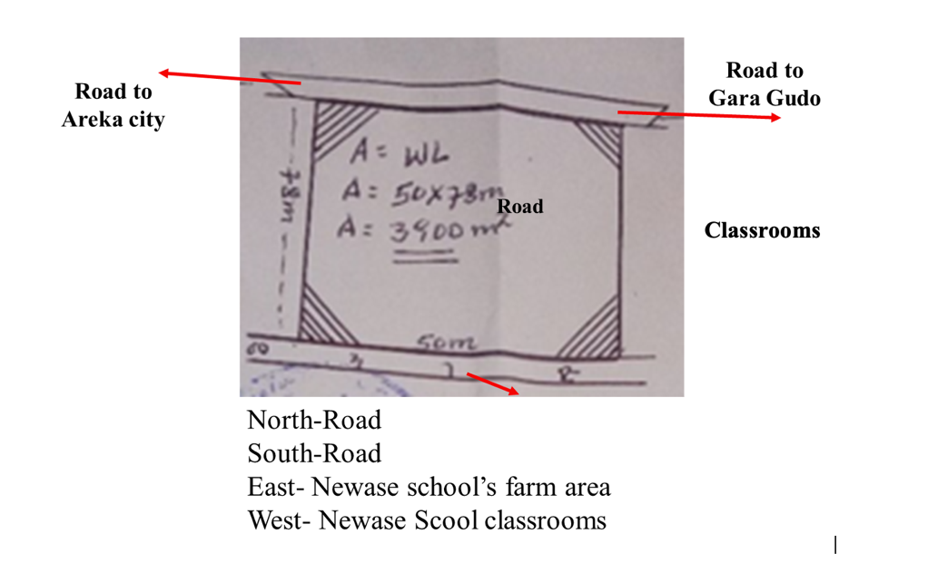

Kebele | Woreda | Place of the school | Area (back site) | Owner | Purpose
Basa gofera Boloso Sore | Boloso Sore | Newase school | 3900km² (50m*78m) | Newase school | Solar Demonstration site

Figure 2 – Back site1, 2, 3 images

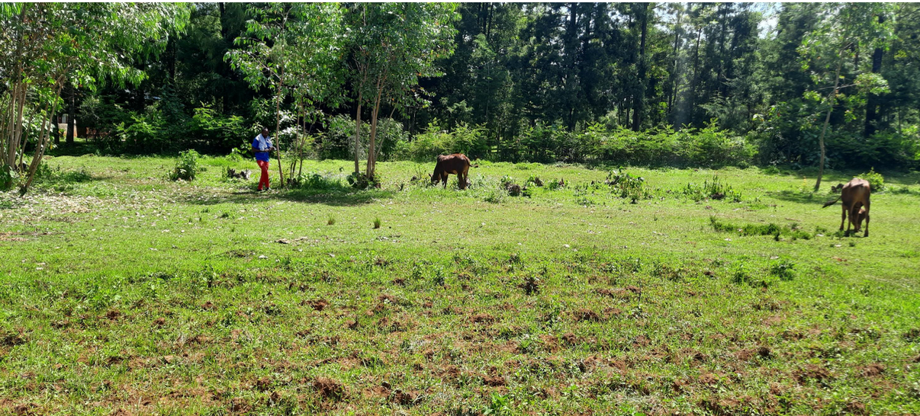

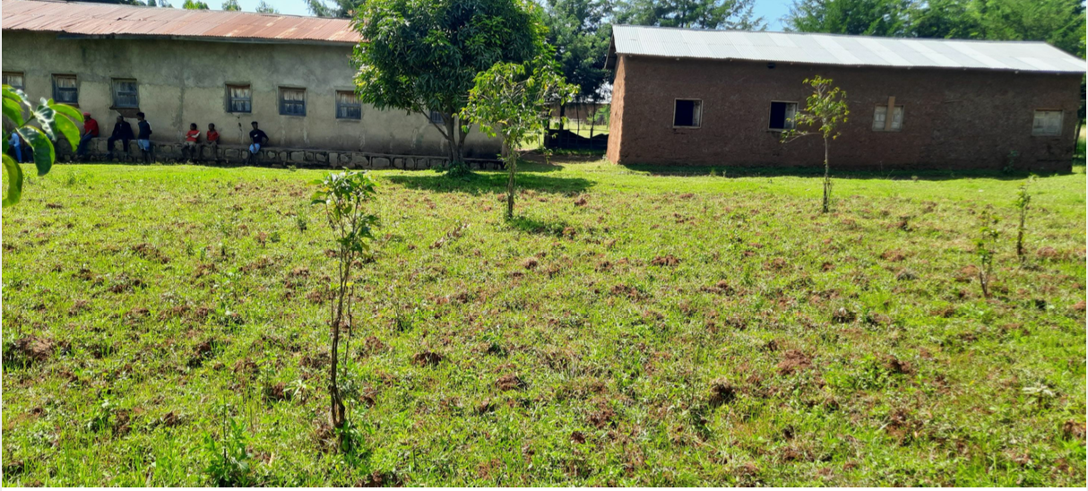

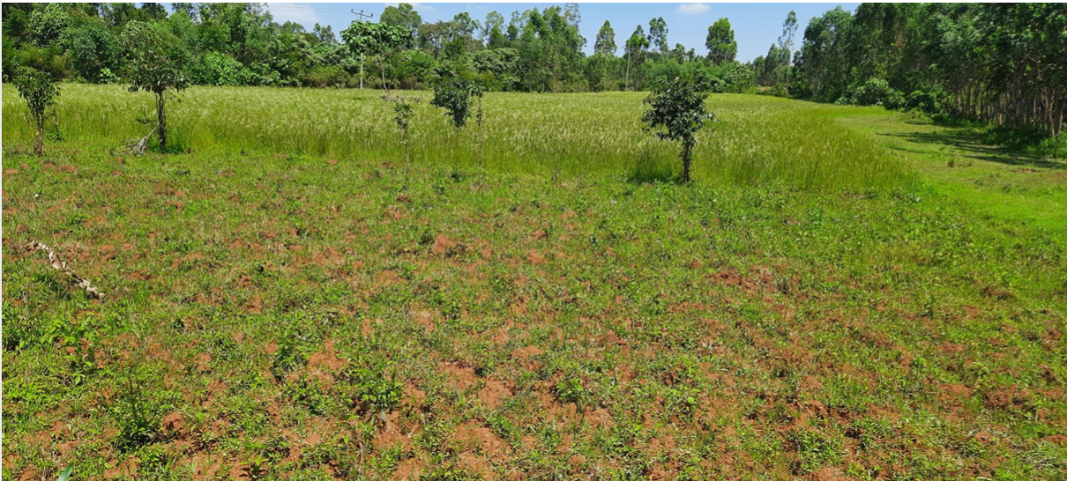

Figure 3 – Director Office, Classrooms images

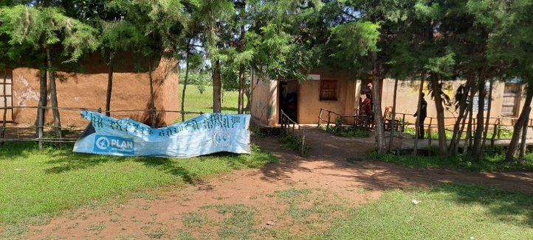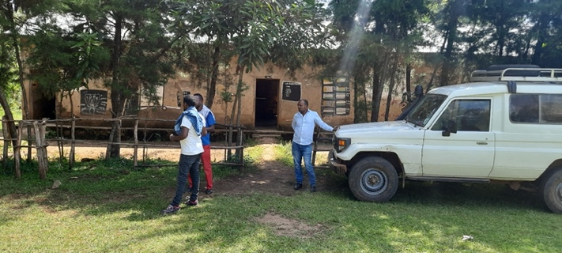

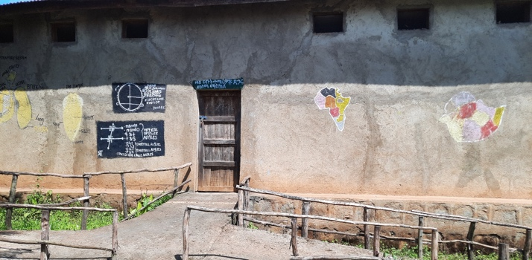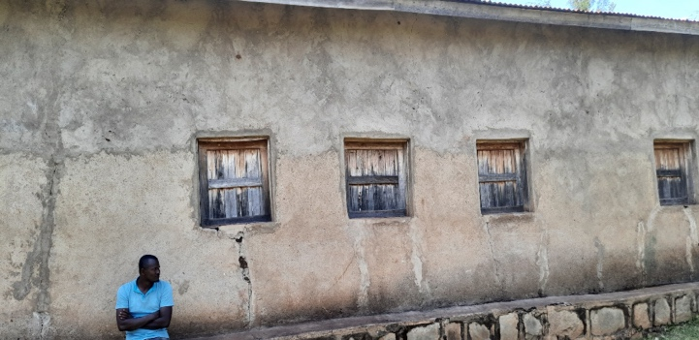

- The school received Desktops, laptops, LCD projectors, LED TVs, and tape recorders from the regional education office and other donors. But the school doesn’t use these all appliances due to the lack of electricity. The energy demand of Newase primary and secondary school from solar PV system is shown below.

Items | Quantity | Wattage(W/unit) | ON time per day | Wh/unit | Wh/day
Bulb | 47 | 25 | 4 | 100 | 4,700
LCD TV | 2 | 55 | 4 | 220 | 440
Desk top computer | 21 | 200 | 4 | 800 | 16,800
Printer | 1 | 120 | 4 | 480 | 480
Photocopy machine | 1 | 180 | 4 | 720 | 720
UPS | 1 | 900 | 4 | 3,600 | 3,600
Total |  |  |  | 5,920 | 26,740

- The details of systems and specifications are described below as follows:
No. | Items | Specification | Unit | Quantity
1 | Solar module | Category: Single-crystal silicon, Grade A  Power: 335w - 455w  Rated voltage: 40- 42V  Rated current: 10 A – 11 A  Module efficiency: about 20.5% - 21.4% | No. | 18
2 | PV module bracket | Hot dip galvanized photovoltaic bracket; C41*62 hot dip galvanized steel; Matching hot dip galvanized screws and nuts. Life span more than 25 years.  Note: Bidder can clearly specify based on site conditions in destinations and must be compatible with all relevant proposed equipment. | Set | 1
3 | MPPT | Operating voltage: 96V  Operating current: 100A  Charging mode: MPPT  Display mode: LCD | No. | 1
4 | Off-grid inverter | Rated power: 10KW  Input voltage: DC96V  Output voltage: AC220V  Wave type: pure sine wave | No. | 1
5 | Valve-controlled, lead acid, maintenance-free colloid storage battery (life cycle: 6 years) | Rated voltage: DC12V，250Ah | No. | 32
6 | Control cabinet and accessories (Outdoor control box, short circuit protection, over voltage and over current protection, lightning protection, temperature detection) | Bidder to clearly specify based on site conditions in destinations, and must be compatible with all relevant proposed equipment | Set | 1
7 | Auxiliary material, e.g., Cables |  | Set | 1
8 | Batteries bracket |  | Set | 1
9 | Photovoltaic bus box (3 in 1 out) |  | Set | 2
Installation: The installation is to provide by the Supplier, hence, all the required accessories and other works related with the installations of the Solar PV System should be indicated in the technical proposal and financial offer.

2. PV System for Harari Education Bureau (Kara Primary School) in Harari Region
- Kara Primary School (Latitude 9.370, Longitude 42.236) is one of the two primary schools selected by Harari Education Bureau in the Erer woreda among eight schools that is not electrified. The school is located in Shenkor Woreda, Harari regional state of Ethiopia.

Figure 4 – Kara Primary School Building image

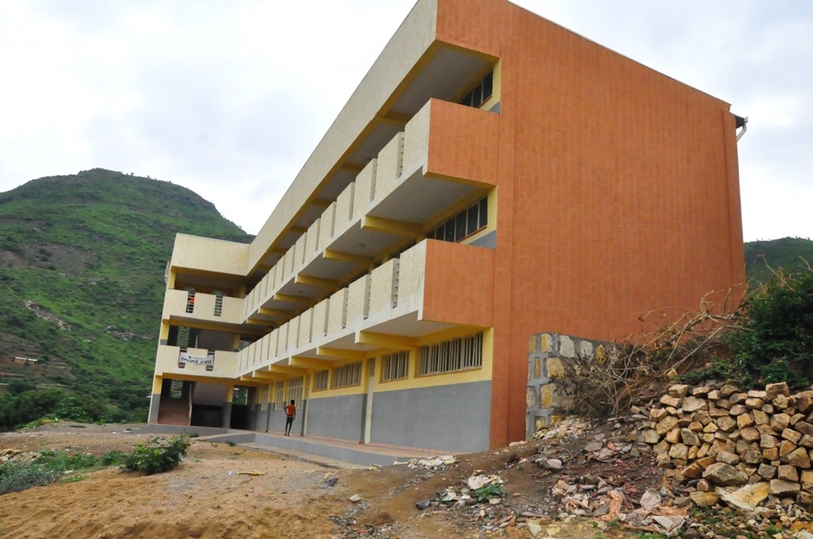

- The Solar Panels are suggested to be located on the roof of the building. The plan of the roof can be seen below in Figure 5.

Figure 5 – Roof design drawings
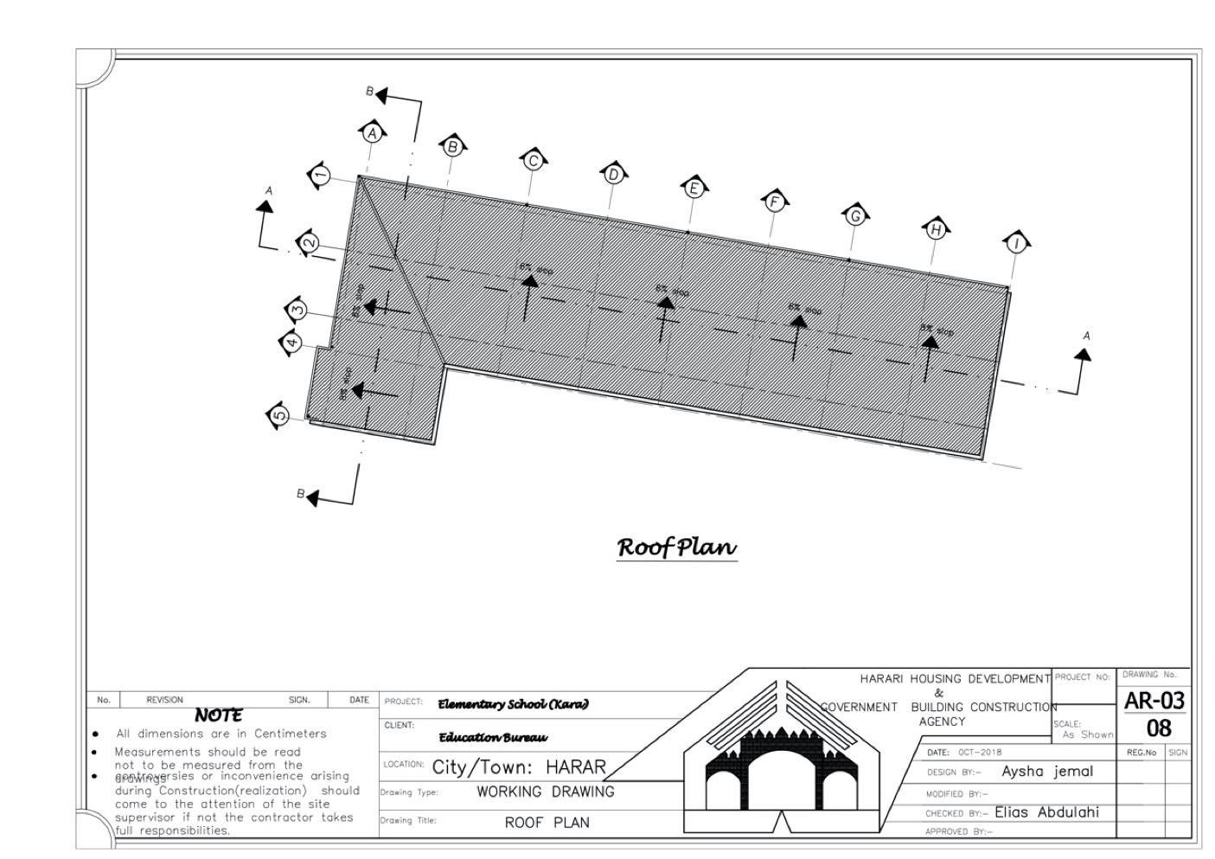
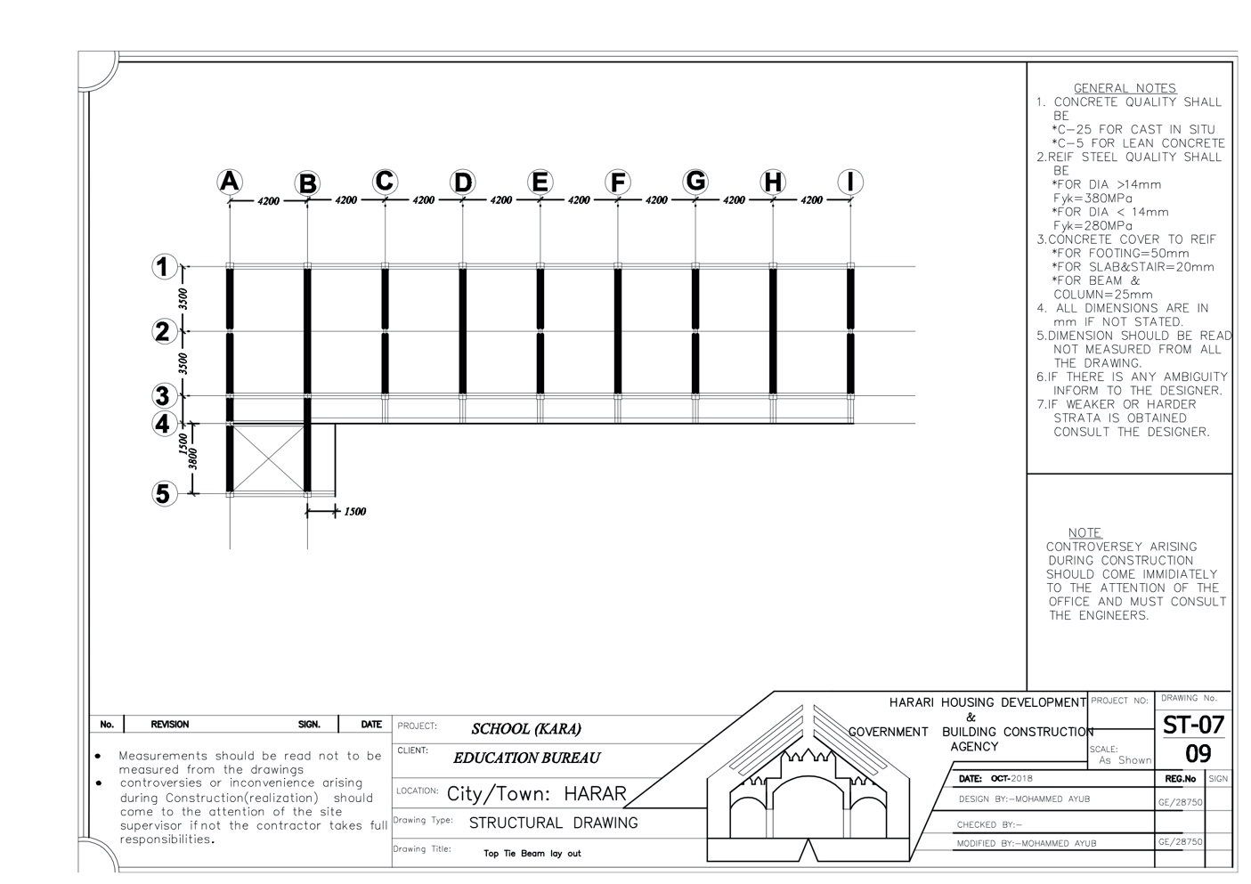

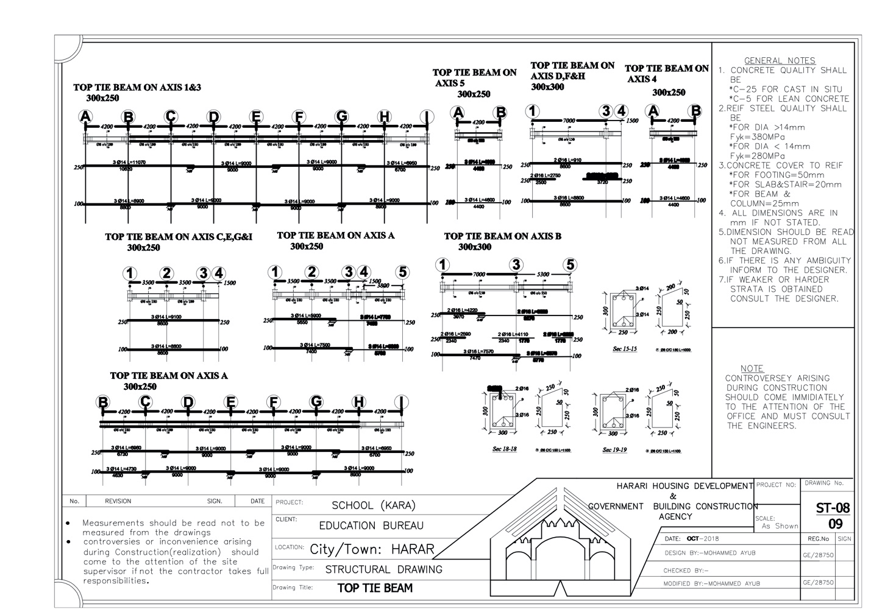

- Since there is no overhead transmission line in the school area, there is no electricity/ energy source and no electric energy expense. The electricity needs of the school is shown below.

No. | Appliances | Powe (W) | No. of Appliances | Daily use(hrs.) | Daily Energy (Wh/d)
1 | Desktop computer | 200 | 25 | 6 | 30000
2 | Led bulb | 8.5 | 75 | 6 | 3825
3 | Amplifier | 150 | 1 | 2 | 300
4 | Laser jet Pro M102a Printer | 380 | 1 | 2 | 760
5 | LCD TV for laboratory | 150 | 2 | 7 | 2100
6 | A satellite dish receiver-SUPER MAX | 60 | 1 | 7 | 420
Total |  |  |  |  | 37405

- The details of systems and specifications are described below as follows:
No. | Items | Specification | Unit | Quantity
1 | Solar module | Category: Single-crystal silicon, Grade A  Power: 335w - 455w  Rated voltage: 40- 42V  Rated current: 10 A – 11 A  Module efficiency: about 20.5% - 21.4% | No. | 27
2 | PV module bracket | Hot dip galvanized photovoltaic bracket; C41*62 hot dip galvanized steel; Matching hot dip galvanized screws and nuts. Life span more than 25 years.  Note: Bidder can clearly specify based on site conditions in destinations and must be compatible with all relevant proposed equipment. | Set | 1
3 | MPPT | Operating voltage: 96V  Operating current: 100A  Charging mode: MPPT  Display mode: LCD | No. | 1
4 | Off-grid inverter | Rated power: 10KW  Input voltage: DC96V  Output voltage: AC220V  Wave type: pure sine wave | No. | 1
5 | Valve-controlled, lead acid, maintenance-free colloid storage battery (life cycle: 6 years) | Rated voltage: DC12V，200Ah | No. | 64
6 | Control cabinet and accessories (Outdoor control box, short circuit protection, over voltage and over current protection, lightning protection, temperature detection) | Bidder to clearly specify based on site conditions in destinations, and must be compatible with all relevant proposed equipment | Set | 1
7 | Auxiliary material, e.g., Cables |  | Set | 1
8 | Batteries bracket |  | Set | 1
9 | Photovoltaic bus box (3 in 1 out) |  | Set | 3
Installation: The installation is to provide by the Supplier, hence, all the required accessories and other works related with the installations of the Solar PV System should be indicated in the technical proposal and financial offer.

3. PV System for Harai Education Bureau (Semire Primary School) in Harari region
- Semire Primary School (Latitude 9.334, Longitude 42.195) is one of the primary schools selected by Harari Education Bureau in the Erer woreda among eight schools that is not electrified. The school is located in Shenkor Woreda, Harari regional state of Ethiopia.

Figure 6 – Semire Primary School Building image

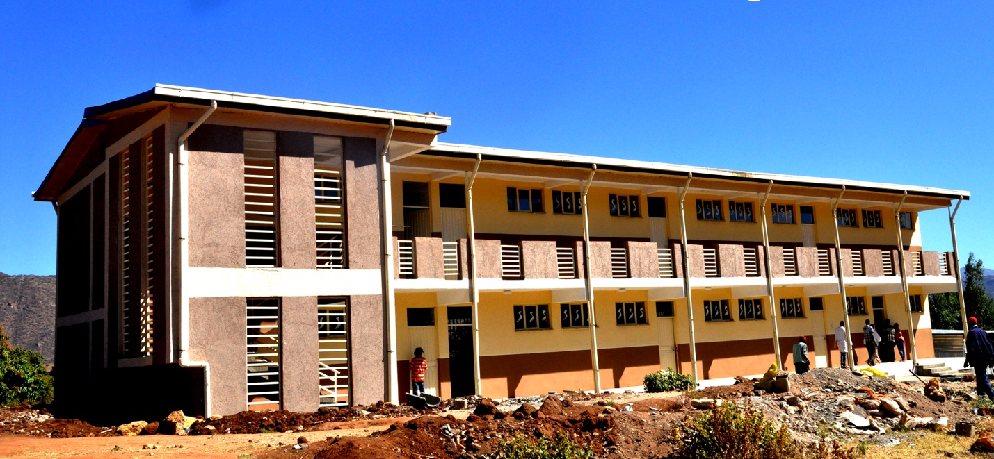

- The Solar Panels are suggested to be located on the roof of the building. The plan of the roof can be seen below in Figure 7.

Figure 7 – Roof design drawings

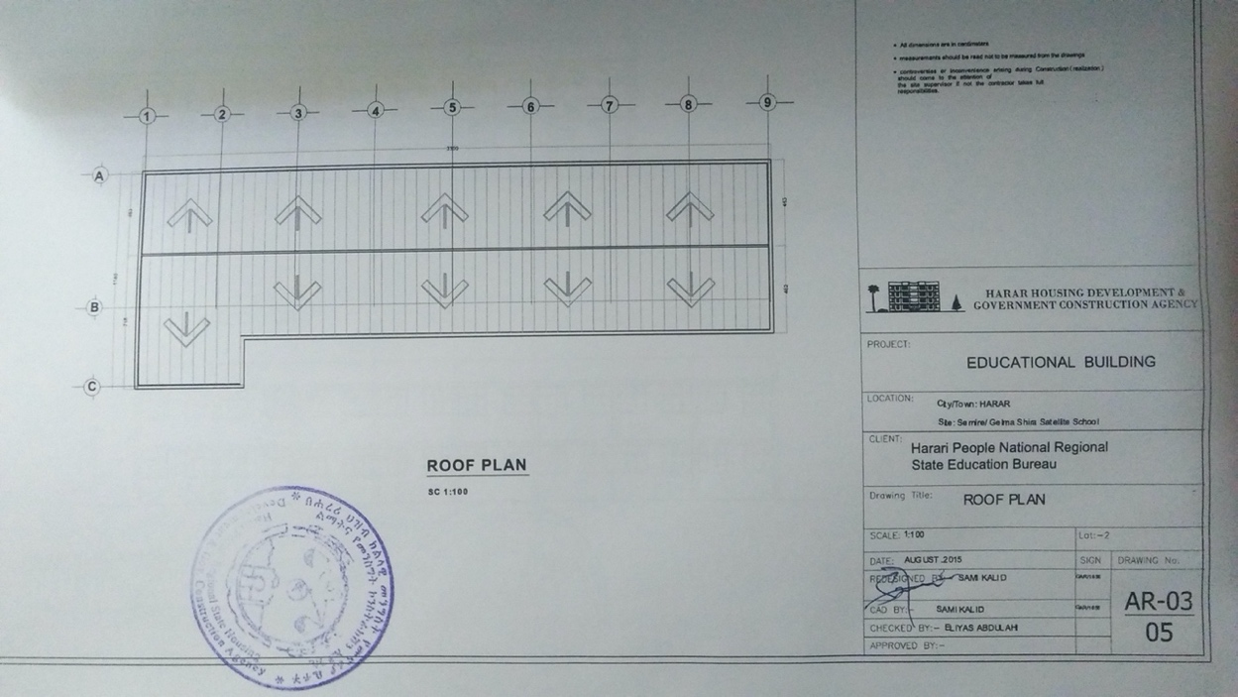

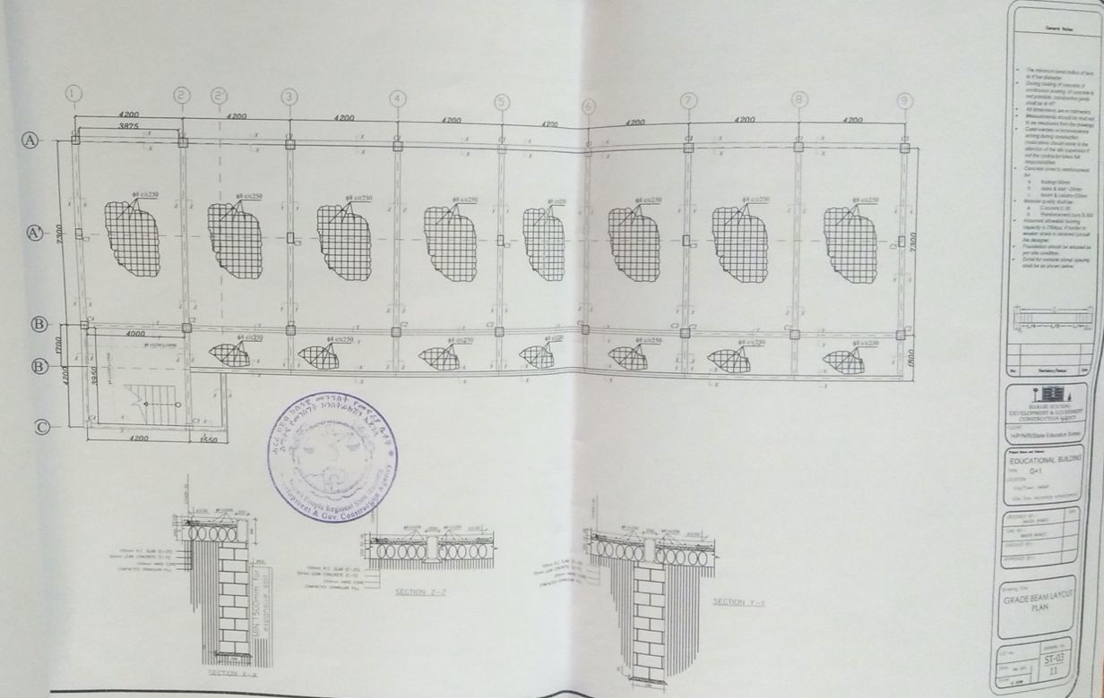

- Since there is no overhead transmission line in the school area, there is no electricity/ energy source and no electric energy expense. The electricity needs of the school is shown below.

No. | Appliances | Power(W) | No. of Appliances | Daily use(hrs.) | Daily Energy (Wh/d)
1 | Desktop computer | 200 | 25 | 6 | 30000
2 | Led bulb | 8.5 | 75 | 6 | 3825
3 | Amplifier | 150 | 1 | 2 | 300
4 | Laser jet Pro M102a Printer | 380 | 1 | 2 | 760
5 | LCD TV for laboratory | 150 | 2 | 7 | 2100
6 | A satellite dish receiver-SUPER MAX | 60 | 1 | 7 | 420
Total |  |  |  |  | 37405

- The details of systems and specifications are described below as follows:
No. | Items | Specification | Unit | Quantity
1 | Solar module | Category: Single-crystal silicon, Grade A  Power: 335w - 455w  Rated voltage: 40- 42V  Rated current: 10 A – 11 A  Module efficiency: about 20.5% - 21.4% | No. | 27
2 | PV module bracket | Hot dip galvanized photovoltaic bracket; C41*62 hot dip galvanized steel; Matching hot dip galvanized screws and nuts. Life span more than 25 years.  Note: Bidder can clearly specify based on site conditions in destinations and must be compatible with all relevant proposed equipment. | Set | 1
3 | MPPT | Operating voltage: 96V  Operating current: 100A  Charging mode: MPPT  Display mode: LCD | No. | 1
4 | Off-grid inverter | Rated power: 10KW  Input voltage: DC96V  Output voltage: AC220V  Wave type: pure sine wave | No. | 1
5 | Valve-controlled, lead acid, maintenance-free colloid storage battery (life cycle: 6 years) | Rated voltage: DC12V，200Ah | No. | 64
6 | Control cabinet and accessories (Outdoor control box, short circuit protection, over voltage and over current protection, lightning protection, temperature detection) | Bidder to clearly specify based on site conditions in destinations, and must be compatible with all relevant proposed equipment | Set | 1
7 | Auxiliary material, e.g., Cables |  | Set | 1
8 | Batteries bracket |  | Set | 1
9 | Photovoltaic bus box (3 in 1 out) |  | Set | 3
Installation: The installation is to provide by the Supplier, hence, all the required accessories and other works related with the installations of the Solar PV System should be indicated in the technical proposal and financial offer.

4. PV System for Amhara Water Irrigation and Energy Development Bureau in Amhara Region
- Amhara Water Irrigation and Energy Development Bureau is located in Ambassel worda (Tisabalima), Amhara National Regional State North Wollo zone of Ethiopia. Its geographical location (GPS) is longitude 39.751and its latitude is 11.566. Groundwater well Irrigation project is located in ANRS North Wollo zone. The site is 56km from Woldia zonal capital, 26km from Woreda, Mersa town. 1km of the road is accessed on foot. The irrigated area is 54 ha. It has a grid system nearby 3.6km from the project site. The distribution line voltage level is 15kV, but this high-tension power is not efficient enough to run a 75kw electrical motor. The electrical line installed from nearby the substation is about 56km. There is suitable place (1000m²) around the powerhouse.

Figure 8 –The areas around the powerhouse and water well images

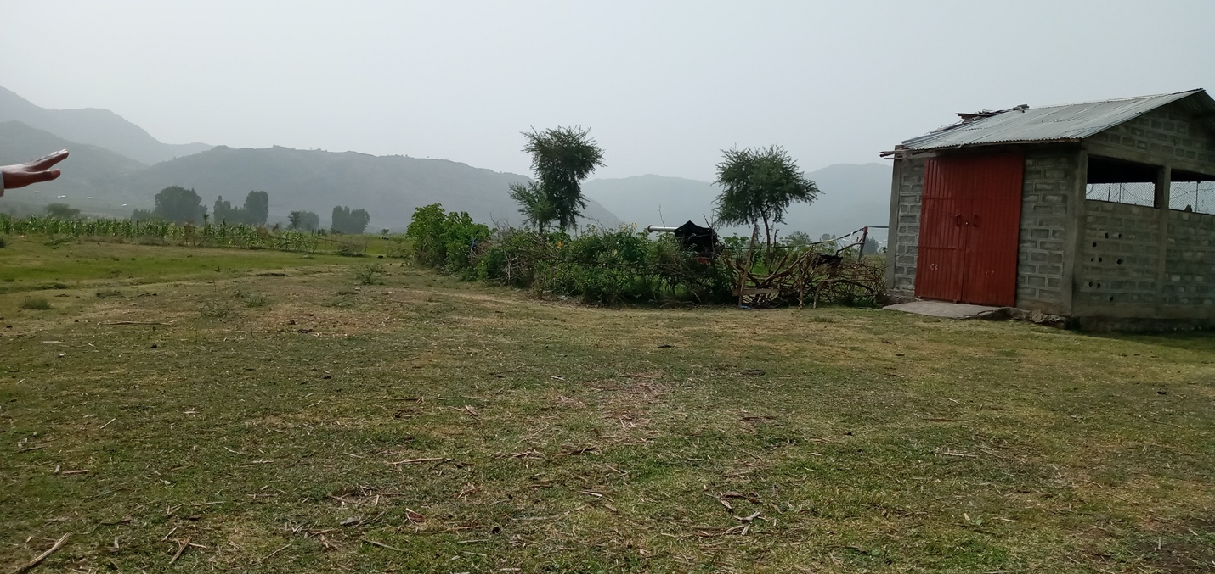

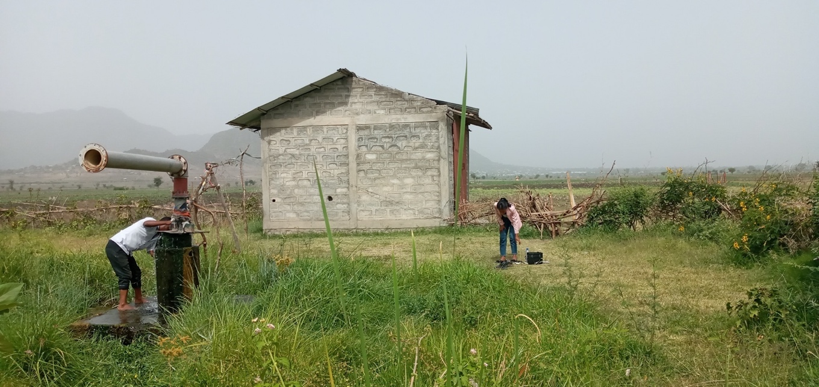

- The details of systems and specifications are described below as follows:
No. | Items | Specification | Unit | Quantity
1 | Solar module | Category: Single-crystal silicon, Grade A  Power: 335w - 455w  Rated voltage: 40- 42V  Rated current: 10 A – 11 A  Module efficiency: about 20.5% - 21.4% | No. | 322
2 | PV module bracket | Hot dip galvanized photovoltaic bracket; C41*62 hot dip galvanized steel; Matching hot dip galvanized screws and nuts. Life span more than 25 years.  Note: Bidder can clearly specify based on site conditions in destinations and must be compatible with all relevant proposed equipment. | Set | 1
3 | Pump | 90-96kW, 380V, Total head>90m | No. | 1
4 | Specific solar pump inverter | 110KW, 380V, Max efficiency 97% | No. | 1
5 | Control cabinet and accessories (Outdoor control box) | Bidder to clearly specify based on site conditions in destinations, and must be compatible with all relevant proposed equipment | Set | 1
6 | Auxiliary material, e.g., Cables |  | Set | 1
7 | Photovoltaic bus box (3 in 1 out) |  | Set | 2
Installation: The installation is to provide by the Supplier, hence, all the required accessories and other works related with the installations of the Solar PV System should be indicated in the technical proposal and financial offer.

Section 5b: Other Related Requirements
Further to the Schedule of Requirements in the preceding Table, Bidders are requested to take note of the following additional requirements, conditions, and related services pertaining to the fulfillment of the requirements: [check the condition that applies to this ITB, delete the entire row if condition is not applicable to the goods being procured]

Delivery Term [INCOTERMS 2020]  (Pls. link this to price schedule) | CIP, Incoterms 2020  (Carriage & Insurance Paid)  The Supplier is responsible for Export packing - Marking & Labelling - Export Clearance - Freight Forwarder Documentation Fees – Sea/Inland Freight to Main Carrier - Origin Terminal Charges - Vessel Loading Charges - Ocean Freight - Nominate Export Forwarder - Unload Main Carrier Charges - Destination Terminal Charges - Nominate on-Carrier.
Exact Address of Delivery/Installation Location | Delivery of the Solar PV Systems to Addis Ababa Customs Office via Djibouti Port;  Delivery of Solar PV Systems to the following Cities within Ethiopia: One week after the machines are cleared from Addis Ababa Customs.  1) Newase Primary and Junior Secondary School in Wolaita Sodo town, SNNPR region  2) Harari Education Bureau (Kara Primary School) in Harari Region  3) Harai Education Bureau (Semire Primary School) in Harari region  4) Amhara Water Irrigation and Energy Development Bureau is located in Ambassel worda (Tisabalima), Amhara National Regional State North Wollo zone of Ethiopia
Mode of Transport Preferred | Sea and land
UNDP Preferred Freight Forwarder, if any | N/A
Distribution of shipping documents  (if using freight forwarder) | N/A
Customs, if required, clearing shall be done by: | UNDP
Ex-factory / Pre-shipment inspection | If there are any inspection Report by Independent party, you can Submit, but it’s optional.
Inspection upon delivery | Required. Up on delivery of the items by the suppliers, the items will be inspected by UNDP and end user for its correctness.
Installation Requirements | Installation/Testing/Commission: Upon delivery of Solar PV Systems to their final destination (specific cities), the Supplier must complete the installation/commission and testing of Machines.  The Supplier must provide the installation schedule for UNDP's review. However, the actual timeline for installation/commissioning and testing shall be discussed with recommended bidder during the pre-contract award phase.
Testing Requirements | Required: Any test for materials shall be on the Supplier cost ( Refer Annex 3 : Detailed ToR and Spec).
Scope of Training on Operation and Maintenance | Provide training material (manual and video clips in English) and in-person/on-site training for the targeted group (no less than 2 persons in each demonstration sites) on how to operate the system and do regular checks or maintenance.
Commissioning | Required
Warranty Period | ☒ The supplier warrants for a minimum period of two (2) years after the sale of that Equipment, other than consumables, will be free from defects in material and workmanship. It is the Seller's sole obligation under this warranty to repair or replace the defective parts at no charge to Purchaser.  ☒ Technical Support on call bases if required for a minimum period of one (1) year
Local Service Support | Required on call base if required for a minimum period of one (1) year is needed
Technical Support Requirements | Required during the installation, Testing and Commissioning. After that, technical support on call basis, if required, for a minimum period of one (1) year.
After-sale Services Requirements | ☒ Warranty on Parts and Labor for a minimum period of one (1) year  ☒ Technical Support on call base if required for a minimum period of one (1) year is needed.  ☒ Provision of Service Unit when pulled out for maintenance /repair  Refer Annex 3 : Detailed ToR and Spec
Payment Terms  (max. advanced payment is 20% as per UNDP policy) | 100% within 30 days upon UNDP’s acceptance of the goods delivered as specified and receipt of invoice
Conditions for Release of Payment | ☒ Inspection upon arrival at destination  ☒ Installation  ☒ Testing  ☒ Training on Operation and Maintenance  ☒ Written Acceptance of Goods based on full compliance with ITB requirements
All documentations, including catalogues, instructions and operating manuals, shall be in this language | English

Section 6: Returnable Bidding Forms / Checklist

This form serves as a checklist for preparation of your Bid. Please complete the Returnable Bidding Forms in accordance with the instructions in the forms and return them as part of your Bid submission. No alteration to format of forms shall be permitted and no substitution shall be accepted.

Before submitting your Bid, please ensure compliance with the Bid Submission instructions of the BDS 22.

Technical Bid:
Have you duly completed all the Returnable Bidding Forms?
- Form A: Bid Submission Form | ☐
- Form B: Bidder Information Form | ☐
- Form C: Joint Venture/Consortium/ Association Information Form | ☐
- Form D: Qualification Form | ☐
- Form E: Format of Technical Bid/Bill of Quantities | ☐
- From G: Form of Bid Security
- [Add other forms as necessary] | ☐
Have you provided the required documents to establish compliance with the evaluation criteria in Section 4? | ☐

Price Schedule:
- Form F: Price Schedule Form | ☐

Form A: Bid Submission Form
Name of Bidder: | [Insert Name of Bidder] | Date: | Select date
ITB reference: | [Insert ITB Reference Number]
We, the undersigned, offer to supply the goods and related services required for [Insert Title of goods and services] in accordance with your Invitation to Bid No. [Insert ITB Reference Number] and our Bid. We hereby submit our Bid, which includes this Technical Bid and Price Schedule.
Our attached Price Schedule is for the sum of [Insert amount in words and figures and indicate currency].
We hereby declare that our firm, its affiliates or subsidiaries or employees, including any JV/Consortium /Association members or subcontractors or suppliers for any part of the contract:
- is not under procurement prohibition by the United Nations, including but not limited to prohibitions derived from the Compendium of United Nations Security Council Sanctions Lists;
- have not been suspended, debarred, sanctioned or otherwise identified as ineligible by any UN Organization or the World Bank Group or any other international Organization;
- have no conflict of interest in accordance with Instruction to Bidders Clause 4;
- do not employ, or anticipate employing, any person(s) who is, or has been a UN staff member within the last year, if said UN staff member has or had prior professional dealings with our firm in his/her capacity as UN staff member within the last three years of service with the UN (in accordance with UN post-employment restrictions published in ST/SGB/2006/15);
- have not declared bankruptcy, are not involved in bankruptcy or receivership proceedings, and there is no judgment or pending legal action against them that could impair their operations in the foreseeable future;
- undertake not to engage in proscribed practices, including but not limited to corruption, fraud, coercion, collusion, obstruction, or any other unethical practice, with the UN or any other party, and to conduct business in a manner that averts any financial, operational, reputational or other undue risk to the UN and we embrace the principles of the United Nations Supplier Code of Conduct and adhere to the principles of the United Nations Global Compact.
We declare that all the information and statements made in this Bid are true and we accept that any misinterpretation or misrepresentation contained in this Bid may lead to our disqualification and/or sanctioning by the UNDP.
We offer to supply the goods and related services in conformity with the Bidding documents, including the UNDP General Conditions of Contract and in accordance with the Schedule of Requirements and Technical Specifications.
Our Bid shall be valid and remain binding upon us for the period specified in the Bid Data Sheet.
We understand and recognize that you are not bound to accept any Bid you receive.
I, the undersigned, certify that I am duly authorized by [Insert Name of Bidder] to sign this Bid and bind it should UNDP accept this Bid.
Name: _____________________________________________________________
Title: _____________________________________________________________
Date: _____________________________________________________________
Signature: _____________________________________________________________
[Stamp with official stamp of the Bidder]

Form B: Bidder Information Form
Legal name of Bidder | [Complete]
Legal address | [Complete]
Year of registration | [Complete]
Bidder’s Authorized Representative Information | Name and Title: [Complete]  Telephone numbers: [Complete]  Email: [Complete]
Are you a UNGM registered vendor? | ☐ Yes ☐ No If yes, [insert UGNM vendor number]
Are you a UNDP vendor? | ☐ Yes ☐ No If yes, [insert UNDP vendor number]
Countries of operation | [Complete]
No. of full-time employees | [Complete]
Quality Assurance Certification (e.g. ISO 9000 or Equivalent) (If yes, provide a Copy of the valid Certificate): | [Complete]
Does your Company hold any accreditation such as ISO 14001 or ISO 14064 or equivalent related to the environment? (If yes, provide a Copy of the valid Certificate): | [Complete]
Does your Company have a written Statement of its Environmental Policy? (If yes, provide a Copy) | [Complete]
Does your organization demonstrates significant commitment to sustainability through some other means, for example internal company policy documents on women empowerment, renewable energies or membership of trade institutions promoting such issues | [Complete]
Is your company a member of the UN Global Compact | [Complete]
Contact person that UNDP may contact for requests for clarifications during Bid evaluation | Name and Title: [Complete]  Telephone numbers: [Complete]  Email: [Complete]
Please attach the following documents: | - Company Profile, which should not exceed fifteen (15) pages, including printed brochures and product catalogues relevant to the goods and/or services being procured  - Certificate of Incorporation/ Business Registration  - Tax Registration/Payment Certificate issued by the Internal Revenue Authority evidencing that the Bidder is updated with its tax payment obligations, or Certificate of Tax exemption, if any such privilege is enjoyed by the Bidder  - Trade name registration papers, if applicable  - Quality Certificate (e.g., ISO, etc.) and/or other similar certificates, accreditations, awards and citations received by the Bidder, if any  - Environmental Compliance Certificates, Accreditations, Markings/Labels, and other evidences of the Bidder’s practices which contributes to the ecological sustainability and reduction of adverse environmental impact (e.g., use of non-toxic substances, recycled raw materials, energy-efficient equipment, reduced carbon emission, etc.), either in its business practices or in the goods it manufactures  - Patent Registration Certificates, if any of technologies submitted in the Bid is patented by the Bidder  - Certification or authorization to act as Agent on behalf of the Manufacturer, or Power of Attorney.  - Export Licenses, if applicable  - Local Government permit to locate and operate in assignment location, if applicable  - Official Letter of Appointment as local representative, if Bidder is submitting a Bid on behalf of an entity located outside the country

Form C: Joint Venture/Consortium/Association Information Form

Name of Bidder: | [Insert Name of Bidder] | Date: | Select date
ITB reference: | [Insert ITB Reference Number]

To be completed and returned with your Bid if the Bid is submitted as a Joint Venture/Consortium/Association.

No | Name of Partner and contact information (address, telephone numbers, fax numbers, e-mail address) | Proposed proportion of responsibilities (in %) and type of goods and/or services to be performed
1 | [Complete] | [Complete]
2 | [Complete] | [Complete]
3 | [Complete] | [Complete]

Name of leading partner  (with authority to bind the JV, Consortium, Association during the ITB process and, in the event a Contract is awarded, during contract execution) | [Complete]

We have attached a copy of the below referenced document signed by every partner, which details the likely legal structure of and the confirmation of joint and severable liability of the members of the said joint venture:

☐ Letter of intent to form a joint venture OR ☐ JV/Consortium/Association agreement

We hereby confirm that if the contract is awarded, all parties of the Joint Venture/Consortium/Association shall be jointly and severally liable to UNDP for the fulfillment of the provisions of the Contract.

Name of partner: ___________________________________ | Name of partner: ___________________________________
Signature: ______________________________ | Signature: _______________________________
Date: ___________________________________ | Date: ___________________________________
Name of partner: ___________________________________ | Name of partner: ___________________________________
Signature: ______________________________ | Signature: _______________________________
Date: ___________________________________ | Date: ___________________________________

Form D: Eligibility and Qualification Form

Name of Bidder: | [Insert Name of Bidder] | Date: | Select date
ITB reference: | [Insert ITB Reference Number]

If JV/Consortium/Association, to be completed by each partner.

History of Non- Performing Contracts
☐Non-performing contracts did not occur during the last 3 years
☐ Contract(s) not performed in the last 3 years
Year | Non- performed portion of contract | Contract Identification | Total Contract Amount (current value in US$)
Name of Client:
Address of Client:
Reason(s) for non-performance:

Litigation History (including pending litigation)
☐ No litigation history for the last 3 years
☐ Litigation History as indicated below
Year of dispute | Amount in dispute (in US$) | Contract Identification | Total Contract Amount (current value in US$)
Name of Client:
Address of Client:
Matter in dispute:
Party who initiated the dispute:
Status of dispute:
Party awarded if resolved:

Previous Relevant Experience
Please list only previous similar assignments successfully completed in the last 3 years.

List only those assignments for which the Bidder was legally contracted or sub-contracted by the Client as a company or was one of the Consortium/JV partners. Assignments completed by the Bidder’s individual experts working privately or through other firms cannot be claimed as the relevant experience of the Bidder, or that of the Bidder’s partners or sub-consultants, but can be claimed by the Experts themselves in their CVs. The Bidder should be prepared to substantiate the claimed experience by presenting copies of relevant documents and references if so requested by UNDP.
Hence, please list the previous similar assignments successful completed ( as per the attached table) and we will use them to carryout out background check:

Project name & Country of Assignment | Client & Reference Contact Details | Contract Value | Period of activity and status | Types of activities undertaken
Bidders may also attach their own Project Data Sheets with more details for assignments above.
☐ Please attach the Statements of Satisfactory Performance from the Top 3 (three) Clients or more.

Financial Standing
Annual Turnover for the last 3 years | Year USD  Year USD  Year USD
Latest Credit Rating (if any), indicate the source

Financial information  (in US$ equivalent) | Historic information for the last 3 years
 | Year 1 | Year 2 | Year 3
 | Information from Balance Sheet
Total Assets (TA)
Total Liabilities (TL)
Current Assets (CA)
Current Liabilities (CL)
 | Information from Income Statement
Total / Gross Revenue (TR)
Profits Before Taxes (PBT)
Net Profit
Current Ratio
☐ Attached are copies of the audited financial statements (balance sheets, including all related notes, and income statements) for the years required above complying with the following condition:
  - Must reflect the financial situation of the Bidder or party to a JV, and not sister or parent companies;
  - Historic financial statements must be audited by a certified public accountant;
  - Historic financial statements must correspond to accounting periods already completed and audited. No statements for partial periods shall be accepted.

Form E: Format of Technical Bid

Name of Bidder: | [Insert Name of Bidder] | Date: | Select date
ITB reference: | [Insert ITB Reference Number]

The Bidder’s Bid should be organized to follow this format of the Technical Bid. Where the bidder is presented with a requirement or asked to use a specific approach, the bidder must not only state its acceptance, but also describe how it intends to comply with the requirements. Where a descriptive response is requested, failure to provide the same will be viewed as non-responsive.

SECTION 1: Bidder’s qualification, capacity and expertise

  - General organizational capability which is likely to affect implementation: management structure, financial stability and project financing capacity, project management controls, extent to which any work would be subcontracted (if so, provide details).
  - Relevance of specialized knowledge and experience on similar engagements done in the region/country.
  - Quality assurance procedures and risk mitigation measures.
  - Organization’s commitment to sustainability.

SECTION 2: Scope of Supply, Technical Specifications, and Related Services
This section should demonstrate the Bidder’s responsiveness to the specification by identifying the specific components proposed, addressing the requirements, as specified, point by point; providing a detailed description of the essential performance characteristics proposed; and demonstrating how the proposed bid meets or exceeds the requirements/specifications. All important aspects should be addressed in sufficient detail.
  - A detailed description of how the Bidder will deliver the required goods and services, keeping in mind the appropriateness to local conditions and project environment. Details how the different service elements shall be organized, controlled and delivered.
  - Explain whether any work would be subcontracted, to whom, how much percentage of the requirements, the rationale for such, and the roles of the proposed sub-contractors and how everyone will function as a team.
  - The bid shall also include details of the Bidder’s internal technical and quality assurance review mechanisms.
  - Implementation plan including a Gantt Chart or Project Schedule indicating the detailed sequence of activities that will be undertaken and their corresponding timing.
  - Demonstrate how you plan to integrate sustainability measures in the execution of the contract.

Note to Bidders: You can use either the attached excel sheet ( Annex- ) to fill out your items or you can copy Column “a”, of Section 5a. Related services and requirements such as installation, training and after-sales should also be listed as required.
Goods and services to be Supplied and  Technical Specifications | Your response
 | Compliance with technical specifications |  | Delivery Date  (confirm that you comply or indicate your delivery date) | Quality Certificate/Export Licenses, etc. (indicate all that apply and attach) | Comments
 | Yes, we comply | No, we cannot comply  (indicate discrepancies)

Other Related services and requirements  (based on the information provided in Section 5b) | Compliance with requirements |  | Details or comments  on the related requirements
 | Yes, we comply | No, we cannot comply  (indicate discrepancies)
Delivery Term of 90 days (3months)
Two Year Manufacture Warranty
Local Service Support
After Sales Service Requirements

SECTION 3: Management Structure and Key Personnel
  - Describe the overall management approach toward planning and implementing the project. Include an organization chart for the management of the project describing the relationship of key positions and designations. Provide a spreadsheet to show the activities of each personnel and the time allocated for his/her involvement. The proposed project manager and team for this project needs to have the relevant experiences in the area and the Project manager needs to have a communication skill in English.
  - Provide CVs for key personnel that will be provided to support the implementation of this project using the format below. CVs should demonstrate qualifications in areas relevant to the scope of goods and/or services.

Management Structure and Key Personnel

Designation | Resp. | QTY | Qualification | Min Relevant Work  experience
Team / Project leader | Responsible in managing, overseeing, and delivering outputs of the assignment and key communication person with UNDP | 1 | - Minimum Bachelor’s degree in civil/electrical/mechanical engineering | - Specific experience relevant to the assignment – at least 5 years  - Regional/Ethiopia experience  - Experience of project manager position on similar reference overseas projects
Site manager | Responsible in managing implementation all the works at the location | 1 | - Minimum Bachelor’s degree in civil/electrical/mechanical engineering | - Specific experience relevant to the assignment – at least 3 years  - Regional/Ethiopia experience
Mechanical engineer | Responsible in designing a high-quality mechanical design and installation | 1 | - Minimum Bachelor’s degree in mechanical engineering | - Experience: >5 years in industry; plant engineering, installation of mechanical equipment  - Good knowledge of Regional or Ethiopian construction regulations
Electrical engineer | Responsible in designing a high-quality electrical design and installation | 1 | - Minimum Bachelor’s degree in electrical engineering | - Experience: >5 years in industry; design and implementation of electrical installations, small to medium scale electricity generation systems  - Good knowledge of Regional or Ethiopian electrical installation regulations
Civil engineer | Responsible in designing a high-quality civil design and civil work | 1 | - Minimum Bachelor’s degree in civil engineering | - Specific experience relevant to the assignment – at least 3 years

Format for CV of Proposed Key Personnel
Name of Personnel | [Insert]
Position for this assignment | [Insert]
Nationality | [Insert]
Language proficiency | [Insert]
Education/ Qualifications | [Summarize college/university and other specialized education of personnel member, giving names of schools, dates attended, and degrees/qualifications obtained.]
 | [Insert]
Professional certifications | [Provide details of professional certifications relevant to the scope of goods and/or services]
- Name of institution: [Insert]
- Date of certification: [Insert]
Employment Record/ Experience | [List all positions held by personnel (starting with present position, list in reverse order), giving dates, names of employing organization, title of position held and location of employment. For experience in last five years, detail the type of activities performed, degree of responsibilities, location of assignments and any other information or professional experience considered pertinent for this assignment.]
 | [Insert]
References | [Provide names, addresses, phone and email contact information for two (2) references]
Reference 1:
[Insert]

Reference 2:
[Insert]

I, the undersigned, certify that to the best of my knowledge and belief, the data provided above correctly describes my qualifications, my experiences, and other relevant information about myself.

________________________________________ ___________________
Signature of Personnel Date (Day/Month/Year)

FORM F: Price Schedule Form

Name of Bidder: | [Insert Name of Bidder] | Date: | Select date
ITB reference: | [Insert ITB Reference Number]
The Bidder is required to prepare the Price Schedule following the below format. The Price Schedule must include a detailed cost breakdown of all goods and related services to be provided. Separate figures must be provided for each functional grouping or category, if any.

Any estimates for cost-reimbursable items, such as travel of experts and out-of-pocket expenses, should be listed separately.

NB: We have attached an excel sheet as Annex 2: Price Schedule to enable you to properly fill all the list of equipment, accessories and other related costs for each location/sites.
Currency of the Bid: [Insert Currency]
Price Schedule
Item # | Description | UOM | Quantity | Unit Price | Total Price
FCA charges, if any
Bid Subtotal FCA (Incoterms 2020)
(please state FCA International Airport):
Transportation/Delivery Cost
Bid Total CIP , off-loaded/cleared, Place, Country (Incoterms 2020)
Installation
Training
Warranty
After Sales
GRAND TOTAL

Note: UNDP reserves the right to vary the quantity of the goods up to a maximum of twenty-five per cent (25%) of the total offer, without any change in the unit price or other terms and conditions.
Name of Bidder: ________________________________________________
Authorised signature: ________________________________________________
Name of authorised signatory: ________________________________________________
Functional Title: _______________________________________________

FORM G: Form of Bid Security

Bid Security must be issued using the official letterhead of the Issuing Bank.
Except for indicated fields, no changes may be made on this template.

To: UNDP
[Insert contact information as provided in Data Sheet]

WHEREAS [Name and address of Bidder] (hereinafter called “the Bidder”) has submitted a Bid to UNDP dated Click here to enter a date. to execute goods and/or services [Insert Title of Goods and/or Services] (hereinafter called “the Bid”):

AND WHEREAS it has been stipulated by you that the Bidder shall furnish you with a Bank Guarantee by a recognized bank for the sum specified therein as security if the Bidder:

- Fails to sign the Contract after UNDP has awarded it;
- Withdraws its Bid after the date of the opening of the Bids;
- Fails to comply with UNDP’s variation of requirement, as per ITB instructions; or
- Fails to furnish Performance Security, insurances, or other documents that UNDP may require as a condition to rendering the contract effective.

AND WHEREAS we have agreed to give the Bidder such Bank Guarantee:

NOW THEREFORE we hereby affirm that we are the Guarantor and responsible to you, on behalf of the Bidder, up to a total of [amount of guarantee] [in words and numbers], such sum being payable in the types and proportions of currencies in which the Price Bid is payable, and we undertake to pay you, upon your first written demand and without cavil or argument, any sum or sums within the limits of [amount of guarantee as aforesaid] without your needing to prove or to show grounds or reasons for your demand for the sum specified therein.

This guarantee shall be valid up to 30 days after the final date of validity of bids.

SIGNATURE AND SEAL OF THE GUARANTOR BANK
Signature: _____________________________________________________________
Name: _____________________________________________________________
Title: _____________________________________________________________
Date: _____________________________________________________________
Name of Bank __________________________________________________________
Address ________________________________________________________________
[Stamp with official stamp of the Bank]
[insert: address and email address]
35

Non-performance, as decided by UNDP, shall include all contracts where (a) non-performance was not challenged by the contractor, including through referral to the dispute resolution mechanism under the respective contract, and (b) contracts that were so challenged but fully settled against the contractor. Non-performance shall not include contracts where Employers decision was overruled by the dispute resolution mechanism. Non-performance must be based on all information on fully settled disputes or litigation, i.e. dispute or litigation that has been resolved in accordance with the dispute resolution mechanism under the respective contract and where all appeal instances available to the Bidder have been exhausted.
A factor of the Incoterms stipulated in the ITB. The use of a UNDP preferred freight forwarder may be considered for purposes of ensuring forwarder’s familiarity with procedures and processing of documentary requirements applicable to UNDP when clearing with customs authority of the country of destination.

