INVITATION TO BID
DRILLING OF ADDITIONAL BOREHOLE IN GUMSURI, REHABILITATION OF GUMSURI-DAMBOA WATER PIPELINE AND SOLARIZATION OF DAMBOA RESERVIOR WATER SUPPLY SYSTEM AT DAMBOA, DAMBOA LGA, BORNO STATE
ITB No.: UNDP/NGA/2019/011
Country: NIGERIA
Issued on: 20 August 2019

Contents
Section 1. Letter of Invitation 4
Section 2. Instruction to Bidders 5
A. GENERAL PROVISIONS 5
1. Introduction 5
2. Fraud & Corruption, Gifts and Hospitality 5
3. Eligibility 5
4. Conflict of Interests 6
B. PREPARATION OF BIDS 6
5. General Considerations 6
6. Cost of Preparation of Bid 6
7. Language 7
8. Documents Comprising the Bid 7
9. Documents Establishing the Eligibility and Qualifications of the Bidder 7
10. Technical Bid Format and Content 7
11. Price Schedule 7
12. Bid Security 7
13. Currencies 8
14. Joint Venture, Consortium or Association 8
15. Only One Bid 9
16. Bid Validity Period 9
17. Extension of Bid Validity Period 9
18. Clarification of Bid (from the Bidders) 9
19. Amendment of Bids 10
20. Alternative Bids 10
21. Pre-Bid Conference 10
C. SUBMISSION AND OPENING OF BIDS 10
22. Submission 10
Hard copy (manual) submission 10
Email and eTendering submissions 11
23. Deadline for Submission of Bids and Late Bids 11
24. Withdrawal, Substitution, and Modification of Bids 11
25. Bid Opening 11
D. EVALUATION OF BIDS 12
26. Confidentiality 12
27. Evaluation of Bids 12
28. Preliminary Examination 12
29. Evaluation of Eligibility and Qualification 12
30. Evaluation of Technical Bid and prices 12
31. Due diligence 13
32. Clarification of Bids 13
33. Responsiveness of Bid 13
34. Nonconformities, Reparable Errors and Omissions 13
E. AWARD OF CONTRACT 14
35. Right to Accept, Reject, Any or All Bids 14
36. Award Criteria 14
37. Debriefing 14
38. Right to Vary Requirements at the Time of Award 14
39. Contract Signature 14
40. Contract Type and General Terms and Conditions 14
41. Performance Security 14
42. Bank Guarantee for Advanced Payment 15
43. Liquidated Damages 15
44. Payment Provisions 15
45. Vendor Protest 15
46. Other Provisions 15
Section 3. Bid Data Sheet 16
Section 4. Evaluation Criteria 19
Section 5a: Schedule of Requirements and Technical Specifications/Bill of Quantities 19
Section 5b: Other Related Requirements Error! Bookmark not defined.
Section 6: Returnable Bidding Forms / Checklist 21
Form A: Bid Submission Form 27
Form B: Bidder Information Form 28
Form C: Joint Venture/Consortium/Association Information Form 30
Form D: Eligibility and Qualification Form 31
Form E: Technical Bid FORMAT 33

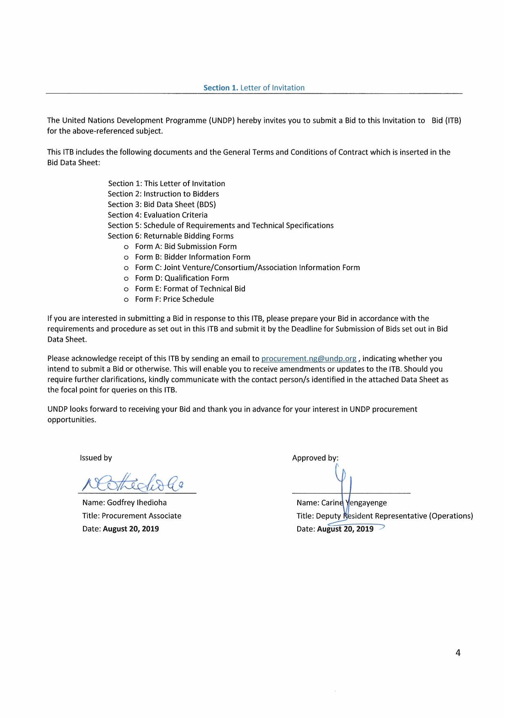

Section 2. Instruction to Bidders

GENERAL PROVISIONS
Introduction | - Bidders shall adhere to all the requirements of this ITB, including any amendments made in writing by UNDP. This ITB is conducted in accordance with the UNDP Programme and Operations Policies and Procedures (POPP) on Contracts and Procurement which can be accessed at https://popp.undp.org/SitePages/POPPBSUnit.aspx?TermID=254a9f96-b883-476a-8ef8-e81f93a2b38d  - Any Bid submitted will be regarded as an offer by the Bidder and does not constitute or imply the acceptance of the Bid by UNDP. UNDP is under no obligation to award a contract to any Bidder as a result of this ITB.  - UNDP reserves the right to cancel the procurement process at any stage without any liability of any kind for UNDP, upon notice to the bidders or publication of cancellation notice on UNDP website.  - As part of the bid, it is desired that the Bidder registers at the United Nations Global Marketplace (UNGM) website (www.ungm.org). The Bidder may still submit a bid even if not registered with the UNGM. However, if the Bidder is selected for contract award, the Bidder must register on the UNGM prior to contract signature.
Fraud & Corruption,  Gifts and Hospitality | - UNDP strictly enforces a policy of zero tolerance on proscribed practices, including fraud, corruption, collusion, unethical or unprofessional practices, and obstruction of UNDP vendors and requires all bidders/vendors observe the highest standard of ethics during the procurement process and contract implementation. UNDP’s Anti-Fraud Policy can be found at http://www.undp.org/content/undp/en/home/operations/accountability/audit/office_of_audit_andinvestigation.html#anti  - Bidders/vendors shall not offer gifts or hospitality of any kind to UNDP staff members including recreational trips to sporting or cultural events, theme parks or offers of holidays, transportation, or invitations to extravagant lunches or dinners.  - In pursuance of this policy, UNDP:  (a) Shall reject a bid if it determines that the selected bidder has engaged in any corrupt or fraudulent practices in competing for the contract in question;  (b) Shall declare a vendor ineligible, either indefinitely or for a stated period, to be awarded a contract if at any time it determines that the vendor has engaged in any corrupt or fraudulent practices in competing for, or in executing a UNDP contract.  - All Bidders must adhere to the UN Supplier Code of Conduct, which may be found at http://www.un.org/depts/ptd/pdf/conduct_english.pdf
Eligibility | - A vendor should not be suspended, debarred, or otherwise identified as ineligible by any UN Organization or the World Bank Group or any other international Organization. Vendors are therefore required to disclose to UNDP whether they are subject to any sanction or temporary suspension imposed by these organizations.  - It is the Bidder’s responsibility to ensure that its employees, joint venture members, sub-contractors, service providers, suppliers and/or their employees meet the eligibility requirements as established by UNDP.
Conflict of Interests | - Bidders must strictly avoid conflicts with other assignments or their own interests, and act without consideration for future work. Bidders found to have a conflict of interest shall be disqualified. Without limitation on the generality of the above, Bidders, and any of their affiliates, shall be considered to have a conflict of interest with one or more parties in this solicitation process, if they:  - Are or have been associated in the past, with a firm or any of its affiliates which have been engaged by UNDP to provide services for the preparation of the design, specifications, Terms of Reference, cost analysis/estimation, and other documents to be used for the procurement of the goods and services in this selection process;  - Were involved in the preparation and/or design of the programme/project related to the goods and/or services requested under this ITB; or  - Are found to be in conflict for any other reason, as may be established by, or at the discretion of UNDP.  - In the event of any uncertainty in the interpretation of a potential conflict of interest, Bidders must disclose to UNDP, and seek UNDP’s confirmation on whether or not such conflict exists.  - Similarly, the Bidders must disclose in their Bid their knowledge of the following:  - If the owners, part-owners, officers, directors, controlling shareholders, of the bidding entity or key personnel who are family members of UNDP staff involved in the procurement functions and/or the Government of the country or any Implementing Partner receiving goods and/or services under this ITB; and  - All other circumstances that could potentially lead to actual or perceived conflict of interest, collusion or unfair competition practices.  Failure to disclose such an information may result in the rejection of the Bid or Bids affected by the non-disclosure.  - The eligibility of Bidders that are wholly or partly owned by the Government shall be subject to UNDP’s further evaluation and review of various factors such as being registered, operated and managed as an independent business entity, the extent of Government ownership/share, receipt of subsidies, mandate and access to information in relation to this ITB, among others. Conditions that may lead to undue advantage against other Bidders may result in the eventual rejection of the Bid.

PREPARATION OF BIDS
General Considerations | - In preparing the Bid, the Bidder is expected to examine the ITB in detail. Material deficiencies in providing the information requested in the ITB may result in rejection of the Bid.  - The Bidder will not be permitted to take advantage of any errors or omissions in the ITB. Should such errors or omissions be discovered, the Bidder must notify the UNDP accordingly.
Cost of Preparation of Bid | - The Bidder shall bear all costs related to the preparation and/or submission of the Bid, regardless of whether its Bid is selected or not. UNDP shall not be responsible or liable for those costs, regardless of the conduct or outcome of the procurement process.
Language | - The Bid, as well as any and all related correspondence exchanged by the Bidder and UNDP, shall be written in the language (s) specified in the BDS.
Documents Comprising the Bid | - The Bid shall comprise of the following documents and related forms which details are provided in the BDS:  - Documents Establishing the Eligibility and Qualifications of the Bidder;  - Technical Bid;  - Price Schedule;  - Bid Security, if required by BDS;  - Any attachments and/or appendices to the Bid.
Documents Establishing the Eligibility and Qualifications of the Bidder | - The Bidder shall furnish documentary evidence of its status as an eligible and qualified vendor, using the Forms provided under Section 6 and providing documents required in those forms. In order to award a contract to a Bidder, its qualifications must be documented to UNDP’s satisfaction.
Technical Bid Format and Content | - The Bidder is required to submit a Technical Bid using the Standard Forms and templates provided in Section 6 of the ITB.  - Samples of items, when required as per Section 5, shall be provided within the time specified and unless otherwise specified by the Purchaser, at no expense to the UNDP. If not destroyed by testing, samples will be returned at Bidder’s request and expense, unless otherwise specified.  - When applicable and required as per Section 5, the Bidder shall describe the necessary training programme available for the maintenance and operation of the equipment offered as well as the cost to the UNDP. Unless otherwise specified, such training as well as training materials shall be provided in the language of the Bid as specified in the BDS.  - When applicable and required as per Section 5, the Bidder shall certify the availability of spare parts for a period of at least five (5) years from date of delivery, or as otherwise specified in this ITB.
Price Schedule | - The Price Schedule shall be prepared using the Form provided in Section 6 of the ITB and taking into consideration the requirements in the ITB.  - Any requirement described in the Technical Bid but not priced in the Price Schedule, shall be assumed to be included in the prices of other activities or items, as well as in the final total price.
Bid Security | - A Bid Security, if required by BDS, shall be provided in the amount and form indicated in the BDS. The Bid Security shall be valid for a minimum of thirty (30) days after the final date of validity of the Bid.  - The Bid Security shall be included along with the Bid. If Bid Security is required by the ITB but is not found in the Bid, the offer shall be rejected.  - If the Bid Security amount or its validity period is found to be less than what is required by UNDP, UNDP shall reject the Bid.  - In the event an electronic submission is allowed in the BDS, Bidders shall include a copy of the Bid Security in their bid and the original of the Bid Security must be sent via courier or hand delivery as per the instructions in BDS.  - The Bid Security may be forfeited by UNDP, and the Bid rejected, in the event of any, or combination, of the following conditions:  - If the Bidder withdraws its offer during the period of the Bid Validity specified in the BDS, or;  - In the event the successful Bidder fails:  - to sign the Contract after UNDP has issued an award; or  - to furnish the Performance Security, insurances, or other documents that UNDP may require as a condition precedent to the effectivity of the contract that may be awarded to the Bidder.
Currencies | - All prices shall be quoted in the currency or currencies indicated in the BDS. Where Bids are quoted in different currencies, for the purposes of comparison of all Bids:  - UNDP will convert the currency quoted in the Bid into the UNDP preferred currency, in accordance with the prevailing UN operational rate of exchange on the last day of submission of Bids; and  - In the event that UNDP selects a Bid for award that is quoted in a currency different from the preferred currency in the BDS, UNDP shall reserve the right to award the contract in the currency of UNDP’s preference, using the conversion method specified above.
Joint Venture, Consortium or Association | - If the Bidder is a group of legal entities that will form or have formed a Joint Venture (JV), Consortium or Association for the Bid, they shall confirm in their Bid that : (i) they have designated one party to act as a lead entity, duly vested with authority to legally bind the members of the JV, Consortium or Association jointly and severally, which shall be evidenced by a duly notarized Agreement among the legal entities, and submitted with the Bid; and (ii) if they are awarded the contract, the contract shall be entered into, by and between UNDP and the designated lead entity, who shall be acting for and on behalf of all the member entities comprising the joint venture.  - After the Deadline for Submission of Bid, the lead entity identified to represent the JV, Consortium or Association shall not be altered without the prior written consent of UNDP.  - The lead entity and the member entities of the JV, Consortium or Association shall abide by the provisions of Clause 15 herein in respect of submitting only one Bid.  - The description of the organization of the JV, Consortium or Association must clearly define the expected role of each of the entities in the joint venture in delivering the requirements of the ITB, both in the Bid and the JV, Consortium or Association Agreement. All entities that comprise the JV, Consortium or Association shall be subject to the eligibility and qualification assessment by UNDP.  - A JV, Consortium or Association in presenting its track record and experience should clearly differentiate between:  - Those that were undertaken together by the JV, Consortium or Association; and  - Those that were undertaken by the individual entities of the JV, Consortium or Association.  - Previous contracts completed by individual experts working privately but who are permanently or were temporarily associated with any of the member firms cannot be claimed as the experience of the JV, Consortium or Association or those of its members, but should only be claimed by the individual experts themselves in their presentation of their individual credentials  - JV, Consortium or Associations are encouraged for high value, multi-sectoral requirements when the spectrum of expertise and resources required may not be available within one firm.
Only One Bid | - The Bidder (including the individual members of any Joint Venture) shall submit only one Bid, either in its own name or as part of a Joint Venture.  - Bids submitted by two (2) or more Bidders shall all be rejected if they are found to have any of the following:  - they have at least one controlling partner, director or shareholder in common; or  - any one of them receive or have received any direct or indirect subsidy from the other/s; or  - they have the same legal representative for purposes of this ITB; or  - they have a relationship with each other, directly or through common third parties, that puts them in a position to have access to information about, or influence on the Bid of another Bidder regarding this ITB process;  - they are subcontractors to each other’s Bid, or a subcontractor to one Bid also submits another Bid under its name as lead Bidder; or some key personnel proposed to be in the team of one Bidder participates in more than one Bid received for this ITB process. This condition relating to the personnel, does not apply to subcontractors being included in more than one Bid.
Bid Validity Period | - Bids shall remain valid for the period specified in the BDS, commencing on the Deadline for Submission of Bids. A Bid valid for a shorter period may be rejected by UNDP and rendered non-responsive.  - During the Bid validity period, the Bidder shall maintain its original Bid without any change, including the availability of the Key Personnel, the proposed rates and the total price.
Extension of Bid Validity Period | - In exceptional circumstances, prior to the expiration of the Bid validity period, UNDP may request Bidders to extend the period of validity of their Bids. The request and the responses shall be made in writing, and shall be considered integral to the Bid.  - If the Bidder agrees to extend the validity of its Bid, it shall be done without any change to the original Bid.  - The Bidder has the right to refuse to extend the validity of its Bid, in which case, the Bid shall not be further evaluated.
Clarification of Bid (from the Bidders) | - Bidders may request clarifications on any of the ITB documents no later than the date indicated in the BDS. Any request for clarification must be sent in writing in the manner indicated in the BDS. If inquiries are sent other than specified channel, even if they are sent to a UNDP staff member, UNDP shall have no obligation to respond or confirm that the query was officially received.  - UNDP will provide the responses to clarifications through the method specified in the BDS.  - UNDP shall endeavour to provide responses to clarifications in an expeditious manner, but any delay in such response shall not cause an obligation on the part of UNDP to extend the submission date of the Bids, unless UNDP deems that such an extension is justified and necessary.
Amendment of Bids | - At any time prior to the deadline of Bid submission, UNDP may for any reason, such as in response to a clarification requested by a Bidder, modify the ITB in the form of an amendment to the ITB. Amendments will be made available to all prospective bidders.  - If the amendment is substantial, UNDP may extend the Deadline for submission of Bid to give the Bidders reasonable time to incorporate the amendment into their Bids.
Alternative Bids | - Unless otherwise specified in the BDS, alternative Bids shall not be considered. If submission of alternative Bid is allowed by BDS, a Bidder may submit an alternative Bid, but only if it also submits a Bid conforming to the ITB requirements. Where the conditions for its acceptance are met, or justifications are clearly established, UNDP reserves the right to award a contract based on an alternative Bid.  - If multiple/alternative bids are being submitted, they must be clearly marked as “Main Bid” and “Alternative Bid”
Pre-Bid Conference | - When appropriate, a pre-bid conference will be conducted at the date, time and location specified in the BDS. All Bidders are encouraged to attend. Non-attendance, however, shall not result in disqualification of an interested Bidder. Minutes of the Bidder’s conference will be disseminated on the procurement website and shared by email or on the e-Tendering platform as specified in the BDS. No verbal statement made during the conference shall modify the terms and conditions of the ITB, unless specifically incorporated in the Minutes of the Bidder’s Conference or issued/posted as an amendment to ITB.

SUBMISSION AND OPENING OF BIDS
Submission | - The Bidder shall submit a duly signed and complete Bid comprising the documents and forms in accordance with requirements in the BDS. The Price Schedule shall be submitted together with the Technical Bid. Bid can be delivered either personally, by courier, or by electronic method of transmission as specified in the BDS.  - The Bid shall be signed by the Bidder or person(s) duly authorized to commit the Bidder. The authorization shall be communicated through a document evidencing such authorization issued by the legal representative of the bidding entity, or a Power of Attorney, accompanying the Bid.  - Bidders must be aware that the mere act of submission of a Bid, in and of itself, implies that the Bidder fully accepts the UNDP General Contract Terms and Conditions.
Hard copy (manual) submission | - Hard copy (manual) submission by courier or hand delivery allowed or specified in the BDS shall be governed as follows:  a) The signed Bid shall be marked “Original”, and its copies marked “Copy” as appropriate. The number of copies is indicated in the BDS. All copies shall be made from the signed original only. If there are discrepancies between the original and the copies, the original shall prevail.  (b) The Technical Bid and Price Schedule must be sealed and submitted together in an envelope, which shall:  - Bear the name of the Bidder;  - Be addressed to UNDP as specified in the BDS; and  - Bear a warning not to open before the time and date for Bid opening as specified in the BDS.  If the envelope with the Bid is not sealed and marked as required, UNDP shall assume no responsibility for the misplacement, loss, or premature opening of the Bid.
Email and eTendering submissions | - Electronic submission through email or eTendering, if allowed as specified in the BDS, shall be governed as follows:  - Electronic files that form part of the Bid must be in accordance with the format and requirements indicated in BDS;  - Documents which are required to be in original form (e.g. Bid Security, etc.) must be sent via courier or hand delivered as per the instructions in BDS.  - Detailed instructions on how to submit, modify or cancel a bid in the eTendering system are provided in the eTendering system Bidder User Guide and Instructional videos available on this link: http://www.undp.org/content/undp/en/home/operations/procurement/business/procurement-notices/resources/
Deadline for Submission of Bids and Late Bids | - Complete Bids must be received by UNDP in the manner, and no later than the date and time, specified in the BDS. UNDP shall only recognise the actual date and time that the bid was received by UNDP  - UNDP shall not consider any Bid that is received after the deadline for the submission of Bids.
Withdrawal, Substitution, and Modification of Bids | - A Bidder may withdraw, substitute or modify its Bid after it has been submitted at any time prior to the deadline for submission.  - Manual and Email submissions: A bidder may withdraw, substitute or modify its Bid by sending a written notice to UNDP, duly signed by an authorized representative, and shall include a copy of the authorization (or a Power of Attorney). The corresponding substitution or modification of the Bid, if any, must accompany the respective written notice. All notices must be submitted in the same manner as specified for submission of Bids, by clearly marking them as “WITHDRAWAL” “SUBSTITUTION,” or “MODIFICATION”  - eTendering: A Bidder may withdraw, substitute or modify its Bid by Cancelling, Editing, and re-submitting the Bid directly in the system. It is the responsibility of the Bidder to properly follow the system instructions, duly edit and submit a substitution or modification of the Bid as needed. Detailed instructions on how to cancel or modify a Bid directly in the system are provided in the Bidder User Guide and Instructional videos.  - Bids requested to be withdrawn shall be returned unopened to the Bidders (only for manual submissions), except if the bid is withdrawn after the bid has been opened.
Bid Opening | - UNDP will open the Bid in the presence of an ad-hoc committee formed by UNDP of at least two (2) members.  - The Bidders’ names, modifications, withdrawals, the condition of the envelope labels/seals, the number of folders/files and all other such other details as UNDP may consider appropriate, will be announced at the opening. No Bid shall be rejected at the opening stage, except for late submissions, in which case, the Bid shall be returned unopened to the Bidders.  - In the case of e-Tendering submission, bidders will receive an automatic notification once the Bid is opened.

EVALUATION OF BIDS
Confidentiality | - Information relating to the examination, evaluation, and comparison of Bids, and the recommendation of contract award, shall not be disclosed to Bidders or any other persons not officially concerned with such process, even after publication of the contract award.  - Any effort by a Bidder or anyone on behalf of the Bidder to influence UNDP in the examination, evaluation and comparison of the Bids or contract award decisions may, at UNDP’s decision, result in the rejection of its Bid and may subsequently be subject to the application of prevailing UNDP’s vendor sanctions procedures.
Evaluation of Bids | - UNDP will conduct the evaluation solely on the basis of the Bids received.  - Evaluation of Bids shall be undertaken in the following steps:  - Preliminary Examination including Eligibility  - Arithmetical check and ranking of bidders who passed preliminary examination by price.  - Qualification assessment (if pre-qualification was not done)  - Evaluation of Technical Bids  - Evaluation of prices  Detailed evaluation will be focussed on the 3 - 5 lowest priced bids. Further higher priced bids shall be added for evaluation if necessary
Preliminary Examination | - UNDP shall examine the Bids to determine whether they are complete with respect to minimum documentary requirements, whether the documents have been properly signed, and whether the Bids are generally in order, among other indicators that may be used at this stage. UNDP reserves the right to reject any Bid at this stage.
Evaluation of Eligibility and Qualification | - Eligibility and Qualification of the Bidder will be evaluated against the Minimum Eligibility/Qualification requirements specified in the Section 4 (Evaluation Criteria).  - In general terms, vendors that meet the following criteria may be considered qualified:  - They are not included in the UN Security Council 1267/1989 Committee's list of terrorists and terrorist financiers, and in UNDP’s ineligible vendors’ list;  - They have a good financial standing and have access to adequate financial resources to perform the contract and all existing commercial commitments,  - They have the necessary similar experience, technical expertise, production capacity, quality certifications, quality assurance procedures and other resources applicable to the supply of goods and/or services required;  - They are able to comply fully with the UNDP General Terms and Conditions of Contract;  - They do not have a consistent history of court/arbitral award decisions against the Bidder; and  - They have a record of timely and satisfactory performance with their clients.
Evaluation of Technical Bid and prices | - The evaluation team shall review and evaluate the Technical Bids on the basis of their responsiveness to the Schedule of Requirements and Technical Specifications and other documentation provided, applying the procedure indicated in the BDS and other ITB documents. When necessary, and if stated in the BDS, UNDP may invite technically responsive bidders for a presentation related to their technical Bids. The conditions for the presentation shall be provided in the bid document where required.
Due diligence | - UNDP reserves the right to undertake a due diligence exercise, aimed at determining to its satisfaction, the validity of the information provided by the Bidder. Such exercise shall be fully documented and may include, but need not be limited to, all or any combination of the following:  - Verification of accuracy, correctness and authenticity of information provided by the Bidder;  - Validation of extent of compliance to the ITB requirements and evaluation criteria based on what has so far been found by the evaluation team;  - Inquiry and reference checking with Government entities with jurisdiction on the Bidder, or with previous clients, or any other entity that may have done business with the Bidder;  - Inquiry and reference checking with previous clients on the performance on on-going or completed contracts, including physical inspections of previous works, as deemed necessary;  - Physical inspection of the Bidder’s offices, branches or other places where business transpires, with or without notice to the Bidder;  - Other means that UNDP may deem appropriate, at any stage within the selection process, prior to awarding the contract.
Clarification of Bids | - To assist in the examination, evaluation and comparison of Bids, UNDP may, at its discretion, request any Bidder for a clarification of its Bid.  - UNDP’s request for clarification and the response shall be in writing and no change in the prices or substance of the Bid shall be sought, offered, or permitted, except to provide clarification, and confirm the correction of any arithmetic errors discovered by UNDP in the evaluation of the Bids, in accordance with the ITB.  - Any unsolicited clarification submitted by a Bidder in respect to its Bid, which is not a response to a request by UNDP, shall not be considered during the review and evaluation of the Bids.
Responsiveness of Bid | - UNDP’s determination of a Bid’s responsiveness will be based on the contents of the bid itself. A substantially responsive Bid is one that conforms to all the terms, conditions, specifications and other requirements of the ITB without material deviation, reservation, or omission.  - If a bid is not substantially responsive, it shall be rejected by UNDP and may not subsequently be made responsive by the Bidder by correction of the material deviation, reservation, or omission.
Nonconformities, Reparable Errors and Omissions | - Provided that a Bid is substantially responsive, UNDP may waive any non-conformities or omissions in the Bid that, in the opinion of UNDP, do not constitute a material deviation.  - UNDP may request the Bidder to submit the necessary information or documentation, within a reasonable period, to rectify nonmaterial nonconformities or omissions in the Bid related to documentation requirements. Such omission shall not be related to any aspect of the price of the Bid. Failure of the Bidder to comply with the request may result in the rejection of its Bid.  - For the bids that have passed the preliminary examination, UNDP shall check and correct arithmetical errors as follows:  - if there is a discrepancy between the unit price and the line item total that is obtained by multiplying the unit price by the quantity, the unit price shall prevail and the line item total shall be corrected, unless in the opinion of UNDP there is an obvious misplacement of the decimal point in the unit price; in which case, the line item total as quoted shall govern and the unit price shall be corrected;  - if there is an error in a total corresponding to the addition or subtraction of subtotals, the subtotals shall prevail and the total shall be corrected; and  - if there is a discrepancy between words and figures, the amount in words shall prevail, unless the amount expressed in words is related to an arithmetic error, in which case the amount in figures shall prevail.  - If the Bidder does not accept the correction of errors made by UNDP, its Bid shall be rejected.

AWARD OF CONTRACT
Right to Accept, Reject, Any or All Bids | - UNDP reserves the right to accept or reject any bid, to render any or all of the bids as non-responsive, and to reject all Bids at any time prior to award of contract, without incurring any liability, or obligation to inform the affected Bidder(s) of the grounds for UNDP’s action. UNDP shall not be obliged to award the contract to the lowest priced offer.
Award Criteria | - Prior to expiration of the period of Bid validity, UNDP shall award the contract to the qualified and eligible Bidder that is found to be responsive to the requirements of the Schedule of Requirements and Technical Specification, and has offered the lowest price.
Debriefing | - In the event that a Bidder is unsuccessful, the Bidder may request for a debriefing from UNDP. The purpose of the debriefing is to discuss the strengths and weaknesses of the Bidder’s submission, in order to assist the Bidder in improving its future Bids for UNDP procurement opportunities. The content of other Bids and how they compare to the Bidder’s submission shall not be discussed.
Right to Vary Requirements at the Time of Award | - At the time of award of Contract, UNDP reserves the right to vary the quantity of goods and/or services, by up to a maximum twenty-five per cent (25%) of the total offer, without any change in the unit price or other terms and conditions.
Contract Signature | - Within fifteen (15) days from the date of receipt of the Contract, the successful Bidder shall sign and date the Contract and return it to UNDP. Failure to do so may constitute sufficient grounds for the annulment of the award, and forfeiture of the Bid Security, if any, and on which event, UNDP may award the Contract to the Second highest rated or call for new Bids.
Contract Type and General Terms and Conditions | - The types of Contract to be signed and the applicable UNDP Contract General Terms and Conditions, as specified in BDS, can be accessed at http://www.undp.org/content/undp/en/home/procurement/business/how-we-buy.html
Performance Security | - A performance security, if required in the BDS, shall be provided in the amount specified in BDS and form available at  https://popp.undp.org/_layouts/15/WopiFrame.aspx?sourcedoc=/UNDP_POPP_DOCUMENT_LIBRARY/Public/PSU_Solicitation_Performance%20Guarantee%20Form.docx&action=default within a maximum of fifteen (15) days of the contract signature by both parties. Where a performance security is required, the receipt of the performance security by UNDP shall be a condition for rendering the contract effective.
Bank Guarantee for Advanced Payment | - Except when the interests of UNDP so require, it is UNDP’s standard practice to not make advance payment(s) (i.e., payments without having received any outputs). If an advance payment is allowed as per the BDS, and exceeds 20% of the total contract price, or USD 30,000, whichever is less, the Bidder shall submit a Bank Guarantee in the full amount of the advance payment in the form available at  https://popp.undp.org/_layouts/15/WopiFrame.aspx?sourcedoc=/UNDP_POPP_DOCUMENT_LIBRARY/Public/PSU_Contract%20Management%20Payment%20and%20Taxes_Advanced%20Payment%20Guarantee%20Form.docx&action=default
Liquidated Damages | - If specified in the BDS, UNDP shall apply Liquidated Damages for the damages and/or risks caused to UNDP resulting from the Contractor’s delays or breach of its obligations as per Contract.
Payment Provisions | - Payment will be made only upon UNDP's acceptance of the goods and/or services performed. The terms of payment shall be within thirty (30) days, after receipt of invoice and certification of acceptance of goods and/or services issued by the proper authority in UNDP with direct supervision of the Contractor. Payment will be effected by bank transfer in the currency of the contract.
Vendor Protest | - UNDP’s vendor protest procedure provides an opportunity for appeal to those persons or firms not awarded a contract through a competitive procurement process. In the event that a Bidder believes that it was not treated fairly, the following link provides further details regarding UNDP vendor protest procedures: http://www.undp.org/content/undp/en/home/procurement/business/protest-and-sanctions.html
Other Provisions | - In the event that the Bidder offers a lower price to the host Government (e.g. General Services Administration (GSA) of the federal government of the United States of America) for similar goods and/or services, UNDP shall be entitled to the same lower price. The UNDP General Terms and Conditions shall have precedence.  - UNDP is entitled to receive the same pricing offered by the same Contractor in contracts with the United Nations and/or its Agencies. The UNDP General Terms and Conditions shall have precedence.  - The United Nations has established restrictions on employment of (former) UN staff who have been involved in the procurement process as per bulletin ST/SGB/2006/15 http://www.un.org/en/ga/search/view_doc.asp?symbol=ST/SGB/2006/15&referer

Section 3. Bid Data Sheet
The following data for the goods and/or services to be procured shall complement, supplement, or amend the provisions in the Invitation to Bid In the case of a conflict between the Instructions to Bidders, the Bid Data Sheet, and other annexes or references attached to the Bid Data Sheet, the provisions in the Bid Data Sheet shall prevail.
BDS No. | Ref. to Section.2 | Data | Specific Instructions / Requirements
1 | 7 | Language of the Bid | English
2 |  | Submitting Bids for Parts or sub-parts of the Schedule of Requirements (partial bids) | Not Allowed
3 | 20 | Alternative Bids | Shall not be considered
4 | 21 | Pre-Bid conference | Will not be held
5 | 16 | Bid Validity Period | 90 days
6 | 13 | Bid Security | Not Required
7 | 41 | Advanced Payment upon signing of contract | Allowed up to a maximum of 20% of contract value
8 | 42 | Liquidated Damages | Will not be imposed
9 | 40 | Performance Security | Required in an amount equivalent to 10% of the contract sum and valid to cover the defect liability period. The performance security will only be required of the selected contractor.
10 | 12 | Currency of Bid | Local currency NGN
11 | 31 | Deadline for submitting requests for clarifications/ questions | 3 days before the submission deadline
12 | 31 | Contact Details for submitting clarifications/questions | Focal Person in UNDP: The Procurement Analyst  E-mail address: procurement.ng@undp.org
13 | 18, 19  and 21 | Manner of Disseminating Supplemental Information to the ITB and responses/clarifications to queries | Direct communication to prospective Proposers by email
14 | 23 | Deadline for Submission | 12:00am, 3rd September, 2019
14 | 22 | Allowable Manner of Submitting Bids | ☒ Submission by email
15 | 22 | Bid Submission Address | Bidsubmissions.ng@undp.org
16 | 22 | Electronic submission (email or eTendering) requirements | - Format: PDF files only  - File names must be maximum 60 characters long and must not contain any letter or special character other than from Latin alphabet/keyboard.  - All files must be free of viruses and not corrupted.  - Max. File Size per transmission: 5MB  - Mandatory subject of email:  Bidders are required to indicate the name of the project as the subject of the mail e.g  1. DRILLING OF ADDITIONAL BOREHOLE IN GUMSURI, REHABILITATION OF GUMSURI-DAMBOA WATER PIPELINE AND SOLARIZATION OF DAMBOA RESERVIOR WATER SUPPLY SYSTEM AT DAMBOA, DAMBOA LGA, BORNO STATE
17 | 27,  36 | Evaluation Method for the Award of Contract | Lowest priced technically responsive, eligible and qualified bid.
18 |  | Expected date for commencement of Contract | September 24, 2019
19 |  | Maximum expected duration of contract | 8 weeks
20 | 35 | UNDP will award the contract to: | One Proposer, depending on the following factors:  Lowest Priced Technically Responsive Eligible and Qualified Bid
21 | 39 | Type of Contract | Contract for Civil Works  http://www.undp.org/content/undp/en/home/procurement/business/how-we-buy.html
22 | 39 | UNDP Contract Terms and Conditions that will apply | UNDP General Terms and Conditions for Works  http://www.undp.org/content/undp/en/home/procurement/business/how-we-buy.html
23 |  | Other Information Related to the ITB | [All other instructions and information not yet mentioned so far in this Data Sheet but are relevant to the ITB must be cited here, and any further entries that may be added below this table row]

Section 4. Evaluation Criteria
Preliminary Examination Criteria
Bids will be examined to determine whether they are complete and submitted in accordance with ITB requirements as per below criteria on a Yes/No basis:
- Minimum Bid documents provided
- Bid Validity
- Bid Security (if required) submitted as per ITB requirements with compliant validity period

Minimum Eligibility and Qualification Criteria
Eligibility and Qualification will be evaluated on a Pass/Fail basis.
If the Bid is submitted as a Joint Venture/Consortium/Association, each member should meet the minimum criteria, unless otherwise specified.
Subject | Criteria | Document Submission requirement
ELIGIBILITY
Legal Status | Vendor is a legally registered entity.  Submit Company Profile at least 5 pages, CAC Certificate, C02 & C07 | Form B: Bidder Information Form
Eligibility | Vendor is not suspended, nor debarred, nor otherwise identified as ineligible by any UN Organization or the World Bank Group or any other international Organization in accordance with ITB clause 3. | Form A: Bid Submission Form
Conflict of Interest | No conflicts of interest in accordance with ITB clause 4. | Form A: Bid Submission Form
Bankruptcy | Has not declared bankruptcy, is not involved in bankruptcy or receivership proceedings, and there is no judgment or pending legal action against the vendor that could impair its operations in the foreseeable future. | Form A: Bid Submission Form
QUALIFICATION
History of Non-Performing Contracts | Non-performance of a contract did not occur as a result of contractor’s default for the last 3 years. | Form D: Qualification Form
Litigation History | No consistent history of court/arbitral award decisions against the Bidder for the last 3 years. | Form D: Qualification Form
Previous Experience | Evidence of Minimum 5 contracts of similar value, nature and complexity implemented over the last 3 years.  (For JV/Consortium/Association, all Parties cumulatively should meet requirement). | Form D: Qualification Form
Financial Standing | Bidder must demonstrate the current soundness of its financial standing and indicate its prospective long-term profitability by submitting audited financial reports covering the last three years.  (For JV/Consortium/Association, all Parties cumulatively should meet requirement). | Form D: Qualification Form
 |  | Form D: Qualification Form

Detailed Technical and Financial Evaluation
TECHNICAL EVALUATION
Technical Evaluation | The technical bids shall be evaluated on a pass/fail basis for compliance or non-compliance with the technical specifications identified in the bid document. | Form E: Technical Bid Form
FINANCIAL EVALUATION
Financial Evaluation | Detailed analysis of the price schedule based on requirements listed in Section 5 and quoted for by the bidders in Form F.  Comparison with budget/internal estimates. | Form F: Price Schedule Form

Section 5a: Scope of Works
SCOPE OF WORK AND TECHNICAL SPECIFICATIONS
SCOPE OF WORK
The location of this project is Gumsuri, Damboa and the connecting road at Damboa LGA, Borno State. The scope of work consists of :
- Drilling of Solar powered Middle Aquifer Borehole at Gumsuri and linking to the main Gumsuri-Damboa water pipeline;
- Rehabilitation of approximately 10km of Gumsuri-Damboa Water Pipeline;
- Provision of 1 No Animal Water Trough (6000mm x 5000mm x 500mm deep blockwork/concrete work) at designated location along Gumsuri-Damboa water pipe line
- Solarization of Damboa Reservoir Water Supply System at Damboa
- Cleaning of Damboa Water Reservoir and Overhead tank
- Servicing and commissioning of existing Chlorine-dosing machine and provision of chlorine for water treatment at Damboa Reservoir
- Provision of 15 Nos Water fetching points at designated locations in Damboa town and 5 Nos Water fetching points at designated locations in Gumsuri (Names and/or GPS Coordinates shall be provided by Supervising Engineer)
Note:. This document shall be read and understood in conjunction with the BOQ and design drawings provided. The vendor shall consult the supervising Civil Engineer for directives/clarification in the event of a conflict.

PROJECT DURATION : 2 MONTHS

TECHNICAL SPECIFICATIONS
- The works shall follow a sequence and methods that will have the least impact on the natural environment, pedestrian and vehicular traffic, private property and minimal duration of downtime for the supply of water to the communities
- All excavations, demolition works, removal & arranged construction materials must be clearly marked with safety signs and encircled with caution tapes during works.
- Contractor shall keep and provide photographs and/or videos of all milestone activities during the project.
- Trenches for water pipes are to be excavated in straight lines to the correct depths and gradients. Trench bottoms shall be well rammed and consolidated before laying pipes. All linear items of trenches for pipes or drains, etc, shall include for excavation for any type of pipe, planking and strutting, return filling the excavated material, well ramming and consolidating, and carting away all surplus soil to a tip provided by the Contractor.
- Filling around foundations etc. is to be of selected earth obtained from the excavation and is to be filled in 150mm layers, each layer well rammed and compacted
- All formation level must be compacted before concrete blinding
- Ordinary Portland cement shall be used for all masonry and concrete works and must be lump free
- Fine aggregates shall be sieved and free of organic matter and other impurities
- The sand for plastering/rendering shall comply with B.S 1199.
- Well-graded crushed granite shall be used as coarse aggregate (20-25mm for reinforced concrete; 35-40mm for mass concrete)
- Water-Cement ratio by weight shall not exceed 0.55. The quantity of water used in the mixing of the concrete must be adequate to ensure proper hydration of the cement and to bring the mass to a proper consistency and to a workable mix.
- Batching of concrete shall be by volume and Tilting Mixer shall be employed for mixing of fresh concrete except for small works
- Concrete shall be placed gently and not tipped or dropped from a height, it shall then be thoroughly rammed into positions to fill the forms and surround the reinforcement without displacing it and without the formation of voids or cavities.
- Compaction of fresh concrete shall be done with a poker vibrator for adequate compaction except for small works
- Curing of concrete shall be in accordance with the recommendation set out in the B.S. Code of Practice and all surfaces shall be kept continually wet after concreting and protected from the sun and drying winds by covering with wet sacking, etc. for not less than one week.
- 28-day compressive strength shall be 15N/mm² (1:3:6 mix ratio) for mass concrete and 21N/mm² (1:2:4 mix ratio) for reinforced concrete
- Hollow sandcrete blocks (225mm X 225mm X 450mm) shall be machine-molded and not hand molded
- Minimum crushing strength of sandcrete blockwork shall not be less than 2.5N/mm² (cement-sand ratio of 1:6 by volume; no of blocks must not exceed 25 per 50kg bag of cement during fabrication).
- Formwork shall be removed without damage to the concrete. A schedule of suggested minimum striking times is given below:
Walls, sides of R.C beams sides of columns- 2 days after concreting
Soffits of slabs and soffits of casting to steel beams- 7 days after concreting
Soffits to R.C beam- 14 days after concreting
- All blockwork at substructure level shall be filled solid with concrete mix 1:3:6 while the use of broken blocks, laterite or mortar as a substitute shall not be accepted.
- The mortar used shall be composed of cement and sand and approved to give a strength equal to the strength of the blocks
- All reinforcement shall comply with BS 4449 and associated codes with regards to bending, lapping, binding and cranking
- Reinforcement shall be kept free of oil, mud, rust prior to use
- Concrete cover of 25mm shall be provided to reinforcement in beams and columns; and 50mm cover for foundation
- High yield steel (tensile strength of 410N/mm²) of specified size shall be used for both main reinforcements and links/stirrups.
- The internal and external rendering shall be composed of one-part Portland Cement and four parts and trowelled hard and smooth with a wood float in one coat not less than 12mm thick. All concrete surfaces which are to be rendered are to be carefully and thoroughly hacked with a suitable tool to provide an adequate and suitable keyed surface. All block walling which is to be rendered shall have the joints raked out to provide an adequate and suitable keyed surface.
- All electrical installations in connection with the submersible pumps must be earthed, and fittings must be tested and commissioned using a power generator prior to handover of project.
- Water Supply pipes and fittings shall be galvanized iron Class C in accordance with BS 1387. Pipe length shall be 6 inches (20 feet). All pipes shall be laid with sockets pointing up the gradient of the trench. The prices for pipe work shall include for building in ends at manholes and the like in branches not exceeding 3m long.
- Gate-valves, check valves etc shall be bronze or brass with screwed ends and be designed for a working pressure of not less than 125 P.S.I.G (861.85KN/m²).
- The borehole shall be middle aquifer borehole. The provisional depth of the borehole is provisionally fixed at 250m. The provision given herein would by no means affect the final depth of the boring recommended by geophysical and hydrogeological survey.
- Method of drilling and type of equipment to be used shall be specified by the Contractor.
- The borehole shall be fully sleeved and provided with screens at its base.
- Development of drilled borehole shall include be by airlifting or flushing/pumping-to-waste until the borehole is clear. Pump testing shall be carried out for a minimum of 24hrs after development with at least 1.5hp pump for minimum of 6hours.
- Disinfection of borehole with prescribed dosage of chlorine shall be carried out before pump installation.
- Inverter and Solar pump shall be original Grundfos/Lorentz of specified rating.
- The inverter shall be installed with adequate protection against theft and water
- Solar panels shall be 240w Polycrystalline made by Yinglin, Exide or equivalent quality brand approved by Supervising Engineer
- The walls/floors of all water fetching points shall be concrete (Grade 15) based and finished with white or blue color vitrified non-skid tiles and located at area designated by Supervising Engineer
- All tap stands must be Galvanized Iron with push taps made by ‘Even Products’ shown in picture below or similar quality approved by supervising engineer

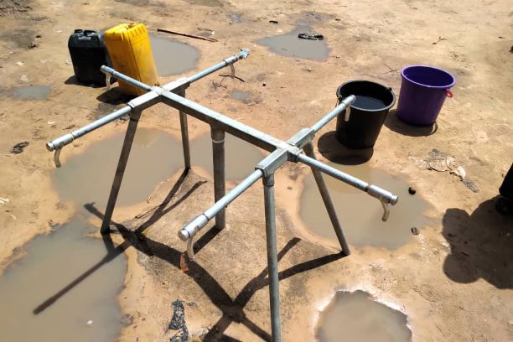
- All tap heads that fail within the 6-month retention period shall be replaced
- The project shall be deemed incomplete until:
- Series of laboratory results of water quality analysis meet Nigerian Standard/ World Health Organization (W.H.O) minimum quality for drinking water. Samples for testing shall be taken at new and existing water fetching points
- Water of adequate pressure is flowing at all new and existing water fetching points without visible leakages along the supply lines.

CONDITIONS AND SCHEDULE OF PAYMENT

Payments shall be made in 4 tranches. Invoices shall be presented by contractor upon achieving milestones as detailed below:

Milestone  No. | Milestone Description | Payment Amount (%) | Completion Date
Milestone No. 1 | - Signing and Submission of Contract  - Submission of Performance Bond, invoice and other document(s) required by Procurement Unit  - Attend Entrance meeting in UNDP Sub-Office, Maiduguri with (signed contract, proposed workplan and list of staff)  - Handing over of site/Taking over of site | 20% | 2 weeks after contract signoff
Milestone No. 2 | Mobilization of equipment and staff to site.  - Completion of pipe excavation works  - Completion of Drilling and Casing of Borehole  - Solarization (Hybrid System of Damboa water supply)  - Cleaning of Overhead tank and Reservoir, commissioning of chlorine dosing pump.  - Submit list of workers as prescribed in the SoW (not less than 70 with 10% as women) and Invoice (hardcopy)  - Submission of detail progress reports with photographs showing work completed.  - Certification of works by Supervising Civil Engineer | 40% | End of Week 6
Milestone No. 3 | - Construction of Animal Trough complete with connections to water pipeline  - Completion of all pipe laying and pipe repair works  - Completion of all fetching points and reticulation works  - Water flow at all fetching points  - Completion of visibility signboards  - Submission of detailed Borehole report and overall project report (3 hardcopies) including as-built drawing  - Submission of 3nos Water Quality tests results which meet Nigerian Water Quality minimum standards  - Submission of list of workers using Cash for work template (not less than 70 workers with 10% as women) and Invoice (hardcopy)  - Satisfactory completion of all works and Certification by Supervising Civil Engineer | 35% | End of Week 8
Milestone No. 4 | - Post-completion inspection and certification report by UNDP Engineer that defects which occurred within 6months of practical completion have been satisfactorily repaired | 5% | 6 months after practical completion

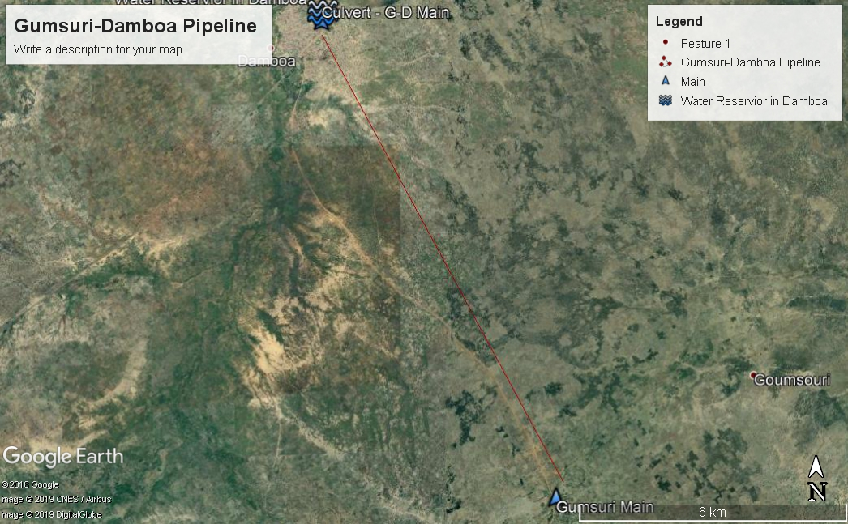
Figure 1: Google Earth Map with Red-line showing Gumsuri-Damboa Pipeline
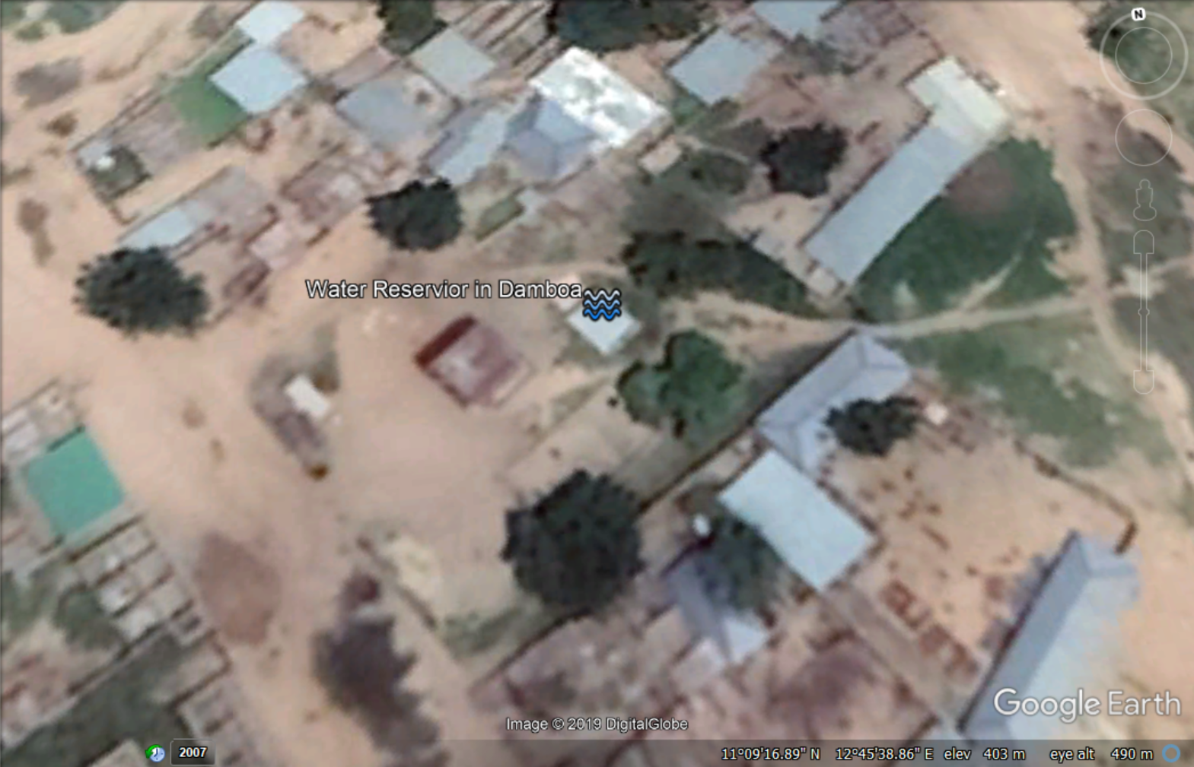
Figure 2: Google Earth Map showing Damboa Main Reservoir

Section 6: Returnable Bidding Forms / Checklist

This form serves as a checklist for preparation of your Bid. Please complete the Returnable Bidding Forms in accordance with the instructions in the forms and return them as part of your Bid submission. No alteration to format of forms shall be permitted and no substitution shall be accepted.

Before submitting your Bid, please ensure compliance with the Bid Submission instructions of the BDS 22.

Technical Bid:
Have you duly completed all the Returnable Bidding Forms?
- Form A: Bid Submission Form | ☐
- Form B: Bidder Information Form | ☐
- Form C: Joint Venture/Consortium/ Association Information Form | ☐
- Form D: Qualification Form | ☐
- Form E: Format of Technical Bid/Bill of Quantities | ☐
Have you provided the required documents to establish compliance with the evaluation criteria in Section 4? | ☐

Price Schedule:
- Form F: Price Schedule Form | ☐

Form A: Bid Submission Form

Name of Bidder: | [Insert Name of Bidder] | Date: | Select date
ITB reference: | [Insert ITB Reference Number]
We, the undersigned, offer to supply the goods and related services required for [Insert Title of goods and services] in accordance with your Invitation to Bid No. [Insert ITB Reference Number] and our Bid. We hereby submit our Bid, which includes this Technical Bid and Price Schedule.
Our attached Price Schedule is for the sum of [Insert amount in words and figures and indicate currency].
We hereby declare that our firm, its affiliates or subsidiaries or employees, including any JV/Consortium /Association members or subcontractors or suppliers for any part of the contract:
- is not under procurement prohibition by the United Nations, including but not limited to prohibitions derived from the Compendium of United Nations Security Council Sanctions Lists;
- have not been suspended, debarred, sanctioned or otherwise identified as ineligible by any UN Organization or the World Bank Group or any other international Organization;
- have no conflict of interest in accordance with Instruction to Bidders Clause 4;
- do not employ, or anticipate employing, any person(s) who is, or has been a UN staff member within the last year, if said UN staff member has or had prior professional dealings with our firm in his/her capacity as UN staff member within the last three years of service with the UN (in accordance with UN post-employment restrictions published in ST/SGB/2006/15);
- have not declared bankruptcy, are not involved in bankruptcy or receivership proceedings, and there is no judgment or pending legal action against them that could impair their operations in the foreseeable future;
- undertake not to engage in proscribed practices, including but not limited to corruption, fraud, coercion, collusion, obstruction, or any other unethical practice, with the UN or any other party, and to conduct business in a manner that averts any financial, operational, reputational or other undue risk to the UN and we embrace the principles of the United Nations Supplier Code of Conduct and adhere to the principles of the United Nations Global Compact.
We declare that all the information and statements made in this Bid are true and we accept that any misinterpretation or misrepresentation contained in this Bid may lead to our disqualification and/or sanctioning by the UNDP.
We offer to supply the goods and related services in conformity with the Bidding documents, including the UNDP General Conditions of Contract and in accordance with the Schedule of Requirements and Technical Specifications.
Our Bid shall be valid and remain binding upon us for the period specified in the Bid Data Sheet.
We understand and recognize that you are not bound to accept any Bid you receive.
I, the undersigned, certify that I am duly authorized by [Insert Name of Bidder] to sign this Bid and bind it should UNDP accept this Bid.
Name: _____________________________________________________________
Title: _____________________________________________________________
Date: _____________________________________________________________
Signature: _____________________________________________________________
[Stamp with official stamp of the Bidder]

Form B: Bidder Information Form

Legal name of Bidder | [Complete]
Legal address | [Complete]
Year of registration | [Complete]
Bidder’s Authorized Representative Information | Name and Title: [Complete]  Telephone numbers: [Complete]  Email: [Complete]
Are you a UNGM registered vendor? | ☐ Yes ☐ No If yes, [insert UGNM vendor number]
Are you a UNDP vendor? | ☐ Yes ☐ No If yes, [insert UNDP vendor number]
Countries of operation | [Complete]
No. of full-time employees | [Complete]
Quality Assurance Certification (e.g. ISO 9000 or Equivalent) (If yes, provide a Copy of the valid Certificate): | [Complete]
Does your Company hold any accreditation such as ISO 14001 or ISO 14064 or equivalent related to the environment? (If yes, provide a Copy of the valid Certificate): | [Complete]
Does your Company have a written Statement of its Environmental Policy? (If yes, provide a Copy) | [Complete]
Does your organization demonstrates significant commitment to sustainability through some other means, for example internal company policy documents on women empowerment, renewable energies or membership of trade institutions promoting such issues | [Complete]
Is your company a member of the UN Global Compact | [Complete]
Contact person that UNDP may contact for requests for clarifications during Bid evaluation | Name and Title: [Complete]  Telephone numbers: [Complete]  Email: [Complete]
Please attach the following documents: | - Certificate of Incorporation/ Business Registration  - Current Tax Clearance Certificate  - Quality Certificate (e.g., COREN, etc.) and/or other similar certificates, accreditations, awards and citations received by the Bidder, if any

Form C: Joint Venture/Consortium/Association Information Form

Name of Bidder: | [Insert Name of Bidder] | Date: | Select date
ITB reference: | [Insert ITB Reference Number]

To be completed and returned with your Bid if the Bid is submitted as a Joint Venture/Consortium/Association.

No | Name of Partner and contact information (address, telephone numbers, fax numbers, e-mail address) | Proposed proportion of responsibilities (in %) and type of goods and/or services to be performed
1 | [Complete] | [Complete]
2 | [Complete] | [Complete]
3 | [Complete] | [Complete]

Name of leading partner  (with authority to bind the JV, Consortium, Association during the ITB process and, in the event a Contract is awarded, during contract execution) | [Complete]

We have attached a copy of the below referenced document signed by every partner, which details the likely legal structure of and the confirmation of joint and severable liability of the members of the said joint venture:

☐ Letter of intent to form a joint venture OR ☐ JV/Consortium/Association agreement

We hereby confirm that if the contract is awarded, all parties of the Joint Venture/Consortium/Association shall be jointly and severally liable to UNDP for the fulfillment of the provisions of the Contract.

Name of partner: ___________________________________ | Name of partner: ___________________________________
Signature: ______________________________ | Signature: _______________________________
Date: ___________________________________ | Date: ___________________________________
Name of partner: ___________________________________ | Name of partner: ___________________________________
Signature: ______________________________ | Signature: _______________________________
Date: ___________________________________ | Date: ___________________________________

Form D: Eligibility and Qualification Form

Name of Bidder: | [Insert Name of Bidder] | Date: | Select date
ITB reference: | [Insert ITB Reference Number]

If JV/Consortium/Association, to be completed by each partner.

History of Non- Performing Contracts
☐Non-performing contracts did not occur during the last 3 years
☐ Contract(s) not performed in the last 3 years
Year | Non- performed portion of contract | Contract Identification | Total Contract Amount (current value in US$)
Name of Client:
Address of Client:
Reason(s) for non-performance:

Litigation History (including pending litigation)
☐ No litigation history for the last 3 years
☐ Litigation History as indicated below
Year of dispute | Amount in dispute (in US$) | Contract Identification | Total Contract Amount (current value in US$)
Name of Client:
Address of Client:
Matter in dispute:
Party who initiated the dispute:
Status of dispute:
Party awarded if resolved:

Previous Relevant Experience
Please list only previous similar assignments successfully completed in the last 3 years.

List only those assignments for which the Bidder was legally contracted or sub-contracted by the Client as a company or was one of the Consortium/JV partners. Assignments completed by the Bidder’s individual experts working privately or through other firms cannot be claimed as the relevant experience of the Bidder, or that of the Bidder’s partners or sub-consultants, but can be claimed by the Experts themselves in their CVs. The Bidder should be prepared to substantiate the claimed experience by presenting copies of relevant documents and references if so requested by UNDP.

Project name & Country of Assignment | Client & Reference Contact Details | Contract Value | Period of activity and status | Types of activities undertaken
Bidders may also attach their own Project Data Sheets with more details for assignments above.
☐ Attached are the Statements of Satisfactory Performance from the Top 3 (three) Clients or more.

Financial Standing
Annual Turnover for the last 3 years | Year NGN  Year NGN  Year NGN
Latest Credit Rating (if any), indicate the source

Financial information  (in NGN equivalent) | Historic information for the last 3 years
 | Year 1 | Year 2 | Year 3
 | Information from Balance Sheet
Total Assets (TA)
Total Liabilities (TL)
Current Assets (CA)
Current Liabilities (CL)
 | Information from Income Statement
Total / Gross Revenue (TR)
Profits Before Taxes (PBT)
Net Profit
Current Ratio
☐ Attached are copies of the audited financial statements (balance sheets, including all related notes, and income statements) for the years required above complying with the following condition:
  - Must reflect the financial situation of the Bidder or party to a JV, and not sister or parent companies;
  - Historic financial statements must be audited by a certified public accountant;
  - Historic financial statements must correspond to accounting periods already completed and audited. No statements for partial periods shall be accepted.

Form E: Format of Technical Bid

Name of Bidder: | [Insert Name of Bidder] | Date: | Select date
ITB reference: | [Insert ITB Reference Number]

The Bidder’s Bid should be organized to follow this format of the Technical Bid. Where the bidder is presented with a requirement or asked to use a specific approach, the bidder must not only state its acceptance, but also describe how it intends to comply with the requirements. Where a descriptive response is requested, failure to provide the same will be viewed as non-responsive.

SECTION 1: Bidder’s qualification, capacity and expertise

  - General organizational capability which is likely to affect implementation: management structure, financial stability and project financing capacity, project management controls, extent to which any work would be subcontracted (if so, provide details).
  - Relevance of specialized knowledge and experience on similar engagements done in the region/country.
  - Quality assurance procedures and risk mitigation measures.
  - Organization’s commitment to sustainability.
SECTION 2: Scope of Supply, Technical Specifications, and Related Services
This section should demonstrate the Bidder’s responsiveness to the specification by identifying the specific components proposed, addressing the requirements, as specified, point by point; providing a detailed description of the essential performance characteristics proposed; and demonstrating how the proposed bid meets or exceeds the requirements/specifications. All important aspects should be addressed in sufficient detail.

NOTE: THIS SECTION MAKES UP THE TECHNICAL BID & FORMS AN IMPORTANT PART OF THE EVALUATION. DO WELL TO ADDRESS THIS SECTION.
  - A detailed description of how the Bidder will deliver the required goods and services, keeping in mind the appropriateness to local conditions and project environment. Details how the different service elements shall be organized, controlled and delivered.
  - Explain whether any work would be subcontracted, to whom, how much percentage of the requirements, the rationale for such, and the roles of the proposed sub-contractors and how everyone will function as a team.
  - The bid shall also include details of the Bidder’s internal technical and quality assurance review mechanisms.
  - Implementation plan including a Gantt Chart or Project Schedule indicating the detailed sequence of activities that will be undertaken and their corresponding timing.
  - Demonstrate how you plan to integrate sustainability measures in the execution of the contract.

Scope of Works and
Technical Specifications

 | Compliance with technical specifications |  | Delivery Date  (confirm that you comply or indicate your delivery date) | Comments
 | Yes, we comply | No, we cannot comply  (indicate discrepancies)

SECTION 3: Management Structure and Key Personnel
  - Describe the overall management approach toward planning and implementing the project. Include an organization chart for the management of the project describing the relationship of key positions and designations. Provide a spreadsheet to show the activities of each personnel and the time allocated for his/her involvement.
  - Provide CVs for key personnel that will be provided to support the implementation of this project using the format below. CVs should demonstrate qualifications in areas relevant to the scope of goods and/or services.

Format for CV of Proposed Key Personnel
Name of Personnel | [Insert]
Position for this assignment | [Insert]
Nationality | [Insert]
Language proficiency | [Insert]
Education/ Qualifications | [Summarize college/university and other specialized education of personnel member, giving names of schools, dates attended, and degrees/qualifications obtained.]
 | [Insert]
Professional certifications | [Provide details of professional certifications relevant to the scope of goods and/or services i.e COREN for supervising Engineer of the project]
- Name of institution: [Insert]
- Date of certification: [Insert]
Employment Record/ Experience | [List all positions held by personnel (starting with present position, list in reverse order), giving dates, names of employing organization, title of position held and location of employment. For experience in last five years, detail the type of activities performed, degree of responsibilities, location of assignments and any other information or professional experience considered pertinent for this assignment.].
 | [Insert]
References | [Provide names, addresses, phone and email contact information for two (2) references]
Reference 1:
[Insert]

Reference 2:
[Insert]

I, the undersigned, certify that to the best of my knowledge and belief, the data provided above correctly describes my qualifications, my experiences, and other relevant information about myself.

________________________________________ ___________________
Signature of Personnel Date (Day/Month/Year)

FORM F: Price Schedule Form

Name of Bidder: | [Insert Name of Bidder] | Date: | Select date
ITB reference: | [Insert ITB Reference Number]

The Bidder is required to prepare the Price Schedule using the bill of quantities for each lot that it is interested in.

Name of Bidder: ________________________________________________
Authorised signature: ________________________________________________
Name of authorised signatory: ________________________________________________
Functional Title: ____________________________________

Non-performance, as decided by UNDP, shall include all contracts where (a) non-performance was not challenged by the contractor, including through referral to the dispute resolution mechanism under the respective contract, and (b) contracts that were so challenged but fully settled against the contractor. Non-performance shall not include contracts where Employers decision was overruled by the dispute resolution mechanism. Non-performance must be based on all information on fully settled disputes or litigation, i.e. dispute or litigation that has been resolved in accordance with the dispute resolution mechanism under the respective contract and where all appeal instances available to the Bidder have been exhausted.

