ETHIOPIA

REQUEST FOR QUOTATION (RFQ)
(GOODS)
QUOTATION SUBMISSION FORM
Supply of Safety and Security Equipment for Dollo Project

Procurement Reference No.: ETH1522
Published (Posted on): 03 August 2020
Submission Deadline: 10 August 2020 @ 11:30 AM in the afternoon (UTC+03:00) Addis Ababa/Nairobi Time Zone
Note: those who submit afterwards will be automatically rejected. Thus you all are strongly advised to meet the submission deadline and avoid last hour rush.

United Nations Development Programme (UNDP)
Addis Ababa, Ethiopia
03 August 2020

REQUEST FOR QUOTATION (RFQ)
(GOODS) ETHIOPIA

RFQ Procurement Ref.: ETH1522
03 August 2020

Subject: Supply of Safety and Security Equipment for Dollo Project

Dear Sir / Madam:

We kindly request you to submit your quotation for Supply of Safety and Security Equipment for Dollo Project , as detailed in Annex 1 of this RFQ. When preparing your quotation, please be guided by the form attached hereto as Annex 2.

Quotations may be submitted on or before 10th August 2020 and via:

☒ e-mail through Official Address for e-submission: procurement.et@undp.org
Attn: FT
United Nations Development Programme (UNDP)
ECA Compound, Congo Bld. 6th Floor
P.O. Box: 5580
Addis Ababa, Ethiopia

E-mail address dedicated for request for clarifcation is: info.procurementet@undp.org (please note that it is only dedicated for enquiry and confirmation for quotation submission. Do not submit Quotation to this account. If you do so, your Quotation will be rejected, and UNDP will not be accountable for it).

Quotations submitted by email must be virus-free and no more than one (1) email transmissions. They must be free from any form of virus or corrupted contents, or the quotations shall be rejected.

It shall remain your responsibility to ensure that your quotation will reach the address above on or before the deadline. Quotations that are received by UNDP after the deadline indicated above, for whatever reason, shall not be considered for evaluation. If you are submitting your quotation by email, kindly ensure that they are signed and in the .pdf format, and free from any virus or corrupted files.

Please take note of the following requirements and conditions pertaining to the supply of the abovementioned goods:

INSTRUCTION FOR QUOTATION SUBMISSION

No. | Data | Requirements and Conditions pertaining to the Supply of the Goods
1 | Delivery Terms  [INCOTERMS 2010] | ☒ CIP Addis Ababa, Bole International Airport
2 | Customs clearance, if needed, shall be done by: | ☒ UNDP Ethiopia will be responsible to clear cargo from Addis Ababa Bole International Airport
3 | Exact Address/es of Delivery Location/s (identify all, if multiple) | ☒ [UNDP Ethiopia, Addis Ababa]
4 | UNDP Preferred Freight Forwarder, if any | ☒ With freight forwarder whose global presence is proved, safe and reliable in offering the freight forwarder service
5 | Ex-factory / Pre-shipment inspection | ☒ Shall be conducted by supplier at Factory Level and issue pre-delivery inspection certificate
6 | Packing Requirements | ☒ Shall use ISO standard packaging materials to allow the cargo to move safely in multi-modal transportation and sever weather conditions  ☒ Stretch wrap (plastic film) with plastic strapping to deter pilferage while in transit
7 | Inspection upon delivery | ☒ UNDP/Ethiopian Postal Service Enterprise experts will conduct post-delivery inspection on each unit, and will then verify operating functions as per the requirement
8 | Distribution of Shipping Documents (if using freight forwarder) | ☒ Commercial Invoice: One Original and two copies of Commercial Invoice (stamped and signed by Chamber of Commerce)  ☒ Airway Bill (AWB): Two Original and two copies of Waybill (AWB)  ☒ Packing List: One Original and three copies of Packing List  ☒ Delivery Note: One Original and three copies of Packing List  ☒ Insurance Coverage Certificate: Three copies of Insurance Certificate and insurance claim procedure  ☒ Warranty Certificate: One Original and two copies of Warranty Certificate  ☒ Certificate of Origin (C/O): One (1) Original and two (2) copies (stamped and signed by Chamber of Commerce)  ☒ Pre-delivery Inspection at Factory Level: One Original and two copies of Pre-delivery Inspection Sheet by Supplier
9 | Latest Expected Delivery Date and Time [if delivery time exceeds this, quote may be rejected by UNDP] | ☒ 20 calendar days from the issuance of the Purchase Order (PO)
10 | Delivery Schedule | ☒ Required
11 | Mode of Transport | ☒ AIR
12 | Preferred  Currency of Quotation | ☒ United States Dollars (US$)  ☒ Reference date for determining UN Operational Exchange Rate (UNOER): this RFQ submission date
13 | Value Added Tax on Price Quotation | ☒ Must be inclusive of VAT and other applicable indirect taxes
14 | After-sales services required | ☒ Warranty on Parts and Labor for minimum period of one (1) year  ☒ Technical Support  ☒ Provision of Service Unit when pulled out for maintenance/ repair
15 | Manner of Disseminating Supplemental Information to the RFQ and responses/clarifications to queries | ☒ Direct communication to prospective Bidders by email  ☒ Direct communication to prospective Bidders by email, and Posting on the website https://www.ungm.org or http://procurement-notices.undp.org/ on which the captioned RFQ Procurement Notice is posted
16 | Deadline for the Submission of Quotation | ☒ Date and Time: 10th August 2020 @ 11:30 AM in the Morning  ☒ Time Zone: (UTC+03:00) Addis Ababa/Nairobi Time  ☒ Please schedule your time to submit on or ahead of the stated time. Submission after 11:30 hr will not be considered and be returned.
17 | Manner of Submitting Bid | ☒ Electronic submission of Bid
18 | No. of copies of Bid that must be submitted in case of Courier | N/A
19 | Bid submission address in case of Courier/Hand Delivery | N/A
20 | Conditions and Procedures for electronic submission and opening | ☒ Official Address for e-submission: procurement.et@undp.org  ☒ Free from virus and corrupted files  ☒ Format: PDF files only and password protected  ☒ Password for Quotation Submission must not be provided to UNDP until the date and time of Bid Opening as indicated in the following row (Row No. 21 hereunder).  ☒ UNDP Ethiopia Office uses Adobe PDF reader version 9 and Microsoft 2007 & Microsoft 2010  ☒ For electronically transferred data, the maximum capacity is 9MB. Thus, if the size of the file is greater than 9MB attach them with two or more emails. In this case you are kindly advised to label each email as “Attachment 1 of 2; 2 of 2; . . .  ☒ Mandatory email subject line: your Quotation shall be sent as per the following subject lines***:  - ETH1522 - [insert Firm Legal Name]  ☒ For failing and/or incorrectly state the above subject line may result in failing to exactly locate your quotations as the Procurement Unit processes several of such type RFQ process and will not be liable for any consequences thereof.  ☒ Once you submitted your Quotation electronically to designated Secured Email; kindly confirm same (without attaching the Quotation for the purpose keeping its integrity) to the Focal Person the submission of the Quotation. The Focal Person Address: Attn: FT at info.procurementet@undp.org  Your confirmation is important in order to ensure all Proposing Firms’ Quotations are not missed and considered for subsequent Technical Evaluation. ***  *** Compulsory
 | Date and time for opening of Quotations | ☒ Date and Time: 10th August 2020 @ 1:30 PM in the Afternoon  ☒ Time Zone: (UTC+03:00) Addis Ababa/Nairobi Time  ☒ Venue: United Nations Development Programme (UNDP)  ECA Compound, Congo Bld. 6th Floor, North Wing  Addis Ababa, Ethiopia  ☒ Bidders attendance is not required. Bid opening will take place on the presence of approved Technical Evaluation Panel by UNDP
22 | All documentations, including catalogs, instructions and operating manuals, shall be in this language | ☒ English
23 | Documents to be submitted | ☒ Duly Accomplished Form as provided in Annex 2, and in accordance with the list of requirements in Annex 1;  ☒ A statement whether any import or export licenses are required in respect of the goods to be purchased including any restrictions on the Country of Origin, use/dual use nature of goods or services, including and disposition to end users;  ☒ Quality Certificates (ISO, etc.);  ☒ Latest Business Registration Certificate ;  ☒ Latest Internal Revenue Certificate / Tax Clearance;  ☒ Manufacturer’s Authorization of the Company as a Sales Agent (if Supplier is not the manufacturer);  ☒ Certificate of Exclusive Distributorship in the country (if applicable, and if Supplier is not the manufacturer);  ☒ Evidence/Certification of Environmental Sustainability (“Green” Standards) of the Company or the Product being supplied;  ☒ Complete documentation, information and declaration of any goods classified or may be classified as “Dangerous Goods”.  ☒ Patent Registration Certificates (if any of technologies submitted in the quotation is patented by the Supplier);  ☒ Written Self-Declaration of not being included in the UN Security Council 1267/1989 list, UN Procurement Division List or other UN Ineligibility List as per the template attached on the Quotation Submission Form hereto;
24 | Period of Validity of Quotes starting the Submission Date | ☒ 120 days  ☒ In exceptional circumstances, UNDP may request the Vendor to extend the validity of the Quotation beyond what has been initially indicated in this RFQ. The Quotation shall then confirm the extension in writing, without any modification whatsoever on the Quotation.
25 | Partial Quotes | ☒ Not Permitted
26 | Payment Terms | ☒ 100% within 30 days upon UNDP’s acceptance of the goods delivered as specified and receipt of invoice
27 | Liquidated Damages | ☒ Will be imposed under the following conditions:  Percentage of contract price per day of delay: 0.5%  Max. no. of days of delay: Thirty (30) Calendar Days  Next course of action: Thereafter, the contract may be terminated
28 | Evaluation Criteria | ☒ Technical responsiveness/Full compliance to requirements and lowest price  ☒ Full acceptance of the PO/Contract General Terms and Conditions
29 | UNDP will award to: | ☒ One or more Supplier, depending on the following factors: Technically responsiveness/ full compliance to requirements and lowest price ; and full acceptance of the PO/Contract General Terms and Conditions
30 | Type of Contract to be Signed | ☒ Purchase Order (PO)
31 | Special Conditions of Contract | ☒ Cancellation of PO/Contract if the delivery/completion is delayed by Thirty (30) Calendar Days
32 | Conditions for Release of Payment | ☒ Passing Inspection: as per the specification  ☒ Passing all Testing: functionality as per specification  ☒ Written Acceptance of Goods based on full compliance with RFQ requirements
33 | Annexes to this RFQ | ☒ Specifications of the Goods Required (Annex 1)  ☒ Form for Submission of Quotation (Annex 2)  ☒ General Terms and Conditions for Supply of Goods/ Special Conditions (Annex 3).  ☒ Non-acceptance of the terms of the General Terms and Conditions (GTC) shall be grounds for disqualification from this procurement process.
34 | Deadline for submitting requests for clarifications/questions | ☒ Three (3) days before the submission date.
35 | Contact Person for Inquiries  (Written inquiries only) | ☒ Focal Person in UNDP: FT  ☒ Address: United Nations Development Programme (UNDP)  ECA Compound, Congo Bld. 6th Floor  Addis Ababa, Ethiopia  ☒ E-mail address dedicated for this purpose: info.procurementet@undp.org (dedictedd only for enqueries or Request for clarifications)  ☒ Any delay in UNDP’s response shall be not used as a reason for extending the deadline for submission, unless UNDP determines that such an extension is necessary and communicates a new deadline to the Proposers.
36 | Other Information Related to the RFQ | ☒ Not Available

Goods offered shall be reviewed based on completeness and compliance of the quotation with the minimum specifications described above and any other annexes providing details of UNDP requirements.

The quotation that complies with all the specifications, requirements and offers the lowest price, as well as all other evaluation criteria indicated, shall be selected. Any offer that does not meet the requirements shall be rejected.

Any discrepancy between the unit price and the total price (obtained by multiplying the unit price and quantity) shall be re-computed by UNDP. The unit price shall prevail, and the total price shall be corrected. If the supplier does not accept the final price based on UNDP’s re-computation and correction of errors, its quotation will be rejected.

After UNDP has identified the lowest price offer, UNDP reserves the right to award the contract based only on the prices of the goods in the event that the transportation cost (freight and insurance) is found to be higher than UNDP’s own estimated cost if sourced from its own freight forwarder and insurance provider.

At any time during the validity of the quotation, no price variation due to escalation, inflation, fluctuation in exchange rates, or any other market factors shall be accepted by UNDP after it has received the quotation. At the time of award of Contract or Purchase Order, UNDP reserves the right to vary (increase or decrease) the quantity of services and/or goods, by up to a maximum twenty five per cent (25%) of the total offer, without any change in the unit price or other terms and conditions.

Any Purchase Order (PO) that will be issued as a result of this RFQ shall be subject to the General Terms and Conditions attached hereto. The mere act of submission of a quotation implies that the vendor accepts without question the General Terms and Conditions of UNDP herein attached as Annex 3.

UNDP is not bound to accept any quotation, nor award a contract/Purchase Order, nor be responsible for any costs associated with a Supplier’s preparation and submission of a quotation, regardless of the outcome or the manner of conducting the selection process.

Please be advised that UNDP’s vendor protest procedure is intended to afford an opportunity to appeal for persons or firms not awarded a purchase order or contract in a competitive procurement process. In the event that you believe you have not been fairly treated; you can find detailed information about vendor protest procedures in the following link:
http://www.undp.org/content/undp/en/home/operations/procurement/protestandsanctions/

UNDP encourages every prospective Vendor to avoid and prevent conflicts of interest, by disclosing to UNDP if you, or any of your affiliates or personnel, were involved in the preparation of the requirements, design, specifications, cost estimates, and other information used in this RFQ.

UNDP implements a zero tolerance on fraud and other proscribed practices and is committed to identifying and addressing all such acts and practices against UNDP, as well as third parties involved in UNDP activities. UNDP expects its suppliers to adhere to the UN Supplier Code of Conduct found in this link: http://www.un.org/depts/ptd/pdf/conduct_english.pdf

Thank you and we look forward to receiving your quotation.

Yours sincerely,

Endrias Getachew
Deputy Regional Representative (Operations), a.i
UNDP Ethiopia Country Office
ANNEX 1

TECHNICAL SPECIFICATIONS

I. PRODUCT SPECIFICATIONS AND COMPLIANCE SHEET
The UNDP Ethiopia Country Office on behalf of the Implementing Partner (IP) hereby invites potentially qualified bidders to supply the following product and service specification and/or “its substantially equivalent” product:
No. | Item/s to be Supplied | Description/Specifications of Goods  (Minimum  Technical Requirements Including Applicable Standards) | UoM | Qty | Remarks  (if any)
1 | First Aid Kit | As attached | Pcs | 2
2 | Fire Extinguisher | As attached | Pcs | 3
3 | Hand Metal Detector | As attached | Pcs | 2
4 | Under Vehicle Search Mirrors | As attached | Pcs | 2
5 | Smoke Detectors | As attached | Pcs | 4
6 | Public Address System | As attached | Pcs | 1
Pls. attach delivery schedule.

* DETAIL TECHNICAL SPECIFICATION (TS)
Attached as Annex I

II. RECOMMENDED PRESENTATION OF QUOTATION SUBMISSION
For purposes of generating quotations whose contents are uniformly presented and to facilitate their comparative review, a prospect bidder hereto is given a proposed Table of Contents. Therefore, prospective Bidder’s Quotation Submission must have at least the preferred content which is outlined in the RFQ Quotation Submission Form hereto.

(This Form must be submitted only using the
Service Provider’s Official Letterhead/Stationery)

Cover Page

Supply of Safety and Security Equipment for Dollo

Procurement Reference No.: ETH1522

QUOTATION SUBMISSION FORM

Legal Name of Proposing Organization / Firm: | [insert here]
Country of Registration: | [insert here]
Year of Registration: | [insert here]
Name of Signatory for this Quotation: | [insert here]
Designation of the Signatory: | [insert here]
Date of Preparation: | [insert here]
Email: | [insert here]
Business Address: | [insert here]
Phone / Fax: | [insert here]
Skype Account: | [insert here]

Do not Open before the RFQ Opening Date
Table of Contents

Page
QUOTATION SUBMISSION COVER PAGES
Statement of Declaration (use the template hereto)
Statement of Full Disclosure (use the template hereto)
Scope of Supply and Technical Specifications and Related Services
Form for Submitting Supplier’s Quotation (Annex 2)
TABLE 1: Offer to Supply Goods Compliant with Technical Specifications and Requirements
TABLE 2: Estimated Operating Costs (if applicable otherwise cancel it out)
TABLE 3: Offer to Comply with Other Conditions and Related Requirements
BANK REFERENCE
Documentation Checklist (as per the attached checklist attached hereto)

Statement of Declaration
(This should be written in the Letterhead of the Bidder. Except for indicated fields, no changes may be made in this template.)
Location: [Insert]
Date: [insert]
To: United Nations Development Programme
Addis Ababa, Ethiopia
Dear Sir/Madam;
We, the undersigned, hereby offer to supply the goods and related services required for the supply of Safety and Security Equipment for Dollo in accordance with your Request for Quotation (RFQ) dated 03rd August 2020. We are hereby submitting our Bid, which includes the Technical Specs and Price Schedule.
We hereby declare that:
- All the information and statements made in this Bid are true and we accept that any misrepresentation contained in it may lead to our disqualification;
- We are currently not on the removed or suspended vendor list of the UN or other such lists of other UN agencies, nor are we associated with, any company or individual appearing on the 1267/1989 list of the UN Security Council;
- We have no outstanding bankruptcy or pending litigation or any legal action that could impair our operation as a going concern; and
- We do not employ, nor anticipate employing, any person who is or was recently employed by the UN or UNDP.
We confirm that we have read, understood and hereby fully accept the Schedule of Requirements and Technical Specifications describing the duties and responsibilities required of us in this RFQ, and the General Terms and Conditions of UNDP’s Standard Contract for this RFQ.
We agree to abide by this Bid for 120 days.
We undertake, if our Bid is accepted, to initiate the supply of goods and provision of related services not later than the date indicated in the Data Sheet.
We fully understand and recognize that UNDP is not bound to accept this Bid, that we shall bear all costs associated with its preparation and submission, and that UNDP will in no case be responsible or liable for those costs, regardless of the conduct or outcome of the evaluation.
We remain,
Yours sincerely,
Name of Signatory:

Designation:

Signature: ______________________

Date Signed: Company Seal: ______________________
[please mark this letter with your corporate seal]

(This Form must be submitted only using the Service Provider’s
Official Letterhead/Stationery)
Date: [insert the date]
Statement of Full Disclosure
To: United Nations Development Programme
Addis Ababa, Ethiopia

Dear Sir/Madam;

We hereby declare that we have no conflicts to disclose in accordance with the definition of conflict in this RFQ. Specifically, we have not/do not:
  - Been associated in the present or past, with a firm or any of its affiliates which have been engaged UNDP to provide services for the preparation of the design, specifications, Terms of Reference (ToR) and other documents to be used for the procurement of the goods and services to be purchased in this selection process;
  - Been involved in the preparation and/or design of the programme/project related to the services requested under this RFQ;
  - Have owners, officers, directors, controlling shareholders, or key personnel who are related by blood or affinity up to third civil degree to UNDP staff involved in procurement functions and/or the Government of the country receiving services under this RFQ;
  - Submitted more than one Quotation in this RFQ, either as an individual entity, or through its membership with a joint venture/consortium/association that is also submitting a Quotation for the same contract.
  - Combined functions of consulting and supply of goods, and the advisory services may lead to the procurement of such goods;
  - In addition, we are not in conflict for any other reason, as may be established by, or at the discretion of, UNDP.
We remain,

Yours sincerely,

Name of Signatory:

Designation:

Signature: ______________________

Date Signed: Company Seal: ______________________
[please mark this letter with your corporate seal]

Scope of Supply and Technical Specifications and Related Services

Please provide a detailed description of the goods to be supplied, indicating clearly how they comply with the technical specifications required by the RFQ (see below table); describe how the organisation/firm will supply the goods and any related services, keeping in mind the appropriateness to local conditions and project environment.
Item  No. | Item/s to be Supplied (Minimum Technical Requirements Including Applicable Standards) | UoM | Qty | Specification Offered | Bidder's Remark on Compliance of Specification Offered | UNDP Technical Evaluators’ Remark
1 | First Aid Kit | Pcs | 2
2 | Fire Extinguisher | Pcs | 3
3 | Hand Metal Detector | Pcs | 2
4 | Under Vehicle Search Mirrors | Pcs | 2
5 | Smoke Detectors | Pcs | 4
6 | Public Address System | Pcs | 1
Note: Supporting document(s) with full details may be annexed to this section to help Technical Panel better Review and Appraise your submission.

BANK REFERENCE DETAILS
In case of winning the designated RFQ contract, the Proposing Bidder hereby authorizes UNDP Ethiopia to effect all payments to the following Bank account details.
Attach your client bank confirmation letter where electronic money transfer take place.
Name of the Bank: | [insert here]
Branch Name: | [insert here]
Bank Address: | City: [insert here]  State/Province: [insert here]  Country: [insert here]  Postal Code: [insert here]
Bank ID Qualifier: | [insert here]
Bank ID/Fed Wire / ABA No.  (bank account located in USA) | [insert here]
SWIFT Code: | [insert here]
IBAN ((bank account located in Europe) | [insert here]
Bank Account Number: | [insert here]
Account Type: | Checking  Savings
Note: Double click on the respective Check Box and click checked in the dialogue box of your choice.
ANNEX 2

FORM FOR SUBMITTING SUPPLIER’S QUOTATION
(This Form must be submitted only using the Supplier’s Official Letterhead/Stationery)

We, the undersigned, hereby accept in full the UNDP General Terms and Conditions, and hereby offer to supply the items listed below in conformity with the specification and requirements of UNDP as per RFQ Reference No.: ETH1522
Please verify your Financial Quotation to avoid arithmetic error before submitting.
TABLE 1: Offer to Supply Goods Compliant with Technical Specifications and Requirements
No. | Item/ Description of Minimum Specification | Qty | Country of Origin | Unit Price in _______ (state the currency) | Total Price in ______  (state the currency)
1 | First Aid Kit | 2
2 | Fire Extinguisher | 3
3 | Hand Metal Detector | 2
4 | Under Vehicle Search Mirrors | 2
5 | Smoke Detectors | 4
6 | Public Address System | 1
 | - Total Prices of Goods
 | - Air Freight and other related Logistics Costs
 | - Cost of Insurance
 | - Other Charges [pls. specify]
Total Final and All-Inclusive Price Quotation [ a + b + c + d]
Amount in Words: [Insert the total amount in words]
Name of Signatory:

Designation:

Signature: ______________________

Date Signed: Company Seal: ______________________
[please mark this letter with your corporate seal]
TABLE 3: Offer to Comply with Other Conditions and Related Requirements
SN | Other Information pertaining to our Quotation are as follows: | Your Responses
 |  | YES, We will Comply | NO, We will not Comply | If you cannot comply, indicate the reason(s)
1 | Annexed duly Signed Renewed Business License and/or Company Registration Certificate with Articles of Incorporation or its equivalent
2 | Annexed Tax Registration or TIN/VAT Certificate
3 | Annexed Tax Payment Certificate or Certificate of Tax Exemption by the Internal Revenue Authority of Registered Country
4 | Meet Delivery Lead Time (LT) as Stated in the RFQ
5 | Estimated weight/volume/dimension of the Consignment
7 | Country/ies Of Origin:
8 | Warranty and After-Sales Requirements:
 | - Training on Operations and Maintenance
 | - Minimum one (1) year warranty on both parts and labor
 | - Service Unit to be Provided when the Purchased Unit is Under Repair
 | - Brand new replacement if Purchased Unit is beyond repair
9 | Annexed Confirmation to Submit Quality Inspection and Testing Certificates for the goods to be supplied
10 | Annexed Bank Reference Details as per the Template of your client Bank
11 | Accept All Provisions of Request for Quotation (RFQ) General Terms and Conditions for Goods annexed hereto
12 | Annexed Renewed ISO or Equivalent Quality Certificates
13 | Annexed Renewed Environmental Compliance ISO 14000 or its Equivalent Certificate
14 | Others [pls. specify and list further]
Note: Double click on the appropriate Check Box and click checked in the dialogue box of your choice...
All other information and documentations that we have not provided automatically implies our fully compliance with the requirements, terms and conditions of the RFQ.
Name of Signatory:

Designation:

Signature: ______________________

Date Signed: Company Seal: ______________________
[please mark this letter with your corporate seal]

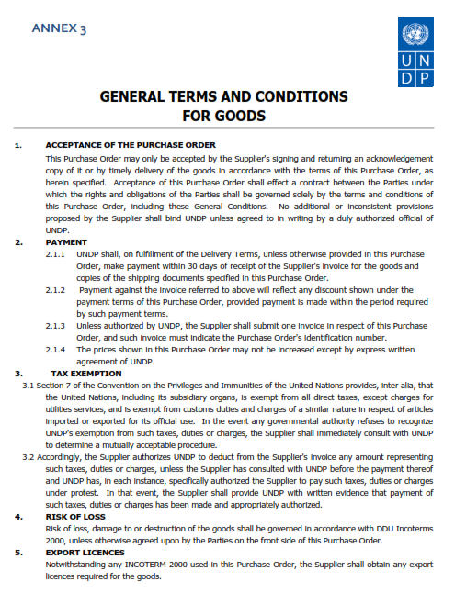

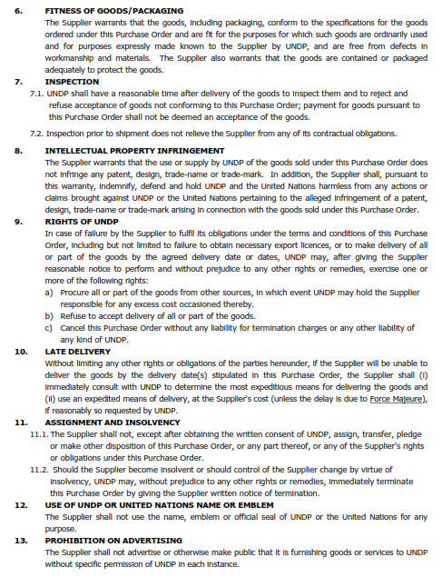

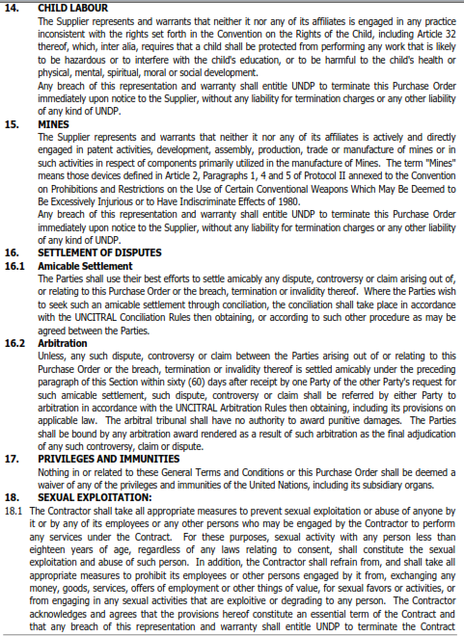

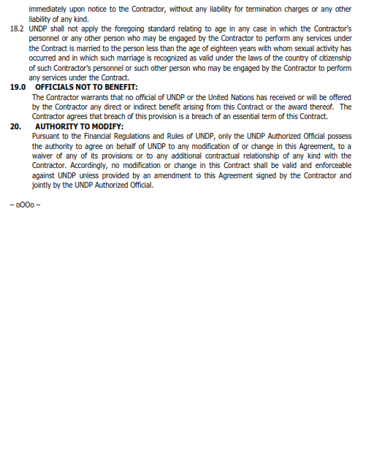

Must be linked to INCO Terms chosen.
Depends on INCO Terms. The suggestion to use a UNDP preferred courier is only for purposes of familiarity with procedures and documentary requirements applicable to the UNDP when clearing with customs.
Local vendors must comply with any applicable laws regarding doing business in other currencies. Conversion of currency into the UNDP preferred currency, if the offer is quoted differently from what is required, shall be based only on UN Operational Exchange Rate prevailing at the time of UNDP’s issuance of Purchase Order.
This must be reconciled with the INCO Terms required by the RFQ. Furthermore, VAT exemption status varies from one country to another. Pls. tick whatever is applicable to the UNDP CO/BU requiring the goods.
Posting on the website shall be supplemented by directly transmitting the communication to the prospective offerors.
If this will be allowed, security features (e.g., encryption, authentication, digital signatures, etc.) are strictly required and must be enforced to ensure confidentiality and integrity of contents.
First 2 items in this list are mandatory for the supply of imported goods
UNDP preference is not to pay advanced amount upon signing of contract. If vendor strictly requires advanced payment, it will be limited only up to 20% of the total price quoted. For any higher percentage, or advanced payment of $30,000 or higher, UNDP shall require the vendor to submit a bank guarantee or bank checque payable to UNDP, in the same amount as the advanced payment made by UNDP to the vendor.
UNDP reserves the right not to award the contract to the lowest priced offer, if the second lowest price among the responsive offer is found to be significantly more superior, and the price is higher than the lowest priced compliant offer by not more than 10%, and the budget can sufficiently cover the price difference. The term “more superior” as used in this provision shall refer to offers that have exceeded the pre-determined requirements established in the specifications.
Where the information is available in the web, a URL for the information may simply be provided.
This contact person and address is officially designated by UNDP. If inquiries are sent to other person/s or address/es, even if they are UNDP staff, UNDP shall have no obligation to respond nor can UNDP confirm that the query was received.
Where the information is available in the web, a URL for the information may simply be provided.
Clustering items by lots, if any, is recommended, especially if partial bids will be allowed.
Official Letterhead/Stationery must indicate contact details – addresses, email, phone and fax numbers – for verification purposes
No deletion or modification may be made in this form. Any such deletion or modification may lead to the rejection of the Bid.
No deletion or modification may be made in this form. Any such deletion or modification may lead to the rejection of the Quotation.
Official Letterhead/Stationery must indicate contact details – addresses, email, phone and fax numbers – for verification purposes
This serves as a guide to the Supplier in preparing the quotation and price schedule.
Official Letterhead/Stationery must indicate contact details – addresses, email, phone and fax numbers – for verification purposes
Pricing of goods should be consistent with the INCO Terms indicated in the RFQ
If the country of Origin requires Export License for the goods being procured, or other relevant documents that the country of destination may require, the supplier must submit them to UNDP if awarded the PO/contract.

