REQUEST FOR PROPOSAL (RFP)
(For Low-Valued Services)

NAME & ADDRESS OF FIRM | DATE: April 23, 2020
 | REFERENCE: OOSP/2020

Dear Sir / Madam:

We kindly request you to submit your Proposal for Development of Office layout and design for the Office of United Nations Development Programme in Guinea-Bissau.

Please be guided by the form attached hereto as Annex 2, in preparing your Proposal.

Proposals may be submitted on or before Thursday, May 07, 2020 and via email summissions.gw@undp.org

United Nations Development Programme

UN Building; 3rd floor; Rua Rui Djassi; Bissau, Guienea-Bissau

Umaro Seidi – CPO or Ariosvaldo da Silva Co – Procurement Assistant

Umaro.seidi@undp.org / ariosvaldo.silva@undp.org
Your Proposal must be expressed in English or French, and valid for a minimum period of 90 days

In the course of preparing your Proposal, it shall remain your responsibility to ensure that it reaches the address above on or before the deadline. Proposals that are received by UNDP after the deadline indicated above, for whatever reason, shall not be considered for evaluation. If you are submitting your Proposal by email, kindly ensure that they are signed and in the .pdf format, and free from any virus or corrupted files.

Services proposed shall be reviewed and evaluated based on completeness and compliance of the Proposal and responsiveness with the requirements of the RFP and all other annexes providing details of UNDP requirements.

The Proposal that complies with all of the requirements, meets all the evaluation criteria and offers the best value for money shall be selected and awarded the contract. Any offer that does not meet the requirements shall be rejected.

Any discrepancy between the unit price and the total price shall be re-computed by UNDP, and the unit price shall prevail, and the total price shall be corrected. If the Service Provider does not accept the final price based on UNDP’s re-computation and correction of errors, its Proposal will be rejected.

No price variation due to escalation, inflation, fluctuation in exchange rates, or any other market factors shall be accepted by UNDP after it has received the Proposal. At the time of Award of Contract or Purchase Order, UNDP reserves the right to vary (increase or decrease) the quantity of services and/or goods, by up to a maximum twenty-five per cent (25%) of the total offer, without any change in the unit price or other terms and conditions.

Any Contract or Purchase Order that will be issued as a result of this RFP shall be subject to the General Terms and Conditions attached hereto. The mere act of submission of a Proposal implies that the Service Provider accepts without question the General Terms and Conditions of UNDP, herein attached as Annex 3.

Please be advised that UNDP is not bound to accept any Proposal, nor award a contract or Purchase Order, nor be responsible for any costs associated with a Service Providers preparation and submission of a Proposal, regardless of the outcome or the manner of conducting the selection process.

UNDP’s vendor protest procedure is intended to afford an opportunity to appeal for persons or firms not awarded a Purchase Order or Contract in a competitive procurement process. In the event that you believe you have not been fairly treated, you can find detailed information about vendor protest procedures in the following link:
http://www.undp.org/content/undp/en/home/operations/procurement/business/protest-and-sanctions.html
UNDP encourages every prospective Service Provider to prevent and avoid conflicts of interest, by disclosing to UNDP if you, or any of your affiliates or personnel, were involved in the preparation of the requirements, design, cost estimates, and other information used in this RFP.

UNDP implements a zero tolerance on fraud and other proscribed practices, and is committed to preventing, identifying and addressing all such acts and practices against UNDP, as well as third parties involved in UNDP activities. UNDP expects its Service Providers to adhere to the UN Supplier Code of Conduct found in this link : https://www.un.org/Depts/ptd/sites/www.un.org.Depts.ptd/files/files/attachment/page/pdf/unscc/conduct_english.pdf

Thank you and we look forward to receiving your Proposal.

Sincerely yours,

Safiata Dia Date
Deputy Resident Representative Operation
4/23/2020

Annex 1

Description of Requirements

Context of the Requirement | Development of Office layout and design for the Office of United Nations Development Programme in Guinea-Bissau
Implementing Partner of UNDP | N/A
Brief Description of the Required Services | To design and supervise the implementation of UNDP GNB Open Space Plan
List and Description of Expected Outputs to be Delivered | As per ToR
Person to Supervise the Work/Performance of the Service Provider | Management
Frequency of Reporting | [ as needed]
Progress Reporting Requirements | N/A
Location of work | ☒ Exact Address/es UN Building 3rd fl; Rua Rui Djassi Bissau, Guinea-Bissau  ☒ At Contractor’s Location
Expected duration of work | 15 Working days
Target start date | 01/06/2020
Latest completion date | 15/06/2020
Travels Expected | Destination/s Estimated Duration Brief Description of Purpose of the Travel Target Date/s
Special Security Requirements | ☐ Security Clearance from UN prior to travelling  ☒ Completion of UN’s Basic and Advanced Security Training  ☒ Comprehensive Travel Insurance  ☒ Others: Medical Certificate and Insurance
Facilities to be Provided by UNDP (i.e., must be excluded from Price Proposal) | ☒ Office space and facilities  ☐ Land Transportation  ☐ Others [pls. specify]
Implementation Schedule indicating breakdown and timing of activities/sub-activities | ☒ Required  ☐ Not Required
Names and curriculum vitae of individuals who will be involved in completing the services | ☒ Required  ☐ Not Required
Currency of Proposal | ☒ United States Dollars  ☒ Euro  ☒ Local Currency
Value Added Tax on Price Proposal | ☐ must be inclusive of VAT and other applicable indirect taxes  ☒ must be exclusive of VAT and other applicable indirect taxes
Validity Period of Proposals (Counting for the last day of submission of quotes) | ☐ 60 days  ☒ 90 days  ☐ 120 days  In exceptional circumstances, UNDP may request the Proposer to extend the validity of the Proposal beyond what has been initially indicated in this RFP. The Proposal shall then confirm the extension in writing, without any modification whatsoever on the Proposal.
Partial Quotes | ☒ Not permitted  ☐ Permitted [pls. provide conditions for partial quotes, and ensure that requirements are properly listed to allow partial quotes (e.g., in lots, etc.)]
Payment Terms | Outputs Percentage Timing Condition for Payment Release  Within thirty (30) days from the date of meeting the following conditions:  - UNDP’s written acceptance (i.e., not mere receipt) of the quality of the outputs; and  - Receipt of invoice from the Service Provider.
Person(s) to review/inspect/ approve outputs/completed services and authorize the disbursement of payment | Management
Type of Contract to be Signed | ☒ Purchase Order  ☐ Institutional Contract  ☒ Contract for Professional Services  ☐ Long-Term Agreement (if LTA will be signed, specify the document that will trigger the call-off. E.g., PO, etc.)  ☐ Other Type of Contract [pls. specify]
Criteria for Contract Award | ☒ Lowest Price Quote among technically responsive offers  ☐ Highest Combined Score (based on the 70% technical offer and 30% price weight distribution)  ☐ Full acceptance of the UNDP Contract General Terms and Conditions (GTC). This is a mandatory criterion and cannot be deleted regardless of the nature of services required. Non-acceptance of the GTC may be grounds for the rejection of the Proposal.
Criteria for the Assessment of Proposal | Technical Proposal (70%)  ☒ Expertise of the Firm 50%  ☒ Methodology, Its Appropriateness to the Condition and Timeliness of the Implementation Plan 30%  ☒ Management Structure and Qualification of Key Personnel 20%  Financial Proposal (30%)  To be computed as a ratio of the Proposal’s offer to the lowest price among the proposals received by UNDP.
UNDP will award the contract to: | ☒ One and only one Service Provider  ☐ One or more Service Providers, depending on the following factors: [Clarify fully how and why will this be achieved. Please do not choose this option without indicating the parameters for awarding to multiple Service Providers]
Contract General Terms and Conditions | ☒ General Terms and Conditions for contracts (goods and/or services)  ☐ General Terms and Conditions for de minimis contracts (services only, less than $50,000)  Applicable Terms and Conditions are available at:  http://www.undp.org/content/undp/en/home/procurement/business/how-we-buy.html
Annexes to this RFP | ☒ Form for Submission of Proposal (Annex 2)  ☒ Detailed TOR [optional if this form has been accomplished comprehensively]  ☐ Others [pls. specify]
Contact Person for Inquiries  (Written inquiries only) | Ariosvaldo da Silva Co  Procurement Assistant  Ariosvaldo.silva@undp.org  Any delay in UNDP’s response shall be not used as a reason for extending the deadline for submission, unless UNDP determines that such an extension is necessary and communicates a new deadline to the Proposers.
Other Information [pls. specify] | N/A

Annex 2

FORM FOR SUBMITTING SERVICE PROVIDER’S PROPOSAL

(This Form must be submitted only using the Service Provider’s Official Letterhead/Stationery)

[insert: Location].
[insert: Date]

To: [insert: Name and Address of UNDP focal point]

Dear Sir/Madam:

We, the undersigned, hereby offer to render the following services to UNDP in conformity with the requirements defined in the RFP dated [specify date] , and all of its attachments, as well as the provisions of the UNDP General Contract Terms and Conditions :

- Qualifications of the Service Provider

The Service Provider must describe and explain how and why they are the best entity that can deliver the requirements of UNDP by indicating the following :

- Profile – describing the nature of business, field of expertise, licenses, certifications, accreditations;
- Business Licenses – Registration Papers, Tax Payment Certification, etc.
- Latest Audited Financial Statement – income statement and balance sheet to indicate Its financial stability, liquidity, credit standing, and market reputation, etc. ;
- Track Record – list of clients for similar services as those required by UNDP, indicating description of contract scope, contract duration, contract value, contact references;
- Certificates and Accreditation – including Quality Certificates, Patent Registrations, Environmental Sustainability Certificates, etc.
- Written Self-Declaration that the company is not in the UN Security Council 1267/1989 List, UN Procurement Division List or Other UN Ineligibility List.

- Proposed Methodology for the Completion of Services

The Service Provider must describe how it will address/deliver the demands of the RFP; providing a detailed description of the essential performance characteristics, reporting conditions and quality assurance mechanisms that will be put in place, while demonstrating that the proposed methodology will be appropriate to the local conditions and context of the work.

- Qualifications of Key Personnel

If required by the RFP, the Service Provider must provide :

- Names and qualifications of the key personnel that will perform the services indicating who is Team Leader, who are supporting, etc.;
- CVs demonstrating qualifications must be submitted if required by the RFP; and
- Written confirmation from each personnel that they are available for the entire duration of the contract.

- Cost Breakdown per Deliverable*

 | Deliverables  [list them as referred to in the RFP] | Percentage of Total Price (Weight for payment) | Price  (Lump Sum, All Inclusive)
1 | Deliverable 1
2 | Deliverable 2
3 | ….
 | Total | 100%
*This shall be the basis of the payment tranches

- Cost Breakdown by Cost Component [This is only an Example]:
Description of Activity | Remuneration per Unit of Time | Total Period of Engagement | No. of Personnel | Total Rate
I. Personnel Services
1. Services from Home Office
a. Expertise 1
b. Expertise 2
2. Services from Field Offices
a . Expertise 1
b. Expertise 2
3. Services from Overseas
a. Expertise 1
b. Expertise 2
II. Out of Pocket Expenses
1. Travel Costs
2. Daily Allowance
3. Communications
4. Reproduction
5. Equipment Lease
6. Others
III. Other Related Costs

[Name and Signature of the Service Provider’s Authorized Person]
[Designation]
[Date]

TERMS OF REFERENCE
Development of Office layout and design for the Office of United Nations Development Programme in Guinea-Bissau
- Background
UNDP, on a global level is transforming the way it works, thinks and implement its projects as we enter the Decade of Action that calls for the acceleration of sustainable solutions to deliver on the 2030 Agenda for Sustainable Development. Innovation and creativity are at the core of our universal commitment to help countries become more peaceful and prosperous.
Anchored in the 2030 Agenda and committed to the principles of universality, equality and leaving no one behind, is the new UNDP People for 2030 strategy, that aims at progressively transforming UNDP’s culture and capacity to better face and resolve the ever-changing challenges impacting our world. The strategy, launched in 2019, also highlights the importance of UNDP’s duty of care as an employer to ensure that all personal work in a safe and healthy organization that contribute to their self-fulfillment and protects their dignity.
Keeping in line with the People for 2030 Strategy and UNDP’s new vision, UNDP Guinea-Bissau is too accelerating it actions in order to stay relevant in today’s ever-changing developmental arena. UNDP Guinea-Bissau would like to renovate and update its office workspace in order to promote collaboration and creativity amongst its staff.
With a view at providing an optimal environment for the acceleration of SDGs implementation in the country, it is essential to provide UNDP personnel with:
- Provide UNDP, its staff; clients and partners a modern, collaborative and creative space adequate to the type of work done in its offices.
- Live up to our own expectations by acting on our motto: “Greening the blue” and promoting the use of sustainable, green practices in the office.
- Offer UNDP personnel a safer, healthier and more efficient work environment that will promote staff morale, innovation and productivity.
- Promote greater integration, creativity, and collaboration of functions and people.
- 5 - Ensuring compliance with international and civil engineering working environment standards and meet all local building regulations in force in Guinea-Bissau
- A review of the organizational approach to flexibility in the workplace with a view to ensuring that it is leveraged more strategically to increase productivity, work effectiveness, workload management, well-being, and ability to maintain a healthy work-life balance.
The creative space is to be themed on the SDGs and will encompass the entire 3rd and 4th floors of the UN House. An open-space floorplan is envisioned to incentivize collaboration and the free flow of information. UNDP Guinea-Bissau requires an engineering/architectural design and building space plan for interior fit-out of its office that will optimize the utilization of space and existing furniture, fixtures, equipment and accessories and promote an effective and efficient work environment.
Office building plans are provided in the Annex II of this TOR.
Scope of works:
1. Design service
- Review the existing structural drawings of the building and prepare the architectural/engineering and space plan suitable to UNDP Guinea-Bissau CO and suggest any internal civil and M&E works;
- Prepare layout for workstations, conference/meeting rooms, single offices for senior staff and other facilities such as kitchen, leisure space, reception, canteen etc;
- Provide standard security requirement maintaining modern space efficient concepts and aesthetic view in consultation with UNDSS/UNDP management while preparing the office layout;
- Provide necessary instruction to the Maintenance team in consultation with the UNDP management for necessary internal civil works;
- Provide functional and innovative interior layouts/solutions;
- Provide proper working drawings for all construction works;
- Provide all other details and budgetary estimate.
2. Advisory services
- Provide technical assistance in the procurement process for the fit out construction and purchase goods and services to implement the architectural/engineering and space plan, including assistance in the preparation of the TOR/Technical specifications/Schedule of requirements and other related documents required for the procurement; and the technical evaluation of the tenders;
- Provide advisory assistance on the progress of the implementation of the architectural and engineering and space plan;
- Submit a completion evaluation report upon the completion of the project.
Schedule of requirements
A. Technical requirements
1. Architectural design − Interior floor plans with furniture and fixtures layout − Furniture layout − Interior elevations and sections − Spot details − Interior perspectives
2. Electrical design − Ceiling and lighting layout − Power layout − Emergency power scheme (if required) − Auxiliary layout: telephone, LAN (structure cabling and wifi) and DATA − CCTV layout − Sound system layout and paging system (if required)
3. if required. Plumbing and sanitary − Revised plumbing layout − Revised restroom layout
4. Mechanical and Fire protection − Revised A/C layout − Revised fire alarm system layout − Sprinkler layout − Signage and decals details
5. Others − Outline specifications/schedules of finishes − Estimate budget
B. General requirements
- Renovation is desired to be cost-effective. However, due expenses to be required for a modern workplace would be considered appropriate.
- Renovation should keep the original outlook of the UNDP Building House traditional architecture.
- Renovation should try to accommodate the current organizational structure of the UNDP or as required by the management.
- Open space on the 4th floor with SDGs decoration on the wall. Space will be visibly divided by 5Ps
- On the 3rd floor open space, programme and operation team will be physically together to provide for better collaboration.
- Offices for senior staff each floor.
C. Specific requirements
- Architects might visit the UN Building House before submitting their proposal.
- Central air-conditioner system might be considered together with air-conditioners.
- Solar energy is installed in the premises.
- Office furniture might be replaced while reuse of existing office furniture is desired to reduce the cost. At the same time, modern furniture of an office is also desired.
- Better running of electrical and networking cabling is also desired.
- Modern restrooms are also desired.
- New efficient blinders are also desired.
- The canteen is desired to be renovated/Built for better use and for the benefits of the staff working at the UN House.
- The main conference room requires better lighting and a good acoustic sound system.
- Lightning in offices should be sectioned to turn on at individual tables when needed in order to save energy. LED lights are desired to replace current neon lights for better efficiency of electricity.
- ICT infrastructure might be updated following the new interior design.
- Layout of offices should consider the generous lighting intensity during the day in Guinea-Bissau in order to reduce use of electrical lightning for saving energy and to maximize use of daylight during the day. The blinders, curtains, window glasses, screening filters should be designed with such consideration if required.
- Guinea-Bissau is normally hot almost throughout year with a lot of sunshine. Use of air conditioning is extensive. Therefore, consideration is needed to provide good isolation of heat through the window glasses to save energy used by air-conditioning. Ventilation is also required to ensure good and comfortable air in workplace for staffs.
- Landscaping around the building is also desired to be nice and pleasant.
- Two lifts are desired to be improved and renovated.

Duration of works:
- 4 months from April to July 2020, with following estimation of working times:
Ref Specific deliverables Estimate number of required working days
Submission deadline
PHASE I - DESIGN 1 Preliminary design with different possible options with estimate costs for UNDP management consideration
- Site visits to prepare details of workstations and other interior elements
- Development of layout and design plan, working drawing for civil works and M&E, including electrical and LAN system.
- Presentation and submission of final version of drawings
PHASE II – TENDERING AND SUPERVISION 1 Preparation of BOQ in consultation with UNDP management.
- Support of the tender dossier preparation and evaluation
- Monitoring and supervision of the project implementation
- Completion report including all as built layouts, BOQ and other technical documents
- Completion date can be extended following the selected option and its implementation plan.
Responsibilities:
The Consultant shall:
- Report in hard and soft copies to UNDP Resident Representative for the project implementation;
- Submit the final proposal in hard and soft copies to the UNDP for approval;
- Be responsible for the needed tools and equipment to produce the deliverables specified in the Scope of works, except as agreed upon by both parties.
- UNDP shall:
- Provide the workspace that may be required by the Consultant
- Provide the Consultant access to a printer and internet facilities
- Provide the Consultant access to relevant documents/records subject to the approval of the project.

Competence and Qualifications
Minimum eligibility criteria for the Firm:
Valid business license - At least 3 years of experience in similar exercise - At least 5 assignments in office premise design
Minimum eligibility criteria for the team leader
BSc. Engineer/Architect from reputed engineering university - At least 5 years of experience in Internal decoration and civil engineering - At least 3 similar working experience with international organization, private sector, UN agencies, reputed corporate offices, etc.

ANNEX I
ORGANIZATION CHART

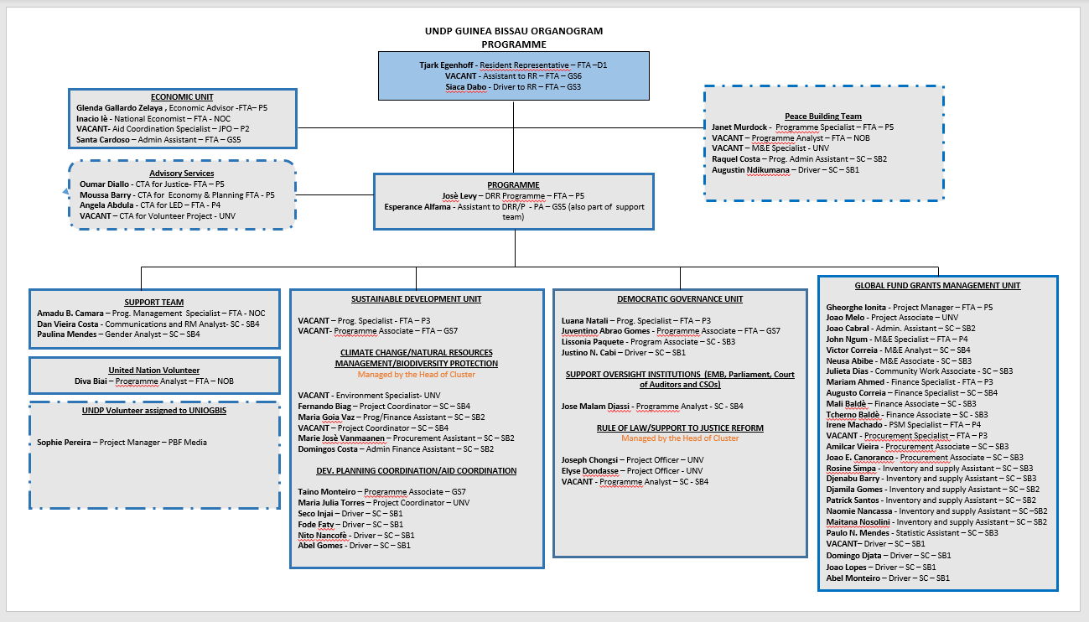

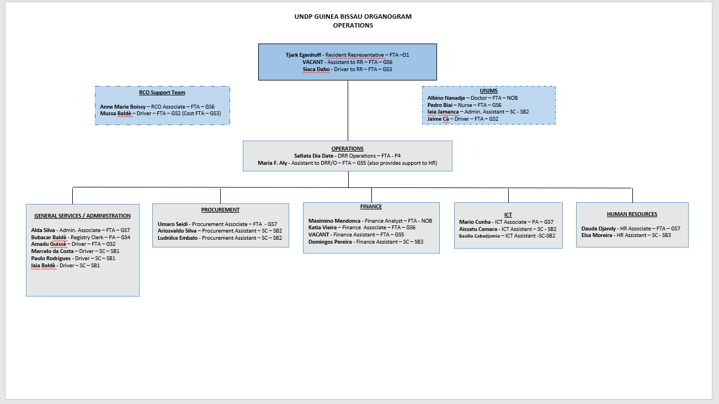

ANNEX II
OFFICE BUILDING PLANS
3rd Floor
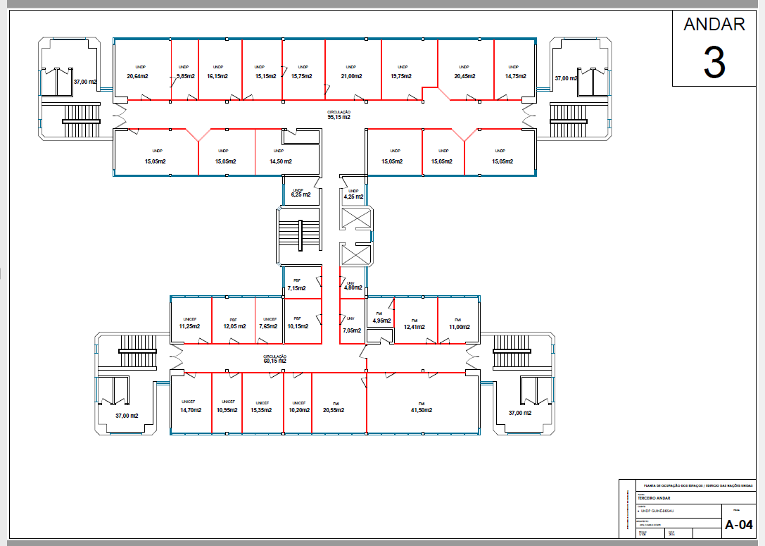

ANNEX III
OFFICE BUILDING PLANS
4th Floor
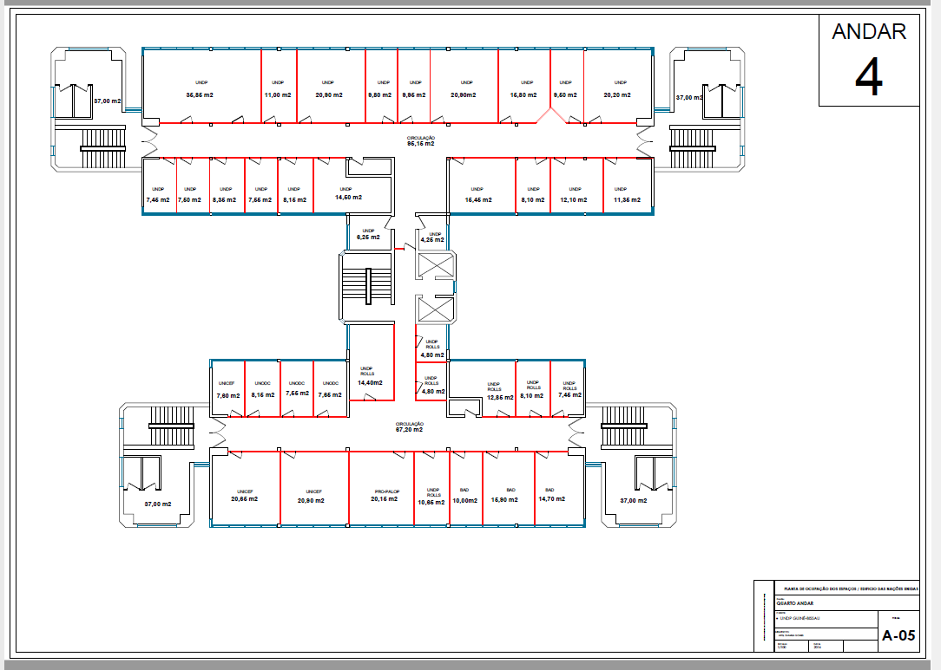

A detailed TOR may be attached if the information listed in this Annex is not sufficient to fully describe the nature of the work and other details of the requirements.
VAT exemption status varies from one country to another. Pls. check whatever is applicable to the UNDP CO/BU requiring the service.
UNDP preference is not to pay any amount in advance upon signing of contract. If the Service Provider strictly requires payment in advance, it will be limited only up to 20% of the total price quoted. For any higher percentage, or any amount advanced exceeding $30,000, UNDP shall require the Service Provider to submit a bank guarantee or bank cheque payable to UNDP, in the same amount as the payment advanced by UNDP to the Service Provider.
Minimum of one (1) year period and may be extended up to a maximum of three (3) years subject to satisfactory performance evaluation. This RFP may be used for LTAs if the annual purchases will not exceed $150,000.00.
Service Providers are alerted that non-acceptance of the terms of the General Terms and Conditions (GTC) may be grounds for disqualification from this procurement process.
Where the information is available in the web, a URL for the information may simply be provided.
A more detailed Terms of Reference in addition to the contents of this RFP may be attached hereto.
This contact person and address is officially designated by UNDP. If inquiries are sent to other person/s or address/es, even if they are UNDP staff, UNDP shall have no obligation to respond nor can UNDP confirm that the query was received.
This serves as a guide to the Service Provider in preparing the Proposal.
Official Letterhead/Stationery must indicate contact details – addresses, email, phone and fax numbers – for verification purposes

