REQUEST FOR QUOTATION (RFQ 116/2020)
(Services)

Preparation of Technical documentation – Detailed designs for reconstruction and adaptation with improvement of energy efficiency of PHI University Clinic of Psychiatry-Skopje

00106869 Building Municipal Capacities for Project Implementation | DATE: October 8, 2020
 | REFERENCE: RFQ 116 /2020

Dear Sir / Madam:

We kindly request you to submit your quotation for RfQ 116/20 Preparation of Technical documentation – Detailed designs for reconstruction and adaptation with improvement of energy efficiency of PHI University Clinic of Psychiatry-Skopje, as detailed in Annex 1 of this RFQ. When preparing your quotation, please be guided by the form attached hereto as Annex 2.

Quotations may be submitted on or before 19 October 2020 by 10:00 via dedicated email: offers.mk@undp.org.

Subject: MKDRFQ 116/2020 for Design za Psihijatriska bolnica, Skopje - company name

It shall remain your responsibility to ensure that your quotation will reach UNDP before the deadline. Quotations that are received by UNDP after the deadline indicated above, for whatever reason, shall not be considered for evaluation.

Delivery Terms  [INCOTERMS 2010]  (Pls. link this to price schedule) | ☐FCA  ☐CPT  ☐CIP  ☐DAP  ☒n/a
Customs clearance, if needed, shall be done by: | ☐UNDP  ☐Supplier/Offeror  ☐Freight Forwarder  N/A
Exact Address/es of Delivery Location/s (identify all, if multiple) | UNDP
UNDP Preferred Freight Forwarder, if any | N/A
Distribution of shipping documents (if using freight forwarder) | N/A
Latest Expected Delivery of assignment Date and Time (if delivery time exceeds this, quote may be rejected by UNDP) | ☒ 20th of December 2020  ☒ As per Delivery Schedule in the TOR  Time Zone of Reference: N/A
Delivery Schedule | ☒Required  ☐Not Required
Packing Requirements | n/a
Mode of Transport | ☐ AIR | ☐LAND
 | ☐SEA | ☐n/a
Preferred  Currency of Quotation | ☐ United States Dollars  ☐Euro  ☒Local Currency: MKD
Value Added Tax on Price Quotation | ☐ Must be inclusive of VAT and other applicable indirect taxes  ☒ Must be exclusive of VAT
After-sales services required | ☐ Warranty on Parts and Labor for minimum period of 1 year  ☐ Technical Support  ☐ Provision of Service Unit when pulled out for maintenance/ repair  X n/a
All documentation produced  shall be in this language | ☐ English  ☐ French  ☐ Spanish  ☒ Macedonian
Documents to be submitted | Bidder company should submit the following documents:  ☒ Company profile (including company general experience of minimum 5 years of professional experience in preparation of technical documentation (Detail designs) in the field of civil engineering and architecture;  ☒ Registration of the Company; (Tekovna sostojba).  The Bidder company should submit the following additional documents:  FOR THE COMPANY  ☒ License for Designing of I category of buildings (License A) issued by the Ministry of Transport and Communications of RNM or ability to obtain verification of foreign Licenses for design as per article 42 of the Macedonian Law on Construction;  ☒ The Company shall have a record of minimum 2 Detail designs for construction/reconstruction of hospitals;  A list of these projects must be submitted with the proposal, including contact details for reference checking purposes (please indicate the e-mail addresses and/or telephone numbers for contact persons).  FOR THE KEY-EXPERTS  ☒ List and CVs of all key-experts  ☒ Statement of availability signed by the expert. One expert can be nominated by one company only. The companies which will nominate the same expert/(one expert is part of two offers) will be disqualified.  ☒ Readily available references from clients are welcomed  The same member/s of the team must not appear in more than 2 ongoing contracts with UNDP. Failure to meet this requirement will lead to disqualification of offer.  Different team members must be assigned in such case, not to overlap with the team working already.  Team Leader – Main Designer (or you may assign any of the 2 engineers Expert 1,2) to be Team leader but one must meet the criteria of the Team Leader below:  ☒ University degree in Civil Engineering or Architecture (MsC or PhD Degree is an asset);  ☒ Authorization A for preparation of technical documentation (in the filed of Architecture or civil engineering);  ☒ At least 5 years of experience in preparation of technical documentation for public buildings;  ☒ Record of at least 2 relevant completed projects that include preparation of detail design for construction/reconstruction of hospital (please indicate the e-mail addresses or telephone numbers of contact persons).  Key-expert 1 – Architect  ☒ University degree in Architecture (MsC or PhD Degree is an asset);  ☒ Authorization A for preparation of technical documentation in the field of Architecture;  ☒ At least of 5 years of relevant work experience for preparation of detailed architectural designs for public buildings;  ☒ Record of at least 2 relevant completed projects that include preparation of detail architectural design for construction/reconstruction of hospital (please indicate the e-mail addresses or telephone numbers of contact persons).  Key-expert 2 – Civil Engineer  ☒University degree in civil engineering, specialization in structural engineering (MsC or PhD Degree is an asset);  ☒ Authorization A for preparation of technical documentation in the field of civil engineering;  ☒ At least 5 years of relevant work experience in preparation of detailed structural designs for public buildings;  ☒ Record of at least 2 relevant completed projects that include preparation of detail structural design for construction/reconstruction of hospital (please indicate the e-mail addresses or telephone numbers of contact persons).  Key-expert 3 – Energy efficiency specialist  ☒University degree in civil/architecture/electrical/mechanical engineering;  ☒ Authorization A for preparation of technical documentation in the field of energy efficiency;  ☒ At least 5 years of relevant work experience in preparation of elaborates for energy efficiency of public buildings;  ☒ Record of at least 2 relevant completed projects that include preparation of elaborate for energy efficiency of public buildings. (please indicate the e-mail addresses or telephone numbers of contact persons).  ☒ Financial offer, VAT presented separately
Period of Validity of Quotes starting the Submission Date | ☐ 60 days  ☐ 90 days  ☒ 120 days  In exceptional circumstances, UNDP may request the Vendor to extend the validity of the Quotation beyond what has been initially indicated in this RFQ. The Proposal shall then confirm the extension in writing, without any modification whatsoever on the Quotation.
Partial Quotes | ☒ Not permitted  ☐ Permitted
Payment Terms | ☐ 100% upon complete delivery of services  ☒ 100% upon received positive Reviewer report in 2 months upon final design
Liquidated Damages | ☒ Will not be imposed  ☐ Will be imposed under the following conditions:  Percentage of contract price per day of delay: ______  Max. no. of days of delay: ______  After which UNDP may terminate the contract.
Evaluation Criteria  [check as many as applicable] | ☒ Technical responsiveness/Full compliance to requirements and lowest price  Comprehensiveness of after-sales services  ☒ Full acceptance of the PO/Contract General Terms and Conditions ☐ Earliest Delivery / Shortest Lead Time  ☐ Others
UNDP will award to: | ☒ One and only one supplier  ☐ One Supplier per LOT, depending on the following factors:
Type of Contract to be Signed | ☒ minimi contracts  ☐ Contract Face Sheet (Goods and-or Services) UNDP (this template is also utilized for Long-Term Agreement and if LTA will be signed, specify the document that will trigger the call-off. E.g., PO, etc.)  ☐ Other Type/s of Contract
Contract General Terms and Conditions | ☐ General Terms and Conditions for contracts (goods and/or services)  ☒ General Terms and Conditions for de minimi contracts (services only, less than $50,000)  Applicable Terms and Conditions are available at  http://www.undp.org/content/undp/en/home/procurement/business/how-we-buy.html  Non-acceptance of the terms of the General Terms and Conditions (GTC) shall be grounds for disqualification from this procurement process.
Special conditions of Contract | Cancellation of PO/Contract ☒ in case no positive Reviewer report is accompanied with the design
Conditions for Release of Payment | ☐ Passing Inspection  ☐ Passing all Testing  ☐ Completion of Training on Operation and Maintenance at all six locations  ☒ Written Acceptance of the design based on full compliance with RFQ requirements verified by Reviewer and accepted by UNDP Project Manager  ☐ Others
Annexes to this RFQ | ☒ TOR of the Services Required (Annex 1)  ☒ List of Company project experience (Annex 2)  ☒ Form for Submission of Quotation (Annex 3)
Contact Person for Inquiries  (Written inquiries only) | procurement.mk@undp.org  Any delay in UNDP’s response shall be not used as a reason for extending the deadline for submission, unless UNDP determines that such an extension is necessary and communicates a new deadline to the Proposers.

Goods offered shall be reviewed based on completeness and compliance of the quotation with the minimum specifications described above and any other annexes providing details of UNDP requirements.

The quotation that complies with all of the specifications, requirements and offers the lowest price, as well as all other evaluation criteria indicated, shall be selected. Any offer that does not meet the requirements shall be rejected.

Any discrepancy between the unit price and the total price (obtained by multiplying the unit price and quantity) shall be re-computed by UNDP. The unit price shall prevail and the total price shall be corrected. If the supplier does not accept the final price based on UNDP’s re-computation and correction of errors, its quotation will be rejected.

After UNDP has identified the lowest price offer, UNDP reserves the right to award the contract based only on the prices of the goods in the event that the transportation cost (freight and insurance) is found to be higher than UNDP’s own estimated cost if sourced from its own freight forwarder and insurance provider.

At any time during the validity of the quotation, no price variation due to escalation, inflation, fluctuation in exchange rates, or any other market factors shall be accepted by UNDP after it has received the quotation. At the time of award of Contract or Purchase Order, UNDP reserves the right to vary (increase or decrease) the quantity of services and/or goods, by up to a maximum twenty-five per cent (25%) of the total offer, without any change in the unit price or other terms and conditions.

Any Purchase Order that will be issued as a result of this RFQ shall be subject to the General Terms and Conditions attached hereto. The mere act of submission of a quotation implies that the vendor accepts without question the General Terms and Conditions of UNDP indicated above - http://www.undp.org/content/undp/en/home/procurement/business/how-we-buy.html .

UNDP is not bound to accept any quotation, nor award a contract/Purchase Order, nor be responsible for any costs associated with a Supplier’s preparation and submission of a quotation, regardless of the outcome or the manner of conducting the selection process.

Please be advised that UNDP’s vendor protest procedure is intended to afford an opportunity to appeal for persons or firms not awarded a purchase order or contract in a competitive procurement process. In the event that you believe you have not been fairly treated, you can find detailed information about vendor protest procedures in the following link:
http://www.undp.org/content/undp/en/home/operations/procurement/protestandsanctions/

UNDP encourages every prospective Vendor to avoid and prevent conflicts of interest, by disclosing to UNDP if you, or any of your affiliates or personnel, were involved in the preparation of the requirements, design, specifications, cost estimates, and other information used in this RFQ.

UNDP implements a zero tolerance on fraud and other proscribed practices, and is committed to identifying and addressing all such acts and practices against UNDP, as well as third parties involved in UNDP activities. UNDP expects its suppliers to adhere to the UN Supplier Code of Conduct found in this link : http://www.un.org/depts/ptd/pdf/conduct_english.pdf

Thank you and we look forward to receiving your quotation.

Annex 1

Terms of Reference
Consultancy services (Bidder Company):
Preparation of Technical documentation – Detailed designs for reconstruction and adaptation with improvement of energy efficiency of PHI University Clinic of Psychiatry-Skopje

Project: | 00106869 Building Municipal Capacities for Project Implementation
Location: | Republic of North Macedonia
Languages Required: | Macedonian
Expected delivery | 20th of December 2020
Expected Duration of the Assignment: | 50 calendar days

Background
UNDP is the development arm of the United Nations system, with offices in 180 countries. Globally the organization employs 17,000 people and manages a budget of USD 5 billion each year.
The UNDP office in Skopje employs a team of 65 and currently manages a portfolio of projects in environmental protection, good governance and social inclusion worth USD 15 million per year.
With the support of the Swedish International Development Cooperation Agency (SIDA), the project Building Municipal Capacity for Project Implementation aims to address the main challenges of local economic and social development. The establishment of the Technical Documentation Fund (TDF) to facilitate the funding of local development projects represents one of the key components of this project. The newly created Fund is already channeling support specifically to those institutions that are struggling the most in terms of socio-economic and infrastructural development in general.
Institutions in North Macedonia are striving to improve living conditions for the citizens and overcome development discrepancies as compared with more advanced countries and regions. The global COVID-19 pandemic due to the SARS-CoV-2 coronavirus results in an increased need for medical care and infrastructure improvements and adjustments. Given the course of the pandemic in other countries, it is expected that general hospitals in the country will not have sufficient capacity to cope with the influx of people seeking medical attention and that additional intervention facilities will need to be established in alternative care facilities for COVID-19 patients.
As per relevant health official guidelines, the main priority of the current COVID-19 response at this phase is to maintain the capacity of the health system to cope with increasing numbers of cases needing intensive medical care, as well as to protect all health care workers. Ensuring sufficient physical infrastructure is one of the crucial factors for dealing with the COVID-19 outbreak.
Responding directly the COVID 19 pandemic and its aftermath, additional funding for preparation of “Technical documentation for the reconstruction of Health care facilities” has been discussed and approved for further development, solely as a result of pandemic crisis and responding efforts to minimizing COVID 19 negative effects on the health care system, on the local economic development and the societal development in general in long run. As part of the efforts to address these challenges, the Technical development Fund (TDF) will provide direct financial support to several public health institutions by providing funding for preparation of technical documentation for their most urgent and priority projects in correlation with improvement of their capacities for dealing with the COVID-19 pandemic crisis.
In partnership with the Ministry of Health, UNDP will channel support (trough TDF) to the public health institutions, specifically to those identified by the health authorities as the most urgent. A number of public health institutions have been selected for development of technical documentation for reconstruction and adaptation of their buildings. It is expected that the adjustment and reconstruction of the buildings will increase their capacities for coping with the pandemic crisis.
The projects with developed technical documentation will be fully eligible for applying for further donor support from relevant international financial and donor institutions such as EU, EBRD, The World Bank and other additional state or donor funding through direct grants or low-interest loans. With this intervention, the Fund will be providing additional support in developing potentials for modernization of healthcare facilities, that can provide better delivery of services and by that - better quality of life.
UNDP is currently seeking several experienced Engineering Design Companies to assist the project Building Municipal Capacities for Project Implementation in preparing technical documentation for reconstruction and adaptation with improvement of energy efficiency of PHI University Clinic of Psychiatry-Skopje.
The selected companies are expected to develop technical documentation and to work jointly with the UNDP project implementation team, in close cooperation with the project focal point in the Ministry of Health in North Macedonia.

Objectives of the Technical Design Services
The overall objective of the assignment is to prepare Technical Documentation - Detail designs for reconstruction and adaptation with improvement of energy efficiency of PHI University Clinic of Psychiatry-Skopje. The technical documentation shall be prepared in accordance with Macedonian Law on construction, location conditions, and all relevant and valid laws and by-laws. It is particularly important to ensure compliance with health, safety, construction energy efficiency and COVID-19 regulations, and to ensure the involvement of all relevant authorities.
More specifically, for the above-mentioned public health institution, the Bidder company shall:
- Prepare Detail Design for reconstruction and adaptation of the building and prepare Elaborate for energy efficiency of the building
- Perform Energy audit and provide a Statement for compliance of the Detailed Design for reconstruction and adaptation with the minimal conditions prescribed for energy characteristics of buildings
PHI University Clinic of Psychiatry in city of Skopje (Fig. 1) is located in the Clinic Center “Majka Tereza” (Fig. 2). The building has ground and three floors (П+3), аnd total area of 6.481,00 m2 (with area of approximately 500 m in ground flour, the precise area will be measured by the bidder company during the activities). It is a top medical institution that provides highly expert and quality health protection and treatment of patients according to valid medical standards.
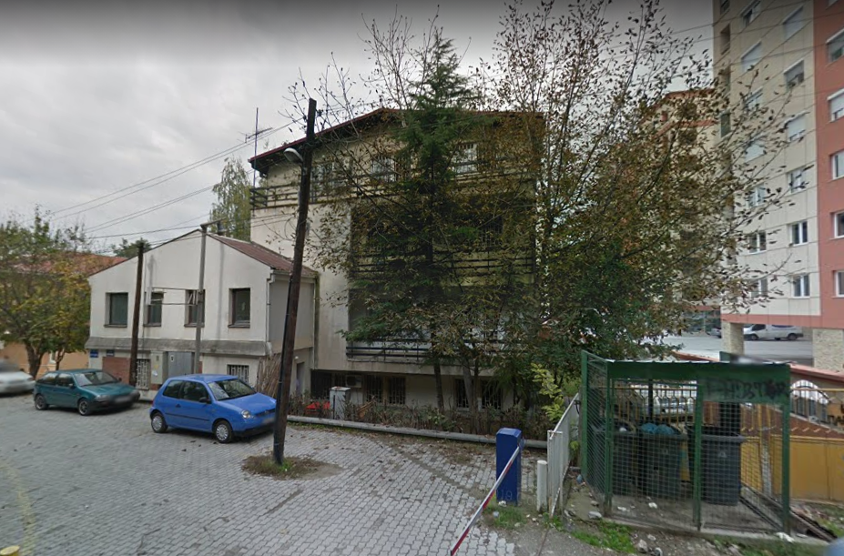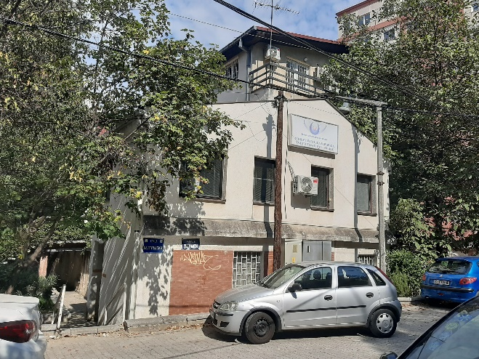
Figure 1: University Clinic of Psychiatry in city of Skopje

Figure 2: Location of the University Clinic of Psychiatry in city of Skopje
The global COVID-19 pandemic due to the SARS-CoV-2 coronavirus results in an increased need for medical care. Given the course of the pandemic in other countries, as well in ours, it is expected that these general hospitals will not have sufficient capacity to cope with the influx of people seeking medical attention and that additional intervention facilities will need to be established, or existing facilities will need to be adapted, for admission and care of COVID-19 patients, in accordance with the COVID standards.
The main purpose of this assignment is to improve the current state of PHI University Clinic of Psychiatry-Skopje by providing a reconstruction of the buildings, to re-purpose (adapt) COVID-19 patient care areas within the existing health care facilities and to improve the energy efficiency of the building.
Scope of Work
As described above, the scope of work for this assignment is to develop technical documentation for reconstruction and adaptation with improvement of energy efficiency of PHI University Clinic of Psychiatry-Skopje.

More specifically the Bidder company shall:
- Prepare Detail Design for reconstruction and adaptation of the building,
- Perform Energy audit, prepare Elaborate for energy efficiency of the building, and provide Statement of compliance of the Detailed Design for reconstruction and adaptation with the minimal conditions prescribed for energy characteristics of buildings.
The Detail Design for reconstruction and adaptation should provide a technically feasible solution for reconstruction of the exiting roof of the building, replacement of the damaged building envelope and facade windows, adaptation of the first floor for treatment of COVID 19 patients, reconstruction of the toilets on the first floor, improvement of the energy efficiency of the building and adaptation of the hospital infrastructure (main entrance door and access stairs) for admission of COVID-19 patients with severe and mild to moderate symptoms.
Due to aging and low maintenance over the years the University Clinic University Clinic of Psychiatry in city of Skopje is in bad condition: the roof of the building is leaking and has to be reconstructed and the building envelope is damaged and has to be repaired (Fig. 3).
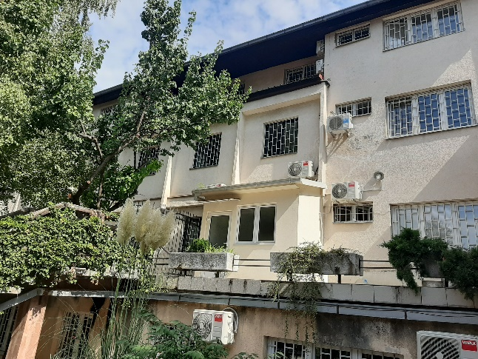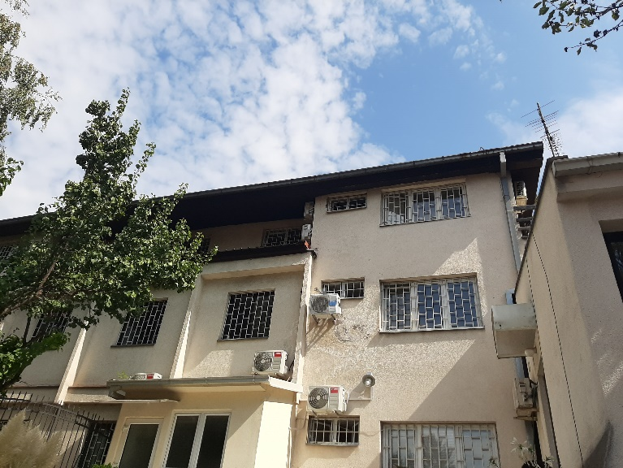
Figure 3: Damaged building envelope of University Clinic of Psychiatry in city of Skopje

The thermomechanical and electrical installations in the hospital are still operational and functional and should remain unchanged. Thus, the existing system for heating, cooling and ventilation and the electrical installation and lightning system are not part of this assignment.
The detailed design should introduce a complete technically feasible and energy efficient solution for the roof reconstruction, façade walls and windows.
The reconstruction of the roof and the building envelope has to be in accordance with the valid and applicable technical regulative, laws and by-laws and has to fulfill the requirements required for achieving energy efficiency prescribed for these types of buildings.

Since the start of the COVID-19 pandemic the University Clinic of Psychiatry in city of Skopje has planned to dedicate separate areas within the building of the hospital for patient admission, care and treatment. More precisely, the whole first floor of the building is planned to be used as COVID center. For that purpose, the Bidder Company should provide a solution for adaptation of the access stairs and entrances in the hospital (Fig. 4), as well as adaptation of the whole first floor (including reconstruction of the toilets on the first floor), by following the requirements given in the COVID-19 standard and technical regulative and standards applicable for hospitals.
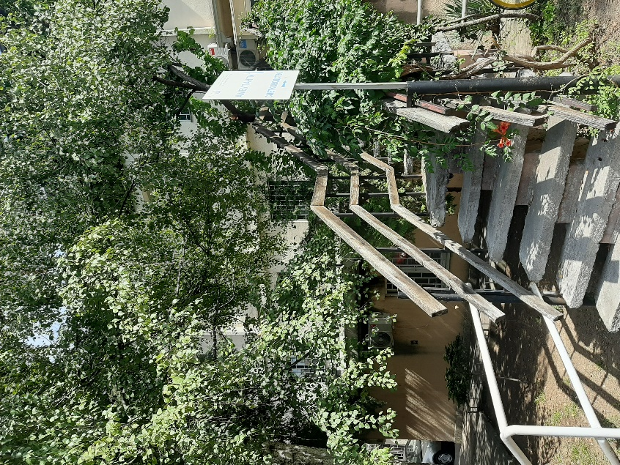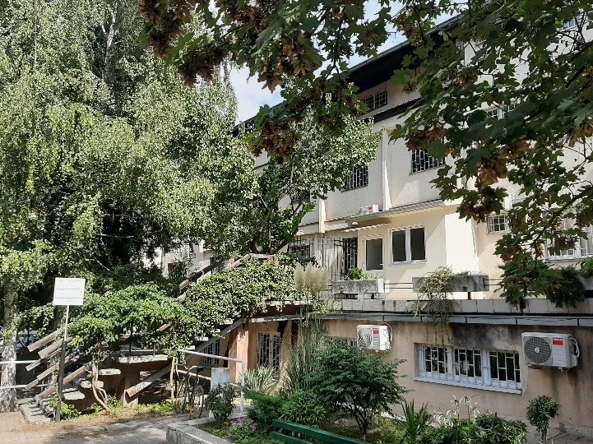
Figure 4: Access stairs and entrance in the first floor of the University Clinic of Psychiatry in city of Skopje

Any modification of the existing infrastructure in the hospital must be undertaken with the prior approval of the competent authorities. The adaptation of the access infrastructure, entrance stairs and internal area of the first floor of the building, should be carried out in accordance with the applicable laws and by instructions of the competent authorities and medical personnel. It is particularly important to ensure compliance with health, safety, construction, energy efficiency and COVID-19 regulations, and to ensure the involvement of all relevant authorities when planning the design for adaptation of access stairs and internal stair area.
Hospitals are responsible for a top-heavy amount of energy demand and joint emissions; due to their 24/7 operation and extra requirements they use larger energy amount than a commercial building. In addition, they need high quality and guaranteed supplies of electricity. Moreover, the high proportion of ageing building stocks makes hospitals among the least energy-efficient buildings.
The Detail Design for reconstruction and adaptation should include an Elaborate for energy efficiency and a proposal for measures and actions that should be taken in order to improve the energy efficiency and improve the internal comfort conditions of University Clinic of Psychiatry-Skopje in city of Skopje.
The proposed reconstruction actions for the roof and building envelope should include (although not limited to) installation of thermal insulation of external walls and roof of the buildings, and thermal insulation of heat bridges.
An energy audit has to be conducted in order to evaluate the current state of the hospital, in terms of energy usage, energy savings, the status of the building envelope, the climatic zone, the use of the rooms within the building, operating hours, number of occupants, the indoor humidity, the age and level of maintenance of the mechanical equipment, the level of energy management etc. As a result of the energy audit different energy-saving measures should be proposed. The proposed measures should be technically feasible and cost-effective. Since any changes to the performance of the building have impact on other aspects, all proposed measured for improvement of the energy efficiency of the hospital must be in accordance with the strict regulations for these types of buildings, and in accordance with the valid and applicable laws and by-laws.

Duties and Responsibilities
Based on the above-described general scope of work for the assignment of the assignment, under the direct supervision of the Project Manager and in close coordination/communication with representative officials from the PHI, and other project experts, the Contractor shall be responsible for carrying out the following activities, as a minimum:
- Setting up the kick-off meeting, where the Client and Bidder company are supposed to discuss and develop an approach for the upcoming cooperation with all project stakeholders. The Client should provide all available information regarding the assignment, so the Bidder company can start its designing activities.
- Development of Detail Design for reconstruction and adaptation of University Clinic of Psychiatry in city of Skopje including all supporting designs, studies and elaborates
  - Collection of basic data needed for the detail design (i.e. detail measurement of the building)
  - Development of solution for reconstruction of the roof, in accordance with the valid and applicable technical regulative, standards, energy efficiency rulebooks, laws and by-laws.
  - Development of solution for reconstruction of the building envelope and replacement of windows, in accordance with the valid and applicable technical regulative, standards, energy efficiency rulebooks, laws and by-laws.
  - Development of solution for adaptation of the hospital access infrastructure: solution for adaptation of access stairs and entrance to the first floor of the hospital for admission and care of COVID-19 patients, in accordance with the valid and applicable technical regulative, COVID standards, energy efficiency rulebooks, laws and by-laws.
  - Development of solution for adaptation of the whole first floor (with reconstruction of the toilets) into a COVID center, for admission and care of COVID-19 patients, in accordance with the valid and applicable technical regulative, COVID standards, energy efficiency rulebooks, laws and by-laws.
  - Detail calculation of the quantities and preparation of Bill of Quantities and Priced Cost Estimate for reconstruction of the roof, building envelope, replacement of windows and for adaptation of stairs.
  - Preparation of Elaborate for energy efficiency and deliver a proposal for measures and actions that should be taken in order to improve the energy efficiency and improve the internal comfort conditions of the building.
  - Preparation of textual part for each phase of the detail design for reconstruction and adaptation (technical report, technical description etc.)
  - Preparation of graphical part for each phase of the detail design for reconstruction and adaptation (i.e. technical drawings in appropriate scale, details etc.)
- To perform an Energy Audit and to provide (issue) a Statement for compliance of the Detailed Design for reconstruction and adaptation with the minimal conditions prescribed for energy characteristics of buildings, in accordance with the valid national standards, energy efficiency rulebooks, applicable laws and by-laws.

The Bidder company must develop the complete Detail Design for reconstruction and adaptation of University Clinic of Psychiatry in city of Skopje according to the Macedonian legislative, based on the results of previous investigations (if any) and those carried out by the Bidder company during this assignment.
With reference to the TOR, legal and technical compliance of the technical documentation, in accordance with the National standards and applicable technical legislation, the Detail Designs (with all related studies and drawings) shall be prepared respecting all legal requirements, design codes and rules.
The Detail Designs shall be prepared by a legal entity that possesses and adequate and valid license – License A for preparation of technical documentation.
The Energy Audit shall be prepared by a legal entity or sole trader (трговец-поединец) that possesses an adequate and valid license – License for energy control.
The key-experts, as responsible design engineers for respective design phases, have to be certified and have to possess individual design licenses, which will be included in the general part of each technical documentation, according to the Macedonian Law on construction.
The set of the technical documentation shall contain a “resolution for appointing the individual/responsible design engineers”, prepared and issued by the legal entity.
The key-experts/designers shall insert a digital copy in each individual DWG and/or PDF format file, digitally signed by the legal entity.
The printed copies of the Detail Designs shall be verified with personal signature and stamp of the responsible design engineers and the legal entity.

In addition, the Bidder company should develop Elaborate for Environmental Protection (Елаборат за заштита на животна средина) and Elaborate for Health and Safety (Елаборат за безбедност и заштита при работа).

Main Deliverables
For compliance of the assignment the main deliverables are:
- Three (3) copies of the Detail Design (e.g. ‘Osnoven Proekt’ in Macedonian) for reconstruction and adaptation for University Clinic of Psychiatry in city of Skopje, printed and folded in A4 format, (including all related phases and elaborates);
- One (1) digital copy of the Detail Design (with all related phases and elaborates) for reconstruction and adaptation for University Clinic of Psychiatry in city of Skopje in PDF format, digitally signed by the responsible person from the legal entity and the Key-Experts (responsible design engineers), and DWG format signed by the responsible person from the legal entity;
- Three (3) copies of the Energy audit for University Clinic of Psychiatry in city of Skopje, printed and folded in A4 format, (including Statement of compliance of the Detailed Design for reconstruction and adaptation with the minimal conditions prescribed for energy characteristics of buildings).
- One (1) digital copy of the Energy audit for University Clinic of Psychiatry in city of Skopje, (including Statement of compliance of the Detailed Design for reconstruction and adaptation with the minimal conditions prescribed for energy characteristics of buildings).
Bidder company qualifications and relevant experience
The Bidder company’s proposal shall be prepared according to the requirements of these Terms of Reference. Interested bidder companies should provide information in the Proposal demonstrating that they have the required qualifications and relevant experience to perform the Services.
General Experience:
- The Bidder company must have a least 5 years of professional experience in preparation of technical documentation in the field of civil engineering and architecture.

Specific Experience:
- The Bidder company must have participated in preparation of (at least) 2 Detail designs for construction/reconstruction of hospitals;
A list of these projects must be submitted with the proposal, including contact details for reference checking purposes (e-mail addresses and/or telephone numbers for contact persons).
- License for Design of I category of buildings (License A), issued by the Ministry of Transport and Communications of RNM or ability to obtain verification of foreign Licenses for design as per article 42 of the Macedonian Construction Law.

Staff requirements and relevant experience
The scope of work for the assignment requires a team of skilled professionals with previous experience in similar projects.
It is expected that the Bidder company will provide a team of experts with experience in similar activities and work under similar conditions and constraints, with specific professional certifications and authorizations for the services provided in the project, required by the legal framework in the Republic of North Macedonia. The core team will consist of key-experts supported by a subsidiary team of non-key experts, which the Bidder company can draw upon when needed.
No. | Team of key members  and/or  areas of expertise | Qualification requirements
1. | Team Leader – Main Designer | The Team Leader will be tasked with the overall coordination of the assignment, outputs revision, provision of technical documentation and delivery of activities within the budget and time limits contracted, and will also actively participate in the design activities. He/she will be the main contact person of the Bidder company and interface with the Client Coordinator. He/she will develop the work plan, manage deliverables, identify required expertise, and allocate tasks.  - University degree in Civil Engineering or Architecture  (MsC or PhD Degree is an asset);  - Authorization A for preparation of technical documentation;  - At least 5 years of experience in preparation of technical documentation for public buildings;  - Record of at least 2 relevant completed projects that include preparation of detail design for construction/reconstruction of hospital (please indicate the e-mail addresses or telephone numbers of contact persons).
2. | Key-expert 1: Architect | - He/she will be responsible for the design of the reconstruction and adaptation options of the buildings, will be nominated as responsible designer and, hence, will be also in charge of bill of quantities and cost estimates.  The minimum necessary qualification for the Architect:  - University degree in Architecture (MsC or PhD Degree is an asset);  - At least of 5 years of relevant work experience for preparation of detailed architectural designs for public buildings;  - Authorization A for preparation of technical documentation in the field of architecture;  - Record of at least 2 relevant completed projects that include preparation of detail architectural design for construction/reconstruction of hospital (please indicate the e-mail addresses or telephone numbers of contact persons).
3. | Key-expert 2:  Civil Engineer | He/she will be responsible for the detailed design for reconstruction of the roof and the static and seismic analysis of the building, will be nominated as responsible designer and, hence, will be also in charge of bill of quantities and cost estimates.  The minimum necessary qualification for the Civil Engineer:  - University degree in civil engineering, specialization in structural engineering (Msc or PhD Degree is an asset);  - At least 5 years of relevant work experience in preparation of detailed structural designs for public buildings;  - Authorization A for preparation of technical documentation in the field of civil engineering;  - Record of at least 2 relevant completed projects that include preparation of detail structural design for construction/reconstruction of hospital (please indicate the e-mail addresses or telephone numbers of contact persons).
4. | Key-expert 3:  Energy efficiency specialist | He/she will be responsible for the energy audit of the buildings, and will be nominated as responsible designer for the elaborate for energy efficiency.  The minimum necessary qualification for the Energy efficiency specialist:  University degree in civil/architecture/electrical/mechanical engineering;  - Authorization A for preparation of technical documentation in the field of energy efficiency;  - At least 5 years of relevant work experience in preparation of energy elaborates for efficiency of public buildings;  - Record of at least 2 relevant completed projects that include preparation of elaborate for energy efficiency of public buildings. (please indicate the e-mail addresses or telephone numbers of contact persons).

NOTES:
- Authorizations for preparing the technical documentation must be issued by the Chamber of Authorized Architects and Authorized Engineers of the Republic of Macedonia, according to Art. 33 of the Law on construction (O.G. of RNM, No. 130/09) and must be members of the Chamber of Authorized Architects and Authorized Engineers of the Republic of North Macedonia.
- Any of the Key-experts may be appointed as Team leader – Main designer.
PLEASE NOTE:
The Bidder company should bid on all deliverables (from 1 to 2) listed in Table 1

Annex 2

Table 1- List of relevant projects:
Please provide the following information in the table below regarding company experiences which are related or relevant to those required for this Contract: minimum 2 projects of comparable nature and complexity degree for development of detail designs for construction/reconstruction of hospitals).
Title of project | Client | Contract Value (in MKD) | Period of activity | Types of activities undertaken | Status or Date Completed | References Contact Details (Name, Phone, Email)

Table 2

FOR THE KEY EXPERTS - Please provide the following information in the tables below regarding key experts’ experiences (general and specific)- for each expert in a separate table

For the Team leader / Main designer:
• At least 5 years of experience in preparation of technical documentation for public buildings;
• Record of at least 2 relevant completed projects that include preparation of detail design for construction/reconstruction of hospital (please indicate the e-mail addresses or telephone numbers of contact persons).

 | Name and Surname of the Key Expert –  Team Leader | Authorization A/B  (indicate) | Total general  experience (in years) in line with CV credentials | Number of ONGOING PROJECTS with UNDP | Relevant project specific experience – for Key Expert (at least two)

For the Key Expert 1: Architect
- At least of 5 years of relevant work experience for preparation of detailed architectural designs for public buildings;
- Authorization A for preparation of technical documentation in the field of architecture;
- Record of at least 2 relevant completed projects that include preparation of detail architectural design for construction/reconstruction of hospital (please indicate the e-mail addresses or telephone numbers of contact persons).

No. 1 | Name and Surname of the Key Expert -Architect | Authorization A/B  (indicate) | Total general  experience (in years) in line with CV credentials | Number of ONGOING PROJECTS with UNDP | Relevant project specific experience – for Key Expert (at least two)

For the Key Expert 2: Civil engineer
- At least 5 years of relevant work experience in preparation of detailed structural designs for public buildings;
- Authorization A for preparation of technical documentation in the field of civil engineering;
- Record of at least 2 relevant completed projects that include preparation of detail structural design for construction/reconstruction of hospital (please indicate the e-mail addresses or telephone numbers of contact persons).
No. 2 | Name and Surname of the Key Expert –  Civil Engineer | Authorization A/B  (indicate) | Total general  experience (in years) in line with CV credentials | Number of ONGOING PROJECTS with UNDP | Relevant project specific experience – for Key Expert (at least two)

For the Key Expert 3: Energy efficiency specialist
- Authorization A for preparation of technical documentation in the field of energy efficiency;
- At least 5 years of relevant work experience in preparation of elaborates for energy efficiency of public buildings;
- Record of at least 2 relevant completed projects that include preparation of elaborate for energy efficiency of public buildings. (please indicate the e-mail addresses or telephone numbers of contact persons).
No. 3 | Name and Surname of the Key Expert - Energy efficiency specialist | Authorization A/B  (indicate) | Total general  experience (in years) in line with CV credentials | Number of ONGOING PROJECTS with UNDP | Relevant project specific experience – for Key Expert (at least two)

Annex 3.

FORM FOR SUBMITTING SUPPLIER’S QUOTATION
(This Form must be submitted only using the Supplier’s Official Letterhead/Stationery

We, the undersigned, hereby accept in full the UNDP General Terms and Conditions, and hereby offer to deliver services in conformity with TOR under RFQ 116/2020 for Preparation of Technical documentation – Detailed designs for reconstruction and adaptation with improvement of energy efficiency of University Clinic of Psychiatry-Skopje

Developing complete technical documentation - Detailed designs for reconstruction and adaptation with improvement of energy efficiency of University Clinic of Psychiatry-Skopje
Table 1
Item No. | Description of milestones and deliverables  Upon completion of the assignments and submission of complete technical documentation as per Annex 1 | Total Price in MKD, VAT excluded | Completion date
1 | Detail Design (e.g. ‘Osnoven Proekt’ in Macedonian) for reconstruction and adaptation of PHI University Clinic of Psychiatry-Skopje, (including all related phases and elaborates);
2 | Energy audit for PHI University Clinic of Psychiatry-Skopje, (including Statement of compliance of the Detailed Design for reconstruction and adaptation with the minimal conditions prescribed for energy characteristics of buildings.)
TOTAL:

All other information that we have not provided automatically implies our full compliance with the requirements, terms and conditions of the RFQ.

We hereby declare that:
- All the information and statements made in this Bid are true and we accept that any misrepresentation contained in it may lead to our disqualification;
- We are currently not on the removed or suspended vendor list of the UN or other such lists of other UN agencies, nor are we associated with, any company or individual appearing on the 1267/1989 list of the UN Security Council;
- We have no outstanding bankruptcy or pending litigation or any legal action that could impair our operation as a going concern; and
- We do not employ, nor anticipate employing, any person who is or was recently employed by the UN or UNDP.

We confirm that we have read, understood and hereby fully accept the Schedule of Requirements and Technical Specifications describing the duties and responsibilities required of us in this RfQ, and the General Terms and Conditions of UNDP’s Standard Contract for this RfQ.

We agree to abide by this Bid for 120 days.

We undertake, if our Bid is accepted, to commence the Works and provision of related services not later than the date indicated in the Data Sheet.

We fully understand and recognize that UNDP is not bound to accept this Bid, that we shall bear all costs associated with its preparation and submission, and that UNDP will in no case be responsible or liable for those costs, regardless of the conduct or outcome of the evaluation.

We remain,

Yours sincerely,

Authorized Signature [In full and initials]:
Name and Title of Signatory:
Name of Firm:
Contact Details:
please mark this letter with your corporate seal, if available]

Must be linked to INCO Terms chosen.
Depends on INCO Terms. The suggestion to use a UNDP preferred courier is only for purposes of familiarity with procedures and documentary requirements applicable to the UNDP when clearing with customs.
Local vendors must comply with any applicable laws regarding doing business in other currencies. Conversion of currency into the UNDP preferred currency, if the offer is quoted differently from what is required, shall be based only on UN Operational Exchange Rate prevailing at the time of UNDP’s issuance of Purchase Order.
This must be reconciled with the INCO Terms required by the RFQ. Furthermore, VAT exemption status varies from one country to another. Pls. tick whatever is applicable to the UNDP CO/BU requiring the goods.
UNDP preference is not to pay advanced amount upon signing of contract. If vendor strictly requires advanced payment, it will be limited only up to 20% of the total price quoted. For any higher percentage, or advanced payment of $30,000 or higher, UNDP shall require the vendor to submit a bank guarantee or bank checque payable to UNDP, in the same amount as the advanced payment made by UNDP to the vendor.
UNDP reserves the right not to award the contract to the lowest priced offer, if the second lowest price among the responsive offer is found to be significantly more superior, and the price is higher than the lowest priced compliant offer by not more than 10%, and the budget can sufficiently cover the price difference. The term “more superior” as used in this provision shall refer to offers that have exceeded the pre-determined requirements established in the specifications.
This shall be used for time-critical and/or exigent requirements (e.g., post-crisis emergencies, elections, etc.).
Minimum of one (1) year period and may be extended up to a maximum of three (3) years subject to satisfactory performance evaluation
Where the information is available in the web, a URL for the information may simply be provided.
This contact person and address is officially designated by UNDP. If inquiries are sent to other person/s or address/es, even if they are UNDP staff, UNDP shall have no obligation to respond nor can UNDP confirm that the query was received.
Copies of the original Authorization, no translation required.
Copies of the original Authorization, no translation required.
Copies of the original Authorization, no translation required.
Copies of the original Authorization, no translation required.
Ministry of Health. COVID-19 Infrastructure Indicators / Alternative Care Facilities;

