OFFEROR’S LETTER TO UNDP
CONFIRMING INTEREST AND AVAILABILITY
FOR THE INDIVIDUAL CONTRACTOR (IC) ASSIGNMENT

Date

Resident Representative
United Nations Development Programme
107 – 108 Duke Street
Kingston,
Georgetown
GUYANA

Dear Sir/Madam:

I hereby declare that:

- I have read, understood and hereby accept the Terms of Reference describing the duties and responsibilities of [Technical and Editorial Review and Updating under the [state project title];

- I have also read, understood and hereby accept UNDP’s General Conditions of Contract for the Services of the Individual Contractors;

- I hereby propose my services and I confirm my interest in performing the assignment through the submission of my CV which I have duly signed and attached hereto as Annex 1;

- I hereby propose to complete the services based on the following payment rate: [please check the box corresponding to the preferred option]:

- An all-inclusive daily fee of [state amount in words and in numbers indicating currency]
- A total lump sum of [state amount in words and in numbers, indicating exact currency], payable in the manner described in the Terms of Reference.

- For your evaluation, the breakdown of the abovementioned all-inclusive amount is attached hereto as Annex 2;

- I recognize that the payment of the abovementioned amounts due to me shall be based on my delivery of outputs within the timeframe specified in the TOR, which shall be subject to UNDP's review, acceptance and payment certification procedures;

- This offer shall remain valid for a total period of ___________ days [minimum of 90 days] after the submission deadline;

- I confirm that I have no first degree relative (mother, father, son, daughter, spouse/partner, brother or sister) currently employed with any UN agency or office [disclose the name of the relative, the UN office employing the relative, and the relationship if, any such relationship exists];

- If I am selected for this assignment, I shall [please check the appropriate box]:

- Sign an Individual Contract with UNDP;
- Request my employer [state name of company/organization/institution] to sign with UNDP a Reimbursable Loan Agreement (RLA), for and on my behalf. The contact person and details of my employer for this purpose are as follows:

- I hereby confirm that [check all that applies]:

- At the time of this submission, I have no active Individual Contract or any form of engagement with any Business Unit of UNDP;
- I am currently engaged with UNDP and/or other entities for the following work:

Assignment | Contract Type | UNDP Business Unit / Name of Institution/Company | Contract Duration | Contract Amount

- I am also anticipating conclusion of the following work from UNDP and/or other entities for which I have submitted a proposal:

Assignment | Contract Type | Name of Institution/ Company | Contract Duration | Contract Amount

- I fully understand and recognize that UNDP is not bound to accept this proposal, and I also understand and accept that I shall bear all costs associated with its preparation and submission and that UNDP will in no case be responsible or liable for those costs, regardless of the conduct or outcome of the selection process.

- If you are a former staff member of the United Nations recently separated, please add this section to your letter: I hereby confirm that I have complied with the minimum break in service required before I can be eligible for an Individual Contract.

- I also fully understand that, if I am engaged as an Individual Contractor, I have no expectations nor entitlements whatsoever to be re-instated or re-employed as a staff member.

- Are any of your relatives employed by UNDP, any other UN organization or any other public international organization?
YES NO If the answer is "yes", give the following information:

Name | Relationship | Name of International Organization

- Do you have any objections to our making enquiries of your present employer?
YES NO

- Are you now, or have you ever been a permanent civil servant in your government’s employ?
YES NO If answer is "yes", WHEN?

- REFERENCES: List three persons, not related to you, who are familiar with your character and qualifications.

Full Name | Full Address | Business or Occupation

- Have you been arrested, indicted, or summoned into court as a defendant in a criminal proceeding, or convicted, fined or imprisoned for the violation of any law (excluding minor traffic violations)?
YES NO If "yes", give full particulars of each case in an attached statement.

I certify that the statements made by me in answer to the foregoing questions are true, complete and correct to the best of my knowledge and belief. I understand that any misrepresentation or material omission made on a Personal History form or other document requested by the Organization may result in the termination of the service contract or special services agreement without notice.

DATE: SIGNATURE:

NB. You will be requested to supply documentary evidence which support the statements you have made above. Do not, however, send any documentary evidence until you have been asked to do so and, in any event, do not submit the original texts of references or testimonials unless they have been obtained for the sole use of UNDP.

Annexes [please check all that applies]:
- CV shall include Education/Qualification, Processional Certification, Employment Records /Experience
- Breakdown of Costs Supporting the Final All-Inclusive Price as per Template
- Brief Description of Approach to Work (if required by the TOR)
ANNEX 2

BREAKDOWN OF COSTS
SUPPORTING THE ALL-INCLUSIVE FINANCIAL PROPOSAL

- Breakdown of Cost by Components:
Cost Components | Unit Cost | Quantity | Total Rate for the Contract Duration
- Personnel Costs
Professional Fees
Life Insurance
Medical Insurance
Communications
Land Transportation
Others (pls. specify)
- Travel Expenses to Join duty station
Round Trip Airfares to and from duty station
Living Allowance
Travel Insurance
Terminal Expenses
Others (pls. specify)
- Duty Travel
Round Trip Airfares
Living Allowance
Travel Insurance
Terminal Expenses
Others (pls. specify)

- Breakdown of Cost by Deliverables*
Deliverables  [list them as referred to in the TOR] | Percentage of Total Price (Weight for payment) | Amount
Deliverable 1
Deliverable 2
….
Total | 100% | GYD ……
*Basis for payment tranches
UNITED NATIONS DEVELOPMENT PROGRAMME
TERMS OF REFERENCE

Job title: Consultant to:
- Strengthen CSO Capacity to engage in Social Contracting as part of the National HIV Response (40%)
- Produce Being LGBTI+ in Guyana Research and Dialogue Reports (60%)
Supervisor: Resident Representative
Type of contract: Individual Consultant (National)
Duration of Assignment: 55 staff days over a 4 months period
Period: November 9, 2020 to March 12, 2021
Duty Station: Guyana
Application deadline: October 26, 2020

- Background
- Strengthen CSO Capacity to engage in Social Contracting as part of the National HIV Response
Based on the Sustainability Plan for the National HIV Programme, the Ministry of Health is working towards the full national ownership of the HIV response. Given the decline in donor support especially the Global Fund and the United States Government’s President’s Emergency Plan for AIDS Relief (PEPFAR), the Plan prioritizes the continued engagement of civil society organizations (CSOs) as partners in both decision-making and service delivery, as critical for a sustainable and effective HIV response.
The epidemic has had a disproportionate effect on key populations, which are defined as men who have sex with men (MSM), sex workers (SW), transgender people, persons who use drugs (PWUD) and miners and loggers. CSOs have played an important role in reaching these key population groups and providing most required prevention services. These services include the provision of HIV/STI information, risk reduction counselling, HIV testing, STI screening, condom and lubricant distribution, psychosocial support, social services, referral for ART, STI, TB, community, and palliative care. More specifically, care and support services being provided by CSOs include referrals or accompanied access to health services, adherence support, and home-based and community care. CSOs also play meaningful roles in advocacy, decision-making, and oversight of the national response. The withdrawal of Global Fund and PEPFAR, the main funders of CSOs, impedes this critical work.
To address the abovementioned challenge, the National Aids Programme Secretariat (NAPS) initiated a social contracting initiative between CSOs and the Government of Guyana (GOG). A pilot run of this initiative was undertaken in 2019 and it is envisioned that it would be sustained in the future. A review of the pilot noted several recommendations for streamlining and improvement in this CSO/GOG collaboration. One such area is to strengthen the CSOs capacity to engage in social contracting.

- Being LGBTI+ in Guyana Research and Dialogue Reports
Lesbian, gay, bisexual, transgender and intersex (LGBTI+) people in the Caribbean face legal, social, and economic barriers to full inclusion and enjoyment of their human rights. Despite positive developments regionally, including increased attention and funding to advance inclusion and the development of anti-discrimination policy and law, there remains much work to be done to guarantee equality of LGBTI+ people under the law and to ensure protection from violence and discrimination as well as equal access to services. Punitive laws and practices have a critical impact on the enjoyment of human rights, health as well as on social and economic development more broadly. Punitive laws, policies and practices contribute to pervasive stigma and discrimination, which can lead to hate crime, police abuse, torture and ill-treatment, and family and community violence.
In recognition of the importance of acting on these issues and the connection between securing the rights of LGBTI+ people and achieving the Sustainable Development Goals for the region, the Being LGBTI in the Caribbean (BLIC) Project was developed. The project aims to enhance knowledge, partnerships, and capacities of LGBTI+ communities, civil society and States to reduce human rights violations and negative attitudes towards LGBTI+ people in the Caribbean. There is country level focus in Guyana, Jamaica, Barbados, St. Lucia and Grenada, the Dominican Republic and Haiti, as well as regional activities and dialogues. The project seeks to increase access to justice for LGBTI+ persons, through the promotion of LGBTI+ inclusive public policies; increased representation of LGBTI+ in national and regional fora; and by addressing stigma and discrimination.
In Guyana, the project is seeking to conduct a desk research as well as a national dialogue on Being LGBTI+. The information gleaned from these two activities will be useful in offering a complete account of the impact of discrimination, exclusion, and vulnerability on Guyanese LGBTI+ people. It will form a comprehensive body of work that can be shared with partners and policy makers to introduce/shape legislative and policy reforms.

- Scope of Work
- Strengthen CSO Capacity to engage in Social Contracting as part of the National HIV Response
- Based on the findings of the Social Contracting pilot initiative that was executed in 2019 and in consultation with NAPS, conduct a mapping of the capacity of CSOs to provide services to HIV key populations.
- Based on the mapping of CSOs, provide recommendations for the enhancement of the capacity of CSOs to provide services to HIV key populations; These recommendations should be focused on areas such as CSOs governance structure, human and financial capacity, SOPs, type of services provided etc; and
- Provision of enhanced guidelines and templates to be utilized by CSOs in applying for, implementing, and reporting on social contract.

- Being LGBTI+ in Guyana Dialogue and Research Reports
- Facilitate an online dialogue forum where government and civil society organizations share insights, experiences and good practices on LGBTI+ issues.
- Building on the research undertaken by the Consultant for the formulation of the UNDP- EU CSO Initiative Contribution Agreement and Project Document:
- Conduct a desk review of LGBTI+ rights in the country including history, activism, legislation, policies, international norms and practices, attitudes and perspectives, discrimination and violence, state organs and related contents in Guyana;
- Work with UNDP, Guyana Trans United, United Brick Layers, Guyana Sex Workers Coalition, SASOD, FACT, Comforting Hearts, Guyana Rainbow Foundation, Guyana Equality Forum, SWAG, Equal Guyana, Artiste in Direct Support and other pertinent groups to develop a detailed assessment and analysis of the LGBTI Guyanese experience in: Employment & Housing, Education, Health, Family and Society, Media and Technology and Community Development;
- Provide a thorough assessment of the capacity of local LGBTI+ organizations, inclusive of interviews with staff and board members. Focus must be on the entities’ legal status, human resources, communication, coordination, and fundraising challenges.
- Provide recommendations to address challenges and gaps facing LGBTI+ people in Guyana as identified in dialogue and desk review.

- Expected Outputs and deliverables
Payments would be made based on the submission and acceptance of the following outputs as detailed in the table below
- Strengthen CSO Capacity to engage in Social Contracting as part of the National HIV Response
Report containing findings of mapping, recommendations, guidelines, and templates for the provision of services to HIV key populations based on social contracting engagements.

- Being LGBTI in Guyana Research and Dialogue Reports
- Report containing findings emanating from online dialogue forum.
- Report containing findings on Desk Research of Being LGBTI+ in Guyana; and
  - Consolidated report on dialogue forum and desk research, inclusive of recommendations to address challenges and gaps facing LGBTI+ people in Guyana.

Deliverables/ Outputs | Estimated number of man-days | Proposed Completion deadline | Percentage payment
Deliverable 1: Implementation Plan | 2 days | November 11, 2020 | 0
Deliverable 2: First draft of report mentioned at 3(Bii) above | 15 days | December 11, 2020 | 30
Deliverable 3: Report on Dialogue mentioned in 3 (Bi) above | 6 days | December 18, 2020 | 10
Deliverable 4: First draft report on desk research mentioned at 3A above | 15 days | January 29, 2021 | 25
Deliverable 5: Final report mentioned at 3A above | 7 days | February 28, 2021 | 15
Deliverable 6: Final consolidated report on dialogue and research mentioned in 3B above. | 10 days | February 26, 2021 | 20
Total | 55 days |  | 100

- Institutional Arrangement
The Consultant will report to the Programme Analyst, Governance and Poverty Reduction under the overall guidance of the Resident Representative, working closely with the UNDP Guyana Programme Team.

- Duration of the Work
- Consultant is expected to be engaged for 55 working days over a four-month period.
- The anticipated start date for the consultancy November 9, 2020.
- UNDP and relevant partners will review and provide comments on deliverables within 5 to 10 business days of receipt of the deliverable.
- Payment for deliverables can only be made upon submission and approval of an invoice. Payment usually take 5-7 consecutive working days to be processed.

- Duty Station
The duty station would be Guyana. Given the COVID 19 containment measures, the Consultant would be expected to work from home and to engage stakeholders via Skype, Zoom or another similar platform, as needed.

- Qualification and Experience Requirements
- Minimum of a Masters Degree in human rights, gender studies, law, history, Economics or a related Social Sciences discipline.
- Minimum five years of relevant experience in LGBTI+ rights, health, human rights and key populations most at risk of HIV.
- Minimum five years of advocacy experience, including advocacy for LGBTI+ rights, human rights, and HIVs rights.
- Minimum two years of experience in researching, reporting and contributing to reports related to the violation of the rights of LGBTI people and other HIV key populations;
- Minimum two years’ experience in writing documents related to the reality of LGBTI people and HIV key populations.
- Evidence of good knowledge of the functioning of international and regional human rights mechanisms.
- Strong interpersonal and communication skills both oral and written in English.

Additionally, the Consultant should meet the following secondary requirements:
Core Values
- Respect for Diversity
- Integrity
- Professionalism

Core Competencies
- Accountability
- Creative Problem Solving
- Effective Communication
- Inclusive Collaboration
- Stakeholder Engagement
- Leading by Example

Functional Competencies
- Ability to perform qualitative and quantitative policy research
- Ability to advocate and provide policy and technical advice
- Excellent networking skills
- Excellent analytical skills
- Excellent writing, presentation and facilitation skills
- Ability to work under pressure and tight deadlines
- Ability to write policy papers, technical documents and briefings involving inputs from multiple sources
And should be available for full participation and intensive work within required timeframes.
- Documents to be included when submitting proposals
Interested individual Consultants must submit the following documents/information to demonstrate their qualifications:
- Letter of confirmation of interest and availability
- Proposal (in English, mandatory):
  - Explaining why they are the most suitable for the work
  - Providing a brief methodology on how they will approach and conduct the work
- CV including experience in similar assignments and at least 3 references.
- Financial proposal
The financial proposal shall specify a total lump sum amount supported by a breakdown of costs, as per template provided; payments would be based upon output, i.e. upon delivery of the services specified in the TOR.

- Assessment of the proposal
Individual Consultants will be evaluated based on the Combined Scoring method.
When using this weighted scoring method, the award of the contract should be made to the individual Consultant whose offer has been evaluated and determined as:
a) responsive/compliant/acceptable, and
b) having received the highest score out of a pre-determined set of weighted technical and financial criteria specific to the solicitation.

10. Criteria for selection
Selection criteria will be based on qualification, knowledge and experience. The proposal will be weighted at a maximum of 100 points with a requirement of 70% pass mark. This will be broken down in the following manner:
Criteria for Selection |  |  | Points Allocated per Criteria
1 |  | Technical Proposal | 25
 |  | Clearly articulated proposal and methodology to undertake the assignment in a rapidly changing and fluid environment. | 25
2 |  | Qualifications & Experience | 65
 |  | Minimum of a Masters Degree in human rights, gender studies, law, history, Economics or a related Social Sciences discipline.  Minimum five years of relevant experience in the area of LGBTI+ rights, health, human rights and key populations most at risk of HIV;  Minimum five years of advocacy experience, including advocacy for LGBTI+ rights, human rights and HIVs rights;  Minimum two years of experience in researching, reporting and contributing to reports related to the violation of the rights of LGBTI people and other HIV key populations;  Minimum two years’ experience in writing documents related to the reality of LGBTI people and HIV key populations; | 20  15  15  7.5  7.5
3 |  | Knowledge and skills | 10
 |  | Evidence of good knowledge of the functioning of international and regional human rights mechanisms;  Strong interpersonal and communication skills both oral and written in English. | 5  5
Total technical score (required pass mark = 70%) |  |  | 100 pts
Financial criteria = 30%

SUBMISSION OF APPLICATION
Please complete and submit to procurement.gy@undp.org Deadline for submission of application is 26 October 2020 on or before 11:00 hrs.
Subject caption “Consultant - Guyana Research and Dialogue Reports”

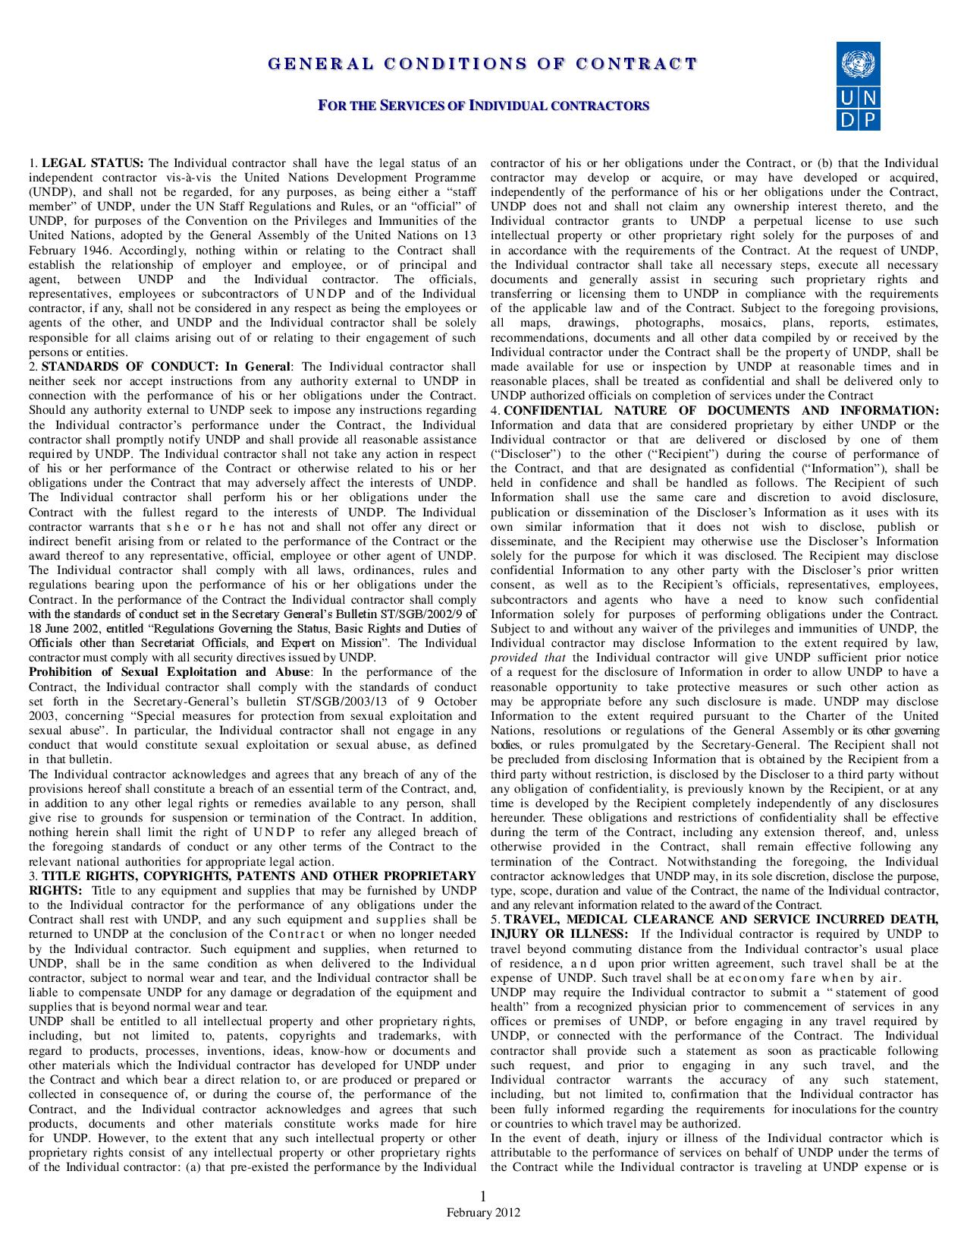
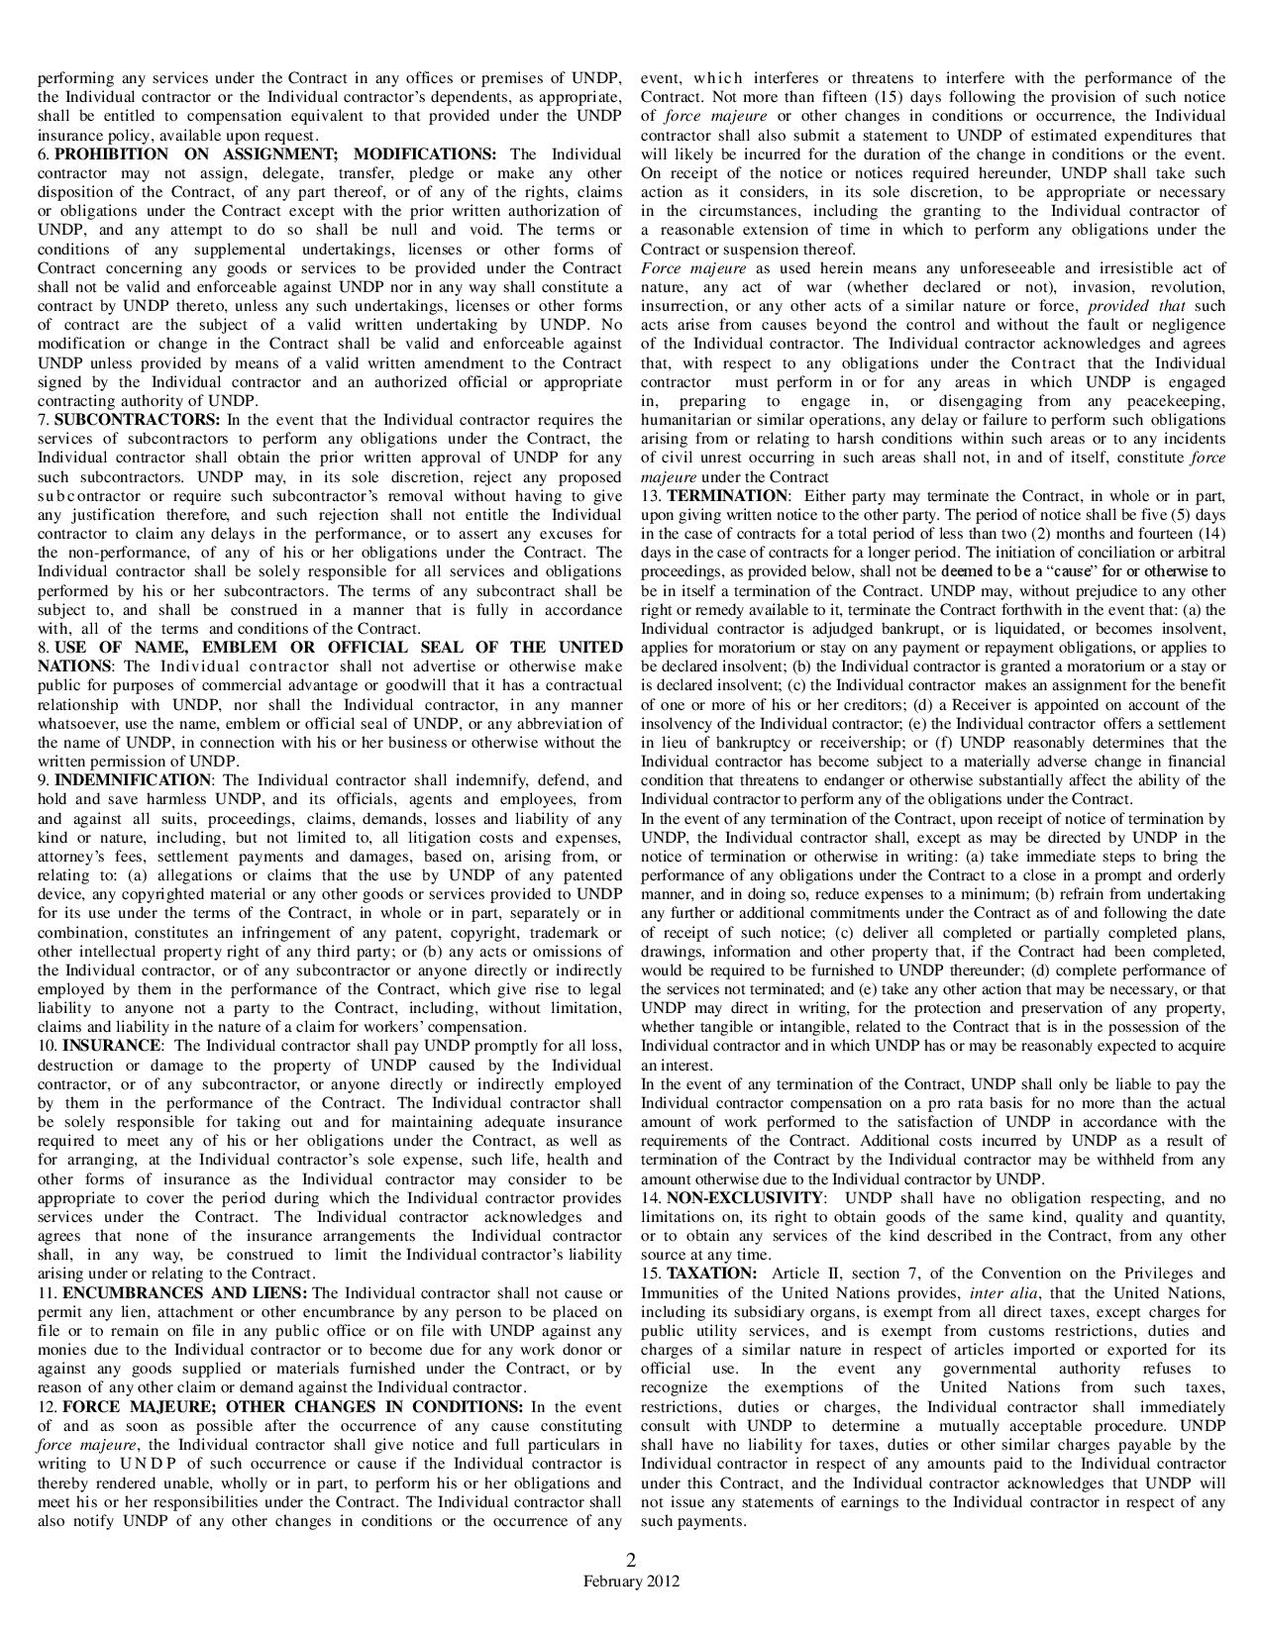
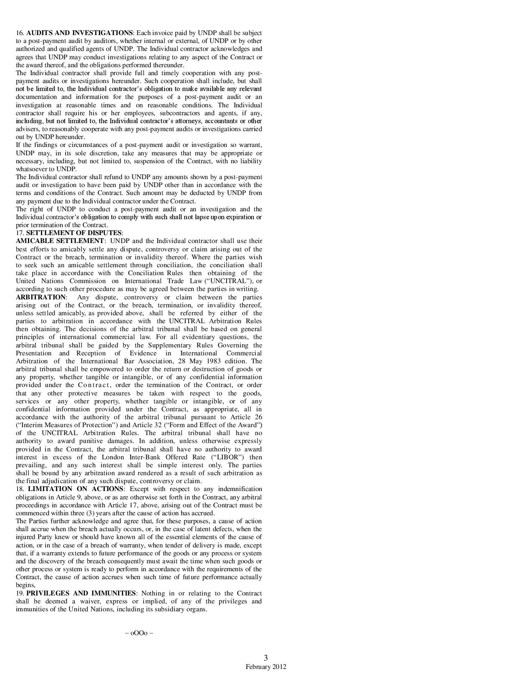

The costs should only cover the requirements identified in the Terms of Reference (TOR)
Travel expenses are not required if the consultant will be working from home.

