REQUEST FOR QUOTATION (RFQ)

UNDP BIH  Zmaja od Bosne bb; Sarajevo | DATE: 30/09/2020
 | REFERENCE: BIH/RFQ/158/20

Dear Sir / Madam:

UNDP BIH kindly requests you to submit your quotation for Construction, delivery and installation of 20 open-air exhibition booths with electrical installations, as detailed in Annex 1 of this RFQ. When preparing your quotation, please be guided by the forms attached hereto as Annex 2 and Annex 3.

Quotations may be submitted on or before 15 October 2020, latest by 17:00 via e-mail or courier mail to the address below:

United Nations Development Programme
Zmaja od Bosne bb, Sarajevo 71000
General Service
registry.ba@undp.org

It shall remain your responsibility to ensure that your quotation will reach the address above on or before the deadline. Quotations that are received by UNDP after the deadline indicated above, for whatever reason, shall not be considered for evaluation.

Please take note of the following requirements and conditions pertaining to the supply of the abovementioned good/s:

Delivery Terms [INCOTERMS 2010]  (Pls. link this to price schedule) | ☒DDP
Customs clearance, if needed,  shall be done by: | UNDP
Exact Address/es of Delivery Location/s (identify all, if multiple) | City of Tuzla (Trg Slobode and two additional locations in close proximity of the center of Tuzla) - as per delivery schedule in Annex 2
Latest Expected Delivery Date and Time | ☒ 45 calendar days upon acceptance of UNDP PO
Delivery Schedule | ☒ Required
Preferred Currency of Quotation | Local Currency: BAM
Value Added Tax on Price Quotation | Must be exclusive of VAT and other applicable indirect taxes; (VAT and custom stated separately)
After-sales services required | Warranty for minimum period as specified in Annex 1
Deadline for the Submission of Quotation | 15 October 2020, 17:00 PM
All documentations, including catalogs, instructions and operating manuals, shall be in this language | ☒ English or  ☒ In one of the official languages of BiH people
Documents to be submitted | - Duly Accomplished Form as provided in Annex 3, and in accordance with the list of requirements in Annex 1 and Bill of Quantity in Annex 2;  - Bill of Quantity from Annex 2 completed in Excel and signed and stamped in pdf. format,  - Delivery Schedule as per Annex 3;  - Registration of the business, including Articles of Incorporation, or equivalent document if Bidder is not a corporation;  - Declaration issued by relevant Tax Administration that Bidder has clear direct tax record, not older than one month (original or certified copy);  - Declaration issued by respective Indirect Taxation Authority that Bidder has clear indirect tax record, not older than one month (original or certified copy);  - Reference list indicating successfully completed contracts for supplies and deliveries of similar items within the past 5 (five) years on the company memorandum letter, indicating exact subject of contract, value and time period – minimum 3 completed contracts.  - Statement regarding warranty, service and after-sales support;  - Written Self-Declaration of not being included in the UN Security Council 1267/1989 list, UN Procurement Division List or other UN Ineligibility List;
Period of Validity of Quotes starting the Submission Date | ☒ 30 days  In exceptional circumstances, UNDP may request the Vendor to extend the validity of the Quotation beyond what has been initially indicated in this RFQ. The Proposal shall then confirm the extension in writing, without any modification whatsoever on the Quotation.
Partial Quotes | ☒ Partial Quotes are not permitted.
Payment Terms | ☒ 100% upon complete delivery of goods
Evaluation Criteria | ☒ Technical responsiveness/Full compliance to requirements  ☒ Lowest priced technically responsive quotation  ☒ Full acceptance of the PO/Contract General Terms and Conditions
UNDP will award to: | ☒ One supplier, depending on the following factors: Technical responsiveness/Full compliance to requirements and lowest price
Type of Contract to be Signed | ☒ Purchase Order
Special conditions of Contract | ☒ Cancellation of PO/Contract if the delivery/completion is delayed by 10 working days from agreed delivery date.
Conditions for Release of Payment | ☒ Written Acceptance of Goods based on full compliance with RFQ requirements  ☒ Written confirmation of acceptance by the beneficiary
Annexes to this RFQ | ☒ Specifications of the Goods Required (Annex 1)  ☒ Delivery Schedule (Annex 2)  ☒ Form for Submission of Quotation (Annex 3)  ☒ General Terms and Conditions / Special Conditions (Annex 4).  Non-acceptance of the terms of the General Terms and Conditions (GTC) shall be grounds for disqualification from this procurement process.
Contact Person for Inquiries  (Written inquiries only) | UNDP BiH, Registry Fax: 033 552 330; email: registry.ba@undp.org  Any delay in UNDP’s response shall be not used as a reason for extending the deadline for submission, unless UNDP determines that such an extension is necessary and communicates a new deadline to the Proposers.

Goods offered shall be reviewed based on completeness and compliance of the quotation with the minimum specifications described above and any other annexes providing details of UNDP requirements. The quotation that complies with all of the specifications, requirements and offers the lowest price, as well as all other evaluation criteria indicated, shall be selected. Any offer that does not meet the requirements shall be rejected.

Any discrepancy between the unit price and the total price (obtained by multiplying the unit price and quantity) shall be re-computed by UNDP. The unit price shall prevail and the total price shall be corrected. If the supplier does not accept the final price based on UNDP’s re-computation and correction of errors, its quotation will be rejected.

After UNDP has identified the lowest price offer, UNDP reserves the right to award the contract based only on the prices of the goods in the event that the transportation cost (freight and insurance) is found to be higher than UNDP’s own estimated cost if sourced from its own freight forwarder and insurance provider. At any time during the validity of the quotation, no price variation due to escalation, inflation, fluctuation in exchange rates, or any other market factors shall be accepted by UNDP after it has received the quotation.

At the time of award of Contract or Purchase Order, UNDP reserves the right to vary (increase or decrease) the quantity of services and/or goods, by up to a maximum twenty five per cent (25%) of the total offer, without any change in the unit price or other terms and conditions.

Any Purchase Order that will be issued as a result of this RFQ shall be subject to the General Terms and Conditions attached hereto. The mere act of submission of a quotation implies that the vendor accepts without question the General Terms and Conditions of UNDP herein attached as Annex 2.

UNDP is not bound to accept any quotation, nor award a contract/Purchase Order, nor be responsible for any costs associated with a Supplier’s preparation and submission of a quotation, regardless of the outcome or the manner of conducting the selection process.

Please be advised that UNDP’s vendor protest procedure is intended to afford an opportunity to appeal for persons or firms not awarded a purchase order or contract in a competitive procurement process. In the event that you believe you have not been fairly treated, you can find detailed information about vendor protest procedures in the following link: http://www.undp.org/procurement/protest.shtml

UNDP encourages every prospective Vendor to avoid and prevent conflicts of interest, by disclosing to UNDP if you, or any of your affiliates or personnel, were involved in the preparation of the requirements, design, specifications, cost estimates, and other information used in this RFQ.

UNDP implements a zero tolerance on fraud and other proscribed practices, and is committed to identifying and addressing all such acts and practices against UNDP, as well as third parties involved in UNDP activities. UNDP expects its suppliers to adhere to the UN Supplier Code of Conduct found in this link: http://www.un.org/depts/ptd/pdf/conduct_english.pdf
Thank you and we look forward to receiving your quotation.

Sincerely yours,
UNDP BIH

Annex I

TECHNICAL SPECIFICATION

Construction, delivery and installation of 20 open-air exhibition booths with electrical installations

The dimensions of the base of each open-air exhibition booth is 250x200 cm. The total height of the booth is about 280 cm. The wooden booth is comprised of 8 pieces or elements: 4 walls, a floor, a roof and two gable walls. The counter is a special element, which is attached to the wooden construction of the front wall (display side). The entire booth is retractable because individual elements can be assembled and dissembled, as needed.

There are 3 openings on the booth: a door (70x190 cm), a window (60x60 cm) and an opening for the wooden shutters (200x90 cm). The outward opening door is located on the back wall, adjacent to the side wall, while the hinges are located on the inside. The door also includes a doorknob and lock set. The window is placed in the middle of the side wall, at a height of 90 cm from the floor, with standard glass (4mm thick). The window opens inward on the vertical axis and a ventus opening on the horizontal axis. An opening of 200x90 cm is constructed on the front with wooden shutters, which move to the right and left when opened. The wooden shutters are placed at a height of 90 cm from the floor and are comprised of 4 pieces, while they are connected to the hinges in pairs and overlap. The shutters are hung on a rack construction and are fastened to it with metal hinges, while they are secured on the inside with a padlock.

The booth will be constructed with wooden planks (8x5 cm and 5x5 cm). The wooden booth is coated with fir wood paneling that is 7 cm wide and 2 cm thick. The wood is protected with a three-layer coating (wood impregnator, sadolin, varnish) and each coat must be applied according to the manufacturer’s technical specifications. The entire wooden construction will be painted white, except for the window, door, shutters and their stocks, which will be painted in turquoise (RAL 5021). The roof is made of sheet metal, imitation tile, in red.

It is necessary to construct the wooden elements of the open-air exhibition booth according to the 8 attached detailed drawings, the material specifications that have been developed for each element, the bill of quantities, and in accordance with this technical description, drawings and images that accompany this technical description. It is also important to secure the delivery of the materials for all 20 booths and the first installation at the designated locations in the City of Tuzla (Trg Slobode and two additional locations in close proximity).

It is necessary to install electrical installations in the 20 wooden booths according to the drawings, schemes, electrical calculation and the given bill of quantities. The supplier must also guarantee a minimum of a five-year warranty on all materials.

Annex II
Bill of Quantity

The attached BoQ has to be completed in Excel and signed and stamped in pdf.

Drawings and Photos

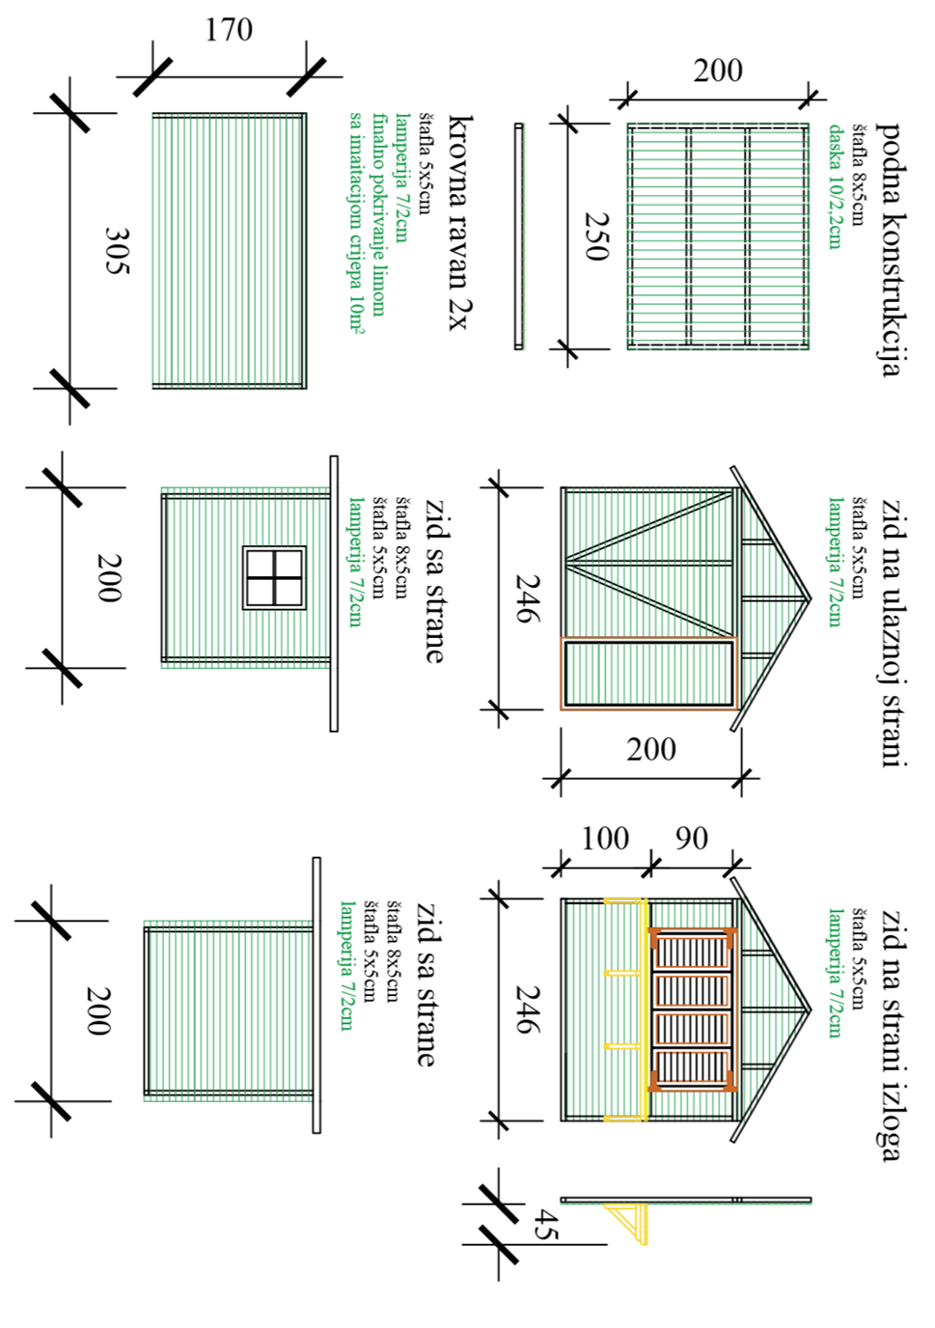

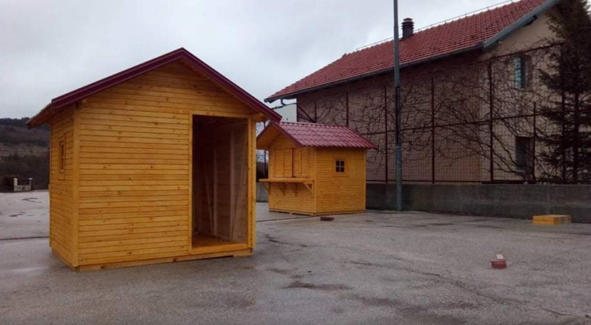

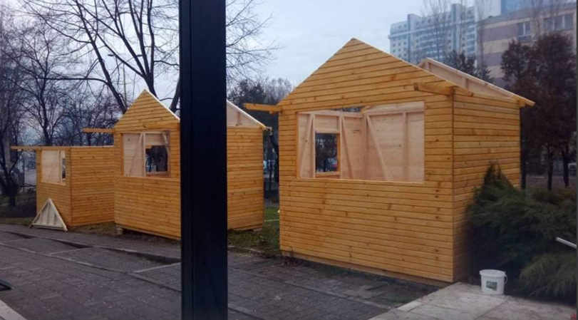

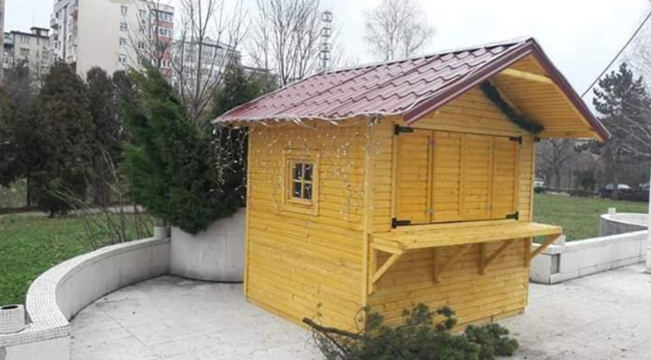

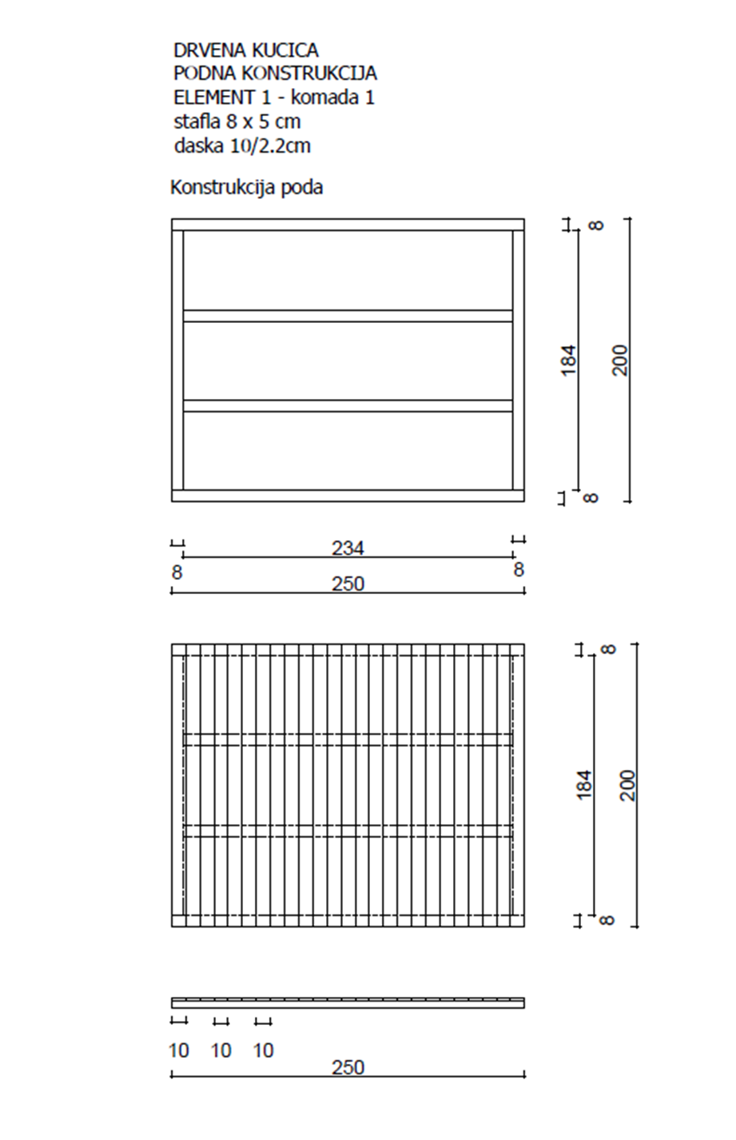

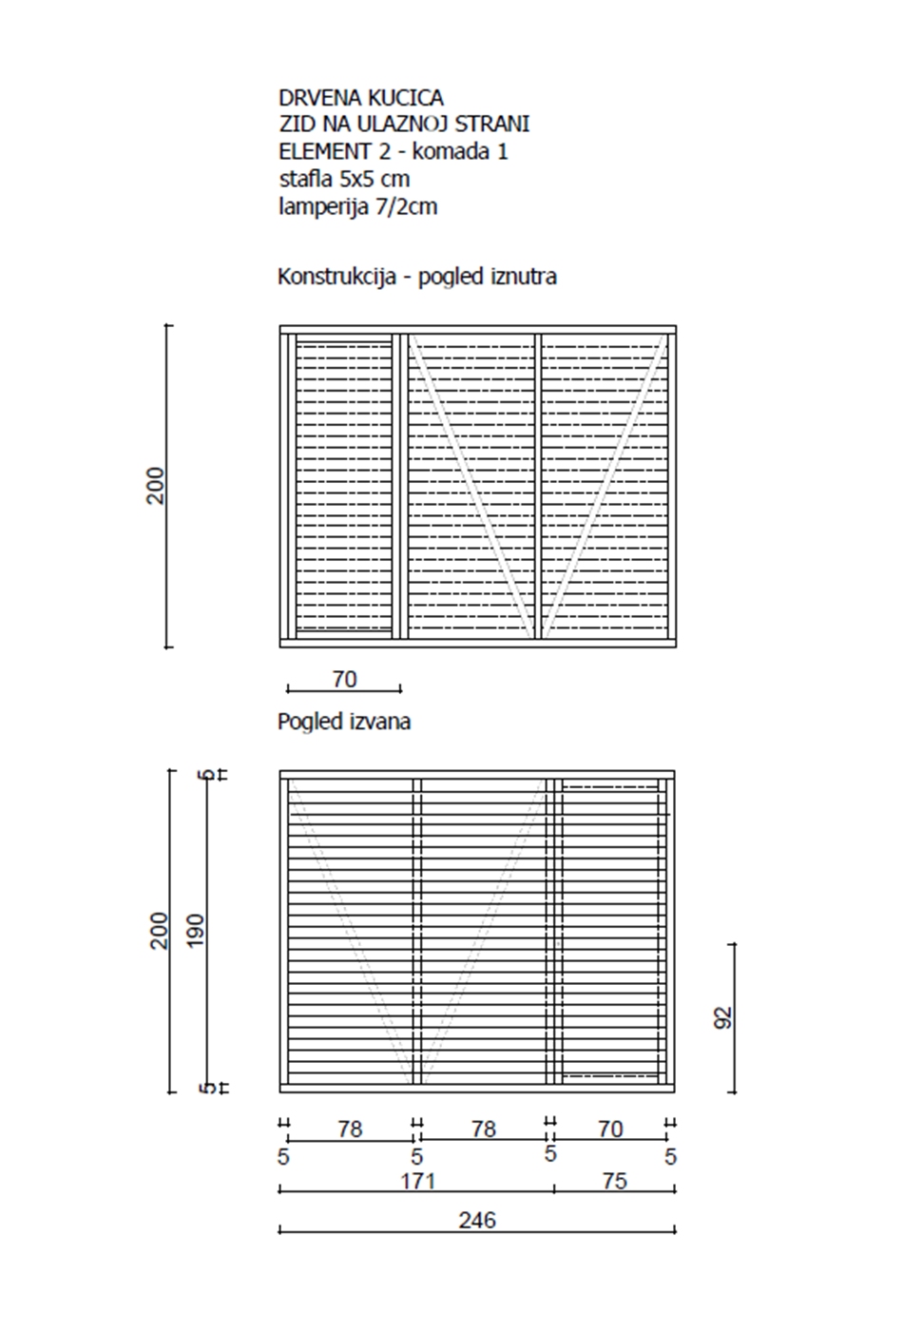

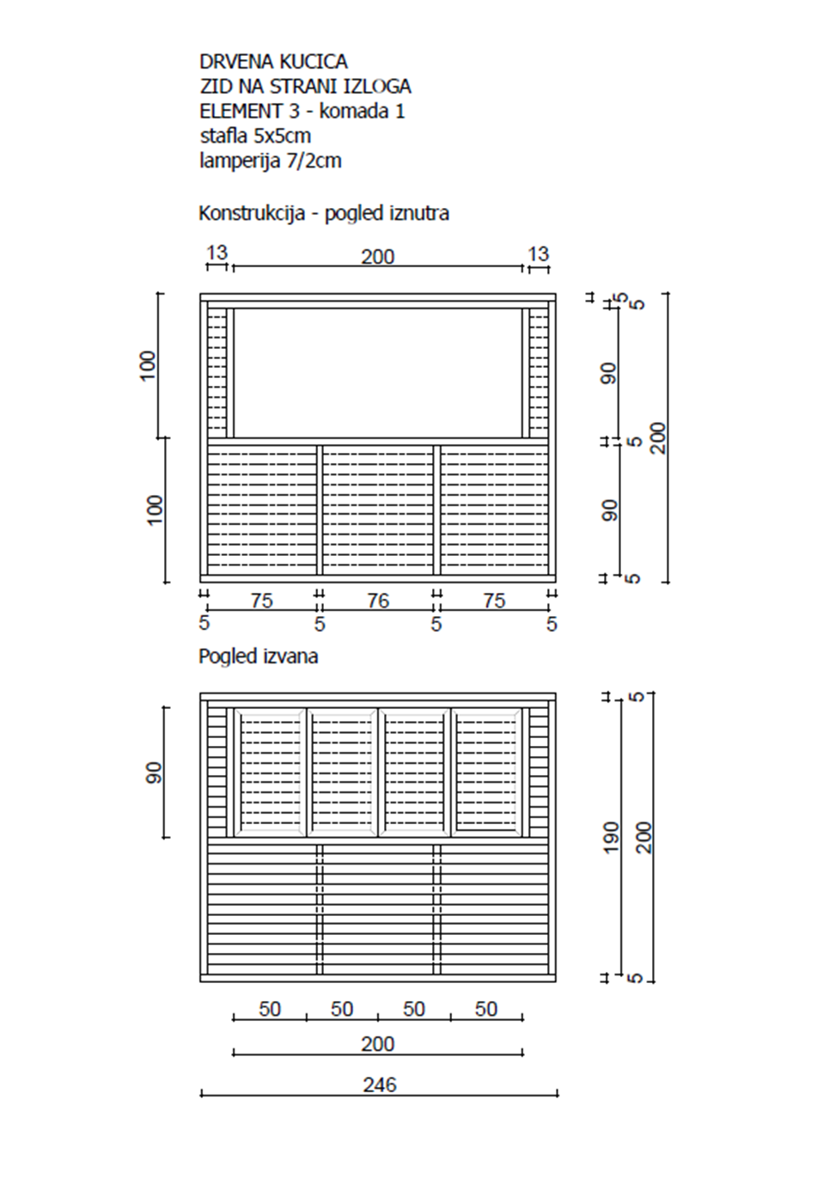

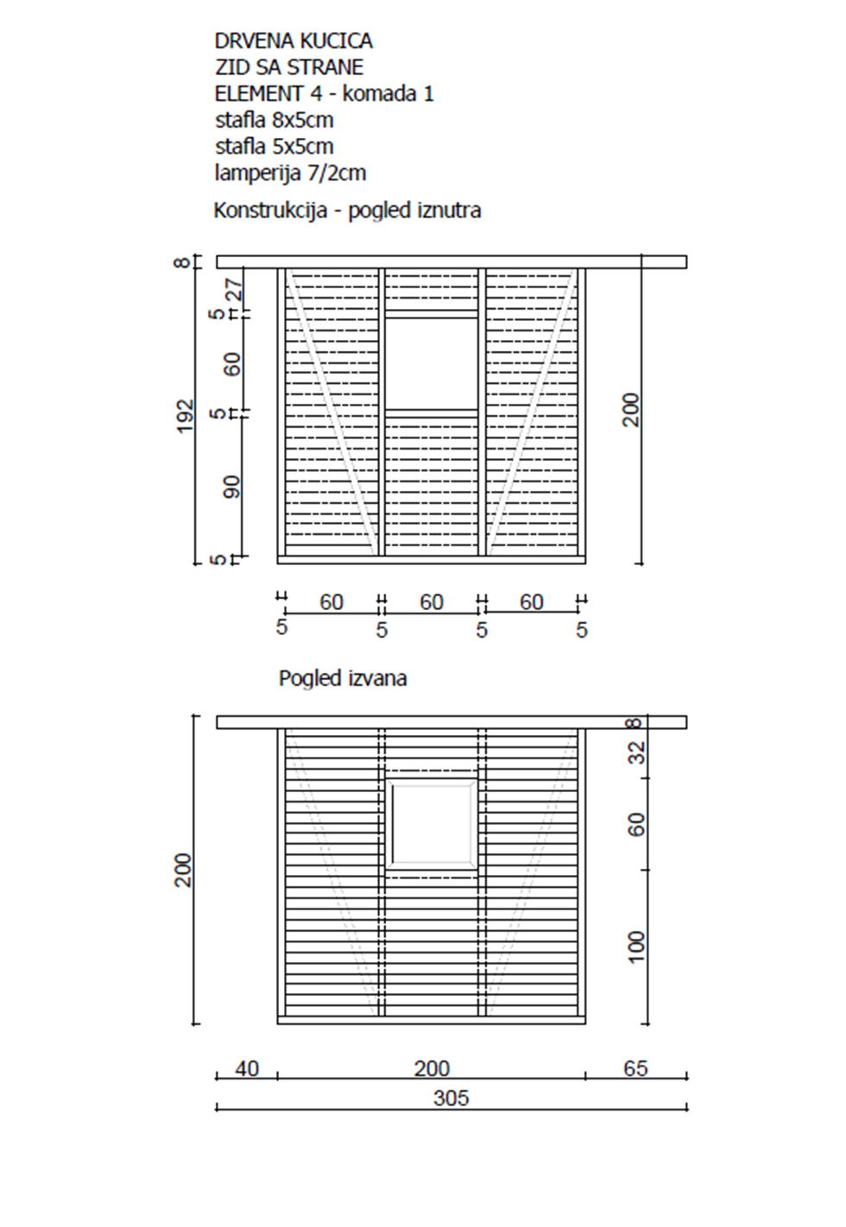
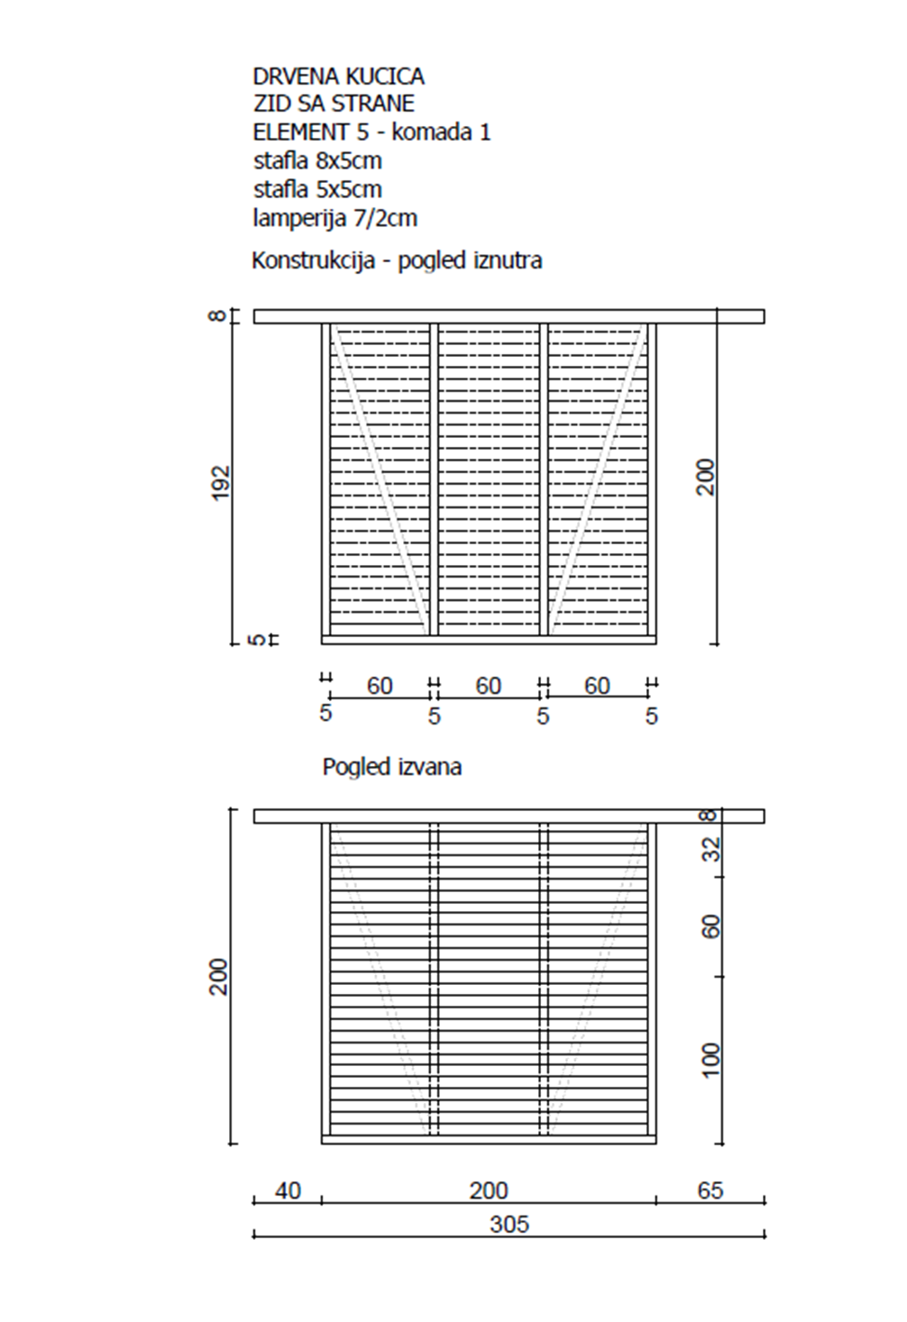
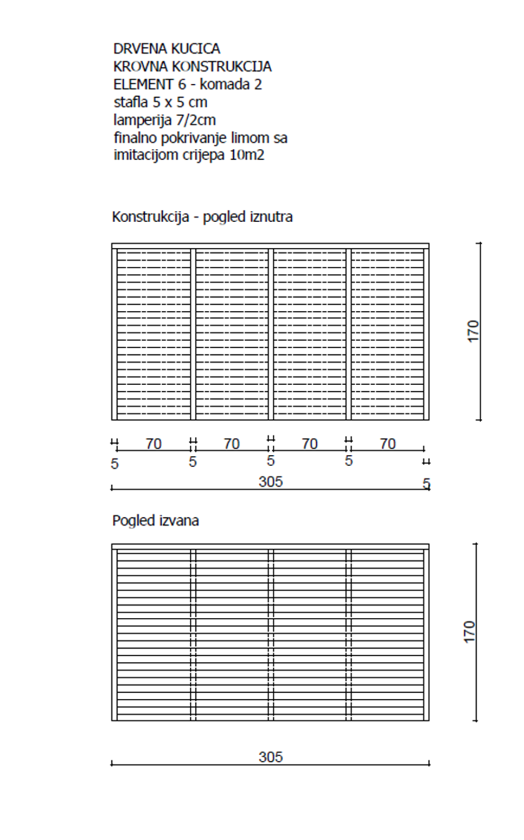
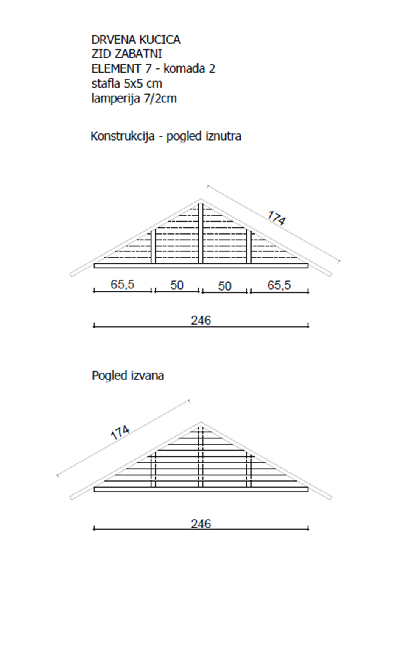
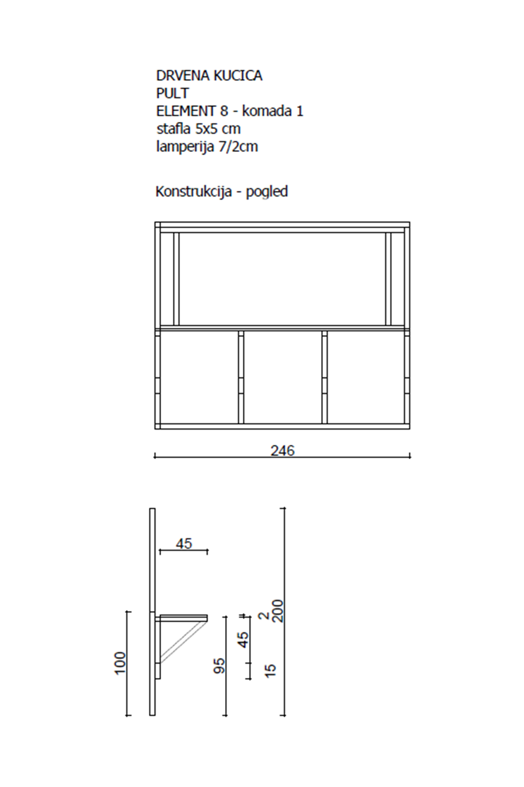

electrical installations
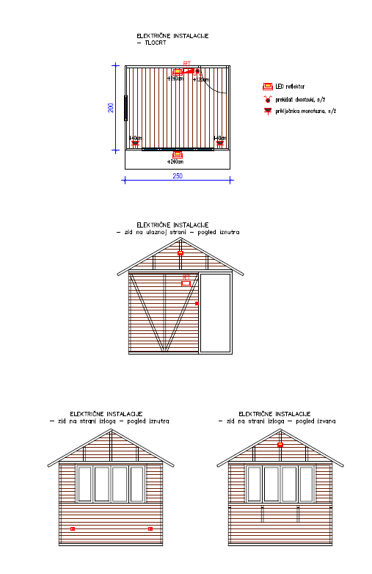
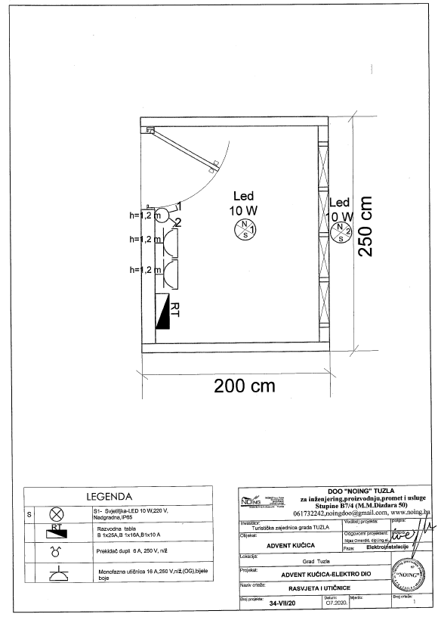

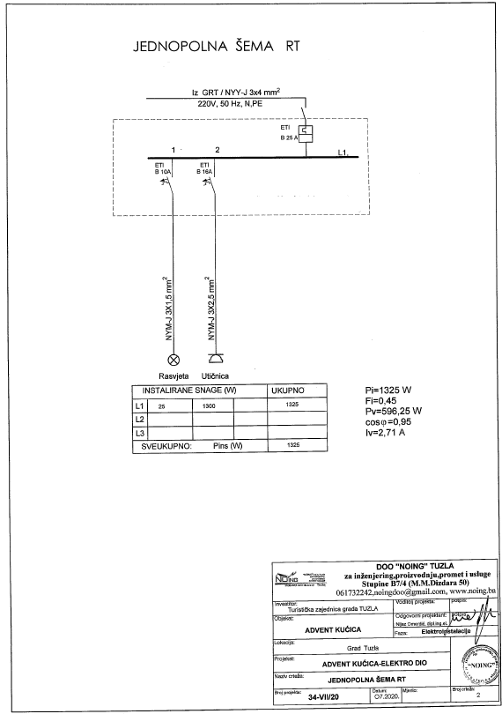

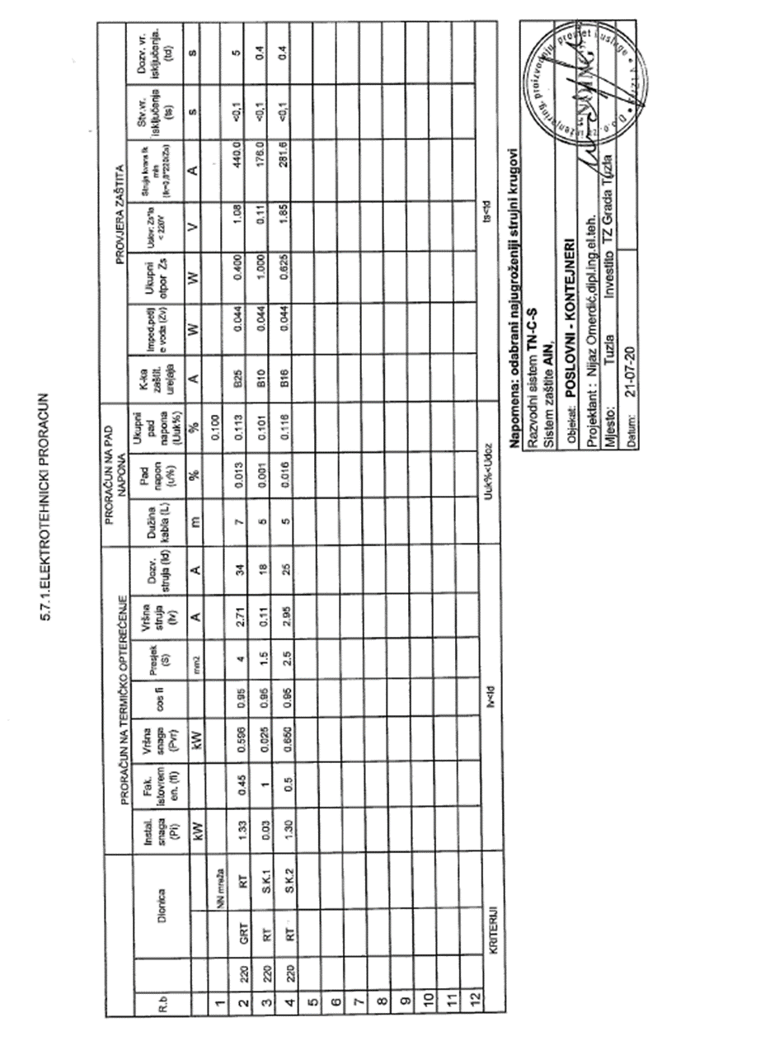

UNOFFICIAL TRANSLATION / NEZVANIČAN PREVOD

DRVENA KUĆICA
Tehnički opis

Izložbena drvena kućica je dimenzija u osnovi 250x200 cm. Ukupna visina kućica je oko 280 cm. Drvena kućica se sastoji od 8 dijelova ili elemenata: 4 zida, pod, krov i dva zabatna zida. Poseban element predstavlja pult, koji je pričvršćen za drvenu konstrukciju prednjeg zida na strani izloga. Kućica je montažno-demontažnog tipa jer se pojedini elementi mogu sastavljati i rastavljati prema potrebi.

Na kućici su ostavljena 3 otvora: vrata dimenzija 70x190 cm, prozor dimenzija 60x60 cm i otvor za drvene kapke dimenzija 200x90 cm. Vrata su postavljena na zadnjoj strani kućice, odmah uz bočni zid, i otvaraju se prema vani a šarke su postavljene iznutra. Vrata imaju šteku i bravu za zaključavanje. Prozor je postavljen na sredini bočnog zida, na visini 90 cm od poda i ustakljen je običnim staklom debljine 4mm. Prozor se otvara oko vertikalne osi sa otvaranjem prema unutra i oko horizontalne osi (otvaranje na ventus). Prozor ima šteku i sve potrebne okove visoke kvalitete. Na prednjoj strani je postavljen otvor 200x90 cm sa drvenim kapcima na otvaranje, koji se otvoreni smaknu na dvije strane, lijevo i desno. Drveni kapci su postavljeni na visini 90 cm od poda, a se sastoje od 4 dijela, po dva su povezana šarkama u cjelinu koja se preklapa. Kapci su ovješani na konstrukciju od štafli i pričvršćeni su sa metalnim šarkama za nju, a iznutra su osigurani rezom i katancem.

Materijal od koje se izrađuje konstrukcija kućice je drvena štafla 8x5 cm i 5x5 cm. Drvena kućica se oblaže jelovom drvenom lamperijom širine 7 cm a debljine 2 cm. Zaštita drveta se radi troslojnim premazom (impregnacija drveta, sadolin, lak) a svaki premaz treba nanijeti u skladu sa tehničkim specifikacijama proizvođača materijala. Kompletna drvena konstrukcija kućice se boji u bijelu boju osim što se prozor, vrata i kapci zajedno sa štokovima za prozor, vrata i kapke boje u tirkiznu boju RAL 5021. Pokrov je od lima, imitacija crijepa, u crvenoj boji.

Potrebno je izraditi drvene elemente advent kućice prema priloženim detaljnim crtežima (8 crteža), specifikaciji materijala koja je izrađena po elementima, predmjeru radova, a i u skladu sa ovim tehničkim opisom, crtežima i slikama koje su dio ovog tehničkog opisa. Potrebno je također, osigurati transport elemenata drvene kućice i prvu montažu na lokaciji u Gradu Tuzla. Projekat u prilogu.

U drvene kućice je potrebno ugraditi i elektro instalacije prema datim crtežima, šemama, elektrotehničkom proračunu i datom predmjeru radova. Projekt u prilogu.

 | Opis radova | Jedinica | Kolicina po objektu | Ukupna kolicina (20 objetaka) | Jed. cijena (BAM) | Ukupna cijena (BAM)
1.1 | Podna konstrukcija - komada 1/objektu
 | štafla 8 x 5cm: 5.00+4.68+3.68 = 13.36 | m1 | 14.00 | 280.00
 | daska 10/2cm: 5.00 | m2 | 5.00 | 100.00
1.2 | Zid na ulaznoj strani - komada 1/objektu
 | štafla 5 x 5cm: 4.92+7.60+4.12+3.80+1.20 = 21.64 | m1 | 22.00 | 440.00
 | lamperija 7/2cm: 5.00 | m2 | 5.00 | 100.00
1.3 | Zid na strani izloga - komada 1/objektu
 | štafla 5 x 5cm: 4.92+3.80+1.80+4.72+1.80+7.20+4.00 = 28.24 | m1 | 29.00 | 580.00
 | lamperija 7/2cm: 5.00 | m2 | 5.00 | 100.00
1.4 | Zid sa strane (prozor) - komada 1/objektu
 | štafla 8 x 5cm: 3.05 | m1 | 3.00 | 60.00
 | štafla 5 x 5cm: 2.00+7.48+4.12+1.20+2.40 = 17.20 | m1 | 18.00 | 360.00
 | lamperija 7/2cm: 4.00 | m2 | 4.00 | 80.00
1.5 | Zid sa strane - komada 1/objektu
 | štafla 8 x 5cm: 3.05 | m1 | 3.00 | 60.00
 | štafla 5 x 5cm: 2.00+7.48+4.12 = 13.60 | m1 | 14.00 | 280.00
 | lamperija 7/2cm: 4.00 | m2 | 4.00 | 80.00
1.6 | Krov - komada 2/objektu
 | štafla 5 x 5cm: 6.10 + 8.50 = 14.60 14.60 x 2 = 29.20 | m1 | 30.00 | 600.00
 | lamperija 7/2cm: 5.20 5.20 x 2 = 10.40 | m2 | 11.00 | 220.00
 | limeni pokrov sa svim potrebnim sitnim materijalom za prikivanje lima za drveni krov: 3.05 x 1.70 = 5.20 5.20 x 2 = 10.40 | m2 | 11.00 | 220.00
1.7 | Zabatni zid - komada 2/objektu
 | štafla 5 x 5cm: 2.46 + 0.70 x2 + 1.00 + 1.74 x2 = 8.34 8.34 x 2 = 16.68 | m1 | 17.00 | 340.00
 | lamperija 7/2cm: 0.86 0.86 x 2 = 1.72 | m2 | 2.00 | 40.00
1.8 | Pult - komada 1/objektu
 | štafla 5 x 5cm: 1.80 + 2.60 + 2.40 = 6.80 | m1 | 7.00 | 140.00
 | lamperija 7/2cm: 1.10 | m2 | 1.10 | 22.00
2 | Električne Instalacije
2.1 | Osigurač automatski 10A | kom |  | 60.00
2.2 | LED reflektor 10W | kom |  | 40.00
2.3 | Monofazna priključnica, 16A, OG | kom |  | 40.00
2.4 | Prekidač dvostruki, 10A, OG | kom |  | 20.00
2.5 | Razvodna kutija, OG | kom |  | 20.00
2.6 | Kutija razvodne table, 4M, OG | kom |  | 20.00
2.7 | Kabal PP/Y, 3x2,5 mm2 | m |  | 60.00
2.8 | Kabal PP/Y, 3x1,5 mm2 | m |  | 60.00
2.9 | Kabal PP/Y, 5x4 mm2 | m |  | 60.00
2.10 | Redne stezaljke 4, 6, 10 mm | kom |  | 100.00
2.11 | Plastična kanalica 25x17mm | m |  | 60.00
2.12 | Ispitivanje instalacije, kontrola Zaštite od opasnog napona dodira TN sistema, kontrola otpora izolacije i izrada Protokola o svim ispitivanjima u dva primjerka - komplet. | pauš
3 | Isporuka i instalacija potrebnih materijala za drvene kućice, zajedno sa odgovarajućim stručnjacima, po planu isporuke
4 | Garancija na kvalitetu materijala – 5 godina
 | TOTAL |  |  |  |  | 0.00
 | PDV 17% |  |  |  |  | 0.00
 | UKUPNO |  |  |  |  | 0.00
Annex III
DELIVERY SCHEDULE

Location | Beneficiary | Address | Open-Air Exhibition Booths | Electrical Installations | Delivery date
Tuzla | City of Tuzla | Trg Slobode (and two additional locations in close proximity)  75000 Tuzla, BiH | 20 | 20

[Name and Signature of the Supplier’s Authorized Person]
Ime i prezime, i potpis ovlaštenog zastupnika ponuđača …………………………………………………………………………………….

Annex IV
FORM FOR SUBMITTING SUPPLIER’S QUOTATION
(This Form must be submitted only using the Supplier’s Official Letterhead/Stationery)
We, the undersigned, hereby accept in full the UNDP General Terms and Conditions, and hereby offer to supply the items listed below in conformity with the specification and requirements of UNDP as per RFQ Reference BIH/RFQ/158/20 - Construction, delivery and installation of 20 open-air exhibition booths with electrical installations

TABLE 1 : Offer to Supply Goods Compliant with Technical Specifications and Requirements
Item No. | Description/Specification of Goods | Quantity | Latest Delivery Date | Unit Price | Total Price per Item
1 | Construction of Open-Air Exhibition Booths | 20
2 | Electrical installations | 20
3 | Delivery and Installation of the booths at the specified location | -
4 | Five-year warranty on materials | -
 | Add : Other Charges (pls. specify)
 | ----
 | ----
 | ----
 | Total Final and All-Inclusive Price Quotation

TABLE 2: Offer to Comply with Other Conditions and Related Requirements

Other Information pertaining to our Quotation are as follows: |  | Your Responses
 |  | Yes, we will comply | No, we cannot comply | If you cannot comply, pls. indicate counter proposal
Delivery Lead Time
Compliance with Technical Specifications
Warranty required
Period of Validity of Quotes starting the Submission Date
All Provisions of the UNDP General Terms and Conditions

Bid validity:

[Name and Signature of the Supplier’s Authorized Person]
Ime i prezime, i potpis ovlaštenog zastupnika ponuđača …………………………………………………………………………………….

[Date]
Datum…………………………………………..
Annex 4

General Terms and Conditions (for Goods and/or Services)

Link: English version

