



**Terms of Reference (ToR) for Environmental Scoping and Development of Environmental Management Plans for Tubussis and Xoxobos Small-Scale Mining (SSM) Hotspots in Erongo Region**

##### **1. Background**

The Ministry of Mines and Energy (MME) in partnership with the United Nations Development Programme (UNDP) would like to ensure that small-scale miners (SSMs) currently mining in small-scale mining hotspots comply with the requirements of the Environmental Management Act (EMA) No. 7 of 2007, along with the Environmental Impact Assessment (EIA) Regulations No. 30 of 2012. These regulatory frameworks require EIAs to be conducted for mining and quarrying activities, given their potential negative environmental impacts. At the moment, Tubussis and Xoboxobos small-scale mining sites in Erongo Region (Annex 1), are operating without Environmental Management Plans (EMPs). However, as a requirement of the EMA, mining operations require Environmental Clearance Certificates (ECC) from the Department of Environmental Affairs (DEA) under the Ministry of Environment, Forestry and Tourism (MEFT).

Each of the sites encompasses several mining claims, owned and operated by different individual persons and/ or groups, from which a range of semi-precious stones such as tourmaline, smoky quartz, beryl, amethyst, prehnite, rock crystals and Schorl are extracted. Presently, mining and extraction of these gemstones is predominantly done in a semi-mechanized manner, involving removal of overburden with excavators, bulldozers and loaders, provided by middlemen, and subsequent manual digging of the targeted gemstones.

MME has recognized the need to enhance the quality of life for the artisanal and small-scale miners working outside of formal legal and economic systems, to help them transition to the formal system and to enhance the contribution of the mining sector to sustainable development. As such, the MME with funding from the UNDP-SEPA Environmental Governance for Natural Resources Management Programme will be facilitating the development of EMPs for the two sites. As part of the financing requirements, in terms of mitigating environmental and socio-economic related risks arising from the mining activities, the Scoping assessment and EMPs will have to comply with the guiding frameworks listed as Annex 2.

Against the above background, MME requires the services of a consultant to conduct a collective scoping study for the two small-scale mining hotspots identified above.

**2. Purpose of assignment**

The main objective of this assignment is to undertake a collective scoping study for Tubussis and Xoboxobos mining hotspots in Erongo Region, and to develop EMPs for the two sites.

##### **3. Scope of Work**

The consultant will be required to conduct a collective scoping study for two small-scale mining hotspots: Tubussis and Xoboxobos. The scoping study will take into account all activities and the anticipated impacts from the sites, and subsequently compile practical/implementable EMPs for each of the sites in order to support the issuance of ECCs for the small-scale miners operating/with particular interest in that specific site. In essence, the scoping study should ensure that socio-economic and environmental factors, including gender aspects, are appropriately integrated and operationalized at the identified mining hotspots.

To be specific, the consultant will be expected to carry out the following tasks:

1. Conduct a collective scoping study for the Tubussis and Xoboxobos small-scale mining hotspots.
2. Conduct a scoping exercise that involves an engagement of all relevant Interested and Affected Parties (I&APs).
3. Assess the bio-physical, socio-economic impacts of small-scale mining activities in all the sites, considering both current and future activities.
4. Conduct public participation meetings in affected communities.
5. Compile two separate Scoping Reports.

Contents:

* *General information*
* Executive summary of the project, which summarises the project characteristics, environmental and social issues, and the proposed mitigation measures.
* Information about the project proponent with following details (a) Name of the project (b) Name of the applicant (c) Present mailing address including telephone number, fax, and email (d) Name of the environmental focal person (e) Telephone number of focal person.
* Justification of the operations highlighting its benefits to surrounding areas and for the economic development of the country as a whole.
* Description on proposed mineral usage and purpose of mining
* Name of the organization / consultant preparing the EIA report, qualifications and experience of experts involved in the assessment and report preparation.
* List of complains / litigations against the mining operations.
* List of all regulatory approvals and permits applicable.
* *Map (cartographic) representations*
* A topographic map of the core buffer zones indicating features such as the drainage patterns, location of human settlements and major constructions, roads, any industries / mines polluting sources, wherever applicable.
* A map specifying the licence area with its coordinates (to be provided by MME).
* *Project Description*

Information on existing land use pattern of the study area:

* Land use pattern of area acquired for mining and existing land use pattern of study area.
* Land ownership pattern of acquired land.
* Distance of the project from key infrastructure installations, if applicable.
* Catchment area characteristics of the study areas, such as water recharge potential and drainage pattern.
* Identification of areas vulnerable to erosion in the core area and buffer area separately.
* If forest land or agricultural land are likely to be diverted, the impact on the availability of fodder, fuel, food and livelihoods.

Information on sensitive receptors at project site and in the study area, if any:

* Distance of forest areas, wildlife sanctuaries, national wildlife corridors, biological corridors, archaeological sites, critical water-shed areas, settlements, important installations and sites of religious importance and others from the mine lease area.

Areas of forest land diverted if any:

* Discuss if the project site or adjoining areas (such as the buffer zone) support any unique habitat, endemic, threatened, or declining species or species of high economic/ecological value.
* List of flora and fauna in the project area, duly authenticated by a government approved organization or independent body such as a university. The findings should be annexed with the report.
* Presence of any wildlife corridors or locations favoured by migratory birds, animals at the project site or in the buffer zone, if any.

Information on the geological setting:

* Geological characteristics of the mining area.

Details of waste generation

* Type of waste being generated and how it is being managed.

Information on technologies and resource requirement:

* Description on the type of mining, technology to be adopted, including details of equipment to be used and their potential impacts. The project should also examine the possibility of use of other technologies, which are environmentally friendly.
* The scoping study should justify the selection of the mining technology and mining method with reference to mine safety, productivity and environment.
* Details on method of mining (manual, semi-mechanized, mechanized) and mode of transportation (dumper, conveyer, ropeways, etc.).
* Resource requirements:
* Source of water, including details of water balance of the entire mine area under following heading. See Table below: Water requirement (m3/day).

**Table 1: Water requirement (m3/day)**

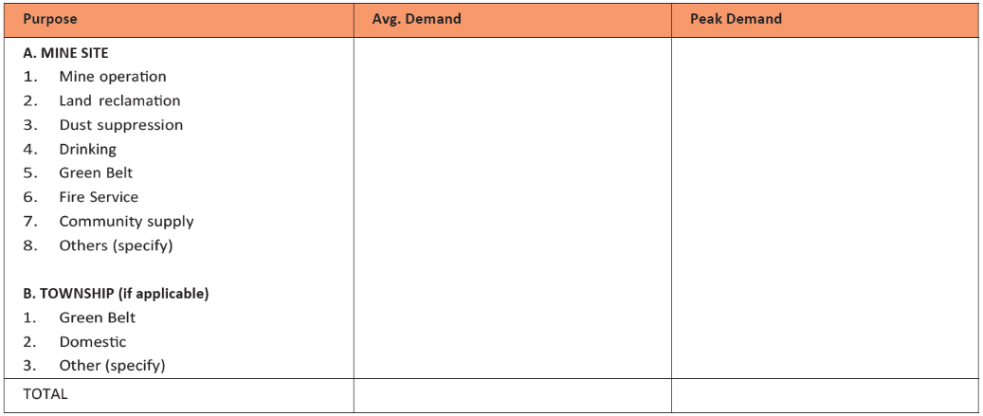

* Details of the workforce involved in operations (per mining claim).
* Provide following details.

1. the quantity of explosives that the mine will require per day or per annum if any.
2. type of blasting techniques used.

* Fuel, oil and electricity requirements.
* Baseline Data
* Surface water characteristics in core and buffer areas.
* Characteristics of topsoil and its thickness.
* Characteristics of overburden with respect to pollution potential.
* Baseline data on ambient air quality (PM10, SOx, NOx), and generation of site-specific information on existing meteorological conditions such as temperature, humidity, rainfall, and wind speed, wind direction, wherever it is applicable.
* Generation of ambient noise data by considering noise-prone areas and sensitive receptors.
* Inventory on tress to be cut down.
* The scoping report should provide an overview of the existing hydro-geological settings of the study area, describing the aquifers, hydraulic characteristics, groundwater quality and the interaction of surface water, if applicable.
* Information on number and distances of water bodies such as rivers, lakes, streams, springs, wells, etc. present in core and buffer zones.
* Existing socio-economic status of the population (demographic characteristics and local amenities, livelihood patterns, income levels, literacy and the presence of indigenous and vulnerable groups) in the study area.
* Data on the health status of local communities and common diseases prevailing in the area, if applicable.
  + - Impact of mining activities on the following parameters:
* Land and water resources;
* Land use and people;
* Biodiversity, if applicable;
* Social and economic setting of an area;
* Modification of natural drainage and diversion of existing water courses flowing through the

mine lease (rivers, streams, springs, drains, etc) or important water resources originating in the mining sites and adjoining areas on local hydrology, if applicable;

* Water bodies, forest and agricultural land, resulting in run-offs
* If applicable, groundwater regime due to mine seepage within the study area. Hydrological and rock characteristic data should be collected and a hydrological model should be prepared for predicting the cone of depression at various stages of mine life.
  + - Information on impact on ambient air quality:
* Potential impact of mining and allied activities on air quality.
  + - Noise and vibration:
* Assess the impact of noise due to mining and allied activities such as transportation, crushing, loading and unloading on the local community and wildlife, if applicable and provide detailed mitigation measures for the same in the EMP.
* Impact of ground vibration on local habitation.
  + - Socio-economic impacts:
* Socio-economic impact of the project, including impact on visual aesthetics and health.
  + - Risks:
* Assess the potential risks associated with various mining operations (such as risk during drilling, slope failure, fly rock and vibration due to blasting, storage of explosives, toxic fumes from blasting, slope destabilization, transportation, etc.) including natural calamities.
  + - Environmental Management Plan (EMP):
* Produce EMPs which cover all aspects related to current and planned operational and decommissioning activities.
* The EMP should present the mitigation measures to be taken against each impact, the timeline for completion, the responsible departments for implementation, the budget for the EMP, post monitoring provisions and reporting to the concerned regulatory authority.
* The EMPs must include environmental monitoring programmes for significant impacts, as well as rehabilitation plans. The EMPs must also be easily integrated with any existing site-specific management plans.
* Compile a site-specific EMP for each site.

##### **4. Expected Outputs and Deliverables**

The outputs and deliverables for this consultancy are presented in the table below:

|  |  |  |  |
| --- | --- | --- | --- |
| **Deliverables/ Outputs** | **Estimated Duration to Complete** | **Target Due Dates** | **Review and Approvals Required** |
| Inception Report presenting the consultant’s understanding of the assignment and the work plan | 1 day | 23 July 2020 | Review by UNDP: 24 July  Review by MME: 25 July |
| Draft scoping reports and two site specific EMPs | 40 days | 30 September 2020 | Review by stakeholders: 14 October  Review by UNDP: 21 October  Review by MME:28 October |
| Final scoping reports and EMPs | 4 days | 6 November 2020 |  |
| Submission of scoping reports and EMPs to DEA | 1 day | 10 November 2020 | DEA |

**5. Institutional Arrangement**

The consultant is expected to commence with the assignment upon contract signature and should work closely with MME and UNDP. In addition, he/she should avail his own office facilities, equipment, transport, meals and accommodation during the field work and the entire duration of the assignment. In case unforeseen costs may be incurred, they will be reimbursed based on acceptable justification and documentation.

**6. Duration of the Work**

The consultancy will commence on the 23rd of June and is expected to end on the 13th of November 2020.

The overall assignment will take approximately 46 days, which exclude about 10 days for the report review by stakeholders (including UNDP and MME), and 20 days for review by the MEFT.

Despite the short time frame, the consultant should take note that this consultancy is urgent, as the ECCs needs to be awarded before the end of the year.

**7. Duty Station**

The consultant is expected to have his/her own workstation from where to operate while carrying out the assignment. However, for the purpose of field work, he/she is expected to arrange for a place of operation in Erongo Region, somewhere closer to the target mining hotspot being assessed. Most importantly, the consultant should maintain constant contact with UNDP and MME, as much as necessary.

**8. Profile of consultants**

A team of consultants to carry out the EIA study should demonstrate experience in conducting environmental assessments, development of plans, policies or strategies. The consultant should have the following expertise:

* 1. **Environmental expert (Team Leader)**
* At least an Honours University degree qualification in a relevant field (e.g. environmental sciences, environmental management, development studies, geology, mining etc.)
* Working experience in natural resources planning (minimum 3 years).
* Experience in developing, conducting, or training of EIAs and /or similar environmental assessment assignments; at least one of these assignments as a team leader
* Experience in environmental sector policies and regulations.
* Experience in environmental stakeholder consultations.
* At least 5 years’ experience in developing countries, preferably in Africa.

**9. Budget formulation and submission of proposals**

Prospective consultants should submit proposals presenting their budget in Namibian Dollars, clearly indicating the daily consultancy fees, transport for field visits, logistics, accommodation and VAT. In addition to the financial proposals, they should present technical proposals clearly indicating the methodology to be employed for the assignment.

1. **Payment of milestones**

The Consultant/s shall receive payments for service fees upon certification of the completed tasks satisfactorily, as per the following payment schedule:

* Upon submission and approval of Inception Report: 30%.
* Upon submission of the Draft Scoping Report and EMP: 60%.
* Upon submission and approval of the Draft Final Scoping Report that includes inputs from stakeholders: 10%.

Further information can be obtained from: [procurement.na@undp.org](mailto:procurement.na@undp.org)

**Submission due date: 15 July 2020**

**Annex 1: SITE LOCATIONS AND DESCRIPTION**

**1.1 Tubussis**

Farm Tubussis is located around 21°40’08” S 15°23’10.6”E via the D2306 road off the Omaruru-Usakos road in Erongo Region.

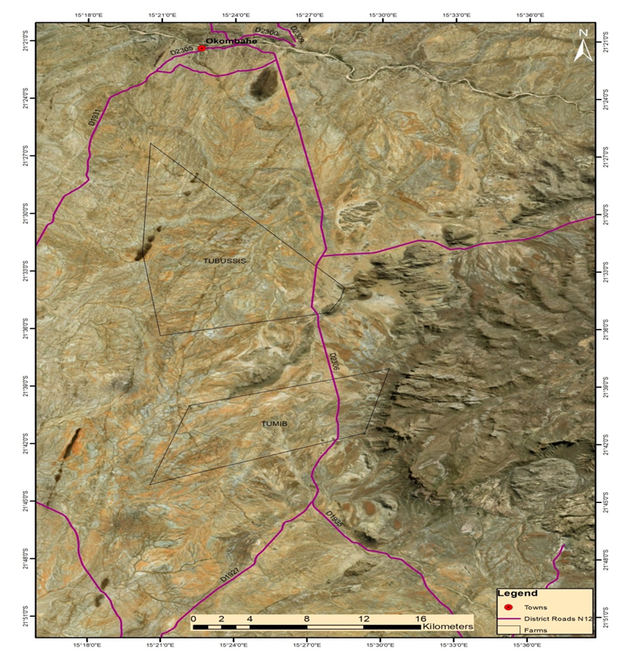

**Figure 1:** Locality map of Tubussis

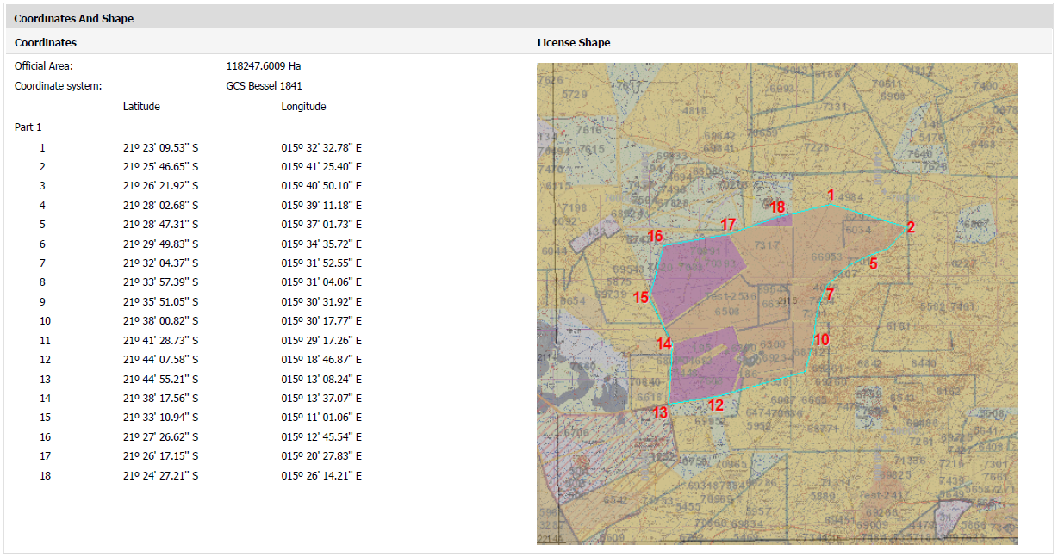

**Figure 2:** Tubussis study area on which EMP is required.

**1.2. Xoboxobos**

Xoboxobos is located approximately 80 km west of Uis, west of the D2342 road from Uis to Brandberg mine on co-ordinates 21°15’00”S 14°10’30”E.



**Figure 3:** Locality map of Xoboxobos (Also known as Goboboseb)

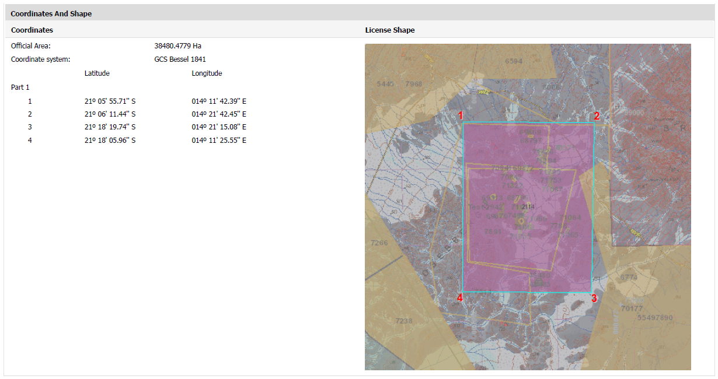

**Figure 4:** Xoboxobos study area on which EMP is required.

**2. BRIEF DESCRIPTION OF SMALL-SCALE MINING ACTIVITIES AND STATUS QUO**

**2.1. Tubussis**

Small Scale miners operate on 35 mining claims which are held under individual’s names. There are approximately 100-120 small scale miners operating on Farm Tubussis. Tubussis miners work in groups on the 35 mining claims registered in the area. They are not organized into an association. However, some individuals are members of the Erongo regional small-scale miners association (ERSMA). ERSMA previously offered services such as an equipment/tool hire at subsidized rates. Similar to the practice at other small-scale mining hotspots, a system where middlemen offer equipment and other necessities such as water and firewood to small scale miners for a share in the production is followed *(Priester, 2010)*.

**2.2. Xoboxobos**

This hotspot has approximately 80 small scale miners who exploit gemstones such as amethyst and rock crystal. This operation mainly focuses on geodes which are sold to local dealers and foreign collectors. Common problems such as the availability of water are experienced. The village has about 25 000 litre storage capacity in the form of tanks provided by Okorusu and Rössing foundation. Their water for everyday usage comes from a borehole west of Brandberg. It is however not the best for drinking.

Living costs at this site are high, as it is isolated, and water is unavailable. Water and amenities are either transported from Uis (60 km) or water is bought from a local borehole “operator”. The village members pay 15 ND/25 ltr for water.

**Annex 2: Guiding and regulatory frameworks for the scoping study**

* The Constitution of Namibia (1990)
* Namibian Environmental Impact Assessment Guidelines for the Mining Sector
* The Environmental Assessment Policy of Namibia 1994
* UNDP Guidelines for Governments and Partners to Integrate Environment and Human Rights into the Governance of the Mining Sector
* The Environmental Management Act No. 7 of 2007
* The Environmental Assessment Regulations of 2012
* The Procedures and Guidelines for Strategic Environmental Assessment of 2008
* The Minerals (prospecting and Mining) Act 33 of 1992
* The National Land Policy of 1998
* The National Heritage Act No. 27 of 2004
* The Mine Health and Safety Regulations, 10th draft
* The Water Act 54 of 1956
* The Water Policy for Namibia (2000)
* The Water Resources Management Act No.11 of 2013
* The Pollution Control and Waste Management Bill
* The Atmospheric Pollution Prevention Ordinance 11 of 1976
* The National Solid Waste Management Strategy
* The Soil Conservation Act 76 of 1969
* The Forest Act 12 of 2001
* The National Policy on Climate Change for Namibia (2011)
* The National Climate Change Strategy & Action Plan 2013 - 2020
* The Nature Conservation Ordinance (1996)
* The Namibia’s Second National Biodiversity Strategy and Action Plan 2013 - 2022
* The Labour Act 11 of 2007
* The National Health Act 2 of 2015
* The National Heritage Act 27 of 2004
* The Health and Safety Regulations GN 156/1997 (GG 1617)
* The Public Health Act 36 of 1919
* The National Gender Policy 2010 – 2020
* The National Resettlement Policy