REQUEST FOR QUOTATION (RFQ)

Subject: Supply and Delivery of Dispensing Pumps | DATE: June 07, 2020
 | REFERENCE: UNDP/AFG/RFQ/2020/ 0000006190

Dear Mr. /Ms: Bidder

The United Nations Development Programme (UNDP) Afghanistan Country Office hereby invites you to submit a Quotation to this Request for Quotation (RFQ) for the above-referenced subject.

This RFQ includes the following documents:
- Letter of Invitation
- Annex 1 - RFQ Bid Data Sheet
- Annex 2 - Technical Specifications
- Annex 3 - Price Schedule
- Annex 4 - General Terms and Conditions
- Annex 5 - E-tendering Instructions Manual for Bidders (Attached separately)
- Annex 6 - FAQ for Bidders (Attached separately)

Your offer, comprising of following documents stated in this RFQ, should be submitted to UNDP Afghanistan in accordance with the Annex 1 (RFQ Data Sheet) through the “UNDP ATLAS E-tendering system” (https://etendering.partneragencies.org).

The step by step instructions for registration of bidders and proposal submission through the UNDP ATLAS E-tendering system is available in the “Instructions Manual for the Bidders”, attached with this RFQ. Should you require any training on the UNDP ATLAS E-tendering system or face with any difficulties when registering your company or submitting your proposal, please send an email to the E-tendering helpdesk at procurement.af@undp.org or call +93728999758during office hours to request for help.
The proposers are advised to use Internet Explorer (Version 10 or above) to avoid any compatibility issues with the e-tendering system.

No hard copy or email submissions will be accepted by UNDP.

Bid submission deadline: Please refer to E-tendering system.

Kindly go through this invitation letter and other documents attached here to this RFQ. Should you have any questions or require any clarification, please feel free to email your questions/clarifications to the procurement officer at procurement.af@undp.org. The subject of the email should be UNDP/AFG/RFQ/2020/0000006190

UNDP looks forward to receiving your quotation and thank you in advance for your interest in UNDP procurement opportunities.

Yours sincerely,

Head of Procurement Unit
07 June 2020

Annex (1) - Data Sheet

Delivery Terms  [INCOTERMS 2010]  (Pls. link this to price schedule) | DAP Kabul- Afghanistan
Customs clearance, if needed, shall be done by: | UNDP Afghanistan
Exact Address/es of Delivery Location/s (identify all, if multiple) | Ministry of Interior Affairs, General Health Directorate, PD5, Kabul Afghanistan.
UNDP Preferred Freight Forwarder, if any | Not Applicable
Distribution of shipping documents (if using freight forwarder) | If custom clearance to be completed by UNDP, the supplier is responsible to provide the below listed documents to UNDP Logistics Officer:  - Bill of Lading/Waybill  - Invoice  - Packing List  Note: all documents shall be issued on the name of UNDP Afghanistan. A complete set of original shipping document listed above must be pouched to UNDP Afghanistan for custom clearance purpose.
Latest Expected Delivery Date and Time (if delivery time exceeds this, quote may be rejected by UNDP) | Four (4) weeks after issuance of the Purchase Order/Contract
Delivery Schedule | Compliance with delivery period is mandatory
Packing Requirements | Standard packaging as recommended for the goods
Mode of Transport | No Preference
Preferred  Currency of Quotation | ☒United States Dollars  For evaluation purposes, the quotation submitted in other currencies will be converted to US$ using the UN Operational Exchange Rate. Reference date for determining UN Operational Exchange: date of closing of tenders
Value Added Tax on Price Quotation | ☒ Must be exclusive of VAT and other applicable indirect taxes
After-sales services required | ☒ N/A
Deadline for the Submission of Quotation | Please Refer to E-Tendering System  As indicated in the e-Tendering system.  Date and Time: As specified in the system (note that the time zone indicated in the system in New York Time zone).  PLEASE NOTE: -  Date and time visible on the main screen of the event (on the E-Tendering portal) will be final and prevail over any other closing time indicated elsewhere, in case they are different. Please also note that the bid closing time shown in the PDF file generated by the system is not accurate due to a technical glitch that we will resolve soon. The correct bid closing time is as indicated in the E-Tendering portal and system will not accept any bid after that time. It is the responsibility of the bidder to make sure bids are submitted within this deadline. UNDP will not accept any bid that is not submitted directly to the system.  Try to submit your bid a day prior or well before the closing time. Do not wait until last minute. If you face any issue submitting your bid at the last minute, UNDP may not be able to assist.
All documentations, including catalogs, instructions and operating manuals, shall be in this language | ☒ English
Documents to be submitted  (Preliminary requirement) | ☒ Scanned copy of duly filled, signed and company stamped Technical Specification/ Compliance Sheet (Annex-2 and Table 1)  ☒ Scanned copy of duly filled, signed and company stamped Annex-3 (Price schedule)  ☒ Copy of two contract/Purchase Orders for similar requirements in the last 3 years, including contract description, contract value, clients name and contact details with national or international organizations, and copies of the contract/Purchase Orders.  ☒ Valid Business License  ☒ Company Profile  ☒ Product Brochure of the offered Brand/product with specifications/details.
Period of Validity of Quotes starting the Submission Date | ☒ 60 days  In exceptional circumstances, UNDP may request the Vendor to extend the validity of the Quotation beyond what has been initially indicated in this RFQ. The Proposal shall then confirm the extension in writing, without any modification whatsoever on the Quotation.
Partial Quotes | ☒ Not permitted
Payment Terms | ☒ 100% upon delivery of goods and final acceptance by UNDP Project Focal Point
Liquidated Damages | Not Applicable
Evaluation Criteria | ☒ Technical responsiveness/Full compliance to requirements and lowest price  ☒ Full acceptance of the PO/Contract General Terms and Conditions  ☒ Delivery timeline within 4 weeks  ☒The bidder must have executed similar orders in the last 3 years  ☒ Bid Validity of 60 days
UNDP will award to: | ☒ One supplier
Type of Contract to be Signed | ☒ Purchase Order  ☒ Contract Face Sheet (Goods and-or Services)
Contract General Terms and Conditions | ☒ General Terms and Conditions for contracts (goods and/or services)  http://www.undp.org/content/undp/en/home/procurement/business/how-we-buy.html  http://www.undp.org/content/dam/undp/library/corporate/Procurement/english/3.%20UNDP%20GTCs%20for%20Contracts%20(Goods%20and-or%20Services)%20-%20Sept%202017.pdf
Special conditions of Contract | ☒ Cancellation of PO/Contract if the delivery/completion is delayed by 7 days
Conditions for Release of Payment | ☒ Written Acceptance of Goods by UNDP based on full compliance with RFQ requirements and quantities,
Annexes to this RFQ | ☒ Data Sheet (Annex 1)  ☒ Technical Specifications of the Goods Required (Annex 2)  ☒ Price Schedule (Annex 3)  ☒ General Terms and Conditions / Special Conditions (Annex 4).  Non-acceptance of the terms of the General Terms and Conditions (GTC) shall be grounds for disqualification from this procurement process.  http://www.undp.org/content/undp/en/home/procurement/business/how-we-buy.html  ☒ E-tendering Instructions Manual for Bidders (Annex 5)  ☒ FAQ for Bidders (Annex 6)
Contact Person for Inquiries  (Written inquiries only) | Procurement.af@undp.org  Any delay in UNDP’s response shall be not used as a reason for extending the deadline for submission, unless UNDP determines that such an extension is necessary and communicates a new deadline to the Proposers.  The deadline for submission of request for clarification shall be 4 days prior to bid closing date  The Subject Line of your email shall be: UNDP/AFG/RFQ/2020/0000006190
Defect Liability Guarantee | N/A

Goods offered shall be reviewed based on completeness and compliance of the quotation with the minimum specifications described above and any other annexes providing details of UNDP requirements.

The quotation that complies with all of the specifications, requirements and offers the lowest price, as well as all other evaluation criteria indicated, shall be selected. Any offer that does not meet the requirements shall be rejected.

Any discrepancy between the unit price and the total price (obtained by multiplying the unit price and quantity) shall be re-computed by UNDP. The unit price shall prevail and the total price shall be corrected. If the supplier does not accept the final price based on UNDP’s re-computation and correction of errors, its quotation will be rejected.

After UNDP has identified the lowest price offer, UNDP reserves the right to award the contract based only on the prices of the goods in the event that the transportation cost (freight and insurance) is found to be higher than UNDP’s own estimated cost if sourced from its own freight forwarder and insurance provider.

At any time during the validity of the quotation, no price variation due to escalation, inflation, fluctuation in exchange rates, or any other market factors shall be accepted by UNDP after it has received the quotation. At the time of award of Contract or Purchase Order, UNDP reserves the right to vary (increase or decrease) the quantity of services and/or goods, by up to a maximum twenty-five per cent (25%) of the total offer, without any change in the unit price or other terms and conditions.

Any Purchase Order that will be issued as a result of this RFQ shall be subject to the General Terms and Conditions attached hereto. The mere act of submission of a quotation implies that the vendor accepts without question the General Terms and Conditions of UNDP indicated above - http://www.undp.org/content/undp/en/home/procurement/business/how-we-buy.html .

UNDP is not bound to accept any quotation, nor award a contract/Purchase Order, nor be responsible for any costs associated with a Supplier’s preparation and submission of a quotation, regardless of the outcome or the manner of conducting the selection process.

Please be advised that UNDP’s vendor protest procedure is intended to afford an opportunity to appeal for persons or firms not awarded a purchase order or contract in a competitive procurement process. In the event that you believe you have not been fairly treated, you can find detailed information about vendor protest procedures in the following link:
http://www.undp.org/content/undp/en/home/operations/procurement/protestandsanctions/

UNDP encourages every prospective Vendor to avoid and prevent conflicts of interest, by disclosing to UNDP if you, or any of your affiliates or personnel, were involved in the preparation of the requirements, design, specifications, cost estimates, and other information used in this RFQ.

UNDP implements a zero tolerance on fraud and other proscribed practices and is committed to identifying and addressing all such acts and practices against UNDP, as well as third parties involved in UNDP activities. UNDP expects its suppliers to adhere to the UN Supplier Code of Conduct found in this link : http://www.un.org/depts/ptd/pdf/conduct_english.pdf

Annex 2 Technical Specifications

No | Item | Description | UoM | QTY | Sample Picture (no particular brand requested)
1 | Dispensing Pumps | Dispenser module for 10 liter canisters of liquid cleaning agents & chemical disinfectant.  Capacity: 10 Ltr,: Fiber, Light Weight Sprayer, Strong Blow Moulded Tank, Nozzle: 3 nozzle set, Adjustable Nylon Belt, Plastic Base Without Bolts, Continuous Mist Spray | Ea. | 100 | 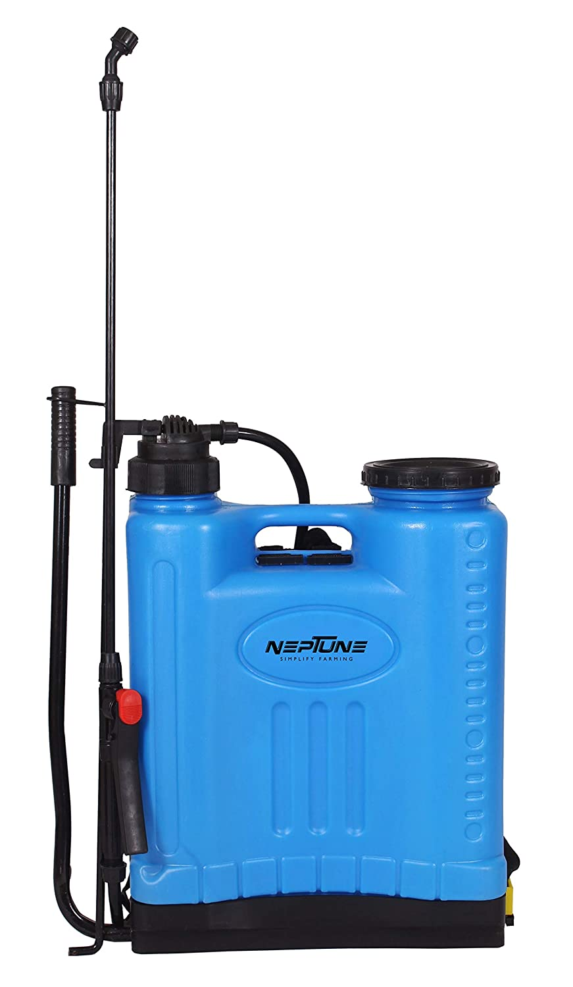

ANNEX 3

OFFER SUBMISSION FORM

Must be duly completed and stamped by the Offeror and returned with the Offer.

To: United Nations Development Programme

Dear Sir/Madam,

We, the undersigned, hereby offer to supply the goods and related services in accordance with your Request for Offer (Ref: ……) dated . We are hereby submitting our offer, which includes the Price Schedule (annex 1).

We hereby declare that:
- All the information and statements made in this Offer are true and we accept that any misrepresentation contained in it may lead to our disqualification;
- We are currently not on the removed or suspended vendor list of the UN or other such lists of other UN agencies, nor are we associated with, any company or individual appearing on the 1267/1989 list of the UN Security Council;
- We have no outstanding bankruptcy or pending litigation or any legal action that could impair our operation as a going concern; and
- We do not employ, nor anticipate employing, any person who is or was recently employed by the UN or UNDP.

We confirm that we have read, understood and hereby fully accept the Schedule of Requirements and Technical Specifications describing the duties and responsibilities required of us in this RFO, and the General Terms and Conditions of UNDP’s Standard Contract for this RFO.

We agree to abide by this Offer for 60 days.

We undertake, if our Offer is accepted, to initiate the supply of goods and provision of related services not later than the date indicated in the Data Sheet.

We fully understand and recognize that UNDP is not bound to accept this Offer, that we shall bear all costs associated with its preparation and submission, and that UNDP will in no case be responsible or liable for those costs, regardless of the conduct or outcome of the evaluation.

Name of the Offeror: ________________________________________________
Address of the Offeror: ________________________________________________
Authorized signature: ________________________________________________
Name of authorized signatory: ________________________________________________
Functional Title: ________________________________________________
Date: ________________________________________________

FORM FOR SUBMITTING SUPPLIER’S QUOTATION
We, the undersigned, hereby accept in full the UNDP General Terms and Conditions, and hereby offer to supply the items listed below in conformity with the specification and requirements of UNDP as per RFQ Reference No. _______:

TABLE 1: Price schedule

No | Item |  | Description | QTY | UOM | Latest delivery time from PO issuance | Unit cost in USD | Total cost in USD
1 | DISPENSING PUMPS |  |  | 100 | Ea.
 | Shipping Costs |  | (DAP to Kabul) – If applicable | 1 | Lumpsum
 |  | Grand Total

TABLE 2: Offer to Comply with Other Conditions and Related Requirements

Other Information pertaining to our Quotation are as follows: | Your Responses
 | Yes, we will comply | No, we cannot comply | If you cannot comply, pls. indicate counter proposal
Delivery timeline within 4 weeks
Acceptance and Compliance of Technical specifications as per Annex 2
Validity of Quotation 60 days
Acceptance of All Provisions of the UNDP General Terms and Conditions
Copy of two contract/Purchase Order of similar goods in the last 3 years with government/national and/or international organizations

All other information that we have not provided automatically implies our full compliance with the requirements, terms and conditions of the RFQ.

[Name and Signature of the Supplier’s Authorized Person]
[Designation]
[DATE]

Annex 4

UNDP General Terms and Conditions

http://www.undp.org/content/dam/undp/library/corporate/Procurement/english/3.%20UNDP%20GTCs%20for%20Contracts%20(Goods%20and-or%20Services)%20-%20Sept%202017.pdf

