Annex B. General requirements for the organization of the web Website

CUSTOMER REQUIREMENTS | Participant comment (YES or NO)
- Website Functionality Requirements
When developing the Website, integration with page data of the Department for International Technical Assistance, Innovative Development and External Relations of the official website of Luhansk Oblast State Administration (LOSA) http://loga.gov.ua/oda/about/depart/dep_ved should be ensured by using API functions.
This will allow reusing the information already entered into the system and integrating it with existing data and processes, as well as preventing duplication of information.
The Website provides for the creation of the content management system (hereinafter – the System).
It is required to analyze the System for its compliance with various technical parameters listed below:
- Analyze the System based on MVC principles;
- The System should run on most servers;
- The System should be compatible with Python, Ruby 2.4.2+; / PHP 5.0;
- The System should be used with PostgreSQL / MySQL database;
- The System should be based on an open source platform;
- The Website should be bilingual (Ukrainian and English), the materials to be added in two languages at once, from a single editing window.
- The System should have technical support and an open community to easily search and solve various issues;
- The System should be able to create users with different levels of access to data modification.
The System must perform the following functions:
- Managing the information structure;
- Managing the visual design and content of webpages;
- Managing interactive services (surveys, etc.);
- Providing support for multilingual interface.
The System must provide the following administration features:
- Changing the structure of Website sections;
- Changing and editing the content of Website sections;
- Ensuring the publication of final materials in related sections according to the Website structure.
- System Administration Interface Requirements
- Being intuitive and easy-to-understand for entry-level users;
- Using conventional interface of file managers (folders, trees, etc.);
System Administration Requirements:
- Providing remote administration of Website resources;
- Making allowance for the System to place the Website software within a third-party company that will provide hosting services subject to its compliance with requirements of information security, as well as its operation under the conformity certificate issued by the State Service of Special Communications and Information Protection.

- Website Rate and Reliability Requirements
- Testing the Website for its download rate and availability from different countries (proxy servers may be used);
- Testing its download rate and availability using Google tools;
- Using no additional plugins increasing the Website vulnerability;
- It is recommended to save one copy of software on external media and regularly copy the database file to the external media if such a service is not provided by web hosting company.

- Mobile Version Requirements
General requirements:
When opening Website pages on mobile devices, responsive web design should be used for ease of its display and usability. Layouts for tablets and smartphones should be implemented for correct display while using standard browsers of the Android and IOS mobile operation systems.

- Website Structure and Representation Requirements
The main unit of the Website structure is a section.
The Website structure should include three (3) levels:
- Home page with direct links to sections containing necessary information;
- Subject sections;
- Cross links to related websites.
The Website structure and content should be based on the following principles:
- Three-click rule: to get all the necessary information, the user of the Website should make no more than three mouse clicks to find the final data;
- Validity and relevance: the information that the Website is filled with must be valid and updated at regular intervals. It is also required to make a regular fact-checking of information for its being valid;
- Website usability: the information on the Website is presented in a comprehensible way and does not overload it. Links and switches to other pages are visible and easy to use;
- Website design: by means of certain visual and stylistic elements (colors, fonts, anchor windows, symbols, etc.), the Website integrity is maintained.

- Home Page Structure of Innovative website

Header
This block will be permanently pinned at the top of the page when viewing the rest of the information on home page (e.g. National HealthCare Innovative Portal of India http://nhinp.org/) and will consist of the following sections:
- Logo: using the developed brand book and other attributive symbols;
- Website search will be located in the upper right corner in the form of “Magnifying Glass” mark. When hovering it (or clicking), a search box for typing the text will appear (e.g. UCONN Innovation Portal https://innovation.uconn.edu/);
- Language: next to the Website search, there will be located a window for selecting the interface language. It will be possible to view the whole Website in Ukrainian and English. It is also required to make it possible selecting another language using Google Translate (e.g. Hamilton Investment Portal http://www.investinhamilton.ca/);
- Switching to an interactive map of infrastructure projects implemented at the ITA expense https://arcg.is/0X0zTL;
- Switching to an interactive map of the innovation structure;
- Switching to the interactive map “Luhansk oblast is interesting”.
These maps must be built-in within the Website.

Menu
Links to subject sections expected to be placed in the Website Menu:
Why Luhansk oblast?
Region Landmark / TOP 10 Competitive Advantages
Outstanding Personalities of Luhansk Oblast
Investment Video of Luhansk Oblast
Region Leading Enterprises

News
Research and Innovation Space
Innovation Analytics and Statistics
Rules and Regulations
Research Institutions
Higher Education Institutions – Scientific Activities
Innovative Companies
Innovation Centers, Platforms, Co-working Centers, Research Laboratories, Clusters
Innovation Projects and Startups
Success Stories
Calls for Proposals
Exhibitions and Conferences
Interactive Map of Innovation Infrastructure
E-democracy
E-democracy Promotion in Luhansk Oblast
Links to Available Resources for E-services in Luhansk Oblast
International Technical Assistance
Current Grant Schemes and Contests
Current and Implemented International Cooperation Projects
For Project Developers
Donor Survey
Project Proposals
About International Organizations
Success Stories
Interactive Map of Infrastructure Facilities Restored with International Support
External Relations
World Features
National Holidays of Foreign Countries
Previews
European Integration
Euro-Atlantic Integration
Agreements and Memorandums
Organizational and Protocol Support for Visits
Promotion
My Luhansk Oblast
Local Doers
Local Sights
Hotels and Local Specialties
Hotel Facilities and Restaurants
Interactive Map «Luhansk Oblast Is Interesting»
Amalgamated Territorial Communities
Ukraine NOW
Materials
Database of Regional Research Projects
Catalog of Innovative Products
Photo Gallery
Video Courses
Webinars
Office Space
Company Catalog of Luhansk Oblast
Useful Links

Contacts
Department of International Technical Assistance, Innovation Development and External Relations
Feedback
Submit an Innovation Project Proposal
Fill in the Innovation Product Form

Options for switching among Website sections:
- When clicking on the section title, there will be a “move” across the page to the relevant section (e.g. the website of Vinnytsia Municipal Center of Innovation http://innovation.vn.ua/);
- When clicking on the section title, a window with subject lists and an option for going to a new page of this section will be opened (e.g. the website of Intellectual Property Office of Berkeley National Laboratory, USA https://ipo.lbl.gov.

Block 2 - Slider
The slider will look like fields changing each other either by automatically moving (at regular intervals) or by clicking on arrows in the lower right corner. When clicking on the field, there will be a switch to a certain section. The slider will contain the following sections:
- Reviews of competent people, officials, and business representatives about the Website (e.g. the experience of Alabama, USA https://www.innovation-portal.com/ ;
- News section will contain the following information:
- Introduction of innovative technologies within the region;
- Changes to legislation at the country level, decisions made in scientific, technical, and innovation sectors;
- Previews of events and activities in the region, Ukraine and all over the world;
- National holidays of foreign countries;
- News about particular sectors, etc.;
- Promo video of Luhansk oblast;
- Investment passport of Luhansk oblast;
- Success stories of ITA projects.
In the “News” section, the news line will be displayed in 3-4 blocks placed in a row chronologically (e.g. the Netherlands Foreign Investment Agency https://investinholland.com/news/).

Block 3 – Success Stories
This block will be divided into two separate large windows: Success Stories and Video Stories.
Success Stories will be displayed on home page as a list of companies with successful use of innovative technologies. When clicking on “Learn more” link, the user will be shown a full description of the company’s story. There are two ways to display information in this section:
- In the form of blocks by moving to a detailed description (e.g. Victoria’s Investment Promotion Agency www.invest.vic.gov.au/why-melbourne);
- In the form of a sequential list (e.g. Invest in MYK http://investinmyk.com/why-mykolaiv).

Block 4 – Innovative Products of Regional Companies
This block will contain two sections:
- The list of companies is displayed as a horizontal list with a slider below, which moves depending on the selected company. The slider will show a photo associated with a company and a link to the appropriate section (e.g. the Netherlands Foreign Investment Agency (key industries field) https://investinholland.com/). When moving to this section, the user will see a brief description of the company, a list of its products, etc.;
- Proposals for innovative products: 6 random innovation proposals will be displayed in a horizontal list under the field (e.g. Invest in MYK http://investinmyk.com/Locate-and-Expand/Projects-and-Objects). Each proposal will have a “Learn more” link displaying a detailed description of the proposal as a questionnaire with additional photos. At the bottom of the block, there will be a “View all proposals” link displaying all proposals for the companies’ innovative products in Luhansk oblast;
- The «Submit a proposal» button will allow submitting a proposal.

Block 5 – Exhibitions and Conferences (Events Calendar)
Thematic exhibitions and conferences in Luhansk oblast and Ukraine.
An example is an events calendar of the Investment Portal of Zaporizhia oblast http://investment.zoda.gov.ua/uk/vistavkovi-zahodi-v-zaporizykiy-oblasti.
Thematic exhibitions and conferences abroad.
An example is an events calendar of the Investment Portal of Zaporizhia oblast http://investment.zoda.gov.ua/uk/exhibitions-abroad.
Luhansk Chamber of Commerce and Industry http://lcci.lg.ua/.

Block 6 – International Technical Assistance: Internal Section
Section I: Current Grant Programmes and Contests – a newsletter called “GRANTS. CONTEST. OPPORTUNITIES” providing an option to download a cover photo as a JPG file and a newsletter as a PDF file (it will be updated monthly, the old file is deleted, a new one is added) will be available for download by users;
Section II: Current and Implemented International Cooperation Projects will include:
- Switch to an interactive map of implemented infrastructure projects https://arcg.is/0X0zTL (the map should be built into the portal);
- Information on the activities of international organizations within the region (adding images which will lead to PDF files). An option to add new images, which allows viewing PDF files, is also required;
Section III: Project Proposals Section will provide an option to download general infographics as a JPG file and proposals as .doc and .xls files available for download by users.

Block 7 – Rules and Regulations: Internal Section
A list of rules and regulations in scientific, technical, and innovation activities (e.g. the website of Donetsk Oblast State Administration https://dn.gov.ua/ua/ekonomika/innovacijna-diyalnist/normativno-pravova-baza).

Block 8 – Contact Details and Feedback
This block is a final block of the home page that will consist of the following sections:
- About us: the information of this section will include the goal, objectives and the main activities of the Department, photos of the Department’s Director and Deputy Directors, and short texts about their activities (e.g. Invest in Bavaria https://www.invest-in-bavaria.com/en/how-we-can-help/about-us.html);
- Feedback will be provided by filling in and submitting a form with a number of fields by Website users (Name, Organization, E-Mail, free field for questions/comments). An example is Invest in Wroclaw (contact form field) http://invest-in-wroclaw.pl/en/contact/;
- There should be provided an option to fill in Applications for Adding Innovative Products which will be automatically opened by clicking thereon and saved when they are filled in.

Block 9 – External Relations
Section І: World Features
The following information may be filled in for each country:
- Country name
- Flag image
- Regional identity:
a) Europe
b) Asia
c) Africa
d) North America
e) South America
f) Australia and Oceania
Descriptions of countries as a plain text with subtitles:
- Country features
- History of cooperation
- Useful information
When editing pages in related sections «World Features», «National Holidays of Foreign Countries», and «Previews», it is required to provide an option for selecting the country they belong to. In this case, we will be able to display not only general information about the country, but also some additional blocks on each country’s page:
- Next national holiday (with reference to all national holidays of this country);
- All expected events related to this country;
- To display the main page of the World Features Section, the following scheme is suggested:
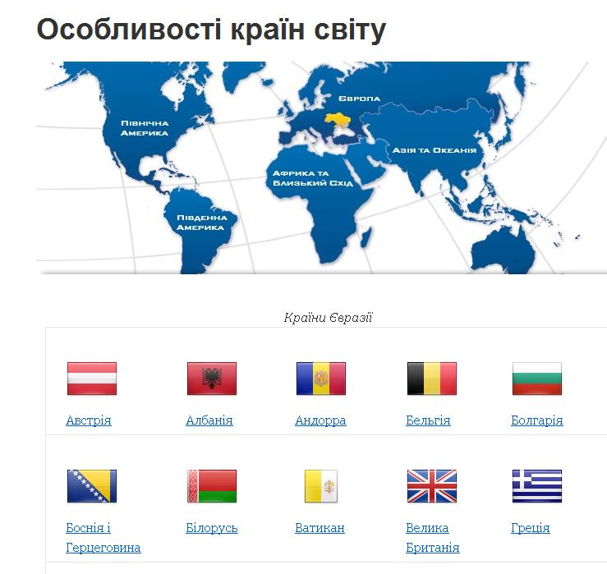
The individual country page will look like this:
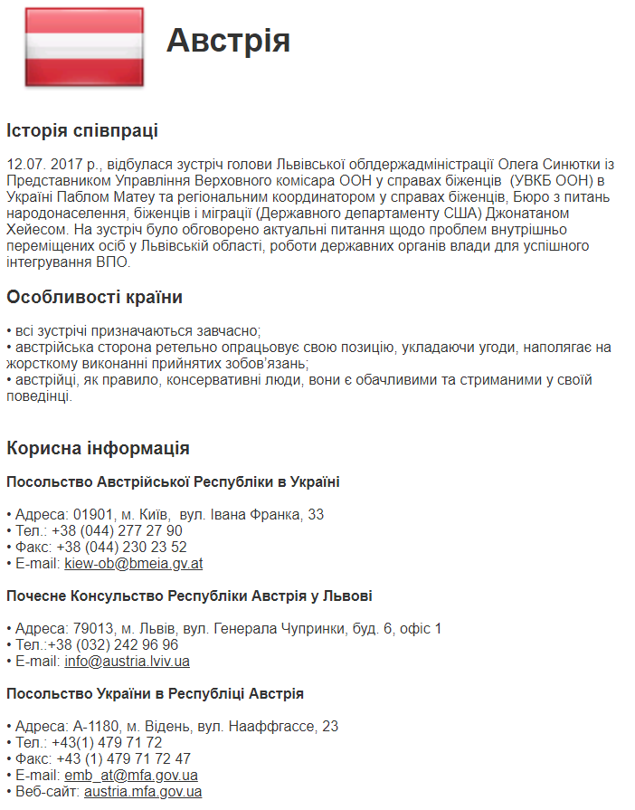
If there is information from sections «National Holidays of Foreign Countries» and «Previews» which refers to the selected country, it will be displayed in appropriate blocks at the bottom of the page.
Section ІІ: National Holidays of Foreign Countries
The section interface will look like this:

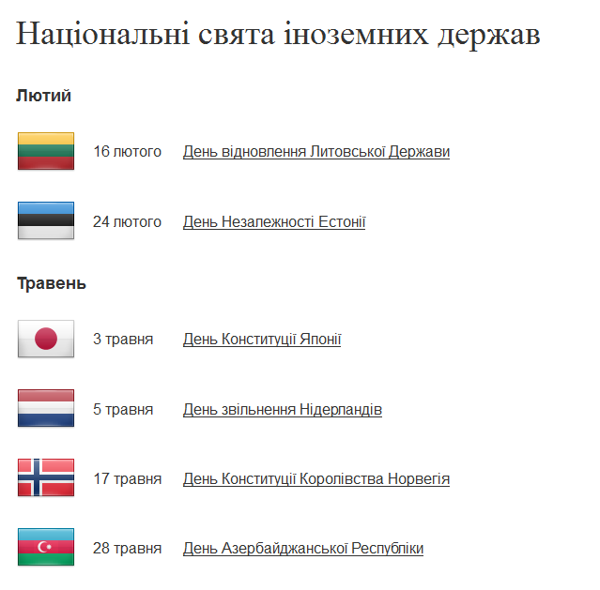
- The list of holidays is arranged from the current date one year in advance;
- The flag image is also a link to the country’s page;
- The holiday name is a link to a page with a detailed description of this holiday.
Section ІІІ: Previews of events in Ukraine
Previews may be linked to countries. In this case, a preview will be automatically displayed on the page of a certain country, until the specified event ends.
Schematically, this section will look like this:

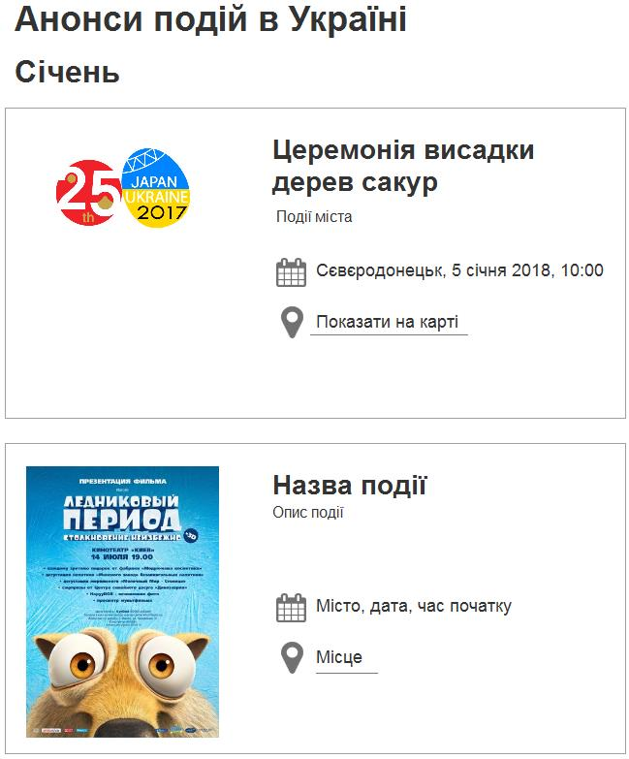

For each event, we may provide a Google map with a label that will appear on the event page.
Section IV: Euro-Atlantic Integration
- Relations with NATO (with option to insert active hyperlinks);
- Official documents (with option to insert active hyperlinks);
- Useful links (with option to insert active hyperlinks).
Section V: European Integration
Section VI: Organizational and Protocol Support for Visits
Section VII: Agreements and Memorandums

Block 10 – E-Learning
This block should provide placing materials for cycles of awareness-building and educational innovation programs.
There should be provided an option to enter comments under lecture courses.

Block 11 – Module for Polling Website Users
This module allows organizing polls and providing detailed statistics.
- This module consists of a form to be entered with a title of the question and a number of answers thereto. Answer options are edited by the administrator in poll settings. The number of answer options is unlimited. The administrator may set a method for answer selection – single (radio) or multiple (checkbox);
- Among answers to the questions, the administrator may set the «Other» option. When selecting this option, a field for typing the text should appear;
- The administrator is able to view the statistics of those who voted;
- The administrator is able to download the statistics in Excel;
- The administrator is able to reset polling results;
- The algorithm will not allow users sending the form more than once.

Footer
Contacts: this section contains contact information (details of the Department of International Technical Assistance, Innovation Development and External Relations), including its address, telephone, e-mail, and website link. An option for subscribing to newsletters and disseminating information about the Website on social networks (Facebook, Google+, Twitter, Telegram, LinkedIn) is also provided.

- Webinar Platform Requirements
The Website should contain a link to a free system for organizing and conducting webinars and meet the following requirements:
- Up to 1000 visitors are able to watch and listen to the webinar at the same time;
- There is a chatroom, which allows communicating with the organizer by sending personal messages;
- The system allows connecting 5 speakers at the same time and managing the process;
- The system is provided with an interactive board for drawing, an option to demonstrate a desktop, videos, presentations, documents, and links;
- There is an option to moderate a chatroom;
- The system is provided with a registration form to attend a webinar with an option to be connected via social networks;
- The system is provided with a built-in video editor. Following the broadcast, the user should be able to add or cancel the function of displaying the chatroom in records, export the video to a computer in the required quality and share it on social networks or on the Website;
- The system must run on desk and mobile devices and all operating systems. It must be supported by all browsers;
- The system should be provided with an option to turn off the listeners’ comments in a chatroom.

- Administration and Content Requirements
The Website administration system must contain two levels. The Website is administrated and filled with content by the following persons:
- Website Administrator
- Website Moderator
When working with the Website, the Website Moderator will perform the following actions (operations):
- Receive information for its publication in the relevant section of the Website, determine its category within his/her powers;
- Prepare for publication a webpage of the appropriate style category, add related materials and files using the Website settings and editing tools;
- Check the material, if necessary, editing its text, changing the list of the Website sections where this material and/or rights of access thereto will be published;
- Provide access to Website users to fill in, edit, and update the information in forms related to land plots and premises.
The Website will be moderated by employees of the Department Offices for External Relations, Promotion and Innovation Development, as well as for International Technical Assistance.
When working with the Website, the Website Administrator will perform the following actions (operations):
- Set up new sections and restructure existing sections of the Website at the request of the Website Moderator;
- Solve current issues of the Website software and hardware maintenance in cooperation with the Contractor;
- Provide access to the Website to employees of the Department’s structural units and other users for collecting the necessary information;
- Provide automatic backup of the Website software and its content.
The web editor must meet the following requirements:
- Ensure preliminary preparation of materials by other means and their transfer to the Website;
- Work with style sheets;
- Provide tools for optimizing the source HTML-code;
- Provide an option to use images in publications;
- Work with tables;
- Provide tools for text formatting;
- Be able to work with lists;
- Create links to other documents;
- Provide an option to work both in visual mode and directly with HTML-code;
- Correct errors.

- Questionnaire Data Entry and Moderation Requirements
To organize the automatic collection and processing applications for innovation proposals, a two-level system is created:
- At the first level, the detailed collection and analysis of information is performed by filling in an appropriate questionnaire:
– A specific module for working with questionnaires and filling them in is used;
- At the second level, the information is accumulated with completed questionnaires using pivot tables displayed on the Website.
The algorithm for collecting data and filling in questionnaires is as follows:
- The information is filled in by users through a specific module on the Website at any time as new data become available;
- The moderator of this Website subsection will accumulate the information entered, perform verification, aggregate the data into a pivot table, and output the updated information on the Website for general use. In this case, the moderator will be an employee of the Department of Promotion and Innovation Development;
- Separate questionnaire fields will be drop-down and the information for their filling in will be optional. For these fields to operate, an internal database will be created to automatically fill them in.

- CMS Requirements
The CMS must allow the Website administrator performing the following operations:
- Adding, editing, and deleting texts (articles);
- Adding, editing, and deleting news and previews;
- Adding, editing, and deleting information on the city map;
- Managing news and previews displayed (whether the material is published or not, publication start date, publication end date);
- Editing meta data of sections, articles, and news (internal information to improve indexing of the Website by search systems);
- Creating new sections of any nesting level (tree-structured sections);
- Editing and deleting current sections;
- Adding, editing, and deleting tags;
- Controlling menu (creating, editing, and deleting menu and submenu items);
- Managing Website users (banning by IP address, blocking, editing user data, restoring and resetting passwords, managing user permissions and access levels);
- Managing access levels (creating, editing, and deleting user roles with appropriate access levels, such as administrator, moderator, participant, expert, and reader);
- Moderating (and pre-moderating) materials added by Website users without administrator (moderator) privileges;
- Moderating (and pre-moderating) comments to Website materials.

- Page Layout Requirements
The Website page layout must allow an automatic page scaling depending on the workspace width of the user’s browser. The minimum size (width) of the browser field ensuring full display of pages (without a horizontal scroll bar) is 1024 pixels.

- Web Image Design Requirements
The Website must meet the attached Requirements for Creating (Modernizing) Official Websites (Web Portals) of Executive Authorities approved by the resolution of the Cabinet of Ministers of Ukraine dated June 12, 2019, No. 493.
The Website image design should be performed according to recommendations provided.
The Customer considers it appropriate to use the following websites as an example of the Website image design:
- Hamilton Investment Portal (Ontario, Canada): http://www.investinhamilton.ca/;
- The Netherlands Foreign Investment Agency: https://investinholland.com/;
- Victoria’s Investment Promotion Agency (Victoria, Australia): http://invest/vic/gov/au/;
- Halle Investment Portal (Saxony-Anhalt, Germany): http://www.halle-investvision.de;
- Invest in Lviv: http://investinlviv.com/uk/;
- Invest in MYK: http://investinmyk.com/.
The image design of Website sections must be implemented in the same presentation style of sections and certain web pages;
It is recommended to use the following basic fonts:
- Nobel
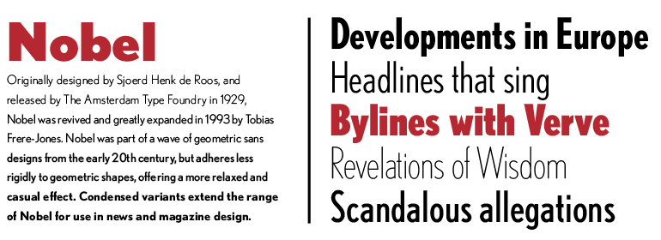
- Brandon Grotesque
And use charset = UTF-8.
It is also recommended to use for the Website the following basic color scheme:
- Cold colors symbolize rigor, confidence, fundamentality, stability suitable for classic, serious corporate clients engaged in financial and investment activities.
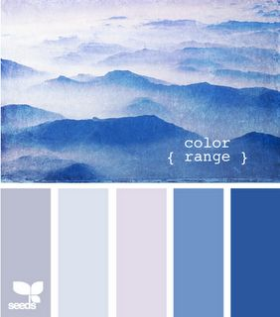

- Styling Requirements

The Website styling should be based on the following elements:
- The style is minimalistic;
- Icons and logos are intuitive for users;
- Home page background is represented by photos of sights of Luhansk oblast;
- The background of other Website pages is white with graphic display of objects associated with Luhansk oblast.

- Requirements for Color Scheme and Graphic Elements of Website Design
The Website design should look professional, stylish, and modern, but at the same time should not be overfilled with extra graphic elements.
The use of small, but stylish and dynamic graphic elements in Website design (with slightly broken edges, icons, and visuals floating when clicked) would be a plus.
The use of small flash elements in Website design is also welcomed (minor logo processing is allowed).

- Usability Requirements
It is recommended to use simple drop-down menus to represent the content of sections.
The page size should not exceed 10 MB.
The page opening time is up to 5 seconds with a data rate of 28,800 bps.
The Website must run, when using the most common browsers:
- Windows (7, 8, 8.1, 10);
- Місгsoft Іnternet Ехрlorer (version 11 or higher);
- Opera (version 67.0.3575 or higher);
- Google Chrome (version 80.0.3987.162 or higher);
- Mozilla Firefox (version 74.0 or higher);
- Apple Safari (version 5.1.7 or higher);
- Microsoft Edge/IE (version 80.0.361 or higher);
- *nix system (e.g. Ubuntu 16.04 LTS and 14.04 LTS);
- Google Chrome;
- Mozilla Firefox;
- Opera;
- macOS (e.g. macOS 10.12 Sierra).

- Software and Hardware Requirements
The Website software must ensure the implementation of actions (operations) performed by the Administrator and Moderator within their powers and these Requirements.
Software requirements:
- Web server functions are performed by NGINX server or its equivalent;
- The application server is at least built on PHP script language;
- The functions of the primary database server are performed by PostgreSQL/MySQL.
The Website software must enable convenient and automated performance of the Website Administrator’s duties related to the creation of new Website sections and restructuring its current content by sections.
The Website Moderator’s functions should be available via HTTPS protocol.
When developing the Website, it is required to provide for the registration of HTTPS certificates.
The accounts created by the Website Administrator must be protected by passwords, which do not allow their reverse decoding within a period of less than 3 calendar moths.
The Website software must ensure its functioning 24 hours a day, 7 days a week, and 365 days a year (subject to its hardware trouble-free operation).
The Website software must provide simultaneous (parallel), continuous work of one thousand (1000) anonymous visitors for eight (8) hours, with parallel processing and publication of five hundred (500) information materials in different Website sections without any denial of service.
The software Website mechanisms must ensure its round-the-clock operation with acceptable breaks for service maintenance with its users being notified thereof in advance.
The Website must be protected from SQL injections, as well as other means of interfering with the continuo Website us Website operation within its software platform.

- Newsletter Subscription Requirements
The Website users should be able to subscribe to e-newsletters by filling in an appropriate form.
The Website must contain a form to fill in and a service for automatic sending e-newsletters to Website users who have registered for such newsletters.

- SEO Requirements
- Each page of the Website when created in the administration system must have a unique CNC address (seo-friendly url) in a form understandable to users;
- An option for editing SEO parameters of the page (title and description). If meta tags are not set individually, they are generated automatically according to the template;
- Availability of robots.txt and sitemap.xml files;
- An option to automatically generate alt and title properties of images;
- Setting up a 301 redirect to the main mirror of the Website. An option for redirecting www to non-www or vice versa;
- Conceptual block layout of templates;
- Correct 404 error handling;
- Download rate optimization (caching, gzip);
- Enabling tools for GoogleAnalytics webmasters.

- Information Security Requirements Adaptation for smartphones and tablets
The following information security requirements must be implemented:
- If a webpage contains links to information resources of another webpage, its operation terms should not violate the security policy established for this webpage.
- The implementation of requirements to protect the integrity and availability of public information posted on the webpage, as well as confidentiality and integrity of its technological data should be ensured.
- The information processing technology should meet the requirements of the information security policy defined for the system ensuring the operation of the webpage.
- The requirements for ensuring the integrity of the webpage public information, confidentiality, and integrity of its technological data provide for the use of technologies implementing the controlled and authorized access to information and blocking its uncontrolled and unauthorized modification.
- Technological processes should provide automatic backup of webpage information and the procedure of its restore using backups. A full backup of the Website content should be done every day.
- Development and Ownership Transfer Requirements
The Customer will approve the Terms of Reference for the Website development after agreeing with the Developer all issues and suggestions.
The program will be accepted after a period of its beta testing. If the Website operates correctly and steadily for 30 calendar days, the period of its beta-testing is considered to be succeeded.
The Contractor shall provide technical support for the software product for 12 months from the beginning of its operation period, eliminate all bugs and inconsistencies with the Terms of Reference (without changing program functions) and provide training for the Website administrators and users.
After the test release, the initial hosting settings and the recent Website version are set.

